The 2nd International Conference
″Computational Mechanics
and
Virtual Engineering″
COMEC 2007
11 – 23 OCTOBER 2007, Brasov, Romania

STRESS DIMENSIONING OF type punches
FOR DIVIDING OPERATIONS

Radostina Petrova¹, Mihaela Topalova², Veselin Raychev³
¹ Faculty of Engineering and Pedagogy – Sliven, TU – Sofia, BULGARIA, rpetrova123@abv.bg
² Faculty of Engineering and Pedagogy – Sliven, TU – Sofia, BULGARIA, mihaelatopalova@yahoo.com
³ Faculty of Engineering and Pedagogy – Sliven, TU – Sofia, BULGARIA, vesraychev@yahoo.com

Abstract: An analysis of the construction of type punches, regarding stress dimensioning, is done. Some recommendations concerning the constructive optimization of the punches for dividing operations are formed.
Keywords: stress dimensioning, constructive optimization, punches for dividing operations, automated design

- INTRODUCTION

The punches are the hardest loaded working elements in the dies for dividing operations (PDO). During working processes different types of stress appear in them. This urges some stress evaluations to be done during the process of design. In classical design methods they are based on the principle relations of strength of materials and in most of the cases no constructive optimization of the designed punches is done. The automated design allows the stress dimensioning of dies to be bounded by their constructive optimization.
The authors of this work analyze the construction of type punches for dividing operations, regarding the stress evaluation, with a view to creating a method for automated design of working elements of PDO.

2. TYPIFICATION OF THE PUNCHES FOR DIVIDING OPERATIONS

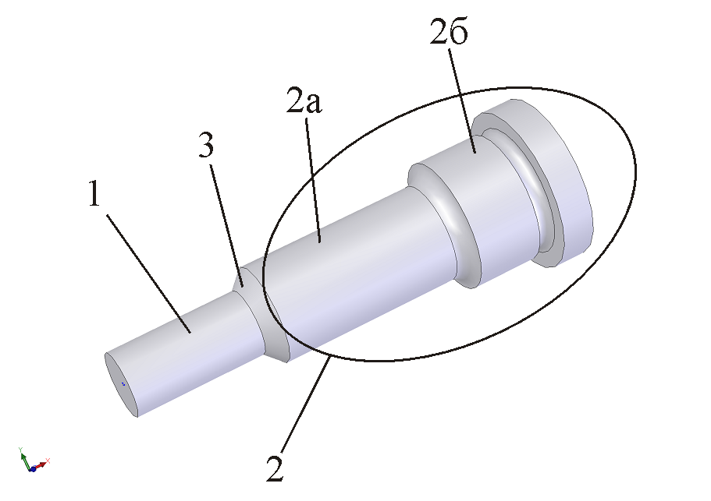

Figure 1: Main parts of a typified punch

It is accepted that the typified punches consist of three main parts (fig. 1) – working part, see position 1, connecting part (position 2) and transitive part (position 3). The connecting part combines two other sections – guiding section (position 2a) and establishing section (position 2b).

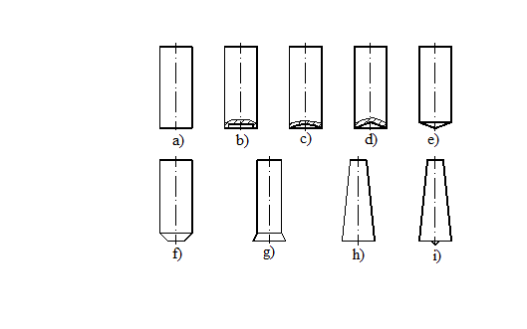

Figure 2: Typical longitudinal profile generants of the working part of punches

The working typification, based on the typification presented in [1], is regarding the longitudinal profile generant.
The typified longitudinal profile generants of the working part of punches are shown in fig. 2. The profile generant can be a line parallel to the central axis of the pressure (fig. 2 – a, b, c, d, e, f, g) or a line, inclined towards the central axis of the pressure (fig. 2 – h, i ).

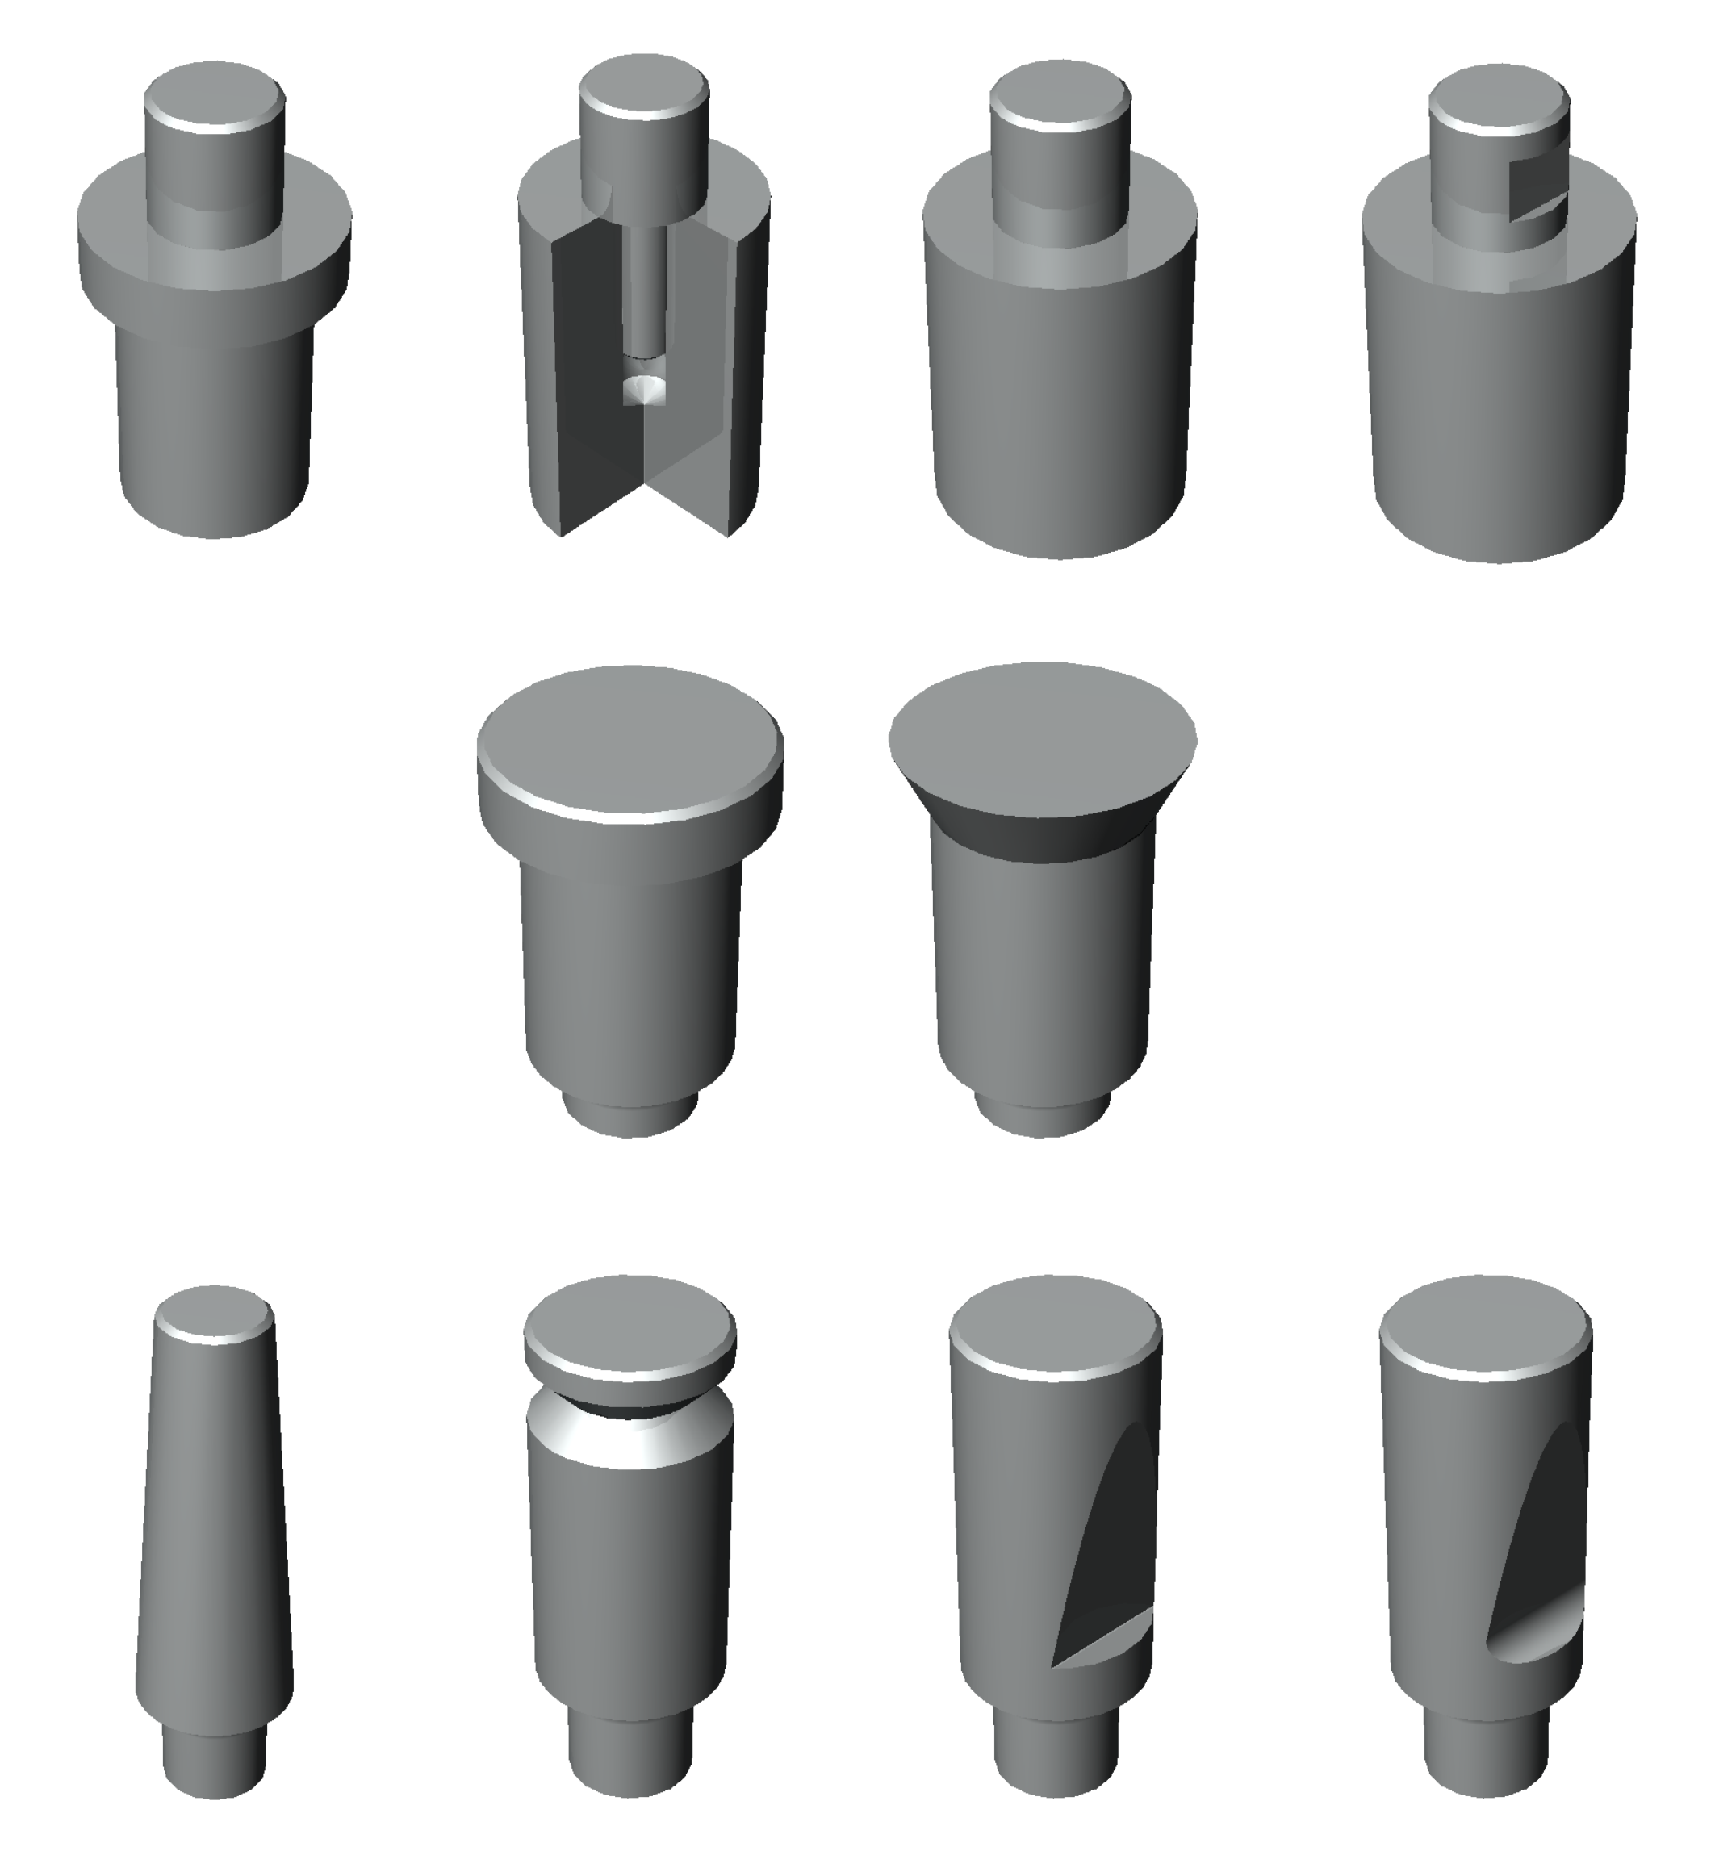 | 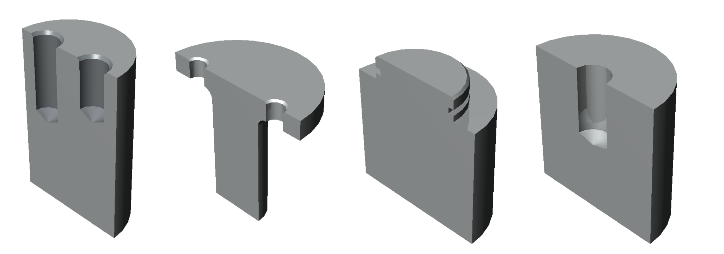
Figure 3a | Figure 3b

Figure 3: Typified connecting parts of punches
Figure 3a: Connecting parts with a head
Figure 3b: Connecting parts without a head

The connecting part of the punches is typified regarding their establishment. The typification is based on the classification given in [1, 3]. The accepted types of connecting parts of the punches are shown in fig. 3 – connecting parts with a head (fig. 3a) and connecting parts without a head (fig. 3b).
The transitive part can not be typified. Each punch is characterized by a specific transitive part that strongly depends on the variants of connection between working and connecting part of the punch and technological parameters of its construction.

3. STRESS DIMENSIONING OF TYPIFIED PUNCHES
The values of some of the constructive parameters of the geometrical characteristics of the punches are calculated during stress dimensioning. Two types of problems are solved:
- problems dealing with calculation of the values of the constructive parameters – According to [2, 4] the stress dimensioning process of a punch involves the following calculations: dimensioning of the narrowest cross section, having in mind pressure; dimensioning of the supporting area, having in mind the mashing stresses and a buckling verification, according to the scheme of fixing and guiding the punch.
- problems performing verification of the stresses in the punches – these types of problems analyze stresses and deformations, which are obtained in already dimensioned spatial finite – element models, exposed to static loading.
This work discusses only the first type of problems.
The stress dimensioning based on pressure calculation applies to the narrowest cross section of the punch. This section, usually, appears to be inside the working part of the punch. The typified working parts of the punches are divided in two groups:
- punches with working part, whose generant is parallel to the central axis of the pressure (fig. 2 – a, b, c, d, e, f, g). Pressure stress dimensioning for this group of punches ought to be done for a cross section above the cutting edge. In order to enable the unification of the dimensioning process it can be accepted that the dimensioned section is the one in the zone connecting the working and the transitive parts.
- punches with working part, whose generant is inclined towards the central axis of the pressure (fig. 2 – h, i). The most dangerous stresses for these types of punches are also inside the zone connecting the working and the transitive parts of the punches.
The punches, having smooth generant of the transitive part (fig. 4 – a and b) makes an exception. The verification of the stresses for these types of punches is done for the narrowest cross section 1-1.

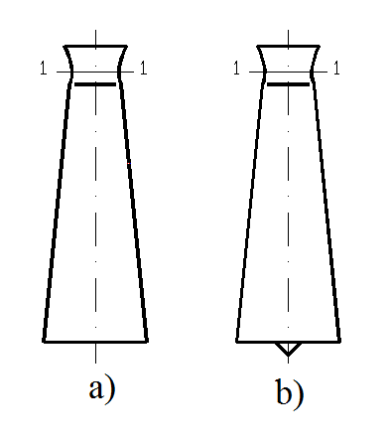

Figure 4: Typified punches with smooth generant of the transitive part

The complete analysis of the pressure stresses of all types of punches, with exception of these shown in fig. 4, shows that the verification of stresses and calculation of constructive parameters have to be done for the section, connecting working and transitive sections.
Stress dimensioning based on calculation of mashing stresses is done for the cutting edge of the punch. The local distribution of these stresses explains their higher admissible values. While performing this stress verification the working parts, shown in fig. 2, are divided into:
- working parts for which there is no need of performing a mashing stress verification. Such types of punches are those shown in fig. 2 – a, g, h;
- working parts for which the cutting edge must be verified for mashing stresses. Such types of punches are shown in fig. 2 – b and f.
The calculation of mashing stresses is of great importance to the width of the cutting edge on the punch, show in fig. 2b. The mashing stresses are much greater than the pressure in the punch. Thus the die-stamping of the detail can be performed by applying a smaller force than the one necessary for the case shown in fig. 2a. At the same time the quality of the cutting is bettered. The stamping force is transformed into force that is constantly spread on the cutting surface forces. Their values must be smaller than the admissible mashing stress.
Additional stresses are generated in the stamped material when a punch of the type shown in fig. 2f is used. Part of them is transferred to the swage. Thus the stresses in the punch are reduced and the shearing stresses are concentrated in the inclined zone and the cutting edge of the swage. This type of punch is recommended for punching, but must be avoided in connection with blacking operations. The mashing stresses are calculated only for the surface that contacts to stamped black first. These mashing stresses must be smaller than the admissible one.
The maximum stresses for types of punches shown in fig. 2c, 2d, 2e and 2i can be approximately calculated regarding the equations of Herz for contact stresses. Still it is better these stresses to be obtained by verifying of a spatial finite – element model.
The performed analysis shows that the stress dimensioning regarding mashing is expedient to be realized only for punches, having working parts shown in fig. 2b and 2f.

For the type of punch shown in fig. 2i, it is necessary that shear stress verification should be done. The shear stresses along the most dangerous section 1 (fig. 5) must be calculated. It is accepted that the cutting forces are uniform linear load, spread along the contour curve 2 from the front of the punch. Its value can be calculated by the condition of equivalence between it and the pressure in the ring 3. The uniform shear stresses generated by these forces must not exceed its admissible value.

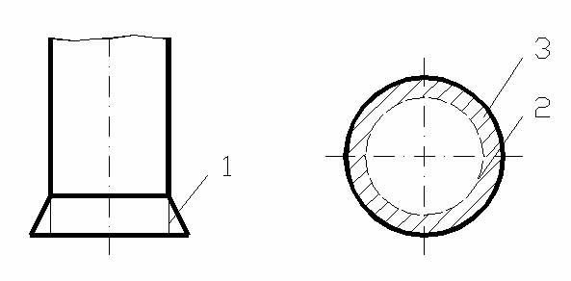

Figure 5: The most dangerous section regarding shear stress verification

Buckling analysis of different types of punches is done by analyzing equivalent schemes that regard the way of fixing and guiding of the punches. The connection between the working part and the transitive part is modeled by fixing support. Depending on the type of the generant of the front surface of the working part the connection “punch - stamped black” can be modeled:

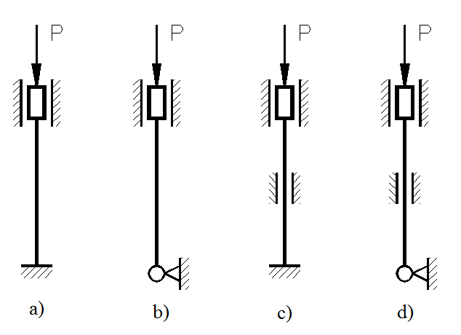

Figure 6: Equivalent schemes for buckling analysis

- with a fixing support (see fig. 6a). This static scheme is used for buckling analysis of punches given in fig. 2a, 2b, 2c, 2d, 2g and 2h. In cases shown in fig. 2c and 2d the cutting force smoothly grows and increases the stability of the bottom end of the punch.
- with an elastic fixing support. This static scheme is equivalent to type of punch shown in fig. 2f. This support can cause a starting deformation of the central pressure axis of the punch, while its equilibrium is preserved.
- with a joint support (see fig. 6b). This is the static scheme of punches in fig. 2e and 2i.
If the buckling verification is not successful the equivalent static scheme of the punch can be changed. An intermediate support is added (fig. 6c and 6d).
Verification of concentrated stresses is performed only for some special cases for heavily loaded punches. The recommended for verification zones can be systematized in the following way:
- for punches of types shown in fig. 2a, 2g and 2h – the dangerous zone is the zone round the cutting edge. Depending on the distribution of concentrated stresses this case is the most preferable one.
- for punches of types shown in fig. 2b, 2c and 2d – there is a clearly defined zone of concentration of stresses, based along the cutting edge.
- for punches shown in fig. 2e and 2i – there is a force, concentrated in the central point at the beginning of the die-stamping, simultaneously there is a peak in the time dependent curve of maximum stresses. Subsequently this peak smoothly disappears. Because of that the verification of concentration of stresses must be done in the moment of the realizing the contact between the punch and the stamped black. Usually there is no need of such type of verification because the wearing of the peak of the punch does not influence the quality of the process and is technologically reasonable.
- for punches shown in fig. 2f – concentrated stresses can arise in the two zones shown in fig. 7: zone 1 – along the cutting edge and zone 2 – in the transition from the inclined generant to a working part with nominal dimension. The stresses grow up constantly and monotonously in this case. They obtain their maximum values along the shearing contour in the moment of destroying the stamped black and these values are less than the ones in cases shown in fig. 2a, 2h and 2i.

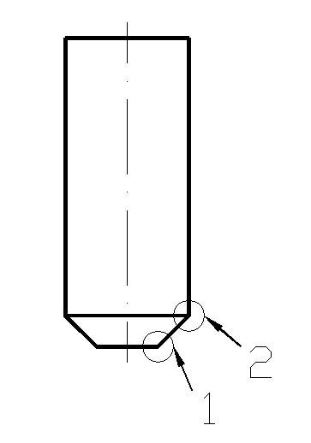

Figure 7: Zones with concentration of stresses

4. CONCLUSIONS

The analysis of the construction of typified punches, regarding their stress dimensioning, leads to the following conclusions:
1. When constructive parameters, whose minimum values can be calculated by classical methods of strength of materials, are optimized, an object function is defined.
When a stress dimensioning regarding pressure is performed the area of the minimum cross section inside transitive part of the typified punches shown in fig. 4 can be optimized. The object function includes the admissible area and the prime cost of the punch.
An optimization of constructive parameters of typified punches shown in fig. 2b must take in mind the mashing stresses. The minimum width of the working head part of the punch is determined by dimensioning based on mashing stresses, and its optimal value – by constructive and technological considerations.
The shear stress dimensioning is decisive for the minimum height of the jag of the punches in fig. 2g, while its optimal value can be defined regarding stress and technological requirements.
The mathematical definition of object functions of the optimizing criteria is part of future investigative works.
2. When the optimization is based on criteria, investigating stress or deformable verification (for example verifying the concentration of stresses in the most dangerous zones or buckling analysis) modern numerical methods such as finite element method are used.
In most of the solved problems it is almost impossible for an object function to be defined when finite-element optimization is performed. Because of that, parametric language is used for defining the optimization problem and the problem is solved for different combinations of the input data.
The inclination of the generant of the working part of typified punches in fig. 2c, 2d, 2e and 2f and of the centering cone in fig. 2i can be optimized on the base minimizing of stress concentration.
Optimization of the length of the working part is based on the buckling verification and the possible necessity of guiding the punch. The length of the working part, the thickness of the guiding plate and its disposition can be optimized. The technological requirements determine the input data.
The results of the performed analysis are the base of the developing method for automated design of punches for dividing operations.

ACKNOWLEDGEMENTS:
The presented work is financed by Fund for Scientific and Research Projects of Technical University of Sofia, contract № 979 НИ-16/2007.

REFERENCES

[1] Мартинов, Г. М., П. К. Данаилов. Конструкции и изработване на щанци и пресформи. Част 1: Конструкции на щанци и пресформи. С., Издателство на ТУ – София, 1992, in Bulgarian
[2] Попов, Г., М. Кръстев, Е. Пенева, М. Иванов, В. Гагов. Проектиране на щанцови инструменти. Русе, Печатна база при ВТУ “А. Кънчев”, 1988, in Bulgarian
[3] Романовский, В. П. Справочник по холодной штамповке. Ленинград, Машиностроение, 1979, in Russian
[4] Томов Б. Технология и инструменти за щанцоване. Русе, ВТУ „А. Кънчев”, 1985, in Bulgarian
[5] Топалова М., В. Райчев, Г. Стефанов, М. Йорданов, М. Милев, П. Чобанов. Типизиране на конструкцията на щанци за разделителни операции, Механика на машините, год. XIV, кн. 2, ТУ – Варна, 2005, in Bulgarian

