The 2nd International Conference
″Computational Mechanics
and
Virtual Engineering″
COMEC 2007
11 – 23 OCTOBER 2007, Brasov, Romania

ON THE RECEIVED DIRECT SOLAR RADIANCE OF THE PV PANELS ORIENTATED BY AZIMUTHAL TRACKERS

I. VIŞA¹, D. DIACONESCU¹, V. DINICU¹
¹Transilvania University of Braşov, Romania, visaion@unitbv.ro

Abstract : This paper models and simulates the incidence angle variations and the afferent received direct solar radiance of the PV panels orientated by means of the azimuthal trackers. The numerical simulation allows to make a comparative analysis of the incidence angle variations and of the received direct radiance variations obtained by the tracked PV panels versus the tilted and horizontal fixed PV panels. The obtained analytical models and the conclusions derived from the interpretation of the numerical simulations are very useful in the tracker’s design.
Keywords : incidence angle, solar radiance, PV panel, azimuthal tracker, solar angles.

1. INTRODUCTION

The main objective of this paper is to model the received direct solar radiance of the orientated PV panel by means of the azimuthal trackers. In order to do this, the paper establishes, firstly, the incidence angle sun-panel (measured between the sun-ray unit vector and the PV panel normal unit vector) and then establishes, by means of the obtained incidence angle, the PV received direct solar radiance. The results of the numerical simulations, developed on the basis of the obtained analytical models, enable the comparative analysis between the tracked PV panels (by means of the azimuthal dual-axis tracker) versus the horizontal and titled fixed PV panels. The results highlight that: a) the incidence angle minimization (by means of an azimuthal tracker) only can not assure the overall energetic efficiency optimization; b) this desideratum can be only reached if the minimization of the incidence angle is properly correlated with the solar radiance daily variation.
In Fig. 1 there are illustrated the sun-ray angles (ψ, α) of the azimuthal system Qx₀y₀z₀ (Fig.1, a) and nearby (Fig.1, b) there is presented the geometrical scheme of the tracker derived from Fig.1,a.

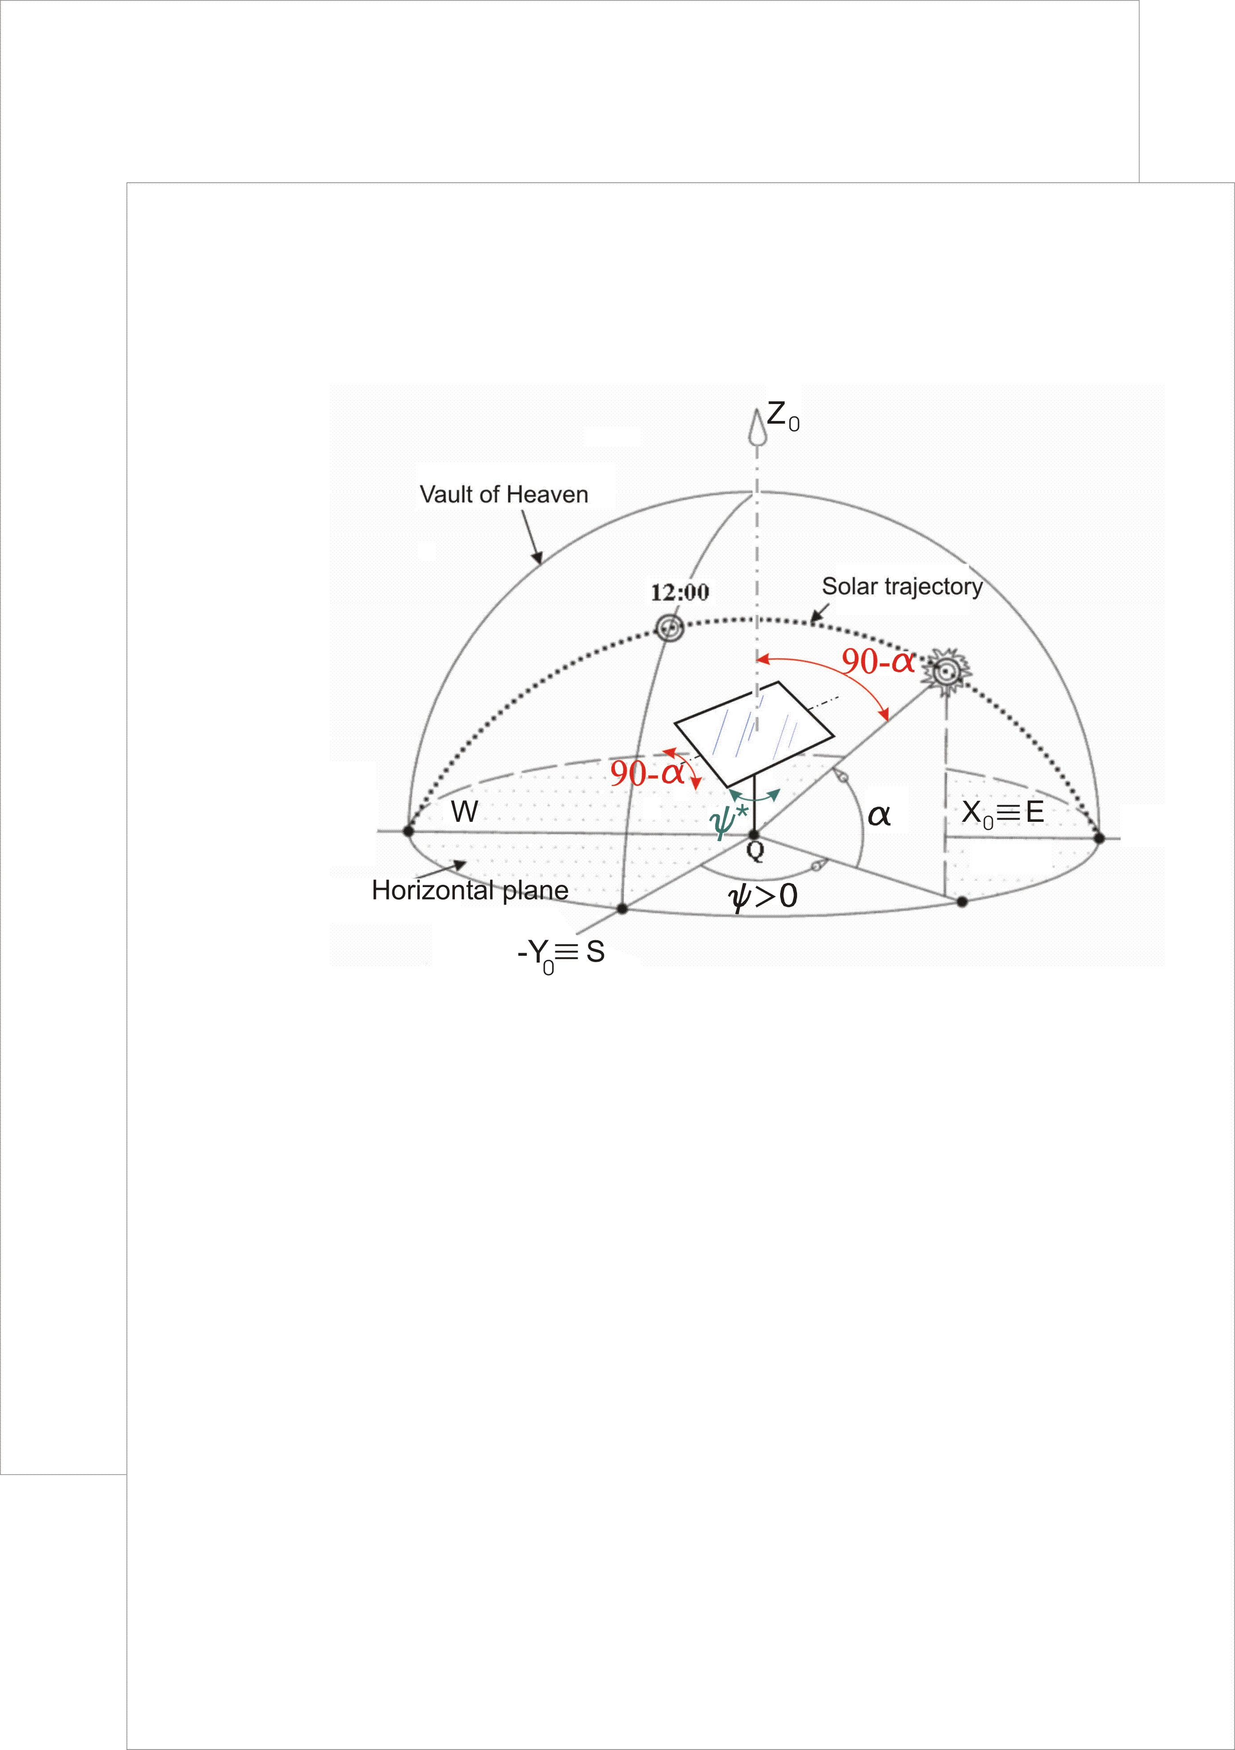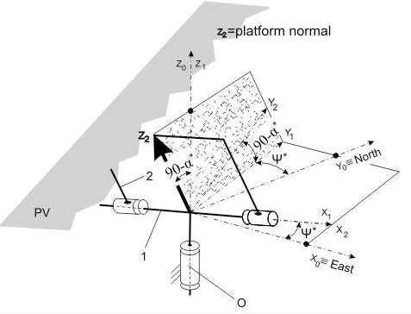
a b
Fig. 1 The sun-ray angles in the azimuthal system Qx₀y₀z₀ (a); Geometrical scheme of the azimutal tracker (b)

2. Unit vectors modelling.

Because of energetical and economical reasons, the angular displacement of the tracked PV panel is made discontinuously (in steps), so the tracker’s angles have discreet variations; in order to distinguish them from the sun-ray angles (which have continuous variations: ψ and α, see Fig.1, a) in the correlations below the tracker’s angles are marked with asterisk: ψ* and α* (see Fig. 1, b).
Obviously, when the angular displacements’ tracker are made continuously then: ψ*=ψ and α*=α.

From Fig.1, a, which shows the sun-ray geometry in the local system Qx₀y₀z₀, the following expression of the sunray unit vector can be obtained:

${\left[{\bar{e}}_{\text{sr}}\right]}_{x_{o}y_{o}z_{o}}=\left[\begin{matrix}\text{cos}α⋅\text{sin}ψ \\ −\text{cos}α⋅\text{cos}ψ \\ \text{sin}α\end{matrix}\right]$ (1)
Fig.1, b illustrates the kinematical scheme of the azimuthal dual-axis tracker, in which interfere three reference systems: the local system X₀Y₀Z₀ and two intermediate systems X₁Y₁Z₁ and X₂Y₂Z₂; the unit vector k₂ (of the axis Z₂) is perpendicular on the PV panel. From Fig. 1, b the following correlation of the PV panel normal unit vector can be established in the local system X₀Y₀Z₀:
${\bar{e}}_{\text{PV}−\text{az}}={\left[k_{2}\right]}_{x_{0}y_{0}z_{0}}=T_{1→0}T_{2→1}{\left[k_{2}\right]}_{2}=$$\left[\begin{matrix}\text{cos}ψ^{} & −\text{sin}ψ^{} & 0 \\ \text{sin}ψ^{} & \text{cos}ψ^{} & 0 \\ 0 & 0 & 1\end{matrix}\right]⋅$ $\left[\begin{matrix}1 & 0 & 0 \\ 0 & \text{cos}(\text{90}−α^{}) & −\text{sin}(\text{90}−α^{}) \\ 0 & \text{sin}(\text{90}−α^{}) & \text{cos}(\text{90}−α^{})\end{matrix}\right]⋅\left[\begin{matrix}0 \\ 0 \\ 1\end{matrix}\right]=$${\left[\begin{matrix}\text{sin}ψ^{}\text{cos}α^{} \\ −\text{cos}ψ^{}⋅\text{cos}α^{} \\ \text{sin}α^{}\end{matrix}\right]}_{x_{0}y_{0}z_{0}}$ (2)

By means of the correlations (1) and (2), the incidence angle sun-PV panel can be established.

3. Sun-PV panel incidence angle ON AN AZIMUTHAL TRACKER

The incidence angle between the sun-ray and the PV panel, orientated by the azimuthal tracker, can be obtained using the correlations (1) and (2):
$\begin{aligned}\text{cos}ν={\bar{e}}_{\text{sun}−\text{ray}}⋅{\bar{e}}_{\text{PV}−\text{az}}=\left[\begin{matrix}\text{cos}α⋅\text{sin}ψ \\ −\text{cos}α⋅\text{cos}ψ \\ \text{sin}α\end{matrix}\right]⋅\left[\begin{matrix}\text{sin}ψ^{}\text{cos}α^{} \\ −\text{cos}ψ^{}⋅\text{cos}α^{} \\ \text{sin}α^{}\end{matrix}\right]= \\ \text{cos}α⋅\text{cos}α^{}⋅\text{cos}(ψ−ψ^{})+\text{sin}α⋅\text{sin}α^{}\end{aligned}$ (3)
Using the incidence angle model, depicted by the relation (3), there were made some numerical simulations by means of the Excel software; these simulations were considering the following input data: a) latitude φ = 45° N, b) day n =172 Summer Solstice (June 21st) δ = +23,45°, c) day n =355 Winter Solstice (December 21st) δ = -23,45° and d) days n = 80 and 262 Spring Equinox (March 21st), respectively Autumn Equinox (October 21st), δ = 0°. The simulations’ results, exemplified in Fig. 3, 6 and 9, compared with the cases of the fixed (horizontal and tilted) panels, are obtained in the angular displacement conditions considered in Fig. 2, 5 and 8: each curve a, from Fig. 3, 6 and 9, is obtained on the basis of the curves a1 and a2 from Fig. 2, 5 and 8 respectively; each curve b, from Fig. 3, 6 and 9, is obtained on the basis of the curves b1 and b2 from Fig.2, 5 and 8 respectively; and so on.
In the considered numerical situation, from Fig.2, 5 and 8, there are presented the case in which the azimuthal tracker has continuous movement (the curves a1 and a2) and two examples in which the tracker has discontinuous movements (in steps). The first example of discontinuous movement is depicted by the curves b1 and b2 and has equal steps (aprox. 1 min. displacement + aprox. 59 min. standing). The second example of discontinuous movement is depicted by the curves c1 and c2 and has less steps. Obviously, in the case of the continuous movement, the incidence angle is standing null (the curve a), in the first example of discontinuous movement, the incidence angle has an reduced and uniform variation (the curve b) and in the second example of

Fig. 2 Variations of the parameters ψ; ψ* (the curves a1; b1 and c1) and α; α* (the curves a2; b2 and c2) for an
azimuthal tracker during the Summer Solstice (day n =172, June 21st, δ = +23,45°) for latitude φ = 45°N
Fig. 3 The incidence angle variations afferent to Fig.2 (the curves a, b and c) vs. a horizontal- and a tilted fixed solar panel (the curves fh and ft)
Fig. 4 Variations of the received direct solar radiance afferent to Fig.2 and 3 (the curves a, b and c) vs. a horizontal- and a tilted fixed solar panel (the curves fh and ft)
.
Fig. 5 Variations of the parameters ψ; ψ* (the curves a1; b1 and c1) and α; α* (the curves a2; b2 and c2) for an azimuthal tracker during the Winter Solstice (day n =355, December 21st, δ = -23,45°) for latitude φ = 45°N
Fig. 6 The incidence angle variations afferent to Fig.5 (the curves a, b and c) vs. a horizontal- and a tilted fixed solar panel (the curves fh and ft)
Fig. 7 Variations of the received direct solar radiance afferent to Fig.5 and 6 (the curves a, b and c) vs. a horizontal- and a tilted fixed solar panel (the curves fh and ft)

Fig. 8 Variations of the parameters ψ; ψ* (the curves a1; b1 and c1) and α; α* (the curves a2; b2 and c2) for an azimuthal tracker during the Spring Equinox (day n =80, March 21st, δ = 0°) for latitude φ = 45°N
Fig. 9 The incidence angle variations afferent to Fig.8 (the curves a, b and c) vs. a horizontal- and a tilted fixed solar panel (the curves fh and ft)
Fig. 10 Variations of the received direct solar radiance afferent to Fig.8 and 9 (the curves a, b and c) vs. a horizontal- and a tilted fixed solar panel (the curves fh and ft)

discontinuous movement, the incidence angle has an unequal variation (the curve c) with higher values in the morning and in the evening.
In the considered numerical situation (see Fig.3, 6, 9), the incidence angles’ variations of the fixed PV panels are almost similar to each other and net higher than the tracked panels.
Further, using the obtained incidence angles, the received direct solar radiance will be determined.

4. RECEIVED direct solar radiance.

Using Meliss’ modeling [2], the direct solar radiance R_{d} depends on the hour and the day of the year and it is modeled with correlation :
$R_{d}\text{= 1367}⋅[\text{1+ 0,0334}⋅\text{cos}(\text{0,9856°}⋅\text{N-2,72°})]\text{.}{\text{e }}^{\text{-Tr / }(\text{0,9 + 9,4}⋅\text{sin }α)}$[W/m²] (4)
in relation (4) N is the day number of the year, α is the altitude angle and T_{r} it is a atmospheric coefficient which is given in [ 2].
If the solar panel normal unit vector is permanently coincident to the sun-ray (tracker movements are continuous), then entire direct solar radiance R_{d}, described by relation (4), is perpendicular to the solar panel and represents the received direct radiance for PV panel . If the two normal unit vectors do not coincide, then the received direct solar radiance of the panel is modelled with correlation:
$R_{\text{dr}}{\text{ = R}}_{d}⋅\text{cos}υ$ (5)
where cos ν is modeled by correlation (3).
In Fig. 4, 7 and 10 there are illustrated the variations of the received direct solar radiance (R_{dr}) afferent to the data from Fig. 3, 6 and 9; the comparative analyses of these variations highlights that the curves a, b and c (Fig. 4, 7 and 10) are almost superposed and the areas under them are almost equal each other and more than the areas under the curves fh and ft.
Therefore, the maximum energetic efficiency can be obtained if the area under the curve of the received direct radiance becomes almost maximum for the least steps number. This conclusion is very important for the optimal design of the azimuthal PV trackers.

5. Conclusions.

In this paper there was modelled the incidence angle for the azimuthal dual-axis PV tracker, in order to establish the received direct radiance of the PV panel. The model was tested with Excel software and on basis of the numerical simulations, there were made comparison analyses of the incidence angle variations vs. the variations of the tilted- and horizontal fixed PV panel. By means of the obtained results, regarding the incidence angle variations, the received direct radiance of the tracked PV panel was modelled and simulated; the results highlight that: a) the incidence angle minimization (by means of an azimuthal tracker) only can not assure the overall energetic efficiency optimization; b) this desideratum can be only reached if the area under the curve of the received direct radiance becomes almost maximum for the least steps number. This conclusion is very important for the optimal design of the azimuthal PV trackers.

REFERENCES

- Diaconescu D. a. o.: Analysis of the Sun-Earth angles used in the design of the solar collectors' trackers, Bulletin of the Transilvania University of Brasov, Vol. 13(47), 2006, p. 99-105.
- Meliss M.: Regenerative Energiequellen, Springer-Verlag Berlin, 1997.
- Messenger R., Ventre J.: Photovoltaic System Engineering, CRC Press, London, 2001.

