The 2nd International Conference
″Computational Mechanics
and
Virtual Engineering″
COMEC 2007
11 – 13 OCTOBER 2007, Brasov, Romania

HAND-ARM VIBRATION ANALYSIS: THE FINITE ELEMENT APPROACH

Simona Lache¹, Catalin Vezeteu¹
¹ Transilvania University of Brasov, ROMANIA, slache@unitbv.ro

Abstract: The study of the vibration influence on the hand-arm system leads to the conclusion that many factors may cause occupational diseases in this field of activity: starting from workers using hand tools, continuing with professional drivers affected by the speed change gear vibrations, several occupational categories are affected. This fact requires enhanced attention from manufacturers’ point of view, in the sense of developing different systems for protection against vibrations. For achieving this, the dynamic behaviour investigation of the hand-arm system is of utmost importance. From the vibration linear theory point of view, the first step of the analysis is to identify the system natural frequencies and natural mode shapes. Although several experimental research have been carried on, theoretical studies are rare and limited to lumped-parameter studies in which distributed masses are reduced to concentrated mass connected to each others via springs and dampers in series or parallel consisting a multiple-degree-of-freedom vibratory system. The reason is maybe linked to the fact that the modeling of human body or part of it is not straightforward, maybe complexities are associated with this type of analysis: it is not possible to consider a single element of body and deal with as if it was isolated; nearly all human body elements have extremely difficult geometries not easily described in terms of simple geometrical shapes; biomaterials do exhibit complicated non-linear viscoelastic behaviour and linear vibration theory fails to succeed in description of such a complex behaviour. The research work presented in this paper aims to develop a model for the hand-arm system. The system consists of arm, forearm and hand, assembled together and linked by different types of joints. The model is obtained with CAD tools and analyzed using the finite elements method. Conclusions are drawn for further improvements.
Keywords: hand-arm vibrations, finite element approach, mode shapes, modal analysis.

1. INTRODUCTION

The use of modelling technique as research method in human body behaviour investigation proved to be successful. It can be stated that significant progress in medicine has been achieved beginning with the moment when human body has not been seen as indivisible but as a set of systems with different functions, well defined from the physical and functional point of view and interconnected in a complex way, by well defined rules. Each system, at its turn, can be seen from anatomic or physiological point of view, in normal or pathologic conditions.
The multitude of studies carried on upon the influence of vibrations on the human body identified the HAVS (Hand-Arm Vibration Syndrome) as one of the most serious professional disease the workers are exposed to. The syndrome incidence is not known at the population sector that works in high risk environment; however, the studies related to this subject appreciate that this affection is underestimated and usually wrongly diagnosed as carpal channel disease [1]. It consists of vascular, neurological and muscle-skeleton disorders produced as a consequence of vibration exposure. The most exposed occupational groups are related to activities in which vibratory machines and tools are manipulated: forestry workers, farmers, workers in mining industry, machine building industry, constructions, dental technicians. The physiological-pathological mechanisms the HAV syndrome is based on are not completely known, however it can be surely stated that following changes are present: vasospasm at vascular level, organic micro-angiopathy with the vascular wall hypertrophy and endothelial cells alteration, occlusive arterial thrombosis, diffused neuropathy that affects the Pacini corpuscles (the mechanical receptors at fingers level) [1].
The progress in studying HAVS and identifying the ways for professional disease prevention is directly linked the dynamic behaviour investigation of the hand-arm system. The research is done aiding classical and modern, analytical and experimental engineering methods. The hand-arm system is considered a deformable, spatial structure, with a certain complexity when it comes to geometry, elastic proprieties and subjected loads. From the vibration linear theory point of view, the first step of the analysis is to identify the system natural frequencies and natural mode shapes. Although several experimental research have been carried on, theoretical studies are rare and limited to lumped-parameter studies in which distributed masses are reduced to concentrated mass connected to each others via springs and dampers in series or parallel consisting a multiple-degree-of-freedom vibratory system. The reason is maybe linked to the fact that the modelling of human body or part of it is not straightforward, maybe complexities are associated with this type of analysis: it is not possible to consider a single element of body and deal with as if it was isolated; nearly all human body elements have extremely difficult geometries not easily described in terms of simple geometrical shapes; biomaterials do exhibit complicated non-linear viscoelastic behaviour and linear vibration theory fails to succeed in description of such a complex behaviour [2].

2. CAD MODEL DEVELOPMENT

The first stage of the analysis consists of CAD model development. It is based on anthropometrical measurements for each constitutive part: forearm, arm and hand. The components are modelled independently and then assembled by creating coinciding plans (Figure 1). The entire system is modelled in order to represent the real operation position as closer as possible (including the hand which simulates the machine grasping).

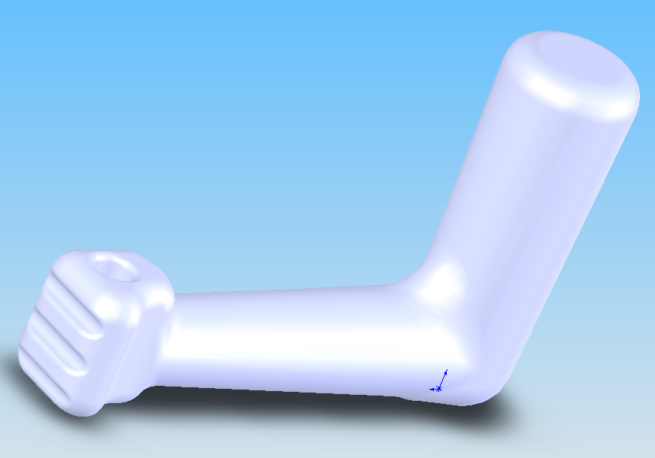

Figure 1. The CAD model of the hand-arm system

3. FINITE ELEMENT METHOD USED FOR HAND-ARM SYSTEM ANALYSIS

Research carried on aims to develop a reliable theoretical model for the hand-arm system, which can be used for further analysis. The model is obtained with CAD tools and analysed using the finite elements method. In Figure 2 the finite element model is presented, for a system simulating the hand-arm position during working with a hand tool. It consists of 41.986 nodes and 28.155 elements (Figure 2).

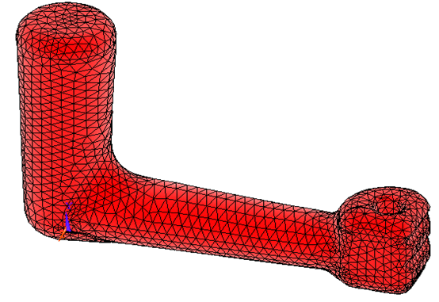
Figure 2. The finite element model

Related to the material properties, due to the biologic variability the bio-mechanical models almost always involve approximations. However, considering an orthotropic material, the literature provides the following physical-mechanical characteristics [3]:
- The E modulus varies in terms of density; therefore a non-homogenous material is used. It has a greater value on axial direction (between 17 and 26,5 GPa) than on the transversal (8,51 – 19,4 GPa) and longitudinal (6,91 – 18,1) direction.
- Poisson ratio for the bone has been chosen as follows: ν_{x} = 0,31; ν_{y} = 0,18; ν_{z} = 0,18.
- The G modulus for the human bone, according to Natali & Miroi, varies between 2,41 – 7,22 GPa on axial direction, between 3,28 – 8,65 GPa GPa on transversal direction, between 3,28 – 8,67 GPa on longitudinal direction.
- Regarding the density, it varies for the human bones according to the chart from Figure 3. The density decreases along the years, having different values in terms of age, race and gender. For the present analysis it has been chosen a value specific for a white male, between 20 and 30, which is 1050 mg/cm³ = 1050 kg/m³.

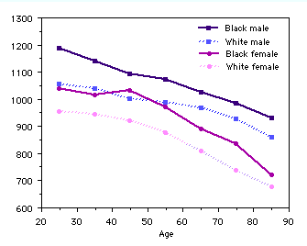
Figure 3. Variation of human bone density [4]

The analysis performed on the model is a free vibration analysis and this means that analysis results are independent of loading conditions. Thus, no specific loading is employed. The frequency range is between 0-200Hz. The first 20 modes have been extracted and the results are listed in Table 3.

Table 3. The results of the modal analysis performed for the hand-arm model
Set | Natural frequency [Hz]
1 | 0.0000
2 | 0.33689E-08
3 | 0.10200E-07
4 | 0.11151E-07
5 | 0.20224E-07
6 | 0.29441E-07
7 | 0.18775E-01
8 | 0.31633E-01
9 | 0.34489E-01
10 | 0.51135E-01
11 | 0.63372E-01
12 | 0.86455E-01
13 | 0.96949E-01
14 | 106.00
15 | 117.25
16 | 127.30
17 | 155.47
18 | 165.30
19 | 179.85
20 | 193.62

The first 6 natural frequencies are close to zero, representing the rigid body motion; this result proves the model is correct and it can be used for further type of analysis (including the effect of different excitation levels on the hand-arm system). Just to have an idea about the analysis outputs, Figure 4 illustrates one of the 20th mode shapes.
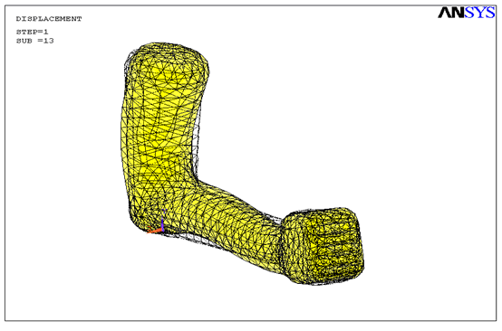
Figure 4. Mode shape 13, f = 0.96949E-01Hz

The results existing in the literature [2] refer only to the forearm model and analysis. This work may complete the research and give useful information for further analysis and testing of the hand-arm system. The natural frequencies are affected by anatomy of individual human samples being considered. The wide range of material physical-mechanical characteristics may also lead to different results. As a validation of the analytical model by classical means (comparison with the original system, which is the human body) can be hardly achieved, the most convenient way is to develop comparative studies on several models for the real system. Thus, the model that approximates the investigated problem in the best way may be identified.

4. CONCLUSION

The study upon the hand-arm vibrations allows for drawing the following conclusions:
- The issue is actual and of great interest for the scientific community both in the engineering and medical field.
- A model has to be designed and analysed such as it can give the original system behaviour, in a certain precision range.
- The hand-arm system modelling and analysis is useful for further developments having as ultimate aim to design and implement advanced systems for human body protection against vibrations.
- The final research results of the project could represent useful information for hand tools manufacturers, for developing advanced systems for human body protection to vibrations.

ACKNOWLEDGMENTS

This work has been financially supported by the Romanian Ministry of Education, Research and Youth, through CNCSIS (National Council for Scientific Research in Higher Education), grant 393/2006.

REFERENCES

[1] ***, Hand-arm vibration syndrome, CMAJ Apr. 12, 2005, 172(8).
[2] Zadpoor, A.A., Finite Element Method Analysis of Human Hand Arm Vibrations, Int. J. Sci. Res., Vol. 15 (2005).
[3] ***, http://courses.washington.edu/bonephys/opbmd.html#old

