The 2nd International Conference
″Computational Mechanics
and
Virtual Engineering″
COMEC 2007
11 – 13 OCTOBER 2007, Brasov, Romania

TENSILE TESTS ON RANDOMLY REINFORCED POLYMER MATRIX COMPOSITES

H. Teodorescu, S. Vlase, V. Munteanu, V. Guiman
Transilvania University, Brasov, ROMANIA, e-mail: draghicescu.teodorescu@unitbv.ro

Abstract: The paper presents the most important results regarding the mechanical properties of composite materials based on polyester resin reinforced with randomly disposed glass fibers such as chopped strand mat CSM 600. Extended researches on stress-strain behaviour of composite specimens and failure modes are presented.
Keywords: Polymer matrix composites, Chopped strand mat, Tensile tests, Failure modes

1. INTRODUCTION

Romanian industry was interested about testing composite materials beginning with the 1990s at a time when the fiber of primary interest was E-glass and an important fabrication technique was hand lay-up. So, it is understandably that many early test methods involved plates. It is well known that a simple tensile test is the most basic of all mechanical property tests. It tells us how strong and stiff a material is. Generally, the strongest material in a class is usually the most difficult to test for tensile properties. Composite materials are no exception and for instance the axial loading of a unidirectional composite presents the greatest challenge.
One of the most important problems in the tensile test of a composite material is the gripping of the specimen without introducing unacceptable stress concentrations. In general, grips are clamped into the specimen ends, transferring the applied tensile force via shear at the specimen surface into tensile stresses within the specimen. We assume that the composite material is strong and therefore the clamping forces are significant. To avoid high clamping forces it is possible to make the specimen as thin as practically possible or to make the grip length longer so that the clamping force is distributed over a larger area.

2. MATERIAL’S FEATURES

The composite material used in the tensile test is a thermosetting polymer, namely unsaturated polyester resin reinforced with chopped strand mat CSM 600 of about 50 mm length. This type of reinforcement is manufactured from "E" glass continuous fibers, bound with powder binder, compatible with synthetic resins and used in naval constructions, sport articles, garden furniture and playgrounds for children, tanks, products for bathrooms, plain and corrugated plates. It is usually used for the hand lay-up technique and for parts that do not require high strength. CSM 600 (fig. 1) presents good solubility in styrene, very easy impregnation, silane size and is suitable for polyester resin systems reinforcement.
The most important features of CSM of various grades are presented in table 1.

Table 1: Characteristics of Chopped Strand Mats produced by SC FIROS SA Bucharest [1]
Specific weight | (150, 225, 300, 375, 450, 600) ± 8% [g/m²]
Width | (1000; 1250) ± 2 [mm]
Moisture | Max. 0.2%
Size content | 2.5 – 7%

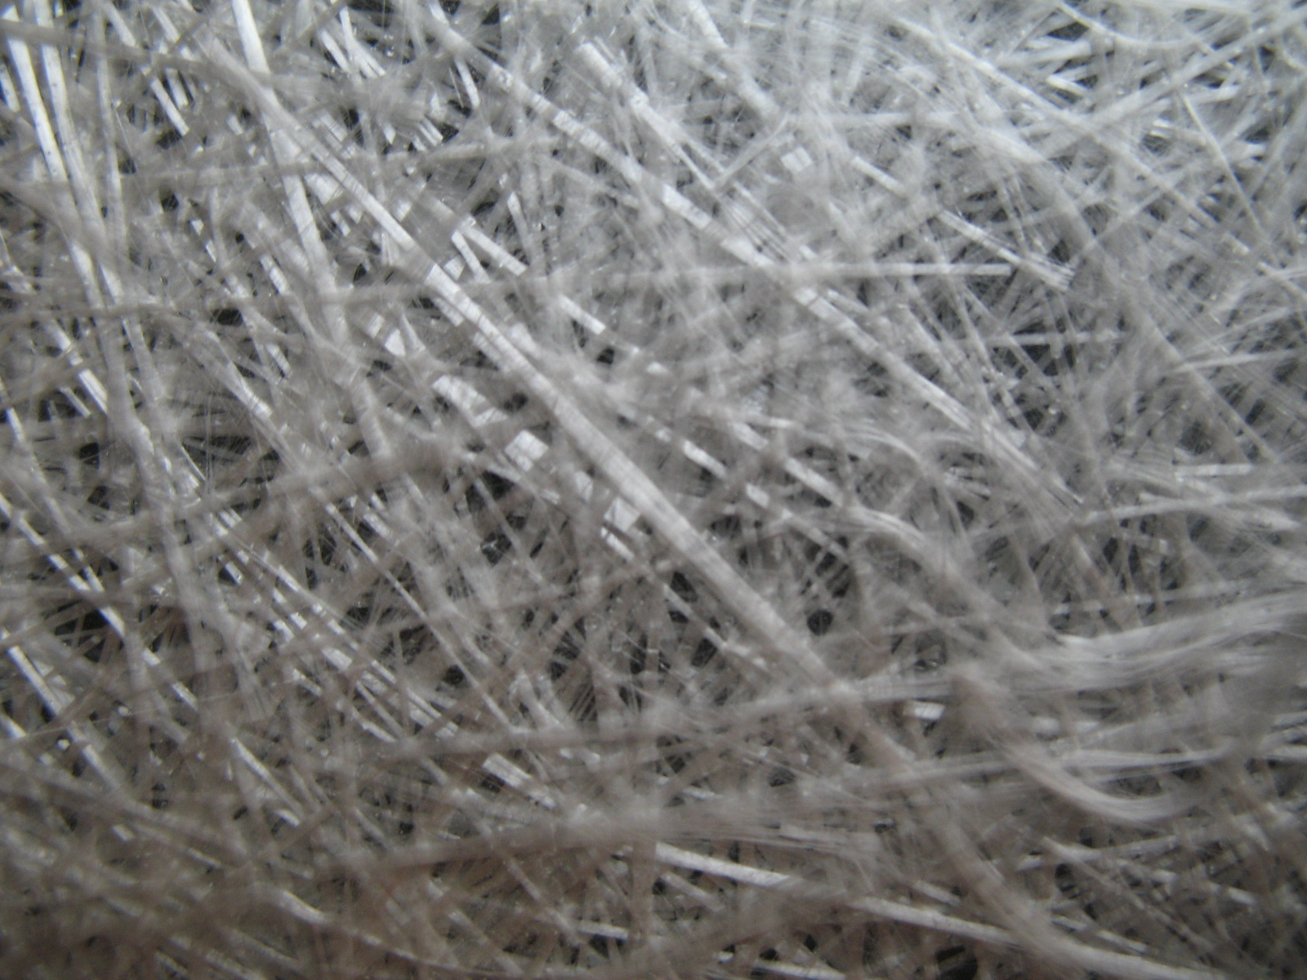
Figure 1: Chopped strand mat reinforcement

3. SPECIMENS

The specimens based on polyester resin reinforced chopped strand mat CSM 600 were manufactured at Compozite Ltd. Brasov, Romania, according to standard SR EN ISO 527-1: Determination of tensile properties of fiber reinforced composite materials (fig. 2). These specimens were cut from a plate with a thin layer of white gelcoat, plate of about 4 mm thick and then tempered.

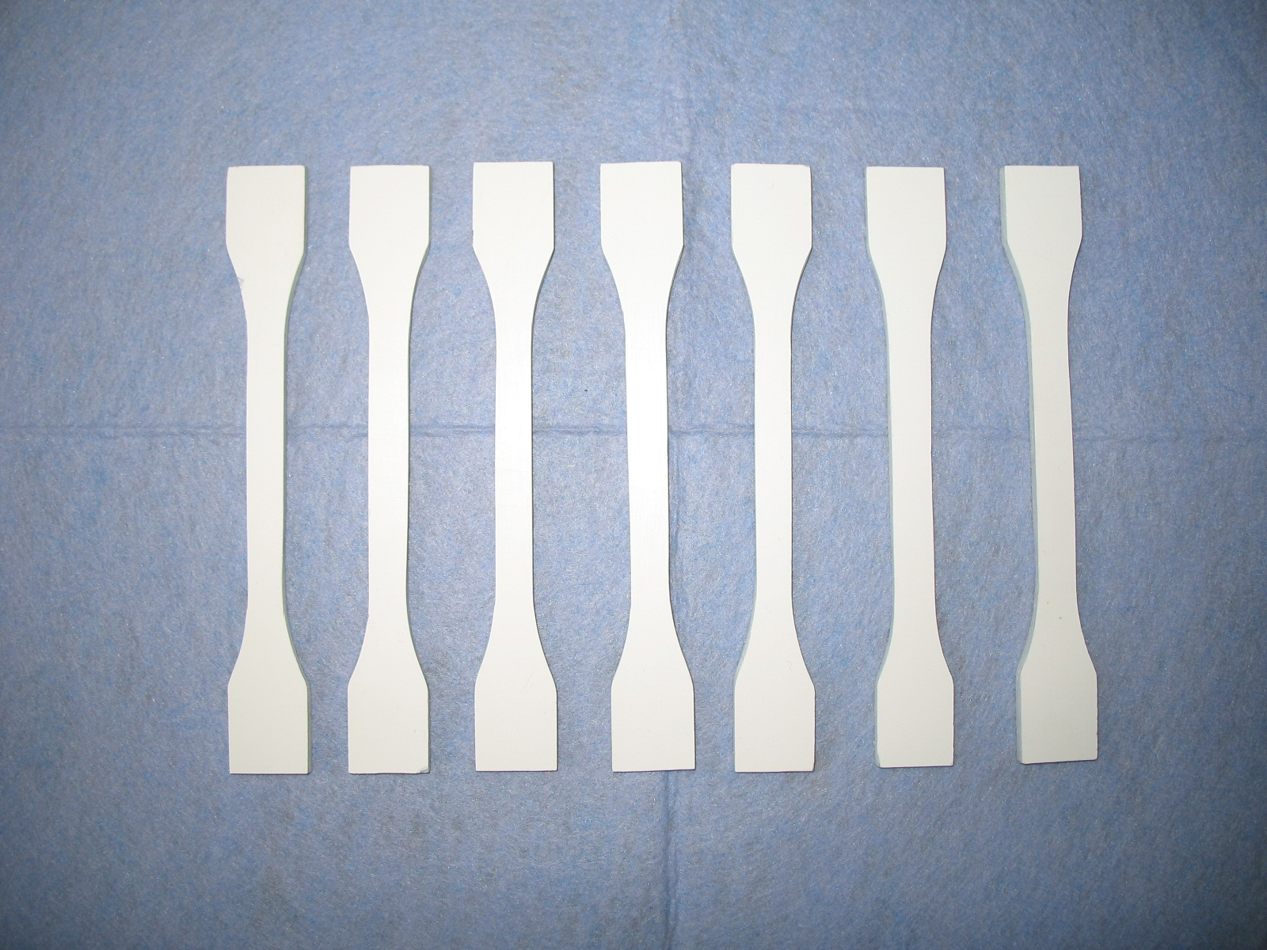
Figure 2: Specimens based on polyester resin reinforced with chopped strand mat CSM 600

The specimens were subjected to tensile loading until break occurs.

4. TENSILE TEST MACHINE

The testing machine (fig. 3) is produced by Lloyd’s Instruments, UK, (type LS100) and presents the following specifications [2]:
- force range: 100 kN;
- speed accuracy: <0.2%;
- travel: 840 mm
- load resolution: <0.01% of loadcell used;
- extension resolution: <0.1 micron;
- loadcell: XLC-100K-A1;
- analysis software: NEXYGEN MT.

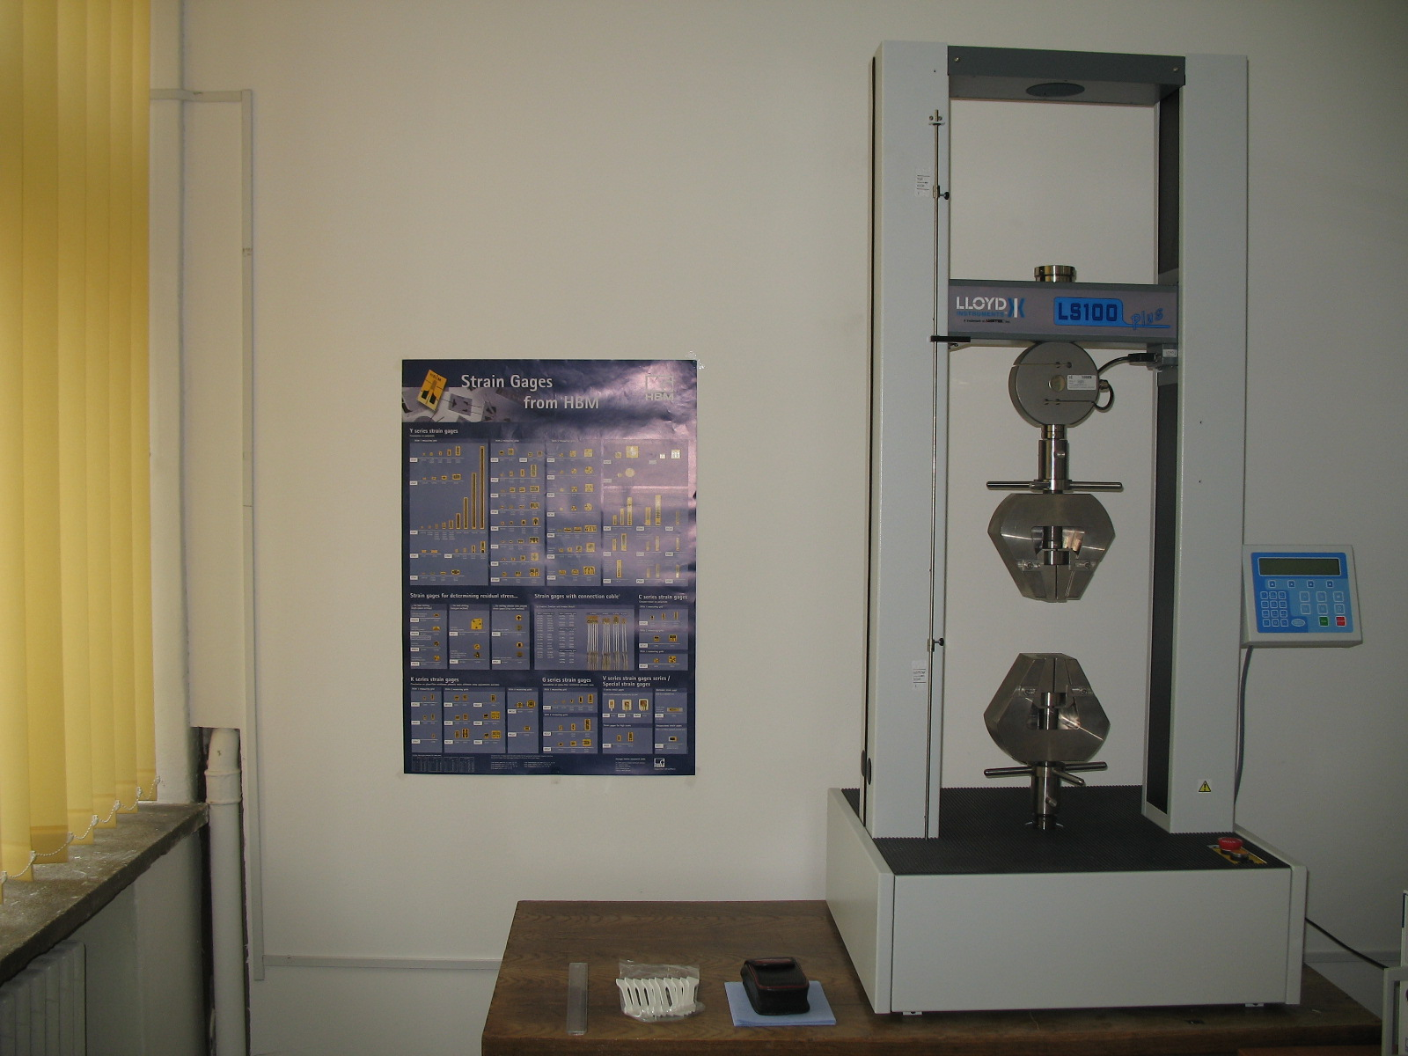
Figure 3: Lloyd’s Instruments LS100 testing machine

5. TENSILE TESTS RESULTS

Specimens’ characteristics and the mean values of tensile tests mechanical features are:
- Gauge length: 66 mm;
- Specimens fibers volume fraction: 30%;
- Preload stress: 0.0056 kN;
- Preload stress speed: 21 mm/min;
- Test speed: 1mm/min;
- Specimen width: 9,87 mm;
- Specimen thickness: 3,87 mm;
- Load at Maximum Load: 2.9244 kN;
- Stress at Maximum Load: 100.26 MPa;
- Load at Maximum Extension: 0.0083 kN;
- Stress at Maximum Extension: 0.20 MPa;
- Load at Minimum Load: 0.0008166 kN;
- Stress at Minimum Load: 0.020415 MPa;
- Tensile Strength: 100.26 MPa;
- Strain at Maximum Load: 0.035109;
- Load at Break: 2.9118 kN;
- Stress at Break: 98.478 MPa;
- Strain at Break: 0.035667;
- Percentage Strain at Break: 3.5667.
Typical stress-strain behaviour of chopped strand mat CSM 600 reinforced polyester resin specimens is presented in fig. 4.
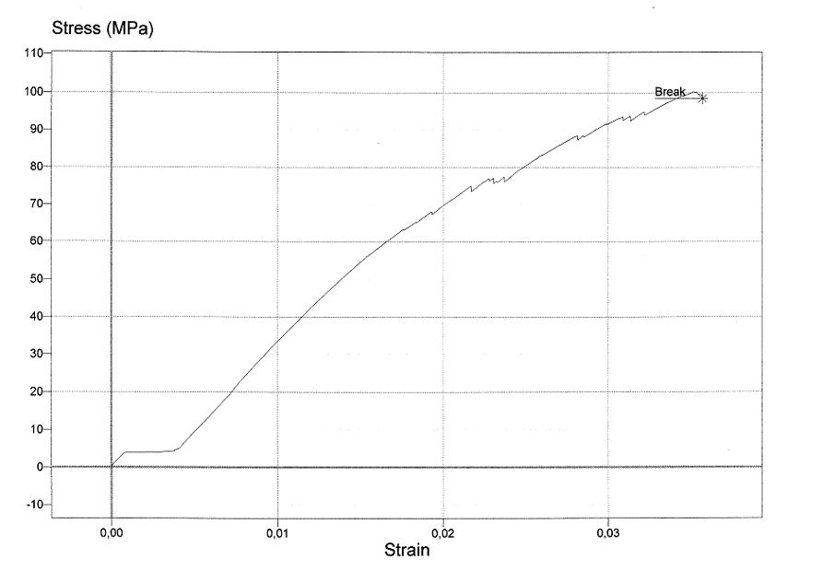
Figure 4: Stress-strain of chopped strand mat CSM 600 reinforced polyester resin specimens

6. CONCLUSIONS

Some failure modes of chopped strand mat CSM 600 reinforced polyester resin specimens are presented in fig. 5 and 6.

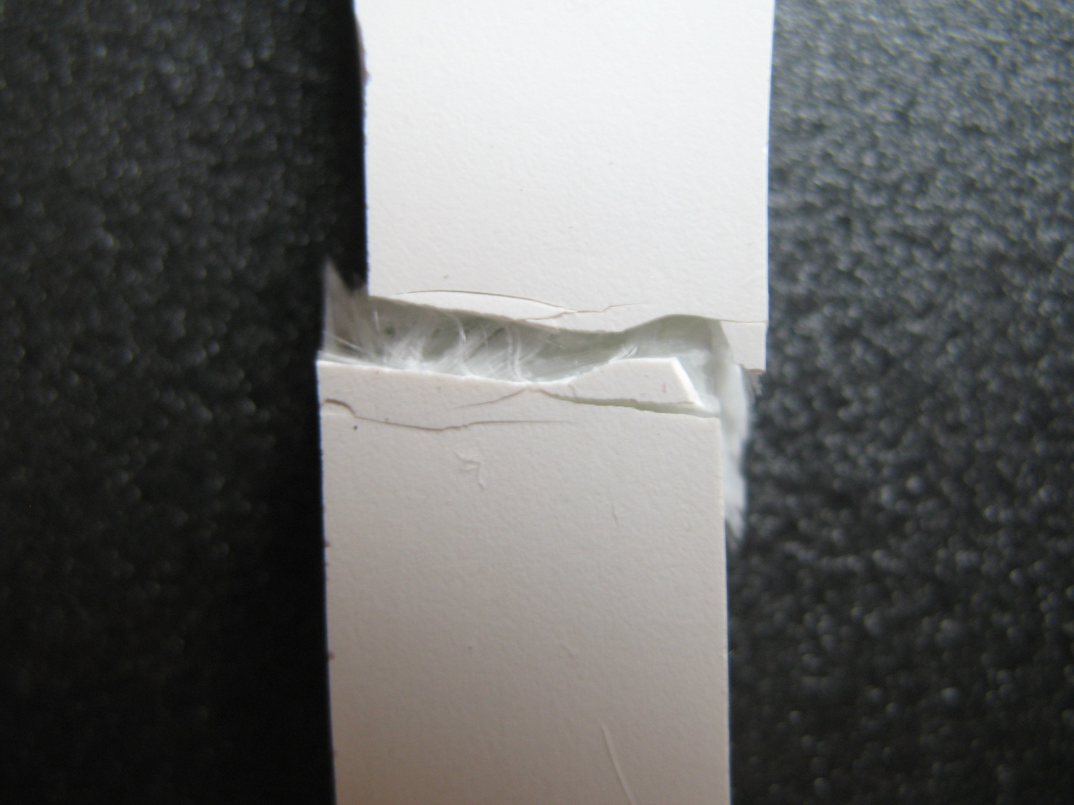 | 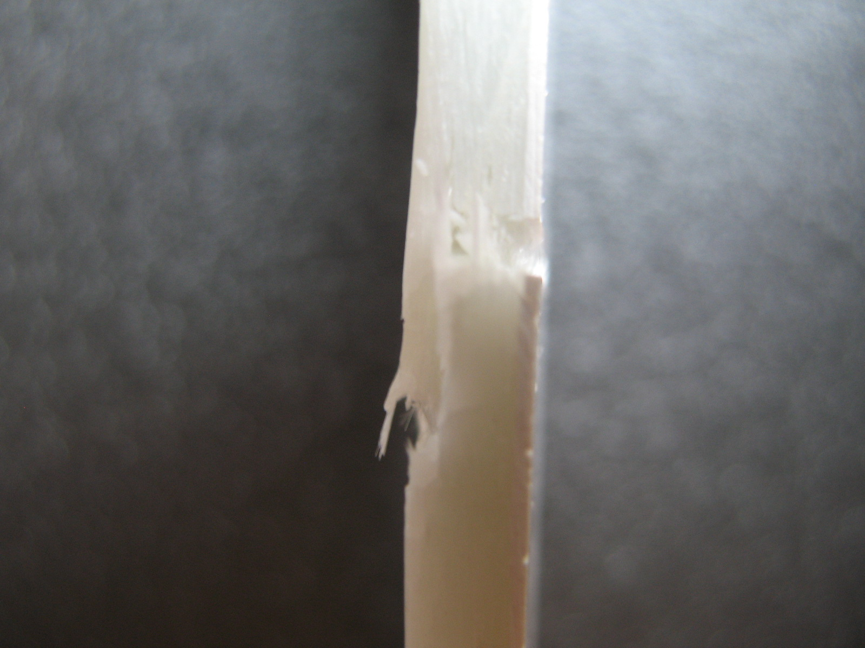
Figure 5: Frontal view of the failure mode | Figure 6: Side view of the failure mode

It can be noticed that the common specimens’ failure mode is the inter-fiber break that begins at a strain of 0.012 as well as fibers break.

REFERENCES

[1] www.firos.ro – CSM for Manual Hand Lay-up. Products SC FIROS SA Bucharest, Romania.
[2]. Lloyd’s Instruments. LS100 User Manual.

