The 2nd International Conference
″Computational Mechanics
and
Virtual Engineering″
COMEC 2007
11 – 13 OCTOBER 2007, Brasov, Romania

ON THE MECHANICAL BEHAVIOUR OF SOME FILAMENT WINDING COMPOSITE TUBES SUBJECTED TO INTERNAL PRESSURE

H. Teodorescu¹, S. Vlase¹, L. Scutaru¹, A. Stanciu¹
¹ Transilvania University, Brasov, ROMANIA, e-mail: draghicescu.teodorescu@unitbv.ro

Abstract: The paper presents a theoretical approach regarding the mechanical behaviour of two kinds of composite tubes: the cross-ply and the balanced angle-ply ones, subjected to internal pressure. An original pre-tensioning procedure of these tubes is presented. The theoretical approach is accomplished on a particular type of pre-tensioned balanced angle-ply composite tube with plies sequence [55/-55]₃. Stresses and strains are computed in all unidirectional tube layers, tube subjected to the internal pre-tensioning pressure p_{p} = 1.37 MPa and under the influence of temperature T = 105°C.
Keywords: weeping pressure, cross-ply composite tube, balanced angle-ply composite tube, pre-tensioning pressure, PMC tubes

1. INTRODUCTION

In a multilayered composite, at the cooling from the curing temperature, thermal internal stresses can form due to the obstacle opposed by the thermal shrinkage of different layers [1]. Since in an unidirectional lamina the coefficient of linear thermal expansion (CLTE) parallel to the fibers direction is lower than that perpendicular to the fibers direction, at the cooling appear tensile internal stresses perpendicular to the fibers direction. Another type of internal stresses that are formed in a multilayered composite is represented by the swelling internal stresses due to the matrix moisture absorbtion. Since, due to the matrix swelling, the lamina expansion perpendicular to the fibres direction is grater than that along the fiber direction, in the composite are formed compression internal stresses perpendicular to the fibers direction and tensile internal stresses along the fibers direction. This internal stress state is one desirable. Of course, in some cases, the swelling internal stresses may have a negative effect. For instance, by drying exterior layers of a multilayered composite these will contract. These shrinkages of the superior layers will be hindered by the still swelled interior layers, forming unfavourable tensile internal stresses [2]. The increase of loading capability of composite laminates can be accomplished introducing internal stresses in composite, so that at least partially, should be made up for the tensile stresses transverse to the fibers direction as well as dangereous shear stresses. A special importance is given by the manner and the types of internal stresses that could be introduced.

2. THE THEORETICAL APPROACH

In practice we can encounter two special cases of tubes: the cross-ply composite tube and the balanced angle-ply composite one. The cross-ply composite tube consists from unidirectional reinforced plies with the same basic elasticity constants. The entire thicknesses t₁ (fibers on axial direction) and t₂ (fibers on circumferential direction) can be different (fig. 1). We suppose that the individual plies of cylindrical tubes are orthotropic ones and the wall thickness t is much smaller than their curvature radius, r. Therefore, the loadings of the tube wall are:
$σ_{C}=p⋅\frac{r}{t}$, (1)
$σ_{A}=p⋅\frac{r}{2t}$, (2)
$τ_{\text{AC}}=0,$ (3)
where A and C represent the axial/circumferential tube direction and p is the internal pressure. For the cross-ply composite tube subjected to internal pressure, the elasticity laws for the entire wall thickness are [3], [4]:
$\left[\begin{matrix}σ_{A} \\ σ_{C}\end{matrix}\right]=\left[\begin{matrix}t_{1}^{'}⋅c_{\text{II}}+t_{2}^{'}⋅c_{} & c_{\text{II}} \\ c_{\text{II}} & t_{1}^{'}⋅c_{}+t_{2}^{'}⋅c_{\text{II}}\end{matrix}\right]⋅\left[\begin{matrix}ε_{A} \\ ε_{C}\end{matrix}\right]$, (4)
where $c_{\text{II}}$, $c_{}$ and $c_{\text{II}}$ are the elastic constants and the relative thicknesses $t_{1}^{'}$ and $t_{2}^{'}$ can be expressed as following:
$t_{1}^{'}=\frac{t_{1}}{t}; t_{2}^{'}=\frac{t_{2}}{t}$. (5)

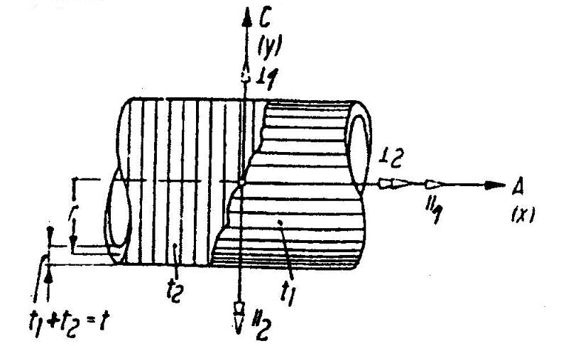
Figure 1: Cross-ply composite tube
For the individual plies:
$\left[\begin{matrix}σ_{A 1} \\ σ_{C 1}\end{matrix}\right]=\left[\begin{matrix}c_{\text{II}} & c_{\text{II}} \\ c_{\text{II}} & c_{}\end{matrix}\right]⋅\left[\begin{matrix}ε_{A} \\ ε_{C}\end{matrix}\right]$, (6)
$\left[\begin{matrix}σ_{A 2} \\ σ_{C 2}\end{matrix}\right]=\left[\begin{matrix}c_{} & c_{\text{II}} \\ c_{\text{II}} & c_{\text{II}}\end{matrix}\right]⋅\left[\begin{matrix}ε_{A} \\ ε_{C}\end{matrix}\right]$. (7)
The tube strains are:
$ε_{A}=1−\frac{υ_{\text{II}}⋅υ_{\text{II}⊥}}{E_{\text{II}}}⋅\frac{{\hat{σ}}_{C}}{2K}⋅\left[\left(t_{1}^{'}+t_{2}^{'}⋅\frac{E_{\text{II}}}{E_{}}\right)−2υ_{\text{II}}\right]$, (8)
$ε_{C}=1−\frac{υ_{\text{II}}⋅υ_{\text{II}⊥}}{E_{\text{II}}}⋅\frac{{\hat{σ}}_{C}}{2K}⋅\left[2\left(t_{2}^{'}+t_{1}^{'}⋅\frac{E_{\text{II}}}{E_{}}\right)−υ_{\text{II}}\right]$, (9)
$γ_{\text{AC}}=0$, (10)
where:
$K=t_{1}^{'}⋅t_{2}^{'}\left(\frac{E_{\text{II}}}{E_{}}+\frac{E_{}}{E_{\text{II}}}−2\right)+1−υ_{\text{II}}⋅υ_{\text{II}⊥}$, (11)
$E_{\text{II}}$, $E_{}$ and $υ_{\text{II}}$ represent the basic elasticity constants and ${\hat{σ}}_{C}$ is the medium stress that acts in the circumferential direction of the composite tube. At the Poisson ratio, the first index represents the shrinkage direction and the second one is the loading direction that produces this shrinkage. The stresses in each ply of the composite tube are expressed as following:
$σ_{\text{II} 1}=\frac{{\hat{σ}}_{C}}{2K}$, (12)
$σ_{\text{II} 2}=\frac{{\hat{σ}}_{C}}{2K}$, (13)
$σ_{ 1}=\frac{{\hat{σ}}_{C}}{2K}$, (14)
$σ_{ 2}=\frac{{\hat{σ}}_{C}}{2K}$. (15)
In the case of the balanced angle-ply composite tube, the unidirectional reinforced plies present the same mechanical properties and the fibers develop on parallel helicoidally lines (fig. 2). The entire fibers quantity, fibers that are disposed under the angles α = +ω and –ω, is half the fibers quantity disposed on axial direction. In the case of the balanced angle-ply composite tube subjected to internal pressure, the elasticity laws for the entire wall thickness are:
$\left[\begin{matrix}{\hat{σ}}_{A} \\ {\hat{σ}}_{C}\end{matrix}\right]=\left[\begin{matrix}c_{\text{11}} & c_{\text{12}} \\ c_{\text{12}} & c_{\text{22}}\end{matrix}\right]⋅\left[\begin{matrix}ε_{A} \\ ε_{C}\end{matrix}\right]$, (16)
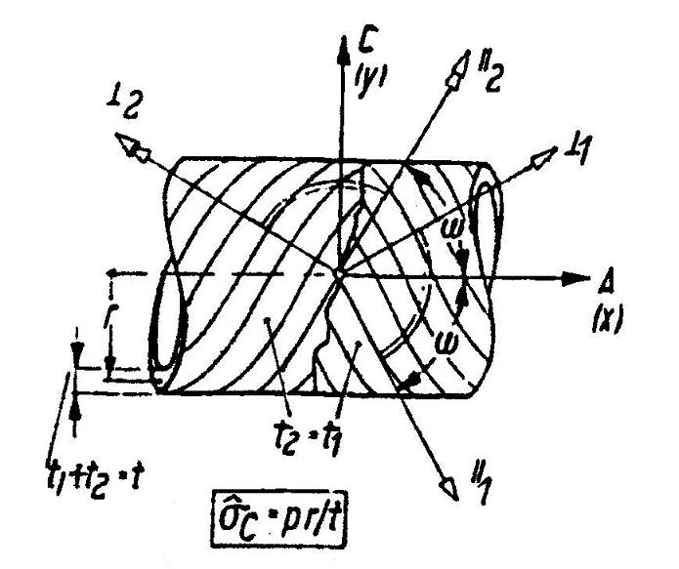
Figure 2: Balanced angle-ply composite tube
For the individual plies:
$\left[\begin{matrix}σ_{A 1,2} \\ σ_{C 1,2} \\ τ_{\text{AC} 1,2}\end{matrix}\right]=\left[\begin{matrix}c_{\text{11}} & c_{\text{12}} & 0 \\ c_{\text{12}} & c_{\text{22}} & 0 \\ c_{\text{13} 1,2} & c_{\text{23} 1,2} & 0\end{matrix}\right]⋅\left[\begin{matrix}ε_{A} \\ ε_{C} \\ 0\end{matrix}\right]$. (17)
From the concordance of the first two relations of the elasticity laws (16) and (17), it results:
$σ_{A 1}=σ_{A 2}={\hat{σ}}_{A}; σ_{C 1}=σ_{C 2}={\hat{σ}}_{C}$. (18)
The tube strains are:
$ε_{A}=\frac{{\hat{σ}}_{C}}{E_{\text{II}}}\left(\frac{1}{2N}\right)⋅\left[3\left(\text{AF}−D\right){\text{sin}}^{2}2ω+H−J⋅\text{cos} 2ω−2L\right]$, (19)
$ε_{C}=\frac{{\hat{σ}}_{C}}{E_{\text{II}}}\left(\frac{1}{2N}\right)⋅\left[3\left(\text{AF}−D\right){\text{sin}}^{2}2ω+2\left(H+J\text{cos}2ω\right)−L\right]$, (20)
$γ_{\text{AC}}=0$. (21)
The stresses in each ply of the tube are:
$σ_{A 1,2}={\hat{σ}}_{A}$, (22)
$σ_{C 1,2}={\hat{σ}}_{C}$, (23)
$τ_{\text{AC} 1,2}=∓ \left(\frac{1}{2N}\right)⋅\left[3\text{AJ}−\left(1−\text{AB}\right)\text{cos}2ω\right]\text{sin}2ω⋅{\hat{σ}}_{C}$, (24)
$σ_{\text{II} 1,2}=\frac{{\hat{σ}}_{C}}{2N}\left\{3\left[1−\left(1−2\text{AR}\right){\text{sin}}^{2}2ω\right]−\text{cos}2ω\right\}$, (25)
$σ_{ 1,2}=\frac{{\hat{σ}}_{C}}{2N}\left\{3\left[1−\left(1−2\text{AP}\right){\text{sin}}^{2}2ω\right]+\text{cos}2ω\right\}$, (26)
$τ_{ 1,2}=∓ \frac{{\hat{σ}}_{C}}{2N}⋅A\left(B+3J\text{cos}2ω\right)\text{sin}2ω$, (27)
where:
$A=\frac{G_{}}{E_{\text{II}}}$, (28)
$B=\frac{E_{\text{II}}}{E_{}}+1+2υ_{\text{II}}$, (29)
$D=\frac{1}{2}\left(\frac{E_{\text{II}}}{E_{}}+1−2υ_{\text{II}}\right)$, (30)
$F=2\left(\frac{E_{\text{II}}}{E_{}}−υ_{\text{II}}^{2}\right)$, (31)
$H=\frac{E_{\text{II}}}{E_{}}+1$, (32)
$J=\frac{E_{\text{II}}}{E_{}}−1$, (33)
$L=2υ_{\text{II}}$, (34)
$N=2\left[1−\left(1−\text{AB}\right){\text{sin}}^{2}2ω\right]$, (35)
$P=1+υ_{\text{II}}$, (36)
$R=\frac{E_{\text{II}}}{E_{}}+υ_{\text{II}}$. (37)
The basic elasticity constants of a composite can be determined either experimentally or from the basic fibers- respective matrix material data. The following relations are valid for isotropic fibers embedded in isotropic matrix. For the Young modulus along fibers direction, the mixture rule can be used:
$E_{\text{II}}=ϕ⋅E_{F}+E_{M}\left(1−ϕ\right)$. (38)
Transverse to the fibres direction, the Young modulus will be:
$E_{}=\frac{E_{M}\left(1+0,\text{85}⋅ϕ^{2}\right)}{\left(1−υ_{M}^{2}\right)\left[{\left(1−ϕ\right)}^{1,\text{25}}+\frac{ϕ⋅E_{M}\left(1−υ_{M}^{2}\right)}{E_{F}}\right]}$. (39)
The shear modulus, parallel and transverse to the fibers direction can be computed as following:
$G_{}=\frac{G_{M}\left(1+0,6⋅ϕ^{0,5}\right)}{{\left(1−ϕ\right)}^{1,\text{25}}+ϕ\frac{G_{M}}{G_{F}}}$. (40)
For the transverse shrinkage perpendicular to the fibers direction, at a parallel loading to these fibers, the following relation can be used:
$υ_{\text{II}}=ϕ⋅υ_{F}+υ_{M}\left(1−ϕ\right)$, (41)
and the transverse shrinkage along the fibers direction, at a perpendicular loading to these fibers is:
$υ_{\text{II}⊥=\frac{υ_{\text{II}}⋅E_{}}{E_{\text{II}}}}$. (42)
The index F refers to the glass fiber and the index M to the matrix.

3. THE PRE-TENSIONING PROCEDURE OF COMPOSITE TUBES

The purpose of pre-tensioning glass-fabric/polyester-resin tubular composite laminates is to introduce internal stresses in tube wall structure that can work against the operational stresses. These internal stresses may increase tube loading capability and its cracking limits. To attain this aim, an original mechanical device has been designed and developed. It consists, generally, of the following parts: a support that can be properly positioned and fixed, a lower and upper piston that can perform only a translation movement and a silicone rubber that can be pressed at the inner of a tubular specimen. The pre-tension method consists in the accomplishment of following successive steps [5], [6]. First, the tube specimen is manufactured in the fabric-winding process. After curing, the specimen is pulled-out of the mandrel. Second, the pre-tension device is positioned and fixed vertically. Third, at this stage, the tube specimen is heated up to 10°C above the glass transition temperature T_{G}. In this field of temperature, the resin elasticity modules decreased quickly and the resin matrix became highly elastic. Fourth, the heated tube specimen is introduced into the pre-tension device and then the silicone rubber is pressed at the inner of the tube. Since during the heating of the tube specimen the matrix elasticity moduli decrease, the inner pre-tension pressure will be taken over by the fiber network. Fifth, while keeping the inner pre-tension pressure, the tube specimen is cooled at the environmental temperature. Sixth, after cooling, the tube specimen is discharged from the inner pre-tension pressure. Now, the fiber network will relax and in wall structure will remain a status of internal stresses. After these six stages, the tube specimen is removed from the device and it is stored 24 hours in a controlled atmosphere room (T = 20°C and 50% relatively air humidity). This is necessary to reduce the internal stresses relaxation due to possible strong temperature and humidity changes. A special note regarding the silicone rubber used for the pre-tension operation can be added here. This material acts like a liquid with extreme high viscosity and its volume decreases very little with the increase of the pre-tension pressure, so that theoretically it can be considered incompressible.

4. MECHANICAL BEHAVIOUR OF [55/-55]₃ PRE-TENSIONED COMPOSITE TUBE

Using the above described pre-tensioning method, a [55/-55]₃ balanced angle-ply composite tube based on unsaturated polyester resin have been heated at 105°C (fig. 3). At this temperature, the matrix basic elasticity constants $E_{p}$ and $G_{p}$ are strongly diminished until $E_{p}$≈ 250 MPa and $G_{p}$≈ 100 MPa. According to these values and using the relations (38) – (42), in tables 1 – 3 the following input data are presented.

Table 1: Basic elasticity constants at pre-tension
Young modulus, $E_{\text{II} p}$ [MPa] | 27350
Young modulus, $E_{ p}$ [MPa] | ≈ 250
Shear modulus, $G_{p}$ [MPa] | ≈ 100
Fibers volume fraction [%] | 35
Poisson ratio, $υ_{\text{II} p}$ [-] | 0.36
Poisson ratio, $υ_{\text{II}⊥ p}$ [-] | 0.11

Table 2: Basic elasticity constants at pre-tension for isotropic materials
 | E-glass | UP resin
Young modulus, E [MPa] | 73000 | ≈ 95
Shear modulus, G [MPa] | 29200 | ≈ 33
Poisson ratio, υ [-] | 0.25 | 0.42

Table 3: Geometric and pre-tension data
Tube diameter [mm] | 80
Plies thickness [mm] | 0.4
Tube wall thickness [mm] | 4
Internal pre-tension pressure, p_{p} [MPa] | 1.37
Fibers winding angle [°] | ± 55

UD1
UD2
UD3
UD4
UD5
UD6
C(y)
║₁
┴₁
r₁
r₃
r₄
r₅
A(x)
Figure 3: Schematic representation of [55/-55]₃ tube windings
According to these input data, the relations (28) – (37) can be then computed. The pre-tensioning circumferential stresses, $σ_{C p}$ according to the tube winding 1 (ply UD1 and UD2) are:
$σ_{C p 1,2}=\frac{p_{p}⋅r_{1}}{\sum_{i=1}^{2}{t_{i}}}$, (43)
for tube winding 2 (ply 3 and 4):
$σ_{C p 3,4}=\frac{p_{p}⋅r_{2}}{\sum_{i=1}^{4}{t_{i}}}$, (44)
and for tube winding 3 (ply 5 and 6):
$σ_{C p 5,6}=\frac{p_{p}⋅r_{3}}{\sum_{i=1}^{6}{t_{i}}}$. (45)
Similar judgements regarding the calculus of the pre-tensioning axial stresses can be made:
$σ_{A p 1,2}=\frac{p_{p}⋅r_{1}}{2}⋅\frac{1}{\sum_{i=1}^{2}{t_{i}}}$, (46)
$σ_{A p 3,4}=\frac{p_{p}⋅r_{2}}{2}⋅\frac{1}{\sum_{i=1}^{4}{t_{i}}}$, (47)
$σ_{A p 5,6}=\frac{p_{p}⋅r_{3}}{2}⋅\frac{1}{\sum_{i=1}^{6}{t_{i}}}$. (48)
Stresses and strains can be computed in all unidirectional tube layers, tube subjected to the internal pre-tensioning pressure p_{p} = 1.37 MPa and under the influence of temperature T = 105°C. The results are shown in table 4.

Table 4: Windings stresses and strains
Stresses and strains at pre-tension | Winding 1 |  | Winding 2 |  | Winding 3
Stresses and strains at pre-tension | UD1 | UD2 | UD3 | UD4 | UD5 | UD6
Circumferential stress [MPa] | 69.18 | 69.18 | 34.93 | 34.93 | 23.51 | 23.51
Axial stress [MPa] | 34.59 | 34.59 | 17.46 | 17.46 | 11.75 | 11.75
Circumferential strain [-] | 0.0036 | 0.0036 | 0.0018 | 0.0018 | 0.0012 | 0.0012
Axial strain [-] | 0.0038 | 0.0038 | 0.0019 | 0.0019 | 0.0013 | 0.0013
Shear stress, $τ_{\text{AC} p}$[MPa] | -47.57 | 47.57 | -24.02 | 24.02 | -16.16 | 16.16
Stress, $σ_{\text{II} p}$[MPa] | 102.53 | 102.53 | 51.77 | 51.77 | 34.84 | 34.84
Stress, $σ_{ p}$[MPa] | 1.28 | 1.28 | 0.64 | 0.64 | 0.43 | 0.43
Shear stress, $τ_{ p}$ [MPa] | 0.013 | -0.013 | 0.006 | -0.006 | 0.004 | -0.004

5. CONCLUSIONS

Regarding the mechanical behaviour of a balanced angle-ply [55/-55]₃ composite tube, the following conclusions can be drawn: due to the low values of internal stresses $τ_{ p }$, these can be neglected so that in the case of a tube pre-tensioning, the tensile internal stresses along the fibers direction $σ_{\text{II} p F }$play a significant role in a further tube’s reloading; these tensile internal stresses $σ_{\text{II} p F }$can cause compression internal stresses in matrix $σ_{\text{II} c M }=−σ_{\text{II} p F}$ that act in the sense of the increase of tube’s loading capability. In the case of reloading the [55/-55]₃ composite tube, to reach the value of compression internal stress in matrix $σ_{\text{II} c M }=−\text{102}\text{.}\text{53}$ MPa is necessary a tube reloading by an internal pressure of 1.74 MPa, which means an increase of tube’s loading capability of 16% versus the reference internal pressure of 1.5 MPa

REFERENCES

[1] Schneider, W., Wärmeausdehnungskoeffizienten und Wärmespannungen von Glasfaser/Kunst-stoff-Verbunden aus unidirektionalen Schichten, Kunststoffe 61, No. 4, 1971, pp. 273-277.
[2] Tsai, S.W., Hahn, H.T., Introduction to Composite Materials, Technomic Publishing Co., Westport, 1980.
[3] Puck, A., Zum Deformationsverhalten und Bruchmechanismus von unidirektionalem und orthogonalem Glasfaser/Kunststoff, Kunststoffe 55, No. 12, 1965, pp. 913-922.
[4] Puck, A., Das Knie im Spannungs-Dehnungs-Diagramm und Rissbildungs bei Glasfaser/ Kunststoffen, Kunststoffe 58, No. 12, 1968, pp.886-893.
[5] Teodorescu, H., Rosu, D., Birtu, C., Teodorescu, F., The increase of cracking limits of glass-fabric/polyester-resin composite tubes, Magazine of Industrial Ecology, Bucharest, Nr. 10-12, 2000, pp. 20-23.
[6] Goia, I., Teodorescu, H., Rosu, D., Birtu, C., The pre-tension of glass fiber-reinforced composite tubes. Experimental method, 17th Danubia-Adria Symposium on Experimental Methods in Solid Mechanics, Prague, 2000, pp. 111-112.

