The 2nd International Conference
″Computational Mechanics
and
Virtual Engineering″
COMEC 2007
11 – 23 OCTOBER 2007, Brasov, Romania

THE ANALYSIS OF THE MONOWHEEL VEHICLE MODEL USING ADAMS SOFTWARE

Dan Botezatu ¹, Gheorghe Deliu ²
¹ Transilvania University, Braşov, ROMANIA, e-mail: dan.botezatu@gmail.com
² Transilvania University, Braşov, ROMANIA, e-mail: deliumec@unitbv.ro

Abstract: A monowheel is a one-wheeled vehicle similar to a unicycle. However, instead of sitting above the wheel, the rider sits either within it or next to it. The wheel is a ring, usually driven by smaller wheels pressing against its inner rim. Most are single-passenger vehicles. In order to dynamically analyze this vehicle we followed the next steps: automotive virtual prototyping, components modeling, standard analysis and the virtual prototyping process (build, test, review, and improve).
Keywords: monowheel, dynamic analysis, CAE

1. INTRODUCTION

Being known firstly at the circus, the one-wheeled vehicle got the attention of many engineers and designers who thought to the possibility of this vehicle to be a future one. Starting with 1869 when Rousseau of Marseilles firstly built such a vehicle, until 2003 when a similar concept won the Gold Award at Annual Design Awards – Industrial Design Society of America & Business Weekmagazine, In this paper, we present our studies about the “strange” conditions in which this single wheel may be controlled by a driver placed inside the wheel! Taking into account that the power source is also placed inside the wheel, the problem presents some challenges to any engineer. This is the main reason we made this study.

2. VEHICLE KINEMATICS AND DYNAMICS
As we can see in the simplified model, the vehicle is composed by:
- An inner body 1, having a rigid frame and possessing a saddle and an engine;
- An outer ring 2 (the wheel), which rolls over the ground;
- A driving roller 3, which rolls inside the rim of the wheel:
Three or more guiding rollers 4, which rolls also inside the rim.

Figure 1. Simplified Model
In steady state conditions, the inner body has a straight translation motion , but in accelerating / braking conditions, it has a true plane motion. In any of these three cases, the outer ring (the wheel) is supposed to have a true plane motion, without slipping on the ground. Evidently, the driving roller has also a plane motion, obtained by the superposition of the translation with the inner body and the rotation relative to it.
Observation: The maximum deceleration happens in a very interesting situation as follows:
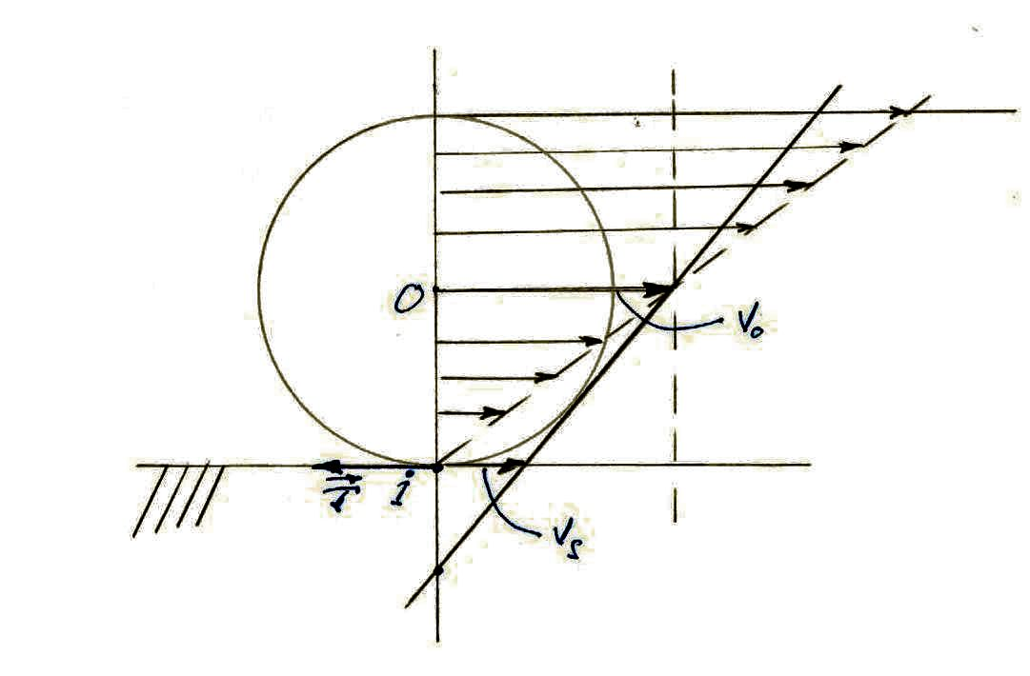
Figure 2. Regular wheel
$\begin{aligned}δ=\frac{v_{s}}{v_{0}} \\ 0<δ<1 \\ μ_{0}=\frac{T}{G} (\text{relative} \text{rest}) \\ μ_{\text{dyn}}=\frac{T}{G} (\text{dynamic} \text{situation})\end{aligned}$ (1)
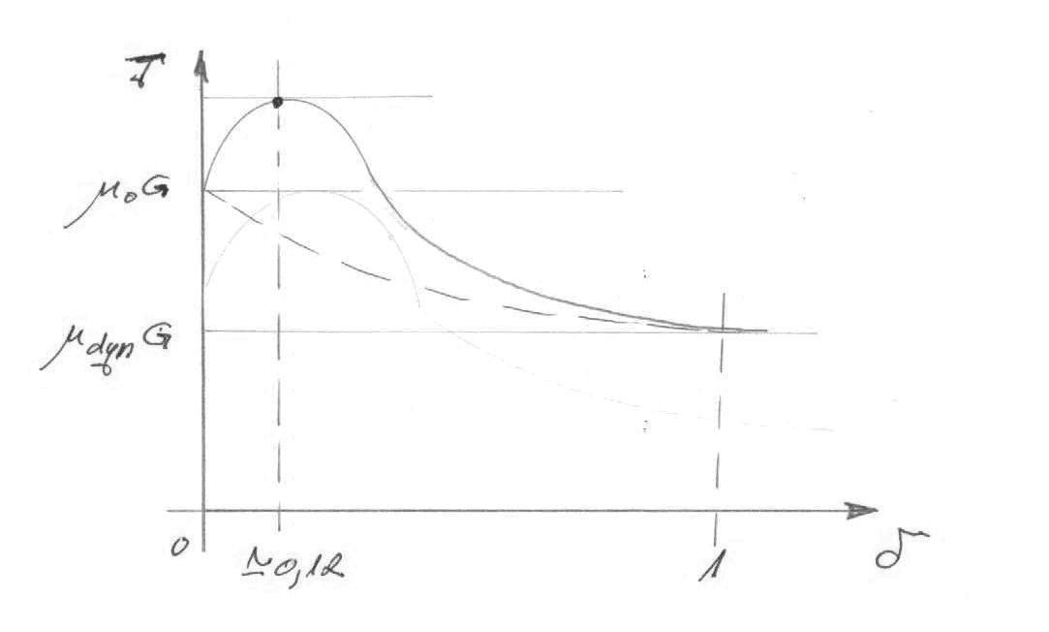
Figure 3. Deceleration graph
The maximum deceleration happens at $δ≃ 0\text{.}\text{12}$ meaning when the value of T is even higher than T at $μ_{0}$.
- $θ_{1}$ - rotation angle of the inner body
- $θ_{2}$ - rotation angle of the ring

3. MULTIBODY SYSTEM METHOD

Figure 4. Explained model

These two coordinates are enough to describe the motion of the system; the relation between them is made through the cinematic motion :
$\begin{aligned}\vec{v_{c_{1}}}=\vec{v_{2}}+\vec{ω_{1}}+\vec{{\text{oc}}_{1}} \\ ω_{1}={\overset{o}{θ}}_{1} \\ v_{2}=R{\overset{o}{θ}}_{2}\end{aligned}$ (2)
From the dynamic point of view, exists a dynamic relation concerning the speed and there is no dynamic relation concerning the forces and the acceleration. This leads to the idea that the two bodies have independent motion.
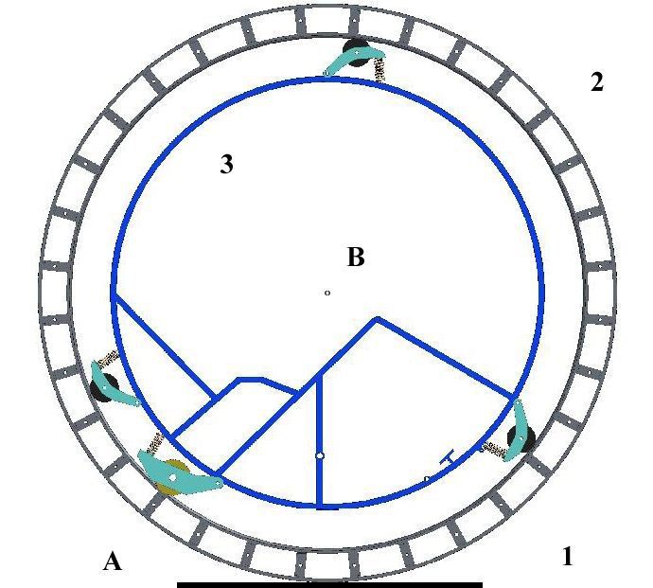

Figure 4. MBS

Table 1
Body I – Body J | Type of constrain | Location | No. of constrains
1 – 2 | RT | A | 1
2 – 3 | R | B | 2
3 – 1 | RT | A | 1

M=3(3-1)-4=2 (3)

5. ADAMS ANALYSIS

Figure 5.Hierarchical database

Modeling session

- Preprocessing → ADAMS/View & other specific modules (ex. Exchange, Controls, AutoFlex …)

- Processing → ADAMS/Solver

- Postprocessing → ADAMS/PostProcessor & ADAMS/Animation

Processing the model by:
- self-formulating the motion governing equations
- solving the differential & algebraic system

Coordinate Systems (CS)
CS – measuring sticks to define kinematic and dynamic quantities.

- Global coordinate system (GCS):
  - Rigidly attaches to the ground part.
  - Defines the absolute point (0,0,0) of your model

- Local coordinate systems (LCS):
  - Part coordinate systems (PCS)
  - Markers

Part Coordinate Systems (PCS)
- They are created automatically for every part.
- Only one exists per part.
- Location and orientation is specified by providing its location and orientation with respect to the GCS.
- When created, each part’s PCS has the same location and orientation as the GCS.

Simulation

Figure 6. Simulation hierarchy

Optimization concept
An optimization problem is described as a problem to minimize or maximize an objective function over a selection of design variables, while satisfying various constraints on the design and state variables of the system.
Steps:
- Parameterize the model
- Defining design variables
- Defining design function
- Defining design constraints
- Performing design studies
- Performing optimization studies

Design objective
- The objective function is a numerical representation of the quality, efficiency, cost, or stability of the model.
- The optimum design is achieved when the objective function is minimized or maximized.
- The optimum value of this function corresponds to the best design possible.
- Examples of objective functions: execution time, energy (effort) required, total material costs.

REFERENCES

[1] Deliu, Gh. : MECHANICS for engineering students, Editura Albastră, Cluj Napoca, 2002, I.S.B.N. 973-650-082-9
[2] On-line documentation and world wide resources on the topic.

