The 2nd International Conference
″Computational Mechanics
and
Virtual Engineering″
COMEC 2007
11 – 13 OCTOBER 2007, Brasov, Romania

ON GLIDER CLIMBING SPEED IN THERMAL AIR FLOW

Gheorghe DELIU¹
Transilvania University of Brasov, ROMANIA, e-mail deliumec@unitbv.ro

Abstract: Some considerations about the choice of the best conduct tactic in order to get the maximum climbing rate of a glider are treated in the paper. The analysis is based on both glider aerodynamic parameters and on the assumption of a radial variation of the air climbing rate in the thermal ascending flow.
Keywords: glider, drag polar, ascending rate

1. INTRODUCTION

In order to control the flight, an aircraft pilot generally may vary the thrust throttle setting to change the propulsive force, and through the control surfaces, he may vary the angle-of-attack and the bank angle to change the aerodynamic force in magnitude and direction. But the glider pilot has a heavier task, he doesn’t have trust throttle because the glider doesn’t have an engine. So, the glider pilot has to conduct the flight only through the control surfaces. It is heavier indeed, but giving more satisfaction, in my opinion.
As it is known, the glider flight is possible by continuous diminution of its potential energy, part of which being permanently transformed into kinetic energy, permits the apparition of a glider velocity relative to the air and finally the presence of lift force. But, fortunately, the pilot can use the atmospheric energy brought by the vertical movement of the air, and so the glider not only can make a level flight, but it can even climb.

2. AERODYNAMICS OF GLIDER FLIGHT

The resultant aerodynamic force acting on a glider must be equal in magnitude and opposite in direction with the weight of the plane. Resolving the aerodynamic force into components, one along the velocity and the other orthogonal to it, we can write:
$L = \frac{1}{2} ρ S v^{2} C_{L}$ - the lift force, (1)
$D = \frac{1}{2} ρ S v^{2} C_{D}$ - the drag force. (2)
Here, C_{D} and C_{L}, called the drag coefficient and the lift coefficient, respectively, are functions of the angle-of-attack $α$(the angle between air velocity and a reference line on the wing profile). If the reference line is taken such as $α = 0$ corresponds to the zero-lift condition, typical variations of C_{D} and C_{L} are shown in Fig.1 [1].

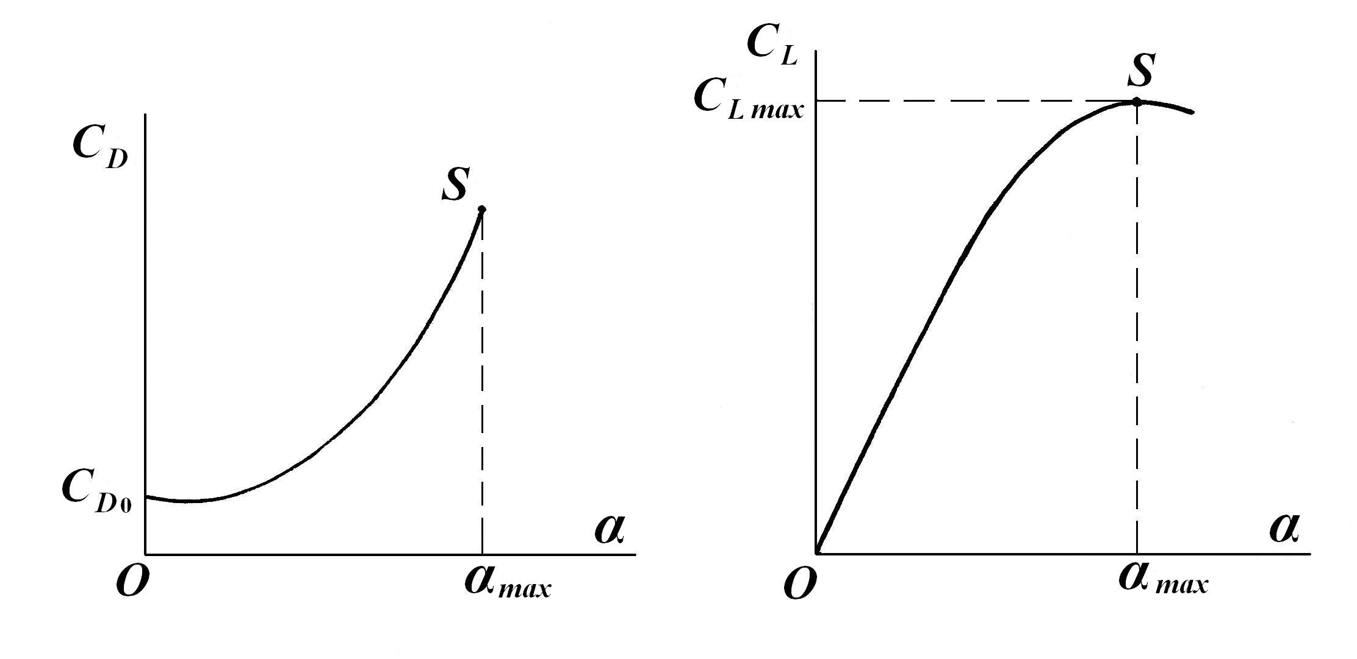
Figure 1: Variations of C_{D} and C_{L} with α

2.1. Drag polar

Depending on optimum performance to be achieved, the angle-of–attack α varies during the flight as a selected function of the time, between the values α =0 and $α = α_{\text{max}}$. For any given value of this parameter one may find a point in the C_{L} – C_{D} plane. These points are laying on a curve named drag polar, and having the approximate equation
$C_{D} = C_{D0} + {\text{KC}}_{L}^{2}$, (3)
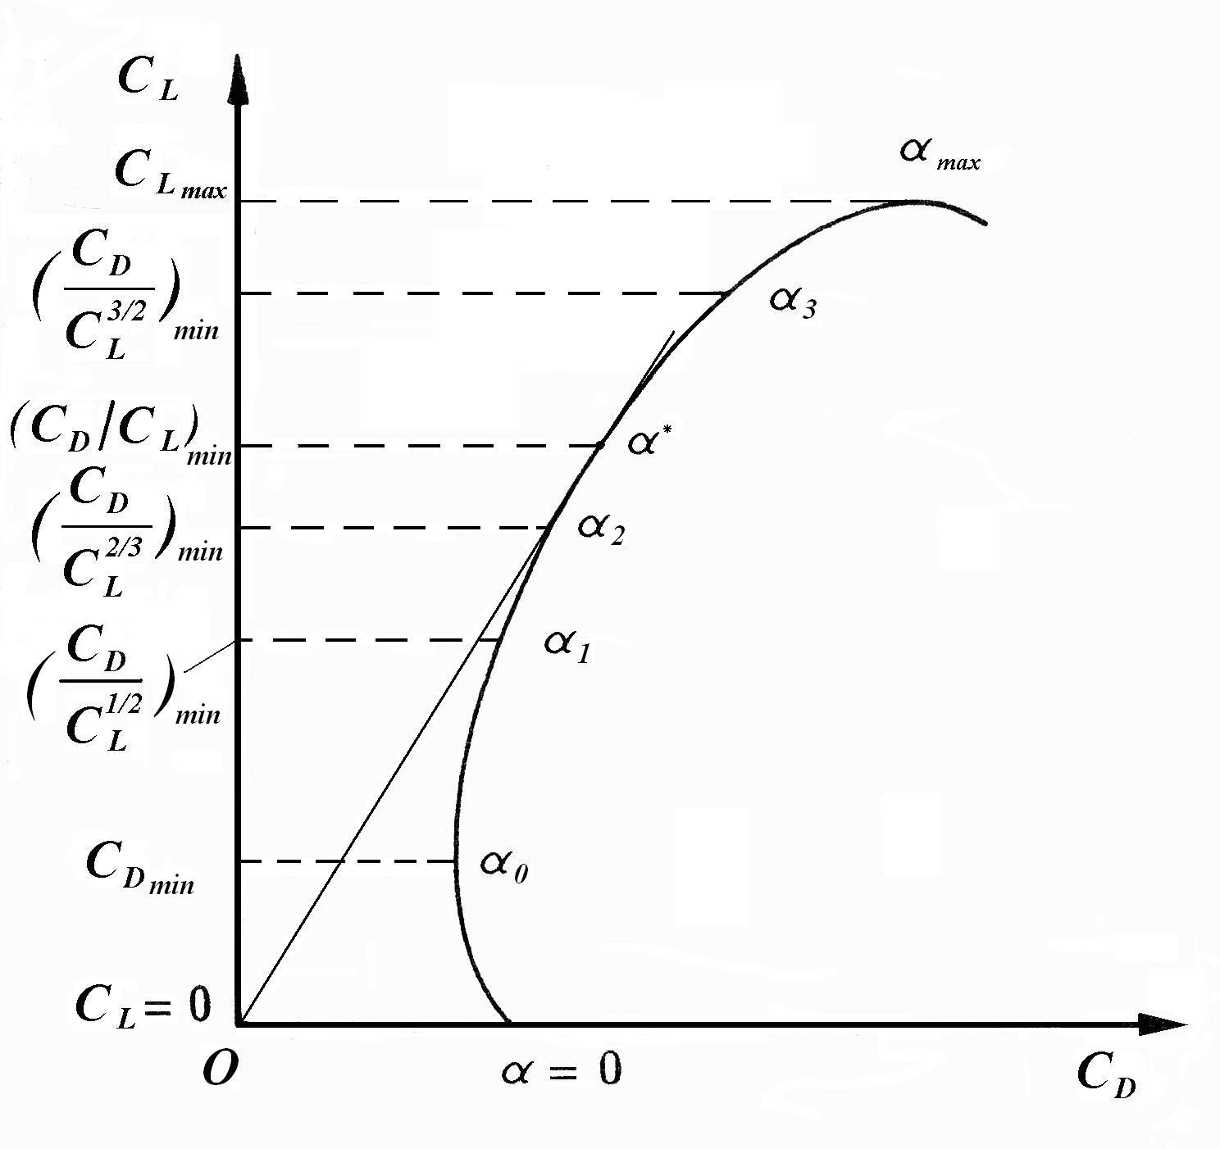
Figure 2: Actual drag polar

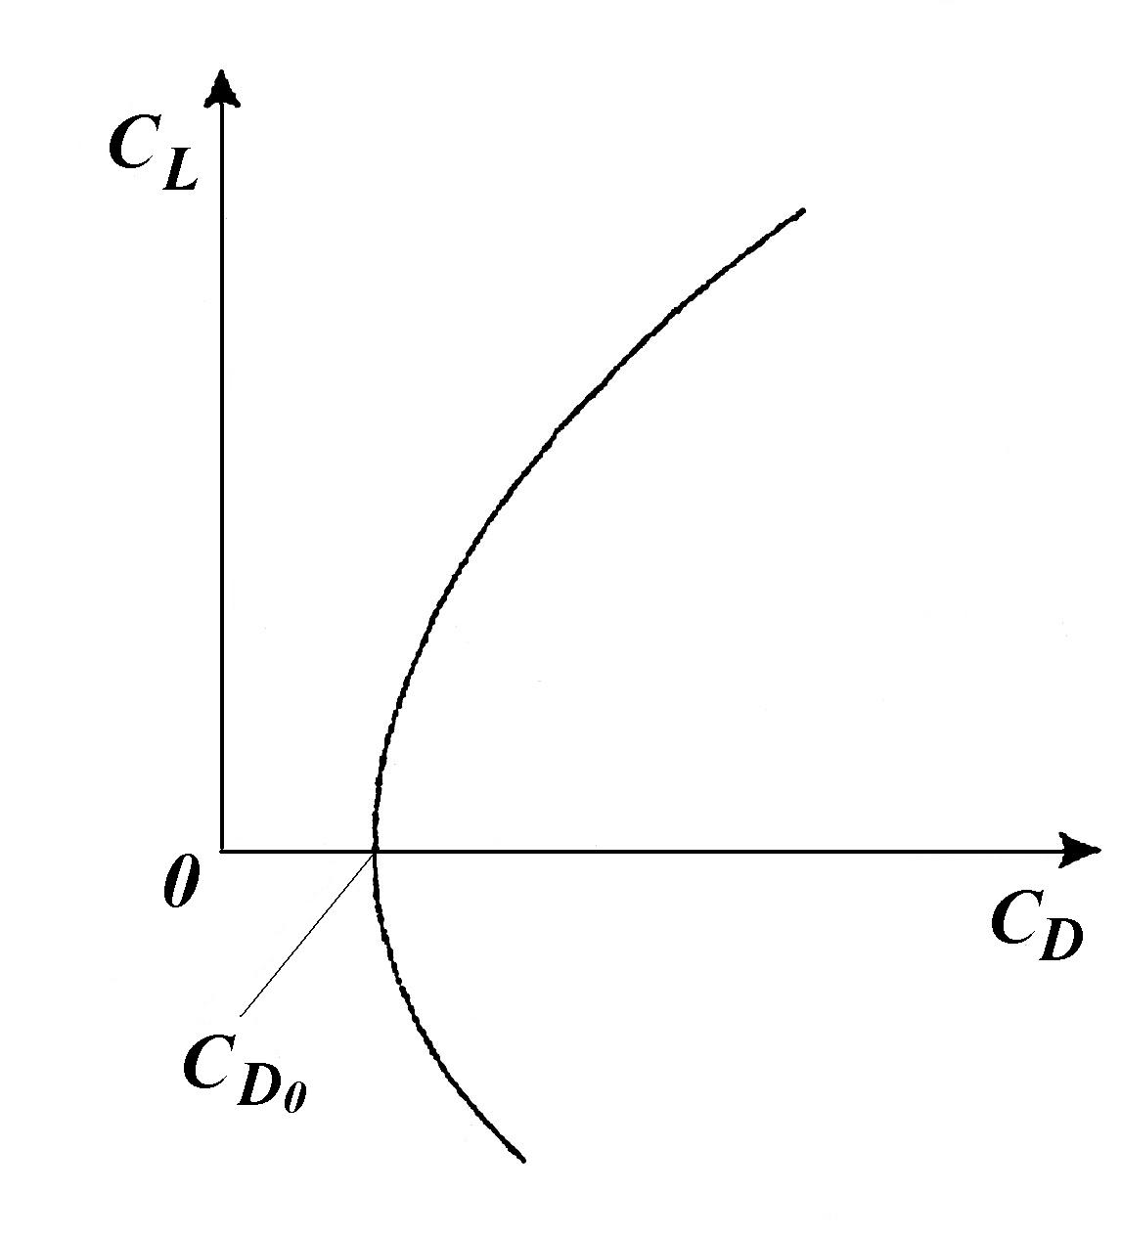
Figure 3: Parabolic drag polar

where $C_{D 0}$ is the drag coefficient at zero lift force. The drag polar obtained from experimental results usually differs slightly from the idealised parabolic form given in equation (3) above. The effect of substantial camber of a wing profile, for example, will result in the minimum drag coefficient $C_{D \text{min}}$ being slightly smaller than$C_{D 0}$, as shown in Fig.2. The parabolic approximated (idealised) drag polar is shown in Fig.3.

A more realistic equation of the actual drag polar might be approximated by
$C_{D} = C_{D \text{min}} + K{\left[C_{L} − C_{L}\left(C_{D \text{min}}\right)\right]}^{2}$. (4)
For most calculations however, the difference between $C_{D \text{min}}$ and $C_{D 0}$ is small and equation (3) can be used.

2.2. Aerodynamic efficiency

The ratio of an aircraft’s lift to drag is an important parameter for performance work. The lift-to-drag ratio, denoted by E, is the main measure of a glider aerodynamic efficiency. By definition
$E = \frac{L}{D} = \frac{C_{L}}{C_{D}}$. (5)
The aerodynamic efficiency is a function of the lift coefficient, as shown in the figure 4.
Although the value of E will change during flight, each glider has a maximum value E _{max}, which it cannot exceed. This value is a design characteristic, as it depends on C_{D 0}, A (aspect ratio of the wing) and e (Oswald’s factor), which are design parameters, not flight ones. The expression of maximum aerodynamic efficiency is [1]:
$E_{\text{max}} = E^{} = \frac{1}{2} \sqrt{\frac{π A e}{C_{D 0}}}$ . (6)

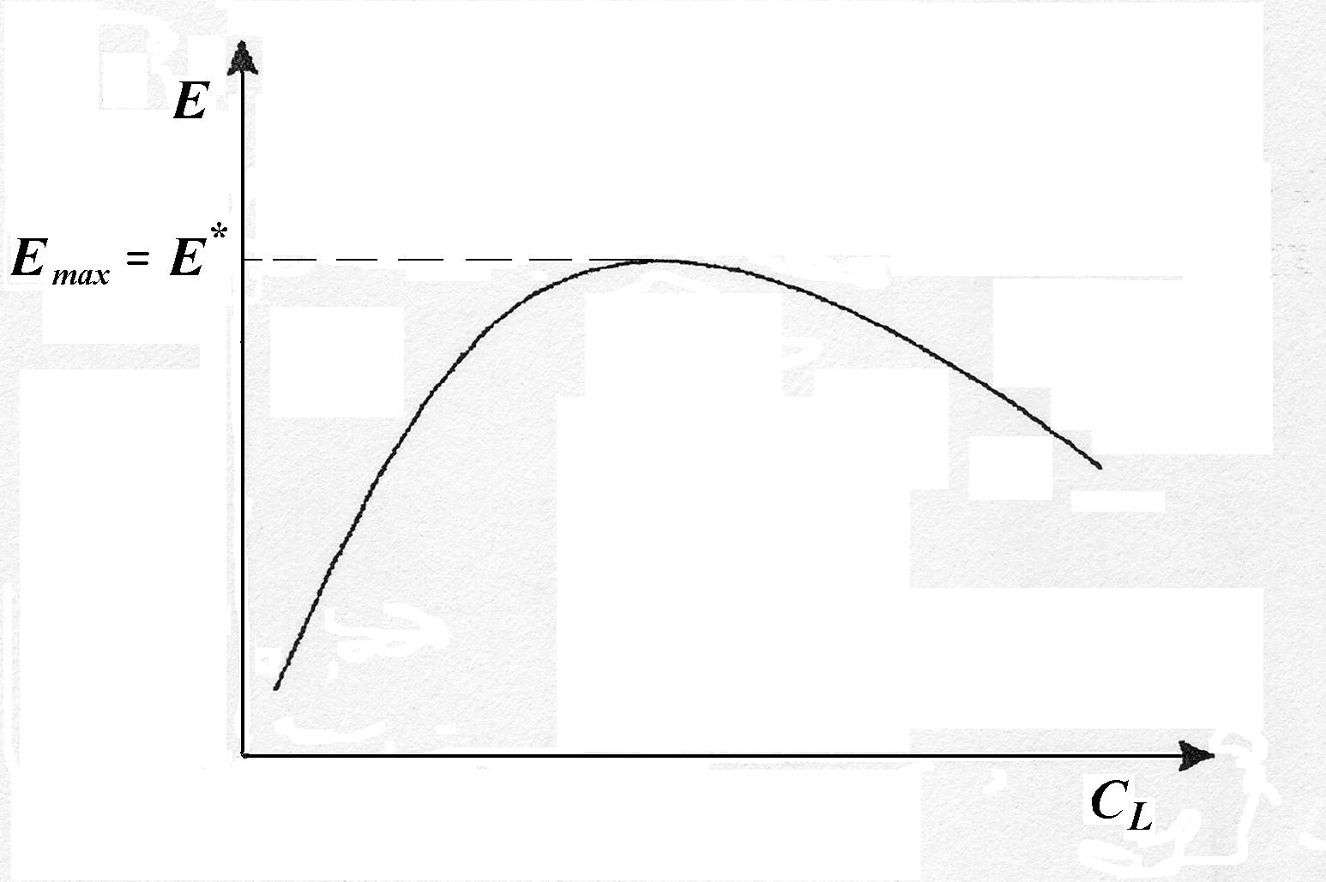
Figure 4: Lift-to-drag ratio versus C_{L}
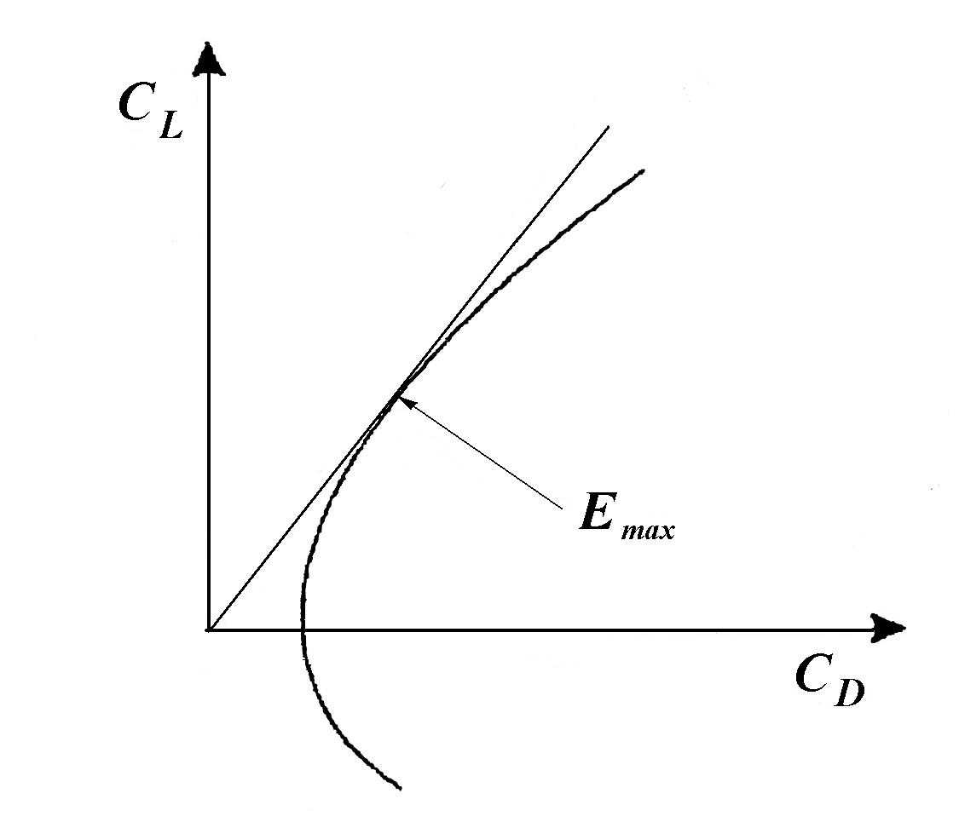
Figure 5: Maximum lift-to-drag ratio

2.3. Velocity polar

In a steady glide, the glider can fly with a wide range of air speeds, on different flight path angles. If we represent all the possible air velocities as vectors having the same origin, the graph described by velocity arrows tips is named velocity polar [Fig.6].
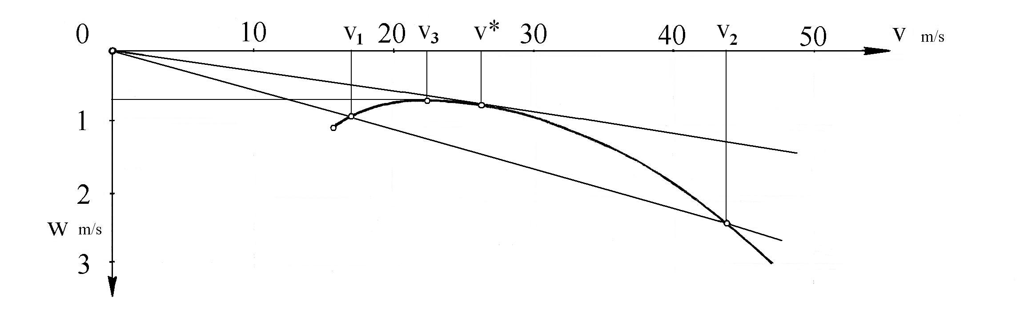
Figure 6: Velocity polar

This graphic representation may provide a simple way to understand the relationship between the air speed V, the rate of descent w, and the path angle γ. Here we have on the O-v axis the horizontal projection of the glide speed, v, and on the O-w axis, the vertical projection of it, w, respectively. If the scales on both axes are equal (that is not the case in figure above), the tangent from origin to the v – w curve is quite the flattest glide path, having the path angle γ*. There are the evident relations:

$v = V \text{cos} γ$, (7)
$w = V \text{sin} γ$. (8)

For small flight path angles (which is almost exactly the case of a glider, but far to be exact for an aircraft), we can evidently take
$\text{sin} γ ≈ γ , \text{cos} γ ≈ 1$. (9)
For example, the flattest glide path of IS - 29 B2 glider, having the maximum lift-to-drag ratio E _{max} = 34, will be done by the relation
$\text{tg} γ^{} = \frac{w^{}}{v^{}} = \frac{1}{E_{\text{max}}} =0\text{.}\text{02941}$, (10)
and the corresponding path angle will be γ* = 1,684º, which confirms the small flight path angles assumption.
The curve shown in Fig.6 was drawn by the author, starting from experimental data [2]. In order to get a mathematical equation which would fit to the curve, the author used the smallest squares method and found the next equation:
$w = 0\text{.}\text{78} +0\text{.}\text{00132} ⋅{\left(v− \text{23}\text{.}\text{61}\right)}^{2\text{.}\text{334}}$. (11)

4. GLIDER AERODYNAMICS IN TURN

4.1. Aircraft steady turn in the horizontal plane

In order to find the flight performance of a glider in turn, it is useful to begin from the well known aircraft’s steady turning characteristics (Fig.7).

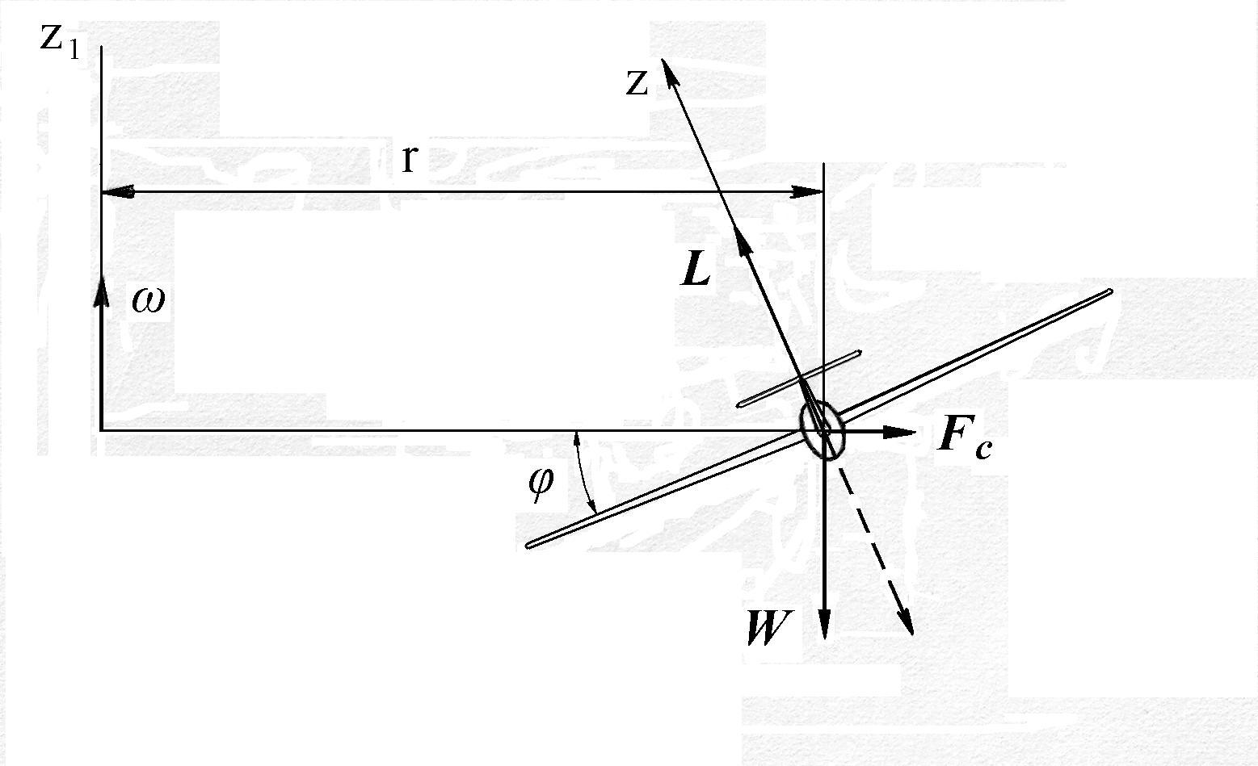
Figure 7: Aircraft level turn

In the above figure, the force diagram for a coordinated turn in the horizontal plane is shown. This means that there is no side slip angle, and the velocity is in plane of symmetry containing the aerodynamic force and the propulsive force. In a perfectly coordinated turn at constant speed, the trust balances the drag and their common line of action is perpendicular to the plane of the figure. From the above figure, it is seen that the weight is balanced by the vertical component of the lift force. Because of the bank angle φ, the lift has a horizontal component with magnitude $L \text{sin} ϕ$ and directed toward the centre of the turn. This force is balanced by a centrifugal force $F_{c}$of magnitude $m {V^{2}}/ r$, where r is the radius of curvature which, in this case, is the turning radius. From the force balance equation, the radius takes the expression
$r = {V^{2}}/ g \text{tan} ϕ$. (12)
This formula can be used to calculate the turning radius with the selected bank angle and turning speed, but always taking into account that no physical constraints can be violated.
The most important thing is to note that during a steady turn the lift must be greater than the weight,
$L = W/ \text{cos} ϕ$. (13)

4.2. Glider in “steady” turn. Optimum turning radius

By “steady” turn of a glider we denoted here a turn at constant air speed, having constant path angle and bank angle. Unlike the aircraft behaviour in a level turn, when a glider pilot begins a turn he has been already diving. It isn’t possible to make a level turn, unless for a short time, in variable flight conditions (for example, in climbing air flow or in a temporary zoom after a dive). However, an approximate study of a continuous turn may be done in the limits of small path angle assumption. Starting from the equation (13), we can write
$V_{t}^{2} C_{L,t} = \frac{1}{\text{cos} ϕ} ⋅ V^{2} C_{L}$, (14)
where V _{t} is the air speed in the turning flight, and $C_{L,t}$is the corresponding lift coefficient.
Returning at the figure (6), we can see that speed increase will be accompanied by an increasing diving rate (sinking speed). Taking then the function (11) in a literal form
$w = w_{\text{min}}+a {\left(V−V_{3}\right)}^{b}$, (15)
we can easily find the rate of change of w versus V,
$\frac{\text{dw}}{\text{dV}} = a b {\left(V−V_{3}\right)}^{b−1}$. (16)
For the numerical example made on the IS-29 B2 glider, the sinking speed rate is
$\frac{\text{dw}}{\text{dV}} = 0\text{.}\text{00308} {\left(V− \text{23}\text{.}\text{61}\right)}^{1\text{.}\text{334}}$. (17)

From his first flight attempts with an airframe (remember Lilienthal’s exploits), the man tried to use the atmospheric air flows in order to reach an easier take-off and/or to extend the flight duration. The main source used for altitude gain by a glider pilot are the convection climbing air flows, produced by heat change between the ground and the atmosphere. These convection air flows are generally vertical “chimneys” in which the warm air is climbing due its smaller density than that of the environmental atmosphere air. The radius of such a chimney may vary between 100 and 300 m, more or less, and the mean climbing speed of the air inside of this flow is generally of 1- 7 m/s.
But because of the drag between the climbing air and the environmental atmosphere (assumed to be in rest, while it is actually descending, at lest in the very proximity of the ascending air flow), the air climbing rate inside the chimney is diminishing from the centre to the border of the ascending air cylinder. In other words, in order to get a faster climbing, the glider pilot will be inclined to reduce the radius of the continuously turning flight inside the chimney.
Unfortunately, the turn radius of a glider in thermal chimney is limited in both senses by:
- the glider’s sinking speed increases as the radius decreases;
- the air flow climbing speed decrement according to the radius increment.

N.B. In a wide air stream having constant climbing speed (like ahead of a cold front , in dynamic ascending flow or in an undulated air stream), the problem of the turning flight parameters has no relevance, because in such conditions the pilot uses other manoeuvring techniques.

a) Sinking speed versus bank angle
Assuming that the pilot wants (and knows how) to keep the same angle-of-attack as in no banked glide, equation (14) gives
$V_{t} = \sqrt{\frac{V^{2}}{\text{cos} ϕ}}$. (18)
Now, replacing this speed in relation (11), we can calculate the sinking speed as a function of the bank angle
$w = w_{\text{min}}+a {\left(\sqrt{\frac{V^{2}}{\text{cos} ϕ}}−V_{3}\right)}^{b}$. (19)
From the above equation, we can see that as the bank angle increases, the sinking speed will increase too.

b) Vertical air movement influence
When a glider flies into an ascending mass of air, it will be transported by the latter and lifted together. The absolute vertical speed will be the geometrical sum between the warm air climbing speed and the velocity of the glider relative to the air. In vertical projections, this means that the absolute climbing speed will be
$\overset{˙}{h} = u−w$, (20)
where u is the vertical air speed in the thermal chimney, and h – the instantaneous altitude/ height of the glider.
As we have mentioned above, the air climbing speed is diminishing from the centre to the border of the chimney; unfortunately, the law $u = u\left(r\right)$ is unknown. One may propose a function or another. But, without experimental data, every attempt will be more or less unfounded. When these data would be put in a mathematical expression, we could find an optimum turning radius, which should lead to the fastest climb.
However, a qualitative conclusion may be drawn. The optimum bank angle (or turn radius) will be reached at a precise set of three correlated values - the glider speed V, the angle-of-attack α and the vertical climbing air speed u. That means, at that very turn radius for which the difference between u and w takes a maximum value.

5. CONCLUSION

In the gliding flight, the manipulation of flight controls leads to the pilot’s choices for air speed V and bank angle φ. Flight path angle γ must be a function of (at most) those variables. Once we get a formula for γ, an expression for sinking speed w is immediate and one for turn radius, while not immediate, is forthcoming.
The small path angle assumption may be used with good approximation in the study of banked glide in the glider case. In the case of aircraft glides (after the engine quits) the study of flight performances has to renounce at that simple approach in the favour of a more “exact” one.
That means to take into account the fact that, because an aircraft has a smaller aerodynamic efficiency than a glider (in the best case, about one half of it), its flight path angle is at least twice than of a glider. For example, while a glider has E _{max} about 40, a high-speed subsonic jet has E _{max} about 18. The corresponding flight path angles are γ = 1.43º for a glider, γ = 3.18º for a jet, and even γ = 8.13º for a supersonic jet [3]. For this cause, the flight path must be taken as it exactly is – a helix wound on some cylinder of radius r. The author intents to study the parameters of such a glide flight in a future work.
An extension of the present work will be also made, when the author will have access to some certified data about the spectrum of air climbing speeds inside an atmospheric thermal chimney.

REFERENCES

[1] Deliu, G.: Mecanica aeronavelor, Editura Albastra, Cluj-Napoca, 2000
[2] Silimon, I.: Zborul planorului, Editura Stadion, Bucuresti, 1971
[3] Young, T.: Flight Mechanics, Limerick University, 2001

