1st International Conference
″Computational Mechanics and Virtual Engineering ″
COMEC 2005
20 – 22 October 2005, Brasov, Romania

ASPECTS CONCERNING THE OPTIMIZATION OF INDUSTRIAL CONTROL NETWORKS

Ioan Ardelean,
Technical University of Cluj-Napoca,Cluj-Napoca, ROUMANIA,
e-mail: ioan_ardelean@yahoo.com

Absteract. Commencing in the late 1960s and continuing through 1999 to the 2000s, industrial data and control networks will capture the ingenuity of control engineers, computer scientists, and, of course, communications specialists. The well-justified thirst for information from top management down the industrial hierarchy will continue undiminished. To date, communication system designs have survived past difficult periods in an effort to find the best network systems for given applications, always with an eye toward finding the “universal” answer, [1]. Open systems hold some promise along these lines. Millions of hours of effort have gone into defining optimal protocols, improved communication media, practical and cost-effective bus configurations, and the reconfiguration of controls, such as programmable logic controllers (PLCs), distributed control systems, and personal computers (PCs), in an effort to make them increasingly “network friendly.”
Keywords : optimization, concerning, control, industrial, networks.

1. INTRODUCTION

Other objectives and there have been tough decisions and roadblocks, but the leading technical societies have mustered strength through special committees in defining terms and establishing standards, [1]. This work will continue apace. Early communication needs were served with point-to-point data links Figure 1. Very early standards, such as TTY (teletypewriter) current loops and RS-232, which allow different equipment to interface with one another, appeared and were accepted. From that, the star topology Figure 2 was developed so
that multiple computers could communicate. The central, or master, node uses a communications port with multiple drops, as shown in Figure 3. In this system the master is required to handle traffic from all the nodes attached, poll the other nodes for status, and, if necessary, accept data from one node to be routed to another,[2]. The heavy software burden on the master is also shared to a lesser degree among all the attached nodes. In addition, star topologies are inflexible as to the number of nodes that can be attached. Either one pays for unused
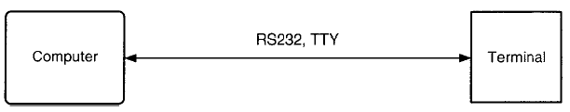
Computer
Terminal
RS-232, TTY

Figure 1. Point-to-point communication.

connections (for future expansion), or a system results that cannot grow with demands. To overcome some of these shortfalls, multidrop protocols were established and standardized. Data loop, such as SDIC (synchronous data link control), were developed as well as other topologies, including buses and rings, Figure 4. The topology of these standards makes it easy to add (or subtract) nodes on the network. The wiring is also easier because a single wire is routed to all nodes. In the case of the ring and loop, the wire also is returned to the master. Inasmuch as wiring and maintenance are major costs of data communications, these topologies virtually replaced star networks, [1],[2]. These systems, however, have a common weakness—one node is the master, with the task of determining which station may transmit at any given time. As the number of nodes increases, throughput becomes a problem because (1) a great deal of “overhead” activity may be required to determine which may transmit and (2) entire messages may have to be repeated because some protocols allow only masterslave communications, that is, a slave-to-slave message must be sent first to the master and then repeated by the master to the intended slave receiver,[1],[4]. Reliability is another problem. If the master dies, communications come to a halt.
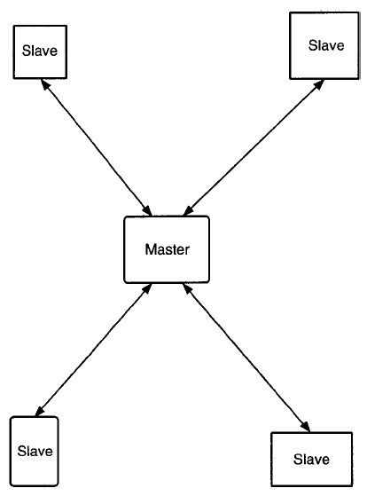
Slave
Slave
Master
Slave
Slave

Figure 2. Star topology.
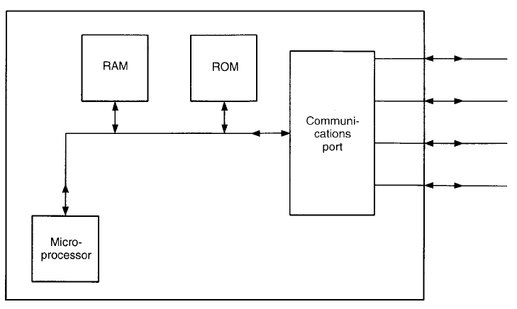
Figure 3. Master node for star topology.
RAM
ROM
Microprocessor
Communication
port

The need for multinode networks without these kinds of problems and restraints led to the development
of the initial local area networks –LANs- using peer-to-peer communications. Here no one node is in charge; all nodes have an equal opportunity to transmit,[1],[3]. An early LAN concept is shown schematically in Figure 5.
In designing LAN architecture, due consideration had to be given to the harsh environment of some manufacturing and processing areas. Design objectives included the following.
1.Noise. Inasmuch as a LAN will have long cables running throughout the manufacturing space, the amount of noise pickup can be large,[1],[5]. Thus the LAN must be capable of working satisfactorily in an electrically noisy area. The physical interface must be defined to provide a significant degree of noise rejection, and the protocol must be robust to allow easy recovery from data errors.
2.Response. The LAN in an industrial situation should have an assured maximum response time, that is, the network must be able to transmit an urgent message within a specified time frame,[1],[4]. The real-time aspect of industrial control demands this.
3.Priority Message. On the factory floor, both control and status, when carried over the same network, should recognize the higher priority of the control message,[1],[5]

2. EARLY DATA HIGHWAYS

In 1972 the very first serial data communications highways were introduced. At that time the only purpose of the data highway was to allow host computers to adjust set points or, in some cases, perform direct digital control (DDC), while providing measurement data to the host computer,[1],[6]. With such radically altered control concepts, in designing a data highway, great emphasis was placed on proposed data highways and their ability to operate at sufficiently high rates. There was concern that, during process upsets, many alarm conditions could suddenly change and these had to be reported to the entire system quickly so that remedial action could be taken, [5],[7]. There also was major concern over start-up and shutdown procedures that cause heavy communication loads. Security also was a major concern.
In 1973 the distributed control system (DCS) appeared. It represented a major departure in control
system architecture and impacted on the configuration of the data highway,[3],[7].
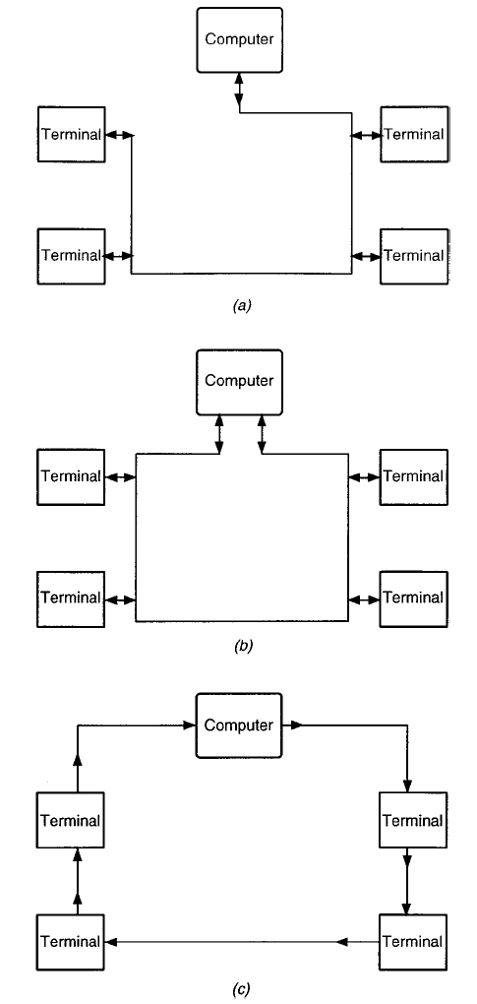
Figure 4. Basic communication standards; a) Data-loop topology; b) Bus topology; c) Ring topology.
Computer
Terminal
Terminal
Terminal
Terminal
a)
Computer
Terminal
Terminal
Terminal
Terminal
b)
Computer
Terminall
Terminal
Terminal
Terminal
c)

Ethernet. The first LAN, developed by Xerox Corporation, has enjoyed years of application,[1],[3]. The network uses CSMA/CD,carrier sense multiple access with collision, and is a baseband system with a bus architecture, Figure 4b. Baseband is a term used to describe a system where the information being sent over the wire is not modulated.

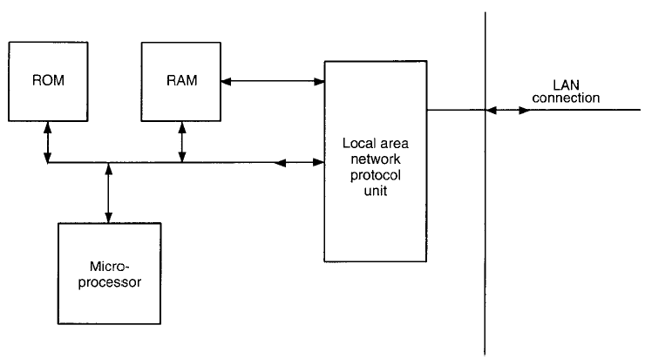
ROM
RAM
Microprocessor
Local area network protocol unit
LAN
Communi- cation

Figure 5. Early LAN concept shown schematically,[1].

DECnet,[1]. DEC (Digital Equipment Corporation) computers, operating on the factory floor in the early 1970s, were linked by DECnet. This was a token passing technique, described later under “Network Protocols.”
DECnet/Ethernet,[1]. In 1980, with an aim to support high-speed local LANs, DECnet and Ethernet
were used together to form DECnet/Ethernet, a network that has been used widely over the years. One of the major advantages of combining the two concepts is that Ethernet’s delay in one node’s response to another’s request is much shorter than that of a token passing protocol. Users generally found that these networks provide good real-time performance. Ethernet is inherently appropriate for transmitting short, frequent messages and it effectively handles the irregular data transfers typical of interactive terminal communications, [1].
CATV Cable,[1] In 1979 a CATV (community antenna television) cable system was announced. This system also had a central point of control and a multimaster protocol, but it used CATV cable at 1 Mbit/s. At these data rates, even in baseband, the transceiver design was based on radio-frequency (RF) technology. The topology of the network used a local star cluster with the CATV interconnecting all clusters. The data communication within the cluster was bit serial, byte parallel.

3. CONCLUSIONS

Later networks offered dual redundant mechanisms so that if one data highway failed, a second data highway would take over. The second highway was unused except for integrity diagnostics. To make certain that these data highways were in good order, elaborate mechanisms were implemented apart from the data communications to ensure cable and station integrity. CATV is mentioned later under MAP protocol.
A data communication protocol may be defined as “a set of conventions governing the format and relative timing of message exchange between two (or more) communications terminals,” or, restated, “the means used to control the orderly communication of information between stations on a data link.”
The communication protocol is vital to equipment design and must be defined accurately if all elements in a system are to work together in harmony in the absence of a lot of local“fixes” Thus much international effort has been made over several years by various technical society committees to accurately identify, define, and refine protocols. Because of the heavy investment involved, a protocol usually is debated for at least a few years before the various committees officially approve standards. “Carrier sense multiple access with collision” is a baseband system with a bus architecture. Normally only one station transmits at any one time. All other stations hear and record the message.
The receiving stations then compare the destination address of the message with their address. The one
station with a “match” will pass the message to its upper layers, while the others will throw it away. Obviously, if the message is affected by noise (detected by the frame check sequence), all stations will throw the message away.

REFERENCE

[1]. McMillan, G. K.,Douglas M. Considine,D.M., PROCESS/INDUSTRIAL INSTRUMENTS AND CONTROLS HANDBOOK, McGRAW-HILL, 1999.
[2]. Edwards, E., and F. Lees, The Human Operator in Process Control, Taylor & Francis, London, 1974.
[3]. Patrick, D., and S. Fardo, Industrial Process Control Systems, Delmar, Albany, New York, 1997.
[4]. Murrill, P. W., Fundamentals of Process Control Theory, 2nd ed., Instrument Society of America, Research
Triangle Park, North Carolina, 1991.
[5]. Polke, M., ed., Process Control Engineering, VCH, New York, 1994.
[6]. Lees, F. P., “Research on the process operator,” in The Human Operator in Process Control, E. Edwards and
F. P. Lees, eds., Halsted, New York, 1974, pp. 386–425.
[7]. Eberts, R. E., S. Y., Nof, B. Zimolong, and G. Salvendy, “ Dynamic process control: cognitive requirements
and expert systems,” in Human–Computer Interaction, G. Salvendy, ed., Elsevier, Amsterdam, 1984, pp.
215–228.
[8]. Swets, J. A., Ed., Signal Detection and Recognition by Human Observers: Comtemporary Readings, Wiley,
New York, 1964.
[9]. Bainbridge, L., “Analysis of verbal protocols from a process control task,” in The Human Operator in Process Control, E. Edwards and F. P. Lees, eds., Halsted, New York, 1974, pp. 285–305.
[10]. Beishon, R. J., “An analysis and simulation of an operator’s behavior in controlling continuous baking ovens,”in The Simulation of Human Behavior, F. Bresson and M. deMontmollen, eds., Durod, Paris.
[11]. Card, S. K., T. P. Moran, and A. L. Newell, The Psychology of Human Computer Interaction, Erlbaum,
Hillsdale, New Jersey, 1983.
[12]. Newell, A., and H. Simon, Human Problem Solving, Prentice-Hall, Englewood Cliffs, New Jersey, 1972.
[13]. Boose, J., “A framework for transferring human expertise,” in Human–Computer Interaction, G. Salvendy,
ed., Elsevier, Amsterdam, 1984, pp. 247–254.
[14]. Kruskal, J. B., and M. Wish, “Multidimensional Scaling,” Sage, Beverly Hills, California, 1978.

