The 2nd International Conference
″Computational Mechanics
and
Virtual Engineering″
COMEC 2007
11 – 13 OCTOBER 2007, Brasov, Romania

SOME CONSIDERATION ABOUT ELECTROMEDICAL DEVICES IMPLEMENTATION IN HUMAN BEHAVIOR ANALYZE

Cristina COSTAŞ¹, Mihaela BARITZ²
¹ “Transilvania” University, Braşov, ROMÂNIA, cristina_mantrini@yahoo.com
² “Transilvania” University, Braşov, ROMÂNIA, baritzm@yahoo.com

Abstracts: This paper presents theoretical aspects about electromedical devices used for determination of physiological parameters of human subjects, computer directly measures date witch. This parameters can be used by physicians for diagnose or by researchers for improvement of human behavior characteristics.
Keywords: blood pressure, electrocardiogram, electomedical apparatus, human behavior analyzes, spirometer

1. INTRODUCTION

Medical equipment is designed to aid in the diagnosis, monitoring or treatment of medical conditions. These devices are usually designed with rigorous safety standards. There are several basic types like diagnostic equipment includes medical imaging machines, used to aid diagnosis; therapeutic equipment includes infusion pumps, medical lasers and LASIK surgical machines; life support equipment is used maintain a patients bodily function (medical ventilators, heart-lung machines, ECMO, and dialysis machines); medical monitors allow medical staff to measure a patients medical state (ECG, EEG, blood pressure, and dissolved gases in the blood), and medical laboratory equipment automates or help analyze blood, urine and genes.

2. ELECTROMEDICAL DEVICES FOR HUMAN BEHAVION STATE

2.1.Pulse oximeter (Saturometer)

A pulse oximeter is a medical device that indirectly measures the amount of oxygen in a patient’s blood (as opposed to measuring oxygen saturation directly through a blood sample) and changes in blood volume in the skin, producing a photoplethysmograph. A photoplethysmograph (PPG) is an optically obtained by using a pulse oximeter which illuminates the skin and measures changes in light absorption conventional pulse oximeter monitors the perfusion of blood to the dermis and subcutaneous tissue of the skin. It is often attached to a medical monitor so staff can see a patient’s oxygenation at all times. Most monitors also display the heart rate.
A blood-oxygen monitor displays the percentage of arterial hemoglobin in the oxyhemoglobin configuration. Acceptable normal ranges are from 95 to 100 percent. For a patient breathing room air, at not far above sea level, an estimate of arterial pO₂ can be made from the blood- oxygen monitor SpO₂ reading.
With each cardiac cycle the heart pumps blood to the periphery. Even though this pressure pulse is somewhat damped by the time it reaches the skin, it is enough to distend the arteries and arterioles in the subcutaneous tissue. If the pulse oximeter is attached without compressing the skin, a pressure pulse can also be seen from the venous plexus, as a small secondary peak.
The change in volume caused by the pressure pulse is detected by illumination the skin with the light from a Light Emitting Diode (LED) and then measuring the amount of light either transmitted or reflected to a photodiode. Each cardiac cycle appears as a peak.

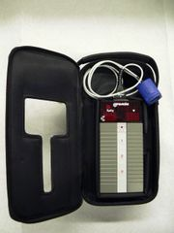
Figure 1: A portable saturometer (for emergencies)

A pulse oximeter is a particularly convenient non-invasive measurement. Typically t has a pair of small light-emitting diodes (LEDs) facing a photodiode through a translucent part of the patient’s body, usually a fingertip or an earlobe. One LED is red, with wavelength of 660 nm, and the other is infrared, 905, 910, or 940 nm. Absorption at these wavelengths differs significantly between oxyhemoglobin and its deoxygenated form, therefore from the ratio of the absorption of the red and infrared light the oxy/deoxyhemoglobin ratio can be calculated.

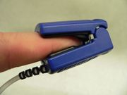
Figure 2: Typical measurement through the fingernail

Because of their simplicity and speed (they clip onto a finger and display results within a few seconds), pulse oximeters are of critical importance in emergency medicine and are also very useful for patients with respiratory or cardiac problems, as well as pilots operating in a non-pressurized aircraft above 10.000 feet, where supplemental oxygen is required.
The latest generation pulse oximeters use digital signal processing to make accurate measurements in clinical conditions that were otherwise impossible. These include situations of patient motion, low perfusion, bright ambient light, and electrical interference.

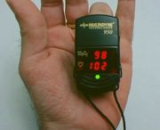
Figure 3: A portable pulse oximeter registering a satisfaction saturation reading

Generally speaking, nail polish and acrylic nails do not affect the readings of modern state-of-the-art pulse oximeters. This has been proved by many recent researches. Many published papers can be found on the website National Center for Biotechnology Information which is operated by the National Library of Medicine and the National Institutes of Health in the U.S.A. There are also numerous other resources, either on the Internet or found in published professional magazines, discussing effects of nail polish and acrylic nails to pulse oximeters.
In the early days of pulse oximetry, researchers conducted some trial to verify the effects of nail polish on pulse oximetry. In the tests, a number of adult volunteers had various colors of name brand nail polish applied to their fingernails. Measured data from some commercialized pulse oximeters are analyzed. Cote et al. reported that the reading of SpO2 is significantly lowered by 3% to 6% for those who use blue, green and black nail polish, and then suggested nail polish should be routinely removed before pulse oximetry monitoring.
However, with the advance of technology, most pulse oximeters can ignore other tissues or nail polish and discern only the absorption caused by arterial blood by examining only the varying part of the absorption spectrum. Brand et al. tested the effects of colors of enamel nail polish to pulse oximeter readings on 12 healthy nonsmoking narcotic volunteers.

2.2. Blood pressure measurement

Blood pressure (strictly speaking: vascular pressure) refers to the force exerted by circulating blood on the walls of blood vessels, and constitutes one of the principal vital signs. Arterial pressure is most commonly measured via a sphygmomanometer, which uses the height of a column of mercury to reflect the circulation pressure. Although many modern vascular pressure devices no longer use mercury, vascular pressure values are still universally reported in millimeters of mercury (mmHg).
Sphygmomanometers are two types:
1. Digital (electronic, easy to operate and practical in noisy environment. Many have not been validated for all patients groups, and can give very inaccurate readings). They measure mean arterial pressure, MAP, and use algorithms to calculate systolic and diastolic values.
2. Manual (older fashioned, though more precise). Must be operated by a trained person [1].

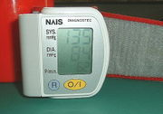
Figure 4: a sphygmomanometer, a device used for measuring arterial

Non-invasive measurement is more commonly used for routine examinations and monitoring.
The auscultatory method uses a stethoscope and a sphygmomanometer. This comprises an inflatable cuff placed around the upper arm at roughly the same vertical height as the heart, attached to mercury or aneroid manometer.

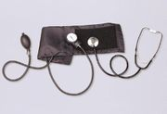
Figure 5: Auscultatory method aneroid sphygmanometerwith stethoscope

While statistically normal values for arterial pressure could be computed for a given population, it need to be remembered that, not only does arterial pressure vary from person, it also varies in individuals from moment to moment. Additionally, since there’s no guarantee the norm of the population in question should even be considered healthy, the relevance of such values would be questionable.
In children the observed normal ranges are lower; in the elderly, they are often higher, largely because of reduced flexibility of the arteries. Factors such as age gender and race influence blood pressure values. Pressure also varies with exercise, emotional reactions, sleep, digestions and time of day [1].

2.3. Spirometer

A spirometer is an apparatus for measuring the volume of air inspired and expired by the lungs. It is a precision differential pressure transducer for the measurements of respiration flow rates. The Spirometer records the amount of air and the rate of air that is breathed in and out over specified time. The Spirometer and attached flow head function together as a pneumotachometer, with an output signal proportional to airflow. The output produced by a spirometer is called a kymograph trace. From this, vital capacity, tidal volume, breathing rate and ventilation rate (=tidal volume x breathing volume) can be calculated. From the overall decline on the graph, the oxygen uptake can also be measured.
The average pair of human lungs can hold about 6 liters of air, but only a small amount of this capacity is used during normal breathing. Lung volumes refer to physical differences combinations of lung volumes, usually in relation to respiration and exhalation.
Breathing mechanism in mammals is called “tidal breathing”. Tidal breathing means that air goes into the lungs the same way that it comes out.

2.3.1. Factors affecting lung volumes [3]

Several factors affect lung volumes, some that can be controlled and some that cannot. These factors include:

Table 1: Factors affect lung volumes
Larger volumes | Smaller volumes
Males | Females
Taller people | Shorter people
Non-smokers | Heavy smokers
Professional athletes | Non-athletes
People living at high altitudes | People living at low altitudes

A person who is born and lives at sea level will have a smaller lung capacity than a person who spends their life at a high altitude. This is because the atmosphere is less dense at higher altitude, and therefore, the same volume of air contains fewer molecules of all gases, including oxygen.
The National Lung Health Education Program (NLHEP) recommends Spirometry for all smokers over 20 pack years, and anyone with coughs, dyspnoea, excess mucus or wheeze.
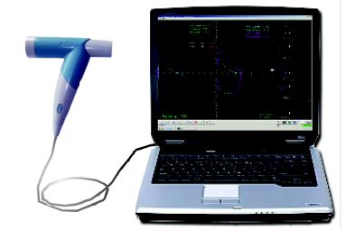
Figure 6: A modern USB-based spirometer (IQTeQ Diagnostic Spirometer)

The IQTeQ Spirometer is a diagnostic Spirometer system for the measurement, recording and assessment of the Flow/Volume and Volume/Time parameters.
In the figure 7 is presents a flow volume test with IQTeQ Spirometer. Space 1 represents Pre and Post Bronchodilator graphs superimposed; automatic best test selection (FVC+FEV1); predicted graph for easy reference and comparison. In 2nd zone are all selected tests superimposed for repeatability and quality control; ATS best test selection criteria displayed. At space 3 we have micro display of all tests for easy sequence and selection analysis; time of test displayed and database storage and retrieval. At 4 we have volume/time graphs with start and end of test criteria for easy control assessment. Zone 5 compound comprehensive computer interpretation with rationale for informed decision and assessment of validity. Space 6 is for selection of reference values and bar chart display of results with normal ranges for easy assessment [2].

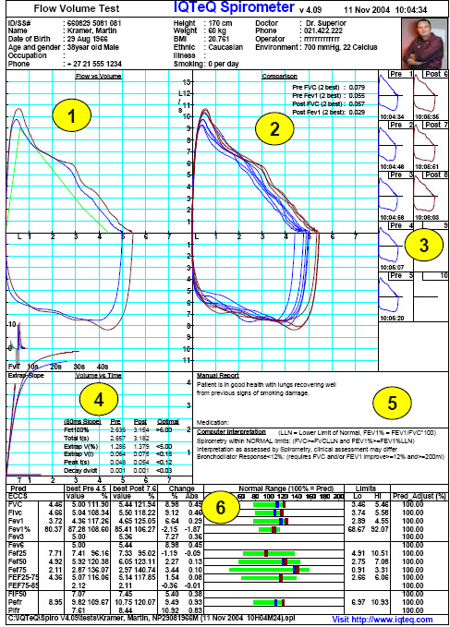
Figure 7: Flow volume test

2.4. Glucometer

A glucose meter (or glucometer) is a medical device for determining the approximate concentration of glucose in the blood. It is a key element of home blood glucose monitoring (HBGM) by people with diabetes mellitus or with proneness to hypoglycemia. A small drop of blood obtained by pricking the skin with a lancet is placed on a disposable test strip, which the meter reads and uses to calculate the blood glucose level. The meter then displays the level in mg/dl or mmol/l.
Are several key characteristic of glucose meters that may differ from model to model: size, test strips, volume of blood sample, testing times, display, clock memory.
Accuracy of glucose meters is a common topic of a clinical concern. Nearly all of the meters have similar accuracy (±10-15%) when used optimally. However, a variety of factors can affect the accuracy of a test. Factors

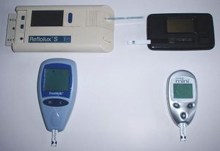
Figure 8: Glucometers

affecting accuracy of various meters have included calibration of meter, ambient temperature, and pressure use to wipe off strip, size of blood sample, and high levels of certain drugs in blood, hematocrit, dirt on meter, humidity, and aging of test strips.

3. CONCLUSION

This paper is a theoretical introduction in electromedical devices used in human behavior analyzes and it will be followed by a practical research consisting in the different analyzes with pulse oximeter, spirometer, sphygmomanometer, glucometer and other electromedical devices, on the some peoples with different types at different time of the day.

REFERENCES

[1] 2003 European Society of Hypertension-European Society of Cardiology guidelines for the management of arterial hypertension. Guidelines committee. J. Hypertens 2003;21: 1011-53.
[2] http://www.iqteq.com/index.php
[3] http://en.wikipedia.org

