The 2nd International Conference
″Computational Mechanics
and
Virtual Engineering″
COMEC 2007
11 – 13 OCTOBER 2007, Brasov, Romania

MODELING OF THE OSCILLATIONS IN THE TRACTOR
WITH ARTICULATED FRAME

Dr. eng. Florin CONSTANTIN¹
“Transilvania” University of Braşov, Romania, flconstantin@unitbv.ro

Abstract: The paper sets itself to present a dynamic model for the study of the oscillations in the body and the seat of the agricultural tractor with articulated frame. On the basis of this dynamic model with six degrees of scope, there are presented, under matrix form, the differential equations of the movements of the concentrated masses with a view to their optimization.
Key words: modeling, tractor, vibrations, mechanical system

1. INTRODUCTION

The approach through calculation of the issue relating to the behavior in time of the tractor structure under the action of dynamic stress implies settling models that should characterize as accurately as possible the real behavior of the elements in the tractor construction, without leading to excessive calculations or to calculations not feasible from the practical point of view. In the study of the tractor dynamics, a central place is occupied by the modeling of the vibrations of the tractor seat and case, with a view to describing as accurately as possible of the interdependence between the excitation and the answer of the system.

In the framework of the current analytical study of the tractor vibrations, there is necessary for the following basic steps to be gone through:
- Elaboration of the calculation model (dynamic modeling);
- Settlement of the motion equations (mathematical modeling);
- Processing the motion equations;
- Elaboration of a set of measures with a view to optimizing the answer of the dynamic pattern.

Through solving the mathematical model for stress conditions identical with those used in the framework of the tests upon the real system, there may be obtained the answer of the dynamic model, in guise of functions of answer in time or in frequency.
Comparing the answer of the real system with the answer of the model, there are evaluated the parameters of the model. This procedure of research, adjustment and improvement of the dynamic model, as a result of the analysis of the experimental results, is based on the scheme of the procedure of dynamic identification in figure1.

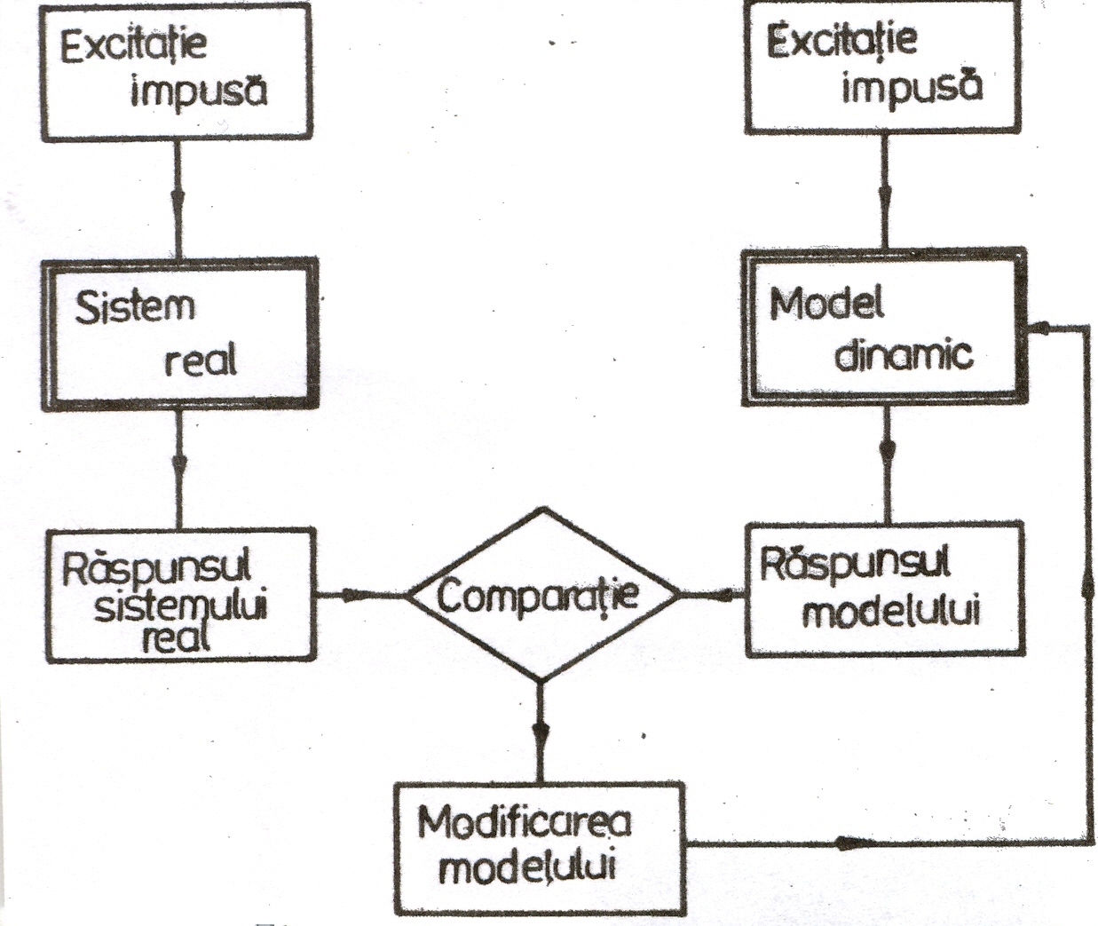

Figure 1: Scheme of the procedure of dynamic identification

2. DYNAMIC MODELING

The dynamic modeling implies the formulation of a “physical” model of calculation, whose behavior should approximate as closely as possible the one of the real system. The calculation models which are admitted to model the dynamic behavior of the tractor structure are usually deemed to be elastic mechanical systems, a fact which means they are made up of elastic elements, too. Schematically, they consist in elastic elements that accumulate kinetic energy (masses and mastic inertia moments) and in elements in which there takes place a continuous loss of energy, which means a dissipation of energy (damping).
The schematization of the tractor structure with the help of the above mentioned elements leads to the hypothesis that in the great majority of the cases, the systems behave linearly elastically, therefore the dynamic answer does not exceed the elastic limit of deformability of the materials.
As regards the tractor with articulated frame, used in agriculture and forestry works, there has been adopted the model with six degrees of scope in figure 2.

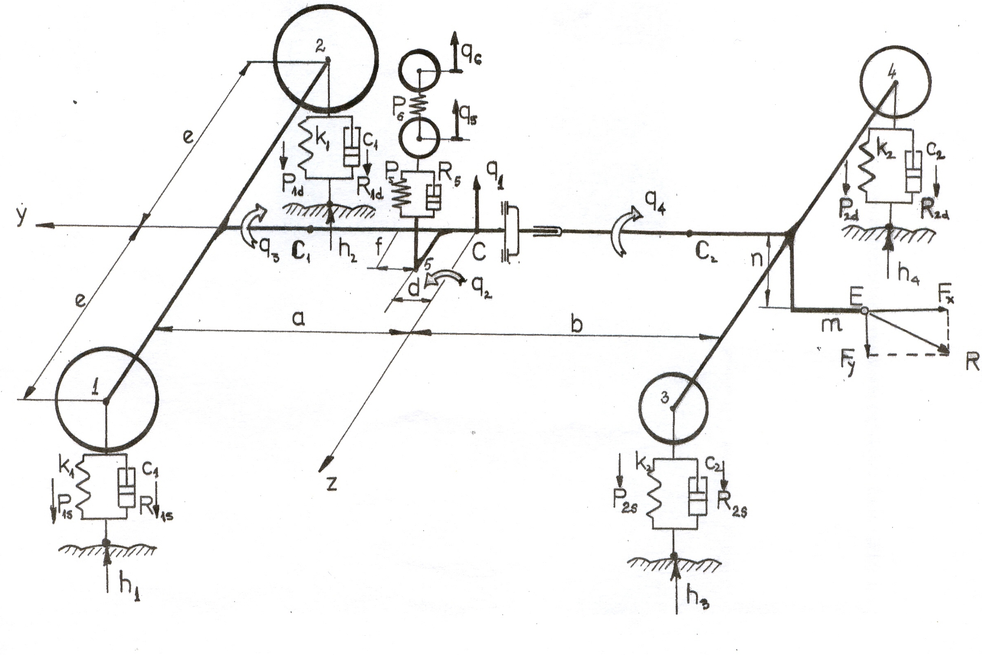

Figure 2: Dynamic model with six degrees of scope
The six degrees of scope are given concrete expression through the following generalized coordinates: q₁ – vertical motion of the tractor body; q₂ – angular pitching motion of the tractor body, round the axis C_{z}, which goes through the tractor weight centre; q₃ – angular motion of the half deck in front; q₄ – angular motion of the half deck in the rear round the axis C_{y}; q₅ – vertical motion of the tractor cabin; q₆ – vertical motion of the seat;
There has been also marked with R – the resistance force to the hook.

3. MATHEMATICAL MODELING

The mathematical modeling implies the elaboration of a mathematical model that should represent the dynamic model, which means the writing of the differential equations which describe the motions of the masses of the physical system. The differential equations which describe the oscillating movements of the masses of the physical model with six degrees of scope, written under the matrix form (1), are presented in figure 3.

$\left[M\right] \left\{{\overset{¨}{q}}_{i}\right\} + \left[c\right] \left\{{\overset{˙}{q}}_{i}\right\} + \left[k\right] \left\{q_{i}\right\} = \left[f\right]$, (1)

Where $\left[M\right]$– is the inertia matrix; $\left[C\right]$– the damping matrix; $\left[K\right]$– the elasticity matrix; $\left[f\right]$ – the column matrix of the perturbing forces; $\left\{q_{i}\right\}$ – the matrix of the vertical and angular motions; $\left\{{\overset{˙}{q}}_{i}\right\}$– the matrix of the generalized speeds; $\left\{{\overset{¨}{q}}_{i}\right\}$ – the matrix of the generalized accelerations

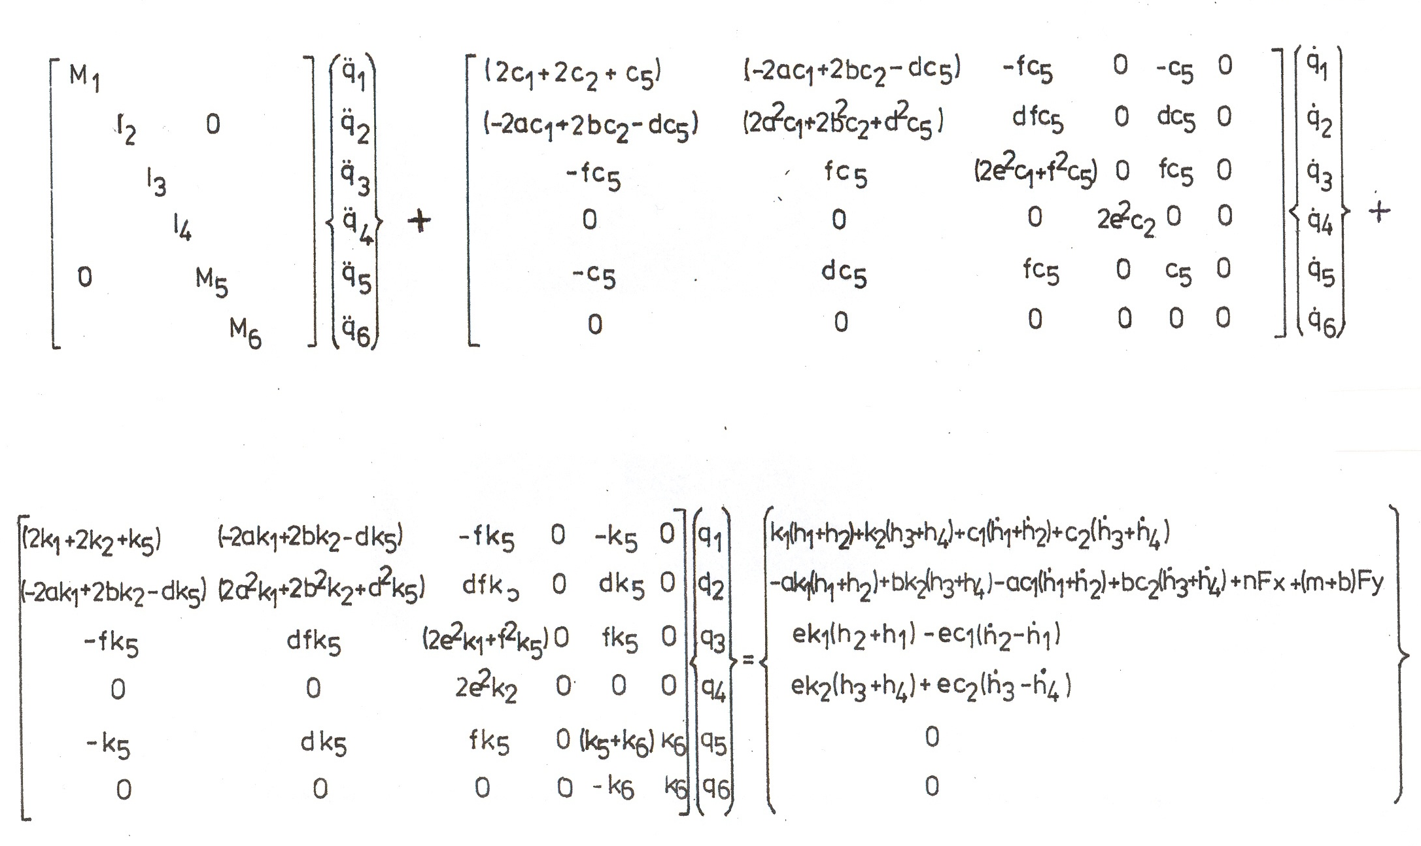
=0

Figure 3: Differential equations of the motion

REFERENCES

[1] CONSTANTIN, FL. Study, Design and Research on Tractor Seat Suspension According to Comfort criterion – Applied to Tractor with Mass Exceeding 3601 kg. Ph. D. Thesis, University of Braşov
[2] CONSTANTIN, FL. “Principiile modelării dinamice şi matematice a vibraţiilor tractoarelor”, International Conference TMCR – 2007, Chişinău, Republica Moldova
[3] CONSTANTIN, FL. Instrument for Detecting Critical Frequency, International Congress of Serbian Society of Mechanics, Kopaonic, Serbia, 2007

