The 2nd International Conference
″Computational Mechanics
and
Virtual Engineering″
COMEC 2007
11 – 13 OCTOBER 2007, Brasov, Romania

ELASTIC CONTACT MODEL (FINITE ELEMENTS)

Enescu Ioan¹, Lepădătescu Dan¹, Enescu Stefania - Daniela¹, Violeta Munteanu¹
¹ Transilvania University, Brasov, ROMANIA, e-mail: v.munteanu@unitbv.ro

Abstract: The difiiculties of elastic contact stress theory arise because the displacement at any point in the contact surface deponds upon the distribution of pressure throughout the whole contact.To find the pressure at any point in the contact of solids of given profile,therefore,requires the solution of an integral pressure.The difficulty is avoided in the solids, can be modelled by a simple Winkler elasticfoundations or “mattress” rather tghan an elastic half-space,and the modelations by finite elements.
Key words: elastic, mattress, finite element

1. ELASTIC FOUNDATION MODEL

The profile, therefore, requires the solution of an integral equation for the pressure.The difficulty is avoided if the solids can be modelled by a simple Winkler elastic foundation or ‘mattress” tather than an elastic half-space .The model is illustrated in fig.1 .The elastic foundation of depth h, rests on a rigid base and is compressed by a rigid indenter. The profile of the indenter, z(x,y), is taken as the sum of the profiles of the two bodies being modelled:

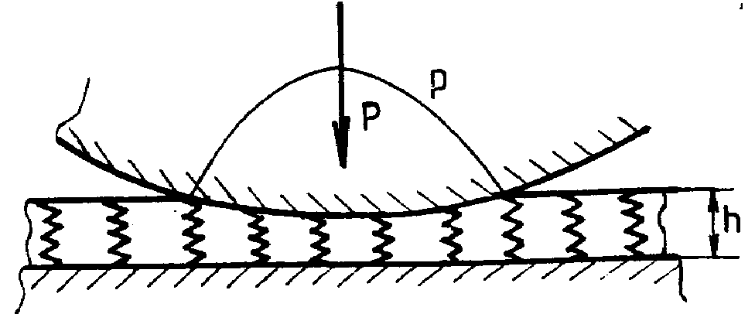

Figure 1

z(x,y)=z₁(x,y)+z₂(x,y) (1)

There The dificulty of elastic contact stress theory arise because the displecement at any point in the contact surface depends upon the distribution of pressure throughout the whole contact.To find the pressure at any point in the contact of solids of given is no interaction between the sptings of the model,shear between adjacent elements of the foundation is ignored. If the penetration at the origin is denoted by δ , then the normal elastic displacements of the foundation are given by :
δ-z (x, y ), δ>z
${\bar{u}}_{z}(x,y)=$ (2)
0 δ<z
The contact pressure at any point depends only on the displecement at that point, thus
p (x ,y)= (K/h)${\bar{u}}_{z}(x,y)$ (3)
where K is the elastic modulus of the foundation.
For two bodies of curved profile having relative radii of curvature R’ and R’’, z(x,y) we can write
${\bar{u}}_{z}=δ−({x^{2}}/2R^{'})−({y^{2}}/2R^{\text{''}})$ (4)
inside the contact area. Since ${\bar{u}}_{z}=0$ outside the contact, the boundary is an ellipse of semi-axes a = (2δR’)^{1/2} and b=(2δR’’)^{1/2}.
The contact pressure by (3) , is :
P(x,y)=(Kδ/h){1-(x²/a²)-(y²/b²)} (5)
Which is paraboloidal rather ellipsoidal as given by Hertz theory. By integration the total load is :
P=Kπabδ/2h (6)
In the axi-symetic case a=b=(2δR)^{1/2} and
$P=\frac{π}{4}(\frac{\text{Ka}}{h})\frac{a^{3}}{R}$ (7)
For the two-dimensional contact of long cylinders:
${\bar{u}}_{z}=δ−{x^{2}}/2R=(a^{2}−x^{2})/2R$ (8)
so that
p(x)=(K/2Rh)(a²-x²) (9)
and the load
$P=\frac{2}{3}(\frac{\text{Ka}}{h})\frac{a^{2}}{R}$ (10)
In the bidimensional case (cilindre) , K/h=1.8E*/a ,and in the axes-symetric case K/h=1.7E*/a where E* is:
$\frac{1}{E^{}}=\frac{1−ν_{1}^{2}}{E_{1}}+\frac{1−ν^{2}}{E_{2}}$ (11)
Equations (7) and (10) express the relationship between the load and the contact width. Comparing them with the corresponding Hertz equations, agreement can be obtained, if in the axi-symmetric case we chose K/h=1.70E*/a and in the two-dimensional case we choose K/h=1.18E*/a. For K to be material constant it is necessary to maintain geometrical similarity by increasing the depth of foundation h in proportion to the contact width a. Alternatively, thinking of h as fixed requires K to be reduced in inverse proportion to a. It is consequence of the approximate nature of the model that the value of K, required to match the Hertz equation are different for the two configurations. However, if we take K/h=1.35E*/a, the value of a under a given load will nod be in error by more than 7% for either line or point contact.
The compliance of a point contact is not so well modeled. Due to the neglect of surface displacements outside the contact, the foundation model gives $δ={a^{2}}/2R$which is half of that given by Hertz. If it were more important in a particular application to model the compliance accurately we should take K/h=0.60E*/a; the contact size a would then be too large by a factor of$\sqrt{2}$.
The foundation model is easily adapted for tangential loading also to viscoelastic solids. A one-dimensional model of the resistance of a tyre to lateral displacement is shown in fig.2.
The lateral deformation of the tyre to lateral displacement is shown in fig.3. The lateral deformation of the tyre is characterized by the lateral displacement u of its equatorial line, which is divided into the displacement of the carcass u_{c} and that of the tread u_{t} . Qwing to the internal pressure the carcass is assumed to carry a uniform tension T. This tension resists lateral deflexion in the manner of a stretched string. Lateral deflexion is also restrained by the walls, which act as a spring foundation of stiffness K per unit length. The tread is also assumed to deflect in the manner of an elastic foundation (‘wire brush’) .

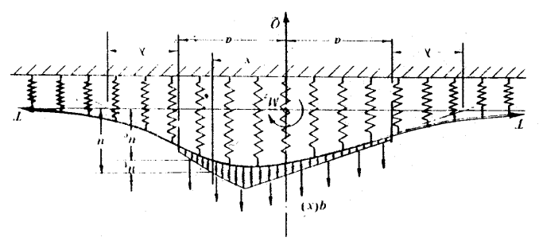

Figure 2
2.ELASTIC FOUDATION MODEL BY FINITE ELEMENT

The model is presented in fig.4, the finite elementsare plane rectangular elements. In fig.2 is presented the variationn of contact pressure between the rolle and the rule .The process is itterative and every date when a node by the possible zone of contact is make in contact,the matrix of stiffness it is modified corresponding.
For the 19-27 nodes it was introduced the stiffness (springs) of one constant size for beginning about of Ox,Oy, directions,determinated by the measure of pressure of the 19-27 nodes.
If the pressure is changed the direction and it is negative and in the anterior node, it is positive , than the limite of the contact zone it’s in those case two nodes wich interacted.
If the process is repeated from them intermediate nodes, until we find the place when the pressure is changing the sign P>0 .
In this way the x coordinate of the respective node represented the semi-breth of contact zone . If every nodes who is in contact, the stiffness matrix is different and the maximum stiffness of the elements by who we works carrying on.
The dates are:
R=150 mm, D=300 mm, b=40 mm, ν=0.3 , E=2.12*10⁵ Mpa, K=3*10⁸ Mpa – the maxim stiffness in this model case and from this case of loads the semi-breath is a=63 mm.
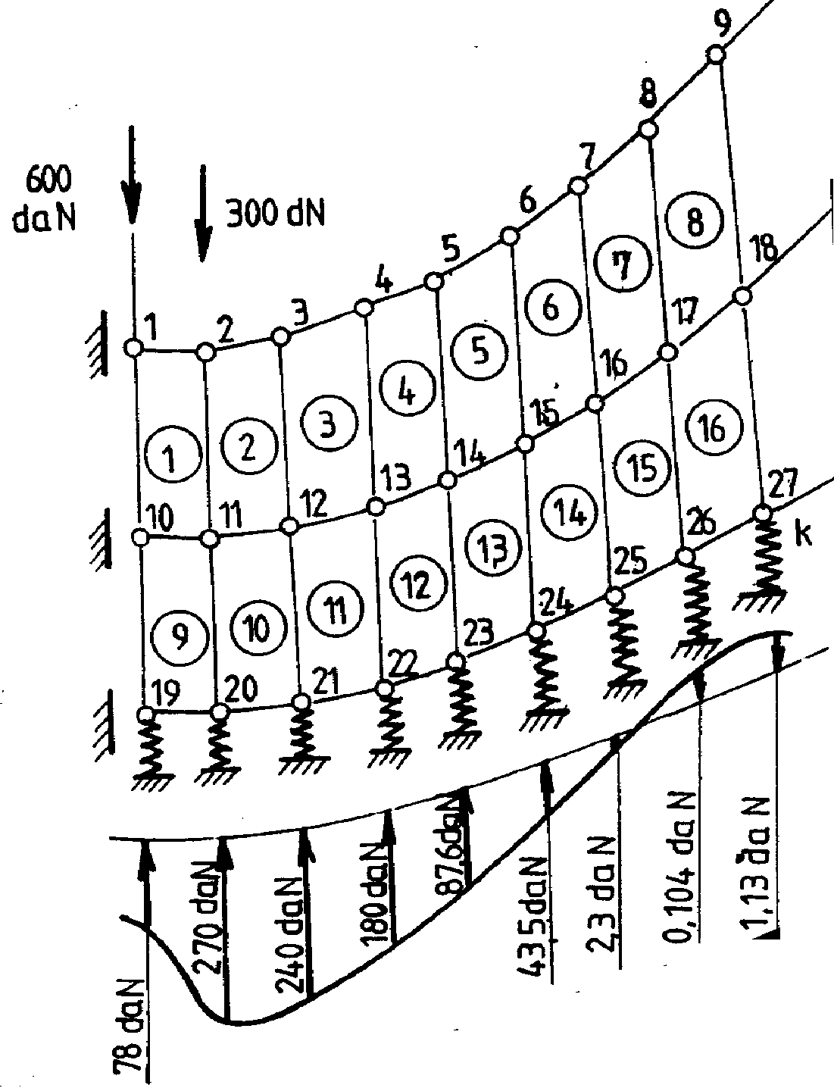

Figure 4

If the process is repeted from them intermediar nodes, until we find the place when the pressure is changing the sign P>0 .
In this way the x coordinate of the respective node represente the semi-breth of contact zone . If every nodes who is in contact, the stiffness matrix is differened and the maximmum stiffness of the elements by who we works carrying on.
The dates are:
R=150 mm, D=300 mm, b=40 mm, ν=0.3, E=2.12*10⁵ Mpa, K=3*10⁸ Mpa – the maxim stuffness in this nodel case and from this case of loads the semi-breath is a=63 mm.

REFERENCE:

[1] I. ENESCU Aspecte ale mecanicii contactului la rulmenti Editura LUX LIBRIS Brasov 2000
[2] K.L. JOHNSON Contact Mechanics CAMDRIDGE UNIVERSITY PRESS Cambridge 1985

