The 2nd International Conference
″Computational Mechanics
and
Virtual Engineering″
COMEC 2007
11 – 13 OCTOBER 2007, Brasov, Romania

OPTIMISE OF THE ASYMMETRIC GEARS DESIGN WITH THE AIM OF MINIMIZING THE CONTACT STRESS

Flavia V. CHIRA¹,
North University of Baia Mare, Baia Mare, ROMANIA, e-mail chira_flavia@yahoo.com

Abstract: The gears with involute asymmetrical teeth, named asymmetric gears, have many advantages in relation with the classical one: reducing of the bending stress, reducing of the contact stress, of the transmission error, of the relative sliding between the mating flanks and increasing the efficiency. Because the performance in function of the asymmetric gears, designed with the same initial data, are depending on the choosing of some designing variable, it is necessary to establish a method to determine the optimum variables for a specific objective. In this paper, using an optimizing program on the base of genetic algorithms, there is designed and performed the 2D model of the asymmetric gear which responds optimal to the aim of minimizing the contact stress.
Keywords: involute spur gears, asymmetrical teeth, optimal design, contact stress, genetic algorithms

1. INTRODUCTION

Designing asymmetric gears having as initial data the centre distance and the number of teeth, with the designing program developed [3] on the base of the direct design of the gear permit to obtain many possible solution [6], [7], [8], [9]. The very different performances in function of these gears are depending on the choosing of some date that the designing engineer must introduce in the first line of the program. These date called “designing variable” are: the mesh angles, different on the two asymmetric profile, the coefficient of modifying the angle of the rack profile, the number of the generation rack, the variant of using the gear, as direct or inverted gear.
It is very important to determiner which is the set of designing variable for obtain an asymmetric gear which give the better performances according with the beneficiary requests. For this reason it was necessary to realise an optimising program.
The majority of optimizing techniques, that take in consideration many parameters, impose to derive the objective function in relation with all the variables [1], [11]. In the case of the objective function that are the result of many calculus performed in different routine of the designing program, that work may be not possible.
The program that was realised and used for optimising the design of asymmetric gears has on the base the general principles of the genetic algorithms optimisation [11]. Although there are many soft that are using genetic algorithms it was necessary to ensure the compatibility between the optimising program and the designing program that is the source for the evaluation functions, so it was necessary to develop an optimising program also as application in MATLAB like the designing program that permit to obtain the geometrical and functional parameters for the asymmetric gears.

2. THE PHASES OF THE OPTIMAL DESIGN OF THE ASYMMETRIC GEARS

An objective of the research performed on the asymmetric gears it was to realise a packet of programs which offer the possibility of designing and analysing the performances in function of those gears. From these programs the optimising program takes the domain of possible solution and the significant values of some parameters that permit to evaluate the performances of every variant.
The necessary and enough conditions for using the optimising techniques that have on the base the genetic algorithms are:
- The possibility that the system that must be optimise can be describe by a set of variable;
- The quality of the system can be evaluated by one or more evaluation or objective function.
In consequence the following phases must be performed until the optimising process:
- establishing the set of variables on which are depending the performances of the system;
- determining the extreme values of the variables, determining in this way the domain of possible solutions;
- establishing the objective by choosing the function that permit the quality evaluation of the transmission.

2.1. Choosing of the designing variable

The problem that must be solved is the design, for centre distance and number of teeth that are known, of an asymmetric gear in such a way to ensure a minimum contact stress.
A individual from the domain of possible solutions it is determined by the following gene, that are variables that can be choose by the designing engineer, as initial data in the designing program developed for the asymmetric gears:
Gene 1: - the mesh angle on the direct profile “d”;
Gene 2: - the mesh angle on the inverted profile “i”;
Gene 3: - the coefficient of modification the gear rack or racks profile angle;
Gene 4: -the number of generating gear rack;
Gene 5: - the variant of using the asymmetric gear;
This set of variables generate an asymmetric gear for which can be determined the geometrical parameters and some functional parameters. On the base of those parameters one can evaluate the performances of the transmission. The vector of the decision variables is:
(1)

2.2. Establishing the extreme values of the variables and the generation of initial population

For the mesh angle on the direct profile there was used values contained in the range degrees and for the mesh angle on the inverted profile values contained in the range degrees. The coefficient “f” with values between 1 and 10 determine the values of the rack shifts [3]. The pinion and the gear can be generated with the same or different gear rack, so the variable noted with “cr” may be 1 or 2. Also the variable noted with “var”, which establish the variant of using, may be 1 for the direct gear or 2 for the inverted gear.
In the optimising program must be also established the number of individuals of the population N_ind, that will be compared, the number of generation N_gen and the number of gene (variable) N_var. There was used a number of 50 individuals for 50 generations with 5 gene.
By generation of some number “u” in the range, for i=1, 2…N_ind, k= 1, 2, N_var, one can determine the “k” gene of the “i” individual on the base of the inferior and superior values attributed to the “k” variable:
. (2)

2.3. Establish the objective function

The developed programs for designing and analysing the asymmetric gears facilitate to determine easy and in a short time, aspect that in the optimising problems it very important, of a lot of parameters that by the minimum or maximum values make possible to evaluate the performances of the transmission
In this paper there is used, as evaluation function, the maximum value of the contact stress, with the aim of minimizing this value:
. (3)
With the developed programs one can determine, for any set of variables, the diagram of variation of the contact stress, in the relation with the point of contact, during the time of a meshing cycle. An example of such diagram, having indicated the initial date used, it is presented in figure 1.
The diagrams are the result of the graphical representation of the function of variation of the contact stress in relation with the pressure angle corresponding to the contact point on the pinion active profile:
, (4)
where:
are the elasticity modules of the pinion and gear materials;
is the normal force on the tooth profile corresponding to the “j” point of contact (for direct gear, for inverted gear);
is the ratio of the number of teeth of the gear and pinion;
is the radius of the base circle of the active profile of the pinion (for direct gear, for inverted gear);
is the pressure angle corresponding to the “j” contact point on the pinion active profile.
The relation 4 permit to calculate the contact stress for any contact point of the pinion profile, implicitly of the gear, defined by the parameter , which vary in the range for direct gear and for inverted gear in the range. The notations are referring to the pressure angles corresponding to the first point of contact from the bottom of the tooth, respectively to the point of contact from the addendum circle of the pinion. Reducing the maximum values of the mentioned function of variation of the contact stress, during the time of the meshing cycle, may be the objective of one optimal design.
The comparison of the possible variants or solutions it is made on the base of the maximum value of the contact stress that can result during the function of the gear that is evaluated. From this comparison, performed with the optimize program, results from all the gears contained in the domain of solutions, the set of designing variable for which one can obtain the minimum contact stress.

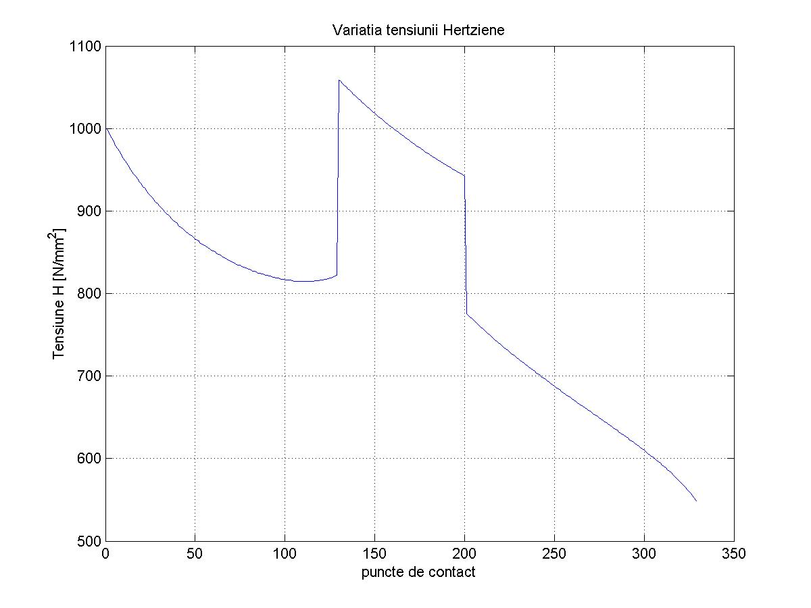
Figure 1: The variation of the contact stress for the inverted gear k<1, generated with two racks

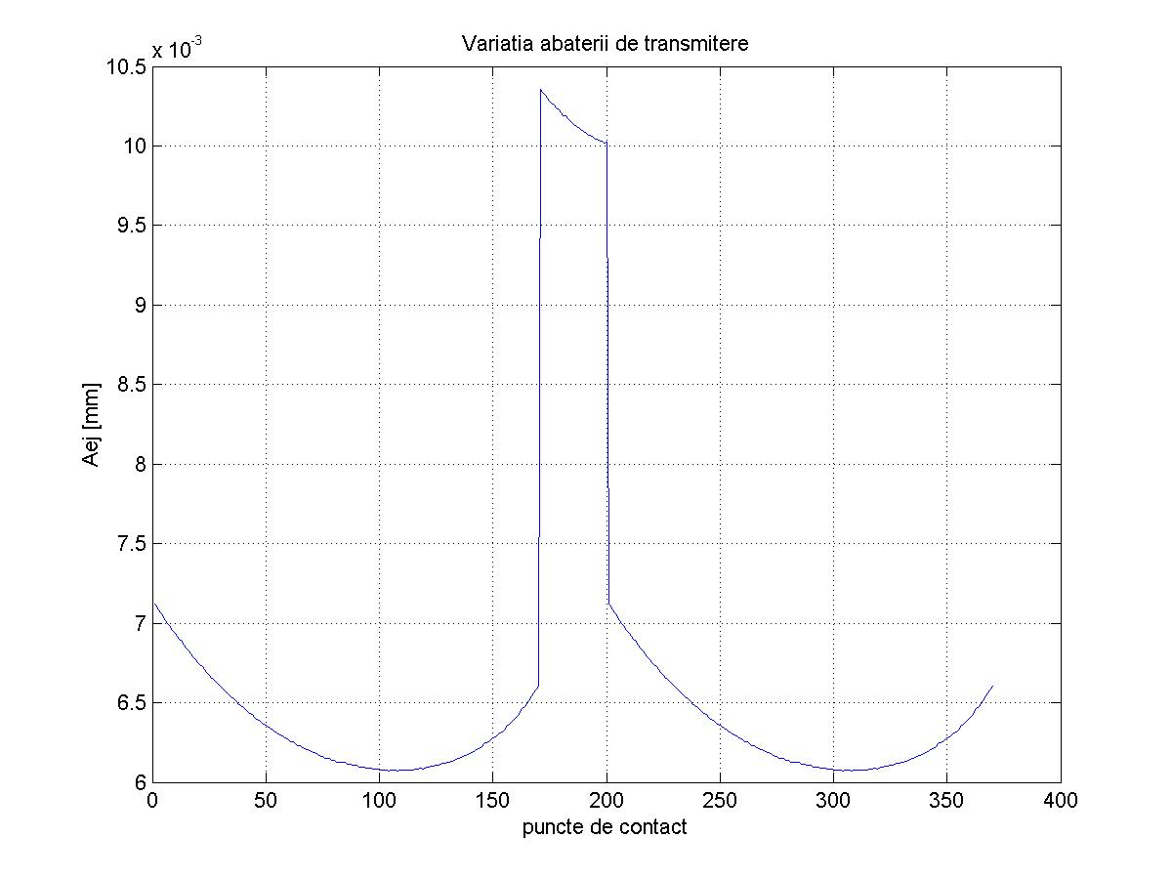
Figure 2: The variation of the transmission error during a meshing cycle. Symmetric gear with the angle of the generating rack equal to ,

In this paper is presented the method for reducing the contact stresses but the contact stress it is not the single parameter that can be determined and optimise.
The developed programs for designing and analysing the asymmetric gears facilitate to determine easy and in a short time, aspect that in the optimising problems it is very important, of a lot of parameters that by the minimum or maximum values make possible to evaluate the performances of the transmission. Some of these parameters are: the transmission error due to the elastic deformations of the teeth (figure 2 ), the bending stress from the bottom of the pinion tooth and gear tooth, the deformations of the teeth, the stiffness of the pair of teeth in contact, the normal force on the active profile of the tooth, the medium efficiency for a meshing period, the specific sliding to the pinion and to the gear (figure 3), the mass of the gear.
Anyone of the mentioned functional parameters can be used as objective function, the evaluation criterion, for a mono-objective optimisation.

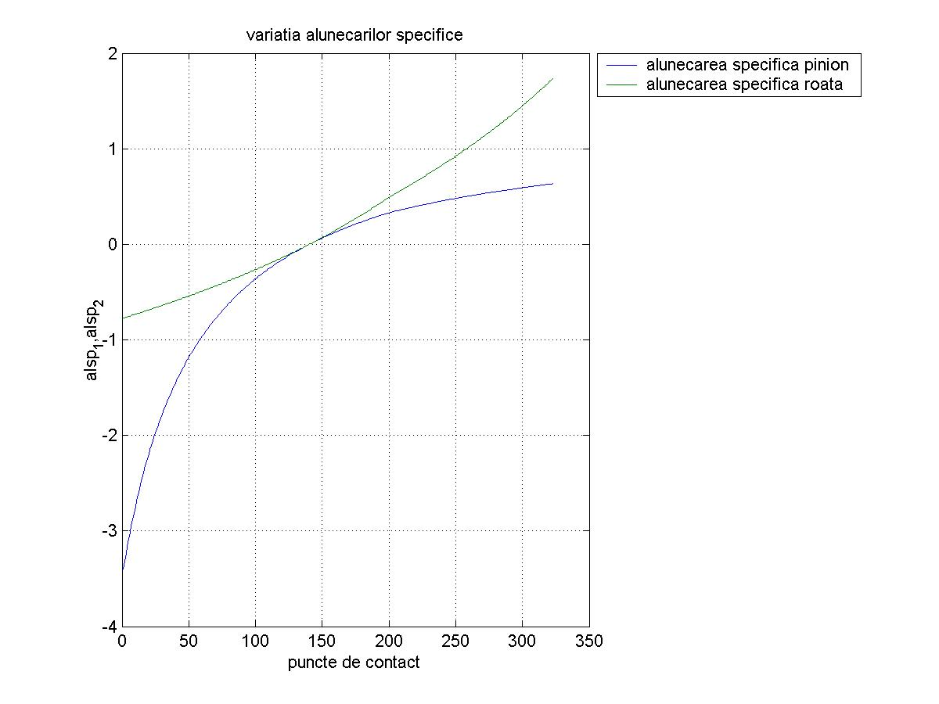
Figure 3: The variation of the specific sliding for the pinion and the gear for inverted asymmetric gear

The ideal solution should be those that permit to optimise all the evaluation function, but it is not possible because the requests of these functions are many times in contradiction. For this reason the definition of optimum for an optimising problem with multiple objectives it is very difficult.
In the case of multiple objectives the vector that must be optimising though can be transformed in a scalar by using the method of balancing the objectives. The method consists in writing the objective function as a balancing sum of many evaluation functions. It is necessary a lot of experience and many tests for discover the best distribution of the coefficients used to establish the weight of every evaluation parameter in the objective function.

3. PRESENTATION OF THE OPTIMISING RESULTS

The minimum value for the evaluation function, provided by the optimising program, is.
The set of designing variables that ensure the mentioned before value, indicated also in the first row of the table 1, is:
.
For verify the result there were determined the values of the maximum contact stress for different asymmetric and symmetric gears choose arbitrary from the domain of possible solution. Those values and the corresponding designing variables are given in the table 1.

Table 1: Values of the objective function for different arbitrary designing variables
Nr. |  |  |  | cr | var
1. | 38 | 20,0401 | 10 | 2 | 1 | 877,4975
2. | 38 | 20,0401 | 10 | 1 | 1 | 877,4975
3. | 38 | 20,0401 | 10 | 1 | 2 | 1048,9000
4. | 38 | 20 | 10 | 2 | 1 | 877,7979
5. | 38 | 20 | 10 | 1 | 1 | 877,7972
6. | 38 | 30 | 10 | 1 | 1 | 978,5200
7. | 38 | 30 | 5 | 1 | 1 | 971,8600
8. | 30 | 20 | 5 | 1 | 1 | 900,8200
9. | 30 | 30 | 5 | 1 | 1 | 1035,1000
10. | 23 | 23 | 3 | 1 | 1 | 1014,8000
11. | 20 | 20 | 0 | 1 | 1 | 1066,9000

There can be considered that the gear indicated by the optimising program satisfy in the best measure the request of the proposed objective. The value of the stress contact obtained for the optimal values of the designing variable is significant smaller in relation with the value corresponding to the symmetrical gear generated with the gear rack with the profile angle equal with 20 degrees (rows 10, 11), considered the classical one, or in relation with the symmetrical gear with great mesh angle (row 9). It can be also observed that the number of generation rack has a small influence on the contact stress. But the generation with two different racks has positive effects on the bending stress.
The diagram of variation of the contact stress, during the meshing cycle, for the gear that result by introduce in the designing program the values of the variable provided by the optimising program, is presented in figure 4.

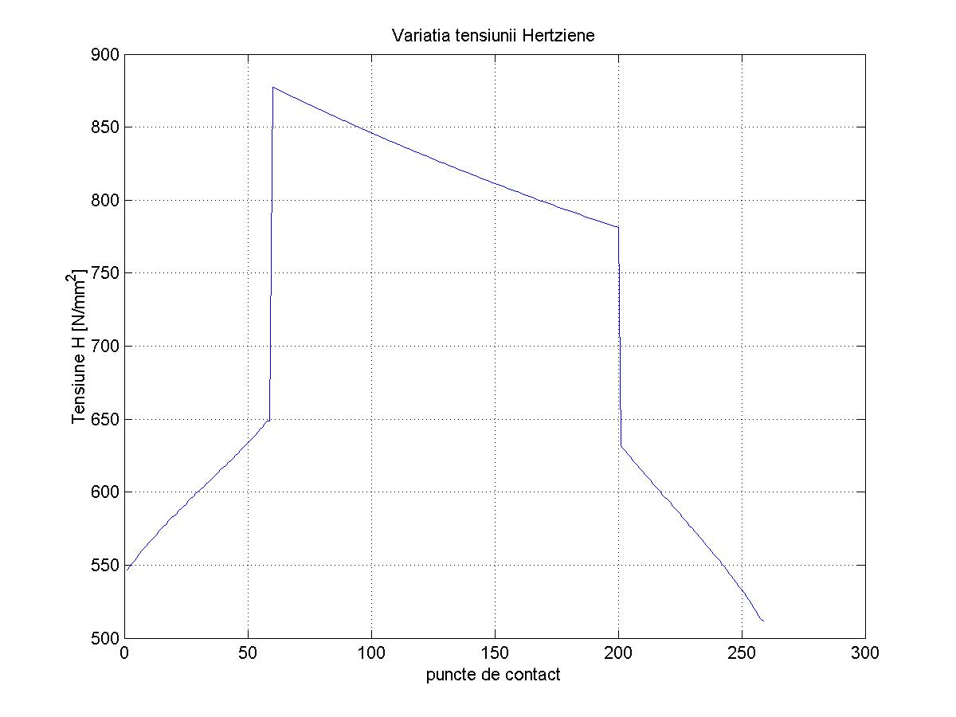
Figure 4: The variation of the contact stress for direct asymmetric gear, generated with two gear racks

4. THE 2D MODEL OF THE GEAR REPRESENTING THE OPTIMAL DESIGNING SOLUTION

On the base of parametrical equations of the involute asymmetric profiles and the equations of the filet profile it has been realised as applications in AUTOLISP for use in AUTOCAD programs [2], [10] that permit the representation of the gear if it has been calculated before the geometrical parameters that are given in the table 2. For obtain this necessary dates can be used the packet of applications in MATLAB realised also for studying asymmetric gear [3].
Figure 3 show the 2D model of the gear designed with the designing variable provided by the optimising program. The gears are represented with contact in the pitch point.
Having the 2D model and the width of the gears, it can be obtained the 3D model that contains all the dates necessary for gear cutting, by reproducing the profile of the model. The dwg. file can be transformed in iges. file. So in the soft of coordinate manufacturing machine the captured dates will be transformed in machine language. Using 3D max program can be verified by simulation the correct meshing. [4].

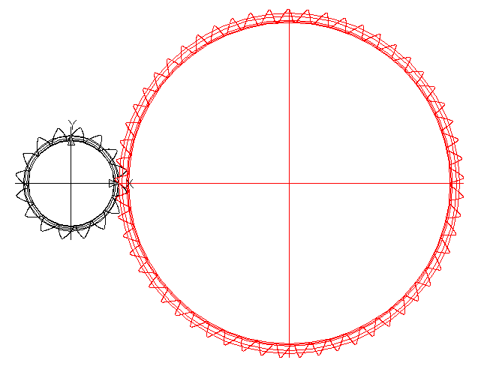 | 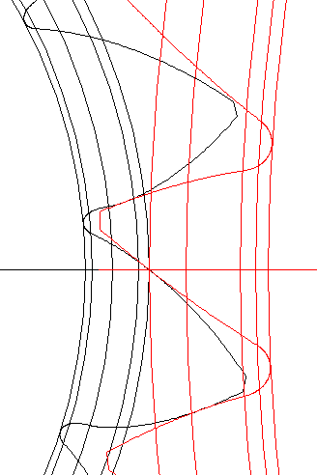
Figure 3: The 2D model of the gear that represent the optimal variant

The geometrical parameters that are necessary to introduce in the representation programs, to obtain the models of the asymmetric pinion and the gear, and must be calculated before, are given in the table 2.

Table 2: Initial data needed in the program that generate the 2D model of the gear
The center distance | mm
The numbers of teeth for the pinion and for the gear
The mesh angle on the direct profile | radians
The mesh angle on the inverted profile | radians
The profile angle on the addendum circle on the pinion tooth direct profile, | radians
The profile angle on the addendum circle on the gear tooth direct profile | radians
The direct profile angle of the asymmetric gear rack | radians
The inverted profile angle of the asymmetric gear rack | radians
The tip radius of the generation gear rack of the pinion | mm
The tip radius of the generation gear rack of the gear | mm
The rack shift for the pinion | mm

5. CONCLUSION

For the same initial data, the method of designing asymmetric gears used in this paper permit to obtain, by choosing of some designing variable, of a great number of solutions. Those possible variant are different from the point of view of geometrical parameters and also from the point of view of the performances during the function.
For obtain better performances it can be useful to study the variation of the parameter that is considered more important in relation with one or two of the variables. But if the aim is the optimal design, taking in consideration the influence of all designing variable on the variation of one or many functional parameters, it is necessary to use an optimising program.
The optimisation method that use genetic algorithms have the advantage that can research in the same time many possible variants, use probabilistic methods for the transition from a generation to the next and can be used for complex objective function, that can result from other programs. It is important to know that the realised optimisation program can be used to solve many other problems for optimal design of different products. The only necessary condition is to have the evaluation function provided by a program in the same language. The optimisation program it is more efficient when the objective function is the result of the combination of many evaluation functions.
This paper is an example, between many others, of the advantages that the computational method of design can offer. That is more evident in the case of non standard products like asymmetric gear. The aim of designing those special gears is to obtain the better performances. The method presented offer the possibility to obtain these superior performances without supplementary costs having provided by the developed programs all the dates necessary for manufacturing.

REFERENCES

[1] Bănică, M., Dynamical Optimization of Spurs Gearing Using Genetics Algorithms, Magyar Tudomanyos Akademia, MTA AMB XXXI. Kutatasi Es Fejlesztesi Tanacskozas Eloadasainak es Konzultacios Temainak Osszefoglaloi, January 2007, Godollo, Hungary, ISBN 978-963-611-442-8, paper 122.
[2] Chira, F., Mathematical Modelling of the Tooth with Asymmetrical Involute Profiles, Kutatási és Fejlesztési Tanácskozás, Nr.30, Magyar Tudományos Akadémia, 30th Conference on R&D in Agricultural Engineering, Gödöllö, Hungary, 24 January, 2006.
[3] Chira, F., - Contributions to the study of the asymmetric gears, Ph. D thesis, North University of Baia Mare, 2006.
[4] Dăscălescu, A., Chira, F., Drăgan, L., Compatibilities of the CAD-CAM Programs Applied to the Cycloid Profile Wheels Processing, Scientific buletin, Serie C, volume XX, Fascicle: Mechanics, Tribology, Machine Manufacturing Technology, The International Conference of the Carpathian Euro-Region Specialists In Industrial Sistems, 6th Edition, May 19-20, 2006.
[5] Ghinea, M., Fireţeanu, V., MATLAB Calcul numeric. Grafica. Aplicaţii., Teora, Bucureşti, 2004.
[6] Ghionea, A., Anania, D., Ghionea, I., Utilization of some computer assisted techniques in generating and study of the hypocicloidal flanks of the spur gear teeth stress, The International Meeting of the Carpathian Region Specialists in the Gears, North University of Baia Mare, may 21-22, 2004.
[7] Kapelevich, A.,L., Geometry and design of involute spur gears with asymmetric teeth, Mechanism and Machine Theory, 35, 2000.
[8] Kapelevich, A.,L., Kleiss, R.E., Direct Gear Design for Spur and Helical Involute Gears, Gear Technology, september/october, 2002.
[9] Litvin F., L., Lian , Q., Kapelevich A., L., Asymmetric Modified Gear Drives: Reduction of Noise, Localization of Contact, Simulation of Meshing And Stress Analysis, Computer Metodhs in Applied Mechanics and Engineering, 188, 2000.
[10] Tisan, V., Grafical representation of gears using the AutoLISP language, Procedings of the MicroCAD 97, Miscolc, Egyetemvaros, february, 27-26, 1997.
[11] Tudose, L., Pop, D., Proiectare Optimală cu Algoritmi Genetici, Editura Mediamira, Cluj-Napoca, 2002.

