The 2nd International Conference
″Computational Mechanics
and
Virtual Engineering″
COMEC 2007
11 – 23 OCTOBER 2007, Brasov, Romania

STUDY WITH MATHCAD IN THE DYNAMICS
OF THE SPATIAL VIBRATING MILL

Prof. Dr. Mariana B. ARGHIR
Technical University of Cluj-Napoca, Romania, e-mail: marianaarghir@yahoo.com, Mariana.Arghir@mep.utcluj.ro

Abstract: Formulation and analysis of nonlinear dynamics problems encountered in various practical engineering problems has attracted considerable attention in recent years. The types of systems are most common in vibration and control engineering. Obtaining the sintered compound out of metallic powders represents a major technological problem, powder milling being here of first importance. The mill is formed by: the tank of the mill – the proper working space, the driving system, and the elastic supporting system. The made analysis we realized that the Euler’s angles time variation is a special one and unusual regarding the spatial vibrations. The computational study is realized with MATHCAD programmes.
Keyword): spatial vibrating mill, dynamics study, differential equations system, numerical integration by MATHCAD

1. INTRODUCTION
Formulation and analysis of nonlinear dynamics problems encountered in various practical engineering problems has attracted considerable attention in recent years. The types of systems are most common in vibration and control engineering. Several related works have been reported in [1].

2. THEORETICAL CONSIDERETIONS

Obtaining the sintered compounds out of metallic powders represents a major technological problem, powder milling being here of first importance. Generally, the milling consumes very much energy: cracking the material particles by crushing, breaking and splitting them, asks for a considerable consumption of energy, as only a small part ( 15 %) is used in the proper milling process. In order to obtain energy consumption as small as possible, the working space - the tank of the mill - must have a form mostly adequate to the theoretical trajectories followed by the material particles (balls, pre-milled powders) during milling.
Figure 1: Vibrating Mill: 1-Spring; 2-Mill Tank;
3-Milling Space; 4-Cylinder; 5-Motor; 6-Eccentric Masses; 7-Rigid Support.
When designing a vibrating mill [1], [3], with the inferior part of the tank in the form of a half - tore, the motion of the particle [7], is not broken by collisions and frictions against the wall and the bottom of the tank. On the contrary, when the energy of a particle gets lower, this is supplemented by the tank motion. During the stationary working conditions the load is presumed to be uniformly distributed inside the tore (the superior half - tore is not materialized, it will describe by the particles inside the tank during the milling process).

2.1. Mechanical Model

For a vibrating mill with spatial motions used for milling the metallic powders the mechanical model may be considered as a solid rigid having geometrical and mechanical symmetry with respect to the axis Cz (Fig.2) of an M_{t} mass in a general motion, supported by an even number of springs, n, having the longitudinal elasticity constant, k, and the transversal one, k_{t} [3], [4]. The mechanical model presented in the figure number 2 is reported at the two reference frames:
In the 2 figure the notations are: x_{1C}, y_{1C}, z_{1C}, ψ, φ, θ – the general coordinates of the tank of the mill – the six freedom degrees in the space; M_{t} – the total mass, that presumes is concentrated in the mass centre of the mill; F₀ – the magnitude of the active forces, that act upon the symmetry axis of the vibrating mill; F_{e} – the instantaneous elastic forces, that is the action of the only one spring upon the tank of the mill.

2.2. The Differential Equations Describing the Spatial Motion of the Tank of the Mill

In order to determine the scalar differential equations describing the spatial motion of the tank of the mill, the fundamental theorems of the dynamics are used: the impulse theorem (transformed into the theorem of motion of the centre of the masses) and the theorem of the kinetic moment with respect to the centre of the masses, C, of the rigid.
The system of the active forces that transmits a spatial vibrating motion to the tank is formed: - the weight of the mechanical system; - the rotative forces of inertia , due to the two eccentric masses.
During the motion of the mill tank, an elastic force opposing the motion appears in each spring. The initial position of mass centre, due to the axial deformation of the supporting springs under the action of the weight of the mill, is noted z_{1CG} . In the initial moment, the two origins of the reference systems, O₁x₁y₁z₁, and Cxyz, they do not coincide. The initial position of mass centre is C_{o}, and it has the coordinates: x_{1C0} , y_{1C0} , z_{1C0}.
Figure 2: Mechanical Scheme of the Vibrating Mill
with Spatial Motions.
It is noticeable that the elastic forces in the springs due to the translation of the tank are equal and parallel all along the translation motion in the same time with mass centre. Thus the central axis corresponding to this system of forces intersects permanently the symmetry axis Cz and the axial moment is related to the axis of symmetry.
There are forces in the springs opposing the spherical motion of the tank, due to its rotation around the mass centre, with the angles ψ , φ , θ .
If the system contains "n" springs (n being an even number ), the groups of two antipodal springs, have equal, parallel, and opposite deformations. (Fig. 2). The elastically forces due to the rotation of the tank of the mill round the mass centre, C, arising in a group of two antipodal springs make a torque having the moment perpendicular on the plane of the forces.
The successively transformations, in detail, for the system, that characterises the dynamics of the tank of the mill, they are realised in the papers [ 2 ], [ 3 ], [ 4 ] and the result is the system (1). The obtained system of differential equations (a very refined and complex one) is non-linear, non-homogeneous and transcendent.
The numerical integration of differential equation system is possible only with the real values of variables. I designed, and I built an experimental mill, for the laboratory experience.
Using the real mill for integration of the differential equations of the system (1), the notations, the constants, and the initial values of variables are:
n = 24 - the springs number;
k = 26785.7 - the longitudinal constant of elasticity;
k_{t} = 1735.77 - the transversal constant of elasticity;
ω₁ = 150.796 - the angular speed;
g = 9.81 - the gravitational acceleration;
M_{t} = 70. - the total mass;
J₁ =.683487 - the mechanical moment of inertia regarding the symmetry axis;
J₂= .51168 - the mechanical moment of inertia regarding the perpendicular axis in mass centre upon the symmetry axis;
m_{O}= 1.2 - the rotating mass, that produces the magnitude of active force;
r = .03 - the radius of rotating mass;
z_{1CG} = .02122 - the constructive position of mass centre;
d = .16 - the distance between the plans of active forces;
D = .412 - the diameter of springs circle;
α = 1.570796 - the angle between the directions of active forces;
δ = 0. - the initial angle position;
x_{1C0} = 0., y_{1C0} = 0., z_{1C0} = 0. - the initial values of mass centre coordinate;
ψ₀ = 0. ,φ₀ = 0. ,θ₀ = 0. - the initial values of Euler's angles.
$\begin{aligned}{\overset{¨}{x}}_{\text{1C}}\text{ = }\frac{2F_{0}}{M_{t}} \text{cos}\frac{α}{2}[\text{cos}(ω_{1}\text{t + }\frac{α}{2}\text{ + }ϕ)\text{cos}ψ− \text{sin}(ω_{1}\text{t + }\frac{α}{2}\text{ + }ϕ)\text{sin}ψ\text{cos}θ]− \\ − \frac{nk_{t}}{M_{t}}(x_{\text{1C}}− x_{\text{1C0}}) \\ {\overset{¨}{y}}_{\text{1C}}\text{ = }\frac{2F_{0}}{M_{t}} \text{cos}\frac{α}{2}[\text{cos}(ω_{1}\text{t + }\frac{α}{2}\text{ + }ϕ)\text{sin}ψ\text{ +} \text{sin}(ω_{1}\text{t + }\frac{α}{2}\text{ + }ϕ)\text{cos}ψ\text{cos}θ]− \\ −\frac{{\text{nk}}_{t}}{M_{t}}(y_{\text{1C}}− y_{\text{1C0}}) \\ {\overset{¨}{z}}_{\text{1C}}\text{ = }\frac{2F_{0}}{M_{t}} \text{cos}\frac{α}{2}\text{sin}(ω_{1}\text{t + }\frac{α}{2}\text{ + }ϕ)\text{sin}θ −\text{ g + }\frac{\text{nk}}{M_{t}}(z_{\text{1CG}}{−z}_{\text{1C}}\text{ + }z_{\text{1C0}}) \\ \overset{¨}{ψ}\text{ = }[(J_{2} −\text{ 2}J_{1})\overset{˙}{θ} \overset{˙}{ψ}\text{cos}θ\text{ + }J_{2}\overset{˙}{θ}\overset{˙}{ψ}\text{ + }F_{0}\text{d }\text{sin}\frac{α}{2} \text{sin}(ω_{1}\text{t + }\frac{α}{2}\text{ + }ϕ)\text{ +} \\ \text{+ k }\frac{D^{2}}{4}\text{sin}θ \underset{\text{i=0}}{\overset{\frac{n}{2} −\text{ 1}}{\sum{}}} \text{sin} \left(\text{i }\frac{4π}{n}\text{ + 2}ϕ\text{ 2}δ\right)]\text{ / }J_{1}\text{sin}θ\overset{¨}{ϕ}\text{ = \{}\overset{˙}{ψ}\end{aligned}\overset{˙}{θ}\text{sin}θ\text{ + }[(2J_{1}− J_{2})\overset{˙}{θ}\overset{˙}{ψ}{\text{cos}}^{2}θ − J_{2}\overset{˙}{θ}\overset{˙}{ϕ}\text{cos}θ−−F_{0}\text{d }\text{sin}\frac{α}{2} \text{sin}(ω_{1}\text{t + }\frac{α}{2}\text{ + }ϕ)\text{cos}θ−\text{ k }\frac{D^{2}}{8} \text{sin}\text{ 2 }θ\underset{\text{i=1}}{\overset{\frac{n}{2}−\text{ 1}}{\sum{}}} \text{sin} \left(\text{i }\frac{4π}{n}\text{ + 2}ϕ−\text{ 2}δ\right)] /{J_{1}}\text{sin}θ\overset{¨}{θ}\text{ = }\left\{(J_{1}−J_{2}){\overset{˙}{ψ}}^{2}\text{sin}θ\text{cos}θ − J_{2}\overset{˙}{ψ}\overset{˙}{ϕ}\text{sin}θ\text{ + }F_{0}\text{d }\text{sin}\frac{α}{2}\text{cos}(ω_{1}\text{t + }\frac{α}{2}\text{ + }ϕ)\text{ +}\right.\text{+ k }\frac{D^{2}}{4}\text{sin}θ$The differential equation system for the vibrating mill, in spatial motion, is:

(1)

3. THE INTEGRATION OF DIFFERENTIAL EQUATIONS SYSTEM USING MATHLAB PROGRAM

The system of differential equations was transformed for the MATHCAD integration having the Runge-Kutta Gill method of the fours order.
The vibrating mill considered as rigid body in spatial motion has six independent coordinates. The mass centre generalized coordinates govern the tank of the mill translational motion. They have the graphical representation in the figure 3, where the corresponding graphics are: S_{n,2} = x_{1C} (the blue colour), S_{n,4} = y_{1C} (the red colour), and S_{n,6} = z_{1C} (the brown colour). The first integration was realized for 1 second. The independent coordinate (the time) is noted with the S_{n,1} and it is on horizontal direction made. The motion is stable, and the milling process does not disturb the constructed mill.
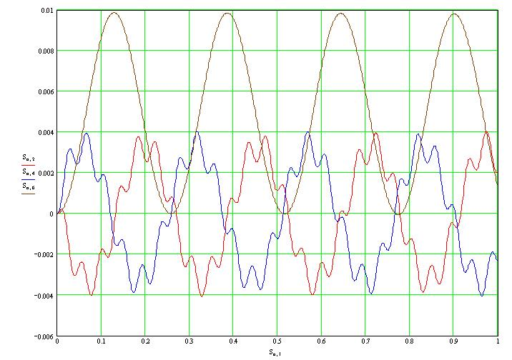
Figure 3: The mass Centre Generalized Coordinates. The notations are: S_{n,1} = t (time); S_{n,2} = x_{1C} (the blue colour), S_{n,4} = y_{1C} (the red colour), and S_{n,6} = z_{1C} (the brown colour).

The next three generalized coordinates (the Euler angles) are represented in the figure 4. For them the MATHCAD notations are: S_{n,1} is the time independent variable. The Euler angles are noted with: S_{n,8} = ψ (the blue colour), S_{n,10} = φ (the red colour) and finally S_{n,12} = θ (the brown colour).

3. CONCLUSION

Looking at the figures 3 and 4 (realized with MATHCAD program ) can be write the following conclusions:

1) The results are the same values for the coordinates x_{1C} , y_{1C} , z_{1C} , θ.

a) The coordinate x_{1C} , and the coordinate y_{1C} , they have the harmonic variations in time with the period of aproximativelly 0,25 sec. A higher harmonic, with a pulsation 5 times greater, is superposed over the fundamental.

b) The variable z_{1C} , it presents a harmonic variation in time with a period about 0.1 sec.

c) The variable θ presents a pseudo harmonic variation in time with a pseudo period of 0.028 sec, comparable as value with a period of the free oscillation and the result of study estimated in [ 3 ].

2) The variables ψ and φ aproximativelly mirror each other.

3) In the present paper the curves of time variations of the six generalized coordinates were drown for α = 90º with the ACSL program, and the representations correspond with the draws realized in [ 3 ].

4) The spatial vibratory motion of the vibrating mill [3] was used in [5] for milling the copper and aluminium powders. That demonstrated the utility of the dynamical study.

5) In time, for the milling process in the mill with spatial motion the author made many study, and the system of the differential equations was integrated having different computational program:

- in 1991 I made my owner program in FORTRAN using the Runge-Kutta-Gill method for the fourth order with variable step;
- in 1995 I made the integration by SAMCEF;
- in 1996 I realized the integration using A.C.S.L.
- in 2003, and 2007 I made the integration using the MATHCAN program.

The results are the same, that means my first proposal and the real constructed mill is a good one and the milling process using this vibrating mill with spatial vibrations are the most economical mill that works in the world for milling the metallic powders. It is 30 time most economical as the any another vibrating mill [3].

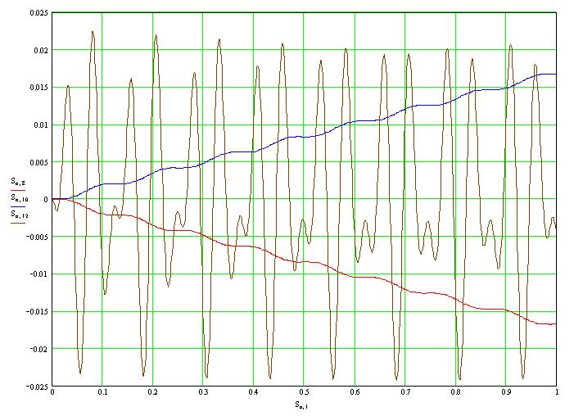
Figure 4: The Euler’s Angles Representation for the Vibrating Mill with Spatial Motions. The Notations Are: S_{n,1} is the independent variable, that means the time; S_{n,8} = ψ (the blue colour), S_{n,10} = φ (the red colour) and finally S_{n,12} = θ (the brown colour).

REFERENCES

[1]. Mariana ARGHIR, A. RIPIANU, E. ABRUDAN, Contributions in the Study of Vibro Milling in Mills with Spatial Motion, P. 153-162, The Scientific Bulletin of the Polytechnic Institute of Cluj-Napoca, 1990, Romania.
[2]. Mariana ARGHIR, The Scalar Differential Equations of the Vibrating Mill in Spatial Movement, Proceeding of "Society of Rheology 62nd Annual Meeting" & "Society of Engineering Science 27th Annual Meeting", 21 - 25 Oct., 1990, Santa Fe, New Mexico, USA.
[3]. Mariana ARGHIR, Contributions to the Dynamic Study of the Vibrating Mills with Spatial Motions for Milling the Metallic Powders ( Rom. Title: = Contribuii la studiul dinamic al morilor vibrante ce execut vibraii spaiale destinate operaiei de mcinare a pulberilor metalice ), Doctoral Dissertation, 213 page., The Polytechnic Institute of Cluj-Napoca, Sept., 1991, Romania.
[4]. Mariana ARGHIR, A. RIPIANU, M. NOORI (from USA, Worcester Polytechnic Institute, MA), Nonlinear Dynamic Analysis of Vibro - Milling Process in Mill with Spatial Motion - I: Formulation of Nonlinear Equations of Motion, Computers & Structures, Vol. 43, Nr. 4, pp. 761 - 767, 1992, England.
[5]. Mariana ARGHIR, G. ARGHIR, E. ABRUDAN, Experimental Results of Milling Copper and Aluminium Powders in a Vibrating Mill with Spatial Motion, Proceedings, "First Australasian Congress on Applied Mechanics", p. 845 - 849, 21-23 February 1996, Melbourne, Australia.
[6]. Mariana ARGHIR, Contributions to the Dynamic Study of the Vibrating Spatial Mills, Proceedings of GAMM Jahrestagung, 27 May - 1 June, 1996, Prag, Check Rep.
[7]. Mariana ARGHIR, A.C.S.L. in the Elastic System Study of the Vibrating Mill with Spatial Motions for Milling the Metallic Powders, Acta Technica Napocensis, ISSN 1221 - 5872, nr. 39, vol I, pag. 45-54, Universitatea Tehnică, 1996, Cluj-Napoca, Romania.
[8]. Mariana ARGHIR, Geamilia ŞOLEA, The Elastic System Stability of the Spatial Vibrating Mill of the Spatial Vibrating Mill for the Milling the Metallic Powders, GAMM International Conference 2001, ETH Zürich, February 12-15, 2001, Switzerland.
[9]. Mariana ARGHIR, Simona RODEAN, Study of the Human Body Vibrations for the Seated Vehicle Driver, Proceedings of the GAMM International Conference, Book of Abstracts Annual Meeting 2006, pages. 89-90, Berlin, 27- 31 March, 2006, Germany.
[10]. Mariana ARGHIR, Parallel Structure for the Powder Milling Process, 2006 IEEE-TTTC International Conference on Automation, Quality and Testing, Robotics, AQTR 2006 (THETA 15), Poster Section, pages 56 – 61, ISBN (10) 973-713-114-2, ISBN (13) 978-973-713-114-0, May 25 – 28 2006, Cluj-Napoca, Romania.
[11]. Hilborn R. C., Chaos and Nonlinear Dynamics. An Introduction for Scientists and Engineers, Oxford University Press, 654 p., 1994, England.
[12]. *** SAMCEF, System of the Advanced Material and Computational with E.F.
[13]. *** Advanced Continuous Simulation Language (ACSL), User's Manual, Mitchell and Gauthier Associates Inc., MA,USA.
[14]. *** MathCAD, User’s Manual, version 11. 2003; 2007

