The 2nd International Conference
″Computational Mechanics
and
Virtual Engineering″
COMEC 2007
11 – 13 OCTOBER 2007, Brasov, Romania

MODELING OF THE FINISHING PROCESS

Enescu Ioan¹, Buzatu Constantin¹, Lepădătescu Dan¹, Violeta Munteanu¹, Enescu Stefania - Daniela¹
¹ Transilvania University, Brasov, ROMANIA, e-mail: v.munteanu@unitbv.ro

Abstract: We come answer to the main question : how are the elastic contact stress and deformation between curved surface in contact , inflence by surface roughness ?
Many processes involve the passage of a strip or sheet of material through the nip between rollers. In this paper we consider the strip to be perfectly elastic and investigate the stress in the strip, the length of the arc of contact with the roller, the maximum indentation of the strip and the precise speed at which it feeds through the nip in relation to the surface speed of the rollers. If the strip is wide and the rollers are long in the axial direction it is reasonable to assume plane deformation
Key words: contact, elastic, friction

1. ELASTIC CONTACT OF ROUGH CURVED SURFACE

The qualitative behaviour is clear fr4om what has been said alrealy. There are two scales of size in the problem: (1) the bulk (nominal) contact dimensions and elastic compresion which would be calculated by the Hertz theory for the „smoth” mean profiles of the two surface and (2) the height ands spatial distribution of the asperities.For the situation to be anable to quantitative analisys these two0 scales of size should be very different . In other words, there should be very different. At any point in the nominal contact area the nominal pressure increases with overall load and the real contact area incrases in proposition, the average real contact remain constant.
The asperities act like a compliant layer on the surface of the body, so that contact is extended over a larger over a larger area than it would be if the surface were smooth , and in consequence , the contact pressure for a given load will be reduced. We shall consider the axi-symmetric case which can be simplified to the contact of the smooth sphere of radius R with a nominally flat rough surface having a standard distribution a summit heights $σ_{s}$, where R and $σ_{s}$
are related to the radii and roughness of the two surfaces : $\frac{1}{R}=\frac{1}{R_{1}}+\frac{1}{R_{2}}$ and $σ_{s}^{2}=σ_{s1}^{2}+σ_{s2}^{2}$.
In figure 1 a datum is taken at the mean leved of the rough surface . The profile of the undeformed sfere relative to the datum is given by
$y=y_{0}−\frac{r^{2}}{2R}$ (1)
At any radius the combined normal displacement of both surfaces is made up of a bulk displacement $w_{b}$ and an asperity displacement $w_{a}$. The „separation” d beween the two surface contains only the bulk deformation :
$d(r)=w_{b}(r)−y(r)=−y_{0}+(\frac{r^{2}}{2R})+w_{b}(r)$ (2)
The asperity displacement $w_{a}=z_{s}−d$, where $z_{s}$is the height of the asperity summit above the datum .

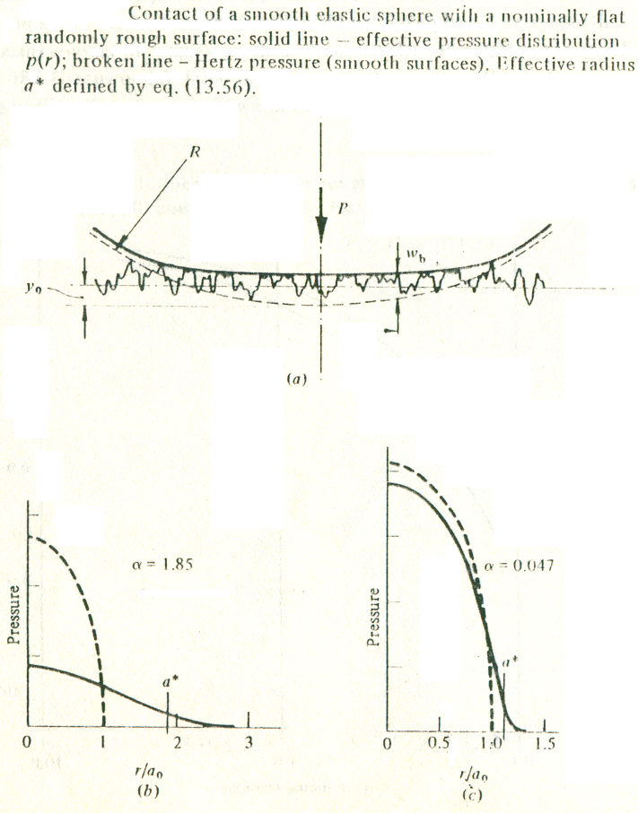

Figure 1

2. AN ELASTIC STRIP BETWEEN ROLLERS

The stresses in an elastic strip due to symmetrical bands of pressure acting on opposite faces have been expressed by Sneddon (1951) in terms of Fourier integral transforms. The form of these integrals is particularly awkward and most problems require elaborate numerical computations for their solution. However, when the thickness of the strip 2b is much less than the
Arc of contact 2a an elementary treatment is sometimes possible. The situation is complicated further by friction between the strip and the rollers. We can analyse the problem assuming (a) no friction ($μ=0$) and (b) complete adhesion ($μ→∞$), but our experience of rolling contact conditions leads us to expect that the arc of contact will, in fact, comprise zones of both “stick” and “slip”.
We will look first at a strip whose elastic modulus is of similar magnitude to that of rollers, and write
$C=\frac{(1−ν_{1}^{2})/{E_{1}}}{(1−ν_{2}^{2})/{E_{2}}}=\frac{1+α}{1−α}$ (3)
where α is defined by the equation (2), and 1,2 refers to the strip and the rollers respectively.
$α=\frac{\left[(1−ν_{1})/{G_{1}}\right]−\left[(1−ν_{2})/{G_{2}}\right]}{\left[(1−ν_{1})/{G_{1}}\right]+\left[(1−ν_{2})/{G_{2}}\right]}$ (4)
If the strip is thick ($(b≥a)$it will deformi like an elastic half-space.
At the other extreme, when $b≤a$, the deformation is shown in fig.1
The compression of the roller is now much greater than that of the strip so that the pressure distribution again approximates to the Hertz
$p(x)=\frac{2P}{πa}(1−{x^{2}}/{a^{2}})^{1/2}$ (5)
The strip is assumed to deforms with plane sections remaining plane so that the compression at the centre of the strip is given by
$d=\frac{b(1−ν_{1}^{2})p(0)}{E_{1}}=\frac{2b(1−ν_{1}^{2})P}{π{\text{aE}}_{1}}$ (6)

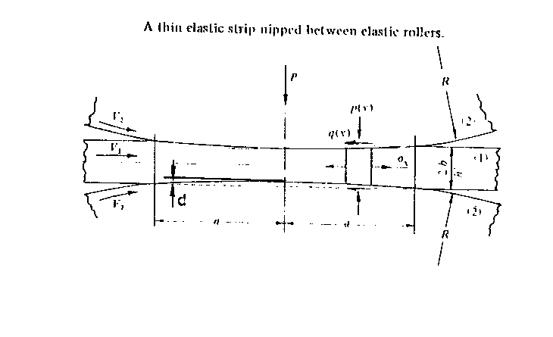

Figure 2

If the deformed surfaces of the strip are more approximated by circular of radius R’, then
$\frac{1}{R'}=\frac{2d}{a^{2}}=\frac{4b(1−ν_{1}^{2})P}{{πa}^{2}E_{1}}$ (7)
The rollers are flattered from a radius R to R’ so that
$a^{2}={\frac{4P(1−ν_{2}^{2})}{{πE}_{2}}}/(\frac{1}{R}−\frac{1}{R'})$ (8)
Eliminating R’ from (4) and (5) gives
$(\frac{a}{a_{o}})^{2}=1+C\frac{b}{a}$ (9)
where $a_{o}=(4\text{PR}(1−ν_{2}^{2})/{E_{2}})^{\frac{1}{2}}$ is the semi-contact width for vanishingly thin slip.
With frictionleas rollers the longitudinal stress in the strip $σ_{x}$ is either zero or equal to any external tension in the strip. Doe to the reduction in thickness, the strip extends longitudinally, whilst the roller surface compresses to the Hertz theory, so that in fact frictional tractions q(x) arise (acting inwards on the strip) whether or not materials of the strip and rollers are the same. For equilibrium of an element of the strip.
$\frac{{dσ}_{x}}{\text{dx}}=\frac{1}{b}q(x)$ (10)
Slip between the rollers and the strip is governed by the equation (9)
${{\overset{\text{.}}{s}}_{x}}/V=ξ_{x}−{ψy}/c+(\frac{∂u_{x1}}{∂x}−\frac{∂u_{x2}}{∂x})$
(11)

${{\overset{\text{.}}{s}}_{y}}/V=ξ_{y}−{ψx}/c+(\frac{∂u_{y1}}{∂x}−\frac{∂u_{y2}}{∂x})$
where ${\overset{\text{.}}{ξ}}_{x}≡({δV}_{x1}−{δV}_{x2})/V$ and $\overset{\text{.}}{ξ}≡({δV}_{y1}−{δV}_{y2})/V$ are the creep rations γ is the non-dimensional spin parameter $(ω_{x1}−ω_{x2})\text{cV}$ and $c=(\text{ab})^{\frac{1}{2}}$.
In a stick region
$\overset{\text{.}}{x_{x}}={\overset{\text{.}}{x}}_{y}=0$ (12)

In additional, the resultant tangential traction must not exceed its limiting value:
$\left|q(x,y)\right|$ (13)
and the direction of q must oppose the velocity :
$\frac{q(x,y)}{\left|q(x,y)\right|}=\frac{\overset{\text{.}}{s(x,y)}}{\left|\overset{\text{.}}{s(x,y)}\right|}$ (14)
If there is no slip equation (9) reduces to :
$\frac{∂u_{x1}}{∂x}−\frac{∂u_{x2}}{∂x}=−ξ$ (15)
where $ξ$ is the creep ratio $(V_{1}−V_{2})/{V_{2}}$ of the strip relative to the periphery of the rollers. The longitudinal strain in a roller within the contact arc is given by equation.
$\frac{∂u_{x1}}{∂x}=\frac{1−ν_{1}^{2}}{E_{1}}\left(σ_{x}+\frac{ν_{1}}{1−ν_{1}}p(x)\right)$ (16)
The integral equation (8) is satisfied by the traction :
$q(x)=(1−\frac{4β}{1+α})\frac{b}{2a}p_{o}\frac{x}{(a^{2}−x^{2})^{\frac{1}{2}}}$ (17)
where β is defined by the equation:
$β=\frac{1}{2}\left[\frac{(1−2ν_{1})/{G_{1}}−(1−2ν_{2})/{G_{2}}}{(1−ν_{1})/{G_{1}}+(1−ν_{2})/{G_{2}}}\right]$ (18)
The result of a complete numerical analysis of this problems for a range b/a is show in fig.2. The contact pressure is close to a Hertzian distribution for all values of b/a. The frictional traction is zero at the extremes of both thick and thin slips, it reaches a maximum when b/a0.25.
Althrough q(x) falls to zero at x=$±$a in the absence of slip the ratio q(x)/p(x) reaches high value. This implies some micro-slip is likely at the edges of the contact.

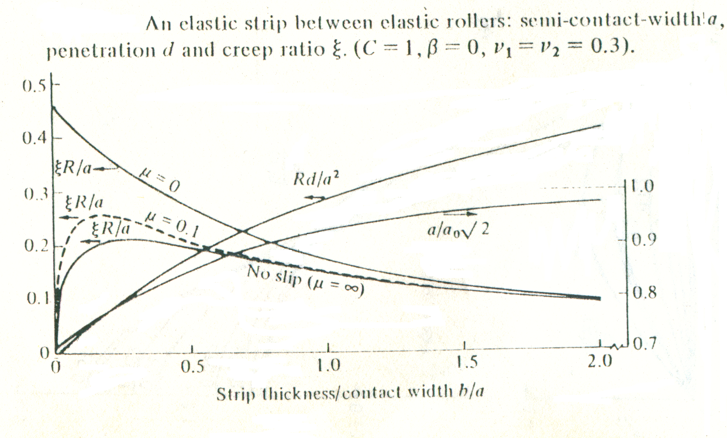

Figure 3
When the strip is more than the rollers (β>0) the friction traction acts outwards on thick strips and inwards on thin ones, so that the patterns of slip depends upon the strip thickness, but is similar to that shown in fig.3 if the strip is thin.

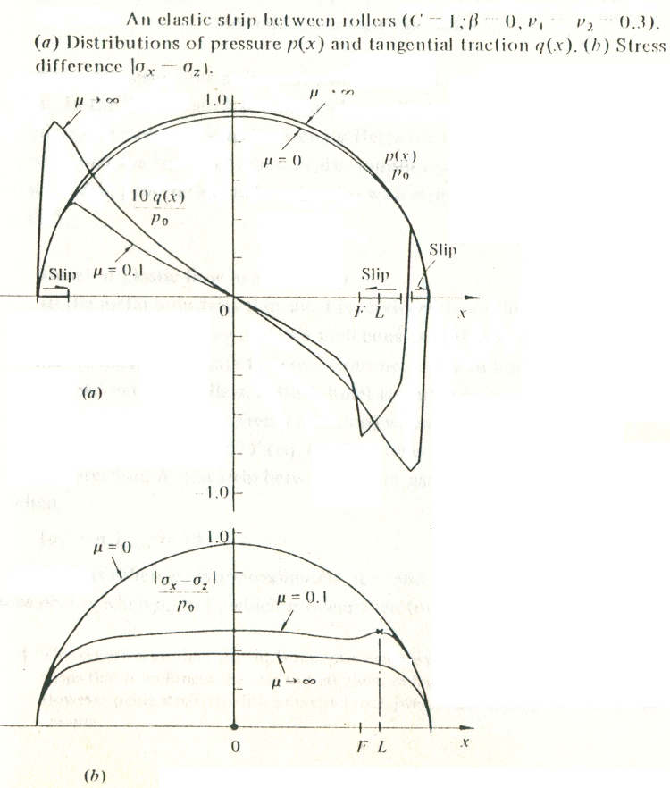
Figure 4

REFERENCES

[1] K.L. JOHNSON ,Contact mechanics Cambridge University Press 1985
[2] D. PAVE4LESCU, M.MUSAT, A. TUDOR Tribologie Editura Didactica si Pedagogica Bucuresti 1977
[3] G. DR4AGHICI, Tehnologia Constructiilor de Masini , Editura Didactica si Pedagogica Bucuresti 1977

