The 2nd International Conference
″Computational Mechanics
and
Virtual Engineering″
COMEC 2007
11 – 13 OCTOBER 2007, Brasov, Romania

KINEMATIC MODELLING BY MBS METHOD APPLIED TO LINKAGES USED TO RUDDER AND ELEVATOR AIRCRAFT CONTROL

Marius GHITESCU¹
¹Department of Product Design and Robotics
TRANSILVANIA University of Brasov Bv. Eroilor 29, Brasov Romania Email: motanmotan34@yahoo.com

Abstract: The aim of the paper is kinematic modelling of linkages used in airplane control, on bases of the Multibody System method (MBS). In virtual prototyping of the aircraft , these linkages have to be modeled by a minimum number of bodies (MBS min). In the paper an appropiate algorithm is descriebed and also applied for concrete mechanical systems. This will be the bases for dynamic modelling of these subsystems as parts of the whole product
Keywords: mechanical systems, multibody systems, structural modeling, kinematic analysis, aircraft, Flaps

1. INTRODUCTION

Generally control surfaces of an aircraft include : ailerons , rudder , elevator and flaps [12].
(see figure1). Movement of this surfaces generate roll, pitch and yaw.
In design process of an aircraft one of the main step is virtual prototyping.
In virtual prototyping of the aircraft, mechanical systems are considered as Multibody Systems (MBS). They have to be modelled as MBS with minimum number of bodies (MBS min) to favorise obtaining real time simulation of aircraft.
The aim of this paper is kinematic modelling of linkages used for actioning of rudder and elevator as multibody systems. On bases of MBS, dynamic models could be obtained.
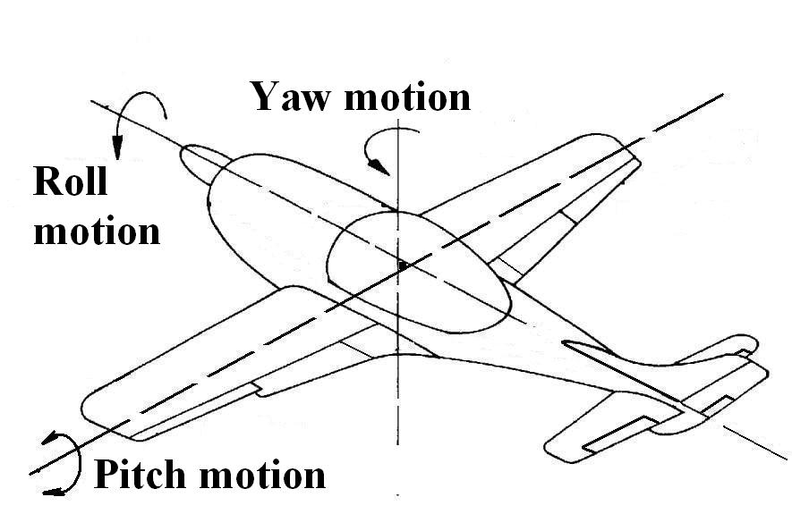
Aileron
Flaps
Elevator
Rudder
Figure 1 Aircraft control

2. KINEMATIC ANALYSIS OF CONCRETE LINKAGES

In this paper , two linkage used for rudder and elevator control are analized.
The bases of this linkage is aircraft structure , that represent for the linkage – fixed body. The output bodies are the rudder and elevator.The input motion is generated by pilot from control lever by intermediate of mechanical / hydraulic actuators.
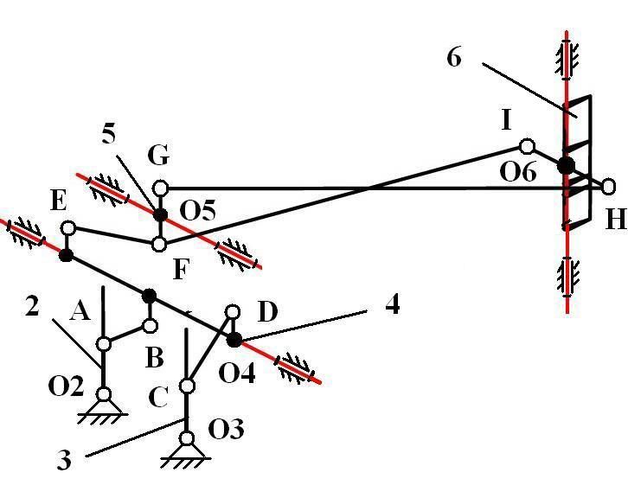
Figure 2 Rudder control

Table 1: Rudder control (see fig 2)
Body i  Body j | gc | Location | Number of  M = S (n_{b} - 1) – Σ r  Σ r = 29  n_{b} = 6 si S = 6  M = 1  constraints
1-2 | R | O2 | 5
1-3 | R | O3 | 5
1-4 | R | O4 | 5
1-5 | R | O5 | 5
1-6 | R | O6 | 5
2-3 | - | - | -
2-4 | SS | AB | 1
2-5 | - | - | -
2-6 | - | - | -
3-4 | SS | CD | 1
3-5 | - | - | -
3-6 | - | - | -
4-5 | SS | EF | 1
4-6 | - | - | -
5-6 | SS | GH | 1

Between bodies “2” and “4” we have geometrical constraint AB type SS (see fig 2):
$${\left(X_{A}−X_{B}\right)}^{2}+{\left(Y_{A}−Y_{B}\right)}^{2}+{\left(Z_{A}−Z_{B}\right)}^{2}={\text{AB}}^{2}$$
$\begin{aligned}\left[X_{A} | \right]\left[Y_{A} | \right] \\ \end{aligned}$ and $\begin{aligned}\left[X_{B} | \right]\left[Y_{B} | \right] \\ \end{aligned}$
(1)
Generally rotation matrix is:
$$M_{i}=\begin{aligned}\left[\text{cos}(X_{i},X)\text{cos}(Y_{i},X)\text{cos}(Z_{i},X) | \right]\left[\text{cos}(X_{i},Y) \text{cos}(Y_{i},Y) \text{cos}(Z_{i},Y) | \right] \\ \end{aligned}$$

For body “2”
$M_{\text{21}}$=$M_{\text{31}}$= $M_{β}$= $M_{\text{41}}$ and $M_{β}=\begin{aligned}\left[\text{cos}β 0 \text{sin}β | \right]\left[0 1 0 | \right] \\ \end{aligned}$

Between bodies “3” and “4” we have geometrical constraint CD type SS (see fig 2):
(2)
$${\left(X_{C}−X_{D}\right)}^{2}+{\left(Y_{C}−Y_{D}\right)}^{2}+{\left(Z_{C}−Z_{D}\right)}^{2}={\text{CD}}^{2}$$
$\begin{aligned}\left[X_{C} | \right]\left[Y_{C} | \right] \\ \end{aligned}$ and $\begin{aligned}\left[X_{D} | \right]\left[Y_{D} | \right] \\ \end{aligned}$

Between bodies “4” and “5” we have geometrical constraint EF type SS (see fig 2):

$${\left(X_{E}−X_{F}\right)}^{2}+{\left(Y_{E}−Y_{F}\right)}^{2}+{\left(Z_{E}−Z_{F}\right)}^{2}={\text{EF}}^{2}$$
$\begin{aligned}\left[X_{E} | \right]\left[Y_{E} | \right] \\ \end{aligned}$ and $\begin{aligned}\left[X_{F} | \right]\left[Y_{F} | \right] \\ \end{aligned}$
(3)
Where
$M_{\text{41}}$= $M_{β}$= $M_{\text{51}}$ and $M_{β}=\begin{aligned}\left[\text{cos}β 0 \text{sin}β | \right]\left[0 1 0 | \right] \\ \end{aligned}$
Between bodies “5” and “6” we have geometrical constraint GH type SS (see fig 2):

$${\left(X_{G}−X_{H}\right)}^{2}+{\left(Y_{G}−Y_{H}\right)}^{2}+{\left(Z_{G}−Z_{H}\right)}^{2}={\text{GH}}^{2}$$
$\begin{aligned}\left[X_{G} | \right]\left[Y_{G} | \right] \\ \end{aligned}$ and $\begin{aligned}\left[X_{H} | \right]\left[Y_{H} | \right] \\ \end{aligned}$
Velocity represente derivate vs.(versus) time (see fig 2):
(4)
$\begin{aligned}\left[{\overset{˙}{X}}_{A} | \right]\left[{\overset{˙}{Y}}_{A} | \right] \\ \end{aligned}$ and $\begin{aligned}\left[{\overset{˙}{X}}_{B} | \right]\left[{\overset{˙}{Y}}_{B} | \right] \\ \end{aligned}$
$\begin{aligned}\left[{\overset{˙}{X}}_{C} | \right]\left[{\overset{˙}{Y}}_{C} | \right] \\ \end{aligned}$ and $\begin{aligned}\left[{\overset{˙}{X}}_{D} | \right]\left[{\overset{˙}{Y}}_{D} | \right] \\ \end{aligned}$

$\begin{aligned}\left[{\overset{˙}{X}}_{E} | \right]\left[{\overset{˙}{Y}}_{E} | \right] \\ \end{aligned}$ and $\begin{aligned}\left[{\overset{˙}{X}}_{F} | \right]\left[{\overset{˙}{Y}}_{F} | \right] \\ \end{aligned}$
(5)
$\begin{aligned}\left[{\overset{˙}{X}}_{G} | \right]\left[{\overset{˙}{Y}}_{G} | \right] \\ \end{aligned}$ and $\begin{aligned}\left[{\overset{˙}{X}}_{H} | \right]\left[{\overset{˙}{Y}}_{H} | \right] \\ \end{aligned}$

Acceleration represente 2 – th order derivate vs. time (see fig.2):

$\begin{aligned}\left[{\overset{¨}{X}}_{A} | \right]\left[{\overset{¨}{Y}}_{A} | \right] \\ \end{aligned}$ and $\begin{aligned}\left[{\overset{¨}{X}}_{B} | \right]\left[{\overset{¨}{Y}}_{B} | \right] \\ \end{aligned}$
$\begin{aligned}\left[{\overset{¨}{X}}_{C} | \right]\left[{\overset{¨}{Y}}_{C} | \right] \\ \end{aligned}$ and $\begin{aligned}\left[{\overset{¨}{X}}_{D} | \right]\left[{\overset{¨}{Y}}_{D} | \right] \\ \end{aligned}$
(6)
$\begin{aligned}\left[{\overset{¨}{X}}_{E} | \right]\left[{\overset{¨}{Y}}_{E} | \right] \\ \end{aligned}$ and $\begin{aligned}\left[{\overset{¨}{X}}_{F} | \right]\left[{\overset{¨}{Y}}_{F} | \right] \\ \end{aligned}$
$\begin{aligned}\left[{\overset{¨}{X}}_{G} | \right]\left[{\overset{¨}{Y}}_{G} | \right] \\ \end{aligned}$ and $\begin{aligned}\left[{\overset{¨}{X}}_{H} | \right]\left[{\overset{¨}{Y}}_{H} | \right] \\ \end{aligned}$

Table 2: Elevator control (see fig 3)
Body i  Body j | gc | Location | Number of  M = S (n_{b} - 1) – Σ r  Σ r = 23  n_{b} = 5 si S = 6  M = 1  constraints
1-2 | R | O2 | 5
1-3 | R | O3 | 5
1-4 | R | O4 | 5
1-5 | R | O5 | 5
2-3 | SS | AB | 1
2-4 | - | - | -
2-5 | - | - | -
3-4 | SS | BD | 1
3-5 | - | - | -
4-5 | SS | EF | 1

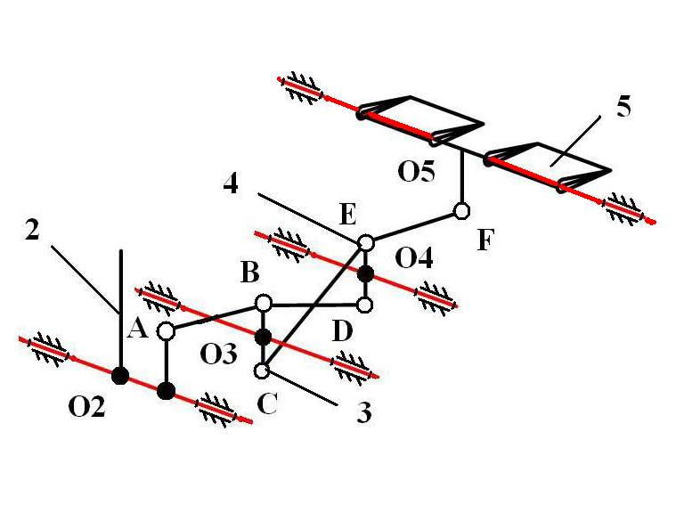
Figure 3 Elevator control

Between bodies “2” and “3” we have geometrical constraint AB type SS (see fig 3):
$\begin{aligned}\left[X_{A} | \right]\left[Y_{A} | \right] \\ \end{aligned}$ and $\begin{aligned}\left[X_{B} | \right]\left[Y_{B} | \right] \\ \end{aligned}$
Between bodies “3” and “4” we have geometrical constraint BD type SS (see fig 3):
(7)
$${\left(X_{B}−X_{D}\right)}^{2}+{\left(Y_{B}−Y_{D}\right)}^{2}+{\left(Z_{B}−Z_{D}\right)}^{2}={\text{BD}}^{2}$$
$\begin{aligned}\left[X_{B} | \right]\left[Y_{B} | \right] \\ \end{aligned}$ and $\begin{aligned}\left[X_{D} | \right]\left[Y_{D} | \right] \\ \end{aligned}$
Where:
$M_{\text{21}}$=$M_{\text{31}}$= $M_{β}$= $M_{\text{41}}$=$M_{\text{51}}$ and $M_{β}=\begin{aligned}\left[\text{cos}β 0 \text{sin}β | \right]\left[0 1 0 | \right] \\ \end{aligned}$
Between bodies “4” and “5” we have geometrical constraint EF type SS (see fig 3):
$${\left(X_{E}−X_{F}\right)}^{2}+{\left(Y_{E}−Y_{F}\right)}^{2}+{\left(Z_{E}−Z_{F}\right)}^{2}={\text{EF}}^{2}$$
$\begin{aligned}\left[X_{E} | \right]\left[Y_{E} | \right] \\ \end{aligned}$ and $\begin{aligned}\left[X_{F} | \right]\left[Y_{F} | \right] \\ \end{aligned}$
Velocity represente derivate vs.(versus) time (see fig 3):
$\begin{aligned}\left[{\overset{˙}{X}}_{A} | \right]\left[{\overset{˙}{Y}}_{A} | \right] \\ \end{aligned}$ and $\begin{aligned}\left[{\overset{˙}{X}}_{B} | \right]\left[{\overset{˙}{Y}}_{B} | \right] \\ \end{aligned}$
(8)
$\begin{aligned}\left[{\overset{˙}{X}}_{B} | \right]\left[{\overset{˙}{Y}}_{B} | \right] \\ \end{aligned}$ and $\begin{aligned}\left[{\overset{˙}{X}}_{D} | \right]\left[{\overset{˙}{Y}}_{D} | \right] \\ \end{aligned}$
$\begin{aligned}\left[{\overset{˙}{X}}_{E} | \right]\left[{\overset{˙}{Y}}_{E} | \right] \\ \end{aligned}$ and $\begin{aligned}\left[{\overset{˙}{X}}_{F} | \right]\left[{\overset{˙}{Y}}_{F} | \right] \\ \end{aligned}$
Acceleration represente 2 – th order derivate vs. time (see fig.3):
$\begin{aligned}\left[{\overset{¨}{X}}_{A} | \right]\left[{\overset{¨}{Y}}_{A} | \right] \\ \end{aligned}$ and $\begin{aligned}\left[{\overset{¨}{X}}_{B} | \right]\left[{\overset{¨}{Y}}_{B} | \right] \\ \end{aligned}$
(9)
$\begin{aligned}\left[{\overset{¨}{X}}_{B} | \right]\left[{\overset{¨}{Y}}_{B} | \right] \\ \end{aligned}$ and $\begin{aligned}\left[{\overset{¨}{X}}_{D} | \right]\left[{\overset{¨}{Y}}_{D} | \right] \\ \end{aligned}$
$\begin{aligned}\left[{\overset{¨}{X}}_{E} | \right]\left[{\overset{¨}{Y}}_{E} | \right] \\ \end{aligned}$ and $\begin{aligned}\left[{\overset{¨}{X}}_{F} | \right]\left[{\overset{¨}{Y}}_{F} | \right] \\ \end{aligned}$

5. REFERENCES

[1] Catalin,Alexandru.,Simularea pe calculator a sistemelor mecanice articulate, Ed.LuxLibris, Brasov2000.
[2] Catalin,Alexandru.,Dinamica sistemelor mecanice pe baza prototiparii virtuale cu aplicare la mecanismele suspensiei vehiculelor,Ed.Universitatii Transilvania din Brasov 2003
[3] Deladi , S. , Deladi , L . , Voicu , C. – Indrumar de laborator – Instalatii de comanda si
conducere a aeronavelor Universitatea Transilvania din Brasov 2001
[4] Deladi , S. , Deladi , L . , Deliu , Gh. – Mecanica aeronavelor Indrumar de proiect –
Universitatea Transilvania din Brasov 2001
[5] Grosu Ion.,Calculul si constructia avionului,Editura Didactica si Pedagogica Bucuresti 1965.
[6] Haug, J.E., Computer Aided Kinematics and Dynamics of Mechanical Systems , Allyn and Bacon,U.S.A., 1989
[7] Shabana, A., Dynamics Of Multibody Systems, A Wiley Interscience Publication, 1989
[8] Visa,I., Alexandru,P., Alexandru,C.,Talaba,D., Proiectarea functionala a mecanismelor ,Metode clasice si moderne, Editura Lux Libris ,Brasov 2004
[9] Visa,I., Antonya,Cs.,Structural synthesis of planar linkages as multibody systems, Proceedings of the Eighth IFToMM International Symposium on Theory of Machines and Mechanisms Bucharest, Romania Syrom,2001
[10] Visa,I.,Mechanical Systems Modeling as Multibody Systems in Product Design, Brasov,Romania,PRASIC 2002
[11] W.T.Rouse., Combination Aileron and Wing Flap, U.S.Patent Nr.1999528/1934
[12] Lawrence,Y,Lam., Michael,Lam.,Aileron For Fixed Wing Aircraft, In: United States Patent US6554229B1,2003

