 | The 2nd International Conference  ″Computational Mechanics  and  Virtual Engineering″  COMEC 2007  11 – 13 OCTOBER 2007, Brasov, Romania

EXPERIMENTAL ASPECTS ABOUT DYNAMICS OF THE ANKLE – SHANK ANATOMICAL SYSTEM DURING NORMAL CYCLE GAIT

C. RADU¹, I.C. ROŞCA¹
¹ Transylvania University, Brasov, ROMANIA, ciprian1_radu@yahoo.com
¹ Transylvania University, Brasov, ROMANIA, ilcrosca@unitbv.ro

Abstract: This paper presents some theoretical and experimental considerations about biomechanics of the ankle – shank anatomical system during normal cycle gait by determining the internal forces (reactions forces in the knee joint) and net muscular momentum in dynamics conditions using inverse dynamics method. To solve the unknowns we used some anatomical and anthropometrical data of a human subject with a body weight of 58.7 kg.
Keywords: foot, inverse dynamics, net muscular momentum, reaction forces, shank.

1. DETERMINATION OF KNEE JOINT INTERNAL REACTION FORCES

Inverse dynamic method is used to compute the internal reaction forces and associated moments (joint torques) that lead to that movement, under a special set of assumptions [1]. These assumptions are written in the scientific paper: “Theoretical aspects about biomechanics of the lower limb during cycle gait” which is published in the same proceeding conference. To solve the unknowns (knee joint reaction forces) we used some anatomical and anthropometrical data of a human subject with a body weight of 58.7 kg (table 1). We assume that the ankle – shank system is a straight beam, with a dimension AD = 0.44 m, which remain constant during limb movement. In this case, the directions and the module of the reaction forces and moment, which act in the ankle joint, are the same to the forces and moment in case of ankle – foot system. Only the senses of the reaction forces and moment are different [2][3].

Table 1: Cinematic and anthropometrical data of a human subject with a body weight of 58.7 kg during stance phases
Phase | M [kg] | m_{g}  [kg] | H  [m] | L  [m] | I_{g}  [kg⋅m²] | Rg_{x}  [N] | Rg_{y}  [N] | Mg  [Nm] | d₅  [m] | d₆  [m] | d₇  [m] | d₈  [m] | α  [°]
1 | 58.7 | 2.73 | 1.75 | 0.44 | 0.16 | 39.26 | -589.87 | -34.53 | 0.279 | 0.34 | 0.139 | 0.17 | 70
2 |  |  |  |  |  | 12.46 | -533.14 | -36.18 | 0.11 | 0.43 | 0.055 | 0.22 | 83
3 |  |  |  |  |  | 8.93 | -499.52 | 37.61 | 0 | 0.44 | 0 | 0.22 | 0
4 |  |  |  |  |  | -3.68 | -569.12 | 126.74 | 0.1 | 0.42 | 0.055 | 0.21 | 76
5 |  |  |  |  |  | -44.17 | -689.63 | 124.20 | 0.25 | 0.36 | 0.125 | 0.18 | 65

To determine the internal reaction forces and net muscular moment, which appear into the knee joint during normal cycle gait, using inverse dynamic method, we have written the dynamic equilibrium equations [3]:
$\begin{aligned}\left\{\sum{F_{x}=m_{g}⋅a_{x}^{'};} | \right.\left\{\sum{F_{y}=m_{g}⋅a_{y}^{'};} | \right.\end{aligned}$ (1)
For the first case, when the heel touches the ground and the knee joint is in flexor moment (figure 1, a), the equilibrium equations are written as:
$\left\{\begin{matrix}R_{g_{x}}−R_{\text{gx}}^{'}=m_{g}⋅a_{x}^{'}; \\ −R_{g_{y}}+R_{\text{gy}}^{'}−G_{g}=m_{g}⋅a_{y}^{'}; \\ −M_{g}^{'}−M_{g}−G_{g}⋅d_{7}−R_{\text{gy}}⋅d_{5}+R_{\text{gx}}⋅d_{6}+m_{g}⋅a_{x}^{'}⋅d_{8}+m_{g}⋅a_{y}^{'}⋅d_{7}=I_{g}⋅θ_{g}\text{.}\end{matrix}\right.$ (2)
From equations (2) we have obtained:
$\left\{\begin{matrix}R_{\text{gx}}^{'}=R_{\text{gx}}−m_{g}⋅a_{x}^{'}; \\ R_{\text{gy}}^{'}=R_{\text{gy}}+G_{g}+m_{g}⋅a_{y}^{'}; \\ M_{g}^{'}=−M_{g}−G_{g}⋅d_{7}−R_{\text{gy}}⋅d_{5}+R_{\text{gx}}⋅d_{6}+m_{g}⋅a_{x}^{'}⋅d_{8}+m_{g}⋅a_{y}^{'}⋅d_{7}−I_{g}⋅θ_{g}\text{.}\end{matrix}\right.$ (3)
Analogue, for the second stance phase (figure 1, b), the equilibrium dynamic equations (1) are written as follow:
$\left\{\begin{matrix}R_{\text{gx}}−R_{\text{gx}}^{'}=m_{g}⋅a_{x}^{'}; \\ −R_{\text{gy}}+R_{\text{gy}}^{'}−G_{g}=m_{g}⋅a_{y}^{'}; \\ M_{g}^{'}−M_{g}−G_{g}⋅d_{7}−R_{\text{gy}}⋅d_{5}+R_{\text{gx}}⋅d_{6}+m_{g}⋅a_{x}^{'}⋅d_{8}+m_{g}⋅a_{y}^{'}⋅d_{7}=I_{g}⋅θ_{g}\text{.}\end{matrix}\right.$ (4)
From equations (4) we have obtained:
$\left\{\begin{matrix}R_{\text{gx}}^{'}=R_{\text{gx}}−m_{g}⋅a_{x}^{'}; \\ R_{\text{gy}}^{'}=R_{\text{gy}}+G_{g}+m_{g}⋅a_{y}^{'}; \\ M_{g}^{'}=M_{g}+G_{g}⋅d_{7}+R_{\text{gy}}⋅d_{5}−R_{\text{gx}}⋅d_{6}−m_{g}⋅a_{x}^{'}⋅d_{8}−m_{g}⋅a_{y}^{'}⋅d_{7}+I_{g}⋅θ_{g}\text{.}\end{matrix}\right.$ (5)
Considering the third stance phase, named midstance (figure 1, c), the dynamic equilibrium equations are:
$\left\{\begin{matrix}−R_{\text{gx}}+R_{\text{gx}}^{'}=m_{g}⋅a_{x}^{'}; \\ −R_{\text{gy}}+R_{\text{gy}}^{'}−G_{g}=m_{g}⋅a_{y}^{'}; \\ −M_{g}^{'}+M_{g}−R⋅d_{6}+m_{g}⋅a_{x}^{'}⋅d_{8}=I_{g}⋅θ_{g}\text{.}\end{matrix}\right.$ (6)
From equation system (6) we obtain the reaction forces and net muscular moment:
$\left\{\begin{matrix}R_{\text{gx}}^{'}=R_{\text{gx}}+m_{g}⋅a_{x}^{'}; \\ R_{\text{gy}}^{'}=R_{\text{gy}}+G_{g}+m_{g}⋅a_{y}^{'}; \\ M_{g}^{'}=M_{g}−R+m_{g}⋅a_{x}^{'}−I_{g}⋅θ_{g}\text{.}\end{matrix}\right.$ (7)
Analogue, the equilibrium dynamic equations (1) for the forth stance phase (terminal stance) presented in figure 1, d are written as follow:
$\left\{\begin{matrix}−R_{\text{gx}}+R_{\text{gx}}^{'}=m_{g}⋅a_{x}^{'}; \\ −R_{\text{gy}}+R_{\text{gy}}^{'}−G_{g}=m_{g}⋅a_{y}^{'}; \\ −M_{g}^{'}+M_{g}−G_{g}⋅d_{7}−R_{\text{gx}}⋅d_{6}−R_{\text{gy}}⋅d_{5}+m_{g}⋅a_{x}^{'}⋅d_{8}+m_{g}⋅a_{y}^{'}⋅d_{7}=I_{g}⋅θ_{g},\end{matrix}\right.$ (8)
and the solutions are:
$\left\{\begin{matrix}R_{\text{gx}}^{'}=R_{\text{gx}}+m_{g}⋅a_{x}^{'}; \\ R_{\text{gy}}^{'}=R_{\text{gy}}+G_{g}m_{g}⋅a_{y}^{'}; \\ M_{g}^{'}=M_{g}−G_{g}⋅d_{7}−R_{\text{gx}}⋅d_{6}−R_{\text{gy}}⋅d_{5}+m_{g}⋅a_{x}^{'}⋅d_{8}+m_{g}⋅a_{y}^{'}⋅d_{7}−I_{g}⋅θ_{g}\text{.}\end{matrix}\right.$ (9)
Finally, for the phase of toe off, the fifth of the stance phase, dynamic equilibrium equations are:
$\left\{\begin{matrix}−R_{\text{gx}}+R_{\text{gx}}^{'}=m_{g}⋅a_{x}^{'}; \\ −R_{\text{gy}}+R_{\text{gy}}^{'}−G_{g}=m_{g}⋅a_{y}^{'}; \\ M_{g}^{'}+M_{g}−G_{g}⋅d_{7}−{\text{Rg}}_{y}⋅d_{5}−{\text{Rg}}_{x}⋅d_{6}+m_{g}⋅a_{x}^{'}⋅d_{8}+m_{g}⋅a_{y}^{'}⋅d_{7}=I_{g}⋅θ_{g}\text{.}\end{matrix}\right.$ (10)
The system of equations (10) has the next solutions:
$\left\{\begin{matrix}R_{\text{gx}}^{'}=R_{\text{gx}}+m_{g}⋅a_{x}^{'}; \\ R_{\text{gy}}^{'}=R_{\text{gy}}+G_{g}+m_{g}⋅a_{y}^{'}; \\ M_{g}^{'}=−M_{g}+G_{g}⋅d_{7}+{\text{Rg}}_{y}⋅d_{5}+{\text{Rg}}_{x}⋅d_{6}−m_{g}⋅a_{x}^{'}⋅d_{8}−m_{g}⋅a_{y}^{'}⋅d_{7}−I_{g}⋅θ_{g}\text{.}\end{matrix}\right.$ (11)
where: a’_{x,y} – acceleration of the foot on the ox, oy directions, a_{x} = 3.45 m/s², a_{y} = 1.1 m/s²;
I_{g} – shank inertial momentum [kgm²];
θ_{g} – shank angular acceleration, which acts in the same plane of movement θ_{g} = 2.112 rad/s²;
α - the angle between horizontal line which passes thru ankle joint center and the symmetrical line of shank for all five stance phases [°];
ϕ - the angle between horizontal line which passes thru knee joint center and the symmetrical line of thigh for all five-stance phases [°];
A – ankle joint; D – knee joint; O′ – shank’s center of weight;
Rg_{x,y} – ankle joint reaction forces on ox, oy directions [N];
Mg – net muscular momentum that acts in the ankle joint [Nm];
Gg – shank weight force [N];
m_{g} – shank’s mass [Kg];
R′g_{x,y} – knee joint reaction forces on ox, oy directions [N];
M′g – net muscular momentum that acts in the knee joint [Nm];

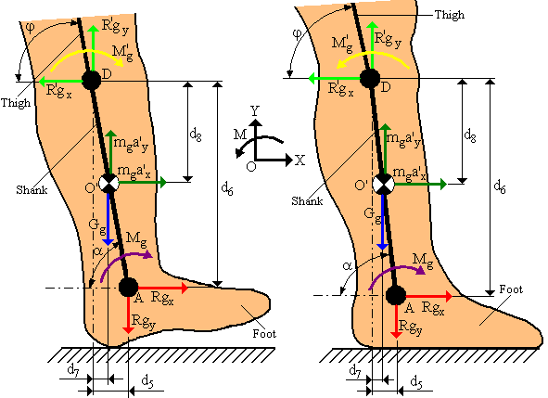
a) b)

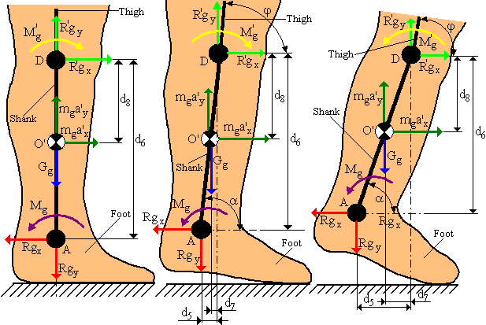
c) d) e)
Figure 1: Free body diagram of the ankle – shank system during stance phases [3]
Introducing the values which are written in the table 1 in the system of equations (3), (5), (7), (9), (11) we obtain the internal reaction forces and net muscular momentum which acts into the knee joint. The final results are written in the table 2.

Table 2: Internal reaction forces and net muscular moment, which act in the knee joint, for all five-stances during normal cycle gait
Phases | R’g_{x}  [N] | R’g_{y}  [N] | M’g  [Nm]
1. (0 – 10%) | 29.841 | -560.117 | 209.58
2. (10 – 30%) | 3.02 | -503.387 | -100.611
3. (10 – 30%) | 18.349 | -469.767 | 35.321
4. (30 – 50%) | 5.739 | -539.367 | 185.531
5. (50 – 60%) | -34.752 | -659.877 | -310.898

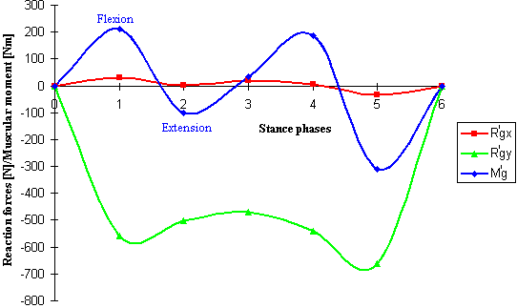
Figure 2: Internal reaction forces and net muscular momentum which act into the knee joint during all five stance phases in case of a human subject with a body weight of 58.7 kg, where: 1 – heel strike (0%); 2 – loading response (0 – 10%); 3 – midstance (10 – 30%); 4 – terminal stance (30 – 50%); 5 – toe off (50 – 60%)

3. CONCLUSIONS

The moment that we obtain from inverse dynamics tells us which muscle (flexor or extensor) is active, and how much moment (torque) that muscle is exerting. A common standard method of representation of these moments in graphical form (figure 2), a flexor moment is shown as positive, while an extensor moment is negative.
The knee moment curve (figure 2) indicates a positive (flexion) moment for three stance phases (heel strike, midstance and terminal stance), with a negative (extension) for the rest two phases (loading response and toe off).

REFERENCES

- Bresler B., Frankel J.: The Forces and Moments in the Leg During Level Walking, Transactions of the ASME, 2000.
- Chris K.: Human Locomotion. Modeling and Inverse Dynamics, The Catholic University of America, USA, 2000.
- Radu C.: Improvements Apported to the Biomechanical Systems Modeling, Second Report of the PhD. Thesis: Improvements Apported to the Prosthetic Elements by Rapid Prototyping, Brasov, 2005.

