The 2nd International Conference
″Computational Mechanics
and
Virtual Engineering″
COMEC 2007
11 – 13 OCTOBER 2007, Brasov, Romania

TENSILE TESTS ON “RT300” ROVING FABRIC REINFORCED POLYMER MATRIX COMPOSITES

H. Teodorescu¹, S. Vlase¹, M. Vasii¹, D. Rosu²
¹ Transilvania University, Brasov, ROMANIA, e-mail: draghicescu.teodorescu@unitbv.ro
² COMPOZITE Ltd., Brasov, ROMANIA, e-mail: compozitebv@yahoo.com

Abstract: The paper presents the results of tensile tests accomplished on RT300 glass fabric reinforced unsaturated polyester resin specimens. The specimens were cut in warp- respective in weft direction from plates manufactured accurately al Compozite Ltd. Brasov. Extended researches on stress-strain behaviour of composite specimens and failure modes are presented.
Keywords: RT300 glass fabric, plain weave, polymer matrix composites, tensile tests, unsaturated polyester resin

1. INTRODUCTION

The fabrics made from glass fibers are characterized by number of nodes on square centimeter, width, thickness, porosity (eye width), bending strength, surface appearance and applied treatments. The main weave modes are the plain weave (in which the warp- and weft threads pass recurrently one above the other), the twill weave (in which the fabric forms a characteristic model with diagonal lines at the fabric surface) and satin weave (in which the fabric surface is formed from threads belonging either to weft or to warp). The fibers weave mode, their thickness and twisting degree play a significant role on the mechanical features of the composite structure. It is well known that a simple tensile test is the most basic of all mechanical property tests. It tells us how strong and stiff a material is. Generally, the strongest material in a class is usually the most difficult to test for tensile properties. Composite materials are no exception and for instance the axial loading of a unidirectional composite presents the greatest challenge.
One of the most important problems in the tensile test of a composite material is the gripping of the specimen without introducing unacceptable stress concentrations. In general, grips are clamped into the specimen ends, transferring the applied tensile force via shear at the specimen surface into tensile stresses within the specimen. We assume that the composite material is strong and therefore the clamping forces are significant. To avoid high clamping forces it is possible to make the specimen as thin as practically possible or to make the grip length longer so that the clamping force is distributed over a larger area.

2. MATERIAL’S FEATURES

The composite material used in tensile tests is a thermosetting polymer, namely unsaturated polyester resin reinforced with RT300 roving fabric. Generally, the RT roving fabrics are obtained from E glass fibers with continuous filaments, with cutted edges and reinforced with Dreher weave (fig. 1). These fabrics are used with polyester- and epoxy resins and presents good impregnation properties. The application areas of these fabric are in electrotechnical-, chemical-, constructions- and aeronautics industry. The most important features of RT roving fabrics of various grades are presented in table 1.

Table 1: Basic properties of RT roving fabrics [1]
PROPERTY | UM | RT300 | RT500 | RT600 | RT800
Specific weight | g/m² | 315±10% | 485±10% | 600±10% | 845±10%
Width | cm | 120±5% | 120±5% | 125±5% | 120±5%
Thickness | mm | 0.3±0.05 | 0.5±0.1 | 0.55±0.05 | 0.75±0.05
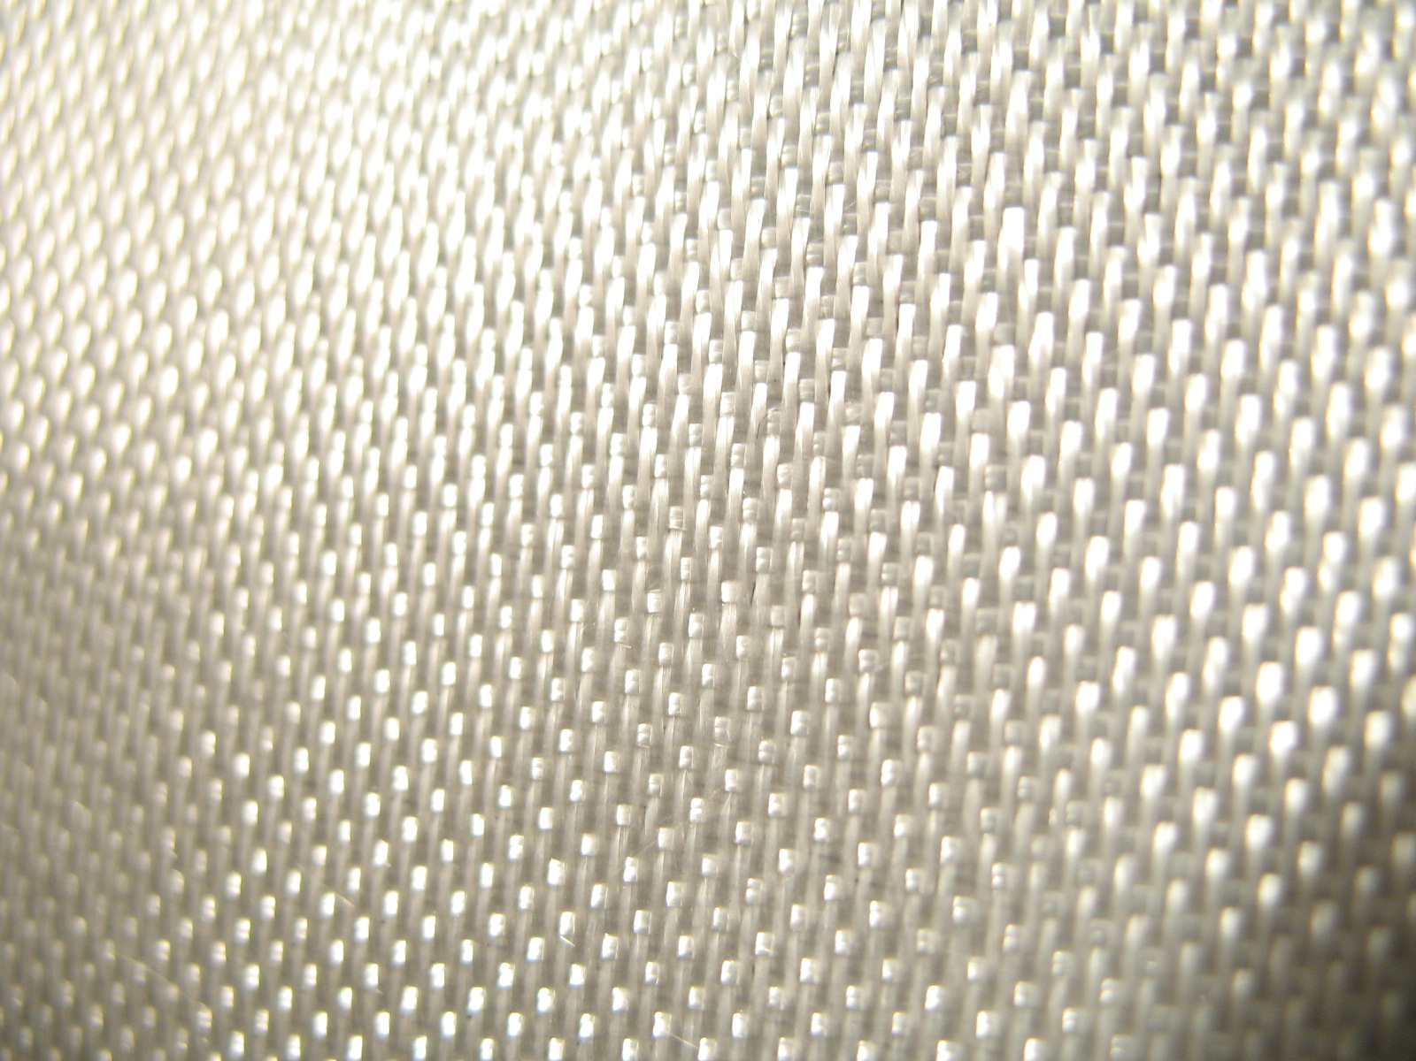
Figure 1: RT roving fabric reinforcement

3. SPECIMENS

The specimens based on polyester resin reinforced with RT300 roving fabric were manufactured at Compozite Ltd. Brasov, Romania, according to the standard SR EN ISO 527-1: Determination of tensile properties of fiber reinforced composite materials (fig. 2). These specimens were cut from a plate of about 4 mm thick and then tempered.

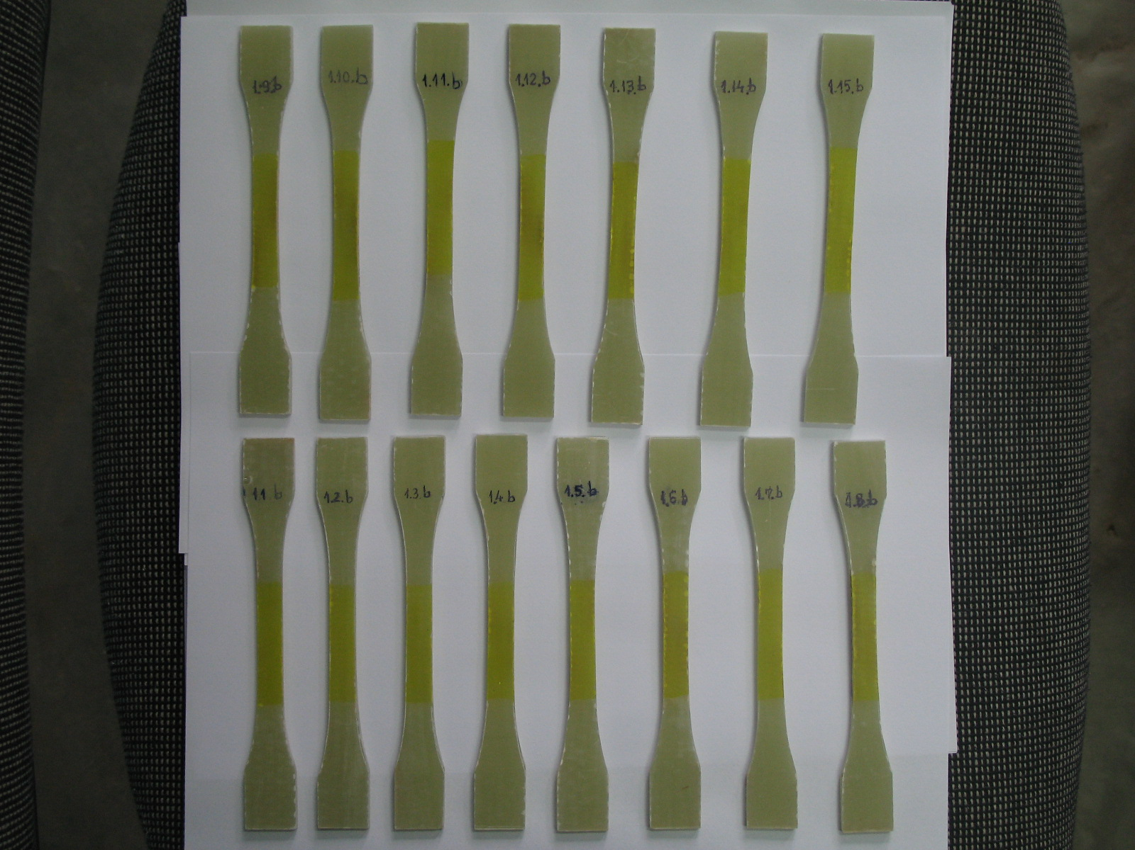
Figure 2: Specimens based on polyester resin reinforced with RT300 roving fabric

The specimens were cut on the fabric warp direction and were subjected to tensile loading until break occurs.

4. TENSILE TESTING MACHINE

The testing machine (fig. 3) is produced by Lloyd’s Instruments, UK, (type LS100) and presents the following specifications [2]:
- force range: 100 kN;
- speed accuracy: <0.2%;
- travel: 840 mm
- load resolution: <0.01% of loadcell used;
- extension resolution: <0.1 micron;
- loadcell: XLC-100K-A1;
- analysis software: NEXYGEN MT.

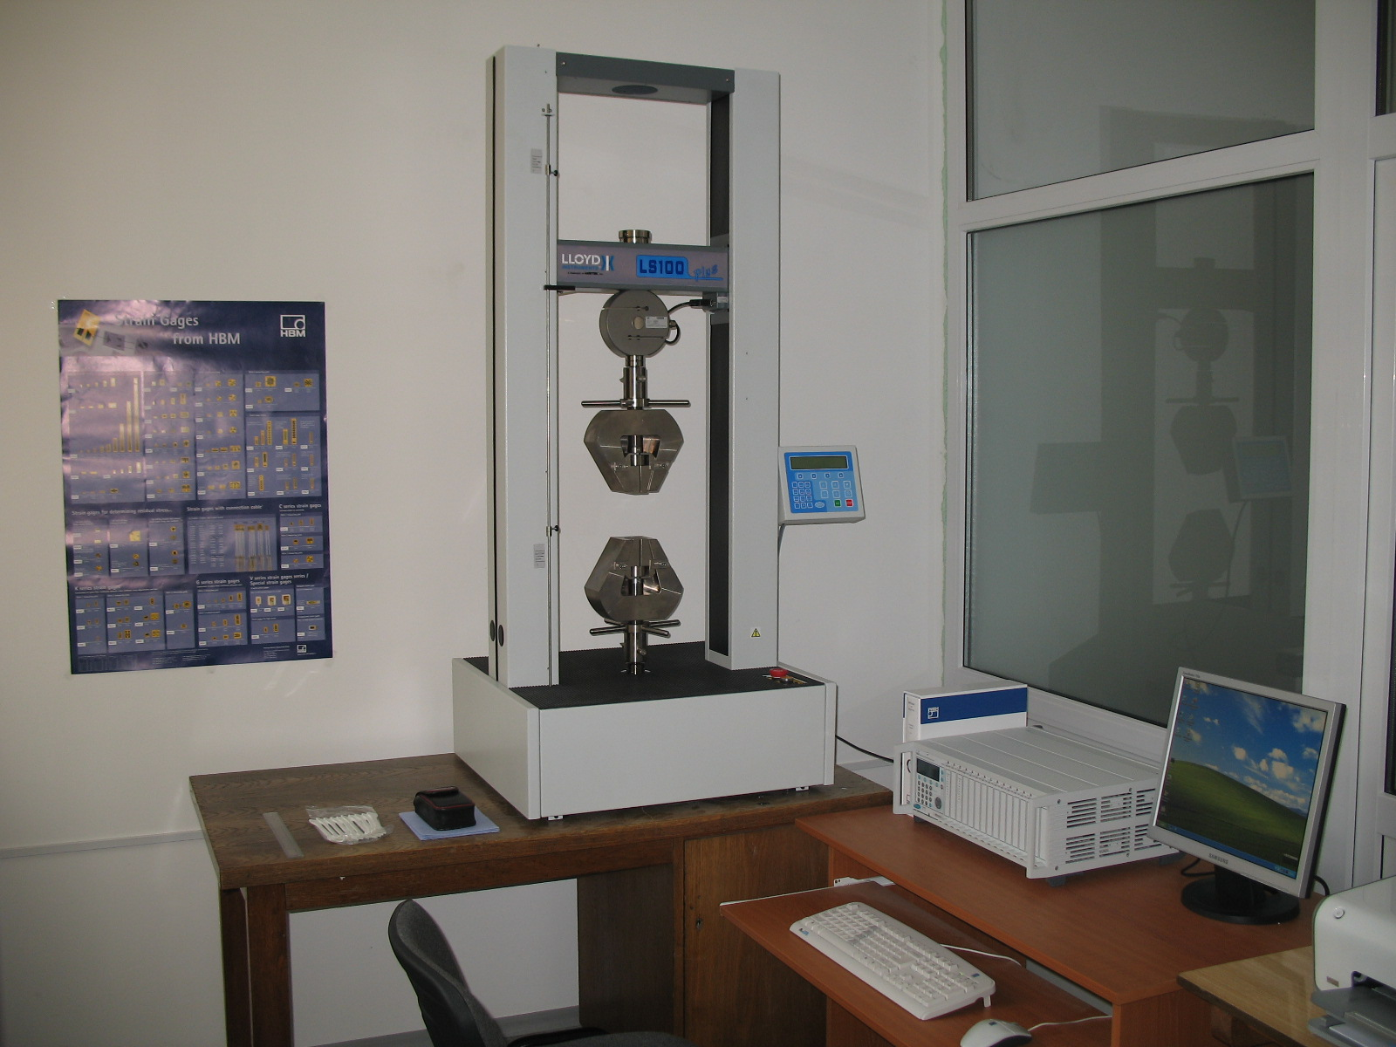
Figure 3: Lloyd’s Instruments LS100 testing machine

5. TENSILE TESTS RESULTS

Specimens’ characteristics and the maximum values of tensile tests mechanical features are:
- Gauge length: 55 mm;
- Specimens fibers volume fraction: 35%;
- Preload stress: 0.0056 kN;
- Preload stress speed: 21 mm/min;
- Test speed: 1mm/min;
- Specimen width: 9,62 mm;
- Specimen thickness: 3,49 mm;
- Load at Maximum Load: 12.942 kN;
- Stress at Maximum Load: 397.25 MPa;
- Load at Maximum Extension: - 0.052443 kN;
- Stress at Maximum Extension: - 1.5739 MPa;
- Load at Minimum Load: - 0.072479 kN;
- Stress at Minimum Load: - 2.1752 MPa;
- Tensile Strength: 397.25 MPa;
- Strain at Maximum Load: 0.075527;
- Load at Break: 12.928 kN;
- Stress at Break: 390.53 MPa;
- Strain at Break: 0.075570;
- Percentage Strain at Break: 7.5570.
Typical stress-strain behaviour of RT300 roving fabric reinforced polyester resin specimens is presented in fig. 4.
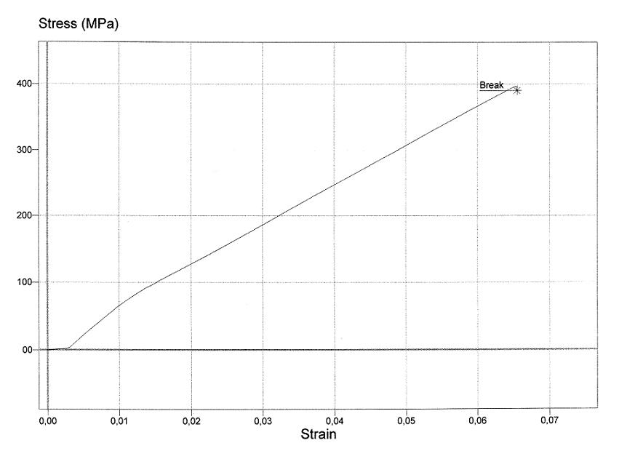
Figure 4: Stress-strain of RT300 roving fabric reinforced polyester resin specimens

6. CONCLUSIONS

Some failure modes of RT300 roving fabric reinforced polyester resin specimens are presented in fig. 5 and 6.

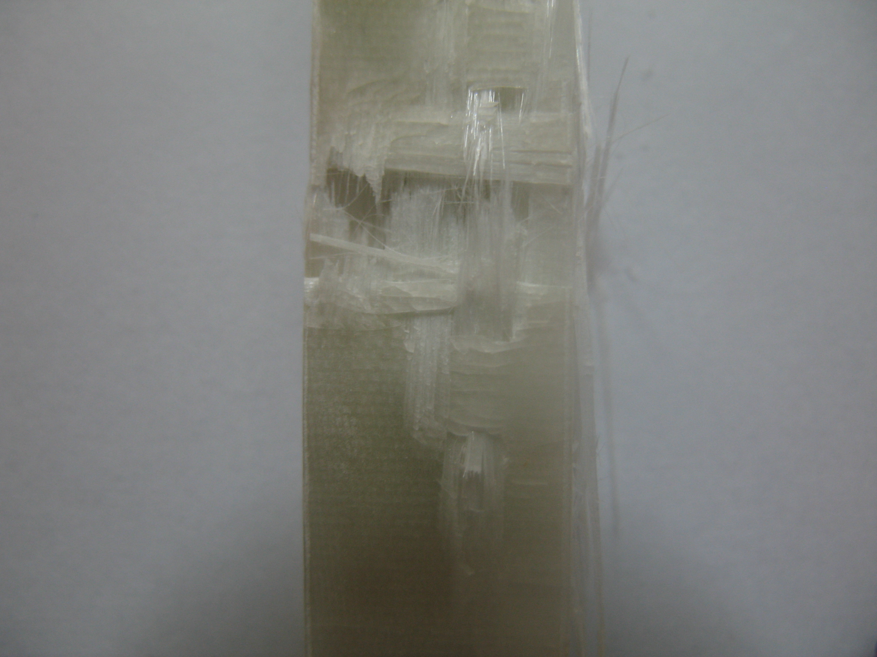 | 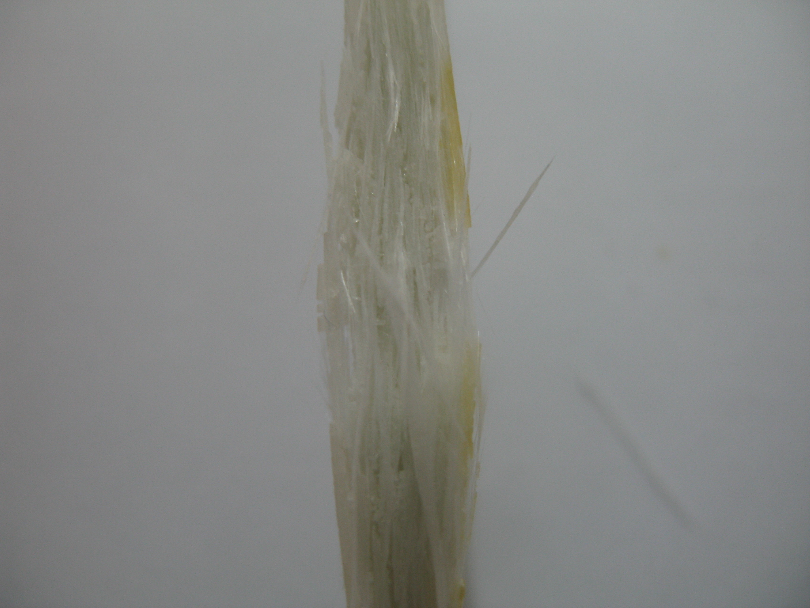
Figure 5: Frontal view of the failure mode | Figure 6: Side view of the failure mode

It can be noticed that the common specimens’ failure mode is the inter-fiber break that begins at a strain of 0.03 as well as fibers break.

REFERENCES

[1] www.firos.ro – RT roving fabrics. Products SC FIROS SA Bucharest, Romania.
[2]. Lloyd’s Instruments. LS100 User Manual.

