The 2nd International Conference
″Computational Mechanics
and
Virtual Engineering″
COMEC 2007
11 – 13 OCTOBER 2007, Brasov, Romania

THE COMPARATIVE ANALYSIS OF THE DIRECT ASYMMETRIC GEARS AND THE INVERTED ASYMMETRIC GEARS USING FINITE ELEMENTS METHODS

Flavia V. CHIRA¹,
North University of Baia Mare, Baia Mare, ROMANIA, e-mail chira_flavia@yahoo.com

Abstract: The paper presents the comparative analysis, from the point of view of stress and displacements, of the two variant of an asymmetric gear that results when the direct or the inverted flank of the asymmetric tooth is the active one. There are analysed, using the 2D model of an asymmetric gear, obtained in AUTOCAD MECHANICAL with a generating program in AUTOLISP , the direct asymmetric gear and the inverted asymmetric gear. The gears have the same geometrical parameters but different functional parameters. The coefficient of asymmetry is different because the active flank is different. There are used, for generating the models and for verify the results, parameters obtained with a packet of Programs for Designing, Modelling and Analysing Asymmetric Gears developed as applications in MATLAB.
Keywords: asymmetric gear, asymmetric tooth, coefficient of asymmetry, stress, displacements

1. INTRODUCTION

The statically analysis with the finite elements method associate to an physical model the mathematical model, and using this model calculate displacements, strains, stress and reaction forces that resulting under the active forces applied on the system that is the subject of the study [9]. For materials with elastic properties the mathematical model is represented by the fundamental equations of the theory of elasticity in the case of three dimensional stress analyses.
For some particular research, using a soft specialised on the finite elements method analysis, the mathematical model it has been created when the algorithm of the program has been elaborated, in this case the routine 2D – FEA of the programme AutoCAD. The precision of the results is depending, in large measure by the physical model that was used. The physical model must contain the complete characteristics of the real solid, from the point of view of the geometry, of the material and the interaction forces with the other parts of the mechanical system. In other words it must be established the loads and the connections. From the study of the papers which are using different programs of finite elements method analysis, with the aim of determiner the behaviour of the involute symmetrical teeth [1], [3], [4] and of the involute asymmetrical teeth [4], [7], [8], one can see the variety of the physical models that has been used.
The concrete phases that has been cover in the statically analysis of the asymmetric gears, more precise of the asymmetric involute teeth of the spur gears, realised with the routine 2D FEA of the program AutoCAD Mechanical 6, are the following:
1. Establishing the geometric model;
2. Choosing the materials of the components of the system;
3. Establishing the connections and the loads applied on the model;
4. Choosing the mesh type;
5. Performing the calculus (by the using program);
6. Visualisation of the stress and displacements;
7. Interpretation and evaluation of the analysis results.

2. THE DESCRIPTION OF THE USED PHYSICAL MODEL

For representing the asymmetric gears components of the transmission, designed on the base direct gear design method [5], [6], have been developed two applications in AUTOLISP noted MDA1 and MDA2 [2]. Also it was necessary to determine the dimension, in frontal plane, of the surface of contact, the pressure angles and the diameters corresponding to the extreme points of the segment of line of action with one pair of teeth in contact. Than has been separated, for the pinion and also for the gear, the close contour limited by the asymmetric profiles of the tooth and the segment between the two points of the filet profiles situated on the dedendum circles. By this segment is represented the maximum cross section of the tooth, considered as a fixed beam in the body of the gear.

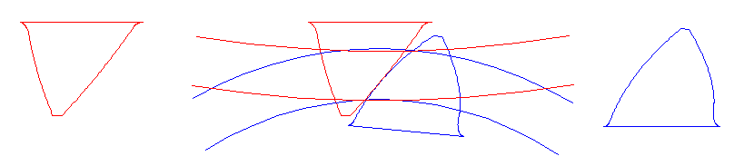
Figure 1: Determination of the geometrical model

For determiner the geometrical parameters, some of theme being initial date at 2D model generation, it was developed, as application in MATLAB, a modelling program for the asymmetric gears. The width of the gears, which is perpendicular on the frontal plane in which is performed the finite element analysis, it has been b = 30 mm. The same value was used in the calculus of the stress and displacements performed with the MATLAB application. There has been considered as material of the gears, which has been choosing from the material tables of the FEA routine, 31CrMo12. It has been considered, every close contour that represents one tooth, of the pinion and of the gear, fixed as a short beam in the body of the respective gear. The maximum values of the stress and displacements corresponding to the extreme points of the segment of the line of action with one pair of teeth in contact, the load it has been applied on the corresponding profile points (figure 2).

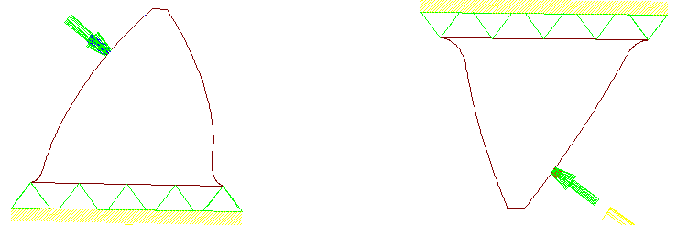
Figure 2: Establishing the loads and the connections

The elliptic distribution of the pressure of contact it has been replaced with a step distribution because the routine 2D FEA of AUTOCAD program admit only uniform distribution of the loads (figure 3). Also the routine 2D FEA of AUTOCAD program considers that the pressure of contact is constant on the direction perpendicular on the frontal plane, in which the analysis has been performed.

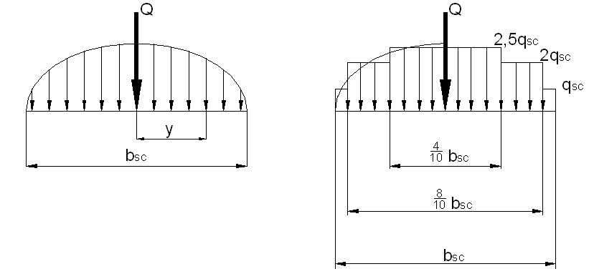
Figure 3: Replacing of the elliptic distribution of the load with step of uniform distribution loads

It has been noted with the minimum value of the intensity of the load, corresponding to the first step, and may there be considered three steps of the load with uniform distribution (). It can be used more exactly approximation of the elliptic distribution, but the time that is necessary in this case, it is not justified by the precision of the results that can be obtained. Taking in consideration that the resultant of all three load with uniform distribution, calculated as function of, with the already known dimension of the contact surface [2], is equal with the normal force on the tooth profile, one can obtain, in relation with the considered point of contact, the three values of the intensity of the uniform distribution load. Because are relevant the maximum values of the stress and displacements, that corresponding to the point B () for the tooth of the gear, and to the point D () for the tooth of the pinion, the finite element analysis carry out the results corresponding to those contact points of the line of action. The lines of action are different, not symmetrical, for the direct and for the inverted gears.

Table 1: Data necessary for the finite element analysis determined with the MATLAB application
Geometrical parameters |  |  |  |  | The load;
 | 0,6981 |  | -1,0600 |  |  | 8531,9 | 6955,2
 | 0,3491 |  | 40,2960 |  |  | 0,4373 | 0,2946
 | 0,8471 |  | 49,4304 |  |  | 9754,1 | 11804
 | 0,7288 |  | 143,5546 |  |  | 19508 | 23609
 | 0,6981 |  | 176,0958 |  |  | 24385 | 29511
 | 0,3491 |  | 50,1075 | 51,9833 |  | 0,3885 | 0,2579
 | 0,0980 |  | 58,1634 | 54,9065 |  | 10981 | 13482
 | 0,6240 |  | 190,0128 | 188,8559 |  | 21961 | 26964
 | 1,0600 |  | 182,2775 | 185,4585 |  | 27451 | 33705

3. PRESENTATION OF THE ANALYSIS RESULTS

For compare the stress and displacements for an asymmetric gear when it is used as direct asymmetric gear, having the coefficient of asymmetry bigger than one, or as inverted asymmetric gear, having the coefficient of asymmetry smaller than one, the analysis has been performed for the two gears noted with A_as_16_57_120_40_20_0_1_1, A_as_16_57_120_40_20_0_1_2, for a trough power P=18kW. For the first gear the load it has been applied on the direct profile and for the second on the inverted profile. The code of the gear indicate the initial date used in the design program: the numbers of teeth (16, 57), the centre distance (120), the mesh angles, in degrees, for the asymmetric involute profiles (40, 20), the angles of the gear rack profiles equals, in this case, with the mesh angles (0), the generation of pinion and gear with one gear rack (1) and the last number indicate the variant of using the asymmetric gear (1) for the direct one and (2) for the inverted one .
Only a part of the obtained results are presented in the tables 2 – 5.

Table 2: The analysis of the pinion tooth stress and displacements for direct asymmetric gear A_as_16_57_120_40_20_0_1_1
Pinion tooth – the exterior point of contact on the line of action segment with one pair of tooth in contact ()
Stress Von Mises  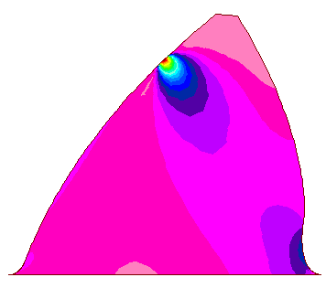 | Displacements  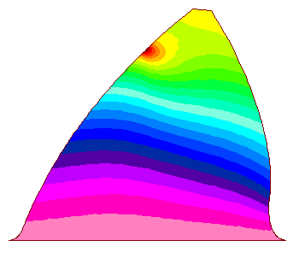 | 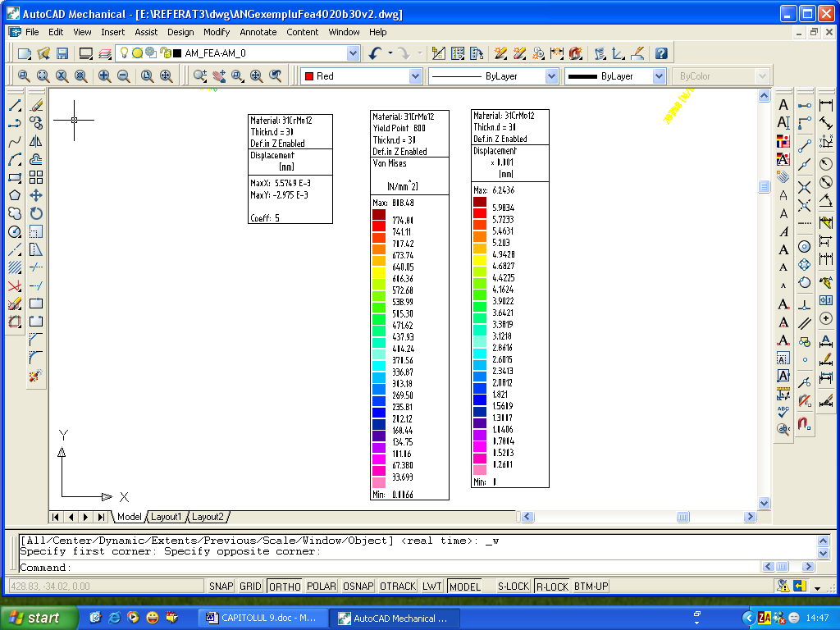
The mesh type
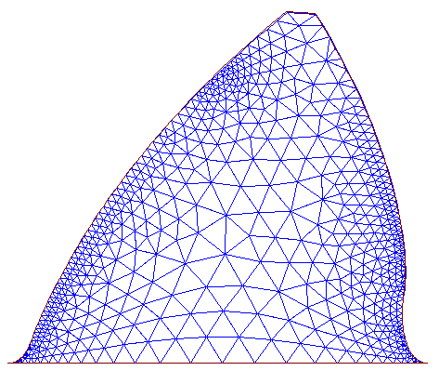

With the same method the results that one can see in the table 2 for the tooth of the pinion and the point of contact has been obtained also for the tooth of the gear (table 3 for point) for all the characteristic points of contact. Also has been performed the analysis for the direct and inverted gear, taking in consideration that the normal force on the active profile is different for that two gears. The load applied and the dimension in frontal plane of the contact surface was determined for each contact point that was analysed. So it has been obtained the distributions of stress and displacements presented in tables 4 and 5.

Table 3: The analysis of the gear tooth stress and displacements for the direct asymmetric gear A_as_16_57_120_40_20_0_1_1
Gear tooth – the exterior point of contact on the line of action segment with one pair of tooth in contact ()
Stress Von Mises  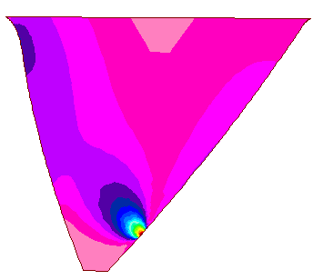 | Displacements  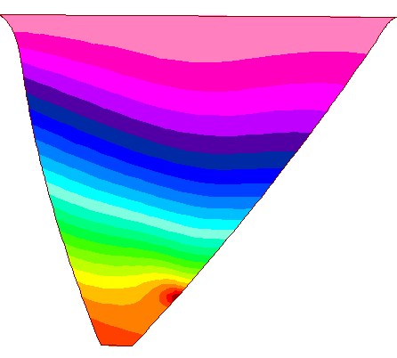 | 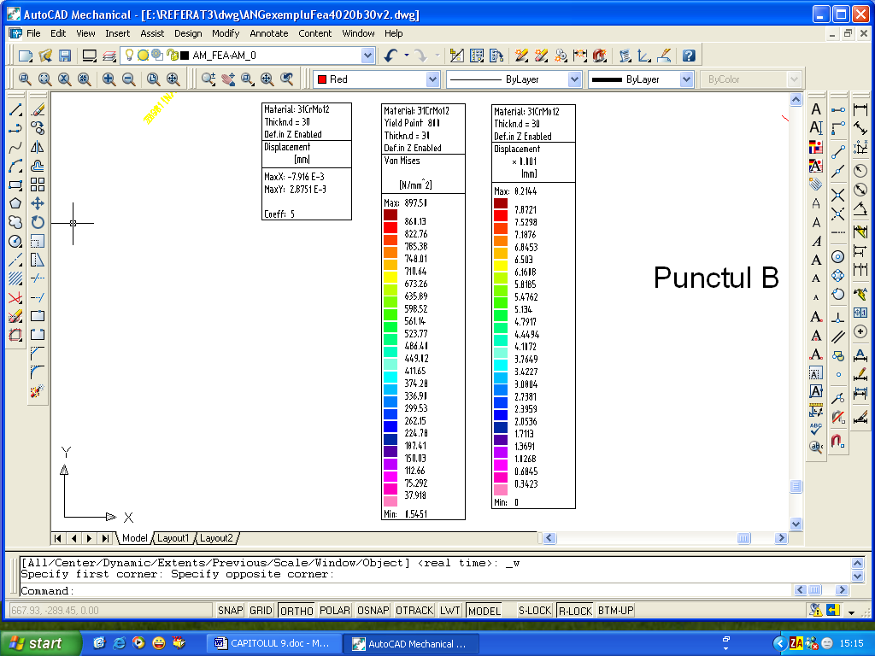
The mesh type
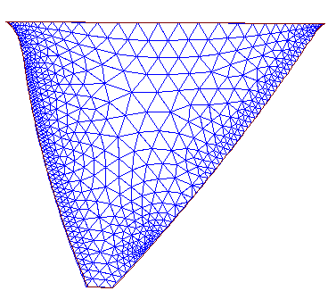

Table 4: Distribution of stress and displacements for the teeth in contact for the limiting points of the segment of meshing line with one pair of teeth in contact for the gear A_as_16_57_120_40_20_0_1_1 (P=18kW, n=1000rot/min, b=30).
Stresses | Displacements
Direct asymmetric gear A_as_16_57_120_40_20_0_1_1
The distribution of stress and displacements for contact point Bd of the line of action AdEd
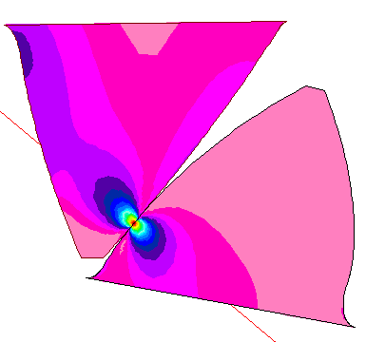 |  | 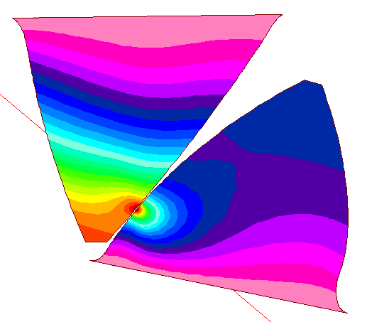
The distribution of stress and displacements for contact point Dd of the line of action AdEd
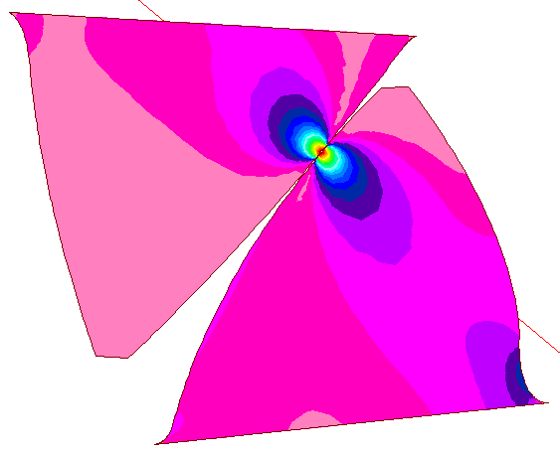 |  | 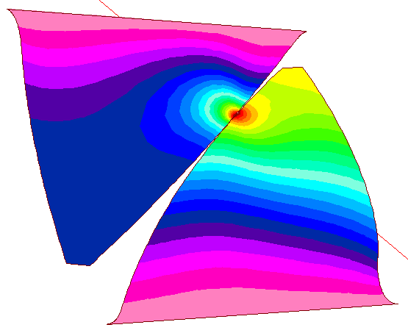

Table 5: Distribution of stress and displacements for the teeth in contact for the limiting points of the segment of meshing line with one pair of teeth in contact for the gear A_as_16_57_120_40_20_0_1_2 (P=18kW, n=1000rot/min, b=30)
Stresses | Displacements
Inverted asymmetric gear A_as_16_57_120_40_20_0_1_2
The distribution of stress and displacements for point Bi of the line of action AiEi
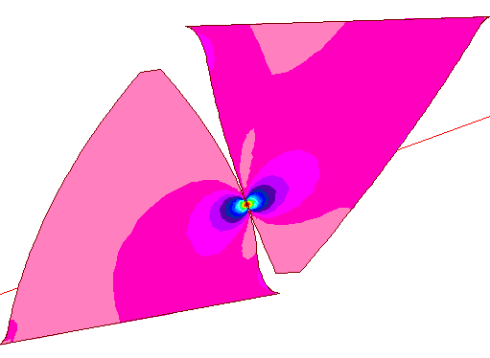 |  | 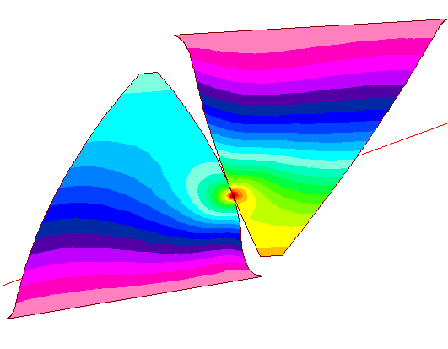
The distribution of stress and displacements for point Di of the line of action AiEi
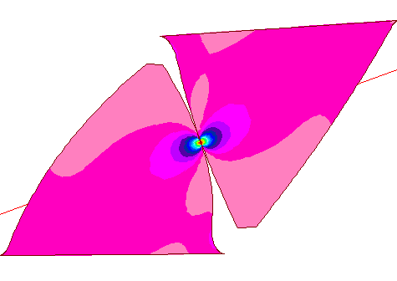 |  | 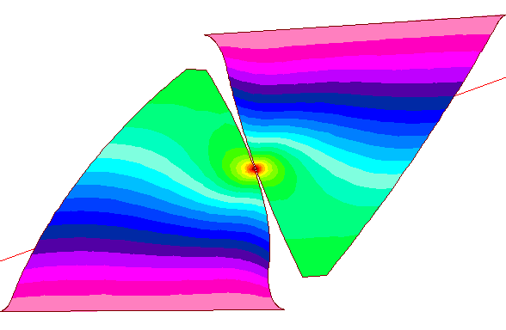
The meshing zone – 2D model detail
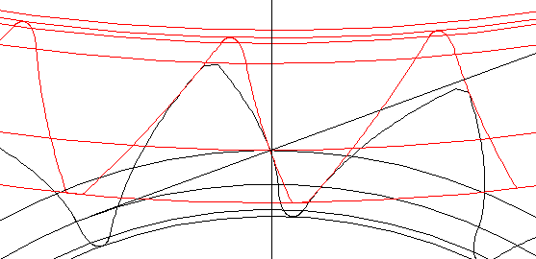

4. INTERPRETATION OF THE RESULTS

Although the Von Mises stress in one node do not define unique the state of stress in the node, because it have not an associate direction being define only by the numerical value, that value permit to evaluate the state of stress for ductile materials. The displacements that have been obtained are also resultant displacements.
The information on the state of stress of asymmetric gears obtained by using the finite element method and also by using the developed modelling application in MATLAB has errors that accompany any calculus method that can only approximate, more or less exactly, on some basis of design, the real phenomena. It can be used one, or other or the booth method, taking in consideration the time necessary for the analysis, the aim, and the precision that is necessary. Also the fact that the results obtained by using the booth method are very nearly it can be considered as an accessible method for verify and confirm the research.
In the table 6 are indicated, for the two gears mentioned before, the maximum values of stress (in points Bd, Bi of the lines of action) and maximum displacements for the pinion tooth (in Dd, Di points) and for the gear tooth (in Bd, Bi points), obtained with the used methods ( MATLAB program / FEA analysis).
The booth method show that the contact stresses is significant bigger in the case of inverted gear in relation with the direct one. Also the booth method show that the displacements for the direct asymmetric gear are bigger in relation with the inverted one, so one can deduce that the bending stress is bigger for the direct gear.

Table 6: The comparative analysis of the results obtained with different method
Angrenaj
Trough power P=18kW
 | 882 | 897 | 6,30 | 6,24 | 7,40 | 8,21
 | 1084 | 1125 | 4,10 | 3,96 | 5,40 | 6,00

According with the precision of the results the booth method can be used. In the stage of the design when the 2D model of the gear it has already obtained, the finite element analysis method may give information for compare the two variant of using the designed asymmetric gear. If the aim of the research is to optimise the design, finding the optimal designing variable, taking in consideration the time that it is necessary for the analysis, the finite element method it is not useful. For optimising it is necessary to compare many design variant for establish which is the best for the beneficiary. That can not be solved, in short time, with finite element method.

5. CONCLUSION

For determine the difference of the stress and displacements for the asymmetric gear with coefficient of asymmetry bigger or smaller than one, or for evaluate the maximum values of the stress and displacements for any designed asymmetric gear, using the finite element analysis method, it is necessary before to have the 2D model of the gear. All geometrical parameters of the pinion and of the gear must be known. It is necessary also to determine the normal force on the active profile in relation with the coefficient of asymmetry. All these mentioned dates can be obtained, in a short time, by any designing engineer with the help of modelling programs developed as application in MATLAB for the study of the asymmetric gears. For obtain the 2D model, and implicitly the 3D model, of pinion and of the gear, also any designing engineer can use the programs developed in AUTOLISP for using in AUTOCAD for the representation of the asymmetric gears. With the computational method established, for all these steps few minutes are enough.
The finite element method being verified in many applications can be considered as a method for determine but more for verify and confirm the results obtained with the MATLAB application, that is more efficient and easily to use.
The booth method that has been used indicates the advantage of using the direct asymmetric gear if the aim is to reduce the contact stress. For reducing the bending stress is better to use the inverted asymmetric gear.

REFERENCES

[1] Bănică, M., Contribuţii la optimizarea comportării dinamice a angrenajelor cilindrice cu dinţi drepţi cu profil evolventic, Teză de doctorat, Universitatea Tehnică Cluj-Napoca, 2005.
[2] Chira, F., - Contributions to the study of the asymmetric gears, Ph. D thesis, North University of Baia Mare, 2006.
[3] Dobre, G. ,Mirică, R.F., Sorohan, Şt., On the gearing simulation using finite elements methods, The International Meeting of the Carpathian Region Specialists in the Field of gears, North University of Baia Mare, may 31-june1,2002.
[4] Ghionea, A., Anania, D., Ghionea, I., Utilization of some computer assisted techniques in generating and study of the hypocicloidal flanks of the spur gear teeth stress, The International Meeting of the Carpathian Region Specialists in the Gears, North University of Baia Mare, may 21-22, 2004.
[5] Kapelevich, A.,L., Geometry and design of involute spur gears with asymmetric teeth, Mechanism and Machine Theory, 35, 2000.
[6] Kapelevich, A.,L., Kleiss, R.E., Direct Gear Design for Spur and Helical Involute Gears, Gear Technology, September/october, 2002.
[7] Karpat, F., Cavdar, K., Babalic, C.,F., An investigation on analysis of involute spur gears with asymmetric teeth: Dynamic load and Transmission errors, The 2nd International Conference “Power Transmissions 2006” Proceedings, Novi-Sad, april 25-26 , 2006.
[8] Litvin F., L., Lian , Q., Kapelevich A., L., Asymmetric Modified Gear Drives: Reduction of Noise, Localization of Contact, Simulation of Meshing And Stress Analysis, Computer Methods in Applied Mechanics and Engineering, 188, 2000.
[9] Mănescu, T., Şt., Nedelcu, D., Analiză structurală prin metoda elementului finit, Editura Orizonturi Universitare, Timişoara, 2005.

