The 2nd International Conference
″Computational Mechanics
and
Virtual Engineering″
COMEC 2007
11 – 23 OCTOBER 2007, Brasov, Romania

ON THE RECIEVED DIRECT RADIANCE OF A PV SOLAR PANEL ORIENTATED BY PSEUDOEQUATORIAL TRACKER

Dorin DIACONESCU¹, Ion VIŞA¹, Bogdan BURDUHOS¹
¹ Transilvania University, Brasov, ROMANIA, dvdiaconescu@unitbv.ro

Abstract: This paper models and simulates the incidence angle variations and the afferent received direct solar radiance of a PV solar panel orientated by means of a pseudoequatorial tracker. The numerical simulations allow to effectuate a comparative analysis of the incidence angle variations and of the received direct radiance variations obtained by the tracked PV solar panel versus the tilted and horizontal fixed PV panel. The obtained analytical models and the conclusions derived from the interpretation of the numerical simulations are very useful in the design of the pseudoequatorial trackers.
Keywords: PV solar panel, pseudoequatorial tracker, solar angles, incidence angle, received direct solar radiance.

1. INTRODUCTION

The main objective of this paper is to model the received direct solar radiance of the orientated PV panel by means of the pseudoequatorial* tracker. In order to accomplish this objective, the paper establishes firstly the incidence angle sun-panel (between the sun-ray unit vector and the PV panel normal unit vector) and then establishes the direct solar radiance received by the PV panel. The results of the numerical simulations, developed on the basis of the obtained analytical models, allow the comparative analysis between the tracked PV panels (by means of the pseudoequatorial tracker) versus the horizontal and titled fixed PV panels. The results highlight that: a) the incidence angle minimization (by means of a pseudoequatorial tracker) only, can not assure the overall energetic efficiency optimization; b) this desideratum can be only reached if the minimization of the incidence angle is properly correlated with the solar radiance daily variation.
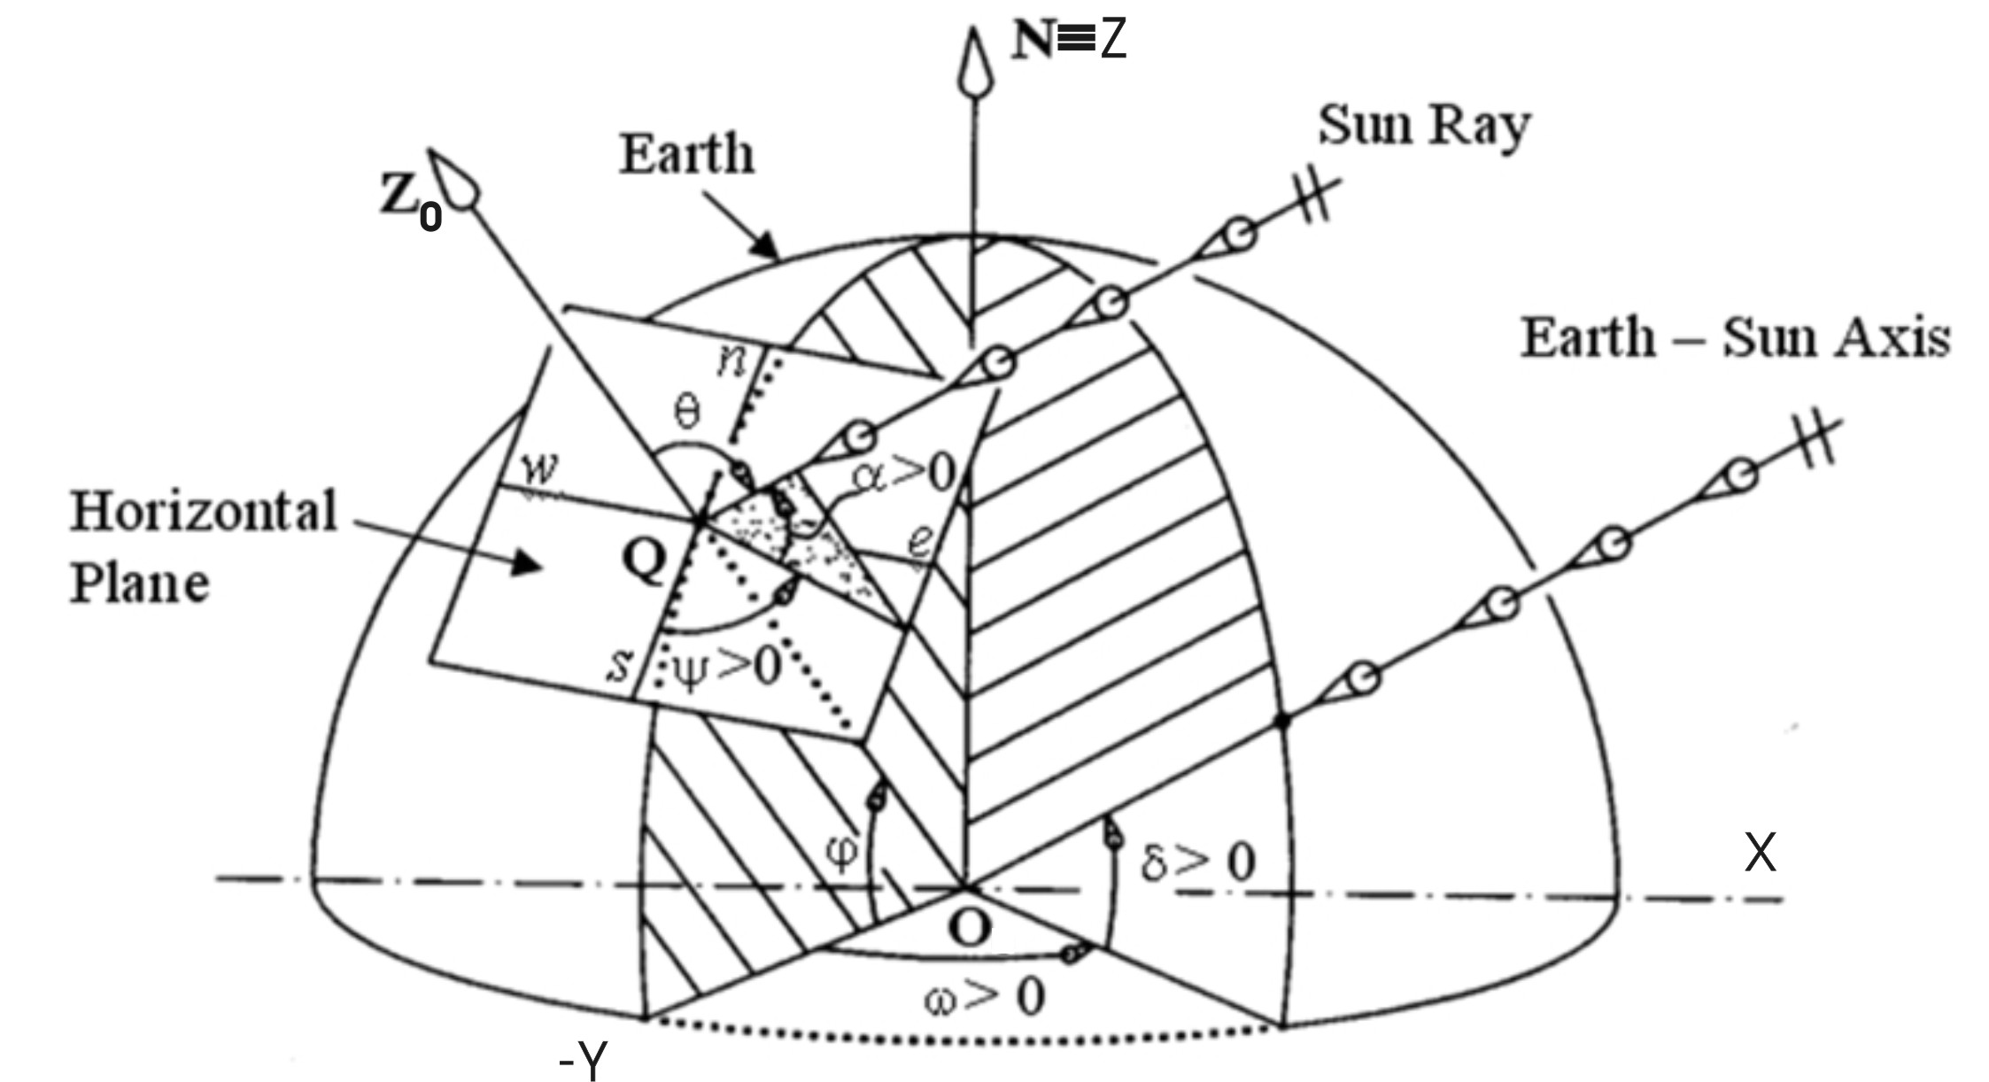  a | 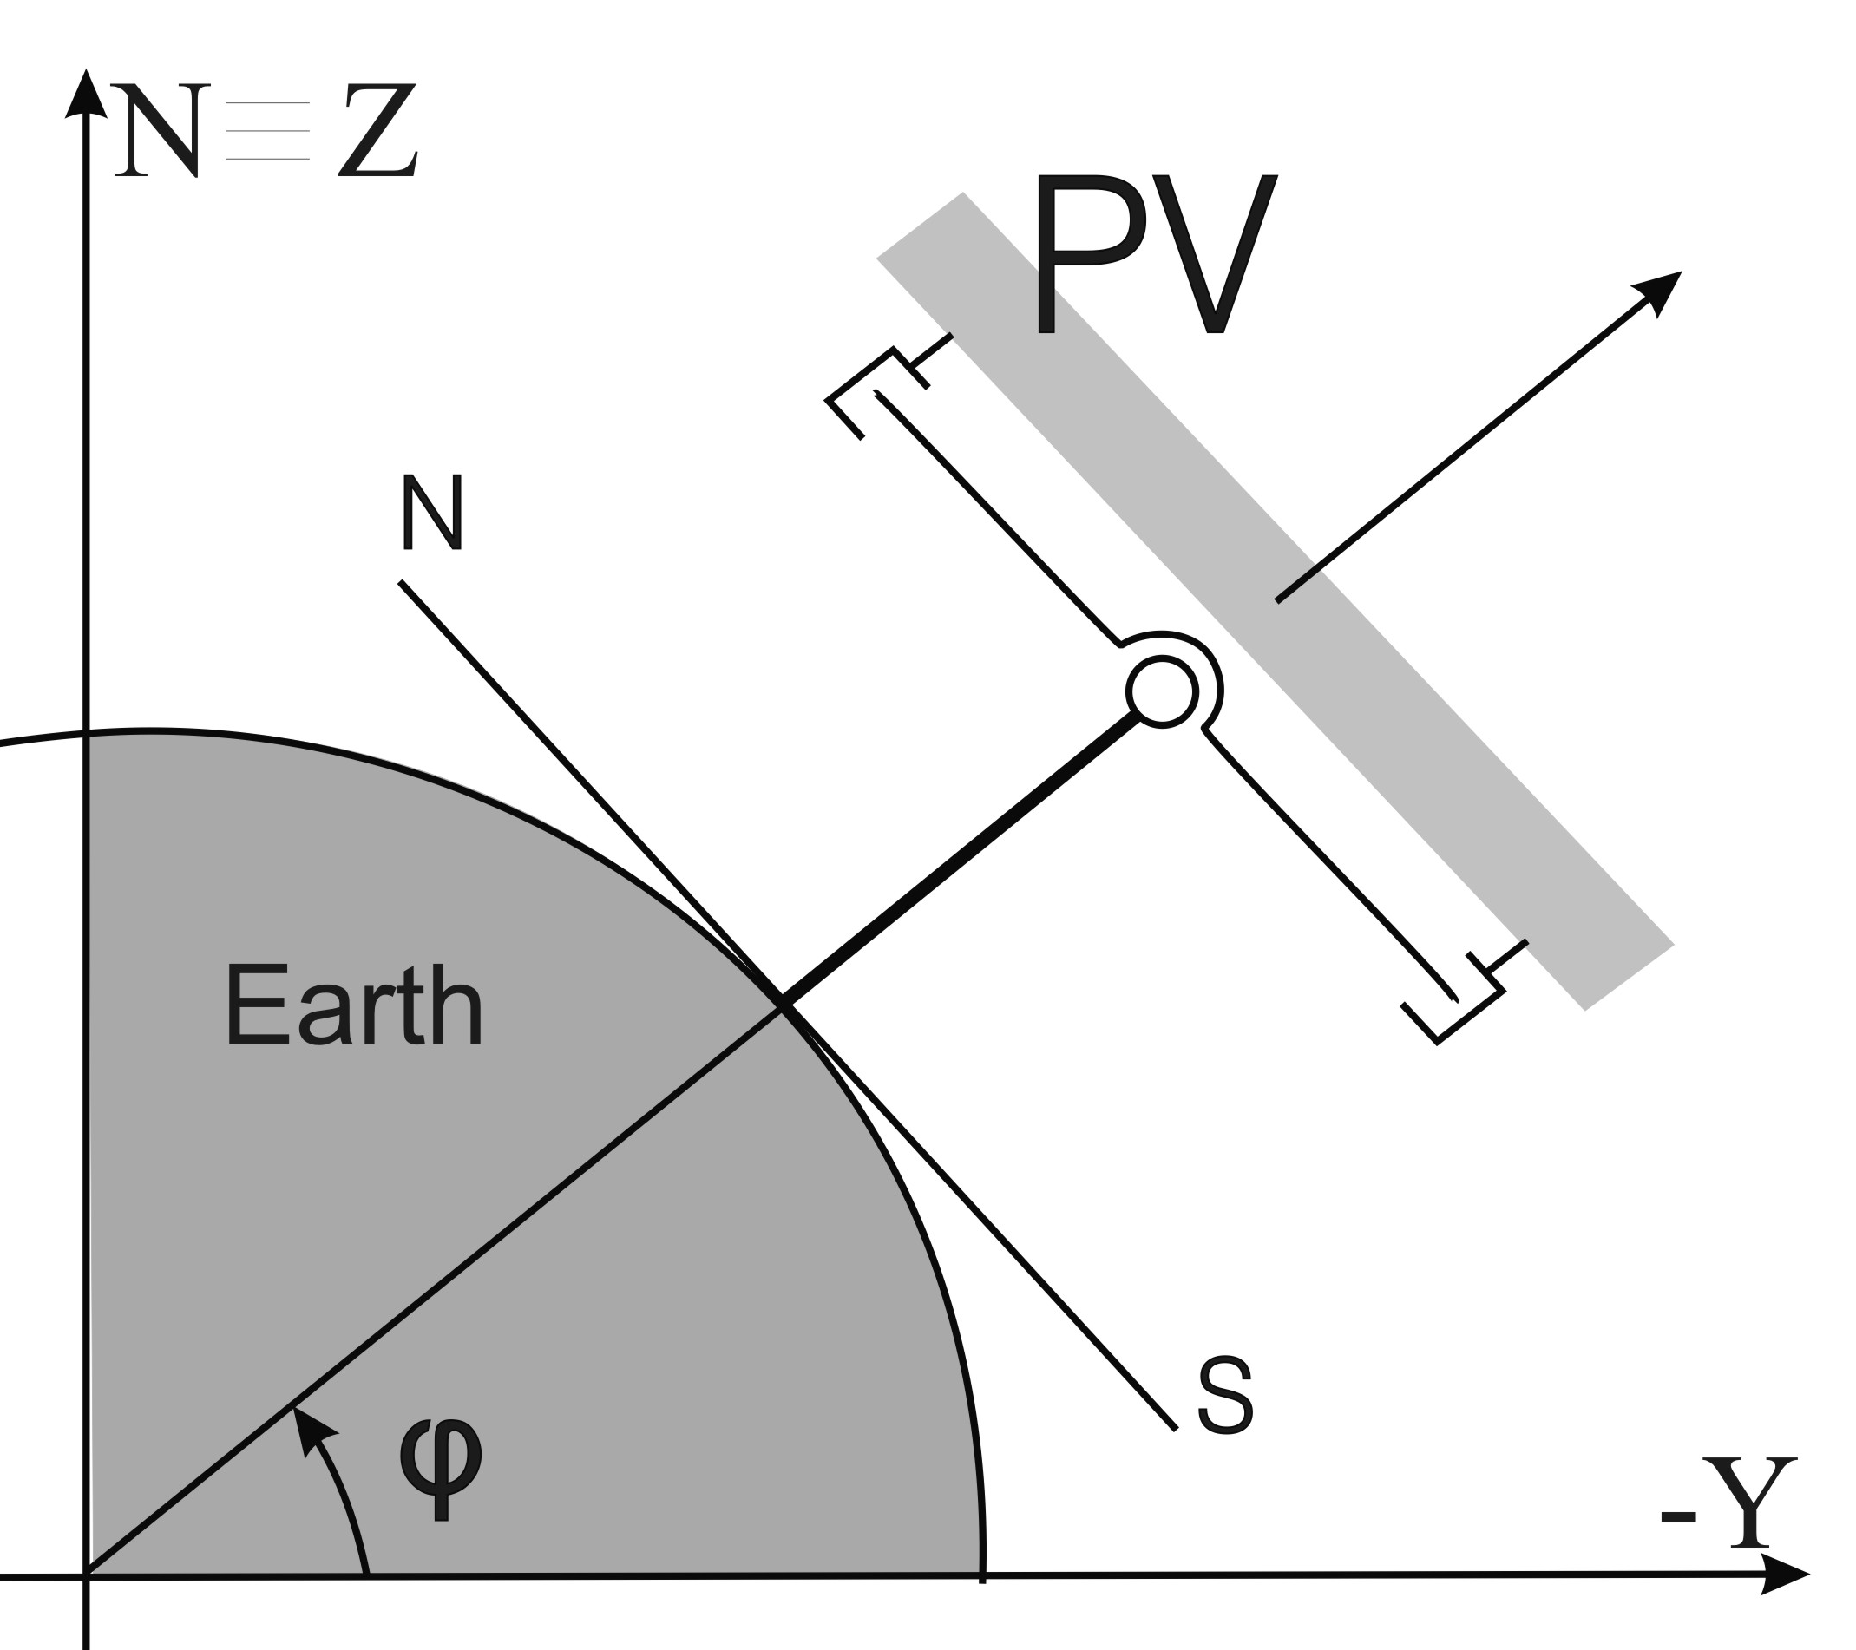  b
Figure 1. Relative geometry Earth-Sun (a) and position of a pseudoequatorial tracker compared to Earth (b)

*Remark: in contrast to the equatorial tracker (in which, the first movement relative to ground is ω and the second is δ, see Figure 1,a), in the pseudoequatorial tracker the movements are assembled in reverse order (see Figure 1,b and 2): the first movement relative to ground is γ (which depends of δ ) and the second is β (which depends of ω); for economical reasons the equatorial tracker is less used in practice.
In Figure 1 there are illustrated the sun-ray angles (ω, δ) compared to the equatorial reference system Qxyz (Figure 1,a) and nearby (Figure 1,b) the geometrical scheme of the pseudoequatorial tracker derived from Figure 1,a is represented.

2. SOLAR ANGLES AND UNIT VECTORS

In order to be able to track a PV panel one has to know the exact direction of the sun ray. This data can be obtained by using one of the two usual systems in which the suns path can be depicted (Figure 1): the equatorial system Oxyz, from which the equatorial tracker type is directly derived, and the azimuthal system Qx₀y₀z₀, from which the azimuthal tracker type is directly derived. The angles used in the first tracker type are: hour angle (ω) and declination (δ), while those used in the second one are: azimuth angle (ψ) and altitude (α), see Figure 1,a. For practical reasons, a new tracker type (derived from the equatorial tracker by reversing the joints’ order) can be introduced; this last type, which uses the angles γ and β (Figure 2), was called pseudoequatorial tracker.
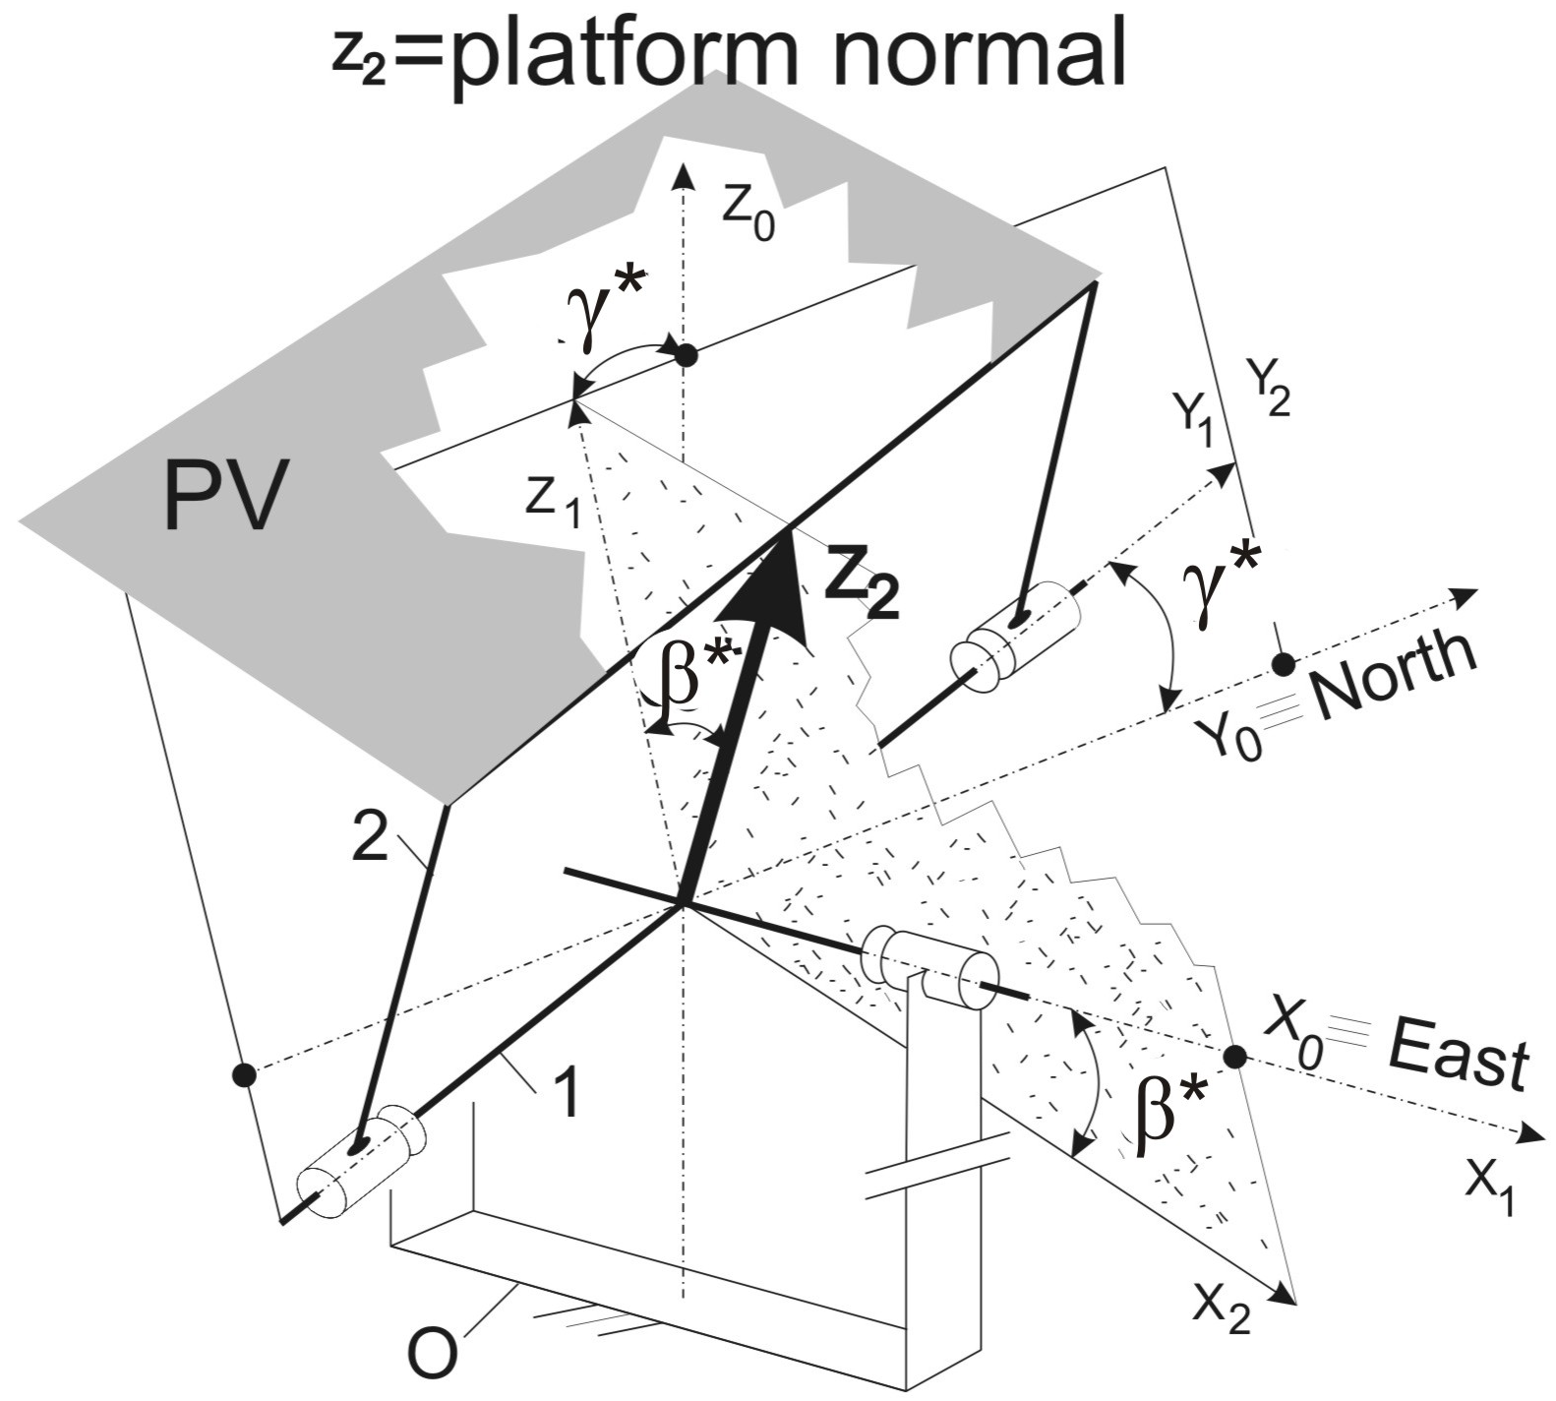  Figure 2. Kinematical scheme of the pseudoequatorial dual-axis tracker | 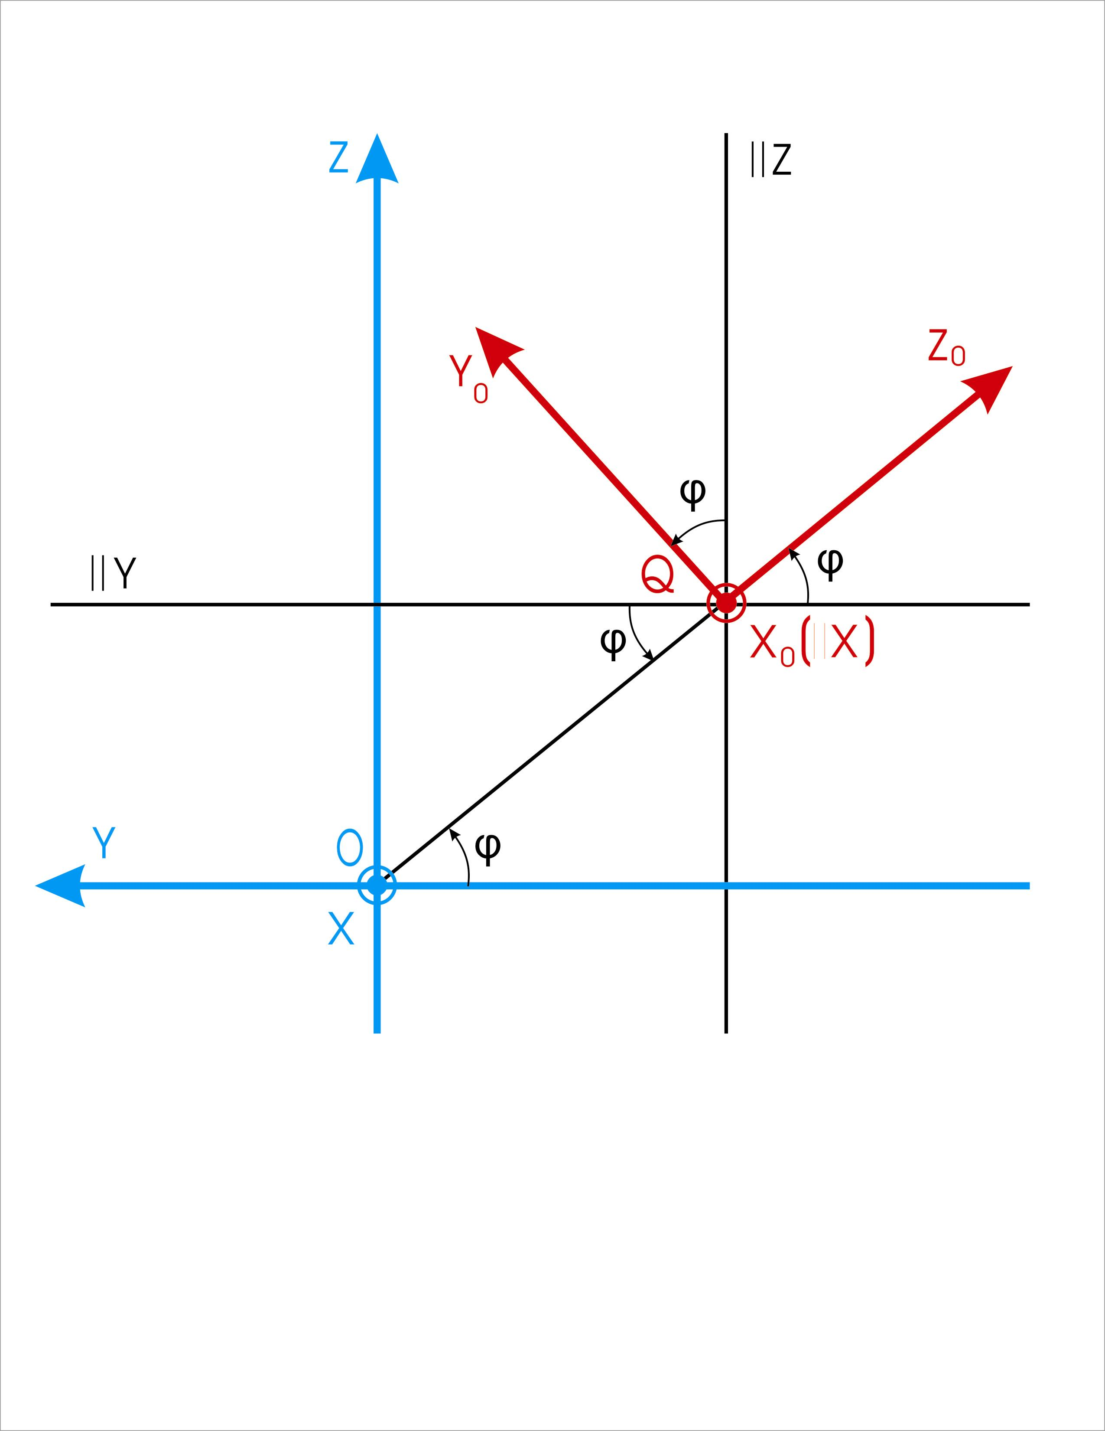  Figure 3. The relative position of the systems Oxyz and Ox₀y₀z₀ relying on the latitude φ (see Figure 1,a)

Because of energetic and economical reasons, the angular displacements of the tracked PV solar panel are made discontinuously (in steps), so the tracker’s angles have discreet variations; in order to distinguish them from the sun-ray angles (which have continuous variations: ω, δ; ψ, α and γ, β) in the below correlations the tracker’s angles are marked with asterisk: ω*, δ* ; ψ*, α* and γ*, β* (see Fig. 2); so, the sizes γ* and β* (effectuated by a pseudoequatorial tracker) approximate the variations of the sizes γ and β (effectuated by the sun-ray). Obviously, when the tracker makes the angular displacements continuously, then: γ* =γ and β* =β.
By means of Figure 1 and 3 the unit vectors of the sunray in the equatorial system Oxyz and in the azimuthal system Qx₀y₀z₀ can be calculated:
${\left[{\bar{e}}_{\text{sr}}\right]}_{\text{xyz}}=\left[\begin{matrix}\text{cos}δ⋅\text{sin}ω \\ −\text{cos}δ⋅\text{cos}ω \\ \text{sin}δ\end{matrix}\right]$; ${\left[{\bar{e}}_{\text{sr}}\right]}_{x_{o}y_{o}z_{o}}=\left[\begin{matrix}\text{cos}α⋅\text{sin}ψ \\ −\text{cos}α⋅\text{cos}ψ \\ \text{sin}α\end{matrix}\right]$; | (1), (2)
Their direct comparison is possible when both unit vectors are depicted in the same system, for example in the system x₀y₀z₀:
$${\left[{\bar{e}}_{\text{sr}}\right]}_{x_{o}y_{o}z_{o}}=T⋅{\left[{\bar{e}}_{\text{sr}}\right]}_{\text{xyz}}=\left[\begin{matrix}1 & 0 & 0 \\ 0 & \text{sin}ϕ & \text{cos}ϕ \\ 0 & −\text{cos}ϕ & \text{sin}ϕ\end{matrix}\right]⋅\left[\begin{matrix}\text{cos}δ⋅\text{sin}ω \\ −\text{cos}δ⋅\text{cos}ω \\ \text{sin}δ\end{matrix}\right]=\left[\begin{matrix}\text{cos}δ⋅\text{sin}ω \\ −\text{cos}δ⋅\text{cos}ω⋅\text{sin}ϕ+\text{sin}δ⋅\text{cos}ϕ \\ \text{cos}δ⋅\text{cos}ω⋅\text{cos}ϕ+\text{sin}δ⋅\text{sin}ϕ\end{matrix}\right]$$ | (3)
From the equality of relations (2) and (3), the next main correlations are obtained:
$α={\text{sin}}^{−1}(\text{sin}δ\text{sin}ϕ+\text{cos}δ\text{cos}ϕ\text{cos}ω)$, $ψ=(\text{sgn}ω){\text{cos}}^{−1}\frac{\text{sin}α\text{sin}ϕ−\text{sin}δ}{\text{cos}α\text{cos}ϕ}$; | (4), (5)
where [1, 2]:
Declination: $δ=\text{23}\text{.}{\text{45}}^{o}\text{sin}\frac{{\text{360}}^{o}\left(n−\text{80}\right)}{\text{365}}$, Hour Angle:$ω={\text{15}}^{o}\left(\text{12}−T\right)$; | (6), (7)
a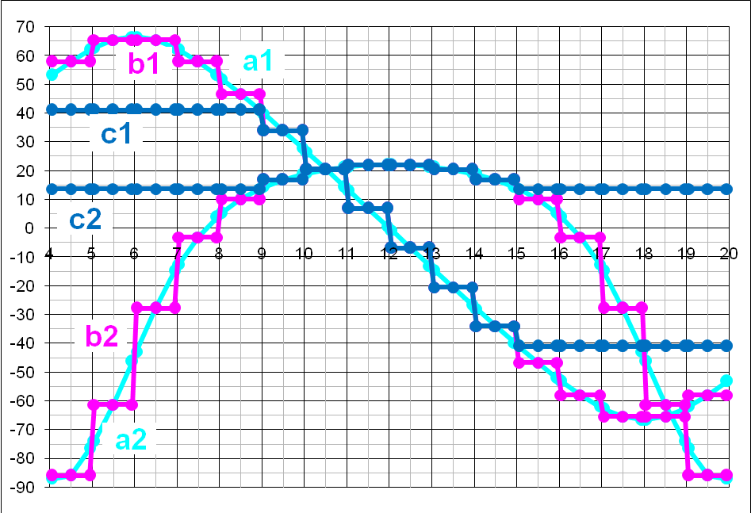
b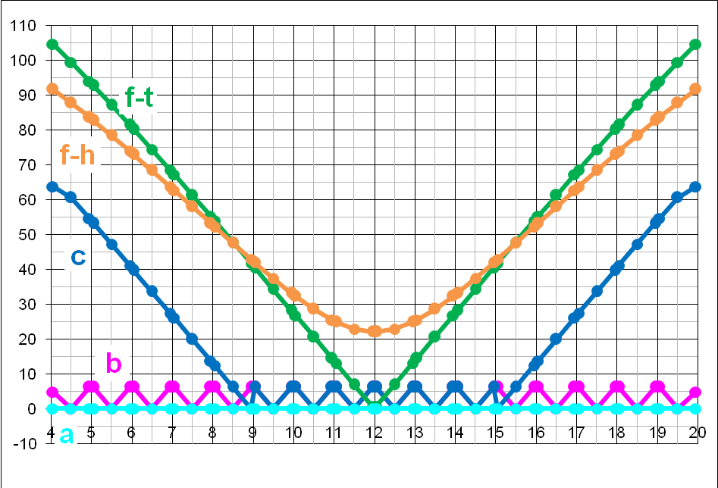
c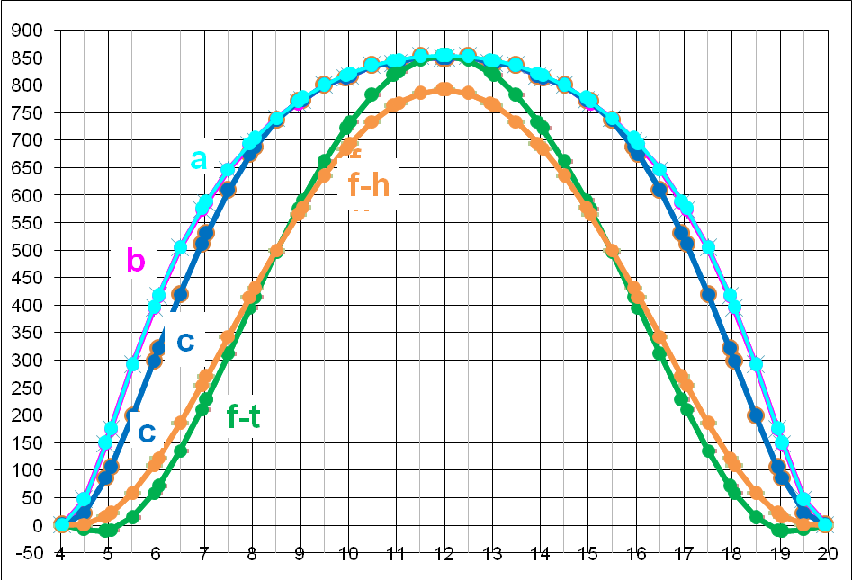
Figure 4. a) Continuous angles’ variations (the curves a1 and a2) and discontinuous/in steps angles’ variations (the curves b1, b2 and c1, c2) in terms of the day hour, realized by a pseodoequatorial tracker, during the summer solstice at 45,5° latitude N; b) the resulting incidence angle variations (the curves a, b and c); c) the variations of the panel received direct radiance (the curves a, b and c) compared with a horizontal and tilted fixed PV panel (the curves fh and ft resp.)
a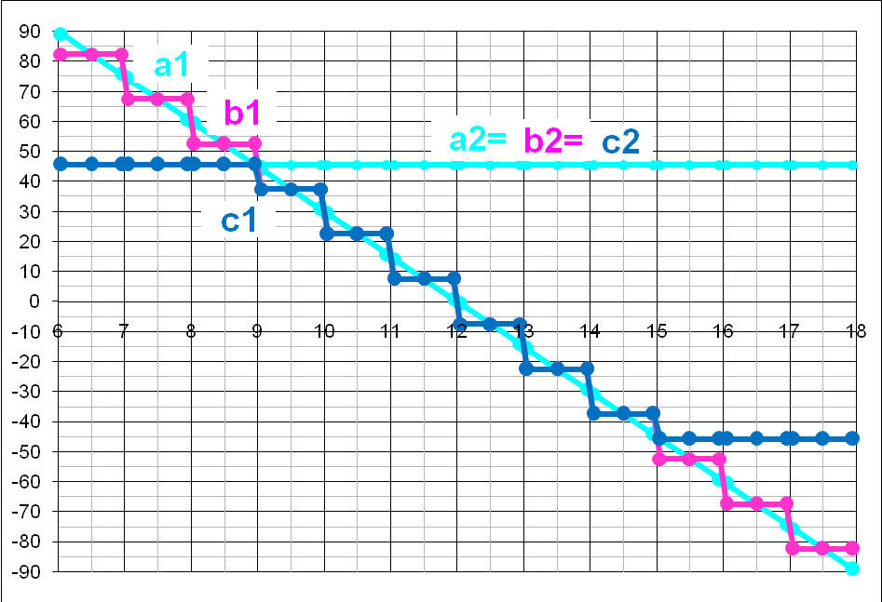
b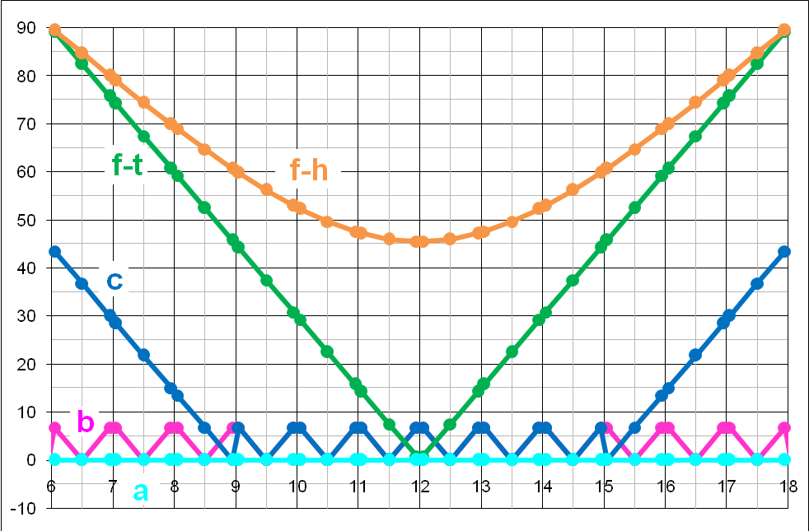
c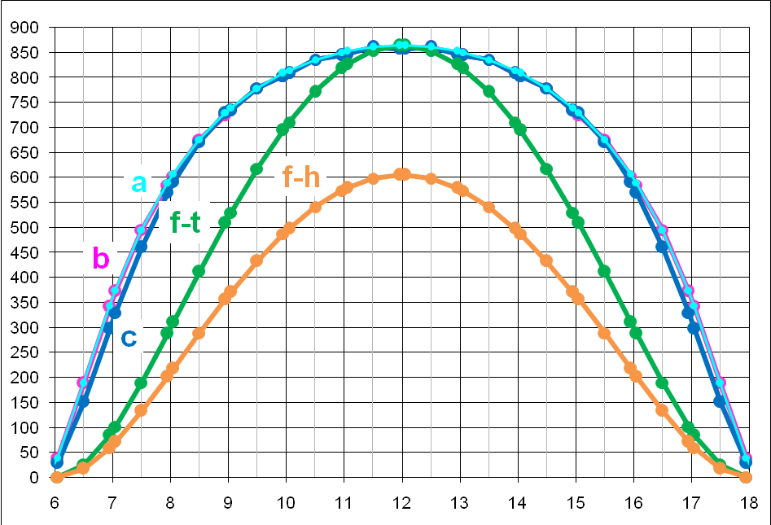
Figure 5. a) Continuous angles’ variations (the curves a1 and a2) and discontinuous/in steps angles’ variations (the curves b1, b2 and c1, c2) in terms of the day hour, realized by a pseodoequatorial tracker, during the spring equinox at 45,5° latitude N; b) the resulting incidence angle variations (the curves a, b and c); c) the variations of the panel received direct radiance (the curves a, b and c) compared with a horizontal and tilted fixed PV panel (the curves fh and ft resp.)
a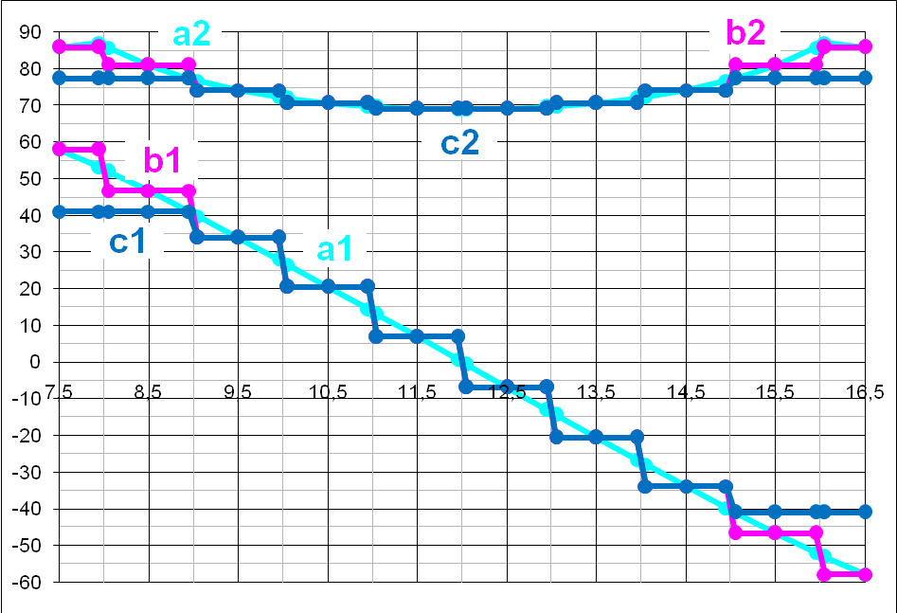
b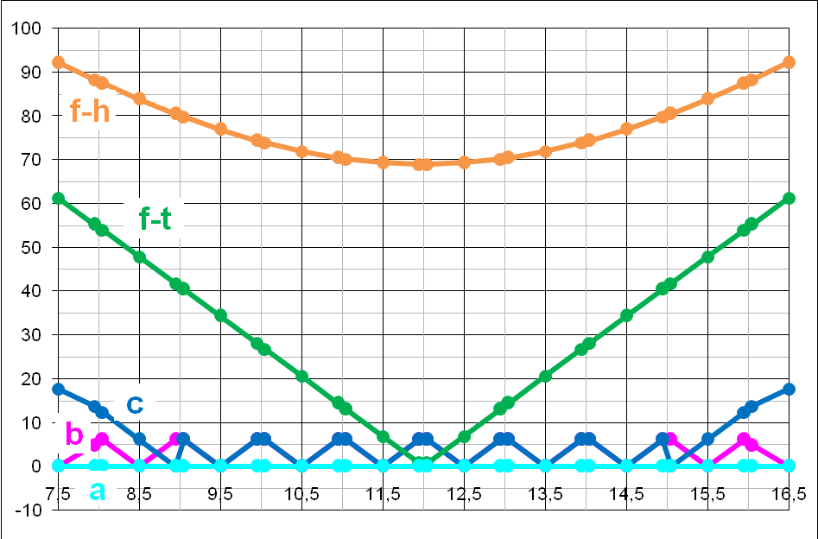
c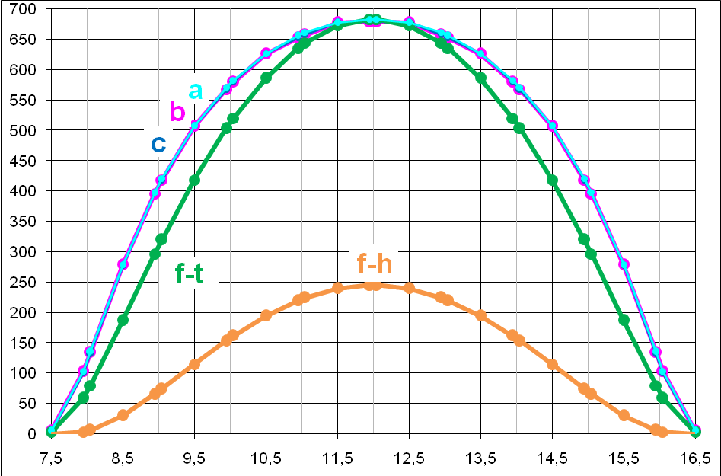
Figure 6. a) Continuous angles’ variations(the curves a1 and a2) and discontinuous/in steps angles’ variations (the curves b1,b2 and c1,c2) in terms of the day hour, realized by a pseodoequatorial tracker, during the winter solstice at 45,5° latitude N; b) the resulting incidence angle variations (the curves a, b and c); c) the variations of the panel received direct radiance (the curves a, b and c) compared with a horizontal and tilted fixed PV panel (the curves fh and ft resp.).
Relations (4) and (5) are used in the azimuthal system, whereas (6) and (7) are used in the equatorial one. Because the pseudoequatorial tracker type (Figure 2) is usually used in practice, instead of the equatorial tracker type, further on there is determined the unit vector of the sun-ray using the pseudoequatorial tracker in the premise that its movement is continuous; in this premise γ* =γ and β* =β (see Figure 2) and the normal unit vector to a panel coincides with the unit vector of the sun-ray:
${\left[{\bar{e}}_{\text{PV}−\text{eq}}\right]}_{x_{o}y_{o}z_{o}}=\left[\begin{matrix}\text{sin}β^{} \\ −\text{sin}γ∗\text{cos}β^{} \\ \text{cos}γ∗\text{cos}β^{}\end{matrix}\right]$; | (8)
By equalizing relations (8) and (3), the expressions of angles β and γ (in terms of angles δ, ω and φ) result:
$β=\text{arcsin}(\text{cos}δ⋅\text{sin}ω)$; $γ=\text{arcsin}\frac{\text{cos}δ⋅\text{cos}ω⋅\text{sin}ϕ−\text{sin}δ⋅\text{cos}ϕ}{\text{cos}β}$; | (9); (10)
Some variations of these angles are illustrated (with continuous lines) in the Fig. 4,a, 5,a and 6,a, in terms of the day hour. Analogous relations to previous ones can be obtained (in terms of angles α, ψ and φ) by equalizing rel. (8) and (2). Further, using the previous relations, the expression of the incidence angle sun-panel is established.

3. INCIDENCE ANGLE AND RECEIVED DIRECT SOLAR RADIANCE

The incidence angle sun-panel, realized by the pseodoequatorial tracker (see Figure 2), is determined as the “dot product” of the sunray unit vector and the PV panel normal unit vector:
$\text{cos}ν={\bar{e}}_{\text{sr}}⋅{\bar{e}}_{\text{PV}−\text{eq}}=\text{cos}β⋅\text{cos}β^{}⋅\text{cos}(γ−γ∗)+\text{sin}β\text{sin}β∗$; | (11)
After [3], the direct solar radiance R_{d} depends on the hour and day by the following expression:
$R_{d}=\text{1367}⋅[1+0,\text{0334}⋅\text{cos}(0,{\text{9856}}^{o}⋅N−2,{\text{72}}^{o})]⋅e^{−\frac{T_{R}}{0,9+9,4⋅\text{sin}α}}[W/{m^{2}}]$; | (12)
where N – number of the day, α – altitude from relation (4) and T_{R} – a factor whose values can be found in [3].
The part of the whole direct radiance R_{d} that falls on the panel, named panel received direct radiance, is given by relation (the Lambert’ cosine law): R_{dr} = R_{d}.cos ν ; because R_{d} ≠ constant, the efficiency optimization of the tracker demands a incidence angle variation which maximizes the size R_{dr}.
In terms of the day hour, in Fig. 4, 5 and 6 there are exemplified by numerical simulations the main variations of the: angles γ, γ*, β and β* (the curves a1, a2; b1, b2 and c1, c2), incidence angle (the curves a, b and c) and the received direct radiance for the tracked panel (the curves a, b and c) versus the horizontal- and tilted fixed panels, at 45°N latitude during the summer solstice, spring equinox and winter solstice resp. The comparative analysis of these variations highlights that the curves a, b and c from Figure 4,c, 5,c and 6,c are almost superposed and the areas under them are almost equal and more than the areas under the curves fh and ft.
Therefore, the maximum energetic efficiency can be obtained if the area under the curve of the received direct radiance becomes almost maximum for the least steps number. This conclusion is very important for the optimal design of the pseudoequatorial PV trackers.

5. CONCLUSIONS

In this paper there was modelled the incidence angle for the pseudoecquatorial dual-axis PV tracker, in order to establish the received direct radiance of the PV panel. The model was tested with Excel software and on basis of the numerical simulations, a comparison analysis of the incidence angle variations was made vs. the variations of the tilted- and horizontal fixed PV panel. By means of the obtained results, regarding the incidence angle variations, the received direct radiance of the tracked PV panel was modelled and simulated; the results highlight that: a) the incidence angle minimization only (by means of an pseodoequatorial tracker), can not assure the overall energetic efficiency optimization; b) this desideratum can be only reached if the area under the curve of the received direct radiance becomes almost maximum for the minimum number of steps; this is a very important conclusion for the optimal design of the PV solar trackers.

REFERENCES

- Messenger R., Ventre J.: Photovoltaic System Engineering, London, CRC Press, 2000.
- Diaconescu D. a.o.: Analysis of the Sun-Earth angles used in the design of the solar collectors' trackers, Bulletin of the Transilvania University of Brasov, vol. 13(47), 2006, pg. 99-105.
- Meliss M.: Regenerative Energiequellen – Praktikum, Berlin Heidelberg, Springer, 1997.

