The 2nd International Conference
″Computational Mechanics
and
Virtual Engineering″
COMEC 2007
11 – 13 OCTOBER 2007, Brasov, Romania

On the dynamics of carbon nanotubes by taking into consideration the van der Waals forces

Petre P.TEODORESCU, Veturia CHIROIU, Dan DUMITRIU, Ligia MUNTEANU
University of Bucharest, Faculty of Mathematics
Institute of Solid Mechanics of the Romanian Academy, Bucharest

Abstract.In this paper, the bending of the zigzag single-walled nanotube of carbon (10,0) is analyzed by coupling a nonlinear continuum theory to an atomistic theory. The effect of surface van der Waals forces on the binding energies is explained by using the soliton theory. The soliton theory is able to generalize the hinge concept towards a solitonic deformation concept. This concept describes the large inelastic deformations of nanotubes, as well as the mechanism nucleation and the fracture.

1. introduction

In the last few years there has been a strong interest in one-dimensional nanostructures based on carbon nanotubes. Devices such as field effect transistors, biosensors and IR light emitting diodes have been demonstrated. Carbon nanotubes are considered a leading candidate for replacing conventional CMOS electronics. Carbon nanotubes are used in composition of the polymer hybrid materials that have good elastic properties, piezoresistive sensing, and electrochemical actuation. We note the importance of the smart nanocomposite materials that are strong and selfsensing for structural health monitoring, or selfactuating to improve the performance and efficiency of structures and devices.
The carbon nanotubes as a quasi-one-dimensional structures were discovered by Iijima [1], Iijima and Ichihashi [2]. The carbon nanotube is one of the most promising building blocks for future development of functional nanostructures (Srivastava, Menon and Cho [3], Gao, Cagin and Goddard [4]). The single-walled carbon nanotubes can be regarded as a rolled-up graphite sheet in cylindrical form. Thess [5] produced crystalline ropes of metallic carbon nanotubes with 100–500 single-walled carbon nanotubes bundled into a two-dimensional triangular lattice. These nanostructures are expected to have remarkable mechanical, electronic and magnetic properties (Ruoff, Qian and liu [6]).
The bonding in carbon nanotubes is similar, but not identical, to the graphene sheet. To identify the types of SWCNT we refer to rolling up the graphene sheet. The geometric parameter associated with this process is the roll-up vector, which is a linear combination of the lattice basis and , with a particular integer pair . For , we have the zigzag form, for , the armchair form, and for other chiral.
For the interlayer potential we consider the Wang, Tomanek and Bertsch [7] expression based on the local density approximation method
, (1.1)
where is the equilibrium binding energy, is the hard-core repulsion energy, is the equilibrium distance between two carbon atoms, and . The van der Waals force is the interaction between the opposite walls of the nanotube when they approach each other. This force depends on the distance between the atoms. For large distances, the van der Waals force is attractive, but when the separation between the atoms is below the equilibrium distance of 3.42 Å, it becomes strongly repulsive.
With the increase in the bending angle , the top and bottom parts of the kink get closer to each other, and at a certain stage, the distance between them reaches the equilibrium distance. Upon additional bending, this distance remains unchanged because there are no external normal loads applied on the walls to prevail over the repulsive van der Waals forces. The van der Waals force between atom i and j can be expressed by the Lennard-Jones potential as (Chiroiu, Ştiucă, Munteanu and Donescu [8])
, (1.2)
where , , and the distance between atoms.
In this paper consider a zigzag carbon nanotube (10,0) of radius 6,26, with the Young modulus 4.88 TPa and Poisson coefficient. When the external bending moment increases, the tube will locally buckle at. For, a coupled atomistic-continuum theory is applied since the continuum theory is no longer valid.

2. Fundamental equations

Let us model the nanotube as a thin elastic, homogeneous and isotropic rod of length l, straight and having a circular cross section of radius al in its natural state. External moments fix the ends of the tube. We suppose the rod deforms in space by bending (Munteanu and Donescu [9), Teodorescu, Chiroiu and Munteanu [10], [11]). The rod occupies at time the region . After motion takes place at time , the rod occupies the region . We know the motion of the rod between and if and only if we know the mapping , which takes a material point in at t = 0 to a spatial position in at t = . The position of a material point in may be denoted by a rectangular fixed coordinate system and the spatial position of the same point in, by the moving coordinate system . Following the current terminology, we shall call X the material or Lagrange coordinates and x the spatial or Euler coordinates. The origin of these coordinate systems is lying on the central axis of the rod. The motion of the rod carries various material points through various spatial positions. This is expressed by . We take s to be the coordinate along the central line of the natural state. The orthonormal basis of the Lagrange coordinate system is denoted by, and the orthonormal basis of the Euler coordinate system by . The basis is related to by the Euler angles and . These angles determine the orientation of the Euler axes relative to the Lagrange axes
(2.1)
The Z-axis coincides with the central axis. The plane intersects the plane (XY) in the nodal line ON. The motion of the rod is described by three vector functions
(2.2)
The material sections of the rod are identified by the coordinate s. The position vector can be interpreted as the image of the central axis in the Euler configuration. The functions , can be interpreted as defining the orientation of the material section s in the Euler configuration. The function , represents the unit tangential vector along the rod. We introduce the strains by, where means the partial differentiation with respect to s.
Since , is orthonormal, there is a vector that measure the bending of the bar,.such as , , with
, , , (2.3)
where and are Euler angles. The exact 3D equilibrium equations of the nanotube with the ends fixed by the external moment are given by
(2.4)
where A is the bending stiffness . The curvature , in the longitudinal direction, the nondimensional curvature , the deformation parameter , are defined as
, , , (2.5)
where and , are the radius before and after deformation. The strain energy per unit length is given by
. (2.6)
The total energy of the tube and the bending moment can be written as
, , (2.7)
where is the bending angle. The critical compressive stress , and the critical bending moment in local buckling are
, , (2.8)
where is the axial load. The deformation decreases the value of the critical bending moment as . For small , the radius of the local curvature is .
Thus, the maximum compressive stress is a fraction of the critical compressive stress , where is the dimensionless extreme fiber stress. The compressive stress is therefore
, , . (2.9)
The coupled atomistic theory is an attempt to bridge the length scales in a single seamless model with the aid of the finite element method). The basic idea of the co8upling method is carried forward to dynamics, in that representative atoms are chosen, and a finite element mesh is constructed with these as nodes. All the atoms of a solid are the same species and the mass of each of them is . In the following, atoms in the atomistic region, atoms on the interface, and pseudoatoms in the pad will be denoted by the subscripts and respectively. The transition region is shown schematically in Fig. 2.1. On one side of the transition region is the atomistic region in which every atom is explicitly represented and treated using interatomic potentials. On the other side, there is a FE mesh with its associated nodes in which the nodes sit on atomic lattice sites although not all atom sites are nodal positions. At the interface between the FE nodes and the atoms there is a one-to-one correspondence between atoms and nodes on the FE mesh. Moving away from the interface on the continuum side, the FE nodes become sparse and the corresponding elements become larger (Teodorescu, Dumitriu and Chiroiu [13]). Finally, there is a pad region where pseudoatoms exist on the continuum side of the interface. Some of the pad atoms coincide with the FE nodes while others lie within the elements. The idea of the pad, as a set of atoms that are degrees of freedom that can be separate from the nodes in the FE mesh, is used to take account of the nonlocal interactions between atoms (Curtin and Miller [14]).
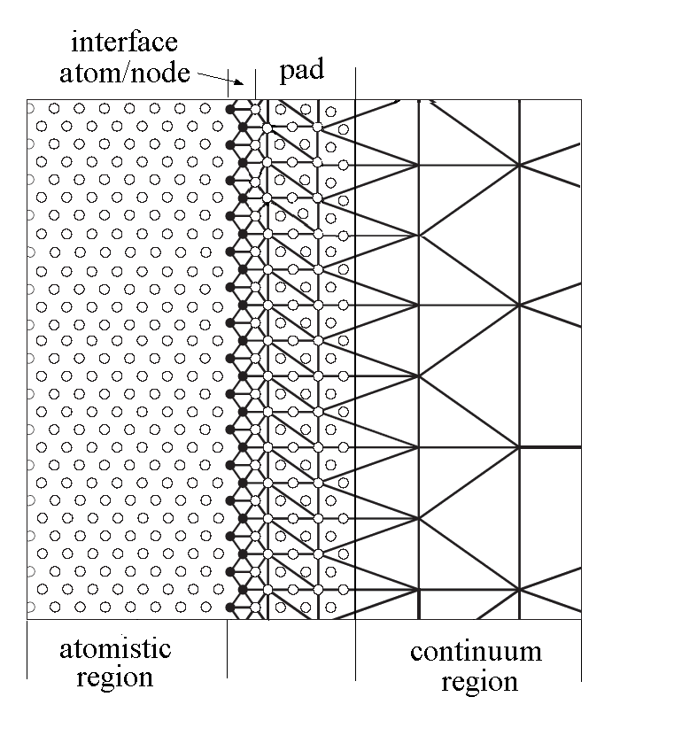
Fig. 2.1. The atomistic/continuum transition region (after Curtin and Miller [14).

The methods at the atomic-scale is governed by quantum mechanics. The total energy is a function of the all coordinates, which are the electronic degrees of freedom. The energy functional is minimized with respect to the electronic degrees of freedom for fixed coordinates. The force on an individual nucleus is obtained by the derivative of the total energy with respect to the considered coordinate.
The total atomic energy obtained from classical potentials is , where is the energy of the ith atom
, (2.10)
with an electron-density dependent embedding energy, is a pair potential between -th and -th and is the interatomic distance.
The electron density at atom i, is the superposition of density contributions from each of the neighbours. Forces on each atom, in the absence of external forces, are , where the comma means differentiation with respect to . In atomistic case, there is no direct consideration of the continuum concepts of strain or displacement. We follow the motion of individual atoms without reference to their original positions, and the occurred deformations may violate many assumptions about the continuity of deformations.

3. The solitonic mechanism

Solitons or solitary waves are localized functions with no change in shape. In the mathematics literature the word soliton refers to solitary traveling waves which preserve their identities after a pair-wise collision. The solutions of (2.4) are
, .
These equations are valid up to the point of local buckling at . For larger angles, the continuum theory must be coupled with the molecular dynamic theory. When the external bending moment increases, the axial compression in the tube increases too, and when the compressive stress reaches a critical value, the tube will locally buckle. The value of at the point of local buckling is around 0.14. Once the solitonic mechanism starts, the nanotube becomes a mechanical mechanism and the formulas in the continuum theory is no longer valid..
For , the coupled theory put into evidence a solitonic mechanism of deformation. In according to experiments and molecular dynamics simulations, the pattern of the deformation resembles the soliton mechanism similar to that of a macrotube. A portion of the wall flattens and forms a domain that rotate about a central hinge line. This portion is treated by the molecular dynamic. The remaining part of the tube remains circular although it flattens and decreases its curvature. This part is treated by the continuum theory. In the coupling theory, the total energy will be a function of the all coordinates, which are the electronic degrees of freedom. The energy functional is minimized with respect to the electronic degrees of freedom for fixed coordinates. The force on an individual nucleus is obtained by the derivative of the total energy with respect to the considered coordinate.
. Upon complete unloading from angles below 110° the nanotube completely recovers. At a very large bending angle of 120°, atomic bonds break and the deformation of the nanotube becomes irreversible. A consequence of the solitonic deformation mechanism is the rippling configuration of the nanotube. For a curvature large enough, our coupled atomistic-continuum analysis leads to a solution corresponding to a rippling configuration.

4. Conclusions

The macroscopic theories attempt to model the smaller scale phenomena into effective properties or constitutive laws, but the macroscopic phenomena such as fracture, depend on the details of smaller scale phenomena. On the other hand, the atomistic description does not provide for the determination of macroscopic behaviour, since the higher scale interactions operate to drive large-scale behaviour.
In this paper, we apply a soliton-atomistic coupled theory for the bending of a zigzag single-walled nanotube of carbon (10,0) analysis. When the external bending moment increases, the axial compression in a (10,0) zigzag nanotube increases too, and when the compressive stress reaches a critical value, the tube will locally buckle at , where is the bending angle. For , a solitonic deformation mechanism is starting and a portion of the nanotube becomes to rotate about a central hinge line. For large distances, the van der Waals force is attractive, but when the separation between the atoms is below the equilibrium distance of 3.42 Å, it becomes strongly repulsive. Upon complete unloading from angles below 110° the nanotube completely recovers. At a very large bending angle of 120°, atomic bonds break and the deformation of the nanotube becomes irreversible.

Acknowledgments

The authors acknowledge the financial support of the National University Research Council (NURC-CNCSIS) Romania, Grant nr. 55/2007, cod 160/2005.
References

- Iijima, S., Helical microtubules of graphitic carbon, Nature, London, 354, pp.56–58, 1991.
- Iijima, S., Ichihashi, T., Single-shell carbon nanotubes of 1 nm diameter, Nature, London, 363, pp. 603–605, 1993.
- Srivastava, D., Menon, M., Cho, K., Nanoplasticity of Single-Wall Carbon Nanotubes under Uniaxial Compression, Physical Review Letters, 83, 15, pp.2973–2976, 1999.
- Gao, G., Cagin, T, Goddard, W. A., Energetics, structure, mechanical and vibrational properties of single-walled carbon nanotubes, Nanotechnology, 9, pp.184–191, 1998.
- Thess, A., Crystalline ropes of metallic carbon nanotubes, Science, 273, pp.483–487, 1996.
- Ruoff, R.S., Qian, D., liu, W.K., Mechanical properties of carbon nanotubes: theoretical predictions and experimental measurements, Comptes Rendus Physique, 4, pp.993–1008, 2003.
- Wang, Y., Tomanek, D., Bertsch, G.F., Stiffness of a solid composed of C60 clusters, Phys. Rev. B 44, 12, pp.6562–6565, 1991.
- Chiroiu, V., Ştiucă, P., Munteanu, L., Donescu, St., Introducere in nanomecanica, Editura Academiei, 2005
- Munteanu, L., Donescu, St., Introduction to Soliton Theory: Applications to Mechanics, Book Series “Fundamental Theories of Physics”, 143, Kluwer Academic Publishers, 2004.
- Teodorescu, P.P., Chiroiu, V., Munteanu, L., On the soliton mechanism of bending for carbon nanotubes, Review Science and Composite Engineering of Material, special issue (ed. Moussa Karama), pp. 291-296, 2006.
- Teodorescu, P.P., Chiroiu, V., Munteanu, L., The pseudosherical reduction of an uniaxial deformation of the Carbon nanotubes, Proceedings of the 5th Conference of Balkan Society of Geometers, Geometry Balkan Press, BSG Proc., 2006 (ed. C. Udriste), pp.157-165, 2006.
- Teodorescu, P.P., Munteanu, L., Chiroiu, V., On the dynamics of carbon nanotubes, A XXX-a Conferinta Nationala de Mecanica Solidelor, 15-16 sept. 2006, vol. 9, pp.7-12, Constanta.
- Teodorescu, P.P., Dumitriu, D., Chiroiu, V., On the coupled atomistic-continuum methods with applications to carbon nanotubes dynamics, International Workshop “Advanced Researches in Computational Mechanics and Virtual Engineering”, 18-20 Oct.2006, pp. 41-46, Brasov, 2006.
- Curtin, W.A., Miller, F., Atomistic/continuum coupling in computational material science, Modelling and Simulation in Materials Science and Engineering, 11, pp. R33-R68, 2003.

