The 2nd International Conference
″Computational Mechanics
and
Virtual Engineering″
COMEC 2007
11 – 13 OCTOBER 2007, Brasov, Romania

STRUCTURAL SYNTHESIS OF RUDDER, AILERON AND
ELEVATOR AIRCRAFT CONTROL
BY MBS METHOD

Marius GHITESCU¹
¹Department of Product Design and Robotics
TRANSILVANIA University of Brasov Bv. Eroilor 29, Brasov Romania Email: motanmotan34@yahoo.com

Abstract: The aim of the paper is structural synthesis of linkages used in airplane control, on bases of the Multibody System method (MBS). In virtual prototyping of the aircraft , these linkages have to be modeled by a minimum number of bodies (MBS min). In the paper an appropiate algorithm is descriebed and also applied for concrete mechanical systems. This will be the bases for dynamic modelling of these subsystems as parts of the whole product.
Keywords: mechanical systems, multibody systems, structural modeling, kinematic analysis, aircraft, Flaps

1. INTRODUCTION

Generally control surfaces of an aircraft include: ailerons , rudder , elevator and flaps [12].
(see figure1). Movement of this surfaces generate roll, pitch and yaw.
In design process of an aircraft one of the main step is virtual prototyping.
In virtual prototyping of the aircraft, mechanical systems are considered as Multibody Systems (MBS). They have to be modelled as MBS with minimum number of bodies (MBS min) to favorise obtaining real time simulation of aircraft.
The aim of this paper is structural modelling of linkages used for actioning of rudder, aileron and elevator as multibody systems. On bases of MBS, kinematic and dynamic models could be obtained.
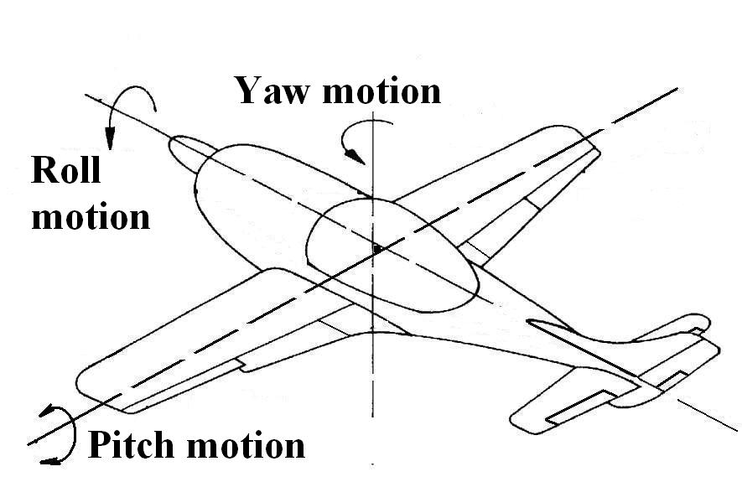
Aileron
Flaps
Elevator
Rudder
Figure 1 Aircraft control

2. THEORETICAL CONSIDERATION

According to MBS theory, a mechanical system is considered as a collection of bodies linked between them by geometrical and driving constraints[1,2,7,8].
The body is an entity which in the dynamic model will have mass and moment of inertia, and also could take over the external forces.
Motion of a rigid body in space can be described by six generalized coordinates - S_{x} , S_{y} , S_{z} = translation, φ_{z} ,φ_{y} ,φ_{z} = rotation (x,y,z are the orthogonal axes) Planar motion has S_{x} , S_{y} , φ_{z} [1,2,7]
Global Reference Frame GRF is a coordinate system represented three orthogonal axes fixed in time. This coordinate system is rigidly connected to fixed body .
Body Reference Frame BRF is a coordinate system formed by three orthogonal axes connected to each mobile body component to the MBS system[1,2,7,8].
In a linkage having “n” elements number of bodies n_{b} is :
(1)
n_{b} n
n_{b min} n_{b} n

n_{b min} representing the minimum number of bodies for modeling a concrete linkage[1,2,8]
The geometrical constraint imposes restrictions in bodies relative motion. Number of restriction is
r =1 and r = 2 in the case of planar systems (S =3), respectiv r = 1…5 in the case of three dimensional systems (S = 6).
The restrictions are imposed by joints or composite joint. In planar systems they are: rotation R
(r =2), translation T (r =2), rotation-rotation RR (r =1), rotation –translation RT (r =1) curve –curve CC (r = 1) [4,9,11].For spatial systems few frequently joints are: cylindrical joint (r=4), spherical joint (r=3), cylinder – plane (r=2),sphere-sphere SS (r=1), rotation – rotation RR – cardan joint (r=4), rotation R (r=5),
sphere – rotationSR (r = 2).
Driving constraints corespond to the mobility M of the system Of course M 1 .Between number of bodies n_{b} number of geometrical constraints (Σr) in a concrete space S , and mobility M there is the relation [1,2,7,8]
(2)
M = S (n_{b} - 1) – Σ r

The algorithm for MBS modelling with minimum number of bodies has the following steps:
- Identifying the bodies , in order:
- fixed body,
- input body (bodies),
- output body (bodies),
- bodies with more than two connection,
- bodies with applied forces,
- other bodies (if necessary).
- Identifying geometrical constraints:
- type ,
- location,
- number of restriction.

3. STRUCTURAL ANALYSIS OF CONCRETE LINKAGES

In this paper , three linkage used for rudder , aileron and elevator control are analized.
The bases of this linkage is aircraft structure , that represent for the linkage – fixed body. The output body are the ailerons,rudder and elevator.The input motion is generated by pilot from control lever by intermediate of mechanical / hydraulic actuators.

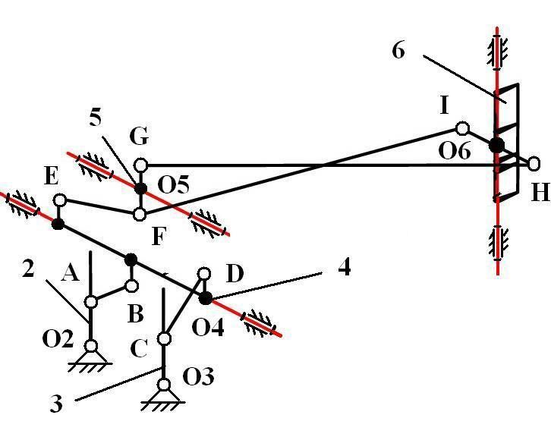
Figure 2 Rudder control

Table 1: Rudder control (see fig 2)
Body i  Body j | gc | Location | Number of  M = S (n_{b} - 1) – Σ r  Σ r = 29  n_{b} = 6 si S = 6  M = 1  constraints
1-2 | R | O2 | 5
1-3 | R | O3 | 5
1-4 | R | O4 | 5
1-5 | R | O5 | 5
1-6 | R | O6 | 5
2-3 | - | - | -
2-4 | SS | AB | 1
2-5 | - | - | -
2-6 | - | - | -
3-4 | SS | CD | 1
3-5 | - | - | -
3-6 | - | - | -
4-5 | SS | EF | 1
4-6 | - | - | -
5-6 | SS | GH | 1

The linkage (rudder control) from fig 2 is modeled as MBS min having 6 bodies, five geometrical constraints type R and four geometrical constraints type SS. The input body is body 2 and the output body is the rudder 6. Mobility M =1.
When pilot push the right leg , body number 4 ( = EO4BD) turn around about fixed axis through O4. Pull rod EF go down and body number 5 = GF turn around along fixed axis through O5 point .Rod IH is fixed to output body 6 (see fig 2).When GO5F turn around to horizontal fixed axis through O5 , body 6 (rudder) turn around along vertical axis through O6 point (see fig 2).
The rudder is controlled by foot pedals in the cockpit.Movement of rudder generate aircraft yaw motion (rotate the aircraft along vertical axis - see fig 1).

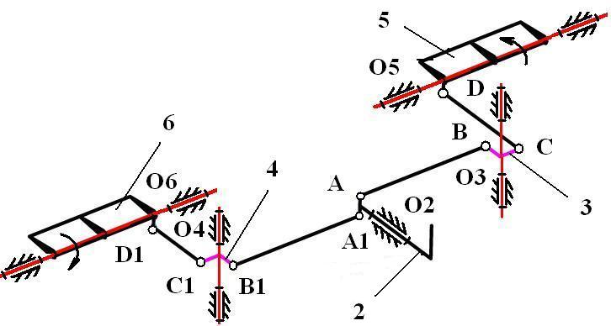
Figure 3 Aileron control

Table 2: Aileron control (see fig 3)
Body i  Body j | gc | Location | Number of  M = S (n_{b} - 1) – Σ r  Σ r = 29  n_{b} = 6 si S = 6  M = 1  constraints
1-2 | R | O2 | 5
1-3 | R | O3 | 5
1-4 | R | O4 | 5
1-5 | R | O5 | 5
1-6 | R | O6 | 5
2-3 | SS | AB | 1
2-4 | SS | A1B1 | 1
2-5 | - | - | -
2-6 | - | - | -
3-4 | - | - | -
3-5 | SS | CD | 1
3-6 | - | - | -
4-5 | - | - | -
4-6 | SS | C1D1 | 1
5-6 | - | - | -

The linkage[11](aileron control) from fig3 is modeled as MBS min having 6 bodies, five geometrical constraints type R and four geometrical constraints type SS. The input body is body 2 and the output bodies are the ailerons 5 and 6. Mobility M =1.
Ailerons can be move up or down.This is made by rotating the control stick 2 (see fig 3) left or right.
When pilot turn control stick 2 (see fig 3) pull rods AB and A1B1 drive the levers BO3C and B1O4C1. This levers move around verticals fixed axis through O4 and O3 points (see fig 3).
Final , rods CD and C1D1 actuate the output bodies 5 and 6 (ailerons) rotate along horizontals fixed axis through O5 and O6 points (see fig 3).
The ailerons are located on the trailing edge of the wing (see fig 1).Movement of this control surfaces generate more lift to one wing and less lift to other wing - aircraft roll motion (see fig 1).
.

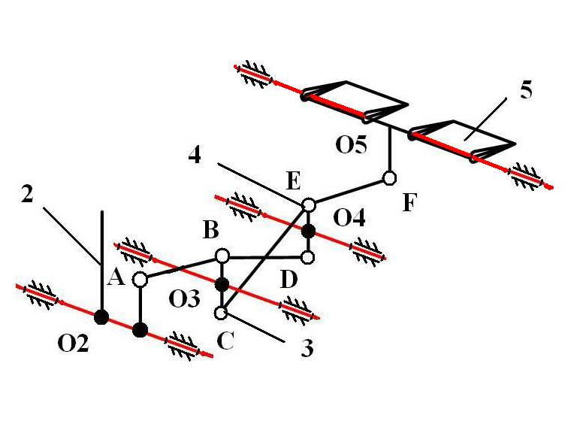
Figure 4 Elevator control

Table 3: Elevator control (see fig 4)
Body i  Body j | gc | Location | Number of  M = S (n_{b} - 1) – Σ r  Σ r = 23  n_{b} = 5 si S = 6  M = 1  constraints
1-2 | R | O2 | 5
1-3 | R | O3 | 5
1-4 | R | O4 | 5
1-5 | R | O5 | 5
2-3 | SS | AB | 1
2-4 | - | - | -
2-5 | - | - | -
3-4 | SS | BD | 1
3-5 | - | - | -
4-5 | SS | EF | 1

The linkage (elevator control) from fig 4 is modeled as MBS min having 5 bodies, four geometrical constraints type R and three geometrical constraints type SS. The input body is body 2 and the output body is the elevator 5. Mobility M =1.
When pilot actuate control stick 2 (see fig 4) pull rod AB go back and turn around body 3 (BO3C) along one horizontal fixed axis through O3 point.Body 4 (EO4D) move around horizontal fixed axis through O4 point. Rod EF actuate outbody 5 (elevator) and move this around horizontal fixed axis through O5.
Elevator 5 (see fig 4) move upward and downward when pilot push and pull back control stick.
This movement of elevators generate aircraft pitch motion (see fig 1).

5. REFERENCES

[1] Catalin,Alexandru.,Simularea pe calculator a sistemelor mecanice articulate, Ed.LuxLibris, Brasov2000.
[2] Catalin,Alexandru.,Dinamica sistemelor mecanice pe baza prototiparii virtuale cu aplicare la mecanismele suspensiei vehiculelor,Ed.Universitatii Transilvania din Brasov 2003
[3] Deladi , S. , Deladi , L . , Voicu , C. – Indrumar de laborator – Instalatii de comanda si
conducere a aeronavelor Universitatea Transilvania din Brasov 2001
[4] Deladi , S. , Deladi , L . , Deliu , Gh. – Mecanica aeronavelor Indrumar de proiect –
Universitatea Transilvania din Brasov 2001
[5] Grosu Ion.,Calculul si constructia avionului,Editura Didactica si Pedagogica Bucuresti 1965.
[6] Haug, J.E., Computer Aided Kinematics and Dynamics of Mechanical Systems , Allyn and Bacon,U.S.A., 1989
[7] Shabana, A., Dynamics Of Multibody Systems, A Wiley Interscience Publication, 1989
[8] Visa,I., Alexandru,P., Alexandru,C.,Talaba,D., Proiectarea functionala a mecanismelor ,Metode clasice si moderne, Editura Lux Libris ,Brasov 2004
[9] Visa,I., Antonya,Cs.,Structural synthesis of planar linkages as multibody systems, Proceedings of the Eighth IFToMM International Symposium on Theory of Machines and Mechanisms Bucharest, Romania Syrom,2001
[10] Visa,I.,Mechanical Systems Modeling as Multibody Systems in Product Design, Brasov,Romania,PRASIC 2002
[11] W.T.Rouse., Combination Aileron and Wing Flap, U.S.Patent Nr.1999528/1934
[12] Lawrence,Y,Lam., Michael,Lam.,Aileron For Fixed Wing Aircraft, In: United States Patent US6554229B1,2003

