2st International Conference
″Computational Mechanics and Virtual Engineering ″
COMEC 2007
11 – 13 October 2007, Brasov, Romania

MODELING THROUGH FINITE ELEMENT METHOD OF ELASTIC ELEMENTS FROM COMPONENCE OF A NEW ELASTIC COUPLING WITH BOLTS AND NONMETALLIC ELEMENTS

M. RADU¹,
¹ Transilvania University of Brasov, Brasov, ROMANIA, marilenaradu@uitbv.ro

Abstract: In this paper will be presents influence of material characteristics and limit and loading conditions on the states of displacements, Von Mises stress and principal tensions. The modeling of the nonmetallic element is made for different qualities of rubber.
Keywords: elastic coupling, cylindrical bolts, nonmetallic forms, finite element method, characteristics of material.

1. INTRODUCTION

The paper presents some aspects about modeling through method by finite element analyze of a new elastic coupling with cylindrical bolts and nonmetallic elements, and the nonmetallic element supposed of modeling by finite elements is presented in figure 1, b [5].

a
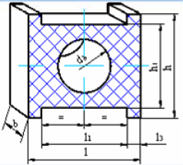
b
Figure 1: Elastic coupling with cylindrical bolts and intermediate nonmetallic elements
2. THE INFLUCENCE OF MATERIAL CHARACTERISTICS, LIMIT AND LOADING CONDITIONS ON THE ANALYSE WITH FINITE ELEMENT OF NONMETALLIC ELEMENT

The method by analyze with finite element of elements from different qualities of rubber has at base hypothesis of nonlinear viscous-elastic behaviour of material used for nonmetallic form. The modeling of nonmetallic element was realized with CATIA V5R8 software [1, 2, 3].
At form presented in figure 1, b, was defined the material characteristics corresponded of Natural Rubber (NR) - for first modeling, respective those of Butadiene Acrilonitrilic Rubber (NBR) – for the second modeling [5].
For establishment of loadings applied of model was realize a functionary analyze of group by component elements plates –gasket of rubber – bolt/bolts and it was imposed the restrictions presented in figures 2 and 3. In these figures may observe that nonmetallic element was bearded in left side on lateral surface, to interior, of pin and fixed on your lateral surface situated to exterior in right side of this form.
The loading of model is realized through introduction of forces (see figure 2 and figure 3). In figure 2 was applied a parabolic distribution of force, and in figure 3 was applied a uniform distribution of force. So, for this form of nonmetallic element was applied, in the both cases, a force by value F=150 N, on the interior circularly surface, by d_{b} =16 mm diameter; this force correspond of capable theoretical torsion moment, M_{t} = 37325 Nmm.

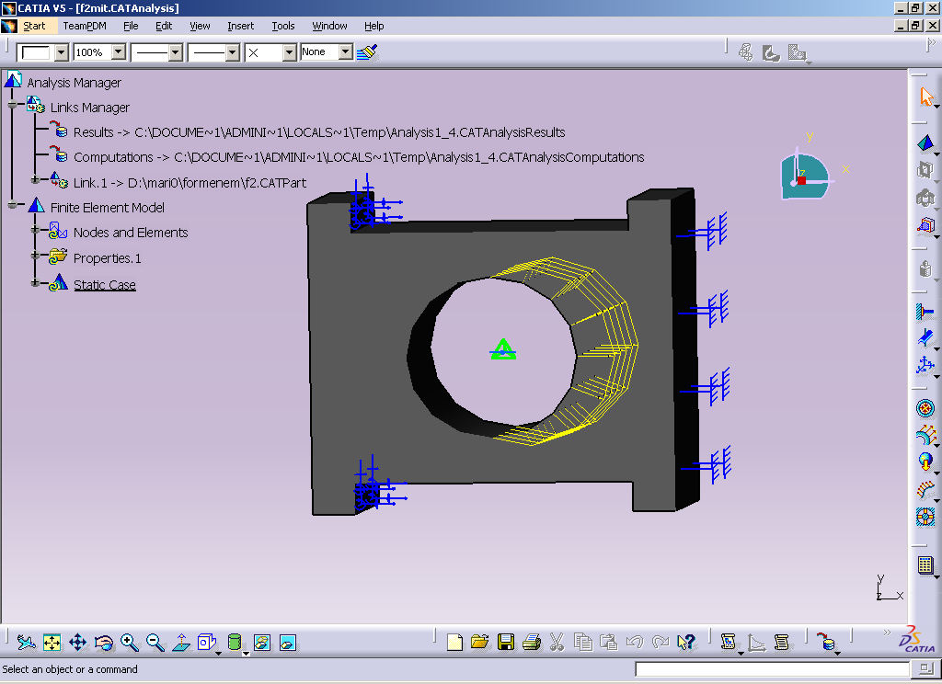
Figure 2: The restrictions and parabolic distribution of applied force

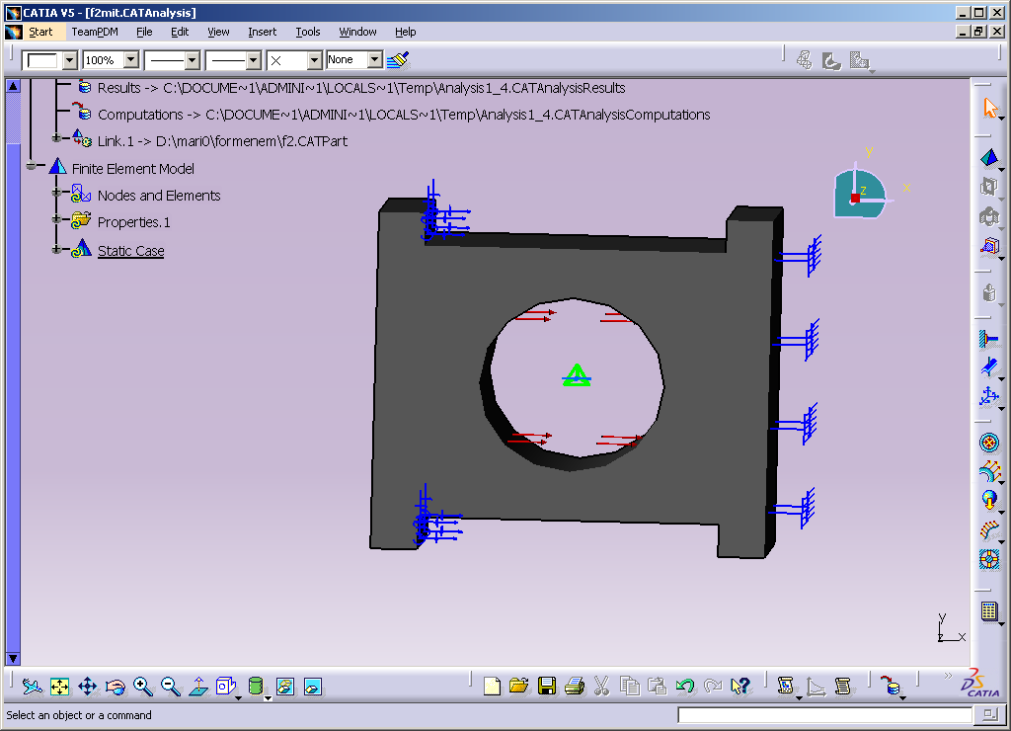

Figure 3: The same restrictions and uniform distribution of applied force

The states of displacements and tensions, in case of material characteristic corresponded of natural rubber (NR) form and parabolic distribution of force, are presenting in figures 4… 6. After how it may observe in figure 4, the maxim deformation of nonmetallic element is by 1,76 mm and it appear in circular zone where it was applied radial force distributed parabolic.
In nonmetallic element appear Von Mises tensions (equivalent tensions – see figure 5), and values diversify between (1,78*10⁴ ... 1,01*10⁶) N/m², but and principal tensions (by compression, traction) which may be observe in figure 6, values of these varied between (- 1,82*10⁶ ... 1,52*10⁶) N/m² .

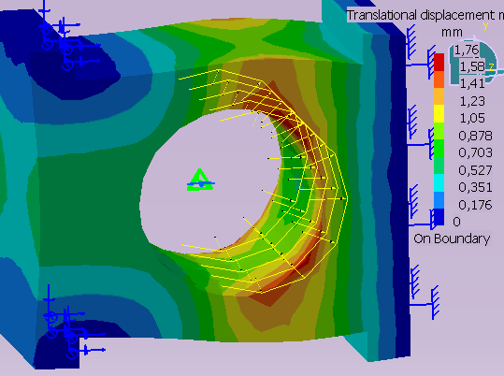 | 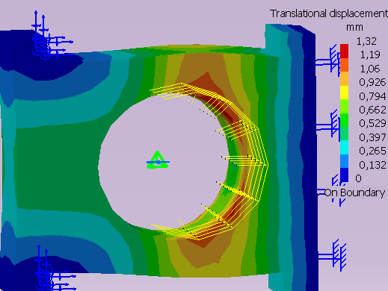
Figure 4: The displacement of nonmetallic element from natural rubber (NR) | Figure 7: The displacement of nonmetallic element from butadiene acrilonitrilic rubber (NBR)
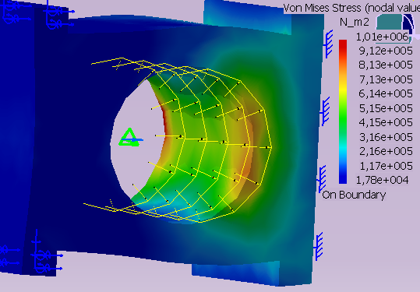 | 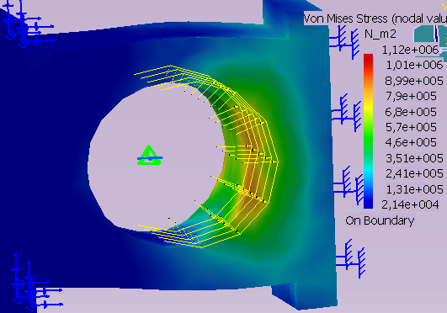
Figure 5: Von Mises Stress - NR form | Figure 8: Von Mises Stress - NBR form
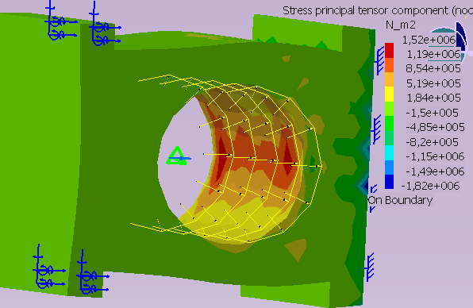 | 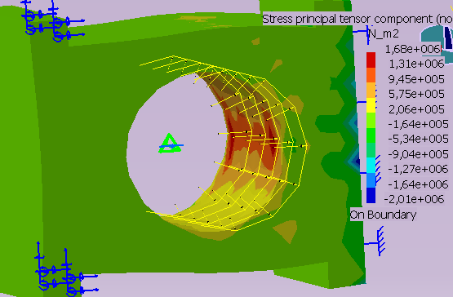
Figure 6: The principal tensions from nonmetallic element from NR | Figure 9: The principal tensions from nonmetallic element from NBR

The states of displacements and tensions, in case of material characteristic corresponded of butadiene acrilonitrilic rubber (NBR) form and parabolic distribution of force, are presenting in figures 7… 9. After how it may observe in figure 7, the maxim deformation of nonmetallic element is by 1,32 mm and it appear in circular zone where it was applied radial force distributed parabolic. In nonmetallic element appear Von Mises tensions (equivalent tensions – see figure 8), and values diversify between (2,14*10⁴ ... 1,12*10⁶) N/m², but and principal tensions (by compression, traction) which may be observe in figure 6, values of these varied between (- 2,01*10⁶ ... 1,68*10⁶) N/m² .
The states of displacements and tensions, in case of material characteristic corresponded of natural rubber (NR) form and uniform distribution of force, are presenting in figures 10… 12.
After how it may observe in figure 10, the maxim deformation of nonmetallic element is by 2,4 mm and it appear in circular zone where it was applied radial force distributed uniform. In nonmetallic element appear Von Mises tensions (equivalent tensions – see figure 11), and values diversify between (1,01*10⁴ ... 3,83*10⁵) N/m², but and principal tensions (by compression, traction) which may be observe in figure 12, values of these varied between (- 9,312*10⁵ ... 5,83*10⁵) N/m² .

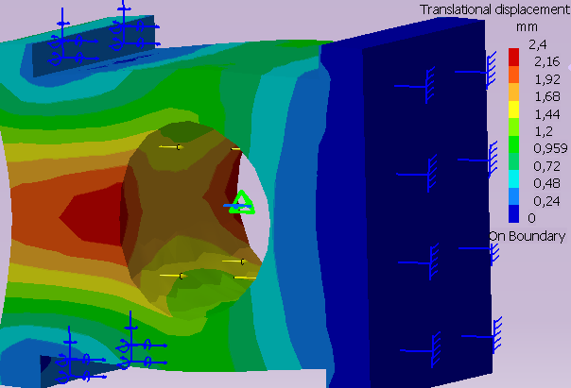 | 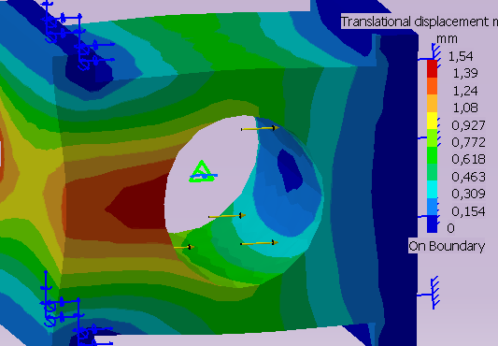
Figure 10: The displacement of nonmetallic element from natural rubber (NR) | Figure 13: The displacement of nonmetallic element from butadiene acrilonitrilic rubber (NBR)
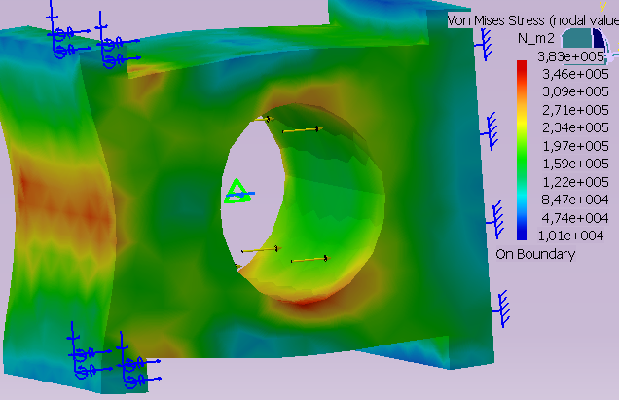 | 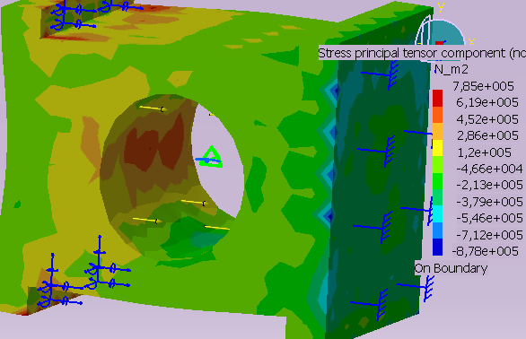
Figure 11: Von Mises Stress - NR form | Figure 14: Von Mises Stress - NBR form
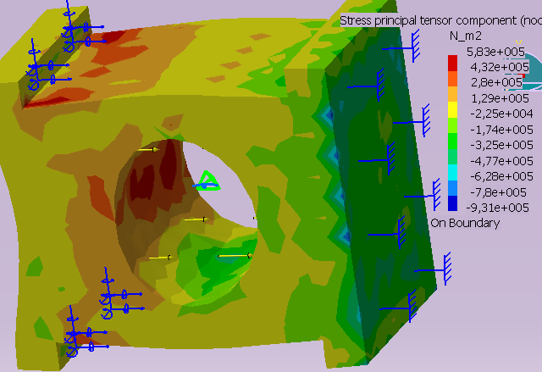 | 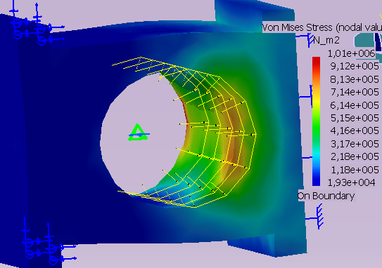
Figure 12: The principal tensions from nonmetallic element from NR | Figure 15: The principal tensions from nonmetallic element from NBR

The states of displacements and tensions, in case of material characteristic corresponded of butadiene acrilonitrilic rubber (NR) form and uniform distribution of force, are presenting in figures 13… 15.
After how it may observe in figure 13, the maxim deformation of nonmetallic element is by 1,54 mm and it appear in circular zone where it was applied radial force distributed uniform.
In nonmetallic element appear Von Mises tensions (equivalent tensions – see figure 14), and values diversify between (-8,78*10⁵ ... 7,85*10⁵) N/m², but and principal tensions (by compression, traction) which may be observe in figure 15, values of these varied between (1,93*10⁴ ... 1,01*10⁶) N/m² .
The previous results presented for states by displacements and tensions which were appeared in analyzed nonmetallic element, for the different characteristics of material, different limit and loading conditions, were centralized in the table 1.

Table 1: The results of modeling
Crt. Nr. | Applied material | Limit and loading conditions | Applied force,  F=150 N
Crt. Nr. | Applied material | Limit and loading conditions | Obtained results behind modeling
1. | Natural Rubber |  | Maxim Displacement: 1,76 mm
1. | Natural Rubber |  | Von Mises Stress: (1,78*10⁴...1,01*10⁶) N/m²
1. | Natural Rubber |  | Principal Tensions:(-1,82*10⁶...1,52*10⁶) N/m²
1. | Natural Rubber |  | Maxim Displacement: 2,4 mm
1. | Natural Rubber |  | Von Mises Stress: (1,01*10⁴...3,83*10⁵) N/m²
1. | Natural Rubber |  | Principal Tensions: (-9,31*10⁵...5,83*10⁵) N/m²
2. | Butadiene acrilonitrilic rubber |  | Maxim Displacement: 1,54 mm.
2. | Butadiene acrilonitrilic rubber |  | Von Mises Stress: (1,09*10⁴...4,01*10⁵) N/m²
2. | Butadiene acrilonitrilic rubber |  | Principal Tensions: (-8,78*10⁵...7,85*10⁵) N/m²
2. | Butadiene acrilonitrilic rubber |  | Maxim Displacement: 1,2 mm
2. | Butadiene acrilonitrilic rubber |  | Von Mises Stress: (1,93*10⁴...1,1*10⁶) N/m²
2. | Butadiene acrilonitrilic rubber |  | Principal Tensions: (-1,82*10⁶...1,52*10⁶) N/m²

3. CONCLUSIONS

The analyze through finite element method of nonmetallic elastic elements from componence of elastic coupling with cylindric bolts and nonmetallic elements was very important.
In modeling with finite element of nonmetallic element was imposed diverse material characteristics, the same limit conditions and realized analyzes for the same values of loading force, but different distribution of force. and arrived following conclusions:

- through imposing of different limit and loading conditions, but and different characteristics of material applied nonmetallic element, is establishment that and of modifications of limit conditions, the displacement of nonmetallic element is decreasing;
- through application of distributed uniform pressure on the interior circularly surface of analyzed element, force corresponded of capable theoretical torsion moment, with rise of Young modulus of applied material, is establishment a decreasing of analyzed element displacement, maxim displacement being obtained in case applying of material characteristics corresponded the natural rubber and uniform distribution of force;
- Von Mises stresses are maximum in case of nonmetallic element from natural rubber and of parabolic distribution of force;
- the principal tensions are maximum in case of nonmetallic element from natural rubber and of parabolic distribution of force.

REFERENCES

- Catia®Software Corporation. Catia® Version 5.8. Copyright © Dassault Systemes 1994-2002.
- Mogan, Gh.L. Finite elements Method in engineering – practice applications. Lux Libris Publishing, Brasov, 1997.
- Mogan, Gh.L. Finite elements Method in engineering–theoretic bases. Lux Libris Publishing, Brasov, 1999.
- Radu M.: A new elastic coupling with nonmetallic elements, 3rd International Conference, „Research and Development in Mechanical Industry”, RaDMI 2003, Herceg Novi, Serbia and Montenegro, pg. 1935-1939.
- Radu, M. ş.a.: Doctoral thesis - Theoretical and experimental studies as concerns couplings with nonmetallic elastic elements. Brasov, 25.11.2005.

