1st International Conference
″Computational Mechanics and Virtual Engineering ″
COMEC 2005
20 – 22 October 2005, Brasov, Romania

MEDICAL REHABILITATION USING VIRTUAL REALITY

Baritz Mihaela Ioana¹
¹ University TRANSILVANIA from Brasov, Brasov, ROMANIA, mbaritz@unitbv.ro

Abstract: In this paper they are presented some considerations about virtual reality used into medical rehabilitation for the persons with different disabilities. It is also presented the principles of the complete virtual reality systems configuration assumed to be used into futures experiments.
Keywords: virtual reality, stroke, disabilities, medical rehabilitation

1. INTRODUCTION

Virtual reality (VR) is an emerging technology that allows individuals to experience three-dimensional (3-D) visual, auditory, and tactile environments. Highly specialized sensors and interface devices allow the individual to become immersed and to navigate and interact with objects in a computer-generated environment.
Most people associate VR with video games; however, researchers and clinicians in the medical community are becoming increasingly aware of its potential benefits for people with disabilities and for individuals recovering from injuries. If we examine these VR application domains today, a clear commonality is that most are expensive, large-scale applications that a few rich customers buy and use. Currently, there’s no such thing as a VR mass market. Successful commercial VR is based on selling expensive pieces of hardware and software to a few clients who have the financial, spatial, and human resources to purchase, house, and maintain them. The one exception has been using virtual environments (VEs) to treat psychological disorders.
The typical customer for these systems isn’t a large government agency or international company but usually a clinician in a hospital or an independent clinic. As a result, VR therapy systems have had to be inexpensive, be easy to use and maintain, and fit into existing space in a clinician’s office. Treating psychological disorders is one aspect of a larger application area of VR that we refer to as clinical virtual reality—the direct use of VR as a tool in treating or assessing psychological and physical disorders. Examples of clinical applications that use VR include treatment of phobias, post-traumatic stress disorder in war veterans, eating disorders, pain distraction, and physical (stroke and orthopaedic) rehabilitation.

2. VIRTUAL REALITY - ENVIRONMENTS AND INTERFACES

The computer-generated environment, or virtual world, consists of a 3-D graphics program that relies on a spatially organized, object-oriented database in which each object in the database represents an object in the virtual world.
The object database is manipulated using a real-time dynamics controller that specifies how objects behave within the world according to user-specified constraints and according to natural laws, such as gravity, inertia, and material properties. Common computer input devices, such as a mouse and a keyboard, do not provide a sense of immersion in a virtual world.
To create a VR experience, the conventional computer interface is replaced by one that is more natural and intuitive for interaction within complex 3-D environments. The need for improved human-computer interaction with virtual environments (VEs) has motivated the development of a new generation of interface hardware.
To date, the most common 3-D input devices used in VR applications are head-mounted displays (HMDs) and instrumented clothing (gloves and suits). VEs may also be created through circumambient projections (1), 3-D spatialized sound (2), haptic feedback, and motion effectors.

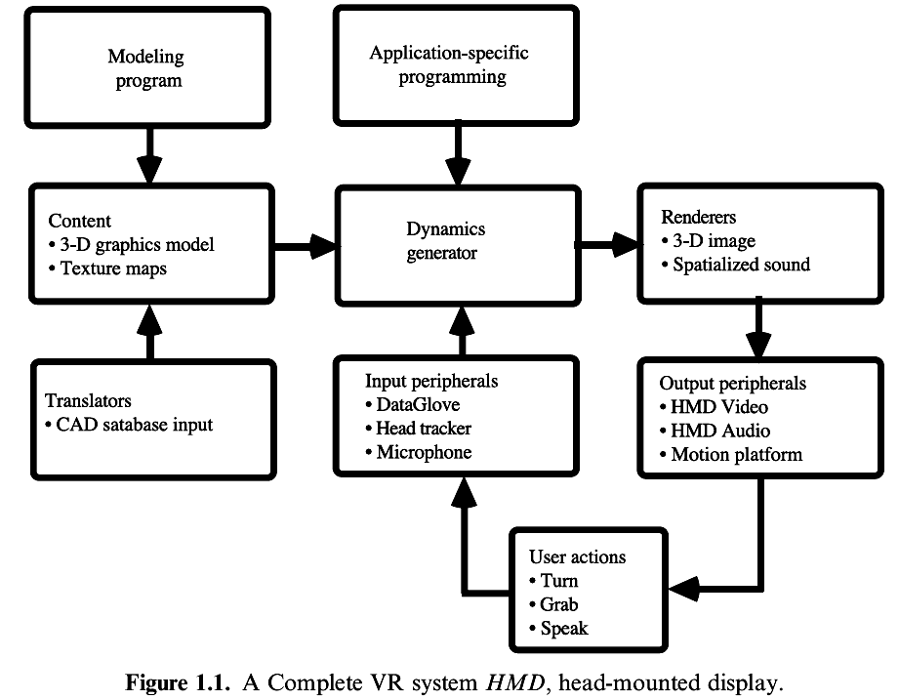
Fig.1. A complete VR system

3. REHABILITATION, FUNCTIONAL MOVEMENT ANALYSIS AND ERGONOMIC STUDIES

The field of VR is still at the proof-of-concept stage, yet there are a growing number of potential applications related to motion monitoring, rehabilitation, and ergonomic analysis. It can be theorized that the rehabilitation process can be enhanced through the use of VR technology.
Evaluation of hand impairment involves detailed physical examination and functional testing of the affected person. The physical examination is designed to determine the presence of pain and any loss of strength, sensation, range of motion, and structure. The results are combined to produce a numerical assessment of impairment that is used to evaluate the patient's progress over time, yet examinations and calculations can be time-consuming, expensive, and subject to observer error. Functional evaluation is usually accomplished by subjective observation of patient performance on standardized tests for motor skills. However, reproducibility of measurements becomes an issue whenever different examiners evaluate the same patient, which makes it difficult to evaluate a patient's progress over time. The more objective assessments of upper extremity motion fall into two categories: visual and effective. Visual methods involve digitizing and estimating a visual record of the motion: The patient is videotaped performing a task; then the individual frames of the video are digitized and evaluated to quantify the degree of motion of the joint under study.
The main limitation of this technique is that the camera can view motion in only two dimensions. To assess movement in the camera's visual plane accurately, the third dimension must be held constant, i.e., the person must move along a known line parallel to the plane of the film in the camera. In most cases, the examiner cannot maintain the correct orientation even for short periods, making this a difficult and cumbersome technique.
Effective methods measure the motion's effect rather than the motion itself. A work simulator is one example of an effective assessment tool. Work simulators measure the force exerted by a subject on a variety of attachments that simulate tools used in the workplace.
A major limitation of this approach is that no data are collected on how the person effects the force. Ideally one would like to collect and compare range of motion data for a joint in several planes simultaneously while specific tasks were being performed by the patient, a measurement that is impossible using a standard goniometry. At one point my group considered using the DataGlove with its multiple sensors as a means of collecting dynamic functional movement data. However, migrating the DataGlove technology from the field of VR to clinical evaluation posed several problems.
For example, during manufacture of the DataGlove, the treatment of individual fiber optic cables was not identical, thus it was impossible to characterize and predict their behaviour. Moreover, empirical observations show hysteretic, making repeated measurements irreproducible and making it difficult to determine the accuracy of the measurements. For highly accurate measurements, it is important to have a perfect fit of the glove, because poor placement of the sensitive areas of fibers yields incorrect measurements. Achieving a perfect fit of the DataGlove posed a serious challenge because of the variability of hand shapes and sizes across a given patient population. Moreover, the use of the fiberoptic DataGlove excluded the population of patients with anatomic deformities. With the goal of obtaining accurate, dynamic range of motion data for the wrist joint, some researchers group [1] investigated other sensor materials and developed the glove-based WristSystem. Fiberoptic sensors were replaced by dual-axis electro-goniometric sensors that could be inserted into machine-washable Lycra gloves that fit different sizes of hands. WristSystem gloves are currently being used to track flexion, extension, radial, and ulnar deviations of the wrist while patients are performing routine tasks. A portable, lightweight DataRecorder worn in a waist pack permits the patient to be ambulatory while data are being collected at the clinic or work site (Fig. 2); no visual observation or supervision is required beyond the initial calibration of the glove sensors. Real-time visual and auditory feedback can also be used to train the patient to avoid high-risk postures in the workplace or at home.
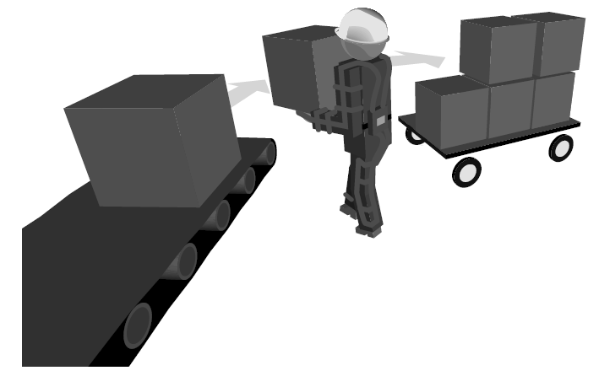
Fig.2. The WristSystem being used to track functional movement at a job site
The WristSystem includes Motion Analysis System (MAS) software for the interpretation of the dynamic-movement data collected by the DataRecorder over several minutes or hours. This software offers rapid, quantitative analysis of data that includes the total and percent time the wrist spends at critical angles (minimum, maximum, and mean wrist angles in four directions), the number of repetitions, and the velocity and acceleration.
The WristSystem is currently being used by occupational and rehabilitation medicine specialists (MDs, PTs, and OTs), ergonomics, industrial safety managers, biomechanical researchers, and risk management consultants. The ultimate extension of the project will be the possibilities to build an augmented-reality environment for quantitative evaluation of functional tasks. The system will link multiple input devices or sensors worn by the patient and 3-D modelling software. Therapists will be able to design a virtual world composed of objects traditionally used in functional assessment tests, such as balls, cubes, keys, and pencils. The therapist will be able to record the motion, location, and trajectory of the user's hand that is required to accomplish the motion and any associated hand tremors or spasms. Once the data are collected, the therapist can use statistical analysis software to interpret them. The clinician can also elect to review the motions by animation of the data and to change the orientation to study the motion from another angle.

4. Neuro-psychological assessment and rehabilitation

The first VR system specifically designed for the assessment and cognitive rehabilitation of cognitive functions in persons with acquired brain injuries was developed in Italy. Using a standard tool (Wisconsin Card Sorting Test--WCST) of neuropsychological assessment as a model, these researchers have created a virtual building wherein the person uses environmental clues in the selection of appropriate choices (doorways) to navigate through the building. The doorway choices vary according to shape, colour, and number of portholes. The patient is required to refer to the previous doorway for clues to make the appropriate next choice. After the choice criteria are changed, the patient must shift the cognitive set, analyze clues, and devise a new choice strategy. The parameters of this system are fully adjustable so that training applications can follow initial standardized assessments. Although this VE was not developed as a telemedicine tool, the authors are now trying to develop a new Internet version using VRML. This VE will be used to document failures in everyday life coping in a patient with an anterior thalamic stroke [11]
Stroke is the most common cause of acquired physical disability with estimates of the annual incidence of stroke ranging from 180 per 100,000 in the USA to 200 per 100,000 in England and 280 per 100,000 in Scotland [1]. The incidence rates increase with age, doubling for every 10 years after the age of 45 [2]. Approximately one-third of the patients surviving from a stroke are left with severe disabilities [2]. Evidence has shown that early and intensive physiotherapy improves patient recovery [3] and several authors have already proposed using robots to deliver this type of physiotherapy. [4,5,6] In the GENTLE/S project (a project under the quality of life initiative of framework 5 of the European Commission to evaluate robot-mediated therapy in stroke rehabilitation) we go further and propose a system based on haptic technology. Haptics have been widely used for different applications ranging from Surgery Simulators [7,8], Virtual Reality- Based Telerehabilitation systems with force feedback [9] to 3D painting interfaces [10]. In the context of haptics and force feedback we have already introduced and implemented a novel mathematical model directed to deliver a system capable of correcting movement in machine assisted stroke rehabilitation. This system can be used for errorless learning techniques and intensive rehabilitation treatment for patients recovering post-stroke. It allows force feedback to be delivered to the patient arm via a 3DOF haptic device (Haptic Master from Fokker Control Systems) strong enough to correct point to point movement within a virtual/real or augmented task oriented therapy.

5. CONCLUSION

It has been shown how Virtual Reality techniques can be successfully applied in the field of physical disabilities. Virtual scenarios can be created, in which patients suffering from motor disturbances like pareses or apraxias perform motor tasks for diagnosis and rehabilitation purposes. Therapy of ataxia and strabismus can also profit from special VR facilities. Also, using VR data-gloves, people with speech disabilities can communicate by hand gestures, which are translated into spoken words. In combination with special devices that measure minimum motor output or even human bio-signals, VR is an adequate assistive technology for paralysed people or with stroke affection.
Furthermore, VR technology can serve the physician as an advanced visualization and animation tool for the diagnosis of physical disabilities like Parkinson diesis, paraplegia or AVC.

REFERENCES

[1] Rui Loureiro*, Farshid Amirabdollahian*, Susan Coote**,Emma Stokes** and William Harwin*Using Haptics Technology to Deliver Motivational Therapies in Stroke Patients: Concepts and Initial Pilot Studies
[2]Abrams, W. B., and Berkow, R. (1996 - 1997). Merk Manual of Geriatrics. NJ, Merk Research Laboratories.
[3] Carr, J. H., and Shepherd, R. B. (1987). A motor relearning programme for stroke, Oxford: Butterworth Heinemann.
[4] Krebs, H. I., Hogan, N., Volpe, B. T., Aisen, M. L., Edelstein, L., and Diels, C. (1999). Robot-Aided neuro-Rehabilitation in Stroke: Three-Year Followup. ICORR - Sixth International Conference on Rehabilitation Robotics, Stanford, CA.
[5] Reinkensmeyer, D. J., Schmit, B. D., and Rymer, W. Z. (1999). Assessment of active and passive restraint during guided reaching after chronic brain injury. Annals of Biomedical Engineering 27(6): 805-814.
[6] Lum, P. S., Burgar, C. G., Kenney, D. E., and Van der Loos, H. F. M. (1999). Quantification of force abnormalities during passive and active-assisted upper-limb reaching movements in post-stroke hemiparesis. IEEE Transactions on Biomedical Engineering 46(6): 652-662.
[7] Loureiro R.C.V. (1999). MSc Dissertation in A Laparoscopic Virtual Surgery Simulator. Department of Electronic and Electrical Engineering, University of Salford.
[8] Salleh, R., Loureiro, R., and Caldwell, D. (2000). Haptic feedback for VR based minimally invasive surgical (MIS) training. EUREL – European Advanced Robotics Systems Master Class and Conference, Salford, Manchester, UK.
[9] Popescu, V.G., Burdea, G.C., Bouzit, M., and Hentz, V.R. PC-based Telerehabilitation System with force feedback. Proceedings of MMR 7, IOS Press, Amsterdam, Vol. 62, pp. 261-267.
[10] Gregory, A., Ehamann, S., and Lin, M.C. (1999). inTouch: Interactive multiresolution modelling and 3D painting with a haptic interface. Technical report, Department of Computer Science, University of North Carolina;
[11] L. Mendozzi, A. Motta, E. Barbieri, D. Alpini, and L. Pugnetti, The application of virtual reality to document coping deficits after a stroke: report of a case, CyberPsychology & Behavior 1 (1998) 79-91.

