1st International Conference
″Computational Mechanics and Virtual Engineering ″
COMEC 2005
20 – 22 October 2005, Brasov, Romania

USING THE FINITE ELEMENT METHOD FOR THE STUDY
OF THE BEHAVIOUR OF A WOVEN WIRE NET STRESSED AT UNIAXIAL TRACTION

I. Curtu¹, Ad. Pascu², Val. Oleksik²
V. Ciofoaia¹, Angela Repanovici¹, Mariana Stanciu¹
¹ “Transilvania” University of Braşov, România, curtui@unitbv.ro
² “Lucian Blaga” University of Sibiu, România, adrian.pascu@ulbsibiu.ro, valentin.oleksik@ulbsibiu.ro

Abstract: In this paper we put forward a study for the finite element method concerning the behavior of a woven wire net stressed at uniaxial traction. We note the appearance of certain maximum stresses in the contact areas between the two thread systems, a fact due to the friction which appears in the respective areas, as well as to the pretensioning of the preundulated wire the wire net is made of.
Keywords: woven wire, tractions, finite element, Ansys

1. INTRODUCTION

For the analysis of this structure, the model created with the ANSYS LS-DYNA 9.60 programme was made up of two parts, a part being by definition the generic denomination for an assembly consisting in the geometry, the finite elements network, the real constants and the types of material for every element of the deformation system. An analysis conducted in the elastic-plastic field undertakes three distinct stages: a pre-processing, a solving and a post-processing stage. Similarly as for the perforated plates studied in this chapter, the pre-processing (which consists, in case of an analysis in the elastic -plastic, of: the modelling of the geometry, the choice of the type of materials, the choice of the type of finite elements, the choice of the real constants, the assignment of the type of elements, of the real constants, and of the material properties, the accomplishment of the finite elements network, the accomplishment of the parts, the definition of the contacts and of the friction conditions among the different parts, and the application of the loads and of the constraints) was accomplished in the ANSYS programme. We must also mention that, in case of an explicit dynamic analysis (as the present case) all the loads depend on the time. This way, all types of constraints and loads were introduced under the form of parameters as time functions.
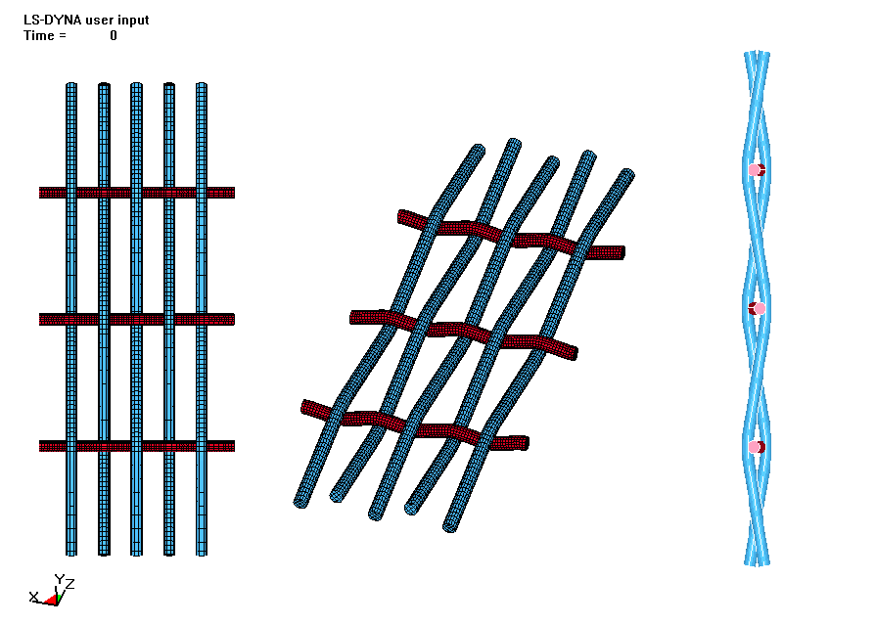  a) Model of the woven wire net specimen | 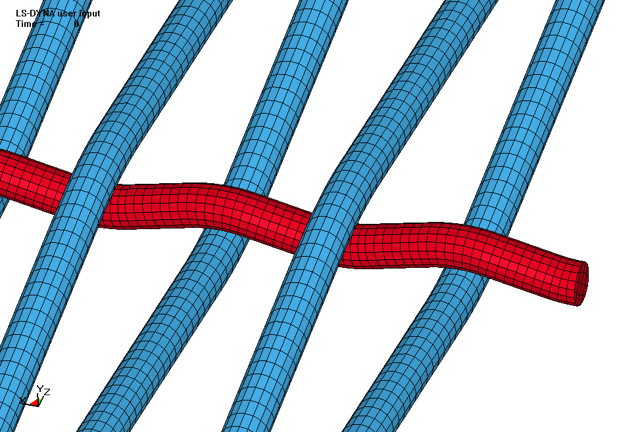  b) Detail of the contact area between the warp threads and the weft yarns.
Figure 1: Woven wire net specimen
The first part is made out of warp threads (the vertical blue threads in figure 1a) and the second part is made out of weft yarns (the horizontal red threads in figure 1a). In figure 1b we present a detail of the contact area between the warp threads and the weft yarns.
The solving of this analysis was realized by the solver placed at our disposal by the ANSYS programme, that is LS-DYNA 960.
The post-processing stage which consisted in viewing the results and in obtaining the images and the animates was accomplished by means of the LS-POST programme from the Livermore Software Technology society.
For the simulation of the breakage, the LS-DYNA programme eliminates the affected finite elements and makes the tensions and deformations upon these elements equivalent to zero.

2. ANALYSIS BASED ON FINITE ELEMENTS

The two parts accomplished according to the algorithm we presented in the introduction to this paper were made discreet as deformable solid bodies, initially composed out of 8,315 elements type SOLID 164 (part 1), respectively 4,031 elements type SOLID 164 (part 2). This way, 12,346 elements resulted. The type of associated element is described, [5] as an element with eight knots, of 12 degrees of liberty in every knot, and which may be made use of only in analyses of an explicit type as the present one. The degrees of liberty associated to every knot are represented by: the knotting displacements, the global rotations, the speeds and the knotting accelerations. For coordinates, displacements and rotations we make use of bilinear interpolations. The specific transverse deformations are calculated at the middle of the sides and they are interpolated at the integration points. Due to the manner of connection of the elements, there are, within the network, as a whole, a number of 19,500 knots, which confer the system a number of 234000 degrees of liberty.
The type of material associated to the elements of the half-finished good is elastic-plastic. The flowing condition taken into consideration is Hill, the flowing law is given as Swift law and the manner of anisotropic cold-hardening is defined by Barlat. The modulus of elasticity taken into consideration is E = 70 Gpa, and the transversive contraction coefficient, v = 0.3. The tangent modulus was E_{T} = 320 Mpa, the cold-hardening coefficient, n = 0.185 and the specific deformation at which the first plastic deformations appear, is ε₀ = 0.002 mm/mm. The criterion used for the apparition of the breakage was the one of the maximum effective plastic deformation. This way, ε_{ef}, _{p}, _{max} = 0.55 mm/mm.
The contact was idealized by resorting to a static friction coefficient, μ = 0.08. The time increment resorted to is of 3e-05 seconds. The programme is stipulated to unfold for 100,000 increments, at a speed of displacement of the mobile blade of 1 mm/s, which leads to obtaining a maximal course of this one of 30 mm.
The contact tolerance was chosen of 0.01 mm and it is equally distributed for the warp threads as well as for the weft yarns. The force of detachment of the knots in contact is considered to be 1e-12kN, which means that the least drawing force leads to the breakage of the contact. This fact is necessary due to the frequent changes of contact that appear during this type of analysis.
In order to solve the system of non-linear equations we make use of the Newton-Raphson method.
The test piece was stressed at uniaxial traction towards the warp threads, and the distributions of the displacements and specific deformations resulted in the framework of this analysis are displayed in figure 2.

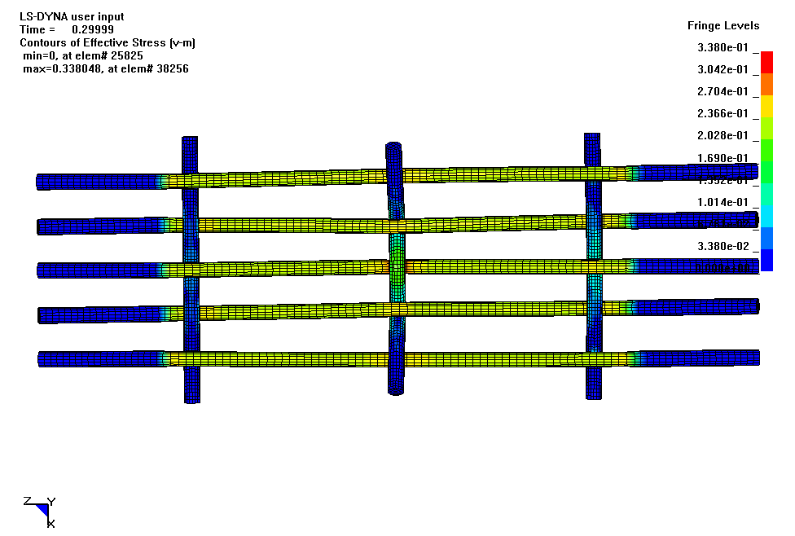  a) Distribution of equivalent stresses at a given time during the stress | 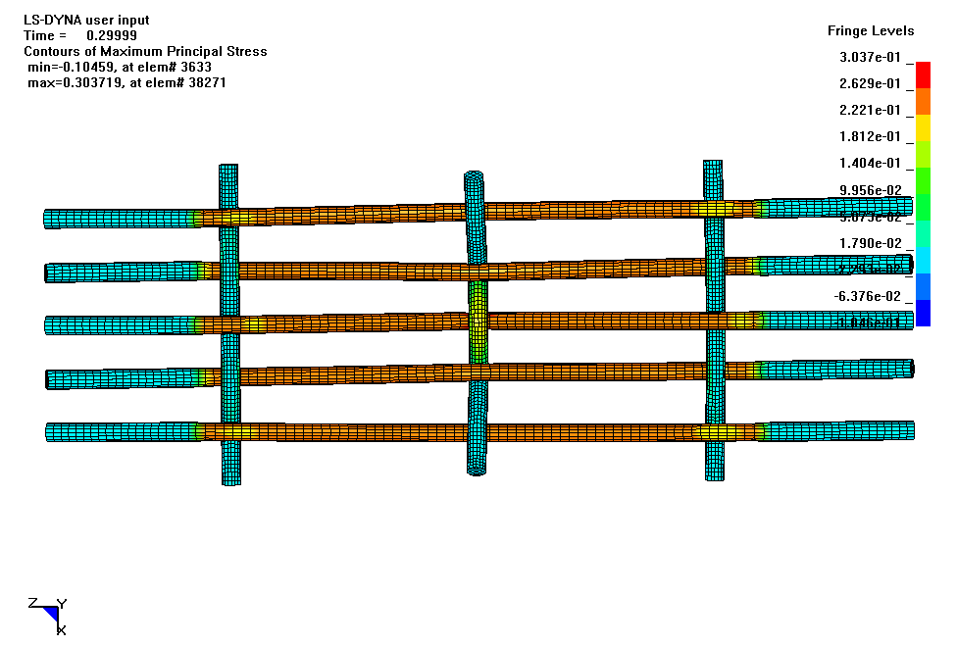  b) Distribution of main stresses at a given time during the stress
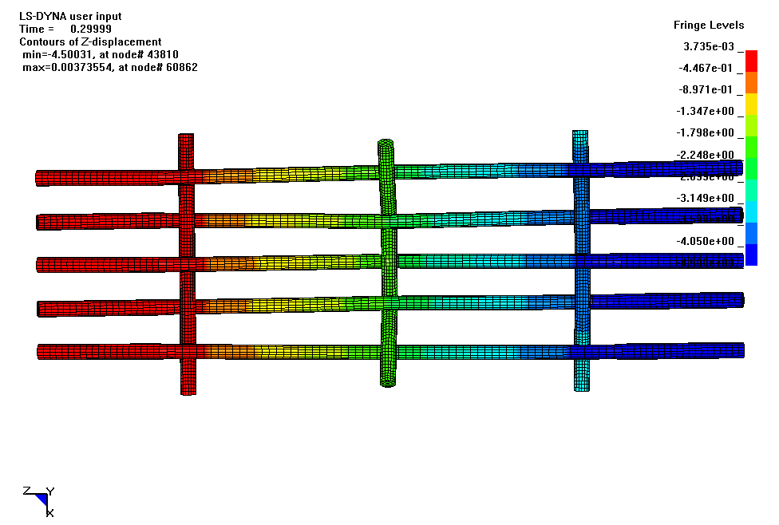  c) Structure displacement on stress direction | 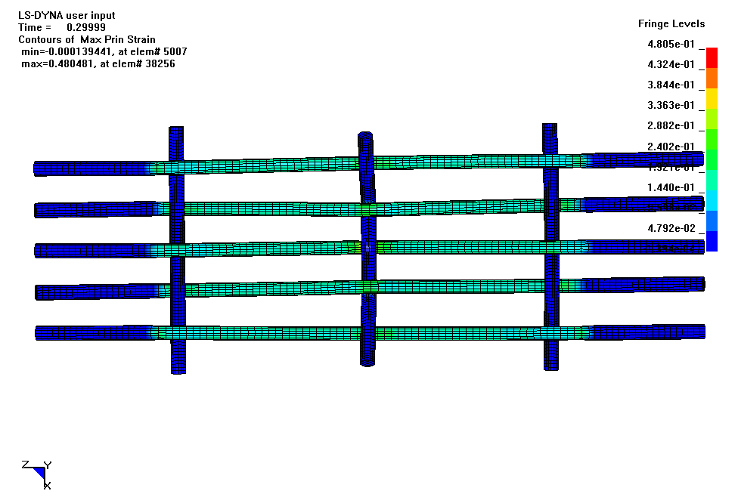  d) Distribution of main specific deformations
Figure 2: Results obtained for a wire net woven of preundulated wire

In figure 3 there are presented for a finite element of the analysed structure, the variation graphs for the stress period of the:
- internal energy for part 1 (warp), in figure 3 a;
- external energy for part 2 (weft), in figure 3 b;

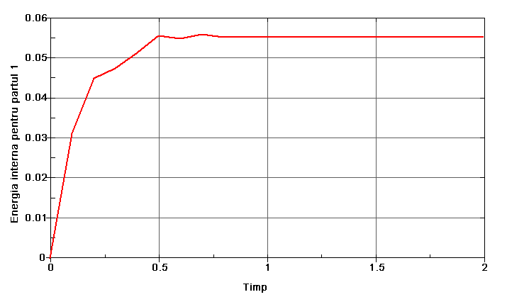
(a)
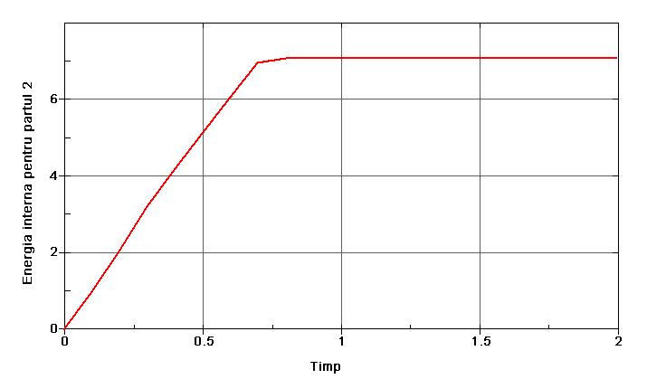
(b)
Figure 3: Variation graphs of the internal energy during the stress under uniaxial traction of the wire net

In figure 4 there is presented, for a finite element out of the analysed structure, the variation graph during the stress period of the friction force between the two thread systems forming such a wire net.

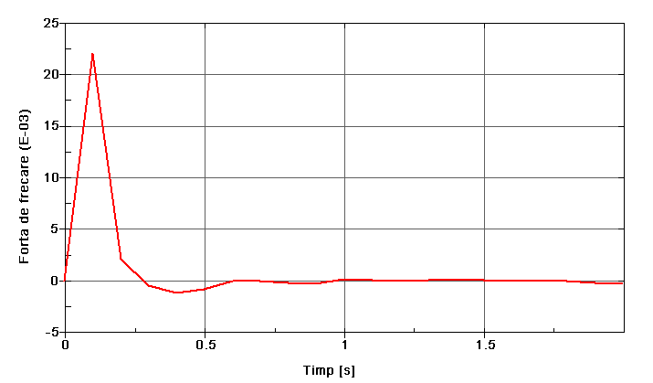
Figure 4: Variation graph of the friction force during the stress period under uniaxial traction of the wire net

3. CONCLUSIONS

As regards both the principal and the equivalent stresses, we note the appearance of certain maximum stresses in the contact areas between the two thread systems, a fact due to the friction which appears in the respective areas, as well as to the pretensioning of the preundulated wire the wire net is made of.
In the case of both parts, we note an increase of the internal energy (more pronounced in case of part 2), subsequently stabilized at the value 0.07 [J] for part 1 and 7 [J] for part 2.
As regards the friction force between the two thread systems (warp and weft) we may note an increase of this force until the moment of the breakage in the warp threads, subsequently this one unawares diminishing to zero.

REFERENCES

- Banihuk N.V.: Introduction to optimization of structures, New Zork, Springer Verlag, 1990.
- Oleksik V., Pascu A.: Identificarea parametrilor de curgere ai tablelor metalice prin analiză inversă, A 4 –a Conferinţă de Dinamica Maşinilor, Braşov, 2005, pag. 303-308..
- Pascu A., Sofonea G., Frăţilă M.: Calculation model of the stress and deformation state in the loop of wire net, A XXVI a Conferinţă Naţională de Mecanica Solidelor, Galaţi – Brăila, 2002.
- * * *, ANSYS Release 8.0, Structural Analysis Guide, 3rd Edition, 000857, SAS IP.
- * * *, ANSYS Release 8.0, Theory References, 9th Edition, 001099, SAS IP

