1st International Conference
″Computational Mechanics and Virtual Engineering ″
COMEC 2005
20 – 22 October 2005, Brasov, Romania

ASPECTS CONCERNING THE IMPLEMENTATION OF THE PROBABILISTIC APPROACH IN EVALUATING THE RELIABILITY OF THE STRUCTURES

A. Camciuc¹, H. Gheorghiu¹, N. Constantin¹, M. Găvan¹
¹Politechnical University of Bucharest, Romania, arthur_camciuc@yahoo.com

Abstract : The aim of this paper is to establish a methodology for simulation of random loads for automotive components. After the methodology was developed, an experimental stress analysis was made on a lower arm of a Daewoo Matiz automobile. The points where the strain gauges had to be mounted were established using the data obtained from finite element analysis. During the ride in normal traffic conditions, the real variations of the strains from the three mounted half bridges were recorded. The signals obtained from the randomly loaded structure during driving were analyzed using statistical methods and then introduced in a simulation calculus code. Finally, structural design observations were made, based on the fatigue calculus predictions of life time. The established methodology has a large degree of generality, so it can be used for almost all automotive parts.
Keywords: random load, statistical methods, life time, reliability methods, simulations techniques.

1. INTRODUCTION

Mechanical engineers engage in many activities, such as analysis, design, structural parameter identification, load identification and more. In studies involving dynamic excitation and response, engineers measure parameters related to dynamic response.
When structural parameters and excitation are deterministic, the engineer’s activities take a standard form, but when structural parameters to which a structure is subjected are random the theories of probability and statistics must be used.
Many of the dynamic environments to which structures are subjected during their live are random processes. Some examples of random processes environments are: wind, ocean wave, rough pavement, air blast, etc. The environments described are classified in two basic sets. When the environments tend to be long-duration and steady, these are vibration environments. The sources of these environments are modelled as stationary random processes. The second set includes the shorter-duration environments named shocks. The sources of these environments are modelled as nonstationary random processes.
The theory of probability develops methods for obtaining the chance of occurrence of random events. The theory of random processes looks at a signal as sequences of random variable.
The theories of statistics and random signals bridge the gap between the practical world of data measurements and the theories of probability and random processes.

2. PROBABILISTIC METHODS RELATED TO RANDOM VIBRATION

In the design process engineers are interested in numerical description of inputs and outputs. A random variable is a quantity which describes a numerical result of an experiment. Random variables are divided in two categories: discrete and continuous.

For a random variable the probabilistic behavior can be described using the probability mass function (pmf), the cummulative distribution function (cdf), the mean value, the variance, the standard deviation and the coefficient of variation. The mathematical description can be found in [1].
It is possible to use histograms to represent statistical distributions, but the mathematical model is preferred for the following reasons:
- it is very compact;
- existing data can be extrapolated;
- a mathematical model is practical for probabilistic design;
- with a mathematical model the influences of different factors can be easily shown.
For the majority of real environments the following distributions can be used to describe them:
- for discrete random variables: Bernoulli, Binomial, Poisson;
- for continuous random variables: Normal, Lognormal, Weibull, Exponential, Rayleigh, Extreme value.
The mathematical description for these distributions can be found in [1]. The normal distribution is used to describe a lot of environments and seems to be the main type for automotive processes. For a Gaussian process the Weibull distribution is used to describe the stress ranges between two consecutive values in stress history.

3. FUNDAMENTALS OF RELIABILITY ANALYSIS

In general, the engineering design consists in proportioning the elements of a structure in order to achieve various criteria of performance, durability, safety, etc. For example, a structure must be designed so the resistance should be greater than the applied loads. There are numerous factors which contribute to uncertainty in load and resistance.
In the deterministic approach, the load is overestimated with a few standard deviations above its mean and the resistance is underestimated with a few standard deviations under its mean value. This is the commonly used method in engineering design. This approach is very simple to use, but it leads to over dimensioned structures.
In the probabilistic approach the probability of failure is computed, based on the distributions of the load and resistance. When the load is greater than the resistance, failure occurs. If the overlapping area of the two curves is greater, the probability of failure increases.
The first step in evaluating the reliability of a structure is to establish the performance criteria and the relevant parameters, called the basic variables$X_{i}$. After than the performance function must be written in terms of the random variables involved.

$Z=g(X_{1},X_{2},\text{.}\text{.}\text{.},X_{n})$ (1)
The failure surface or the limit state can be described when $Z=0$. The failure occurs when $Z<0$. The limit state concept is presented in figure 1.
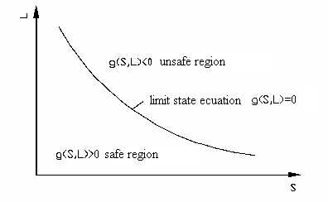

Fig. 1. Limit state concept.

Using the equation (15) the probability of failure, $p_{f}$ can be computed as:
$p_{f}=\int{\text{.}\text{.}\text{.}\int{f_{X}(x_{1},x_{2},\text{.}\text{.}\text{.},x_{n}){\text{dx}}_{1}{\text{dx}}_{2}\text{.}\text{.}\text{.}{\text{dx}}_{n}}}$ (2)
If there is a correlation between the basic random variables, independent random variables must be computed and the limit state function must be modified. For practical large problems the transformation of the correlated random variables to uncorrelated variables can be done using the next relation:
$\left\{X\right\}=\left[σ_{X}^{N}\right]⋅\left[T\right]⋅\left\{Y\right\}+\left\{μ_{X}^{N}\right\}$ (3)
where $\left\{X\right\}$ are the correlated variables and $\left\{Y\right\}$ are the uncorrelated variables, and $\left[T\right]$ is an orthogonal transformation matrix consisting of the eigenvectors of the correlation matrix of the originally correlated variables. The procedure is detailed in [4].
It is very difficult to compute the equation (2) and in most cases impossible. So methods were developed. These methods can be grouped in two basic sets: first order reliability methods (FORM) and second order reliability methods (SORM).
The limit state function can be a linear or a nonlinear of the basics variables. The first order reliability method can be used to compute the equation (2), when the limit state is linear and the random basic variables are uncorrelated and have a normal distribution. If some of the basic variables have a nonnormal distribution equivalent normal variables must be computed as presented in [4]. The second order reliability method estimates the probability of failure by approximating the nonlinear state limit by a second order representation.

4. SIMULATION TECHNIQUES

Estimating the probability of failure using the reliability methods requires a background in statistics and probability theories. The Monte Carlo simulation technique is a relative simple alternative. In the basic form, each random variable is sampled several times, according to its probabilistic characteristics. The solving of the limit state equation deterministically for each realization is known as a simulation cycle. Using many simulation cycles the characteristic of the response random variable can be determined. The simulation technique using a computer is an inexpensive way to study the uncertainty of the problem.
The Monte Carlo simulation technique consists in six steps:
- define of the limit state function ;
- establish the types of the distributions of all variables and its parameters ; if the random variables are correlated they must be transformed into uncorrelated variables and the limit state function must be rewritten ;
- generate of random numbers ;
- evaluate of the limit state for each realization ;
- extract probabilistic information for N realizations;
- determine the accuracy of the simulation.
The probability of failure can be computed as:
$p_{f}=\frac{N_{f}}{N}$ , (4)
where N_{f} are the number of simulations when the limit state function was smaller than zero.
The accuracy of the simulation increases with the number of simulations. It cannot be defined a necessary number of simulations, but for a realistic estimate, one million simulations must be performed for each random variable of the limit state function. One method for estimating the accuracy of the simulation is to calculate the probability of failure from time to time and to observe if the value has the tendency of stabilizing.
In order to achieve efficiency of the simulation a lot of variance-reduction techniques were developed. In [4] there are presented some variance reduction techniques, which can be grouped in two major classes. There are sampling methods and correlation methods. The sampling methods either constrain the sample to be representative or distort the sample to emphasize the important aspects of the function being estimated. The correlation methods employ strategies in order to achieve correlation between functions or different simulations in order to improve efficiency.

5. KEYCASE

An automotive lower arm of a McPherson strut was studied. An experimental stress analysis was made on a lower arm of a Daewoo Matiz automobile. First, the types of loading were identified (bending in two planes and axial), then a finite element model for the lower arm was created. The points where the strain gauges had to be mounted were established using the data obtained from finite element analysis. In figure 2., the lower arm with the strain gauges mounted is presented.

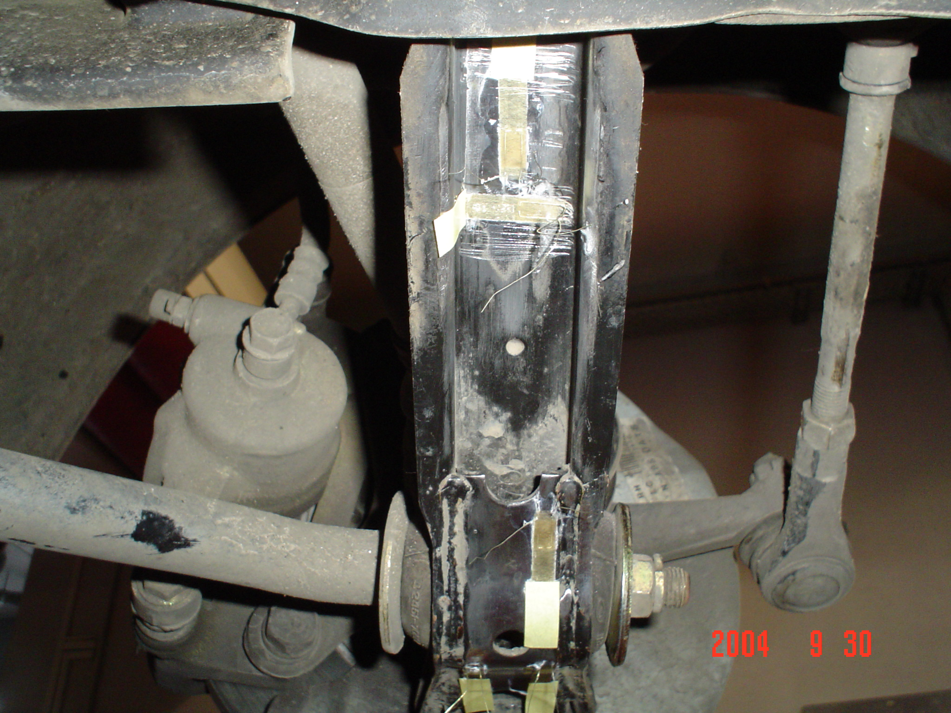

Fig. 2. The lower arm with the strain gauges mounted.

Using the methodology presented in [3], the forces which act on the spherical ball of the lower arm were evaluated. The values were used for the finite element model to estimate the accuracy of the measurements by comparing the maximum values experimentally obtained during braking. The maximum analytical stress obtained with the finite element model is -398 MPa and the maximum experimental stress is -325 MPa. The difference is significant, but it can be explained by the fact that car diving during the braking process could not be accurately considered in the original model. In figure 3 the finite element model of the lower arm is presented.

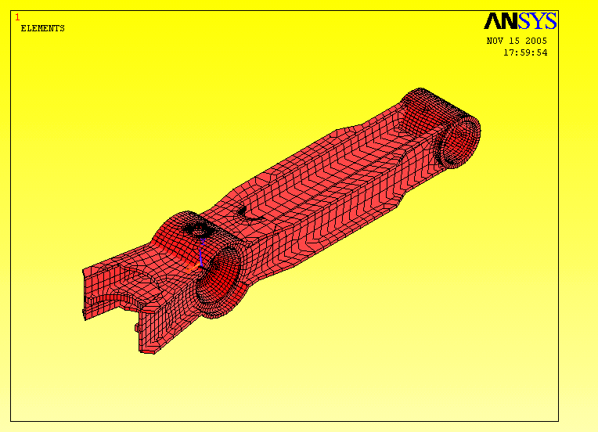

Fig. 3. Finite element model of the lower arm.

After analyzing the experimental measured data, it was clear that the bending induced by braking and accelerated traction is the most important loading. Further consideration about the durability a presented in [2].
The aim of this paper is to create a methodology for the simulation of the random loads, so that a point on this arm was chosen. The corresponding stress histories for that point, given by the three solicitations were isolated. In figure 4. the chosen point is emphasized

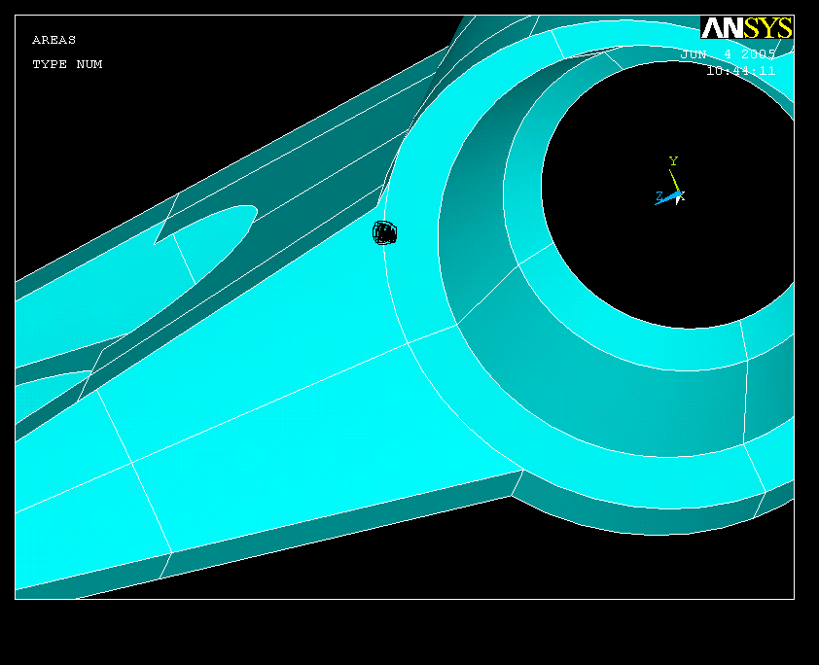

Fig. 6. The chosen point.

All the three solicitations can be described by Gauss distributions, with confidence levels above 95%. In table 1. the parameters of the distributions are presented.

Table 1. The parameters of the distributions.
 | Mean [MPa] | Standard deviation [MPa]
Stress history corresponding to the bending given by longitudinal force from the contact patch | -13,84 | 18,43
Stress history corresponding to the axial solicitation given by the transverse force from contact patch. | 1,08 | 6,84
Stress history corresponding to the bending given by body roll. | -8,25 | 5,46

The three solicitations are correlated. The correlation coefficients were determined, as explained in [1]. So, between the solicitations given by the longitudinal and transversal forces from the contact patch, there is a correlation coefficient of 0.62, between the solicitation given by the transverse force and body roll the coefficient is -0.05 and between the solicitation given by the longitudinal force and body roll the coefficient is -0,15. If the coefficient of correlation in absolute value is less than 0.3 the two solicitations can be considered uncorrelated, but in order to develop the methodology all the correlations were taken into account.
A total number of 500,000 simulations were performed using Microsoft Excel. In figure 7 the histogram of the simulated process is presented.
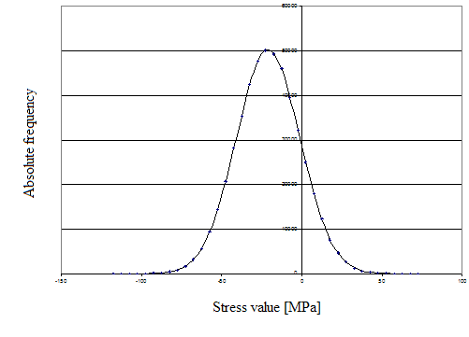

Fig. 7. The histogram of the simulated process.

In order to verify the accuracy of the simulation, the cdf corresponding to a value of the stress was computed using the first reliability method and two variance reduction techniques, conditional expectation and combined conditional expectation and antithetic variates method. In the conditional expectation method, all the basic variables are simulated except one. This is the control variable. The limit state function is modified again. The variance is reduced by removing the random fluctuation of the control variable on which conditioning is not performed. In the antithetic variates method, a negative correlation is induced between different simulation cycles. In table 2 the results are presented.

Table 2. The cdf for the stress value of -50 MPa.

Stress value  [MPa] | Clasic Monte Carlo simulation  [%] | Conditional expectation  [%] | combined conditional expectation and antithetic variates method [%] | Reliability methods  [%]
-50 | 7,2 | 7,1 | 6,9 | 7,2

The good agreement can be explained by the fact that all the basic variables have the normal distribution and the limit state function is a linear combination of them. The simulated process can be described by a normal distribution with a mean of -21 MPa and a standard deviation of 19.8 MPa. Cycles of solicitation were created according to the methodology from [5]. Finally, using the Coffin-Manson relation, a curve which describes the contribution of the different amplitude cycles to the total damage was created.

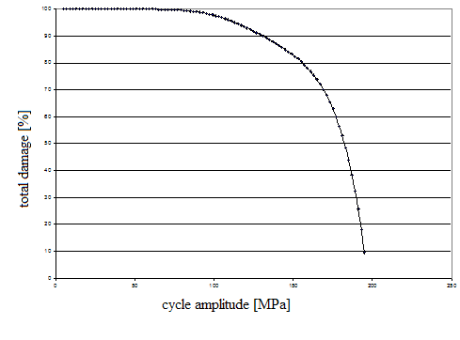

Fig. 8. The contribution of the different amplitude cycles to the total damage.

6. CONCLUSIONS

The Monte Carlo simulation technique is a friendly alternative to the reliability methods. Until recently the use of the Monte Carlo simulation technique was restricted by the not very high performances of the computer.
The use of the variance reduction techniques should not be taken for granted because, even the total number of simulations degreases, the necessary time for one simulation actually increases. So, overall it is very difficult to predict if the efficiency is improved. The simulations save a lot of expensive testing, but short time testing must be performed in order to obtain the types and the parameters of the distributions of the basic variables.
For the studied automotive part, a simplified fatigue calculus was developed. This is very useful in the early stage of the design process. The methodology has a large degree of generality.

REFERENCES

[1] Bendat, J.S., Piersol, A.G., “Random Data: Analysis and Measurement Procedures”, Willey-Interscience, New-York, 1971.
[2] Camciuc A., Găvan M., Constantin N., “Life time evaluation for an automotive lower arm of a McPherson strut”, Proceedings of the second international conference "Reliability, safety and diagnostics of transport structures and means 2005", University of Pardubice, Czech Republic, 7-8 July 2005.
[3] Camciuc,A. Calculul articulaţiei inferioare la fuzetã pentru o suspensie de tip McPherson folosind metoda elementelor finite, a 10-a Conferinţã de lubrificaţie şi tracţiune elastohidrodinamicã, Universitatea Suceava, octombrie 2000.
[4] Haldar, A. and Mahadevan, S. Probability, Reliability and Statistical Methods in Engineering Design, John Wiley & Sons Inc., 2000.
[5] xxx Random Vibrations, a seminar and workshop on analysis, design, and testing of randomly excited structural and mechanical systems, Tucson East, Arizona,1991.

