1st International Conference
″Computational Mechanics and Virtual Engineering ″
COMEC 2005
20 – 22 October 2005, Brasov, Romania

The use of the virtual instrumentation for the dimensioinal control – first part

Braun, B¹ Drugă, C¹, Turcu, C²;
² “TRANSILVANIA” University of Braşov ROMANIA, e-mail: braun@unitbv.ro, druga@unitbv.ro
¹„RULMENTUL” High School Braşov, ROMANIA, e-mail: cturcu@unitbv.ro

Abstract: The paper describes of the dimensional control nowadays, giving emphasis to the advantages of the modern methods. One of these methods is about the dimensional control aided by computer, by creating virtual instruments for measuring. Is presented and described the measuring schema which can be used in case of the dimensional deviations control of some symmetrical revolution probes. Especially is about the data acquisition systems. The virtual instrument is the software environment in which the acquisitioned and stored data can be displayed and analysed to the PC or to a computer network. The advantage of using a virtual instrument for the dimensional control is that it permits a modularized control for different types and dimensions of the probes, due to its relatively simply adaptation, depending by the measured parameter.
Keywords: dimensional control, deviation, virtual instrument

1. Comparative study between the classic dimensional control and the dimensional control aided
by computer

The dimensional control based to the use of classic measuring instruments determines some advantages as:
- the low relative costs;
- the possibility to remedy relatively easy the faults issued to the mechanical measuring instruments.
But the troubles in case of using this kind of apparatus made necessary to develop some modern and more complex systems for the measuring. The main disadvantages of using of a classical measuring instrumentation are:
- the limitation of the measuring precision to micrometer order, due to the apparatus which cannot permit high precision readings;
- the high frequency of subjectives measuring errors caused by the human intervention in the reading and marking of the measuring results;
- the high frequency of the necessity of intervention for the adjustment or to repair the classic measuring apparatus;
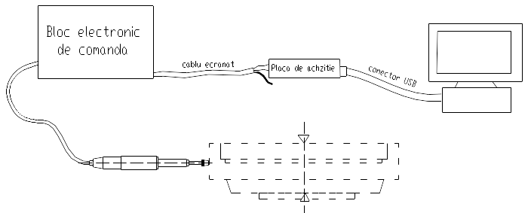

1
2
3
4
5
6

Fig. 1.1. - The measuring aided by computer system of the radial deviation for a symmetrical revolution probe
1 – electronic system for the power of the transducer, 2 – cabled systems for the data transmission, 3 – acquisition plug – in data, 4 – PC, 5 – transducer, 6 – measured probe [1]

The modern measuring instruments and systems eliminates many of the disadvantages presented, but, depending to its applications, these could be or not advantageous. For this reason, especially, when is about of more dimensional ranges measuring, multi-parameter or modularized, very advantageous are the simple sensorial system, who can successfully to replace the classic measuring and control instruments. The sensorial systems can be coupled to a PC or to a computer network, using a plug – in data acquisition board, to adapt to the computers the signals which provide from the sensors and transducers.

  - The virtual instrument and its applications

The dimensional control aided by computer involves complex software programs, destined only for the dimensional deviations measuring. But the use of this kind of software systems involve some disadvantages, referring to their costs and also to their restrictions for the modularized measuring. An other aspect is the relatively high difficulty of the user to learn the proceedings for programs using, due to their high complexity.
For this reason, it is recommended to create manually some software programs (not very complex), but with high possibilities concerning their adaptation and also to be more accessible of the point of view of its costs and utilities. The best solution, in this reason is the named virtual instrumentation, a simple software program, manually created is a virtual instrument (VI) represented graphical, who resembles very much with a real instrument. The goal of the creation of a virtual instrument is that it could be used (aided by computer) like a real instrument.
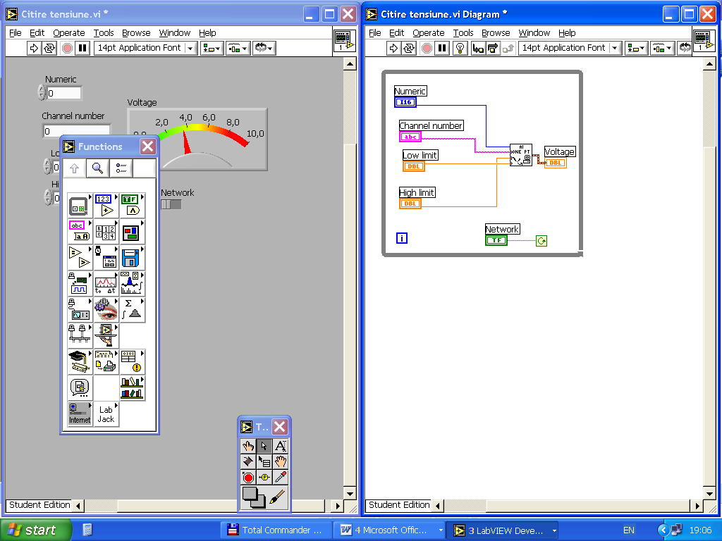
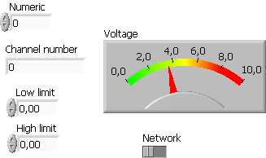
a) b)
Fig. 2.1 - LabVIEW application for the continuous reading of the voltage from an analog input channel of a plug – in data acquisition board [3]

This kind of applications are created in the LabVIEW virtual instrumentation program and it is registered with VI extension, providing from Virtual Instrument and it is composed by two distinct windows, with a high interconnection: a Panel window in which can be defined the virtual instrument components and its parameters, who are used in the application and a Diagram window in which can be showed the program of the application [2]. For the defining of the objects in the Panel, there are used generally input objects (controls) and one or more output objects (indicators). The defining of the objects in the Panel can be made using the Control palette.

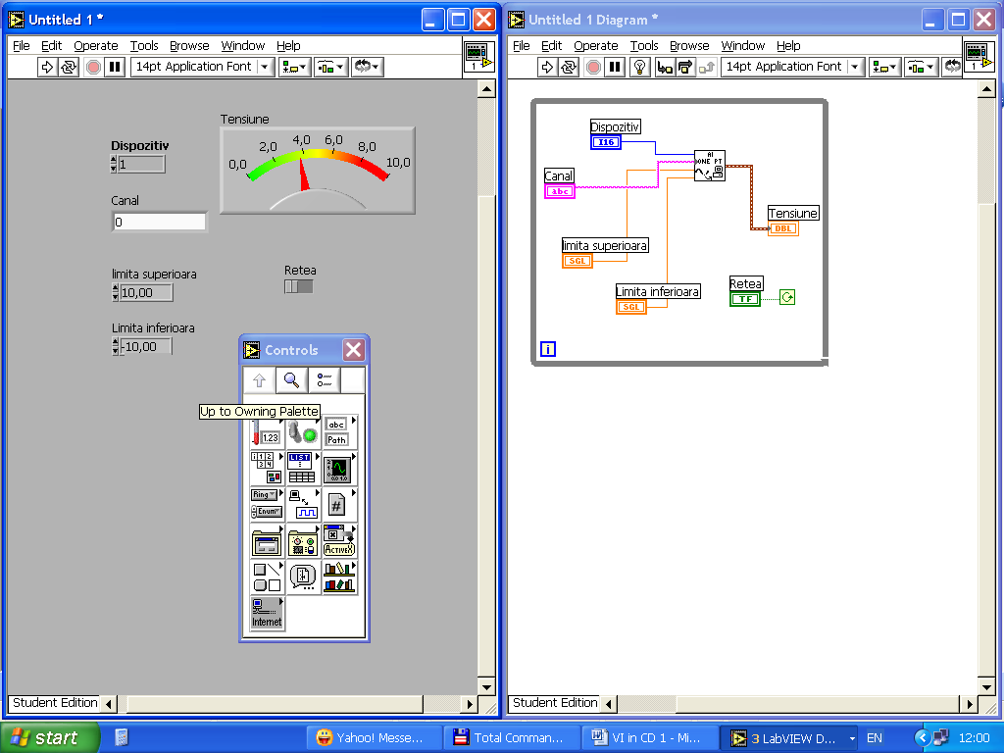
1

2

3

4

Fig. 2.2 – The Control palette for the defining of the objects in the Panel [2]
1 – input / output numerical objects, 2 – Boolean, 3 – string objects, 4 – graphic objects
The input objects can be numerical or analogical objects, and the output objects can be numerical or graphical objects. It can be used also logical operators for the conditioning of some events in the program structure, which, depending by the sequence program structure can be of different types.
The graphical programming in the Diagram can be made using the Functions palette, who contains mathematical operators, programming structures, subVI, different functions for the data acquisition and so on. Generally, a LabVIEW application contains at least one programming structure, for establish some proceedings for the cycles running, or the sequences of the program. In LabVIEW it can be used 5 programming structure types: the Sequential structure , to mark some steps of the program, the Case structure, to establish the proceedings who contains distinct program subsequences, the For – Loop structure, to define a repetitive program sequence, of iterative type, with a predefined number of iterations, the repetitive structure While – Loop, for the running of some program sequences, repetitively, this being conditioned by a Boolean operator logical state and finally the Formula Node in which can be defined some mathematical expressions, simple or complex, of equation or polynomial type.

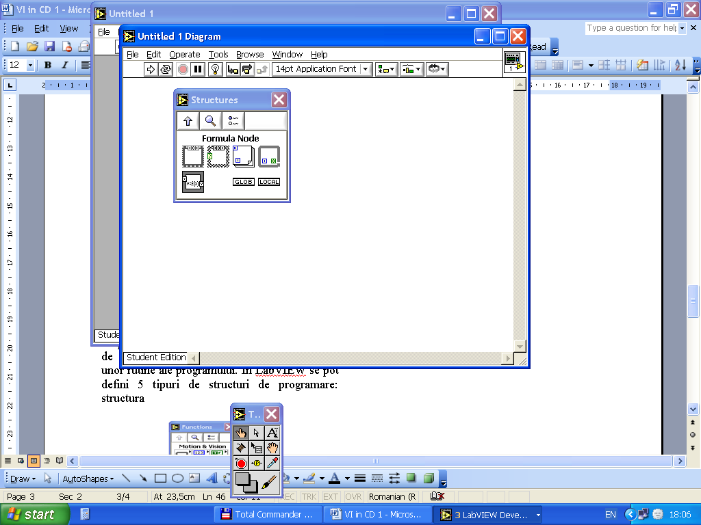
2

1

5
3

4

Fig. 2.3 – Programming structures in LabVIEW
1 – sequential structure, 2 – Case structure, 3 – For – Loop structure, 4 – While – Loop structure, Formula Node structure [2]

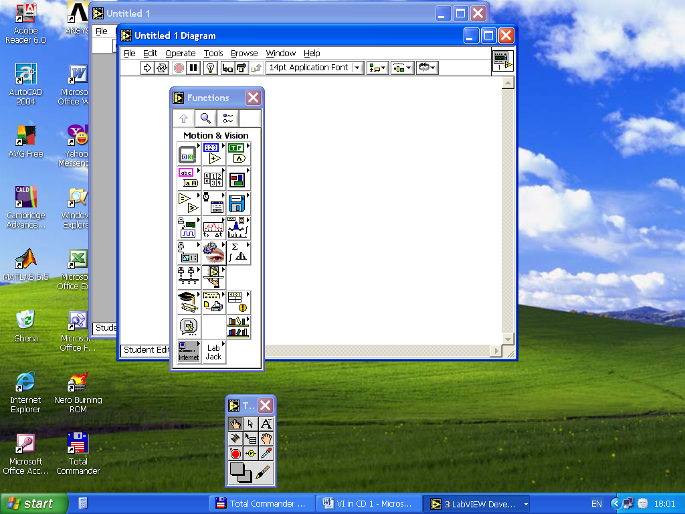
1

2

3

4
5

6

Fig. 2.4 – The Functions palette
1 – mathematical operators, 2 – programming structures, 3 – data acquisition functions, 4 – existing or created subVI, 5 – functions for the sinusoidal signal generation, 6 – complex mathematical functions [2]

A LabVIEW application is characterized by the aspect that all the defined object in the panel appear also in the diagram, with their specific. The relation between the input objects, the output objects and the functions which define a program step, are represented by connect wires.
The advantages of the graphical programming in LabVIEW consists in a very large application range who can be realized, for different domains as: the Mathematics, the Physics, the Electronics, the Chemistry, the Mechanics and so on.
For a better understanding what means the creation of a virtual instrument, for the following is described a very simple application, referring to the second degree equation resolving of type:

${\text{ax}}^{2}+\text{bx}+c=0$ (2.1)

The application suppose the using of a True / False optional programming structure. In the Panel must, first of all, define the a, b and c parameters of the equation, as numerical input controls, for different values. There is also necessary to define 3 boolean operators, for the 3 distinct situations possible: two real distinct roots, one double real root or two complex roots. It is also necessary the defining of a numerical output indicator, to determine Δ equation parameter, a numeric control to compare Δ with zero and two numeric indicators to display the roots [2].
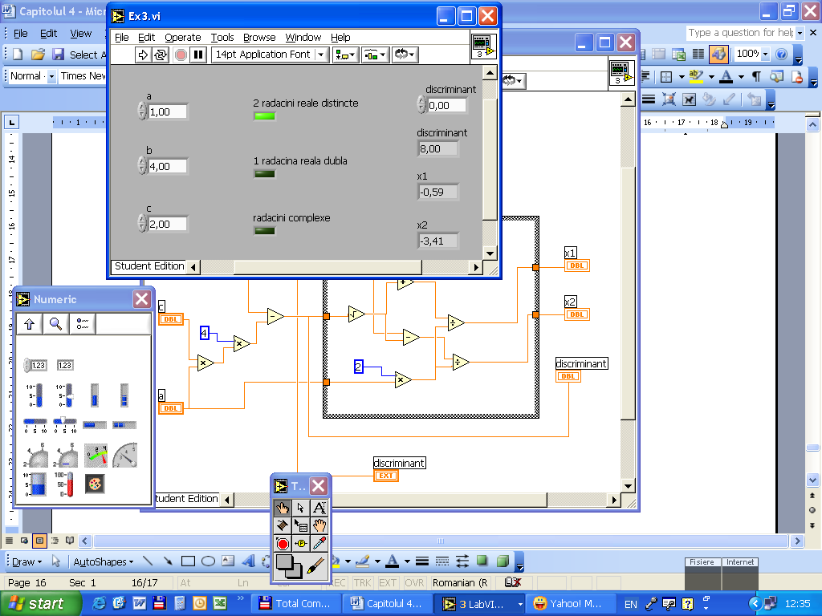

Δ
2 distinct real roots
Δ

1 double root

complex roots

Fig. 2.5 – The panel of a LabVIEW application for the solving of a second degree equation [2]

The application suppose the using of a Case boolean structure, True / False type, to solve the equation depending by the positive or the negative value of Δ parameter. In the False case, it consider that Δ takes positive values, as a result could be determined the real values of the equation roots. In the True case, Δ takes negative values, and, as a result, the two roots take complex values.

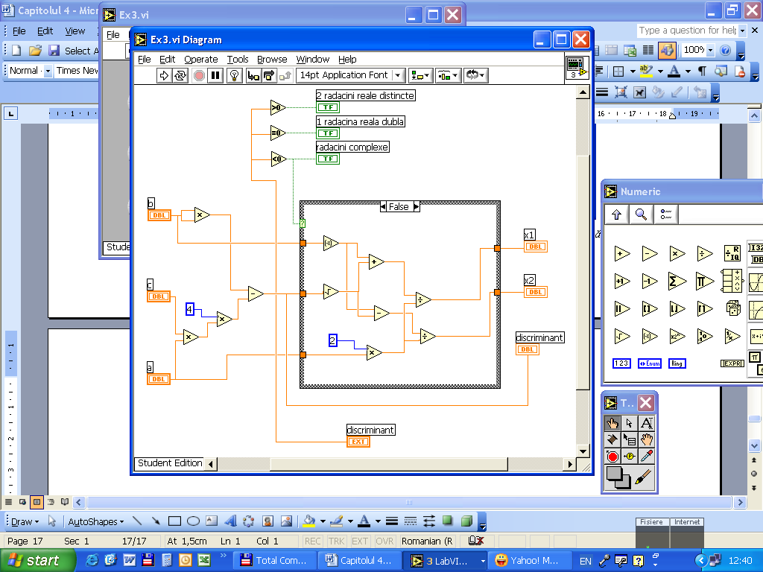
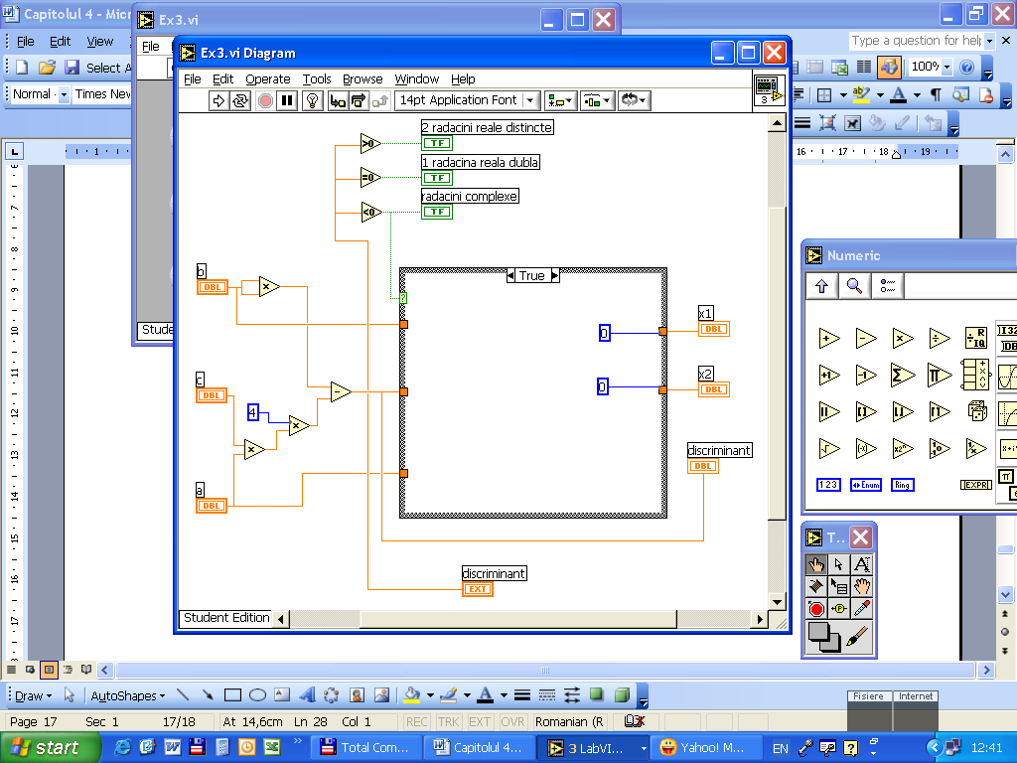
2 real distinct roots
1 real double root
2 complex roots
2 real distinct roots
1 real double root
2 complex roots
Δ
Δ
Δ
Δ

a) b)
Fig. 2. 6 – The diagram of a LabVIEW application for the solving of a second degree equation [2]
a) True case, b) False case
- The creation of a virtual instrument for the radial deviation measuring of a symmetrical revolution probe

For better understanding the proceedings in which a virtual instrument could determine the dimensional deviation values, first of all, is necessary to present and describe a special virtual instrument, named LJSimplelog.exe, who represent an executable program who permits the acquisition and the storage of the voltage values, using 8 channels for analog inputs of a plug – in data acquisition board, LabJack U12. The application is created using the LabVIEW program, consisting in a virtual instrument, named LJSimplelog.vi.
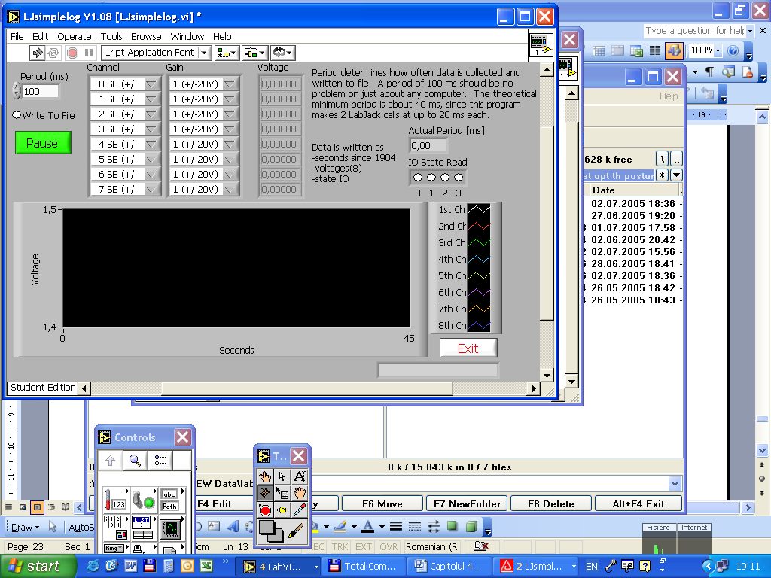

Fig. 3.1 – The panel of the LJSimplelog.vi virtual instrument, permitting to measure the dimensional deviations in voltage levels [4]

Choosing the desired acquisition channel, this virtual instrument permits the signal acquisition, using voltage levels, in real time and continuously, at an acquisition frequency who can be established using the Period control input. The Write to File option permits to save the acquisitioned data into an EXCEL file, in which the data can be take over and analysed, knowing the corresponding voltage levels of the dimensional deviations.
In order to create a virtual instrument who permits to show the results in displacement units (not in voltage units), it were realized the following steps:
- for each measured point, using the virtual instrument LJSimplelog.vi, it was determined the voltage level, being directly proportional with the probe’s radial deviation value. For this reason, the measuring was made with an inductive sensor, MICROLIMIT, TI 1B 0263 – 79, coupled to the PC by a plug – in data acquisition board, LabJack U12;
- the linearity sensor characteristic being known, it was determined the mathematical relation which describes the dependence between the voltage level sensor signal and the radial deviation of the probe, in each measured point.

Table 3.1 – The establishing of the ratio between the voltage sensor signal and the radial deviations, measured in equidistant points [1]
Rotation angle [°] | Voltage level [mV]
0 | 0
45 | 101,1
90 | 176,8
135 | 179,6
180 | 171,9
225 | 86,1
270 | -27,3
315 | -16,9

The relation to establish the dependence between the voltage level of the output signal and the deviation values is defined as the following:

U_{e} = k δ_{BR} (3.1)

k being the signal multiplication factor (k = 2,46), determined from the obtained data and also, basing to the sensor linearity characteristic, and δ_{BR} represents the dimensional deviation of the probe in each measured point, expressed in micrometers.
Basing to this dependence relation, it was created a simple subVI, which is used for the conversion of voltage levels into displacements (expressed in length units).
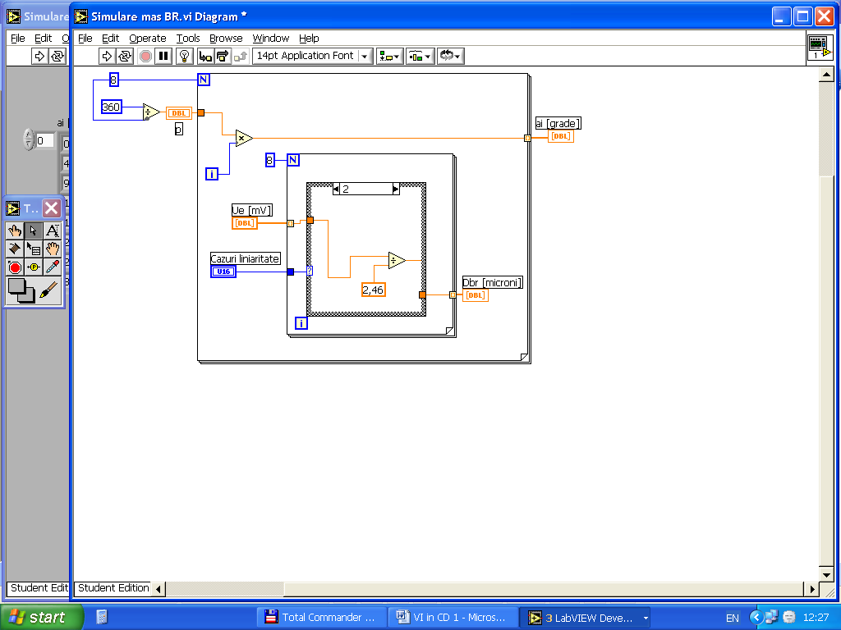
a_{i} degrees
U_{e} mV
linearity
D_{b} μm

Fig. 3.2. – The diagram of the subVI for the converting the measuring results into length units [1]

The diagram contains a sequential structure for each case for the nonlinearity and linearity of the sensor, the complete displacement range of the transducer’s rod touching being known (L = 2,8 mm). The linearity zone measure only 0,13 mm, being situated at the middle of the rod touching range. The taking to “zero” of the transducer was made so that the minimal and maximal form deviations to be included in its linearity domain. For this reason it is presented only the corresponding linearity domain program sequence and, in this order, it was determined the transducer touching rod displacement, using the transducer response linear variation law. For the non – linearity cases, in the other program sequences there are determined the non – linearity variation laws, respecting the transducer characteristic diagram.
Running the subVI, in the panel the radial deviations values are obtained for each measured point.
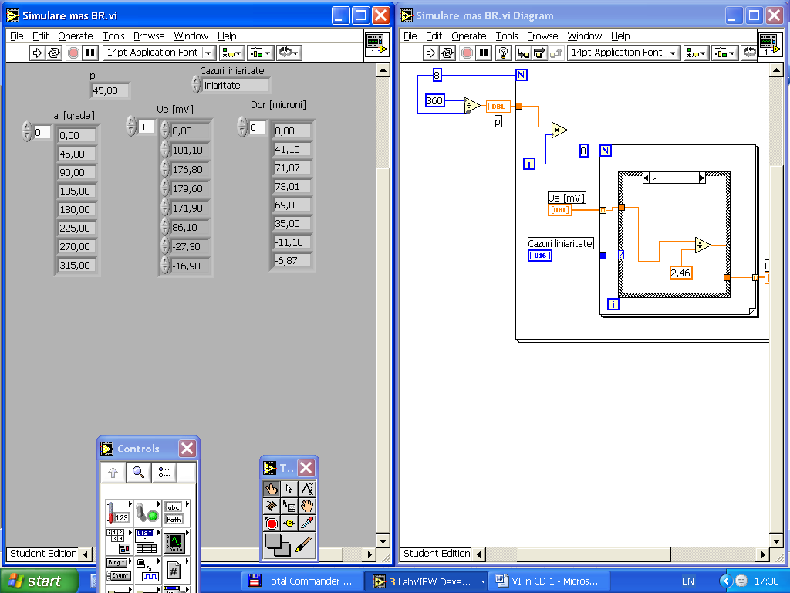
linearity
degrees
micrometers

Fig. 3.3 – Displaying the radial deviations in the panel [1]

Inserting the subVI into the LJSimplelog.vi continuous voltage acquisition virtual instrument, it is possible to obtain a virtual instrument who permits to display the measuring in vivo directly in length units.

References:
[1] Braun, B - Theoretical improvements concerning the optimization of the equipment for measuring of the dimensional control automat machineries - The second paper for the Thesys, 2005;
[2] Cottet, F; Ciobanu, O - The basis for the programming in LabVIEW - MATRIX ROM, Bucureşti, 1998,
[3] Ursuţiu, D - Initiation in LabVIEW. Graphical programming in Physics and Electronics - LUX LIBRIS, Braşov 2001, ISBN 973-9428-60-6, pag. 106;
[4] Natinal Instruments - Measurement & Automation Explorer (MAX). Applications – LJSimplelog.exe / LJSimplelog.vi, site: www.ni.com ;

