1st International Conference
″Computational Mechanics and Virtual Engineering ″
COMEC 2005
20 – 22 October 2005, Brasov, Romania

Mathematical Models for Vehicle Tests

Mat. Petru Cârdei, dr. ing. Muraru Vergil, ing. Raluca Sfîru,
INMA Bucharest, e-mail icsit@sunu.rnc.ro

Abstract

Among the motor vehicle tests there are also the tests of lateral stability. The mathematical models, which represent the subject of this paper, are models attached to this type of tests, but they can be generalized at a large range of tests included into the motor-vehicle tests. For motorcars these tests are settled by [1], [2], [3], [4]. The author of the article has tried to obtain a generalization for the big size vehicles – simple or articulated, as for the lateral stability tests, settled only for cars. During the performed tests important supplements have appeared at the above – mentioned international documents: the double control of the tests and the possibility of partially overtaking the tests from the physical space into the virtual one, by simulating on mathematical models on the computer. Both supplements are demands expressed by the wide-spread international documents [5], [6], [7]. But the international documents haven’t solved yet the problem of the losing stability criteria, the terms in which these criteria can be expressed in the best or the simplest way. The mathematical models lead to the formulation of such criteria. The completions and the improvements brought to the vehicle tests are based on mathematical modelling vehicle represents the topic of this paper.

Key Words: Vehicles, Dynamics, Tests, Stability, Models

- Mathematical Model Used in Order to Perform the Physical Tests Of Vehicles

The mathematical models described in this paper are involved in the performing of the vehicle lateral stability tests. Every model has its own role, both in controlling the testing conditions, as well as anticipating the experimental results, but also in the extrapolation of the results as terms of some tests which should be performed in very high risk level conditions.
The three models presented in the paper are:
M1) The Model of the Kinematics of physical tests;
M2) The Model of the vehicle as a suspended rigid solid;
M3) The Structural Model of the vehicle;
M1 Model has the following data: the axle base of the vehicle, the axle bases of the vehicle bridges, the position of the center of mass on the vehicle longitudinal axle, the hand wheel control, the theoretical or empirical relation between the hand wheel angle and the turning angles of the steering wheels, the constant displacing speed and it produces the trajectory of the vehicle reference point. Moreover, M1 Model can give the expected approximate variations of the physical variables, which must be measured during the tests: speed and accelerations, displacements and angular speeds in various points required by the international documents [1], [2], [3].
M2 model is based on the mathematical model of the suspended rigid solid and it is used for defining the measuring manner of the important variables during the track tests. If the constants (or the model parameters) are well-known, this model can be used also in simulating the track tests and, implicitly, in order to determine the expectation in the field of the important physical variables of the tests.
M3 model requires more geometrical and physical data on the vehicle for construction (modelling by using the finite element method, for example). This model is used for : the calculus of the inertia moments of the vehicle, the calculus of the mass center position as of the radii of gyration. The structural model can be controlled by performing the mass of the vehicle and the suitable distribution of the load on each wheel, and, if the position of the mass center is known experimentally – by confronting the results of the model with the experimental ones. If the structural model follows the reality precisely, it can be used for the dynamic simulation of the track tests, for determining some important physical variables and especially for checking some criteria of losing the formulated stability, as for the lateral limit acceleration at the mass of the center, or the dynamic load on each wheel.
The advantages of using these tests of estimating the lateral stability on vehicles by simulation are:
- the estimation of the physical variables impossible or very difficult to be measured (for example, the variation of the wheel load);
- the possibility of simulation of physical tests with high physical risk, without any physical problems;
- they may lead to the formulation of some criteria of losing the stability of the vehicle and of some comparison criteria between the various types of vehicles, regarding the behaviour during the same types of tests;
- the important reducing of the pilot’s influence on the results of the tests.
In order to simplify all the models are presented for a vehicle with two bridges, having the steering wheels on the front axle.

- M1 Model

The mathematical model of the kinematics of the testing process on the track has as entering parameters the following data :
-the axle base of the vehicle, L;
-the distance between the center of the axle and the mass center, a (b=L-a);
-the axle bases of the vehicle bridges, E₁, E₂;
-the control at the hand wheel namely the variation in time of the angle α=α(t), radians, is given by the requirements of the test of [1], [2], [3], t being the temporal variable;
-the theoretical as empirical connection between the turning angles of the wheels and the angle of the hand wheel, θ_{s}(t)=θ_{s}(α(t)), θ_{d}(t)=θ_{d}(α(t));
-the constant value of the displacement speed (the tangential component to the trajectory measured on the speedmeter of the vehicle), V;
-the initial data are known: the coordinates and the speeds at the beginning of the test, X₀=0, Y₀=0, V_{X0}=V, V_{Y0}=0;
-the model is plane supposing that the track is very high quality, according to the requirements from [1], [2], [3];
The fixed reference system is oriented with the axis OX₁, along the track and the axis OX₂, perpendicular on that to the centre of the track, the origin O being at the initial moment t=0, on the middle of the start line in the test, more precisely on the middle of the strip of initial displacement.
The mobile reference system ox₁x₂ is solidary to the vehicle, having its origin in the reference point, o, of the vehicle and, initially, the coordinate axes ox₁ and ox₂, parallel to the axes OX₁ and OX₂ of the absolute reference system.
The main hypotheses of the model are:
-the displacement speed, V, is constant;
-the intersection between the symmetry plane of the steering wheels and the plane of the testing track are two tangent (straight) lines to the trajectory of the centers of the contacts spots of the two steering wheels;
-the vehicle body behaves with a good approximation as a rigid solid. The turning angle is calculated at the front axle of the vehicle:
$φ(t)=\text{arctg}\left(\frac{b}{L}⋅\frac{2}{\text{tg}(θ_{s}(t))+\text{tg}(θ_{d}(t))}\right)$ (2.1)
In these condition the motion equations of the centers of the contact spots of the steering wheels are:
$\begin{aligned}\vec{r_{s}}\left(t\right)=V\int{{\text{cos}θ_{s}\left(α\left(s\right)\right)\text{ds \{}\vec{I}}_{1}}+V\int{{\text{sin}θ_{s}\left(α\left(s\right)\right)\text{ds \{}\vec{I}}_{2}},\end{aligned}{\vec{r}}_{d}\left(t\right)=V\int{{\text{cos}θ_{d}\left(α\left(s\right)\right)\text{ds \{}\vec{I}}_{1}}+V\int{{\text{sin}θ_{d}\left(α\left(s\right)\right)\text{ds \{}\vec{I}}_{2}}$ (2.2)
Where $\vec{I_{1}},{\vec{I}}_{2}$ are the vectors of the coordinate axes of the absolute (fixed) reference system. The distance between the centers of the two contact spots is not rigurously null, but the difference is small, so that it can be fully taken are by the tyre elasticity. From (2.1), (2.2) and the calculus relations in the rigid solid there are obtained the motion equations of the vehicle reference point (in this case the center of the front axle) and the mass center, G:
$\begin{aligned}{\vec{r}}_{o}=\frac{{\vec{r}}_{s}\left(t\right)+{\vec{r}}_{d}\left(t\right)}{2}, \\ {\vec{r}}_{G}={\vec{r}}_{o}−a⋅\text{cos}\left(φ\left(t\right)\right)⋅{\vec{I}}_{1}+a⋅\text{sin}\left(φ\left(t\right)\right)⋅{\vec{I}}_{2}\end{aligned}$ (2.3)
With these data calculated, using the data in [8] it can be also calculated the motions equations of the trucks mass center. Knowing these motion equations, those are simply determined, by algebraic and differential operations, the expectances as regards the physical sizes which should be measured during the test: the side acceleration at the mass center, the turning angular speed, the angles and angular speeds rolling and pitching angular speeds, etc. For the test control, besides checking the variation law of the hand wheel angle (which is registred during the test), there is traced on the track the trajectory of the reference point, o, or of the contact spots centers of the steering wheels, as marks easier to be followed by the driver (see fig. 2.1). On the other side is also checked the compliance with the limits imposed by the standards of the main physical sizes whose variation is calculated in this model. Thus the programmed test is or is not validated for the
physical experiment.
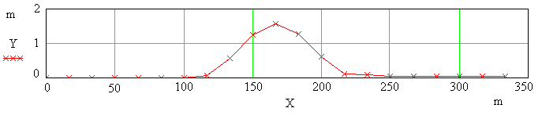
Fig. 2.1 The marked trajectory of the vehicle for a lateral stability test with sinusoidal input, at V= 80 Km/h, amplitude of the hand wheel angle 105º, and 0.2 Hz frequency of the hand wheel angle. Maximum lateral acceleration: 2.572 m/s² and trajectory amplitude: 1.566 m.

- M2 Model

The model of the vehicle as a suspended rigid solid is based on the model of the rigid solid which models the suspended mass of the vehicle. The motion equations of the rigid solid are:
${\vec{X}}_{O}={\vec{X}}_{o}+R\vec{x}$ (3.1)
where ${\vec{X}}_{O},{\vec{X}}_{o},\vec{x}$ the vector of a certain point, P, of the vehicle in the absolute references point (fixed, solidary to the testing track), the absolute vector of the vehicle reference point and the position vector of point P, in the reference system solidary to the vehicle.
The tensor R is the rotation tensor, the three angles defining it being the rolling angle, φ₁, the pitching angle, φ₂ and the gyration angle φ₃. By means of this model the measuring method is defined. For instance for the case when the measuring is fully done with acceleration transducers there is defined a system of three measuring points aligned two by two (see fig. 3.1), in each point being placed three transducers oriented according to the directions of the mobile reference system, so that from the measuring data there are calculated by double integration the displacement and then the rotation tensor, R, after which there is calculated the translation vector, $\overset{→}{X_{0}}$, of the vehicle reference point.
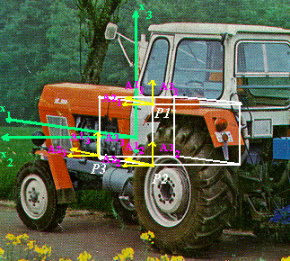
Fig. 3.1 The transducers location on the vehicle.
Once these data being hnown, it can be calculated any interest size in any point of the vehicle. If the suspension is rigid enough or the vehicle has a suspension only on tyres (tractors), then it can be performed the test simulation on this model with a rather good approximation, obliging the rigid solid to move the reference point on the trajectory calculated within the model of the test kinematics and the tangent to the trajectory of this point should be parallel to the longitudinal axis of the vehicle. However there will not be obtained any data on the pitch and the data on the rolling movement will be affected by errors, missing at least the damping effect as long as in the model there are not included any damping elements.

4. M3 Model

The structural model of the vehicle proposed in this paper is build with finite elements. The structural model is given by the modelled structure geometry, the physical paraneters characterizing the materials of the structure and the structure suspensions. Such a model for a vehicle of “Mercedes” moto – utilitarion type, is presented in fig. 4.1. The vehicle geometry is well observed and the measure in which the suitable repartition of the masses inside is cheked by the position of the mass centre coinciding with that one experimentally determined and by the correct load distribution on the four wheels when stationary.
The disavantage of this model is that the used method cannot solve the problem without a minimum of suspensions which are performed by blocking the nodes at the lower part of the wheels. This blocking means the fixing on three directions and in at least one mode also the anmuling of the three rotations. These compulsions are not read for a vehicle because the wheel may lose the contact with the rolling track and this surely happens in the neighbourhood of the overturning moment. For this reason the model should be cautionsly used when simulating tests in resembling condition to those when the overturning occurs. On this model there are the components of the inertia tensor which can be used in dynamic designers on M2 type model. For simulating the dynamic test it is procceded to a load having a side acceleration whose variation in time is determinated by means of M1 model. The result of such a test can be seen in fig. 4.2.
The simulation of the sinusoidal loop test in the hand wheel angle for the “Mercedes” type moto – utilitarion vehicle also gives the variation of the wheel load, so that one can appreciate the direction quality at any moment and some overturning criteria can be checked (those expressing in annuling the wheel load on one side of the vehicle).

5. Conclusions

The mathematical models presented in this paper ensure a considerable quality rising of the tests of vehicle side stability

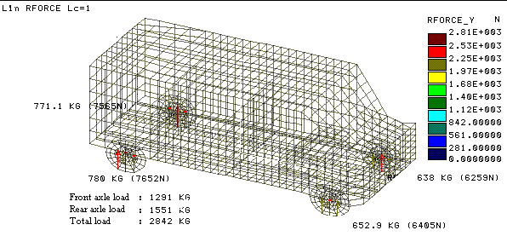
Fig. 4.1. Structural model of a “Mercedes” moto – utilitarion type vehicle.
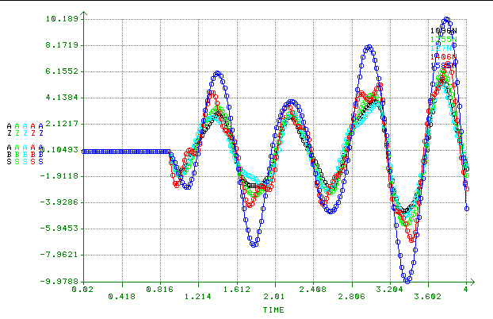
Fig. 4.2. The response of the model in five interest modes at a side acceleration calculated by means of M1 model.

by:
- upper control in the angle at the hand wheel and trajectory,
- expectance calculation in the field of interesting parameters by simulation;
- possibility of measuring the approaching of losing the stability on the basis of some precise criteria;
- simulation of the tests performed in great risk conditions which physically cannot be performed without supplementary protection devices which influence the results;
- determination of some interest sizes in the dynamic and optimization designes.
The introduction into practice of the vehicle tests of these mathematical models is performed by a software ensuring the numerical calculus of the three models. The testing method using these models is still in the stage of experimental confirmation.

References

[1] International Standard, Road Vehicles – Lateral transient response tests methods, ISO 7401, First Edition, 1988-05-01;
[2] Technical Report 8725, Road Vehicles – Transient open – loop response tests method with one period of sinusoidal input, ISO/TR, 1988-05-15;
[3] Technical Report 8726, Road Vehicles - Transient open – loop response tests method with pseudo-random steering input, ISO/TR, 1988-12-01;
[4] ISO/TC 22/SC 9 N 378, U.S. Proposal for a draft international standard test procedure for evaluating the rearward amplification of multi – articulated vehicles;
[5] IDIADA Institute for Applied Automotive Technology, Vehicle Dynamics, “Dynamic Rollover Stability Test” (Annexes 5 and 6), Informal Document 9 – 10 Feb., 1999;
[6] DRAFT, The physical test for the dynamic rollover stability of heavy commercial vehicles (motor vehicles, trailers and semi-trailers of categories M,N and O) with a maximum permissible mass greater than 3,5 t, TNO Road-Vehicles Research Institute, Vehicle Dynamics Department, The Netherlands;
[7] Russian Federation, Comments to the TNO report “ Dynamic rollover stability test” (Anexes 5 and 6), Informal Document No. 24, 1-5 . 02.1999;
[8] Я.X. ЗАКИН, ПРИКЛАДНАЯ ТEOРИЯ ДBИЖЕНИЯ ABTOПОEЗДА, Издameльcmbo “TPANCПOPT”, MOCKBA 1967;

