1st International Conference
″Computational Mechanics and Virtual Engineering ″
COMEC 2005
20 – 22 October 2005, Braşov, Romania

CHANGE OF THE MECHANICAL PROPERTIES
DUE TO THE WATER AND SEAWATER ABSORPTION
IN CASE OF SOME COMPOSITE MATERIALS

Lect. eng. Camelia CERBU ¹, Prof. Ph. D. eng. Ioan CURTU ²
¹“Transilvania” University of Brasov, Romania, cerbu@unitbv.ro
²“Transilvania” University of Brasov, Romania, curtui@unitbv.ro

Abstract: The paper describes the aspects concerning decreasing of the mechanical properties of the glass-reinforced resins due to the water and seawater absorption. In this paper E-glass fibres were used to randomly reinforce polyester resins (Heliopol 8431 ATX, Polylite 440-M880), epoxy resin (LY554) and vinyl-ester resin (ATLAC 582). Specimens for tensile test and flexural test were manufactured. Two different environments (water and natural seawater from the Black Sea) were considered. Then, the specimens were subjected to a tensile test and flexural test (using the three-point method). Results of the tests applied on the specimens after immersion time were compared with the results obtained in case of the dry specimens. Herein, we show that the moisture acts on the strength and stiffness characteristic of the composite materials involved. We note that the moisture absorption into the composite materials analysed leads to the decreasing of the mechanical characteristics.
Keywords: Composite materials, moisture, flexural modulus, strength.

- INTRODUCTION

The primary objectives of this study were to experimentally investigate the degradation of the mechanical properties of the glass-reinforced composite materials subjected to the water or seawater effect. When an organic matrix is exposed to humid air or to a liquid, the moisture content of the composite material may change with time. These changes affect the mechanical characteristics [1, 2, 5, 6]. To use the full potential of the composite materials, their response to environmental effects (moisture, temperature, and thermal cycles) must be known.
The marine environment presents severe and unique problems for composite materials due to long exposure time, presence of numerous ionic species and micro-organisms. Investigations of the effect of marine environments on composite materials are rare and often reduced to accelerated laboratory studies using synthetic seawater. Since the chemistry of the natural seawater is complex, natural seawater from Black Sea was used as environment in the present paper.
Due to the wide acceptance of the glass-reinforced composite materials in the automotive industry, naval structures, environmental tests have been made to evaluate their performance when these are subjected to the environment effect (elevated temperature, water, ultraviolet light etc). Generally, the problem of the durability of the composite materials under the action of the environmental effects consists in two steps. In the first step, the moisture content [2, 3] or the temperature distribution inside the composite material is determinate. In the second step, the changes of the mechanical characteristics (modulus of elasticity, strength) are analysed [4, 5, 6].

- MATERIALS. WORK METHOD

In this paper E-glass fibres (50 mm length) were used to randomly reinforce polyester resins (Heliopol 8431 ATX, Polylite 440-M880), epoxy resin (LY554) and vinyl-ester resin (ATLAC 582). The average volume fibre ratio of the composite materials tested, was equal to 26 %, while the weight fibre ratio was 40 %. The plates made of composite materials were cut to obtain the specimens (fig. 1,2) according to [7, 8]. A total number of 136 specimens were manufactured (tables 1). All sides of a half of the total number of the tensile specimens were coated using the resins used for the matrix while the others were not coated.
Prior to immersion, the specimens were stored in an oven at 30 ± 1°C and weighted to ensure that they were dry prior to environmental conditioning. Water and fresh filtered seawater at room temperature (20 °C) were used for the environmental exposure (fig. 3). Stands were used to maximise the contact surface between specimens and water (see the detail presented in the fig. 3, b). Natural seawater was taken from the Black Sea. The salinity (salt concentration) was approximately of 1.6 % and its chemical analysis is presented in the table 2. The water tanks were covered to minimise evaporation and the water was changed every month to keep conditions constant.
To monitor the uptake of water, quantified by the moisture content, M, the specimens were periodically removed from the tanks, dried superficially with absorbing paper and weighted on a Analytic Balance accurate within ± 0.0001 g. The absorption data were presented in previous papers [3, 5].
Finally, the specimens were subjected to tensile test and flexural test (three-point method) after the saturation point was reached.

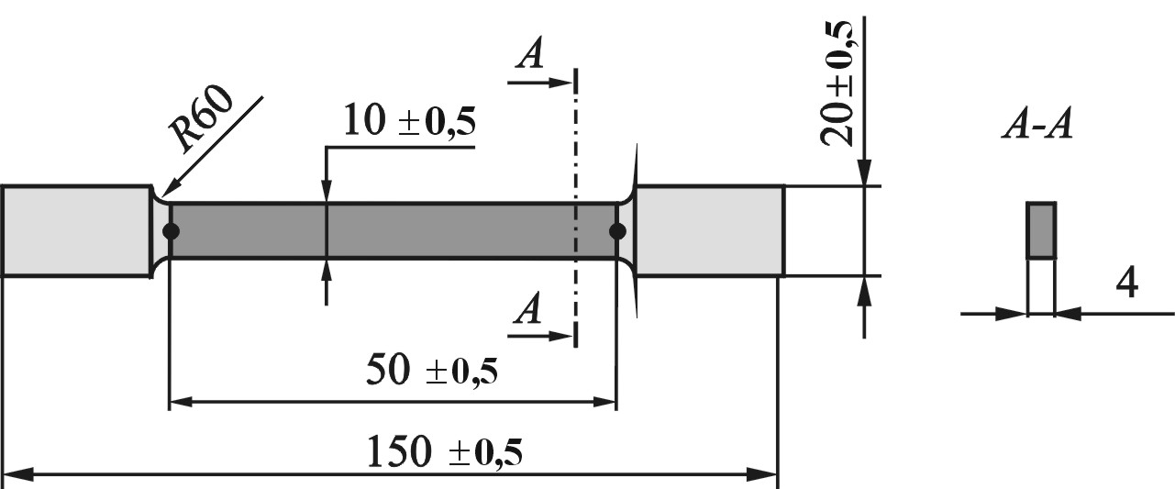 | 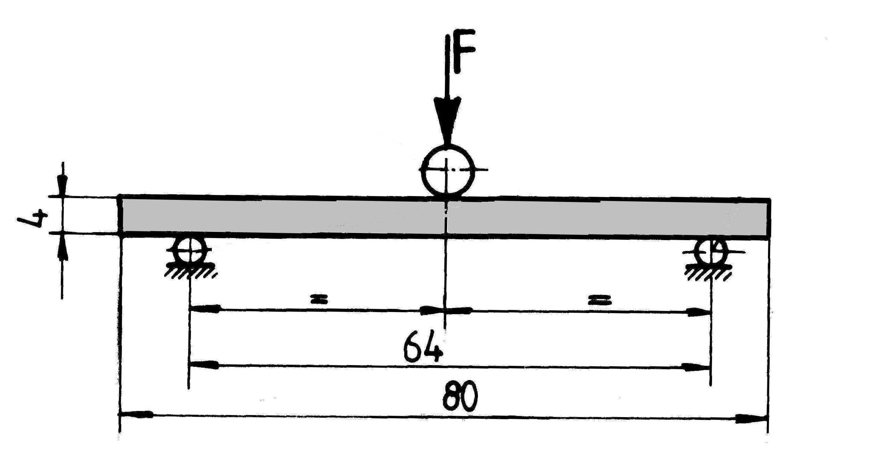  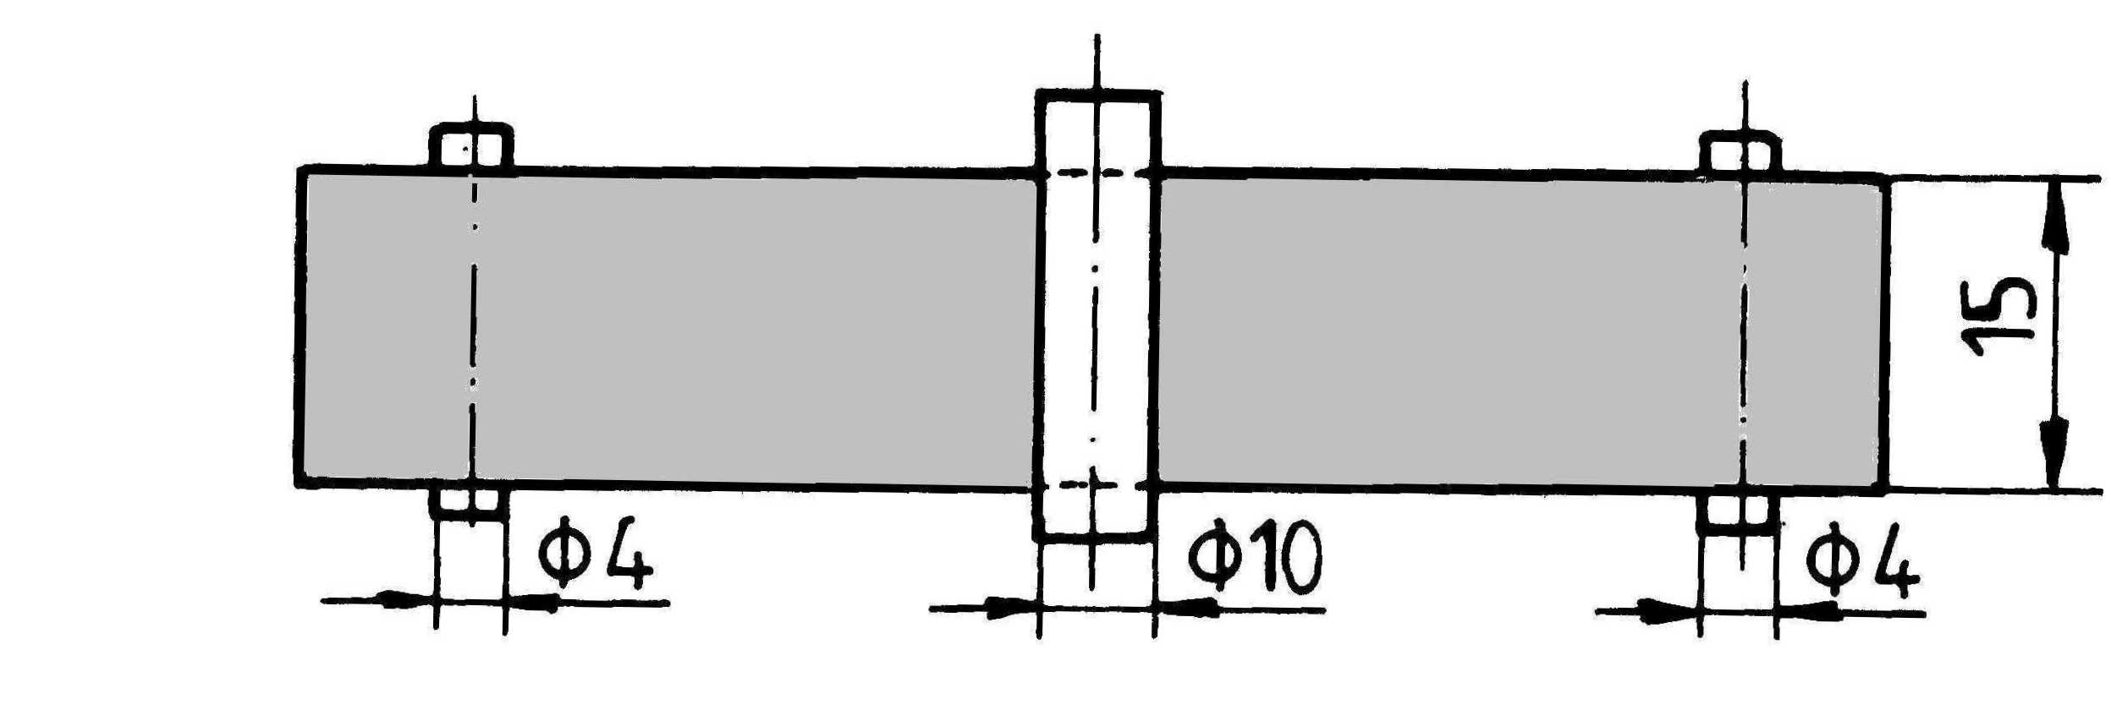
Figure 1: Specimen for tensile test | Figure 2: Specimen used in flexural test and loading scheme

Table 1: Number of specimens for tensile and flexural tests
No. | Composite material | Number of specimens
No. | Composite material | For tensile test |  |  | For flexural test
No. | Composite material | Dry  specimens | Wet specimens |  | Dry  specimens | Wet specimens
No. | Composite material | Dry  specimens | Water | Seawater  (Black Sea) | Dry  specimens | Water | Seawater  (Black Sea)
1 | E-glass / HELIOPOL 8431 ATX | 5 | 6 | 6 | 5 | 6 | 6
2 | E-glass / POLYLITE440-M880 | 5 | 6 | 6 | 5 | 6 | 6
3 | E-glass / epoxy LY 554 | 5 | 6 | 6 | 5 | 6 | 6
4 | E-glass / vinyl-ester ATLAC 582 | 5 | 6 | 6 | 5 | 6 | 6

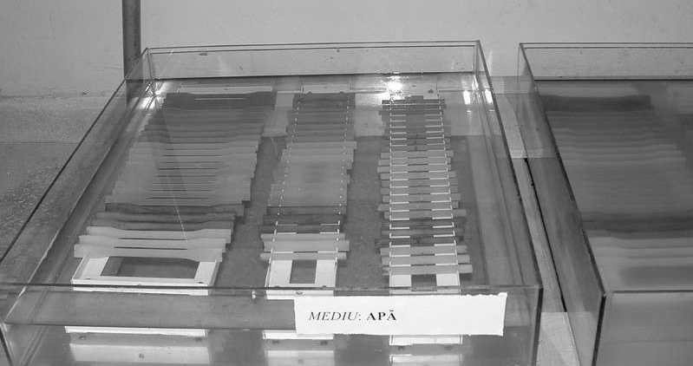 | 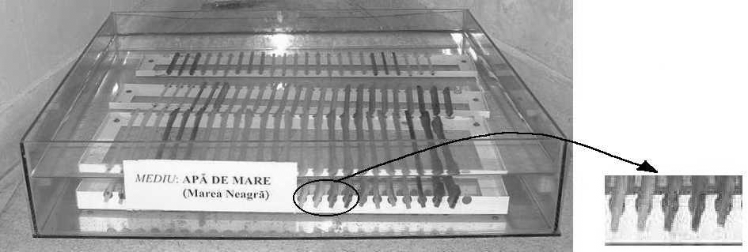
a. | b.
Figure 3: Environments a. Water ; b. Seawater (Black Sea)

Table 2- The results of the chemical analysis of the seawater (from the Black Sea)
pH | Conductivity | Ca²⁺ | Mg²⁺ | Chloride  Content | Sulphate  Content | Salinity
 | $$\left[{μS}/{\text{cm}}\right]$$ | [mg / l] | [mg / l] | [mg / l] | [mg / l] | [%]
7.35 | 22100* | 1603 | 681 | 7940.8 | 967.12 | 1.594
*A great mineral content.
- RESULTS

The first, moisture behaviour was analysed during ten months and the results were analysed [3,5]. After immersion the specimens were subjected to the mechanical tests. Table 3 shows us immersion times in case of the tensile specimens tested. Flexural test (using the three-point method) was considered after 9200 hours of immersion (approximately 11 months). The flexural modulus E was computed on the linear portion of the force-displacement curve while flexural stress $σ_{e}$ corresponds to the end of the elastic domain. The results obtained in case of the wet specimens were compared with these of the dry specimens. Hereinafter, important remarks concerning the effects of the water and seawater absorption on the tensile strength, flexural modulus E and flexural stress to the end of the elastic domain will be noted.

- Tensile strength
The experimental results concerning tensile strength are shown in the figures 4...7 in case of the composite materials involved.

Table 3: Soaking times for the composite materials subjected to tensile test
Composite material |  | Soaking time [hours]
Environment |  | Water | Seawater (Black Sea)
E - glass / HELIOPOL 8431 ATX | All sides not coated | 7197 | 6987
E - glass / HELIOPOL 8431 ATX | All sides coated | 7197 | 6987
E - glass / POLYLITE 440-M880 | All sides not coated | 7197 | 6987
E - glass / POLYLITE 440-M880 | All sides coated | 1821 | 2763
E - glass / epoxy LY 554 | All sides not coated | 7197 | 6987
E - glass / epoxy LY 554 | All sides coated | 7197 | 6987
E-glass / vinyl-ester ATLAC 582 | All sides not coated | 2975 | 6987
E-glass / vinyl-ester ATLAC 582 | All sides coated | 1821 | 2763

Figure 4: Change of the tensile strength in case of E-glass / Heliopol 8431 ATX composite | Figure 5: Change of the tensile strength in case of E-glass / Polylite 440-M880 composite
Figure 6: Change of the tensile strength in case of E-glass / epoxy LY 554 composite | Figure 7: Change of the tensile strength in case of E-glass / vinyl-ester ATLAC 582 composite

Analysing the experimental results obtained in case of the wet specimens we may observe:
- Tensile strength decreases in case of all composites materials tested.
- The tensile strength decreases (40 %) much more after immersion in water than in case of the immersion in seawater, for the specimens made of E-glass / Heliopol 8431 ATX and E-glass / epoxy LY 554 composites (fig. 4 and 6).
- Conservation of the tensile strength was not very different if all sides of the specimens were coated using the resin of the matrix of the composite materials.
- Tensile strength of the specimens decreases with 10 – 20 % in case of the immersion in seawater (fig. 4...7). The reason could be that moisture content was much smaller in case of these environments [3, 5].
- The effect of the water and seawater on the tensile strength is not significant in case of the E-glass / Polylite 440-M880 composite (fig. 5).

- Flexural modulus E
Figures 8 - 11 show us graphically the experimental results concerning flexural modulus, obtained in case of the E-glass / Heliopol 8431 ATX, E-glass / Polylite 440-M880, E-glass / epoxy LY 554 composite materials.

Figure 8: Change of the flexural modulus in case of E-glass / Heliopol 8431 ATX composite  (after 9200 hours of immersion) | Figure 9: Change of the flexural modulus in case of E-glass / Polylite 440-M880 composite  (after 9200 hours of immersion)
Figure 10: Change of the flexural modulus in case of E-glass / epoxy LY 554 composite  (after 9200 hours of immersion) | Figure 11: Change of the flexural modulus in case of E-glass / vinyl-ester ATLAC 582 composite  (after 9200 hours of immersion)

We may note the following remarks analysing the above results:
- Effects of the seawater are more pronounced than the action of the water in case of E-glass / polyester composites (E-glass / polyester Heliopol 8431 ATX and E-glass / polyester Polylite 440-M880) as shown in figures 8 and 9.
- Flexural modulus E decreases by ≈ 12 % in case of the E-glass / polyester Heliopol 8431 ATX composite when the specimens were kept in seawater. One may observe a good conservation of the flexural modulus in case of the specimens after 9200 hours of immersion in water.
- Flexural modulus decreases about 5 % when the specimens were kept in water while the change was ≈ 10 % when were submerged in seawater in case of the E-glass / Polylite 440-M880 composite (fig. 9).
- On the other hand, when the E-glass / epoxy LY 554 composite was submerged in water, the change of the flexural modulus was much more pronounced – about 20 % (fig. 10) while it decreases about 10 % when the specimens were kept in seawater.
- The change of the flexural modulus E was about 5-6 % when the specimens made of E-glass / vinyl-ester ATLAC 582 composite were kept 9200 hours in water and seawater (fig. 11).
- Excepting E-glass / epoxy LY 554 composite, the water absorption (after 9200 hours of immersion) decreases the flexural modulus, the change is about 5 % in case of all composite materials analysed.

- Flexural stress $σ_{e}$
Figures 12...15 show us the changes of the flexural stress in case of the specimens subjected to bending after 9200 hours of immersion. Analysing the results we may deduce:
- Conservation of the flexural stress $σ_{e}$ was good in case of E-glass / Heliopol 8431 ATX after 9200 hours of immersion in water (fig. 12).
- A change (about 11 %, 18 % ) of the flexural stress $σ_{e}$ was also observed in case of the E-glass / Polylite 440-M880 composite (fig. 13) when the specimens were kept in water and seawater, respectively.
- In case of the E-glass / epoxy LY 554 composite (fig. 14), decreasing of the flexural strength was approximately 31 % when the specimens were kept in water, while the decreasing was about 23 % when specimens were submerged in seawater.
- The effects of the water and seawater was approximately the same in case of the E-glass / vinyl-ester ATLAC 582 composite (fig. 15).

Figure 12: Change of the flexural stress $σ_{e}$ in case of E-glass / Heliopol 8431 ATX composite  (after 9200 hours of immersion) | Figure 13: Change of the flexural stress $σ_{e}$ in case of E-glass / Polylite 440-M880 composite  (after 9200 hours of immersion)
Figure 14: Change of the flexural stress $σ_{e}$ in case of E-glass / epoxy LY 554 composite  (after 9200 hours of immersion) | Figure 15: Change of the flexural stress $σ_{e}$ in case of E-glass / vinyl-ester ATLAC 582 composite  (after 9200 hours of immersion)

Analysing the experimental results concerning the degradation of the mechanical properties due to the action of the water and seawater absorption we may observe that E-glass / epoxy LY 554 composite may not be used to manufacture members which are loaded in wet environment. Contrariwise, the mechanical behaviour of the E-glass / Heliopol 8431 ATX and E-glass / Polylite 440-M880 composites is good.
Since the flexural modulus of the composite materials analysed decreases, it follows that the stiffness of these composites decreases by the same ratio (between 10 % and 20 %).

- CONCLUSION

Several researchers [1,2] also found that water absorption causes degradation of matrix-dominated properties such as interface and in-plane shear strengths, compressive strength and transverse tensile strength. In [2] E-glass / epoxy and carbon / epoxy composites were studied. Finally, the loss in the mechanical properties has been attributed to the plasticity of the matrix by water and degradation of the fibre/matrix interfacial bond due to moisture swelling of the matrix.
In case of the composite materials tested during our experimental research the above reason could be again the cause of the decreasing of the mechanical characteristics of the composite materials. We note that the moisture absorption into the composite materials analysed leads to the decreasing of the tensile strength, flexural strength and flexural modulus.
Decreasing of the tensile strength is about 40 % in case of E-glass / epoxy LY 554 composite after ≈ 7000 hours of immersion in water while the decreasing of the flexural stress $σ_{e}$ is 30 % after 9200 hours.
In general, it was found that the E-glass / epoxy composite analysed absorbed more water than seawater or water / detergent mix [5]. The sodium chloride molecules contained in seawater (as well as sulphate) appear to be limiting the diffusion of water into the matrix material. It was observed that the detergent effect was much more pronounced than the sodium chloride effect in case of E-glass / polyester composite [5, 6].
The E-glass / polyester composites (E-glass / polyester HELIOPOL 8431 ATX and E-glass / polyester POLYLITE 440-M880) are recommended as composite materials in case of water or seawater environment.
From point of view of the reasons shown in this paper, it is recommendable to take into account the results of this paper in the design of the structures made of the composite materials studied which work in wet environment.

REFERENCES
[1] Corum, J. M., Battiste, R. L., Ruggles, M. B., Ren, W.: Durability – based design criteria for a chopped-glass-fibre automotive structural composite, Composite Science and Technology, no. 61, 2001;
[2] Pomies, F., Carlson, L. A., Gillespie, J. W.,: Marine environmental effects on polymer matrix composites, Composite Materials: Fatigue and Fracture, Fifth Volume, ASTM STP 1230, R. H. Martin, Ed., American Society for Testing and Materials, Philadelphia, 1995;
[3] Cerbu Camelia, Curtu I., Roşu D.: Moisture behaviour of the glass fibre mat reinforced polymer, V. Sympozium Drevne Kompozitne Materialy (Composite Wood Materials), ISBN 80-228-1302-8, Zvolen, Slovacia, pp. 171 – 176, june of 2004;
[4] Cerbu, Camelia: Aspects concerning the moisture effects on the stiffness of the glass-reinforced polymers, Proceedings of the 4th Youth Symposium on Experimental Solid Mechanics, Castracaro Terme, Italia, ISBN-88-901080-2-9-44406, pp. 161-162, 4th – 7th May 2005;
[5] Cerbu, Camelia, Curtu, I.: Aspects concerning environmental effects on the glass-reinforced polymers, Proceedings of the 9th International Research / Expert Conference “Trends in the Development of Machinery and Associated Technology” TMT2005, ISBN 9958-617-28-5, Antalya, Turcia, 26 – 30 septembrie 2005, p. 1451-1454;
[6] Cerbu, Camelia: Aspects concerning the moisture effects on the mechanical characteristics of the glass-reinforced polymers, Proceedings of the International Conference on Structural Analysis of Advanced Materials, ICSAM 2005, ISBN 973-8449-98-7, Bucuresti, 15 - 17 septembrie 2005, p.109 - 116
[7] ISO 3268, Glass fibre reinforced plastics, Determination of tensile strength, 1978;
[8] SR EN 63, Glass fibre reinforced plastics, Determination of flexural properties, Three point method, CEN, Bruxelles, 1998;

