1st International Conference
″Computational Mechanics and Virtual Engineering ″
COMEC 2005
20 – 22 October 2005, Brasov, Romania

OPTIMIZING THE SANDWICH STRUCTURES WITH LIGHTWEIGHT HONEYCOMB CORE

I.,Curtu, V.,Ciofoaia, M. D.,Stanciu, A.,Repanovici, C. G Tatar,
Transilvania University of Brasov, curtui@unitbv.ro

Abstract. In the paper herein there are established correlations between the nature and dimensions of the layers within a sandwich structure made up of plywood beech faces of 4 mm thickness and styropor core and the characteristics related to strength, rigidity and costs. There are presented the optimised structures of the layers taking into account various criteria – maximum failure stress, minimum weight, rigidity to maximum bending and reduced costs.
Keywords: honeycomb case structures, styropor, rigidity, costs.

1. Introduction

Many different structures may be conceived aiming at addressing a great variety of necessities, but certainly all sandwich-type structures with very light core offer rigidity and strength as compared to their weight. The thin faces with great mechanical strength are separate, through sticking, by a light core of various thickness; the thicker the core the greater the rigidity and strength of the structure as compared to the increase of its weight.
The basic principle in order to obtain new composite materials is the efficient use of materials resources in view of obtaining some optimal properties for the new product. This principle has been introduced in the theory of materials through biomimentism. The biomimetism stands for the engineering-related reproduction phenomenon of composite materials that come from the natural environment; these composite materials represent the structures that determine the optimum physical-mechanical properties by combining the component elements.
Consequently, from certain points of view, the wood stands for a laminated and composite raw material made up of more types of raw materials optimally used taking into account their properties. In other words, the cellular wall is made up of better-shaped layers, each layer having certain mechanical and physical properties and, it is to remark the micro-fibrils orientation and the different substance content of the cellulose, hemi-cellulose and lignine. This disorder of the component substances in the cellular wall makes up a whole where the micro-fibrils play an important role under the traction and compressive stresses with direct effect upon the rigidity, and the lignine between each micro-fibrile is responsible for the tenacity of the cellular wall.
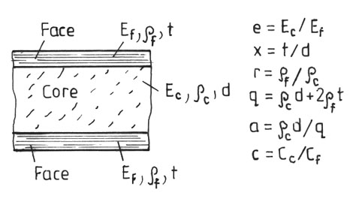  Figure1 Sandwich construction | 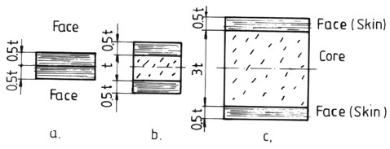  Figure 2 Type of sandwich structure
In a similar way, there have been conducted researches upon the characteristics of some sandwich structures made up of plywood of 4 mm thickness and styropor core with dimensions of 10,20 and 40 mm (fig.1). These are greatly used in furniture industry and wood works [1,2,3].

2. Characteristics of sandwich - type structure

Between the dimensional characteristics (thickness of core and faces) the elastic ones (elasticity modulus E and G), the strength one (under bending σ_{b}, traction σ_{t} compression σ_{comp}), the rigidity ones (displacements, D) as well as between the related costs C (cost of materials, adhesive and of design of sandwich-type structures there is a tight correlation).
In this way, there have been conceived and designed sandwich-type structures with light core (of styropor) and faces of plywood beech (of 4 mm) (fig. 2).
There has been followed the influence of core thickness (d) upon the characteristics of the respective structure: elasticity modulus E, bending deformations f, density ρ, and there have been found the correlations presented in figure 3.
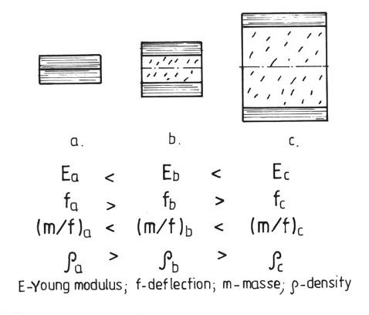  Figure 3 Relation between Young modulus, deflection and density | As compared to the data experimentally obtained there have been also made theoretical investigations.  The characteristics of component materials were:  - for faces, the plywood beech with: density ρ = 700 kg/m³; elasticity modulus under traction E_{t} = 10 000 MPa; tensile strength σ_{t} = 75 MPa; cost C_{f} = 2000 €/m³;  - for core, styropor with: density 50 kg/m³; elasticity modulus E = 4 ... 7 MPa; strength in compression σ_{comp} = 0,06 MPa; strength in shear τ_{f} = 0,023 MPa; elasticity modulus in shearing G = 2 MPa; cost C_{c} = 50 €/m³.  For gluing it was used an adhesive film of UHU type.
The sandwich structures obtained have been experimentally tested according to the European norms EN 789 and EN 408, the strains occurring under bending (in 3 and 4 points) (fig. 4 and 5), traction and shearing the layer between faces.
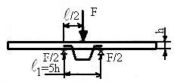  Figure 4 Bending in three points | 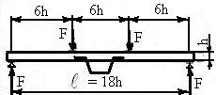  Figure 5 Bending in four points

The results obtained are shown in figures 6...13 and emphasize the following aspects:
- decrease of displacement f while the minimum thickness increases;
- reducing the values of the modulus of elasticity while the thickness of the core layer increases;
- at a ratio x = t/d = 1/2,5 the bending strength is of about. 8 times greater than in case x = 1/10;
- when the ratio between the core thickness and front layer (d/t = 4) increases , the ratio E/f increases with about 1.8 times;
- at the ratio d/t > 2,5 there is obtained an increase with about 20 % of the cost, a reduction of the density with about 80 % and of the displacement under bending of about 10 times;
the rigidity modulus under bending D increases with about 10 times when d = 10 t as compared to the case when d = 2,5 t.
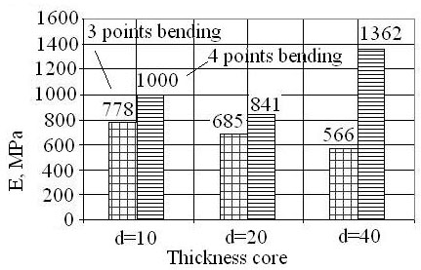  Figure 6 Young modulus E vs thickness core | 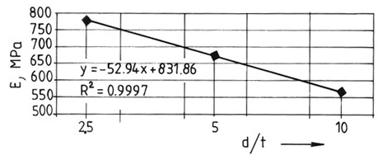  Figure 7 Young modulus vs d/t curve

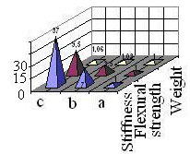  Figure 8 Relation between weight, flexural strength and stiffness (a, b, c see fig.2 and 3) | 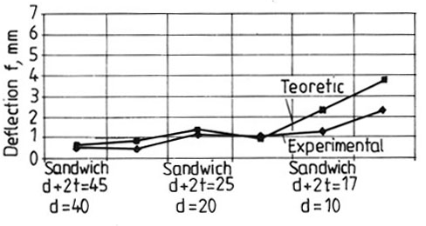  Figure 9 Deflection f vs sandwich core d

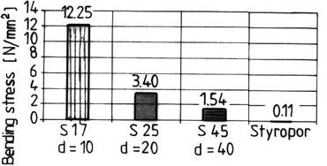  Figure 10 Bending stress vs sandwich core d and styropor | 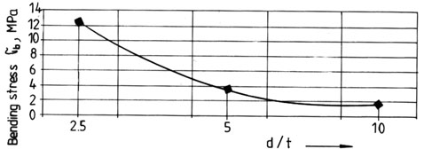  Figure 11 Bending stress vs d/t

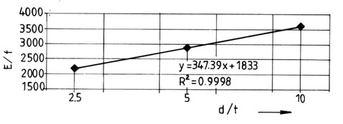  Figure 12 E/f vs d/t | 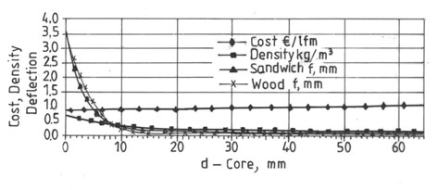  Fig.13 Relation between cost, density and deflection vs core d for sandwich and wood

3. Aspects of optimizing the sandwich-type structure

A sandwich-type structure is optimum when there are achieved the objectives:

- maximum strength (tensile, bending, compression, shearing);
- rigidity D to maximum bending, respectively displacements through minimum bending;
- reduced costs;
- faces increased stability;
- accumulation of a maximum deformation energy;
- increased damping of shocks, noises and vibrations;
- superior thermal and phonic isolation etc [4,5].

  - Flexural stiffness D

This characteristic (fig.14) is directly dependant on geometric and elastic characteristics of face and core layers and is given by the relation:
$D=E_{f}⋅\frac{{\text{btd}}^{3}}{2}\left[{\left(1+x\right)}^{2}+\frac{x^{2}}{3}+\frac{e}{6x}\right]$ (1)
respectively
$D=\frac{E_{f}b}{2}⋅{\left(\frac{q}{q_{f}}\right)}^{2}⋅\left(\frac{q}{2q_{c}}\right)⋅a^{2}⋅\left(1−a\right)⋅\left[1+f(x)\right]$ (2)
where: e = E_{c} / E_{f}; x = t/d; r = ρ_{f} / ρ_{c}; q = ρ_{c}d + 2ρ_{f} d, a = ρ_{c}d/ρ; b = width.
From figure 15 there results that the optimum ratio of the core weight and total weight ratio is of about 0,6.
According to the costs imposed by faces and core, the correlation between rigidity under bending and relative costs has the expression:

$C_{\text{rel}}=\frac{C_{f}\left[1+\left(c−1\right)α\right]}{{\left[α^{2}\left(1−a\right)\right]}^{1/3}}$ (3)
and is graphically shown in figure 16, where a = ρ_{c}d/ρ, ρ being the mass on width unit and c = C_{c}/C_{f}; C_{f} – cost of the side unit C_{c} – cost of the core unit.
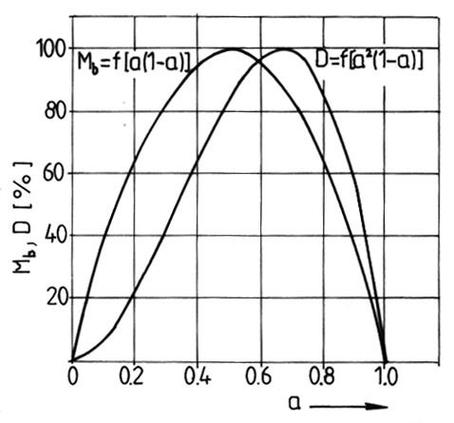  Figure 14 Flexural rigidity and bending strength vs a = core weight/sandwich weight | 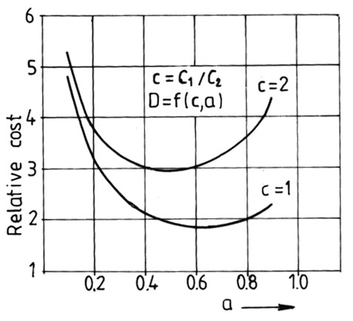  Figure 15 Relative cost vs a = core weight/sandwich weight (C1 core cost and C2 face cost)

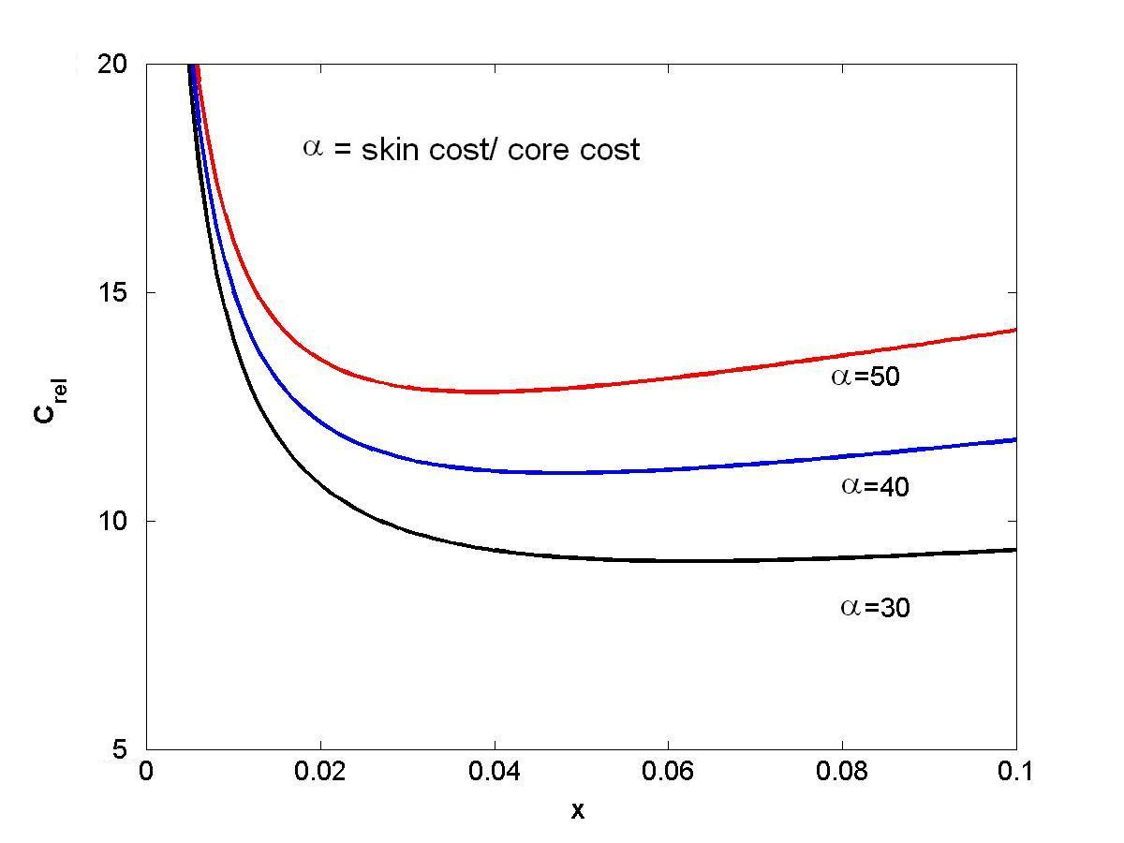
Figure 16 Relative cost vs x =t/d (t thicknees of skin and d - thicknes of core), for flexural rigidity (Sandwich core of Styropor)
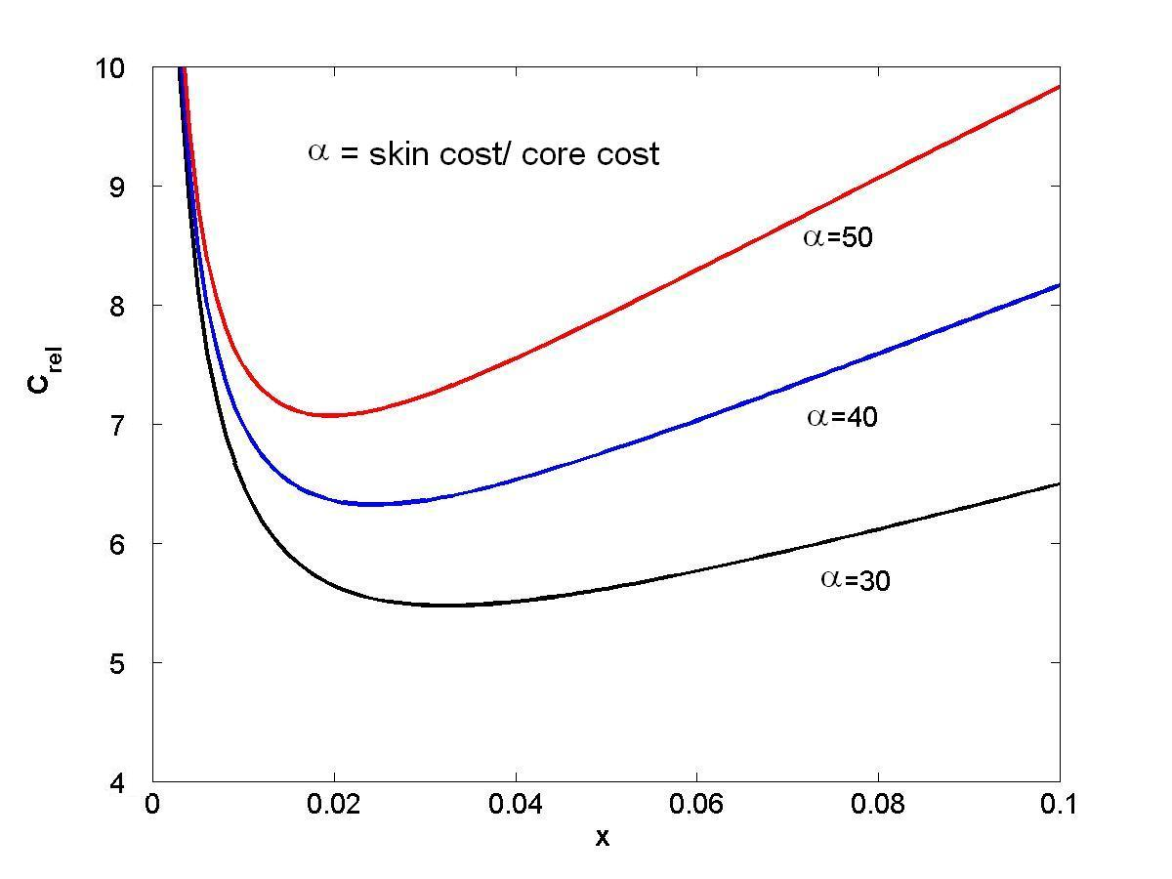
Fig.17 Relative cost vs x = t/d, and α = skin cost/core cost, for bending stress (Sandwich core of Styropor)

According to this criterion, the core mass should be about 0,4 ... 0,6 of the total mass of the sandwich structure.  In the concrete case of sandwich type (plywood and styropor) the correlation C_{rel} = f (x) is shown in figure 17.  3.2 Bending strength σ_{b}  The bending strength σ_{b} respectively the breaking bending moment M_{b} is dependent on the characteristics of the sandwich-type structure under the form:  $M_{b}=σ_{b}b\left(\frac{ρ}{ρ_{f}}\right)\left(\frac{ρ}{2ρ_{c}}\right)\left[a\left(1−a\right)\right]$ . (4) | 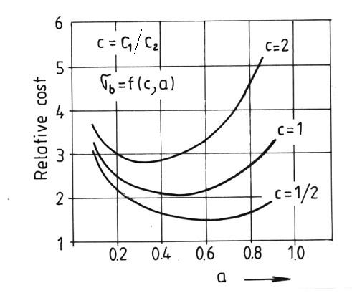  Fig.18 Relative cost vs a = core weight/sandwich weight, for bending stress
As results from figure 15 the optimum ratio between the core and sandwich structure mass is of about 0,5.
If the criterion considered stands for the minimum costs, the correlation between the bending strength and costs is given in figure 18. It is noticed that the optimum ratio between the core and sandwich structure mass is of about 0,25 ... 0,6.
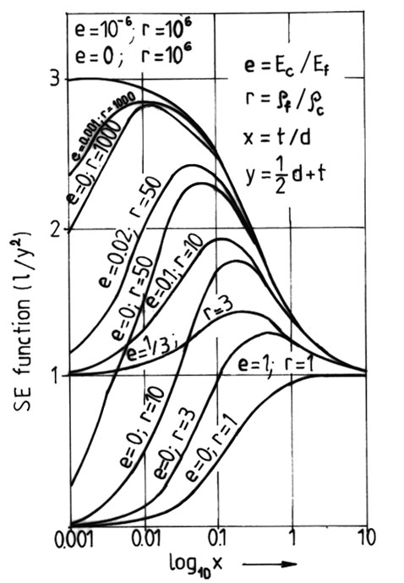  Fig.19 Stored strain energy vs thickness ratio x | 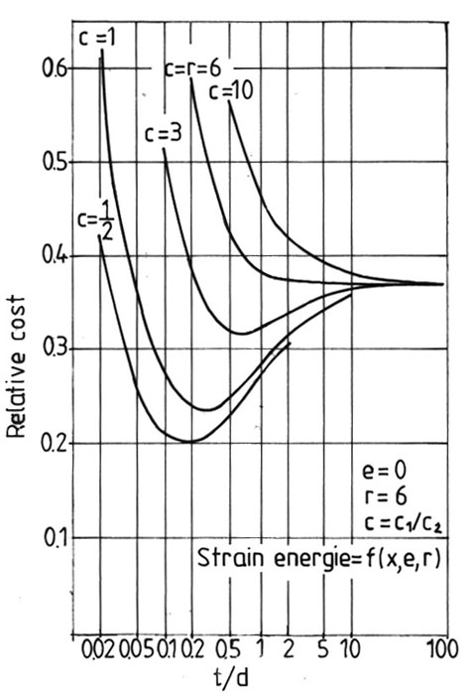  Fig.20 Cost of a given stored strain energy vs thickness ratio t/d
In case of the sandwich-type structure with light core, researched by authors, the correlation between the bending strength and costs is shown in figure 18.

3.3 Deformation energy

The capacity of shocks absorption and vibrations damping is directly dependant on the energy absorption of the sandwich-type structure. The correlation between the deformation energy is given in figure 19. It is notices that the optimum ratio d/t is of about 10…5. Depending on costs, the correlation between the deformation energy and parameters of the sandwich-type structure is given in figure 20. For the structure studied by authors the correlation between the resistance to shock and costs is given in figure 21.

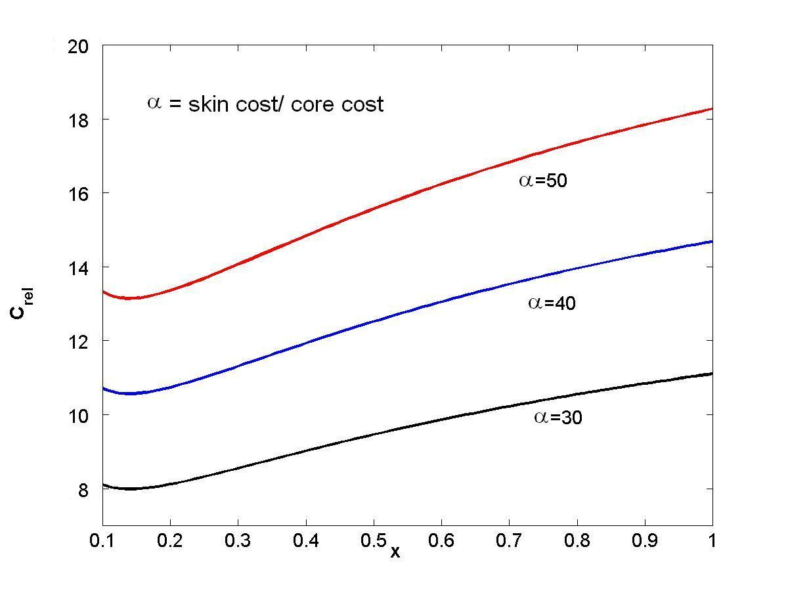
Fig.21 Cost of a given stored strain energy vs thickness ratio x=t/d (Sandwich core of Styropor)

- Conclusions

The researches carried out emphasize a series of advantages of sandwich-type structure with light core, out of which there can be reminded:
- the increase of the core thickness of about 10 time leads to an increase of the rigidity under bending of about 35..40 times, of the weight with about 7% and of costs with about 25%;
- the optimum ratio between the core and face thickness is of about 5;
- the bending strength and rigidity are also limited by the delaminating phenomena between faces and core (fig.23);
- the use of sandwich structures with light core is profitable in furniture industry and wood works [6,7].

References

[1] Timar, I. – Optimierung von Sandwichplatten mit der nichtlinearen SUMT – Methode. In: Konstruction 33 (1981), H 10, S. 403 – 407, Springer Verlag.
[2] Allen, H., G. – Analysis and Design of Structural Sandwich Panels, Oxford, Pergamon Press, 1969.
[3] Froud, G. R. – Your sandwich order, Sir? In: Composites, July, 1980, pp. 133 – 138.

[4] Abd EL – Sayed, Jones, R., Burgess, I., W. – A theoretical approach to the deformation of honeycomb based composite materials. In: Composites, oct. 1979, pp. 209 – 214.
[5] Kelsey, S., Gellatley, Clarke, B. W. – The shear modulus of foil honeycomb cases. In: Aircraft Engineering 30 (1958) pp. 294 – 302.
[6] Curtu, I, Ghelmeziu, N. – Mecanica lemnului şi materialelor pe bază de lemn. Ed. Tehnică, Bucureşti, 1984.
[7] Tatar, C. – Structuri optime de tip sandwich. Disertaţie, Universitatea Transilvania din Braşov, 2005.

