1st International Conference
″Computational Mechanics and Virtual Engineering ″
COMEC 2005
20 – 22 October 2005, Brasov, Romania

Virtual PROTOTYPING of the tracking systems
used for SOLAR THERMAL AND photovoltaic panels

Cătălin Alexandru
University “Transilvania”, Braşov, ROMANIA, calex@unitbv.ro

Abstract: Solar & photovoltaic collectors / panels are products used for conversion of the solar radiation in thermal or electric energy. For increasing the efficiency of the solar & photovoltaic collectors, tracking systems are used; basically, these are mechanical devices for orienting solar systems toward the sun. In this paper we attempt to carry out some aspects regarding the modeling and simulation of the tracking systems by using multibody systems software. The main advantage of this type of simulation consists in the possibility of realizing virtual prototypes of any mechanical system that has moving parts. As example, a dual-axis tracking system, with two degrees of freedom, has been taken into account. The analysis – simulation is made by using the MBS software ADAMS of MSC.
Keywords: solar & photovoltaic panels, tracking system, multibody system, virtual prototype.

1. INTRODUCTION

Increasing CO₂ emissions and the depletion of the fossil fuel resources require strong and active measures to be taken. The answer is Sustainable Energy, including energy efficiency, energy saving and renewable energy systems. For a sustainable energy supply and low environmental pollution, modern energy conversion systems with high efficiency are necessary [6]. The sun is an extremely powerful energy source, and solar radiation is by far the largest source of energy received by the Earth. Solar collectors are products used for conversion of the solar radiation in thermal energy, and on the other hand, the photovoltaic panels are used to transform the solar energy in electric energy.
The function of a solar or photovoltaic panel is simple; it intercepts incoming insolation and turns it into a usable form of energy that can be applied to meet a specific demand. For increasing the efficiency of the solar & photovoltaic collectors, tracking systems (also called, solar trackers) are used. Basically, these are mechanical devices for orienting solar systems toward the sun. The aim of a solar tracker is to get the highest possible input of solar radiation for the solar collectors. The evaluation of the existing products shows that the tracking systems may improve the efficiency of a solar energy conversion system from 25% up to 40% [3].
Determining the real behavior of the tracking systems is a priority in the design stage of these mechanical devices since the emergence of the computer graphic simulation. Recent publications reveal a growing interest on analysis methods for multi-body systems that may facilitate the self-formulating algorithms, having as main goal the reducing of the processing time in order to make possible real-time simulation. These methods were used to develop powerful modeling and simulation environments - MBS programs, which allow building and simulating a computer model of any mechanical system that has moving parts. The mechanical device is treated with the MBS method as a constrained, multibody, spatial mechanical system, in which body elements are connected through mechanical joints and force elements. The main difference of mechanical system dynamics from the conventional structural system dynamics is the presence of a high degree of geometric nonlinearity associated with large rotational kinematics. Governing equations for conventional structural dynamics are linear differential equations, while those equations for mechanical system dynamics are nonlinear differential equations that are coupled with nonlinear algebraic equations of kinematic constraints [5].
In the last decade, a new type of studies was defined through the utilization of the MBS software: Virtual Prototyping. This technology consists mainly in conceiving a detailed model and using it in a virtual experiment, in a similar way with the real case. Virtual Prototyping is a software-based engineering process that enables modeling the mechanical system, simulating the motion under real operating conditions and, finally, optimizing its behavior. An important advantage of this kind of analysis consists in the possibility of make virtual measurements in any point or area, and for any parameter (displacements, velocities, forces etc.). Virtual prototyping-based design practices allow product designers, engineers, and analysts to more quickly assess form, fit, function, and manufacturability of new products throughout concept design, concept refinement, detailed design, release, and production. No longer is it necessary to wait months to build a hardware prototype, instrument it, run tests on it, and make a small number of expensive modifications to it in order to assess proposed design changes.
Due to these important advantages, the virtual prototyping process is used in a lot of industrial applications, including the design, testing and simulation of the mechanical devices used for the renewable energy systems (tracking systems, wind turbines, thin layer deposition installation and so on) [1]. In this paper, we attempt to carry out some specific aspects regarding the modeling, analysis and simulation of the tracking systems by using the virtual prototyping environment ADAMS (Automatic Dynamic Analysis of Mechanical System) of MSC [7], which is licensed to the „Transilvania” University of Braşov, in the frame of „Center for Sustainable Energy”.

2. Virtual Prototyping Process

Traditional CAD/CAM/CAE practices focused on a concept referred to as art-to-part. Nearly all-engineering software activity was oriented toward the design, development, and manufacturing of higher quality parts. Detailed, three-dimensional solid modelers (CAD) allowed for quick part design and understanding of form. Finite element software (CAE) made it feasible to perform detailed meshing and analysis of structural effects, thermal effects, and vibratory characteristics, or function, of individual parts. Software aimed at improving manufacturability of parts (CAM) provided better control of machine tools, robots, mold procedures, stamping procedures, forging processes and so on.
Unfortunately, optimal part design rarely leads to optimal system design. The interaction of form, fit, function, and assembly of all parts in a product is a major contributor to overall product quality. The big opportunity to increase quality and reduce time and cost has now shifted to the system level. The following system-focused solutions can be identified [8]: Digital Mock-Up (DMU) - to investigate product form & fit, Functional Virtual Prototyping (FVP) - to assess product function & operating performance, and Virtual Factory Simulation (VFS) - to assess assembly & manufacturability of the product. Product Data Management (PDM) is the “glue” that enables these system-focused solutions to be successful by making all of the up-to-date component data readily available and manageable. The combination of DMU, FVP and VFS provide a means for realizing an effective transition from hardware prototyping to software prototyping practices with all of the concomitant benefits.
Generally, the virtual prototyping platform includes the following types of programs [2]: Computer Aided Design – CAD (CATIA, PROENGINEER), MultiBody Systems - MBS (ADAMS, DYMES etc.), and Finite Element Analysis - FEA (NASTRAN, ANSYS etc.). The CAD environment is used to create the geometric model of the mechanical system, which contains information about the mass and the inertia properties of the rigid bodies. The solid model can be exported to the MBS environment using standard format file, such as IGES, STEP, DXF, or DWG. To import the geometry of the rigid parts, the MBS software reads the CAD file and converts the geometry into a set of MBS geometric elements. The FEA software is used for modeling flexible bodies in mechanical system and provides the ability to transfer loads from MBS to FEA and to bring component flexibility from FEA back into MBS. The flexible body characteristics are defined in a finite element modeling output file (Modal Neutral File - MNF).
The virtual prototyping process involves the following stages: build - modeling bodies, constrain the bodies, create forces acting on bodies; test - measure characteristics, perform simulation, review animation, review numeric results as plots; validate – import experimental data, compare virtual and experimental results; refine - add friction, define flexible bodies, implement force functions, define controls; optimize - perform design sensitivity studies, design of experiments, and optimization studies.
During the build phase, virtual prototypes are created of both the new product concept and any target products which may already exist in the market. One of the most important axioms for successful functional virtual prototyping is to simulate as you test. Testing of hardware prototypes has traditionally involved both lab tests and field tests in various configurations, which are very expensive. With virtual prototyping, it is enough to create virtual equivalents of the lab tests and the field tests, and this cut time and cost. However, the physical testing is used at various stages to re-validate the model after significant refinement. To validate the virtual prototype, the physical and virtual models are tested identically. The results are compared, and design sensitivity analyses are performed to identify design parameters that have great influence on the performance results that do not correspond. Afterwards, a lot of changes on the main design variables are realized in order to obtain an acceptable correlation between the virtual and hardware prototypes. Refining the virtual prototype involves refining the fidelity and breadth of the model, and refining the product design itself, respectively. Replacing the rigid components with flexible counterparts, adding frictions, and representing the automatic systems that control the operating performance, can make the improvement of the virtual prototype.
3. Modeling the tracking system - virtual prototype

For tracking the sun, there are two main types of trackers: single-axis trackers (by one axis), and dual-axis trackers (by two axes). The single-axis tracker (fig. 1, a) pivot on it axis to track the sun, facing east in the morning and west in the afternoon. The tilt angle of this axis equals the latitude angle of the loco because this axis has to be always parallel with the polar axis. In consequence for this type of single axis tracker is necessary a seasonal tilt angle adjustment. The two-axis trackers (fig. 1, b) follow the sun in both azimuth and elevation, keeping the sun's rays normal to the panel surface. Considering their ability to combine two rotational motions described around perpendicular axis they are able to follow very precisely the sun path along the period of one year, and for this reason the dual-axis trackers are more efficient than the single one.
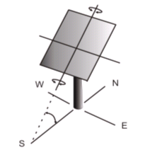  a. | 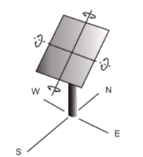  b.
Figure 1: Basic types of tracking systems [3]

For this paper, a dual-axis tracking system, with two degrees of freedom, has been taken into account. The model is designed so that it has 6 moving parts (fig. 2), which are connected one with other, respectively to ground, using geometric constraints: rotor is connected to ground by revolute joint; reduction gear connected to ground by revolute joint; azimuth plate connected to ground by revolute joint; panel support connected to plate by fixed joint; elevation bearings connected to support by fixed joint; panel connected to bearings by revolute joint. At the same time, a rotor gear couples the revolute joint at the rotor to the revolute joint at the reduction gear, and a gear plate couples the revolute joint at the reduction gear to the revolute joint at the plate.

4. Analyzing the virtual prototype AND results

In order to control the two degrees of freedom and to move the panel, the tracking system model includes also two kinematic constraints (rotational joints motions - motion generators), which are applied in the revolute joints between rotor - ground, and panel – bearings, respectively (in a future paper, these drivers will be replaced with torques that move the panel, which are computed by two control systems, based on the error between the actual panel position and the desired panel position).
The functions that define the motion generators are in according to the relationships exiting between sun and the Earth. The point of interest in sun tracking is to follow the path of the sun on local visible sky. The orientation principle is based on the input data referring to the position of the sun on the sky dome. For the highest conversion efficiency, the sunrays have to fall normal on the receiver so the system must periodically modify its position in order to maintain this relation between the sunrays and the panel. The Earth describes along the year a rotational motion following an elliptical path around the sun. On the other hand, during one day, the Earth also spins around its own axis describing a complete rotation.
The declination angle (δ) is the angular position of the sun at solar noon with the respect to the plane of the equator, and the hour angle (ω) is the angular displacement of the sun east or west of the local meridian due to rotation of the earth on its axis at 15° per hour. In these terms, the motion generators from the virtual model have the following expressions: δ=arcsin {0.39795·cos [0.98563·(N-173)]}, ω=15°·(t-12), where N - day number (N=1... 365), t - time hour (t=1... 24).
By analyzing / simulating the above-described virtual prototype, using the specific ADAMS/ Solver module, a lot of results that describe the behavior of the tracking system were obtained. These results were post-processed with ADAMS/PostProcessing and ADAMS/Animation modules [7], in order to obtain specific diagrams. Thus, in figure 3 and 4, the center of mass position of the panel in longitudinal (X) and transversal (Z) direction, which are necessary to equilibrate the system, and animation frames respectively, are presented.
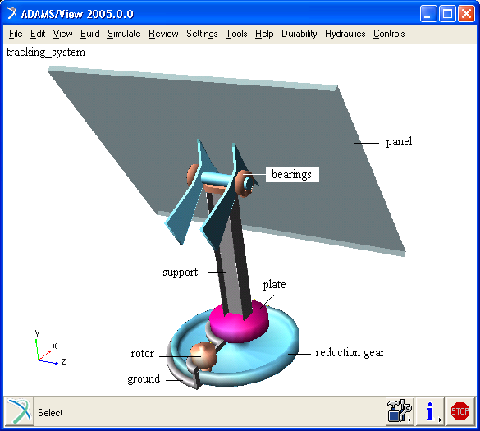

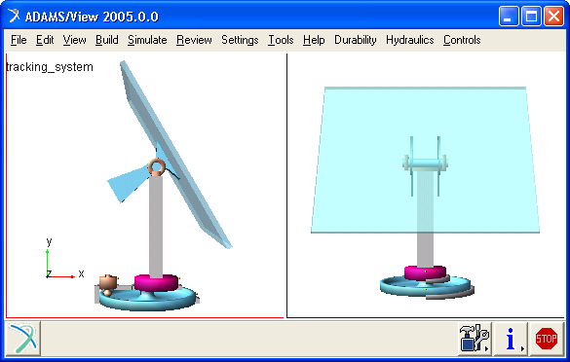
Figure 2: Virtual prototype of the dual-axis tracking system
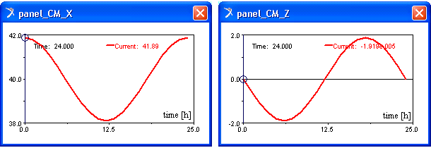
Figure 3: Postprocessing specific results

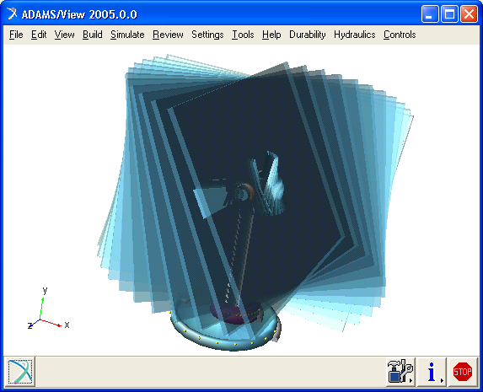
Figure 4: Graphical simulation frames

Afterwards, using the virtual prototyping platform, the optimization of the tracking system can be performed, without going through physical prototype building and testing, in order to obtain the desired behavior of the system. The optimization of the virtual prototype is made with the following steps: parameterizing the model, defining the design variables, defining the objective function for optimization, performing design study to identify the main design variables (with great influence on the design objectives), and optimizing the model on the basis of the main variables.
Parameterizing the model simplifies changes to model because it helps to automatically size, relocate and orient parts. In this way, relationships into the virtual model of the tracking system can be built, so that when a modeling object (for example a point’s coordinate) is changed, the virtual prototyping software updates any other objects that depend on it (bodies, joints, forces, and so on).
Having in view the limited space in this paper, the optimization algorithm of the tracking systems, as well as the control system design, will be at length described in a future paper.
5. conclusions

This paper provides a brief overview of functional virtual prototyping and how it can be successfully implemented in renewable energy industry, in particular case in the field of tracking system design. On the basis of advanced design prototyping software, such as ADAMS, the design engineers have the possibility to build models of not just parts but entire tracking system, and then to simulate the behavior and optimize the design before building an expensive physical prototype. An important advantage of this kind of analysis – simulation consists in the possibility of make virtual measurements in any point or area and for any parameter. In this way, the designers can take decisions on any design changes without going through physical prototype testing.
Critical success factors for implementing virtual prototyping tools in the design process of the tracking systems include a well-defined process, system-level focus, effective target setting, rapid simulation turnaround, and high quality CAE infrastructure.

REFERENCES

- Alexandru C.: Virtual prototyping of mechanical systems used to the renewable energy systems, Proceedings of the first International Conference on Sustainable Energy “CSE 2005”, CD-ROM Edition, p. 69 (Abstract Book), Braşov, 2005
- Alexandru C., Pozna C.: Dynamics of mechanical systems using functional virtual prototyping, “Transilvania” University Publisher, Braşov, 2003
- Comşiţ M.: Mechanical systems of RES – Systems for solar energy applications, Master project, “Transilvania” University of Braşov, 2005
- Covrig C.: Photovoltaic systems – characteristics, opportunities and economical analysis, Proceedings of the first International Conference on Sustainable Energy “CSE 2005”, CD-ROM Edition, p. 55 (Abstract Book), Braşov, 2005
- Haug E.J.: Computer aided kinematics and dynamics of mechanical systems, Allyn and Bacon, Massachusetts, 1989
- Vişa I., Duţă A.: From material to prototype - a concept integrating research and technology transfer, Proceedings of the first International Conference on Sustainable Energy “CSE 2005”, CD-ROM Edition, p. 26 (Abstract Book), Braşov, 2005
- *** Getting started using ADAMS v.2005, MSC Software, 2005
- *** http://www.adams.com

