1st International Conference
″Computational Mechanics and Virtual Engineering ″
COMEC 2005
20 – 22 October 2005, Brasov, Romania

A MULTI-BODY MODEL OF VIBRATORY EQUIPMENT DRIVEN BY UNBALANCED MOTORS

Ionel Batog
Transilvania University of Brasov, Romania, batog@unitbv.ro

Abstract: The paper is focused on vibratory equipments modelling based on the multi-body approach. One mass vibratory machine driven is modelled as a spring-mass-damper system, subjected to linear vibrations A constrained, spatial multi-body model of vibrating machine has been developed, which includes the elastically supported working member and two unbalanced motors. The rotational velocity of eccentric masses modelling the unbalanced motors is prescribed in order to simulate the model. The simulation carried out has been focused on emphasizing the steady state oscillation of the system and the behaviour of the supporting springs in terms of displacement and load during the starting process and steady state.
Keywords: multi-body systems, dynamic simulation, vibratory equipment.

1. INTRODUCTION

Computer models allow the investigation and accurate prediction of the mechanical systems behaviour in simulated working conditions. The mechanical systems simulation is usually based on multi-body approach where the system is regarded as a collection of inter-constrained bodies. This kind of models mainly consists of parts, constraints and force definitions. The model input parameters are real physical data, such as geometrical dimensions, masses, moments of inertia, stiffness and damping coefficients. Parts are used to define the objects of the model that have inertia properties and can move. Constraints define how parts are attached and how they are allowed to move relative to each other. Forces are used to model elastic connections between parts, damping elements, actuation forces and any other part interactions.

2. MODEL

One mass vibrating equipment subjected to linear vibrations generated by unbalanced motors is modelled. The modelling process follows these basic steps: defining the modelling environment, creating the parts, adding constraints and motions, defining forces.
The modelling environment is defined by specifying the unit system, the coordinate system settings and gravitational force orientation and magnitude.
The model developed consists of four parts. The ground part is the only part in the model that remains stationary at all times. The ground part acts as the global coordinate system about which the model is created. The other three parts are rigid bodies modelling the working member and the unbalanced vibrators. Each movable body has its local coordinate system which defines the body position and orientation. The mass and inertia properties of model parts are defined using user input option. The parts of the model are described in table 1.

Table 1: Model parts
No. | Part name | Mass  [kg] | DOF added
1 | ground | – | –
2 | wk_member | 1500 | 6
3 | ecc_lh | 15.0 | 6
4 | ecc_rh | 15.0 | 6

The joints used to connect the model parts allow the same motions as in the real machine. Two revolute joints connect the eccentric masses modelling the unbalanced motors to the working member. A translational joint connects the working member to ground allowing the vertical oscillation of the working member. The joints are described in table 2.
Table 2: Model joints
No. | Constraint name | Constraint type | Body I | Body J | DOF removed
1 | rev_joint_lh | revolute | Ecc_lh | wk_member | 5
2 | rev_joint_rh | revolute | ecc_rh | wk_member | 5
3 | trans_joint | translational | wk_member | ground | 5

The motion of the two eccentric masses is modelled using a motion generator and a coupler. The motion generator is applied to rev_joint_lh and define the rotational velocity of the motion as a function of time. The joint motion removes one DOF from the model. The coupler joint is created between the two rotational joints. It relates the rotational motion of the joints ensuring the synchronous rotation of the two eccentric masses.
The working member is connected to ground through springs modelled using flexible connectors. Flexible connectors applies spring and damper forces to the connected bodies. They do not remove any degrees of freedom from the model.

Table 3: Flexible connectors
No. | Connector name | Connector type | Body I | Body J | Stiffness | Damping
1 | spring_1 | translational | wk_member | ground | 16484000 N/m | 1312 N-sec/m
2 | spring_2 | translational | wk_member | ground | 16484000 N/m | 1312 N-sec/m
3 | spring_1 | translational | wk_member | ground | 16484000 N/m | 1312 N-sec/m
4 | spring_2 | translational | wk_member | ground | 16484000 N/m | 1312 N-sec/m

The model obtained is a constrained, multi-body, spatial mechanical system as shown in Figure 1.

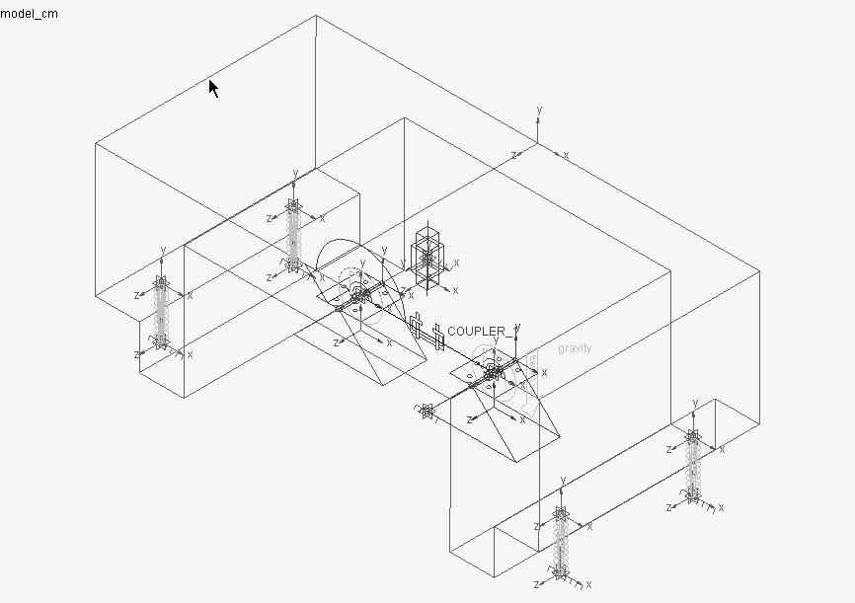

Figure 1: The multi-body model

3. SIMULATION RESULTS

In order to investigate the behaviour of the system the motion of the two eccentric masses was defined in terms of rotational velocity and expressed as a function of angular acceleration. The function used describes the evolution of the rotational velocity during the starting period and further, when the velocity becomes stable. The simulation carried out has been focused on emphasizing: the steady state oscillation of the system; the behaviour of the supporting springs in terms of deformation and load during the starting process and steady state. The simulation was run using 5000 steps for a simulation time of 5 seconds.
Figure 2 shows the time history for vertical displacement, velocity and acceleration of working member plotted for the steady state oscillation.

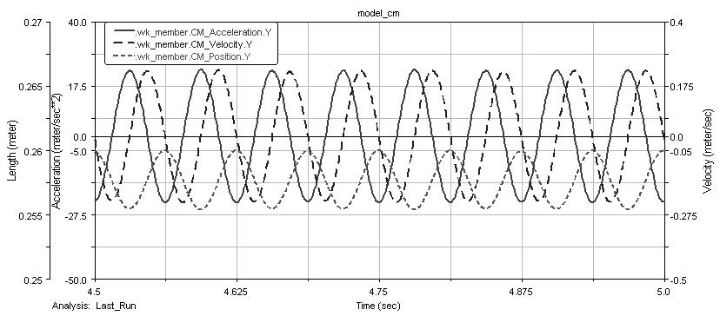

Figure 2: Displacement, velocity and acceleration of working member centre of mass (steady state)

Figure 3 presents the time history for deformation of supporting springs during the start period. The plot shows the initial deformation of the springs due to the weight of working member and eccentric masses. Increases in the magnitude of system oscillation arise under transient conditions. The oscillation has a larger magnitude at frequencies close to the natural frequency of the system. The plot shows a peak at 1.5 seconds.

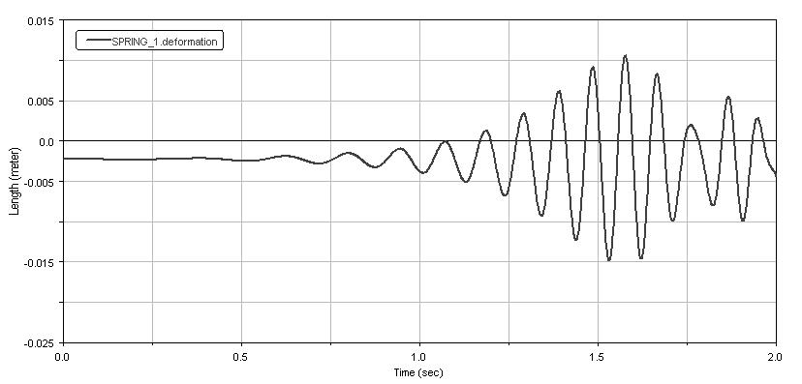

Figure 3: Deformation of supporting springs during the starting period

Figure 4 presents the time history for deformation and load on one supporting spring for steady state oscillation of the system.
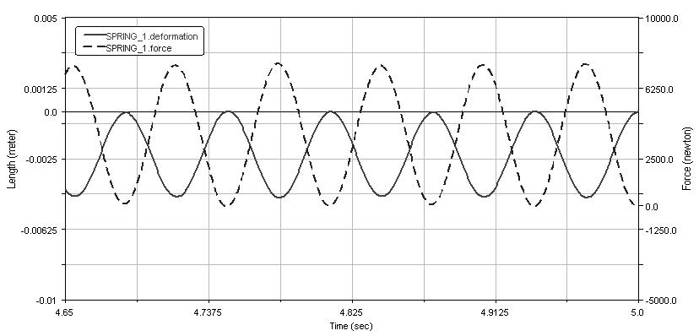

Figure 4: Deformation and load on one supporting spring (steady state)

3. CONCLUSION

The multi-body dynamic model developed includes the main parts of vibratory equipment: the elastic mounted working member and two unbalanced masses modelling the unbalanced vibrators. A rotational motion has been applied to the unbalanced masses in order to simulate the model. Plots have been obtained for displacement, velocity and acceleration of working member steady state oscillation. The spring deformation plot shows an increase in the magnitude of system oscillations at a frequency close to the natural frequency of the system as expected.

4. ACKNOWLEDGMENT
This research was carried out thanks to the support offered by MEC-CNCSIS through the CNCSIS A-997 grant, for which the author wishes to express hereby his gratitude.

references

Bratu, P.: Sisteme elastice de rezemare pentru masini si utilaje, Editura Tehnica, Bucuresti, 1990.
- Munteanu, M.: Introducere in dinamica masinilor vibratoare, Editura Academiei, Bucuresti, 1986.
- Ryan, R.R.: ADAMS multibody system analysis software, MDI Technical Publications, Vol. 2, 1989.
- Volterra, E., Zachmanoglou, E. C.: Dynamics of Vibrations, Charles E. Merrill Books, Inc., Columbus, Ohio, 1965.

