1st International Conference
″Computational Mechanics and Virtual Engineering ″
COMEC 2005
20 – 22 October 2005, Brasov, Romania

ON THE ACCELERATED LIFE TESTS OF PRESSURE GAUGES
PART II –EXPERIMENTAL RESULTS

Ioana COMǍNESCU¹, Gheorghe N. RADU²
¹ Transilvania University of Brasov, ROMANIA, ioanacom@unitbv.ro
² Transilvania University of Brasov, ROMANIA, rngh@unitbv.ro

Abstract: In order to subject the pressure gauges to accelerated tests, one has been conceived an experimental installation which allows the simultaneous testing of three manometers and also the check of the indications, after testing, with a standard pressure gauge. The hydraulic group of the experimental stand relies on a milling machine’s table. The principle of the accelerated test consists in the high frequency of introducing the fluid under pressure in the mechanical devices for pressure measurement.
Keywords: Pressure gauge, reliability, accelerated test.

1. THE EXPERIMENTAL STAND FOR ACCELERATED TESTING

The experimental installation for accelerated life tests of mechanical devices for pressure measurement contains a hydraulic group mounted on a milling machine’s table. The kinematics and hydraulic circuit is shown in Fig. 1, where:
1 – oil tank of the hydraulic group;
2, 3, 8 – admission valves;
4 – hydraulic distributor with slide-valve and active edge;
5 – cam;
6 – safety valve;
7 – gearbox of the milling machine;
9 – standard pressure gauge;
10, 11, 12 – manometers subjected to accelerated life tests;
13 – hydraulic platform;
14 – electric motor of the milling machine;
15 – hydraulic resistance with regulator;
16 – hydraulic pump;
17 – electric motor for the drive of the hydraulic pump;
18 – filter.

With help of the hydraulic distributor with slide-valve and active edge (4) one send a controlled quantity of fluid to the hydraulic platform (13) so that accelerated tests of the manometers are achieved. The variation of the fluid flow which must reach to the tested manometers is commanded by cam (5), which actuates the hydraulic distributor’s piston. The stroke lend by the cam determines the piston to modify the fluid flow under pressure, fluid which enters through admission i, is repressed to the oil tank (1), through exit r and a sinusoidal control signal leaves the exhaust c.

The cam (5) is assembled on the tool holder axle of the milling machine, which gives the rotation motion.

The safety valve (6) is adjusted to be opened when overpressures occur, overpressures which can affect the hydraulic platform (13).

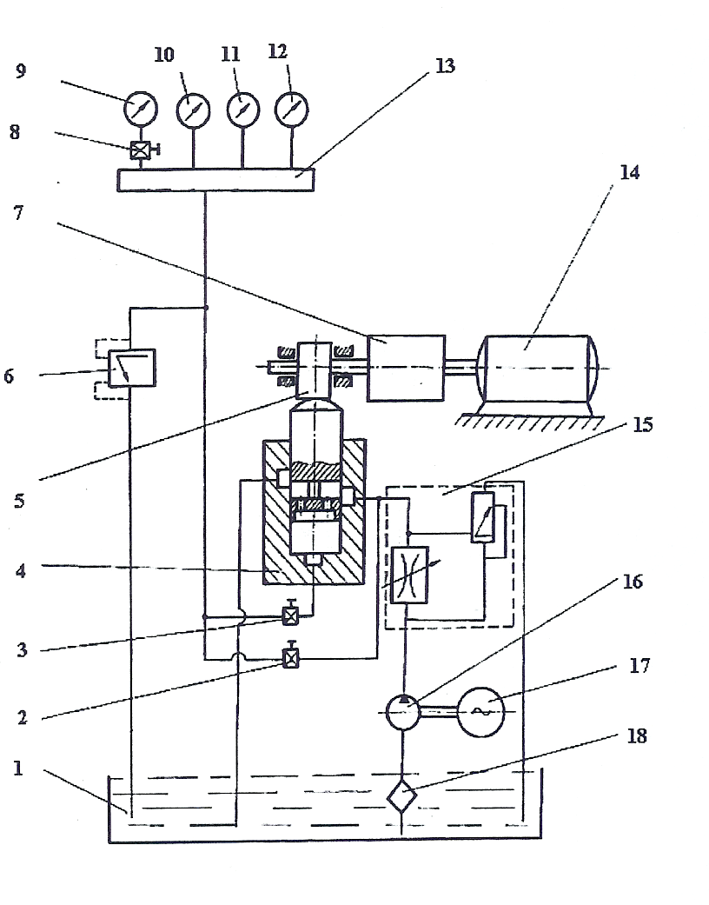

Figure 1: Hydraulic circuit and kinematics of the experimental installation.

On the hydraulic platform (13) the three tested manometers and the standard manometer are assembled. All manometers have the same measurement field and belong to the same precision class.

The hydraulic resistance with regulator contains a chocking-coil and a valve which regulates the fluid pressure at a constant value indifferently to the pressure variation which occurs after this device. This ensemble is necessary because of the use of a constant flow pump with sprocket wheels.

2. THE WORKING OF THE EXPERIMENTAL STAND

Admission valve (2) is open, meanwhile admission valves (3) and (8) are closed. The hydraulic pump (16) provides the flow Q_{p}, a part Q_{u} goes to the hydraulic platform (13) and a part Q_{R} goes to the tank (1), becouse of the hydraulic resistance with regulator (15).

The ensemble (7), (14) drives the axle of the milling machine, on which cam (5) is assembled. This cam acts on the piston of the hydraulic distributor with slide-valve and active edge. The piston has a translation motion, which achieves the flow variation; the fluid is flowing directly in the tank. The cam-piston motion achieves the pressure variation and so, the accelerated test of manometers (10), (11) and (12).

Admission valve (2) is closed and admission valves (3) and (8) are open. The ensemble (7)-(14)-(5) is decoupled and so the drive of the hydraulic distributor (4) stops. On the piston of the device (4) one assembles a shaft (19) with a plate (20) with standard weights (21) (as shown in Fig. 2.). The active surface of the piston measures 1 cm².

The tested manometers indications comparatively to the standard pressure gauge is realized as follows:

The oil under pressure flows through the hydraulic distributor (4) to exit c (admission valve 3 is open) and then to the hydraulic platform (13), in the tested manometers and in the standard manometer.

One compare their indications.

The tested manometers indications comparatively to the shaft-plate and weights ensemble is realized as follows:

One puts on the plate a standard weight measuring 1 kg., which produces in the hydraulic platform a 1 bar pressure. One reads the tested manometers indications.

One continues by putting more standard weights on the plate.

The ensemble (19)-(20)-(21) can be considered as a standard pressure gauge with piston and weights.

The accelerated life tests of the manometers are achieved with help of a hydraulic installation which was presented in the previous paper. This installation allows simultaneous testing by threes manometers, which have the measurement field 0 ÷ 25 bar and belong to 1,6 precision class. The frequencies of the accelerated pulsatory test are adopted depending on the number of rotations of the milling machine’s axle. Based on the pulsatory conditions, the life at accelerated stress is calculated:
ν_{A1} = 106 oscillation/min. → L_{A1} = 157 working hours;
ν_{A2} = 180 oscillation/min. → L_{A2} = 93 working hours;
ν_{A3} = 240 oscillation/min. → L_{A3} = 70 working hours.

The life at use stress was established L_{U} = 1350 working hours.

Table 1: Characteristics of the cam’s motion
Group of manometers | Frequency of cam’s rotation motion  [rot/min]
1. | 106 | 240 | 600
2. | 106 | 240 | 600
3. | 106 | 240 | 600

Figure 2 presents the experimental installation for accelerated testing of the pressure gauges.

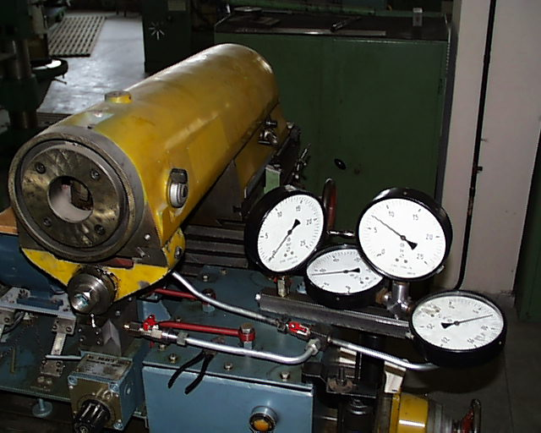

Figure 2: Experimental installation for accelerated testing of pressure gauges

REFERENCES

[1] Comănescu, I.S. – Cercetări privind fiabilitatea metrologică a mijloacelor mecanice de măsurare a presiunilor. Teză de doctorat. – Braşov, Universitatea “Transilvania”, 2003.
[2] Popescu, I. – Bazele cercetării experimentale în tehnologia construcţiilor de maşini – Braşov, 1986.
[3] Oprean, A. – Acţionări şi automatizări hidraulice – Bucureşti, 1989.
[4] Cosma, D. – Contribuţii privind modernizarea lanţurilor cinematice ale maşinii de găurit, în vederea utilizării conducerii adaptive. Teză de doctorat – Braşov, 1998.
[5] Botez, E. – Maşini-unelte – Bucureşti, 1978.

