1st International Conference
″Computational Mechanics and Virtual Engineering ″
COMEC 2005
20 – 22 October 2005, Brasov, Romania

ASSESSING THE SUSPENSION QUALITIES THROUGH SPECTRAL AND CORELATION ANAYSIS OF THE TRACTOR SEAT EXCITATION AND RESPONSE

Dr. eng. Florin CONSTANTIN

„Transilvania” University of Brasov, Romania, flconstantin@unitbv.ro

Abstract

The laboratory tests carried out on the seat suspension enable to record the accelerations at the seat and floor level. Following the computer-aided statistical processing of these accelerations, there are obtained the autocovariance, intercovariance, spectral power density, coherence and transfer functions. In the paper herein there are analyzed the respective functions in view of assessing the suspension qualities and the comfort of a vehicle seat.

Key words: statistical analysis, vibration analysis, suspension

- Introduction

The vertical vibrations of tractors transmitted to the driver through the seat are the major cause of the worsening of working conditions. The vibrations of the low frequency ranging from 1 to 10 Hz are of special interest to the driver and are most dangerous with regard to their effects on the human organism.
Long-term action of vibrations on the human operator leads to damages of the cardiovascular and the respiratory system and of the spinal column.
Tractor designers and manufacturers worldwide are more and more engaged in developing functional seats, which would provide adequate working conditions.
The laboratory tests performed on tractor seat suspension employ mainly the hydropulse testing stand. Tractor seat suspensions are subjected to tests in order to determine the elasticity and vibration damping capacity and to assess the degree of comfort provided by the seat.
The excitation of the hydropulse platform x(t) corresponds to the international norms ISO2631. The seat response y(t) is recorded within 28 seconds with the accelerations transducer T₂. (fig.1)
Following the computer-aided processing of the platform excitation x(t) and of the seat response y(t), there are obtained the response functions in time and frequency.
The objective of the spectral analysis is the determination of vibration vibrations with respect to frequency.
Correlation is a general method of recording the interdependence of statistic type line between excitation and response.
The correlation functions and the power spectral density provide equivalent items of information, ones expressed with respect to time, the others in the field of frequencies. The employed computer program processes the experimental data with respect to time and frequency and plots the functions of autocovariance, intercovariance, acceleration power spectral densities, the coherence function and the transfer function of the platform excitation and the seat response within a frequency range from 0 to 16.667 Hz, which is of interest for the tractor suspension.
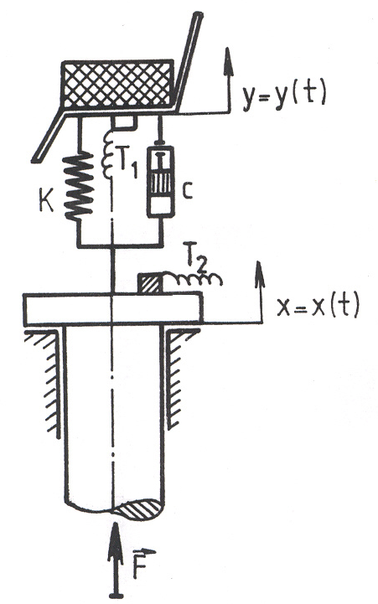
Fig. 1. Hydropulse testing stand
- Processing the statistic functions

In figure 2, “a” stands for the platform accelerations autocovariance function.
This representation emphasizes the existence of a periodical “hidden” signal within the platform excitation random signal. The time-related analyses of this signal has been completed for a total delay time of t = 3 seconds, with a 0.03 step. The autocovariance function has a quasisinusoidal variation of a 0.315 second period. For t = o, the global mean square value of the excitation acceleration is of 4.91 (m/s²)².

C_{XX}(τ)
C_{yy}(τ)
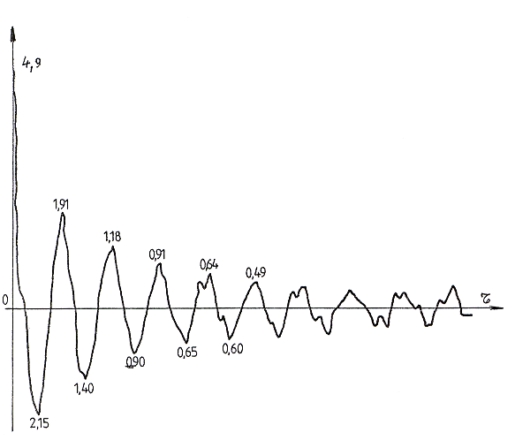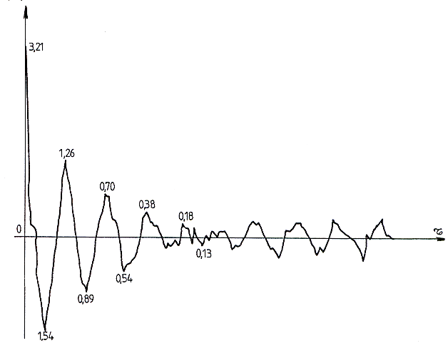
a) Platform b) Seat

Fig.2. Acceleration autocovariance function

In figure 2, “b” stands for the autocovariance function graph of the seat accelerations.
This function too has a quasi-sinusoidal graph, a significant correlation up to a delay time of t = 1.14 seconds can be noticed. In this case the period of the quasi-sinusoidal part is of approximately 0.33 seconds and the global mean square acceleration is of 3.216 (m/s²)². The quantity indicates the damping properties of the suspension.

In figure 3, “a” stands for the variation of the spectral power density of the platform accelerations is represented.
A clear peak can be noticed in relation with frequency 3.167 Hz. This indicates the existence of a narrow hand random signal, the frequency of 3.167 Hz holding a great part of the analyzed signal. The maximum value of the spectral density in relation with this frequency is of 0.561 (m/s²)² Hz.

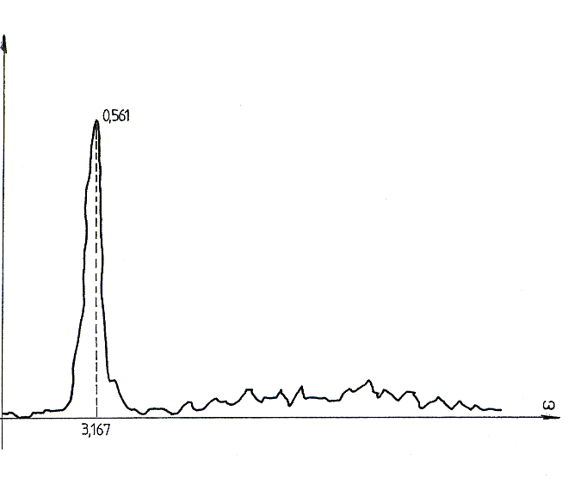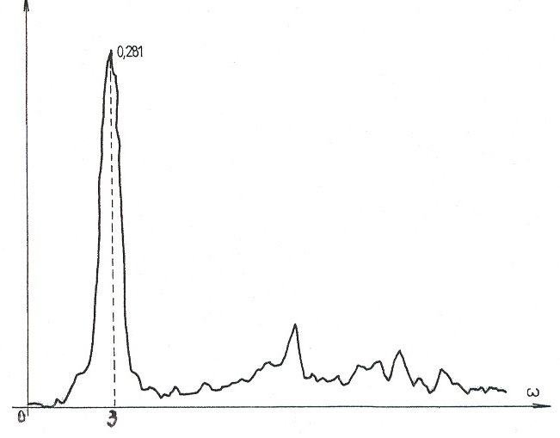
G_{x}(ω)
G_{y}(ω)
0

a) Platform b) Seat

Fig.3. Spectral power density

The power spectral density of the seat accelerations represented in figure 3,b, indicates a maximum of only 0,281 (m/s²)² Hz, for a frequency of 3Hz.
This value offers conclusive information on the seat suspension damping efficiency of the platform variations. The spectral power densities provide within the range of frequencies the same information as the autocovariance functions in the time domain.
The coherence function is a dimensionless real and positive quantity, comprised between 0 and 1. Te studied seat excitation and response coherence function is plotted in figure 4. It represents a quantitative criterion for stating if the analyzed physical system is linear or not. Subsequently to studying this graph it follows, that the system can be considered with a good approximation linear in a larger range of frequencies. For frequencies over 16 Hz, the coherence function is below 0.3 and the platform excitation does not influence seat vibrations anymore. This highlights the filtering property of the suspension, for frequencies over 16 Hz.
Figure 5 represents the transfer function modulus on a logarithmical scale:

$${\left|H(iω)\right|}^{2}=\frac{G_{y}(ω)}{G_{x}(ω)}$$

According to the theory of mechanical vibrations, the transfer function reaches its maximum value for the resonance frequency of the vibrating system. For the suspension of the analyzed seat, we observe a 1.256 maximum of the transfer function for a 1.83 Hz frequency.

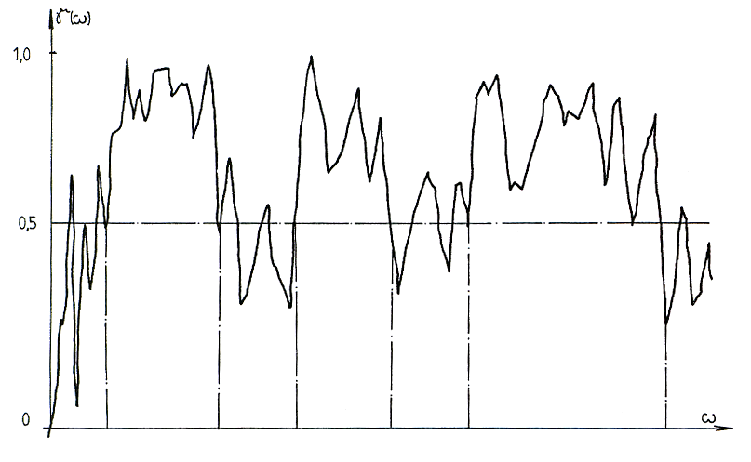
Fig.4. Coherence function

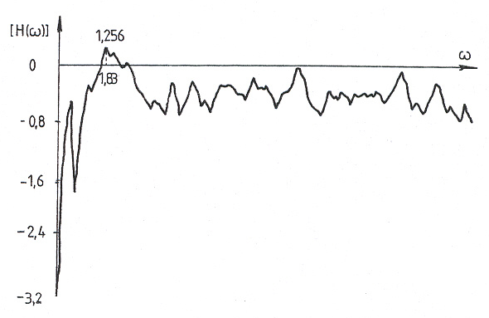

Fig.5. Transfer function

- Conclusion

  - The analyzed tractor seat suspension ensures a very good frequency of only 1.83 Hz;
  - The analyzed suspension dampens vibrations in resonance situations with 42%;
  - The mean square acceleration of the seat, of only 3.216 (m/s²)² as compared to the one of the platform, of 5.910 (m/s2)2 provides the seat with good comfort.

References

[1]. CONSTANTIN, Fl. Study, Design and Research on Tractor Seat Suspension According to Comfort Criterion – Applied to Tractor with Mass Exceeding 3601 kg. Ph.D.Thesis, University of Brasov, 1987;
[2]. CONSTANTIN, Fl. Simulation du roulement du tracteur sur la piste ISO, dans le but d’établir le degré de confort du siège, Buletinul Universitatii Brasov, 1987.
[3]. RADES, M. Identification of vibrating systems. Editura Academiei, Bucuresti, 1978.
[4]. VIERC, K.R. Vibration Analysis. Harper & Row Publishers, New York, Hagerstown, San Francisco, London, 1979
[5]. CONSTANTIN, Fl., URSUTIU D., COMANESCU I., Aplicaţii ale programului Labview la studiul vibraţiilor mecanice, Buletinul celei de a IX-a Conferinţe de vibraţii Mecanice, Timişoara, 1999.

