1st International Conference
″Computational Mechanics and Virtual Engineering ″
COMEC 2005
20 – 22 October 2005, Brasov, Romania

OPTIMIZATION OF PERFORATED PLATE STRUCTURES WITH CIRCULAR HOLES

I. Curtu¹, Ad. Pascu², V.Ciofoaia¹
Mariana Stanciu¹, Angela Repanovici¹
¹ “Transilvania” University of Braşov, Braşov, Romania, curtui@unitbv.ro
² “Lucian Blaga” University of Sibiu, Romania, adrian.pascu@ulbsibiu.ro

Abstract: The paper herein presents an optimization study of holes distribution in a perforated plate with circular holes fully constrained on two parallel sides and stressed by a perpendicular and uniformly distributed stress on the median surface of the plate, so that the maximum equivalent stresses that occur in such a plate should reach minimum values.
Key words: Optimization algorithm, state variables, objective function, “approximate subproblem” method, perforated plate.

1. INTRODUCTION

The optimization of mechanical structures consists of choosing the best computer-aided design alternatives. The optimum structure is the one that meets the desired concepts and that is, at the same time, operational, achievable and demanded by application [1]. The optimization includes all calculations that enable a continuous improvement of certain parameters through systematic variation of their value. The optimization is built up on algorithms where the properties may be determined as regards the quantity, as a shape or structure function.
The most important optimization criteria of the structure elements may be considered as follows, [1]: mechanical resistance criterion, rigidity criterion, stability criterion and weight criterion.
The current optimization techniques may be classified in topology optimization (or configuration optimizations) and shape optimization. The shape and topology optimization requires a flexible representation of the structure geometry and supposes the topology modification during the optimization process. The main advantage of this approach is that the designer does not have “to guess” the optimum typology or to specify the variable frontiers, but only a region where the component should be framed, terminal conditions and stresses applied. Taking into account the type of design variables used, the optimization may be: dimensional optimization, shape and topology optimization. As regards the dimensional optimization, the design variables stand for dimensions of the structure’s strength elements; the geometry change induced by the change of these design variables does not imply the modification of the analysis pattern. The shape optimization implies the variation of structure limits, so that the field of the structural analysis in changed. The topology optimization is based on the removal from structure of the material volume that is not stressed under the conditions of maximizing the structure rigidity.
The optimization of a structure includes all calculations that enable a continuous improvement of certain parameters through systematic variation of their value. The optimization is built up on algorithms where the properties may be determined as regards the quantity, as a shape or structure function. Taking into account the type of design variables used, the optimization may be: dimensional optimization, shape and topology optimization. The paper herein makes reference only to the dimensional optimization, case in which the design variables stand for dimensions of the active elements, and the geometry change induced by the change of these design variables does not imply the change of the analysis pattern. The optimization algorithms accomplish the minimization of an objective function that depends on the structure’s design variables. In order for the solutions to the optimization problems to be reliable, they must meet the imposed functions of restriction that stand for response values that depend on the design variables. In order to minimize the objective function, there are more techniques based on mathematical programming methods or on the optimum criterion method.
The application of optimization algorithms undertakes a great calculation volume; therefore, there were created computer aided engineering programs for structural optimization. The procedures consist of four distinct modules: structure parametric modeling, finite elements analysis, sensitivity analysis and application of the optimization algorithms. The current programs applied for structures optimization generally make use of an analysis program through the finite element method in order to work out the analysis.
The advanced programs based on finite elements analysis consist of specialized optimization modules. For this particular aim, the program used for the present analysis, ANSYS 8.0 comprises an optimization module based on the user’s control upon variables and functions, that are to be constrained and minimized, by using the standard optimization methods.

2. OPTIMISATION OF THE PERFORATED PLATE

In order to solve the optimization problem in case of perforated plates with circular holes stressed under bending, it was chosen the “approximate subproblem” method that may be considered as a zero graded method, where there are required only the values of the dependant variables, the objective function and state variables, but not their derivates. The dependant variables are firstly replaced through approximation with the least mean squares, the problem of constrained minimization being turned into a problem without constraints, making use of approximation functions.

The minimization is then achieved for each iteration through function approximation and reduction, until it is obtained the convergence or it is reached the moment indicated for iteration termination. For this method, each iteration is equivalent with a complete cycle of analyses with finite elements.
In this paper it was chosen for study a perforated plate with circular holes [3], fully constrained on two parallel sides and stressed by a perpendicular and uniformly distributed stress on the median surface of the plate.
The design variables chosen for this case are as follows:
- D stands for the hole diameter;
- Ex – stands for the distance between the edge of the plate and the edge of the circle on Ox direction;
- Ey stands for the distance between the edge of the plate and the edge of the circle on Oy direction;
- X stands for the step on Ox direction;
and the objective function is:
- SIGVM stands for the equivalent von Mises stresses that occurs in the plate
The model was created so that, during the optimization process, the functional and linking dimensions with other elements should not be affected.
The values of the design variables, state variables and objective function of the optimization for the initial set, respectively for the variation intervals during the optimization processes are presented in table 1.

Tabelul 1: Values for the design parameters, state variables and objective function
Variable type | Symbol | Value for the initial set | Variation interval | Tolerance
Design variables | D | 4 mm | 4 ... 8 mm | 0,1
Design variables | E_{x} | 3 mm | 2 ... 5 mm | 0,1
Design variables | E_{y} | 3 mm | 2 ... 5 mm | 0,1
Design variables | X | 0,116 mm | 0 ... 11,67 mm | 0,1
Objective function | SIGVM | 35,96 MPa | - | 0,0001

The variation of the design parameters D, Ex, Ey and X and of the objective function SIGVM during the optimization analysis, are graphically presented in figures 1, a, b, c, d, respectively in figure 2.

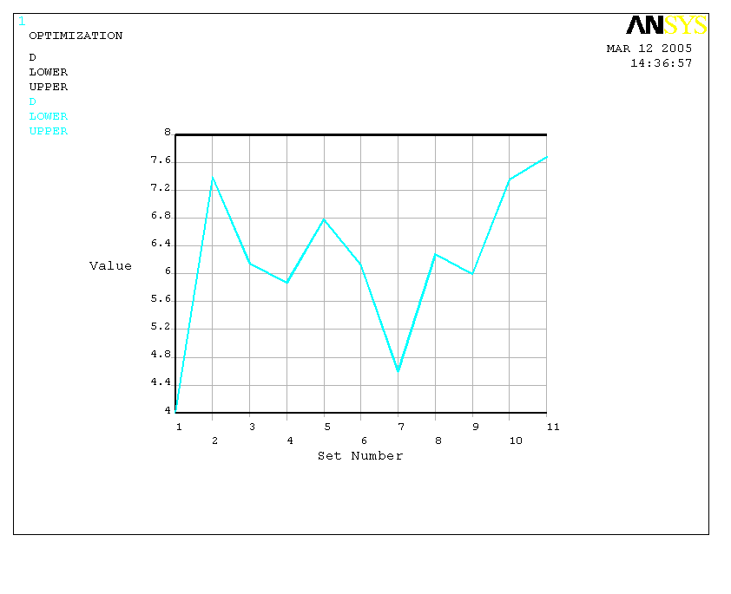 | 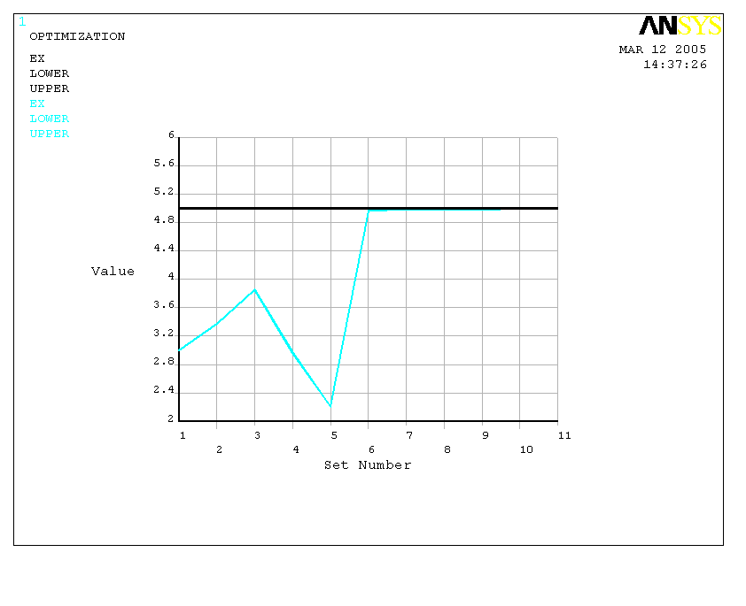
a) Variation of the design parameter D [mm] | b) Variation of the design parameter Ex [mm]

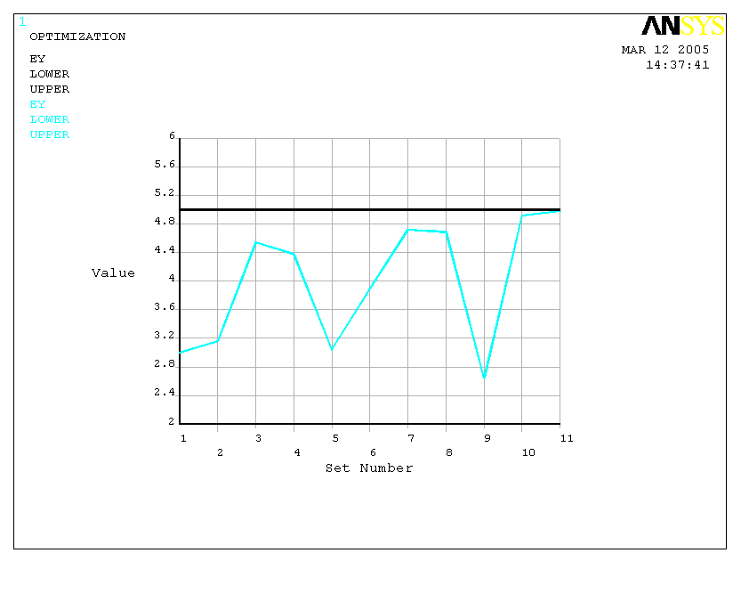 | 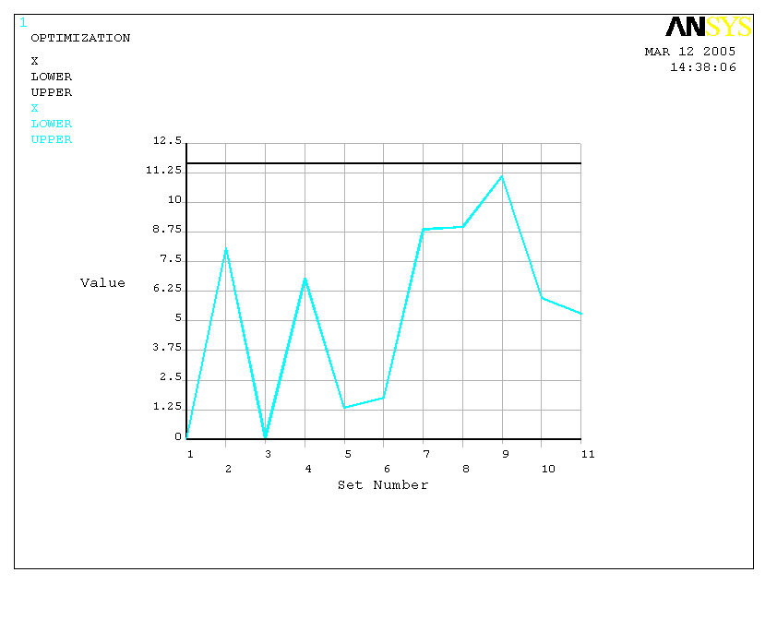
c) Variation of the design parameter Ey [mm] | d) Variation of the design parameter X [mm]
Figure 1: Variation of the design parameters during the optimization process

The set considered optimum, by approaching the optimization procedure of the ANSYS programmer, is set number 7, the values of the objective function being minimum for this set. The values of the design variables and of the objective function are presented in table 2 for the optimum set [3].  At the same time, the distribution of equivalent von Mises stresses (σ_{VM} ), of the main specific strain (ε₁) are presented in figure 3 a and b.  Following the achievement of this optimization through the finite element method, by using the ANSYS 8.0 programmer, aiming at decreasing the equivalent stresses that occur in such a perforated plate, there is noticed a decrease of this stress with 13,85% from the initial value of 35,96 MPa to 31,58 MPa.  The decrease of the equivalent stress through structural optimization was possible through the determination of the optimum values of D, E_{x}, E_{y} and X parameters. | 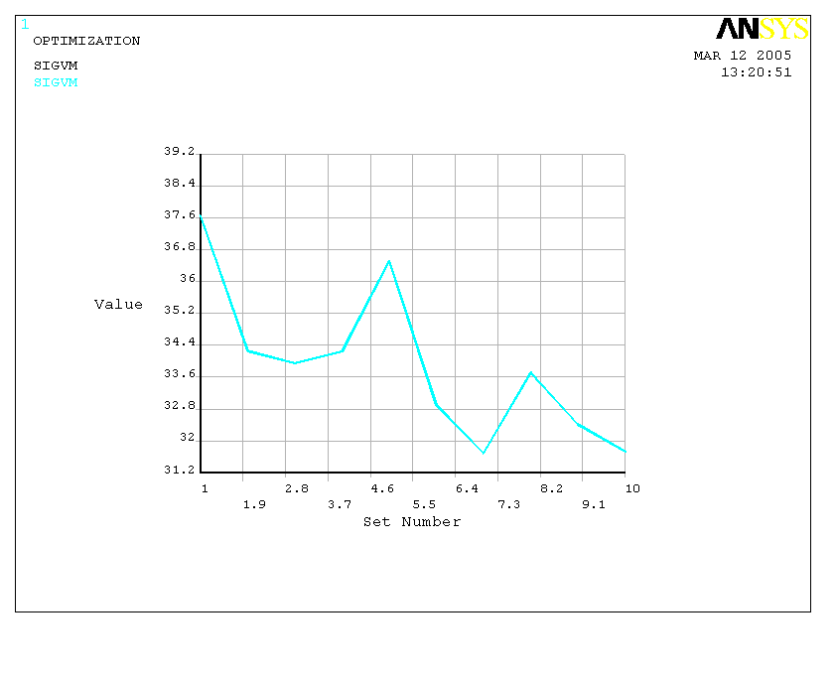  Figure 2: Variation of the objective function SIGVM [MPa] during the optimization process

Table 2: Values for the design parameters and objective function for the optimum set
Variable type | Symbol | Value
Design variables | D | 7,3572 mm
Design variables | Ex | 4,9924 mm
Design variables | Ey | 4,9237 mm
Design variables | Y | 5,9809 mm
Objective function | SIGVM | 31.58 MPa

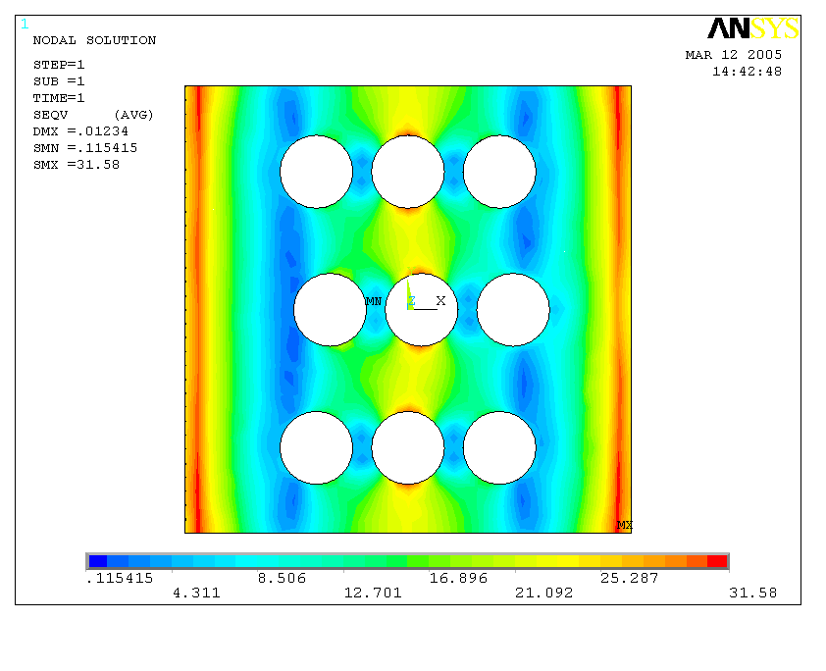  a) distribution of equivalent von Mises stress Von Mises, σ_{VM} [MPa] for the optimum set | 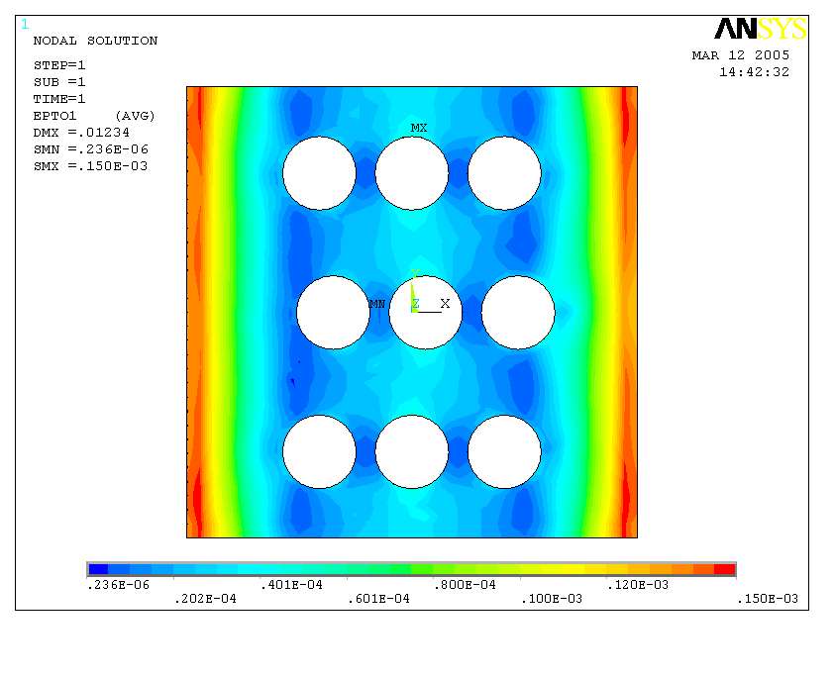  b) distribution of the main specific strain ε₁ [μm/m] for the optimum set
Figure 3: Strains and stresses distribution in the optimized pattern

3. CONCLUSIONS

Provided that these values are comparatively analyzed for the initial and optimum set, there are drawn the following conclusions:
- the increase of the hole diameter (D), from 4 mm to 7,3572 mm (to the upper limit);
- the increase of the distance between the edge of the plate and the edge of the circle on Ox direction (Ex) from 3 mm to 4,9924 mm;
- the increase of the distance between the edge of the plate and the edge of the circle on Oy direction (Ey) from 3 mm to 4,9237 mm;
- the increase of the perforation step on Ox direction (X), from 0,116 mm to 5,9809 mm (approximately at the half of the variation interval)
These observations lead the following conclusion: for the minimization of the equivalent von Mises stress that occurs in a perforated plate with circular holes, submitted to stresses perpendicular on its plane, the holes have to be as large as possible, the step between the holes centers is to be approximately twice the holes diameters, and the distanced between the plates edges and the circle edge on both direction should be greater. All these must be correlated with the form and the geometric conditions imposed to the perforated plate.

REFERENCES

- Banihuk N.V.: Introduction to optimization of structures, New Zork, Springer Verlag, 1990.
- Oleksik V., Bologa O, Racz G., Pascu A.: Research regards the influence of geometrical parameters to energetics of incremental forming process, Jornal of Plastic DeformatioN, Vol. 5, nr. 1 (11), Sibiu, 2003, pag. 45-52.
- Pascu A.: Cercetări privind solicitările structurilor de tip plasă şi plăci perforate realizate din diverse materiale, Teză de doctorat, Universitatea “Transilvania” din Braşov, 2005.

