1st International Conference
″Computational Mechanics and Virtual Engineering ″
COMEC 2005
20 – 22 October 2005, Brasov, Romania

SPEED MECHATRONIC VARIATOR
Part II. DYNAMIC ASPECTS

Dorin Diaconescu¹, Olimpiu Munteanu², Mihai Lates³
¹ Transilvania University of Brasov, Romania, e-mail dvdiaconescu@unitbv.ro
² Transilvania University of Brasov, Romania, e-mail omunt@unitbv.ro
³ Transilvania University of Brasov, Romania, e-mail latesmt@unitbv.ro

Abstract: Starting from the conceptual solution of the mechatronic variator which was proposed in the first part, further there will be established the variator dynamic model and the adjustment algorithm for the operating stationary quantities (which are necessary in the control system design). The dynamic modeling is based on the Newton-Euler method, by considering friction in the gear pairs from the planetary mechanism (through the efficiency of the associated fixed axes mechanism). The numerical testing of the considered variator, based on the dynamical model, will be the subject of a subsequent paper.
Keywords: speed planetary variator, mechatronic variator, speed range, control system.

- INTRODUCTION

The conceptual solution of a mechatronic planetary variator (whose principle solution is illustrated in Fig. 1, a) is proposed and analyzed in the first part of this paper. According to the first part (see Fig. 1), the proposed solution accomplishes the following main objectives:
- There are obtained the continuous variation and the reduction of speed by summing (using a symmetrical differential) two speeds of opposite direction: the speed of an electrical motor, that functions as variator (ω_{m} >0), and the speed of an electrical generator (ω_{g} < 0, |ω_{g} | < |ω_{m} | ); thus, it is obtained the adjusted speed of the output shaft H, as the half-sum of the speeds ω_{m} and ω_{g};
- The energetic loses are minimized through: a) the minimization of the number of gear pairs, b) the limitation of the range of the electrical machines in-service functioning to the sub-range with high efficiencies and c) the reinsertion in the network of the energy given by the electrical generator;
- The life time of the electrical motor is maximized by an adequate choose of the extreme artificial mechanical characteristics (in order to avoid the motor overstresses during the service functioning) ;
- It is ensured the continuous variation of speed at high powers, with an adjustment range superior to the one given by the motor (considered alone, in the same conditions) ;
- It is accomplished the variator under load starting (without overloads): at the motor starting, the output shaft H remains stationary and the generator functions without load, until the generator rotor reaches the idle speed; since this moment, the generator enters under load and the output shaft H starts moving;
- The imposed speed is maintained constant (using an adequate control system) even if the resistant moment is changing.
Further, for this solution of variator, there are established the dynamic model and the adjustment algorithm of the operating stationary quantities (results that are necessary in the control system design).

- THE VARIATOR DYNAMIC MODELING

The schemes and notations used in the variator dynamic modeling are presented in Fig. 1. The method used in modeling is Newton-Euler and the following premises are used:
a) the elements are considered rigid;
b) the inertial effects that are due to the revolute motion of the satellite round its own axis are neglected;
c) the friction effects from the gear pairs are taken into consideration through the efficiency $η_{0}=η_{\text{13}}^{H}=0,{\text{98}}^{2}=0,\text{96}$[1;2];
d) it is used an electrical DC generator that functions on the natural mechanical characteristic, described by relation (5);
e) it is used an electrical DC motor with an adjustable mechanical characteristic, described by relation (8); the characteristic adjustment is obtained by changing the motor supply voltage U [3]:
U/Un = ω_{0m}/ω_{0mn} (through the subscript n there are denoted the nominal quantities).

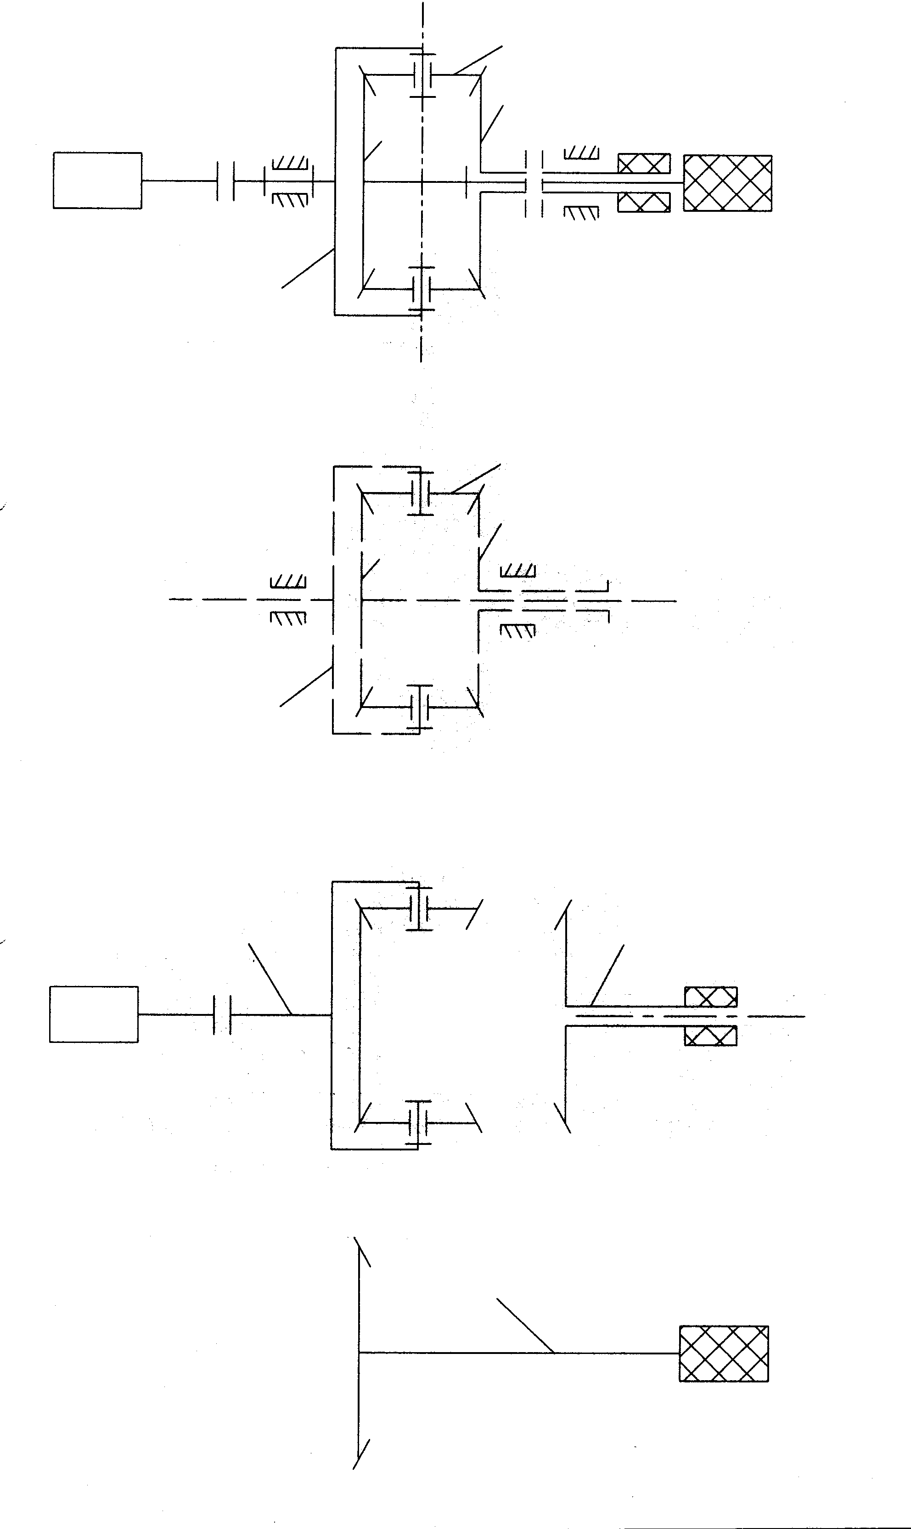
Figure 1: a) The conceptual scheme of the planetary mechatronic variator; b) The scheme of the symmetrical planetary mechanism; c) Schemes necessary in the dynamic modeling
1
2
3
H
+
H
1
2
3
through Newton-Euler method.

According to Fig. 1,b and c, the following relations can be written [1;2]:
$$ω_{H}=0,5⋅\left(ω_{m}+ω_{g}\right) ⇔ ε_{H}=0,5⋅\left(ε_{m}+ε_{g}\right)$$
$\begin{aligned}\begin{aligned}T_{1}+T_{3}+T_{H}=0 \\ |T_{1}⋅i_{0}⋅η_{0}^{w}+T_{3}=0 \\ |i_{0}=i_{\text{13}}^{H}=−1 \\ \end{aligned} ⇒ \begin{aligned}| T_{1}=−\frac{1}{1+η_{0}}T_{H} \\ | T_{3}=T_{1}η_{0}=−\frac{η_{0}}{1+η_{0}}T_{H}\end{aligned}\end{aligned}w=\text{sgn} ω_{1H}T_{1}=\text{sgn} T_{1}\left(ω_{1}−ω_{H}\right)\text{=+}1η_{0}=η_{\text{13}}^{H}=0,{\text{98}}^{2}=0,\text{96}$ (1)

$\begin{aligned}J_{1}ε_{m}=T_{m}−T_{1}=T_{m}+\frac{1}{1+η_{0}}T_{H} \\ J_{3}ε_{g}=T_{g}−T_{3}=T_{g}+\frac{η_{0}}{1+η_{0}}T_{H} \\ J_{H}ε_{H}=−T_{H}+T_{r} ⇒ T_{H}=T_{r}−J_{H}ε_{H}\end{aligned}$
The two motion equations of the differential variator, in a general expression (without expressing the external moments Tg, Tm and Tr) are obtained from the system of equations (1):
$\begin{aligned}J_{1}ε_{m}+\frac{J_{H}}{1+η_{0}}ε_{H}=T_{m}+\frac{1}{1+η_{0}}T_{r} \\ J_{3}ε_{g}+\frac{η_{0}J_{H}}{1+η_{0}}ε_{H}=T_{g}+\frac{η_{0}}{1+η_{0}}T_{r}\end{aligned}$ (2)
The planetary variator dynamic model is obtained by expressing the external moments Tg, Tm and Tr from the general equations (2); as a rule, the output moment (Tr) being known (it is mostly constant), the expressions of the generator and motor moments (Tg, Tm) can be further written.
When the variator is started, the generator has two operating phases: a) and b).
a) The phase of no-load acceleration, in which ω_{g} = 0… ω_{0g} ; in this phase, the shaft H remains immovable and, therefore, the equation (2) are reduced to a single equation:
$T_{g}=0 , ω_{H}=0,ε_{H}=0 ⇒ ε_{m}=−ε_{g}$ (3)
$ε_{m}\left(J_{1}+\frac{1}{η_{0}}J_{3}\right)−T_{m}=0$ (4)

b) The phase of under-load acceleration, in which ω_{g} = ω_{0g} … ω_{g .const} ; in this phase, the generator enters under load, the shaft H becomes mobile and, therefore, the equations (2) can be written as follows (6):
$T_{g}=−ν_{g}ω_{g}+ν_{g}ω_{0g}$, $ν_{g}=\frac{T_{\text{gn}}}{ω_{0\text{gn}}−ω_{\text{gn}}}$ (5)
$\begin{aligned}J_{1}η_{0}ε−J_{3}ε_{g}−ν_{g}ω_{g}=η_{0}T_{m}−ν_{g}ω_{0g} \\ \left(J_{3}+\frac{1}{2}\frac{η_{0}J_{H}}{1+η_{0}}\right)ε_{g}+\frac{1}{2}\frac{η_{0}J_{H}}{1+η_{0}}ε_{m}+ν_{g}ω_{g}=\frac{η_{0}}{1+η_{0}}T_{r}+ν_{g}ω_{0g}\end{aligned}$ (6)
For simplification, it is considered that in phase a) the motor moment is approximately constant (rheostat starting), and in phase b), the motor functions on the artificial characteristic that corresponds to the stationary operating point:
$T_{m}=k⋅T_{m n}$ for $ω_{m}∈\left[0,−ω_{0g}\right]$, $k=\frac{ω_{0m}+ω_{0g}}{ω_{0m n}−ω_{m n}}$ (7)
$\begin{aligned}T_{m}=ν_{m}\left(ω_{0m}−ω_{m}\right) \text{for} ω_{m}≥−ω_{0g} \\ ν_{m}=\frac{T_{m n}}{ω_{0m n}−ω_{m n}}\end{aligned}$ (8)
Replacing relation (7) in (4), it is obtained the motion equation of the variator (with 1 DOF) which corresponds to the starting phase a), in which ω_{g} = 0… ω_{0g} , ω_{m} = 0… -ω_{0g} and, implicitly t= 0…t_{0g}:

$ε_{m}\left(η_{0}J_{1}+J_{3}\right)−η_{0}{\text{kT}}_{m n}=0$ $⇒$
$\begin{aligned}ε_{m}=\frac{η_{0}{\text{kT}}_{m n}}{η_{0}J_{1}+J_{3}} ⇒ ω_{m}=ω_{m}t;ε_{g}=−ε_{m};ω_{g}=−ω_{m} \\ \text{for} t=0 \text{.}\text{.}\text{.} t_{0g}\end{aligned}$ (9)
$\frac{η_{0}{\text{kT}}_{m n}}{η_{0}J_{1}+J_{3}}t_{0g}=−ω_{0g} ⇒ t_{0g}=\frac{−ω_{0g}\left(η_{0}J_{1}+J_{3}\right)}{{kη}_{0}T_{m n}}$
Relations (9), together with relations (10), describe the dynamic response of the variator in the starting phase a):
$\begin{aligned}T_{m}={\text{kT}}_{m n} \\ T_{1}=T_{m}−J_{1}ε_{m} \\ T_{3}=−J_{3}ε_{g}=J_{3}ε_{m} \\ T_{g}=0 \\ T_{H}=−\left(T_{1}+T_{3}\right)=\left(J_{1}−J_{3}\right)ε_{m}−T_{m}\end{aligned}$ (10)
Replacing relations (8) into relations (6), there are obtained the motion equations of the differential variator in the b) phase, in which ω_{g} = ω_{0g} … ω_{g.const}, ω_{m} = -ω_{0g} … ω_{m.const} and, implicitly t = t_{0g} … t_{start} :
$$\begin{aligned}\left[2\left(1+η_{0}\right)J_{1}+J_{H}\right]ε_{m}+J_{H}ε_{g}+2ν_{m}\left(1+η_{0}\right)ω_{m}= \\ =2\left(1+η_{0}\right)ν_{m}ω_{0m}+2T_{r}\end{aligned}$$
$\begin{aligned}\left[2\left(1+η_{0}\right)J_{3}+η_{0}J_{H}\right]ε_{g}+η_{0}J_{H}ε_{m}+2ν_{g}\left(1+η_{0}\right)ω_{g}= \\ =2\left(1+η_{0}\right)ν_{g}ω_{0g}+2η_{0}T_{r}\end{aligned}$ (11)
in the following initial condition:
$\begin{aligned}t=t_{0g}=\frac{−{kη}_{0}T_{m n}}{ω_{0g}\left(η_{0}J_{1}+J_{3}\right)} ⇒ \\ ε_{m}=\frac{{kη}_{0}T_{m n}}{η_{0}J_{1}+J_{3}};ω_{m}=−ω_{0g} \\ ε_{g}=−ε_{m};ω_{g}=ω_{0g}\end{aligned}$ (12)
The variations in time of the quantities ώ_{m}, eps_{m}, ώ_{g} and eps_{g} are obtained by solving system (11); these quantities, together with those given by relations (13), describe the variator dynamic response in the starting phase b):
$\begin{aligned}ε_{H}=0,5\left(ε_{m}+ε_{g}\right) ⇒ ω_{H}=0,5\left(ω_{m}+ω_{g}\right) \\ T_{m}=ν_{m}\left(ω_{0m}−ω_{m}\right) \\ T_{g}=ν_{g}\left(ω_{0g}−ω_{g}\right) \\ T_{1}=T_{m}−J_{1}ε_{m} \\ T_{3}=T_{g}−J_{3}ε_{g} \\ T_{H}=J_{1}ε_{m}+J_{3}ε_{g}−T_{m}−T_{g}=−\left(T_{1}+T_{3}\right)\end{aligned}$ (13)
The starting time t_{start} represents the range of time in which the angular velocities become constant and, implicitly, the acceleration become null (therefore, the operating stationary regime is reached).

- THE ALGORITHM FOR THE ADJUSTMENT OF STATIONARY QUANTITIES

Problem formulation: being imposed the values of the output quantities ω_{H} and T_{r} (Fig.1), it is required to establish an algorithm for determining the stationary quantities, necessary in compensating the variator adjustment errors.
Solution: Based on the differential mechanism relations (see Fig.1,b and relations (1)) and on the equations (5) and (8), that describe the mechanical characteristics of the electrical DC machines, the following series of calculations is obtained (in stationary operating conditions: eps = 0 => T_{r} = T_{H}, T₁ = T_{m}, T₃ = T_{g}):
$\begin{aligned}T_{g}=−\frac{η_{0}}{1+η_{0}}T_{r};T_{m}=−\frac{η_{0}}{1+η_{0}}T_{r} \\ ω_{g}=ω_{0g}−\frac{1}{ν_{g}}T_{g}=ω_{0g}+\frac{η_{0}}{ν_{g}\left(1+η_{0}\right)}T_{r} \\ ω_{m}=2ω_{H}−ω_{g}\end{aligned}$ (14)
$\begin{aligned}ω_{0m}=2ω_{H}−ω_{0g}−\frac{T_{r}}{1+η_{0}}\left(\frac{η_{0}}{ν_{g}}+\frac{1}{ν_{m}}\right) \\ U=U_{n}\frac{ω_{\text{om}}}{ω_{0m n}}\end{aligned}$
in which:
$ν_{m}=\frac{T_{m n}}{ω_{0m n}−ω_{n}};ν_{g}=\frac{T_{g n}}{ω_{0g}−ω_{g n}}$ (14’)
It is considered that the variator is at least equipped with instruments for measuring the real angular velocities ώ_{m.r} , ώ_{g.r} and the real supply voltages of the motor (U_{m.r}) and generator (U_{g.r}).
From different reasons, it is possible that the measured quantities not to be the same with the calculated ones, so that the error of the output velocity | ω_{H} – 0,5.( ω_{m.r}+ ω_{g.r})| to become bigger than the admissible maximum error δ.
The correction of the output velocity 0,5.( ω_{m.r}+ ω_{g.r}) at the imposed value ω_{H} , on the basis of the measured quantities (real ones), can be made (using a controller) following the series of calculations:
$\begin{aligned}T_{g}=ν_{g}\left(ω_{0g}\frac{U_{\text{gr}}}{U_{g n}}−ω_{\text{gr}}\right) \\ T_{m}=ν_{m}\left(ω_{0m n}\frac{U_{\text{mr}}}{U_{m n}}−ω_{\text{mr}}\right) \\ ω_{g}=ω_{\text{gr}} \\ ω_{m}=2ω_{H}−ω_{\text{gr}} \\ ω_{0m}=ω_{m}−\frac{T_{m}}{ν_{m}} \\ U=U_{m}=U_{m n}\frac{ω_{0\text{mr}}}{ω_{0m n}} \\ T_{H}=−\left(T_{m}+T_{g}\right); η_{0}=T_{g}/T_{m}\end{aligned}$ (15)
For a better understanding, relations (14) and (15) were systematized in an algorithm, illustrated in Fig. 2 as a logical organogram.

- CONCLUSIONS

In this paper (part II) there were established the dynamic model and the adjustment algorithm of the stationary operating quantities for the proposed and analyzed solution of variator from part 1, results that are necessary in the control system design.
The dynamic model of the planetary variator (Fig.1) was established using the Newton-Euler method and based on the following premises:
a) the elements are considered rigid;
b) the inertial effects that are due to the revolute motion of the satellite round its own axis are neglected;
c) the friction effects from the gear pairs are taken into consideration through the efficiency $η_{0}=η_{\text{13}}^{H}=0,{\text{98}}^{2}=0,\text{96}$ [1;2];
d) it is used an electrical DC generator that functions on the natural mechanical characteristic;
e) it is used an electrical DC motor with an adjustable mechanical characteristic by changing the motor supply voltage U.
The numerical testing for the considered variator, based on the aforesaid dynamic model and adjustment algorithm, will form the subject of a subsequent paper.

NOT
YES
Figure 2 :. Algorithm for the compensation of the variator adjustment errors.

REFERENCES

[1] Diaconescu, D. : The products conceptual design (in Romanian), Ed. Transilvania University of Brasov, 2005.
[2] Miloiu, G., Dudita, F., Diaconescu, D.: Modern mechanical transmissions (in Romanian), Ed. Tehnica, Buc.
[3] Saal, C. s.a. : Electrical actuation and automatization (in Romanian) , Ed. didactica si pedagogica, Bucuresti.

