1st International Conference
″Computational Mechanics and Virtual Engineering ″
COMEC 2005
20 – 22 October 2005, Brasov, Romania

DYNAMICS OF A MONOWHEEL VEHICLE

Gheorghe Deliu ¹, Dan Botezatu ²
¹ Transilvania University, Braşov, ROMANIA, e-mail: deliumec@unitbv.ro
² Transilvania University, Braşov, ROMANIA, e-mail: dan.botezatu@gmail.com

Abstract: Monowheel vehicles present a number of challenges to the designer and several compromises have to be made to get everything come together into a functional machine. The first problem is stability; because monowheel depends on gyroscopic effect to keep it upright. In the paper, the conditions of acceleration period , of steady state movement, of deceleration and of the braking are presented . After this study we have obtained the equations needed to the simulation and the optimisation of the motion on computer.
Keywords: monowheel, vehicle, movement, equations, dynamics.

- INTRODUCTION
Being known firstly at the circus, the one-wheeled vehicle got the attention of many engineers and designers who thought to the possibility of this vehicle to be a future one. Starting with 1869 when Rousseau of Marseilles firstly built such a vehicle, until 2003 when a similar concept won the Gold Award at Annual Design Awards – Industrial Design Society of America & Business Weekmagazine, In this paper, we present our studies about the “strange” conditions in which this single wheel may be controlled by a driver placed inside the wheel! Taking into account that the power source is also placed inside the wheel, the problem presents some challenges to any engineer. This is the main reason we made this study.

2. VEHICLE KINEMATICS
One of the last designs of monowheel is the Kerry McLean’s vehicle (Michigan, 2001), shown in Fig.1. Its simplified model is presented in Fig.2.
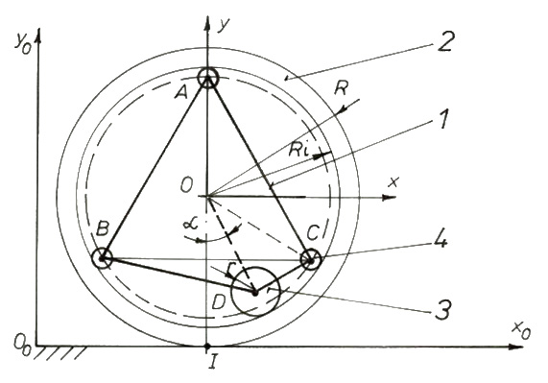
Figure 2: Simplified model
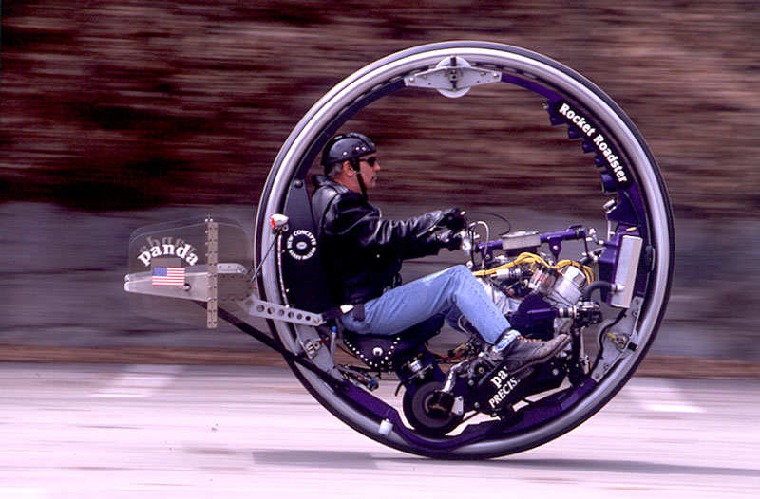
Figure 1: McLean’s vehicle

As we can see, the vehicle is composed by:
- An inner body 1, having a rigid frame and possessing a saddle and an engine;
- An outer ring 2 (the wheel), which rolls over the ground;
- A driving roller 3, which rolls inside the rim of the wheel:
- Three or more guiding rollers 4, which rolls also inside the rim.
In steady state conditions, the inner body has a straight translation motion , but in accelerating / braking conditions, it has a true plane motion. In any of these three cases, the outer ring (the wheel) is supposed to have a true plane motion, without slipping on the ground. Evidently, the driving roller has also a plane motion, obtained by the superposition of the translation with the inner body and the rotation relative to it.
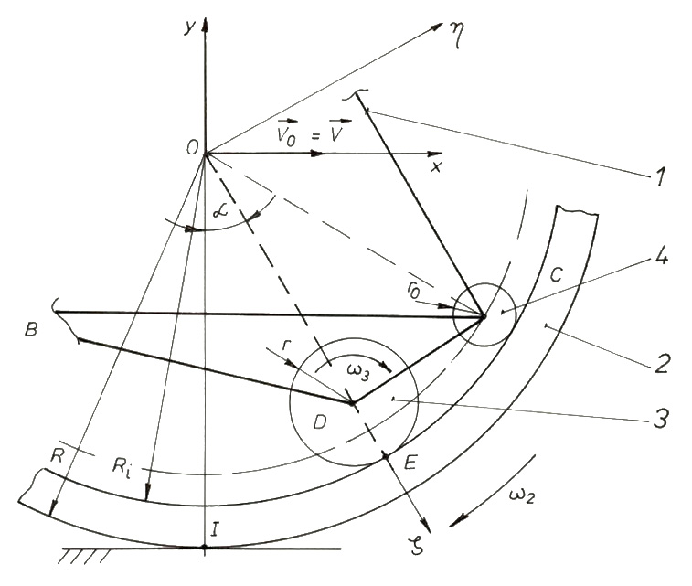
Figure 3: Partial zoom-in of Fig.2
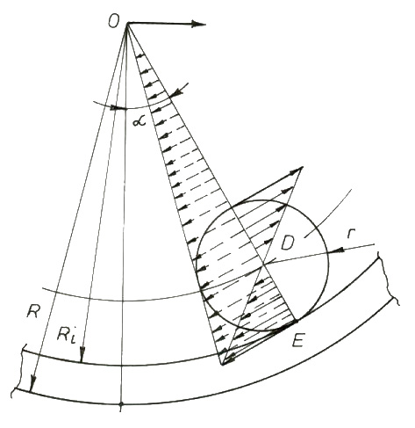
Figure 4: Motions relative to Ο ζ η -frame
In order to express the position of the inner body center of mass, relative to a frame bound on this body, we introduce a new reference frame Ο ζ η (Fig.3). Its position is given by the angle α (see also Fig.3).

2.1. Kinematical relations

According to above presented figures, we have the relation:
$v_{O} = ω_{2}⋅R$ (1)
Further, according to Fig.4, we can write:
$ω_{2} ⋅R_{i} = ω_{3} ⋅r ⇒ ω_{3} = \frac{R_{i}}{r} \frac{v_{O}}{R}$ (2)
From the relations above, we can write evidently:
$ε_{2} = \frac{a_{O}}{R} ; ε_{3} = \frac{R_{i}}{r} \frac{a_{O}}{R}$ , (3)
where a_{O} is the linear acceleration of the vehicle, and ε₂ , ε₃ – angular accelerations of the respective bodies.
In order to express the velocity of the center of mass of the entire vehicle, we shall introduce the coordinates $ς_{1} ,η_{1}$ for the center of mass of the inner body 1. Then, taking into account that the rim 2 has a central axial symmetry, we can write the coordinates of the center of gravity for the entire vehicle as:
$ς^{} = \frac{ς_{1} W_{1}}{W_{1}+W_{2}} ; η^{} = \frac{η_{1} W_{1}}{W_{1}+W_{2}}$ (4)
Now, the velocity of the center of mass will be:
${\vec{v}}_{G} = {\vec{v}}_{O} + {\vec{ω}}_{1}x\vec{\text{OG}}$, (5)
where ${\vec{ω}}_{1}$is the angular velocity of the inner body $\left(ω_{1}= \overset{˙}{α}\right)$.
In the same way, the acceleration of the center of mass will be[1]:
${\vec{a}}_{G} = {\vec{a}}_{O}+{\vec{ε}}_{1}x \vec{\text{OG}}+{\vec{ω}}_{1}x\left({\vec{ω}}_{1}x\vec{\text{OG}}\right)$, (6)
where ${\vec{ε}}_{1}$is the angular acceleration of the inner body $\left(ε_{1} = \overset{¨}{α}\right)$.

2.2. Steady state motion

As we already have seen, the condition of a steady state motion requires a constant speed of the center O, which means in turn constant values for the position angle α (ω₁ = 0) , for the angular velocities ω₂ and ω₃, as well as zero values for all the angular accelerations. The relations above, become then:
${\vec{v}}_{O} = {\vec{v}}_{A} = {\vec{v}}_{B} = {\vec{v}}_{C} = {\vec{v}}_{D} = {\vec{v}}_{G} = \vec{\text{const}}$, (7)
while relations (1) and (2) are maintained.

3. DYNAMICS

As it is evident from Fig.2, the system has two degrees of freedom. Therefore, the most short an elegant approach will be the Lagrangean method. In this sense, we shall retain as independent coordinates: q₁ = ψ ( ψ = α + γ, where γ is a constant angle ) and $q_{2} = x_{O}^{0} /R$. The rest of coordinates may be expressed in terms of these ones as follows (see Fig.5):
$θ_{2} = q_{2} ;$$θ_{3} ≃ \frac{R_{i}}{r} q_{2}$ ; $x_{G}^{0} = R q_{2} +l \text{sin} q_{1}$ , $y_{G}^{0} = R− l \text{cos} q_{1}$ (8)
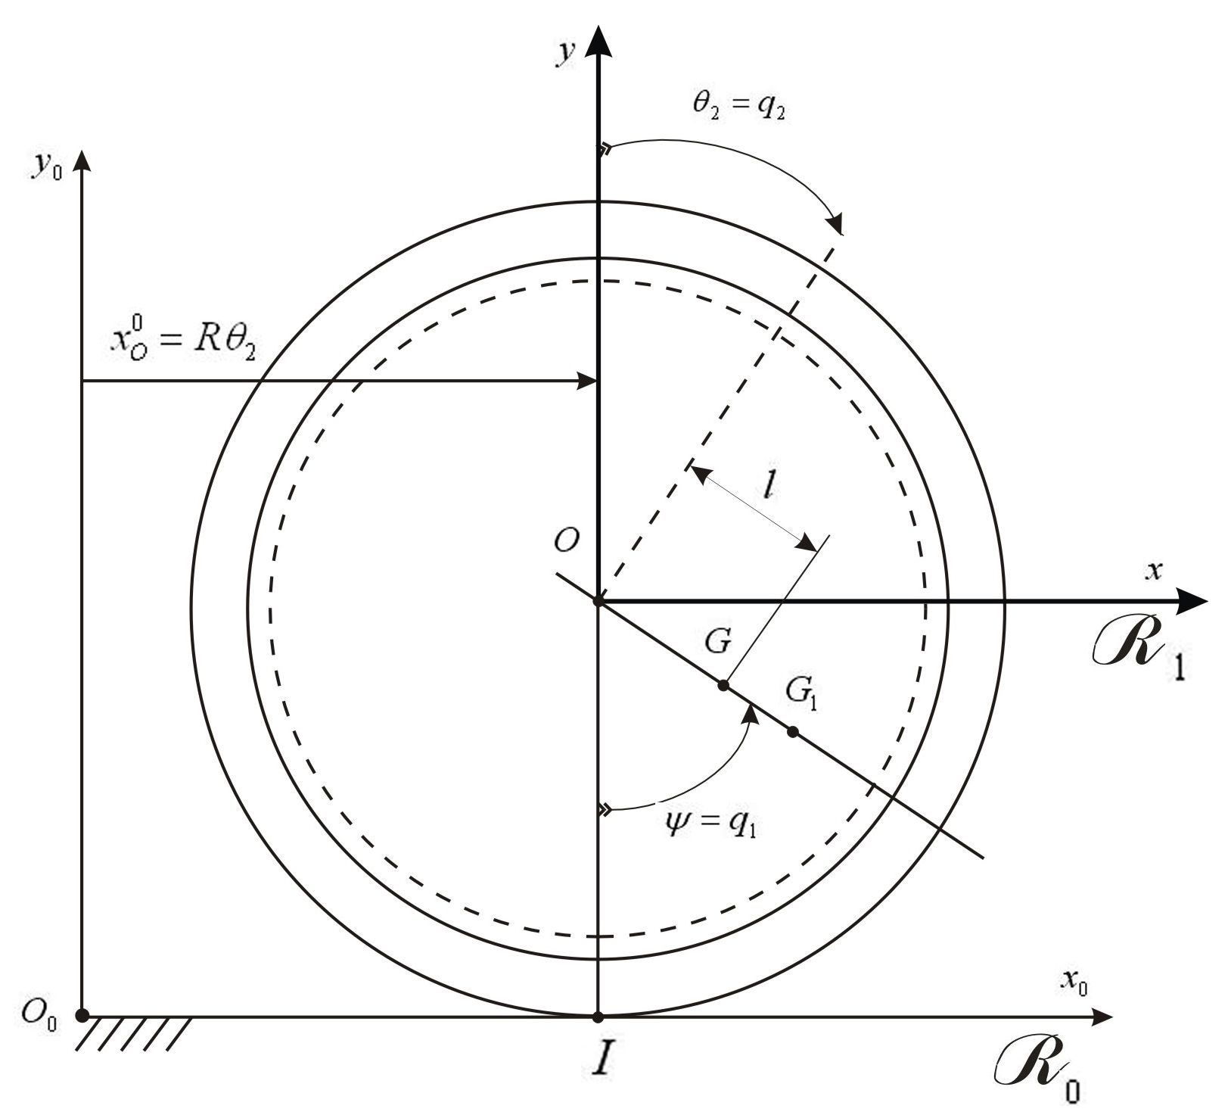
Figure 5: Generalized coordinates

From these relations, we can derive the corresponding relations between velocities:
$ω_{2} = {\overset{˙}{q}}_{2} ; ω_{3} ≃ \frac{R_{i}}{r} {\overset{˙}{q}}_{2} ; v_{G}^{x} = R {\overset{˙}{q}}_{2}+l {\overset{˙}{q}}_{1}\text{cos}q_{1} , v_{G}^{y} = −l {\overset{˙}{q}}_{1} \text{sin} q_{1}$ (9)
Now, we write the kinetic energy of the vehicle as:
$T = \frac{1}{2}\left\{m_{1}v_{1}^{2}+J_{1}ω_{1}^{2}+m_{2}v_{2}^{2}+J_{2}ω_{2}^{2}+m_{3}v_{3}^{2}+J_{3}ω_{3}^{2}\right\}$ (10)
where:
$v_{1}^{x} = R {\overset{˙}{q}}_{2}+l_{1} {\overset{˙}{q}}_{1}\text{cos}q_{1} ; v_{1}^{y} = −l_{1} {\overset{˙}{q}}_{1}\text{sin}q_{1} ; v_{1}^{2} = (v_{1}^{x})^{2}+(v_{1}^{y})^{2}$ , (11)
$ω_{1} = {\overset{˙}{q}}_{1}$, (12)
$v_{2} = R {\overset{˙}{q}}_{2}$ , (13)
$v_{3}^{x} = R {\overset{˙}{q}}_{2}+ (R_{i}−r) {\overset{˙}{q}}_{1}\text{cos}q_{1} ; v_{3}^{y} = − (R_{i}−r) {\overset{˙}{q}}_{1}\text{sin}q_{1} ; v_{3}^{2} = (v_{3}^{x})^{2}+(v_{3}^{y})^{2}$, (14)
$m_{i} , J_{i}$- the mass and the moment of inertia of the i-component .
On the other hand, the work done by the “external” forces on the system (under conditions of constant driving torque) may be written as:
$L = M_{m}⋅θ_{3}−M_{r}⋅θ_{2}−W_{1}⋅l_{1}\left(\text{cos}ψ_{e}−\text{cos}ψ\right)$, (15)
where:
M_{m} – the driving torque applied to the driving roller shaft;
M_{r} – the rolling resistance couple on the wheel;
W₁ – the weight of the inner body 1;
Ψ_{e} – the steady state value of the angle ψ
$l_{1}$- the distance OG₁.
In terms of generalized coordinates, relation (15) becomes:
$L = M_{m}⋅\frac{R_{i}}{r} q_{2}−M_{r}q_{2}−W_{1}⋅l_{1}\left(\text{cos}q_{1e}−\text{cos}q_{1}\right)$ (16)
The Lagrange’s equations have then the form:
$\frac{d}{\text{dt}}\left(\frac{∂T}{∂{\overset{˙}{q}}_{j}}\right)−\frac{∂T}{∂q_{j}} = \frac{∂L}{∂q_{j}}$ , (17) which will conduce to the differential equations of the motion. For now, in the present paper, we shall continue the study with the steady state motion of the vehicle only. In this particular case, the system will became a one-degree-of-freedom system. It is obvious that these conditions will resume in following relations:
$ψ = ψ_{e} ∪ \overset{˙}{ψ} = 0$, (18)
and consequently
$v_{1} = v_{2} = v_{3} = R {\overset{˙}{q}}_{2} ∪ ω_{1} = 0, ω_{2} = {\overset{˙}{q}}_{2} , ω_{3} = \frac{R_{i}}{r} {\overset{˙}{q}}_{2}$ . (19) Then, the kinetic energy of the system will be:
$T = \frac{1}{2}\left\{\left(m_{1}+m_{2}+m_{3}\right)R^{2}+J_{2}+{\left(\frac{R_{i}}{r}\right)}^{2}J_{3}\right\} {\overset{˙}{q}}_{2}^{2}$ (20)
The work done by the external forces will became: $L = \left(M_{m}\frac{R_{i}}{r}−M_{r}\right) q_{2}$ (21) Now, introducing these expressions in the Lagrange’s equation, we shall obtain: $\frac{d}{\text{dt}}\left(J_{\text{red}}ω_{2}\right) = M_{m} \frac{R_{i}}{r}−M_{r} ⇒ J_{\text{red}} ε_{2} = M_{m}\frac{R_{i}}{r}−M_{r}$ (22)
Equation (22) shows that if the driving torque has quite equal value to that necessary for equilibrium, the acceleration of the system is zero. For a small increase of the driving torque $\left(M_{m} | | M_{r}\frac{r}{R_{i}}\right)$, we still may neglect the swing motion of the inner body 1, and then calculate the acceleration of the vehicle as follows:
$a = R ε_{2} ≃ \frac{R}{J_{\text{red}}} \left(M_{m}\frac{R_{i}}{r}−M_{r}\right)$ . (23)

3. CONCLUSION

First of all, our studies show that the problem of the motion of such a vehicle is not very simply, but in spite of this it is solvable. In further papers, we shall present the results of our continued studies about the unsteady longitudinal motion as well as about the turn of such a vehicle.

REFERENCES

[1] Deliu Gh.: Mechanics for engineering students, Editura Albastră, Cluj Napoca, 2002, I.S.B.N. 973-650-082-9
[2] On-line documentation and world wide resources on the topic.

