1st International Conference
″Computational Mechanics and Virtual Engineering ″
COMEC 2005
20 – 22 October 2005, Brasov, Romania

UNIFORM PRESSURE APPLIED TO A
POLIGONAL REGION

Ioan Enescu

“ Transilvania” University, Brasov, Romania , enescu@unitbv.ro

Keywords: contact,half-space,uniform pressure
Abstract: We consider the stress and deformations produce in an elastic half-space, bounded by the plane surface z=0,under the active of normal and tangential tractions applied to a closed area of the surface in the neighbourhood of the origin.The aplications to to bearings is make by half-space method (exemple).

1.Uniforme presure applied to a polygonal region

We shall consider in this section a uniform pressure p applied to a region of the surface consisting of a straight-sided polygon, as shown in fig (1.a). It is required to find the depression at a general point B (x,y) on the surface and the stress components at a subsurface point A(x,y) ,BH₁, BH₂, etc, are perpendiculars of lenghts h₁,h₂, etc. onto the side of polygon DE,EF respectively. The loaded polygonal is then made up of the algebric addtion ofeight right angle triangles:

DEFG=[BEH₁+BEH₂+BFH₂+BFH₃]-[BDH₁+BDH₄+BGH₃+BGH₄] (1)
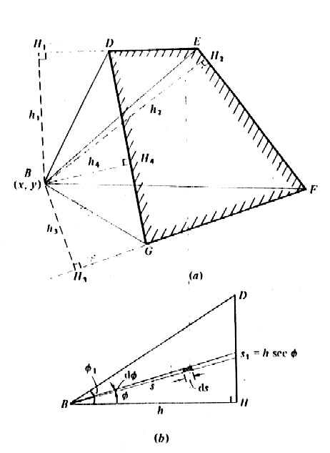
Fig.1 Straight-side poligon

A similar breakdown into rectangular triangles would have been possible if B had lain inside the polygon a typical triangular area is shown in fig.(1.b)

$({\bar{u}}_{y})_{B}=\frac{1−ν^{2}}{πE}p\int_{0}^{φ_{1}}{dφ}\int_{0}^{s_{1}}{\text{ds}}=\frac{1−ν^{2}}{πE}p\int_{0}^{φ_{1}}{h\text{sec}φdφ=\frac{1−ν^{2}}{πE}}p\frac{h}{2}\text{ln}\left(\frac{1+\text{sin}φ_{1}}{1−\text{sin}φ_{1}}\right)$ (2)

The total displecement at B due to a uniforme pressure on the polygonal region DEFG can then be found by combining the results of equations (2) for the eight constitutive triangles. The stress components at an interior point A(x,y,z) beliw B can be found by integration of the stress components due to a point force given by known equation but the procedure is tedious.
The effect of a uniform pressure acting on arectangular area 2a*2b has been analysed in detail by Love (1929) . The deflexion of a general point (x,y) on the surface is given by:

D=$\frac{πE}{1−ν^{2}}\frac{{\bar{u}}_{z}}{p}=(x+a)\text{ln}\left[\frac{(y+b)+((x+a)+(x+a)^{2})^{1/2}}{(y−b)+((y−b)+(x+a)^{2})^{1/2}}\right]+$

$(y+b)\text{ln}\left[\frac{(x+a)+{\left((y+b)^{2}+(x+a)^{2}\right)}^{1/2}}{(x−a)+{\left((y+b)^{2}+(x−a)^{2}\right)}^{1/2}}\right]+$

$(x−a)\text{ln}\left[\frac{(y−b)+{\left((y−b)^{2}+(x−a)^{2}\right)}^{1/2}}{(y+b)+{\left((y+b)^{2}+(x−a)^{2}\right)}^{1/2}}\right]+$ (3)

$(y−b)\text{ln}\left[\frac{(x−a)+{\left((y−b)^{2}+(x−a)^{2}\right)}^{1/2}}{(x+a)+{\left((y−b)^{2}+(x+a)^{2}\right)}^{1/2}}\right]$
Expressions have been found by Love (1929) from which the stress components at ageneral point in the solid can be found. Love comments on the fact that the components of shear stress τ_{xy} has a theoretically infinite value at the corner of the rectangle. Elsewhere all stress components are finite. On the surface at the centre of the rectangle:

[σ_{x}]₀=-p{2ν+(2/π)(1-2ν)tan⁻¹(b/a)}

[σ_{y}]₀=-p{2ν+(2/π)(1-2ν)tan⁻¹(a/b)} (4)

[σ_{z}]₀=-p

These results are useful when a uniform loaded rectangle is used as a ‘boundary elements’ in the numerical solution of more general contact problems.
The elastic deformation in a point (x,y) make by the uniforme distribute pressure from the rectangulare surface (2a*2b) will be fig.(2) :
$δ'=\frac{p}{πE}\int_{−a}^{a}{\int_{−b}^{b}{\frac{\text{dxdy}}{{\left[(y−y_{1})^{2}+(x−x_{1})^{2}\right]}^{1/2}}}}$ (5)
By integrations the equation result :

$δ=\frac{\text{pD}}{{πE}^{'}}$ (6)
where the displacement D is calculated by the formule (2)
The total deformation make by the uniform load from the rectangulare surface in the inside of the con
$δ_{i}=\frac{1}{πE}\sum{p_{j}D_{i,j}}$ (7)
The results obtained by this method utilised for the contact of cilindrical bearings N2256 is giving in application.

2. Application

Application: N2256

Body 1
-diameter: 58.5 mm
-characteristic of material : E=208000 Mpa, ν=0.3
Body 2
-diameter: 15 mm
-characteristic of material: E=208000 Mpa, ν=0.3
The generatrix of profile bodirs about Oy directions

Y | H1 | H2
0.00000 | 0.00000 | 0.00000
0.50000 | -0.00000 | 0.00011
1.00000 | -0.00000 | 0.00045
1.50000 | -0.00000 | 0.00101
2.00000 | -0.00000 | 0.00180
2.50000 | -0.00000 | 0.00281
3.00000 | -0.00000 | 0.00404
3.50000 | -0.00000 | 0.00550
4.00000 | -0.00000 | 0.00718
4.50000 | -0.00000 | 0.00909
5.00000 | -0.00000 | 0.01122
5.50000 | -0.00000 | 0.01358
6.00000 | -0.00000 | 0.01616
6.20000 | -0.00000 | 0.01725
6.40000 | -0.00000 | 0.01955
6.70000 | -0.00000 | 0.02015
6.80000 | -0.00000 | 0.02075
6.90000 | -0.00000 | 0.02137
6.92000 | -0.00000 | 0.02149
6.94000 | -0.00000 | 0.02162
6.95000 | -0.00000 | 0.02168
6.96000 | -0.00000 | 0.02174
6.97000 | -0.00000 | 0.02184
6.98000 | -0.00000 | 0.02187
6.99000 | -0.00000 | 0.02193
7.00000 | -0.00000 | 0.02201
7.01000 | -0.00000 | 0.02218
7.02000 | -0.00000 | 0.02245
7.03000 | -0.00000 | 0.02283
7.04000 | -0.00000 | 0.02330
7.05000 | -0.00000 | 0.02387
7.05500 | -0.00000 | 0.02419
7.06000 | -0.00000 | 0.02454
7.06500 | -0.00000 | 0.02491
7.07000 | -0.00000 | 0.02510
7.07500 | -0.00000 | 0.02573
7.08000 | -0.00000 | 0.02618
7.08500 | -0.00000 | 0.02665
7.09000 | -0.00000 | 0..02750
7.09500 | -0.00000 | 0.02768
7.10000 | -0.00000 | 0.02823
7.10500 | -0.00000 | 0.02880
7.11000 | -0.00000 | 0.02940
7.11500 | -0.00000 | 0.03002
7.12000 | -0.00000 | 0.03060
7.12500 | -0.00000 | 0.03035
7.13000 | -0.00000 | 0.03205
7.14000 | -0.00000 | 0.03553
7.16000 | -0.00000 | 0.03680
7.18000 | -0.00000 | 0.04047
7.20000 | -0.00000 | 0.04460

The discretisation of the contact zone:
-simetry by Ox
-number of rectangular : 9*51=459
-coordinates of the nodes on the Ox direction:
0.00000
0.01000
0.10000
0.15000
0.20000
0.25000
0.30000
0.35000
0.40000
0.45000

The coordinates on the Oy direction: the nodes is places symmetrical by the Ox
The numember of rectangular surfaces: 6*18=108
- the normal force 33800 N
-the maxime pressure 6515.5 Mpa, on the rectangulars 1-29
-the pressures on rectangulares : [Mpa]

 | 1 | 2 | 3 | 4 | 5 | 6 | 7 | 8 | 9
1 | 4058.6 | 3984.4 | 3835.2 | 33658 | 33398.4 | 3043.4 | 2553.5 | 1869.7 | 92.2
2 | 4050.8 | 3976.5 | 3827.1 | 3649.6 | 3389.3 | 3033..5 | 2541.9 | 1855.7 | 60.3
3 | 4035.2 | 3960.6 | 3810.5 | 3632.2 | 3370.7 | 3012.8 | 2517.9 | 1824.1 | 0.0
4 | 4011.2 | 33936.1 | 3784.9 | 3605.1 | 3341.1 | 2979.9 | 2476.9 | 1731.4 | 0.0
5 | 3979.0 | 3903.2 | 3750.5 | 3568.7 | 3301.4 | 2933.2 | 2421.6 | 1606.2 | 0.0
6 | 3938.8 | 3862.1 | 3707.6 | 3523.3 | 3251.3 | 2876.2 | 2352.6 | 1449.9 | 0.0
7 | 3890.9 | 3813.1 | 3656.4 | 3469.1 | 3192.5 | 2808.0 | 2270.1 | 1263.2 | 0.0
8 | 3835.4 | 3756.4 | 3597.1 | 3406.4 | 3124.0 | 2729.2 | 2174.7 | 1047.1 | 0.0
9 | 3772.9 | 3692.5 | 3530.3 | 3335.7 | 3046.7 | 2640.3 | 2067.1 | 803.5 | 0.0
10 | 3704.5 | 3622.6 | 3457.1 | 3258.3 | 2962.1 | 2542.9 | 1949.2 | 536.1 | 0.0
11 | 3632.5 | 3548.9 | 3380.0 | 3176.5 | 2872.6 | 2439.8 | 1824.2 | 252.3 | 0.0
12 | 3560.3 | 3475.0 | 3302.4 | 3094.0 | 2781.7 | 2324.4 | 1682.0 | 0.0 | 0.0
13 | 3562.5 | 3439.8 | 3236.1 | 3051.7 | 2732.0 | 2273.2 | 1541.7 | 0.0 | 0.0
14 | 3522.6 | 3435.3 | 3258.5 | 3044.6 | 2722.1 | 2258.6 | 1497.8 | 0.0 | 0.0
15 | 3546.3 | 3458.4 | 3280.3 | 3064.8 | 2740.4 | 2274.5 | 1513.5 | 0.0 | 0.0
16 | 3612.2 | 3523.3 | 3345.5 | 3126.5 | 2800.9 | 2334.7 | 1610.3 | 0.0 | 0.0
17 | 3702.8 | 3612.4 | 3429.9 | 3210.4 | 2882.3 | 2414.5 | 1733.3 | 0.0 | 0.0
18 | 3933.6 | 3839.7 | 3648.9 | 3421.1 | 2882.3 | 2414.5 | 1733.3 | 241.3 | 0.0
19 | 4289.3 | 4189.1 | 3986.9 | 3745.8 | 3389.7 | 2892.8 | 2204.0 | 609.5 | 0.0
20 | 4376.8 | 4274.9 | 4070.2 | 3826.1 | 3465.4 | 2962.4 | 2262.4 | 691.1 | 0.0
21 | 4535.0 | 4430.7 | 4221.4 | 3972.0 | 3603.7 | 3090.8 | 2377.8 | 833.6 | 0.0
22 | 4650.7 | 4544.8 | 4332.5 | 4079.4 | 3705.8 | 3186.0 | 2463.4 | 933.0 | 0.0
23 | 4808.6 | 4700.8 | 4484.6 | 4227.0 | 3846.6 | 3317.7 | 2582.4 | 1065.7 | 0.0
24 | 5013.3 | 4903.1 | 4682.6 | 4419.7 | 4031.5 | 3491.8 | 2741.0 | 1233.1 | 0.0
25 | 5316.7 | 5204.0 | 4978.3 | 4709.4 | 4312.0 | 3759.4 | 2989.5 | 1481.4 | 0.0
26 | 5807.4 | 5691.5 | 5460.1 | 5184.1 | 4775.8 | 4207.7 | 3414.2 | 1888.8 | 0.0
27 | 6247.5 | 6128.2 | 5889.9 | 5605.6 | 5184.4 | 4597.2 | 3773.8 | 2202.7 | 0.0
28 | 6444.8 | 6321.3 | 6075.0 | 5780.8 | 5344.0 | 4733.3 | 3870.6 | 2212.2 | 0.0
29 | 6515.5 | 6386.9 | 6131.1 | 5825.0 | 5369.1 | 4728.8 | 3812.1 | 2007.5 | 0.0
30 | 6492.3 | 6357.6 | 6090.3 | 5769.7 | 5290.9 | 4611.5 | 3615.9 | 1587.7 | 0.0
31 | 6347.2 | 6204.9 | 5922.9 | 5583.6 | 5072.4 | 4240.3 | 3215.6 | 451.2 | 0.0
32 | 6328.1 | 6178.8 | 5883.3 | 5526.2 | 4984.4 | 4196.8 | 2924.1 | 0.0 | 0.0
33 | 6171.0 | 6016.9 | 5712.3 | 5342.9 | 4779.6 | 3949.7 | 2555.5 | 0.0 | 0.0
34 | 6031.1 | 5871.2 | 5555.0 | 5170.0 | 4578.3 | 3690.1 | 2114.4 | 0.0 | 0.0
35 | 5870.8 | 5704.1 | 5374.6 | 4971.1 | 4344.7 | 3380.4 | 1534.5 | 0.0 | 0.0
36 | 5687.5 | 5513.1 | 5168.0 | 4742.0 | 4072.1 | 3751.2 | 2536.2 | 0.0 | 0.0
37 | 5478.3 | 5295.1 | 4931.2 | 4474.2 | 3751.2 | 2536.2 | 0.0 | 0.0 | 0.0
38 | 5239.9 | 5046.2 | 4659.4 | 4170.3 | 3369.9 | 1931.6 | 0.0 | 0.0 | 0.0
39 | 4967.7 | 4761.8 | 4345.9 | 3810.0 | 2898.4 | 703.5 | 0.0 | 0.0 | 0.0
40 | 4655.7 | 4434.9 | 3890.9 | 3379.8 | 2300.8 | 0.0 | 0.0 | 0.0 | 0.0
41 | 4294.6 | 4055.5 | 3548.7 | 2848.3 | 1306.1 | 0.0 | 0.0 | 0.0 | 0.0
42 | 3870.0 | 3607.3 | 3020.2 | 2165.6 | 0.0 | 0.0 | 0.0 | 0.0 | 0.0
43 | 3555.9 | 3059.4 | 2346.8 | 767.9 | 0.0 | 0.0 | 0.0 | 0.0 | 0.0
44 | 2704.4 | 2361.3 | 1089.7 | 0.0 | 0.0 | 0.0 | 0.0 | 0.0 | 0.0
45 | 1657.8 | 1017.1 | 0.0 | 0.0 | 0.0 | 0.0 | 0.0 | 0.0 | 0.0
46 | 0.0 | 0.0 | 0.0 | 0.0 | 0.0 | 0.0 | 0.0 | 0.0 | 0.0
47 | 0.0 | 0.0 | 0.0 | 0.0 | 0.0 | 0.0 | 0.0 | 0.0 | 0.0
48 | 0.0 | 0.0 | 0.0 | 0.0 | 0.0 | 0.0 | 0.0 | 0.0 | 0.0
49 | 0.0 | 0.0 | 0.0 | 0.0 | 0.0 | 0.0 | 0.0 | 0.0 | 0.0
50 | 0.0 | 0.0 | 0.0 | 0.0 | 0.0 | 0.0 | 0.0 | 0.0 | 0.0
51 | 0.0 | 0.0 | 0.0 | 0.0 | 0.0 | 0.0 | 0.0 | 0.0 | 0.0

Avertisement : The contact is made from 2 rectangulare limite
[Mpa}
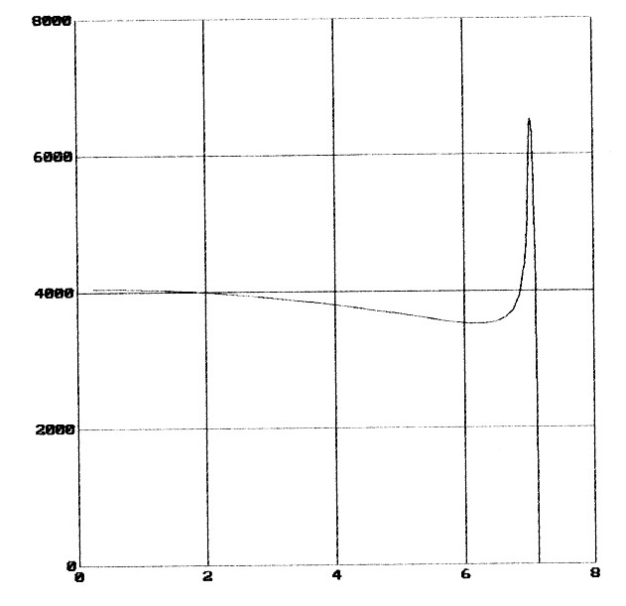
Fig.2 [mm]

Reference
[1] I. ENESCU Aspecte ale mecanicii contactului la rulmenti Editura LUX LIBRIS Brasov 2000
[2] K.L.JOHNSON Contact mechanics CAMBRIDGE UNIVERSITY PRESS Cambridge 1985
[3] I.ROGOZEA, R.DESZO Proiectarea asistata de calculator a contactelor hertziene utilizand metoda semispatiului. Sesiunea de comunicari stiintifice a Academiei Aviatiei si Apararii Antiaeriene “Henri Coanda” Brasov 1988.

