1st International Conference
″Computational Mechanics and Virtual Engineering ″
COMEC 2005
20 – 22 October 2005, Brasov, Romania

STRUCTURAL MODELING BY MBS METHOD APPLIED TO LINKAGES USED TO FLAPS AIRCRAFT CONTROL
Marius GHITESCU , Ion VISA,
Department of Product Design and Robotics
TRANSILVANIA University of Brasov Bv. Eroilor 29, Brasov Romania Email ion322@go.ro
Department of Product Design and Robotics
TRANSILVANIA University of Brasov Bv. Eroilor 29, Brasov Romania Email visaion@unitbv.ro

Abstract: The aim of the paper is structural modelling of linkages used in airplane flaps control, on bases of the Multibody System method (MBS). In virtual prototyping of the aircraft , these linkages have to be modeled by a minimum number of bodies (MBS min). In the paper an appropiate algorithm is descriebed and also applied for six concrete mechanical systems. This will be the bases for kinematic and dynamic modelling of these subsystems as parts of the whole product (airplane).
Keywords: mechanical systems, multibody systems, structural modeling, kinematic analysis, aircraft, Flaps

- INTRODUCTION
The aircraft control motion (roll,pitch,yaw) during the flying by appropiate systems is made. The name and location of these systems are given in figure 1.a -for a large aircraft and in figure1.b- for a small airplane [3].Their actioning is made from the pilot usually by intermediate of mechanical transmissions (linkages, cams, etc).
In design process of an aircraft (very complex product)one of the main step is virtual prototyping, whose aim is analysis and dynamic behavior optimization by using software. That means an unitary modelling of all the subsystems of the aircraft.
In virtual prototyping of the aircraft, mechanical syatems are considered as Multibody Systems (MBS). They have to be modeled as MBS with minimum number of bodies (MBS min) to favorise obtaining real time simulation of the whole product (aircraft).
The aim of this paper is structural modelling of linkages used for actioning of flaps , as multibody systems with minimum number of bodies (MBSmin). By using an appropiate algorithm the analysis is applied for six different types of linkages. On bases of MBS min, kinematic and dynamic models could be obtained.

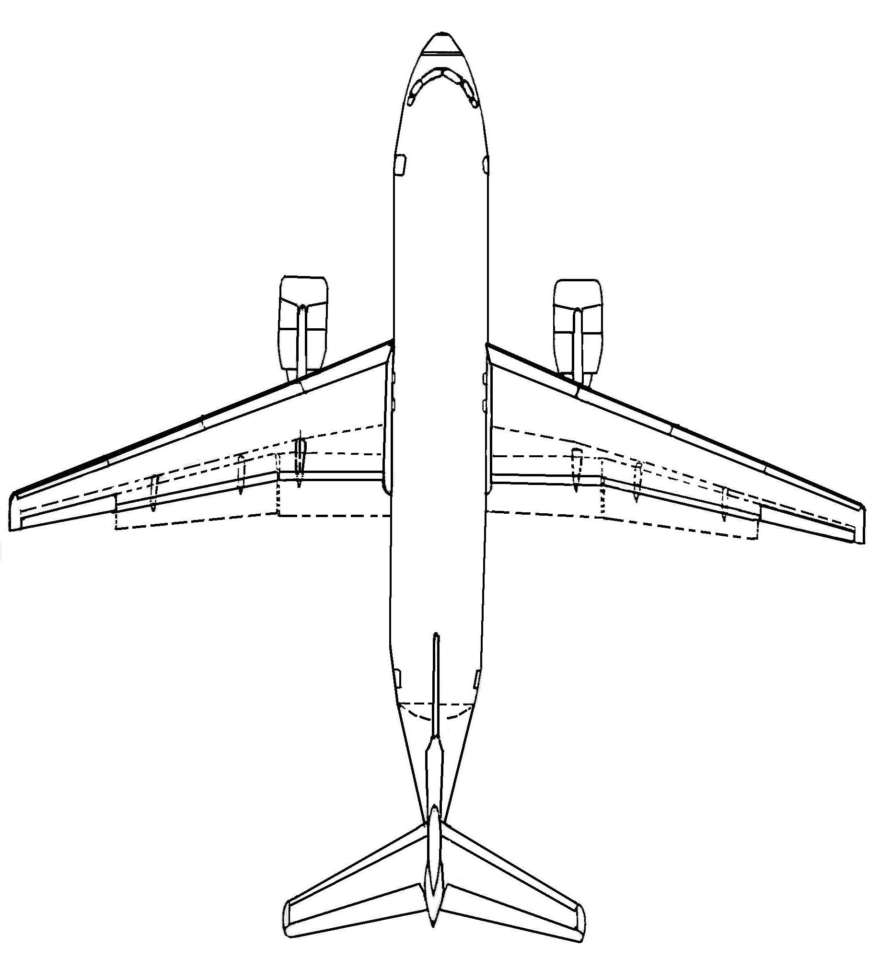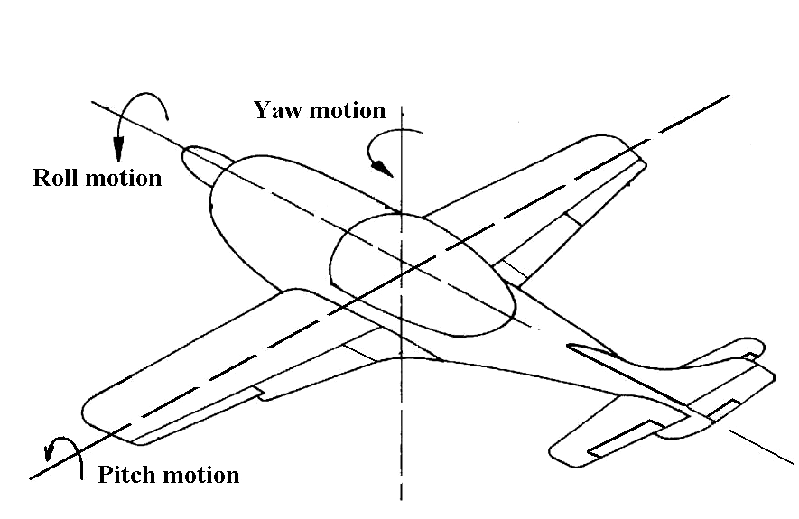
Inboard flap

Slats
Outboard flap
Aileron
Wing
Flap
Aileron
Rudder
Elevator
Tab
Elevator
Rudder
Fig 1

a.
b.

2. MBSmin METHOD

According to MBS theory , a mechanical system is considered as a collection of bodies linked between them by geometrical and driving constraints[1,5].
The body is an entity which in the dynamic model will have mass and moment of inertia, and also could take over the external forces.
In a concret mechanical system , a body could be fixed or moobile, input/output body, body with two or more connections.
In a linkage having “n” elements number of bodies n_{b} is
(1)
n_{b} n
Generally
(2)
n_{b min} n_{b} n

n_{b min} representing the minimum number of bodies for modeling a concrete linkage.
The motion of the mobile bodies is descriebed in a space whose number of dimension is S . Of course S=3 for planar systems and S=6 for the systems in three dimensional space.
The geometrical constraint imposes restrictions in bodies relative motion Number of restriction is
r =1and r = 2 in the case of planar systems (S =3), respectiv r = 1…5 in the case of three dimensional systems (S = 6)
The restrictions are imposed by joints or composite joint [1,5]. In planar systems they are:
rotation R (r =2), translation T (r =2), rotation-rotation RR (r =1), rotation –translation RT (r =1)
curve –curve CC (r = 1) [1,4,7].
Driving constraints corespond to the mobility M of the system Of course M 1 .
Between number of bodies n_{b} , number of geometrical constraints (Σr) in a concrete space S , and mobility M
there is the relation
(3)
M = S (n_{b} - 1) – Σ r

The algorithm for MBS modelling with minimum number of bodies has the following steps:
- Identifying the bodies , in order:
- fixed body,
- input body (bodies),
- output body (bodies),
- bodies with more than two connection,
- bodies with applied forces,
- other bodies (if necessary).
- Identifying geometrical constraints:
- type ,
- location,
- number of restriction.
c. The figure M and interpretation
The algorithm is applied in structural analysis of the following linkages.

- STRUCTURAL ANALYSIS OF CONCRETE LINKAGES

In the paper , six linkages used for flaps control are analized. Linkages from fig 2,3,4,6 are used for trailling edge flaps control and linkages from fig 5,7 are used for leading edge flaps control.
The bases of these linkages is wing structure , that represent for the linkages – fixed body. The output body is the flaps. The input motion is generated by pilot from control lever by intermediate of mechanical / hydraulic actuators.
The linkage [2] from fig 2 is modeled as MBS min having 5 bodies, four geometrical constraints type R and three geometrical constraints type RR. The input body is body 2 and the output body is the flap3. It has mobility
M =1.
The linkage [10] from fig 3 has n_{b} = 4 , three geometrical constraints typeR and one RR The mobility is M = 2

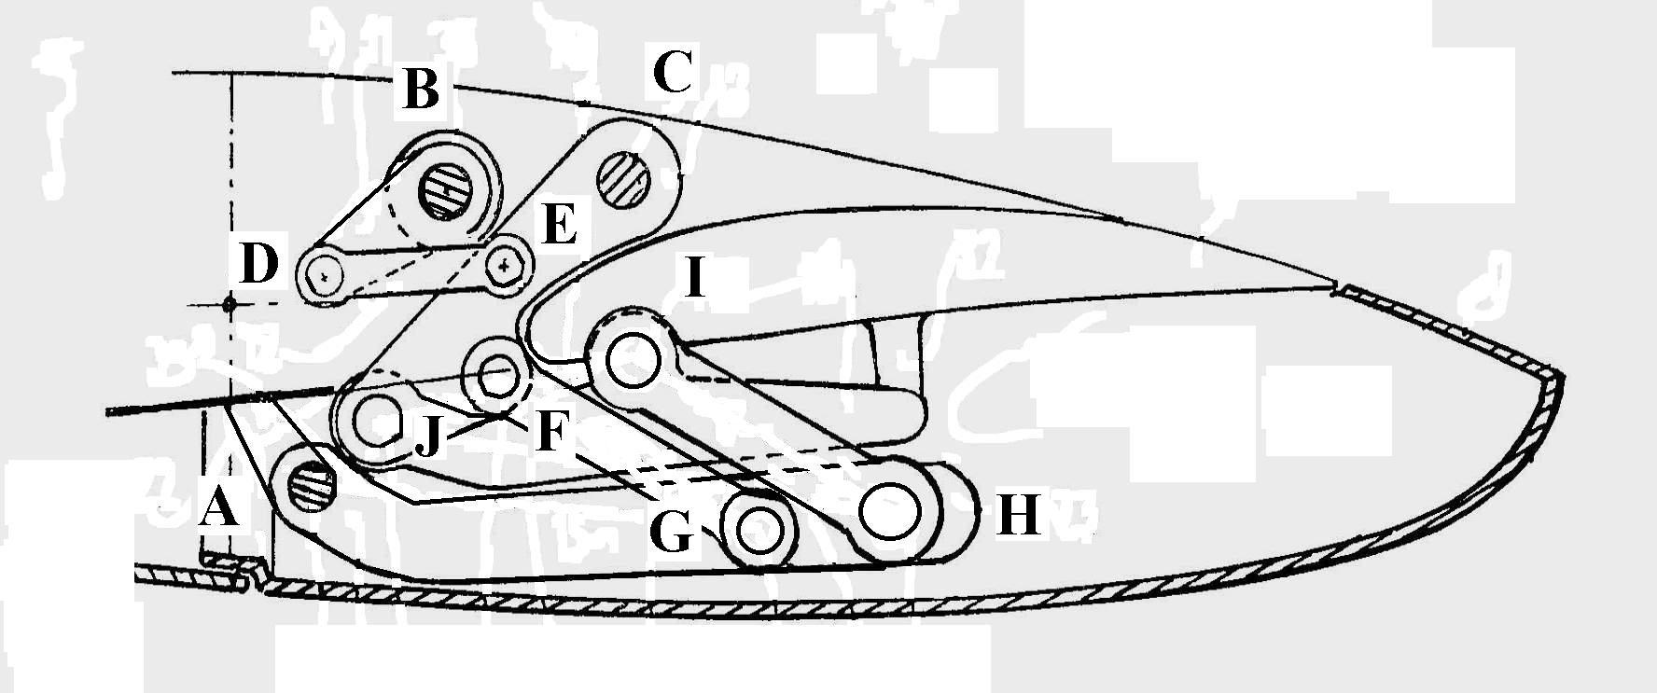
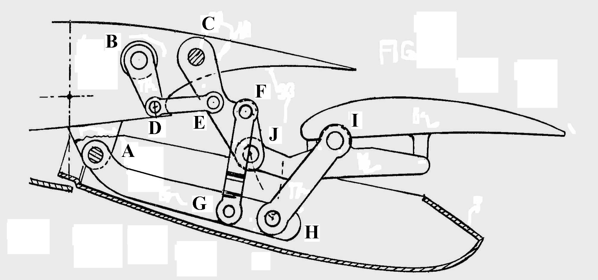
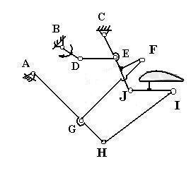
2
3
5
Wing
Flap
M=3(5 –1) – 11 =1
Σr=11
n_{b}=5
(4)
1
4
Fig 2

Table1: flaps control (fig 2)
Body i  Body j | gc | Location | Number of  constraints
1-2 | R | B | 2
1-3 | - | - | -
1-4 | R | A | 2
1-5 | R | C | 2
2-3 | - | - | -
2-4 | - | - | -
2-5 | RR | DE | 1
3-4 | RR | HI | 1
3-5 | R | J | 2
4-5 | RR | GF | 1
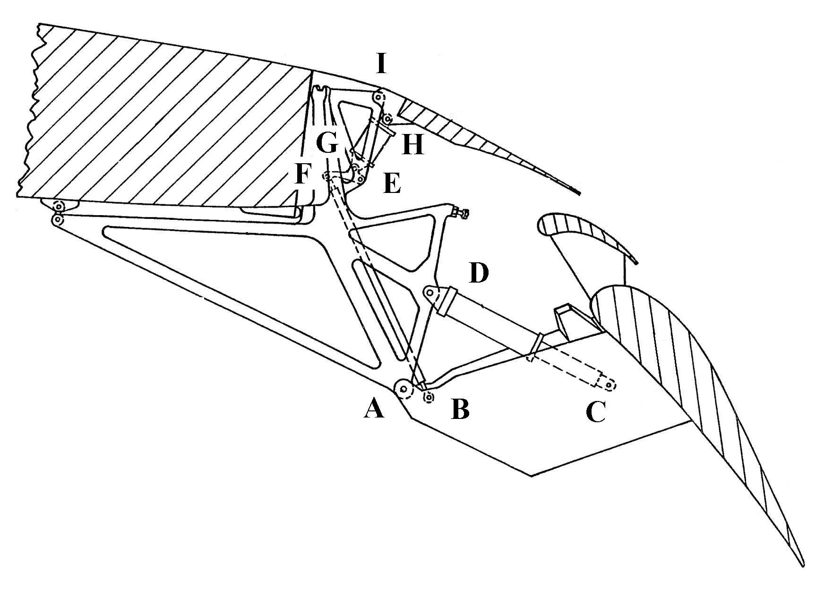
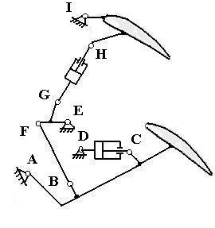
Flap
3
4
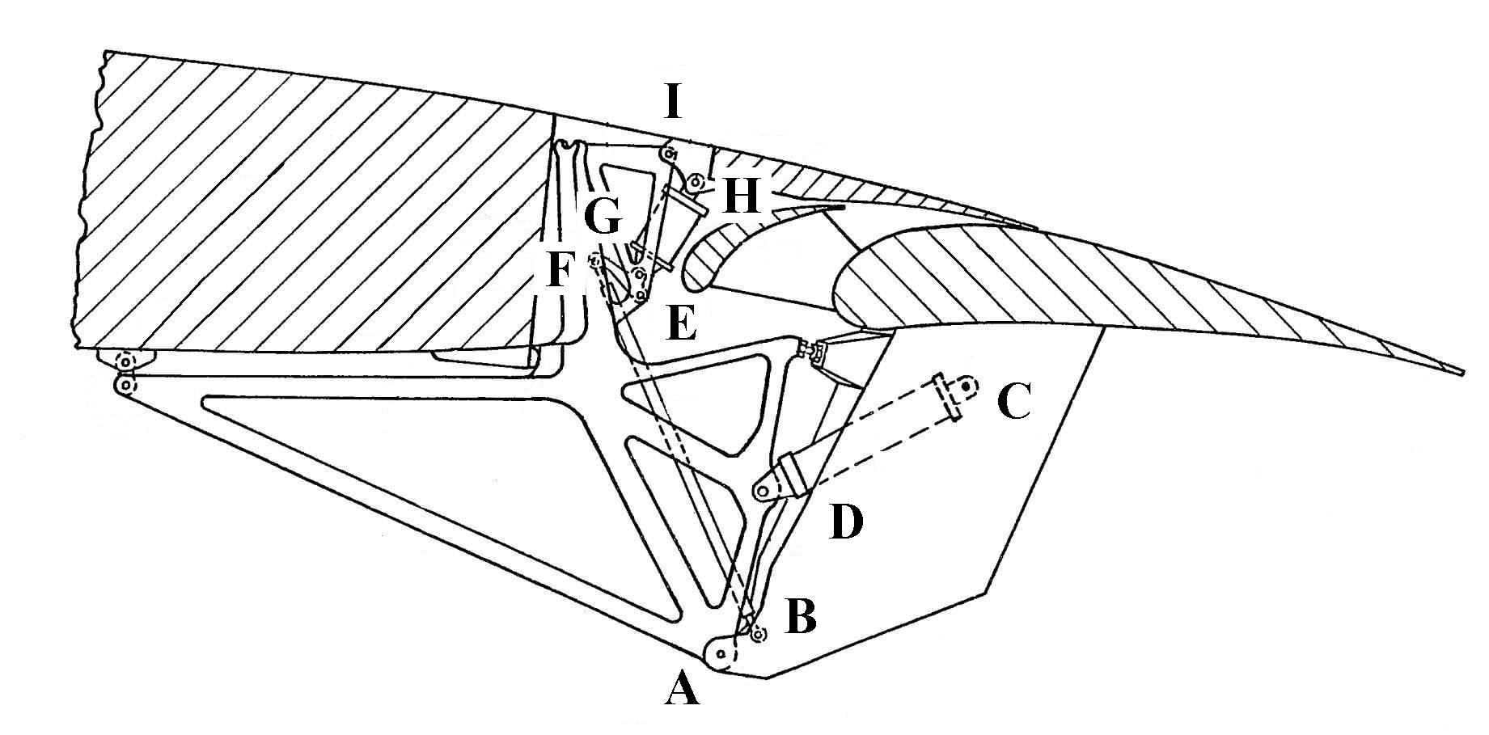
M=3(4 – 1) – 7=2
n_{b}=4
Σr = 7
(5)
Fig 3
Wing
Hydraulic actuator
1=0
2

Table 2: flaps control (fig 3)
Body i  Body j | gc | Location | Number of  constraints
1-2 | R | A | 2
1-3 | R | I | 2
1-4 | R | E | 2
2-3 | - | - | -
2-4 | RR | BF | 1
3-4 | - | - | -

In fig 4 the linkage [11] is modeled by n_{b} = 6 , six geometrical constraints type R and two of type RR
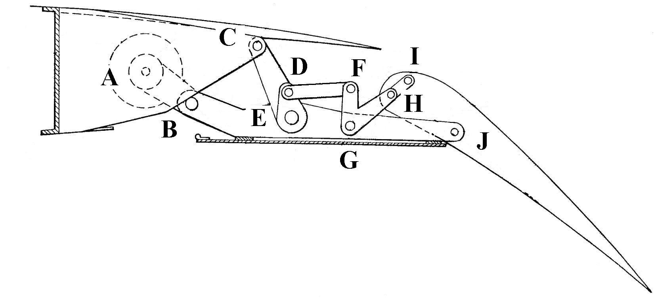
It has the mobility M = 1
Flap
3
5
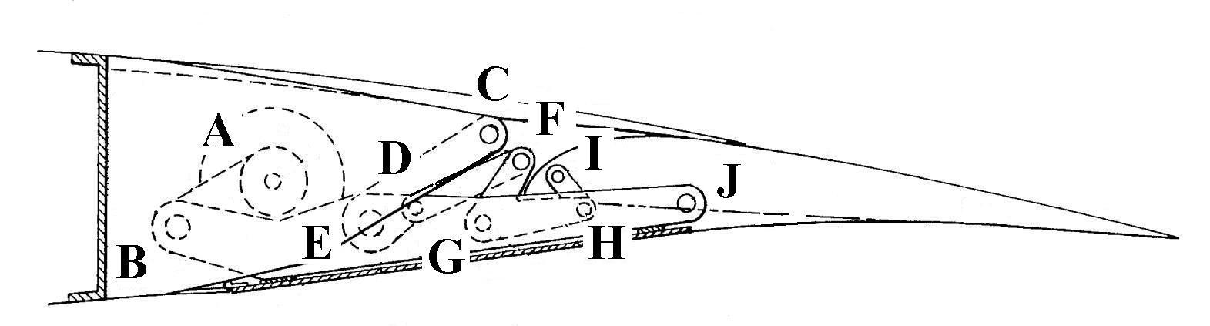
Table 3: flaps control (fig 4)
Fig 4
Wing
1
2
4
6
Body i  Body j | gc | Location | Number of  constraints
1-2 | R | A | 2
1-3 | - | - | -
1-4 | - | - | -
1-5 | R | C | 2
1-6 | - | - | -
2-3 | - | - | -
2-4 | R | B | 2
2-5 | - | - | -
2-6 | - | - | -
3-4 | R | J | 2
3-5 | - | - | -
3-6 | RR | HI | 1
4-5 | R | E | 2
4-6 | R | G | 2
5-6 | RR | DF | 1
M=3(6 – 1) – 14 =1
Σ r =14
n_{b}=6
(6)

The linkage [12] from fig 5 have n_{b} = 5 , four geometrical constraints type R, three geometrical constraints type RR
n_{b} = 5 and mobility M = 1
The linkage [13] from fig 6 has n_{b} = 5, four geometrical constraints type R , two type RR and one of type RT The mobility is M =1

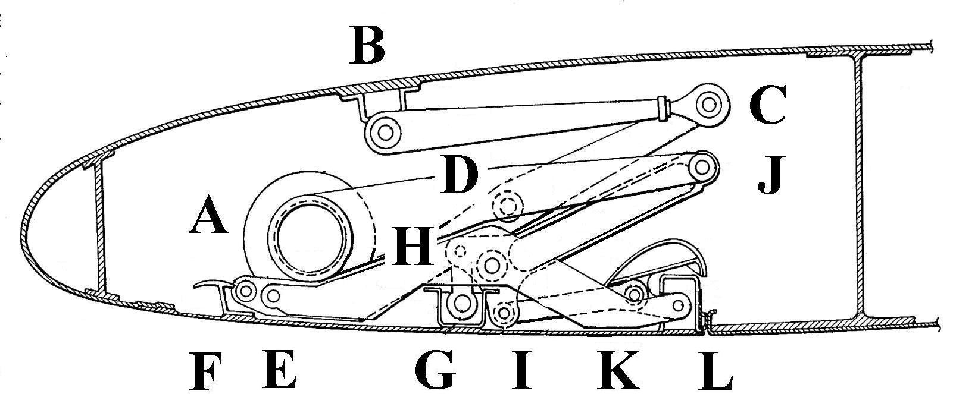
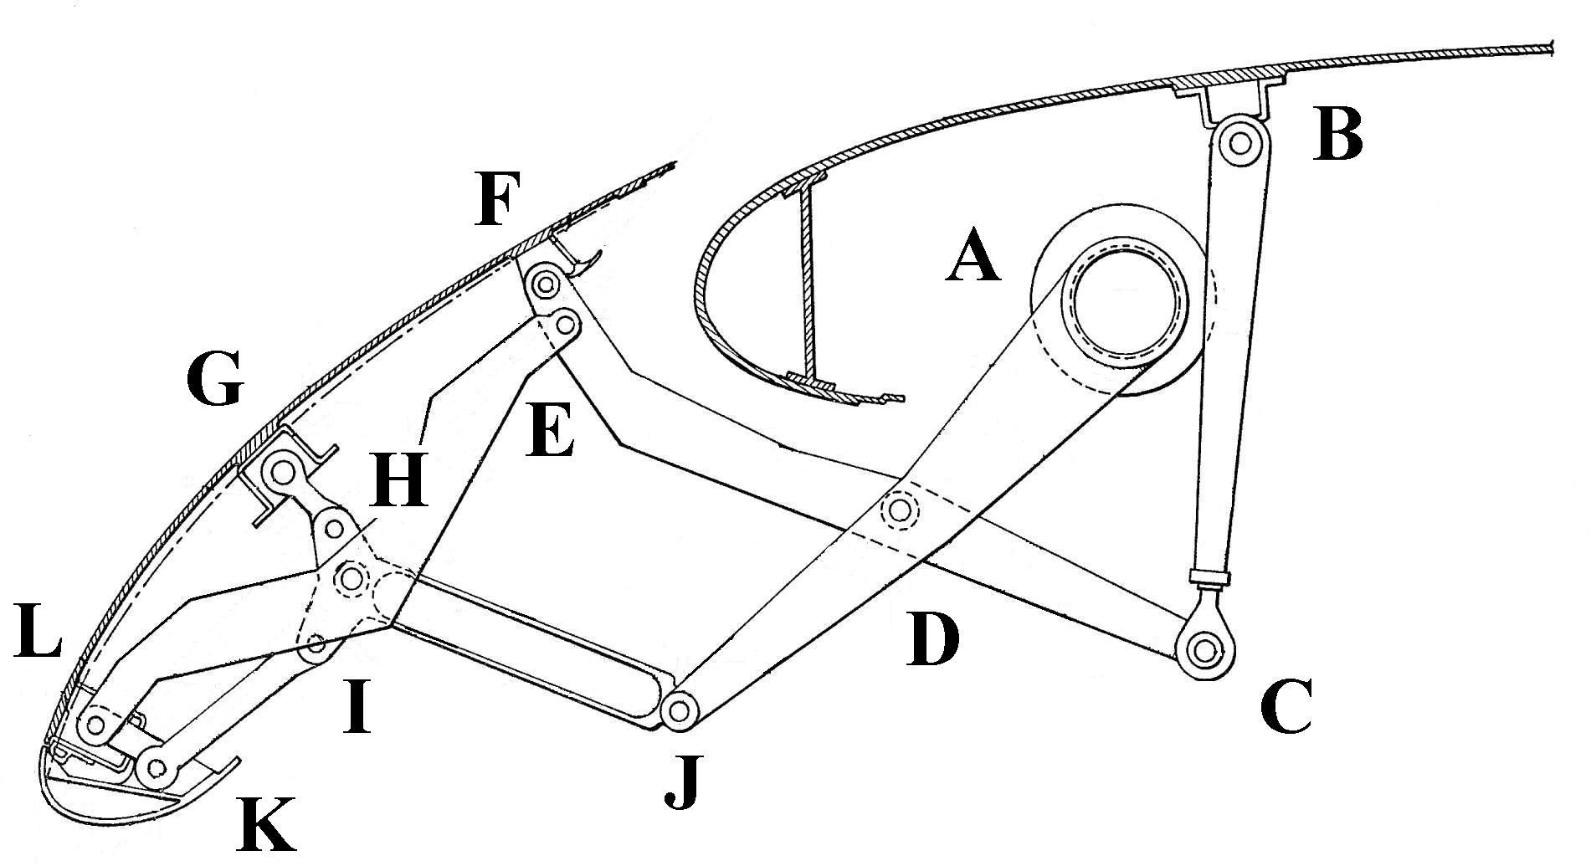
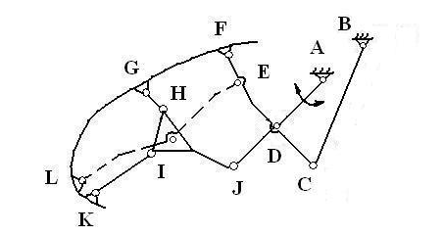
Table 4: slats control (fig5)
Fig 5
Slat
Wing
3
5
2
4
1
Body i  Body j | gc | Location | Number of  constraints
1-2 | R | A | 2
1-3 | - | - | -
1-4 | RR | BC | 1
1-5 | - | - | -
2-3 | - | - | -
2-4 | R | D | 2
2-5 | R | J | 2
3-4 | R | F | 2
3-5 | RR+RR | GH,IK | 1+1
4-5  M=3(5 – 1) – 11=1  Σr=11  n_{b}=5  (7) | - | - | -
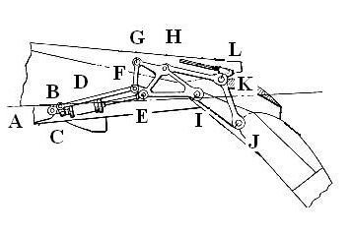
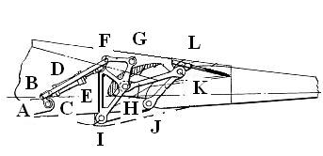
4

1
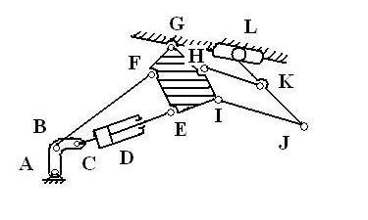
Flap
2
3
5
Wing

Fig 6

Table 5: flap control (fig 6)
Body i  Body j | gc | Location | Number of  constraints
1-2 | R | A | 2
1-3 | R | G | 2
1-4 | - | - | -
1-5 | RT | L | 1
2-3 | RR | BF | 1
2-4 | - | - | -
2-5 | - | - | -
3-4 | R | I | 2
3-5 | RR | HK | 1
4-5 | R | J | 2
M=3(5 – 1) – 11 =1
n_{b}=5
Σr=11
(8)

2
4
1
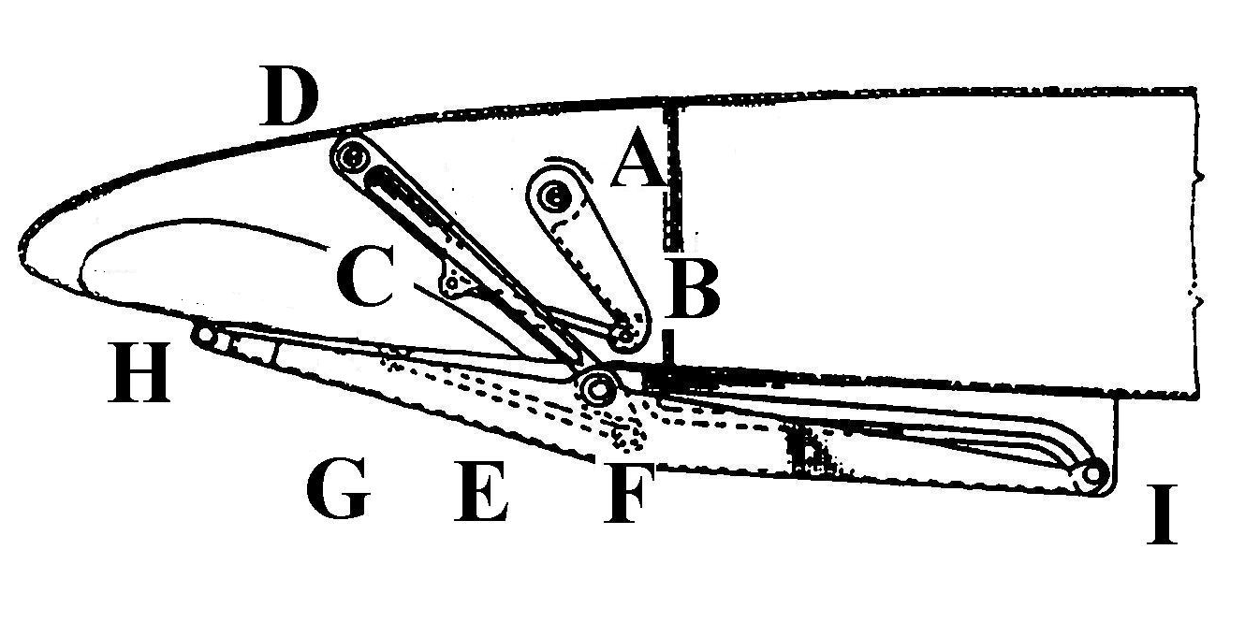
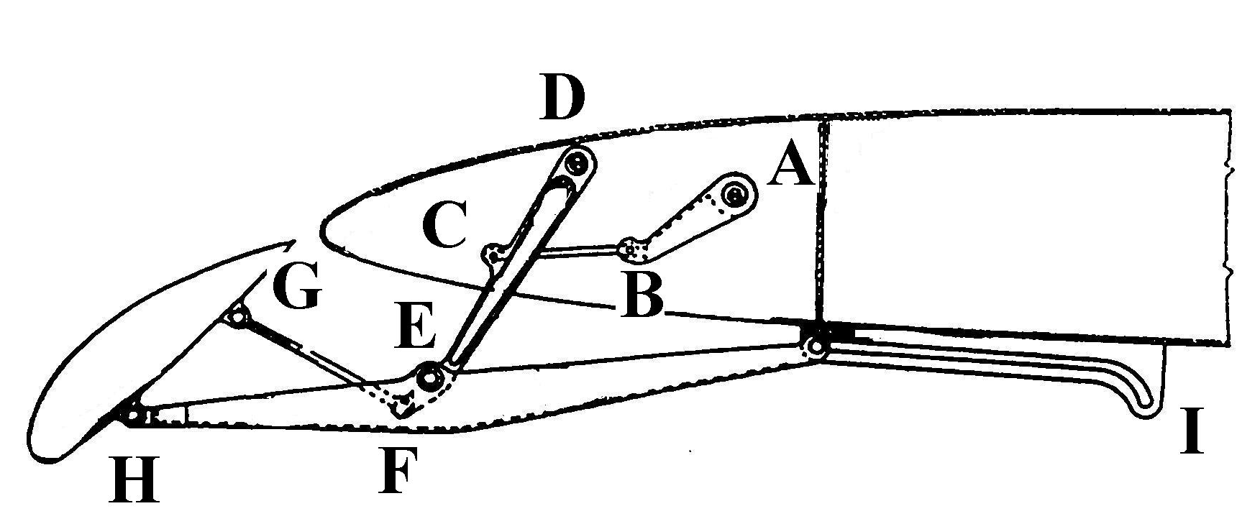

3

5
Wing
Slat
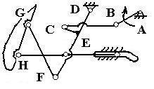

Fig 7

Table 6: slats control (fig 7)
Body i  Body j | gc | Location | Number of  constraints
1-2 | R | A | 2
1-3 | - | - | -
1-4 | R | D | 2
1-5 | RT | I | 1
2-3 | - | - | -
2-4 | RR | BC | 1
2-5 | - | - | -
3-4 | RR | GF | 1
3-5 | R | H | 2
4-5 | R | E | 2

M=3(5 – 1) – 11=1
n_{b}=5
Σr=11
(9)

The linkage from fig 7 have n_{b} = 5 , four geometrical constraints type R, two geometrical constraints
type RR One typeRT and mobility M = 1

REFERENCES
- Shabana, A., Dynamics Of Multibody Systems, A Wiley Interscience Publication, 1989
- Frans Willem de Haan., Cornelis Adrianus.,Aircraft fitted with wing trailing edge flaps actuated by six-bar mechanisms, In: UK Patent Aplication GB 2079688 A, 1982
- Lawrence,Y,Lam., Michael,Lam.,Aileron For Fixed Wing Aircraft, In: United States Patent US6554229B1,2003
- Visa,I., Alexandru,P., Alexandru,C.,Talaba,D., Proiectarea functionala a mecanismelor ,Metode clasice si moderne, Editura Lux Libris ,Brasov 1998
- Haug, J.E., Computer Aided Kinematics and Dynamics of Mechanical Systems , Allyn and Bacon,U.S.A., 1989
- Visa,I., Antonya,Cs.,Structural synthesis of planar linkages as multibody systems, Proceedings of the Eighth IFToMM International Symposium on Theory of Machines and Mechanisms Bucharest,Romania Syrom,2001
- Visa,I.,Mechanical Systems Modeling as Multibody Systems in Product Design, Brasov,Romania,PRASIC 2002
- Klose, A, J., Airplane Aileron System, In: United States Patent US2369832 , 1945
- Stephenson, M, F., Wash, Issaquah., Wing Flap Mechanism, In: United States Patent US4605187, 1986
- Brine, Gerald, T. Flap System For Short Takeoff and Landing Aircraft , United States Patent US4784355,1988
- Lee, Norman. Aircraft Flap System, United States Patent US3785594 , 1972
- Wang, Timothy., Variable camber leading edge flap, United States Patent US4189120 , 1980
- Westburg,P.W.,Aircraft flap supporting and operating mechanism United States Patent US3013748

