1st International Conference
″Computational Mechanics and Virtual Engineering ″
COMEC 2005
20 – 22 October 2005, Brasov, Romania

RESEARCH REGARDING SPECIFIC ISSUES OF PRESSURE MICROSENSORS CONCEPTUAL DESIGN

Lache Simona
¹ University Transilvania of Brasov, ROMANIA, slache@unitbv.ro

Abstract: Being a component of what we call today microsystems, or MEMS, pressure microsensors have specific features regarding design and manufacturing, taking into account the MST considerations. Due to the relatively high cost of prototypes, it is strongly recommended to use analytic models for simulation. This paper presents some aspects regarding design principles and results of the finite element modelling of a pressure microsensor. The analysis determines the stress distribution along the membrane due to different pressure loads. These results would allow the precise positioning of piezoresistors on the pressure sensor..
Keywords: microsystem analysis, analytic models, simulation, pressure microsensor

1. INTRODUCTION

Microsystems domain, known in the literature also as MEMS (Micro-Electro-Mechanical Systems) has been internationally acknowledged only two decades ago, even if it is based on preoccupation regarding sensors and actuators miniaturization that has been started more then forty years ago. As a result of the rapid progress microelectronics has lately achieved, the domain has been developed, nowadays it finds several applications in many fields: medicine, biology, chemistry and, the last but not least, automotive industry. Today we speak about Microsystems or MEMS, which are integrated sensors, actuators and electronic parts for signal acquisition and processing. Due to their simple construction and large applications, the mechanical sensors have an important role in microsystem technology (MST). The first developed and used in industry were the pressure microsensors since they succeeded to meet the full set of requirements: to be cheep, to have good resolution, precision, linearity and stability. Nowadays a large range of silicon based sensors are used, being possible the integration with electronics for signal processing on a single chip.
Since they have specific features (dimensions in the millimeter range and below, forces other then gravity dominate due to the scaling effects, new materials involved - with different mechanical characteristics) the whole design and manufacturing process differs from the one we are acquainted with from the macroworld. There are specific design techniques and microfabrication methods developed in order to realize microsystems able to respond to complex functions (mechanical, electronic and control functions).

2. SPECIFIC FEATURES IN MICROSYSTEMS DESIGN

Microsystems design requires some different description and detail levels: in the first place, the documentation regarding the microsystem specific features and needs has to be achieved, together with the assessment of different microfabrication possibilities (1), (2). If the designed device will become a commercial product, the calculation of the fabrication cost is needed, as well. Secondly, the following steps have to be performed for each proposed version of the designed device: the system division in components, materials choice, operations sequence setting-up for each component, assembly methods set-up and product compact packaging.
It is emphasize that, due to the prototypes high cost, the analytical model development – for simulations – is strongly recommended. Thus the research and development cost is significantly reduced. Microsystems modeling and analysis is a very complex issue. Modeling is present at different levels and uses a large variety of formulations, depending on the level. Four design levels are identified: system level, device or component level, physical level and process level. Among these levels there is a bilateral information exchange.
On the top there is the system level, described by the bloc diagrams and the distributed systems models, each of them leading to ordinary differential equations for system dynamic behavior description. The state-space formulation us usually used, the equations system being transformed in first order coupled differential equations (state-space equations) (3).
System
Device
Physical
Process
Simulation
Verifying
Inputs in the
design process
Figure 1: Design levels in microsystems modelling and simulation
On the other extremity it is the process level, which includes the manufacturing operations sequence and the photo masks fabrication techniques. At this level the numerical modeling is sophisticated, that is the reason why several commercial CAD tools have been developed, named as ‘CAD Technologies’ or simply ‘TCAD’. For MEMS designers the TCAD tools importance consists mainly in the possibility of determining in advance the microsystem geometry in terms of the mask it will be used and in terms of the manufacturing operations sequence that can be achieved. In other words, TCAD techniques allow the designer to apply the principle of ‘concurrent engineering’ in this field (4). As it has been stated in the previous paragraph, the material properties may depend on the operations sequence, which means the designer has to thoroughly know the product manufacturing technology, in order to set-up the correct material properties in the modeling stage.
The physical level deals with the real microsystem behavior in the 3D space. The governing equations are mostly differential partial derivative equations. That is why, at this level, the simulation is done by numerical methods, for example the finite element method, the boundary element method, the finite difference method, etc. Although the microsystem behavior representation at physical level by partial derivative equations is useful, it becomes too complicated when it refers to the overall system (including the components and the links between them). This is the reason why the next level has been introduced, which is the device or component level. At this stage the reduced order models are developed: they preserve the main features regarding the dynamic behavior at physical level of each microsystem component, being, at the same time, compatible with the system level description.
(111)
(100) Surface Orientation
Figure 2: Pressure sensor obtained by bulk micromachining of silicon (100)
As a conclusion regarding the specific features of microsystem design, even if it is fully acknowledged the role of experiment in confirming the design assumptions, due to the prototypes high cost, one can fully make use of the advantages of numerical modeling and simulation before developing the experimental model.

3. CONSIDERATIONS REGARDING THE PRESSURE SENSOR DESIGN

The operating principle of a pressure sensor is simple and well known. It consists of a silicon membrane developed on a substrate (Figure 2) by bulk micromachining and using the selective chemical etching techniques [1], [2].
When a pressure is applied, the membrane curves, the curvature measured being proportional to the pressure value. Figure 3 presents the scheme of a resistive pressure sensor, having the piezoresistors integrated into the membrane; they change their resistance proportional to the applied pressure. The resistance change, measured with a Wheatstone bridge, shows how much the membrane has been curvated.
Membrane
Figure 3: Operating scheme of a resistive pressure sensor
Piezoresistors
Pressure
The design procedure, based on the literature [3], is described in Figure 4. The desired sensor properties are recorded inside the design specifications. The mechanical structure is then set up, considering the limitations of the manufacturing process. The geometrical model is developed which represents, together with the material properties, the solid model for finite element analysis. The analysis results in stress distribution along the membrane due to different pressure loads. These results would allow the precise positioning of piezoresistors on the pressure sensor. Thus it yields the optimal geometry for the maximum sensor sensitivity. Further, the finite element analysis results are used for manufacturing process optimisation and for determining the electronic components best placement on the substrate (considering an integrated MEMS is developed).
Electronic Technology
(process data)
MEMS specifications
Micromechanics
(process data)
Electrical structure
(process simulation)
Components design
Mechanical structure
(process simulation)
Geometric model of the structure
Structure modeling and simulation by FEM
Material properties
Sensor simulation
Requirements fulfilled?
Fabrication, packaging and testing
NO
DA
Figure 4: Design procedure for a piezoresistive pressure sensor [3]
The analysis is performed both in static and dynamic regime, the later being useful for resonance frequencies calculation and components behaviour investigation at different frequencies.
Whatever the design analysis is performed, one has to bare in mind that the dimensional reduction determines a considerable change in the requirements regarding the material properties, together with an increase of the surface forces with respect to the volume forces. This leads to increased friction and wear. Unlike the macrosystems, where the inertial effects are prevalent, for structures with dimensions of millimeters or below the surface phenomena change their dynamic behavior. In this sense, many problems may occur due to the Van der Waals forces, the structure mechanical strength, the surface state and the micro-friction elements.

4 RESULTS OF FINITE ELEMENT ANALYSIS

The finite element model consists of the free part of the membrane, subjected to the pressure. The finite element code used for analysis is ANSYS. The microstructure has the following dimensions: 7.5 mm (length) × 5 mm (width) × 0.1 mm (height); the active part of the membrane is along the length of 2.5 mm. The material properties for silicon, necessary for modelling, are: Young modulus, Poisson ratio and density. The structure is modelled with volumes and discretized in solid finite elements. The constraints are considered along the two lateral areas that simulate the parts of the membrane fixed on the substrate. The analysis is performed for a pressure range from 2kPa to 40Mpa. Figure 5 presents the deformed structure under a pressure of 40 Mpa. Figures 6 and 7 present the results of structural strain and stress, respectively.
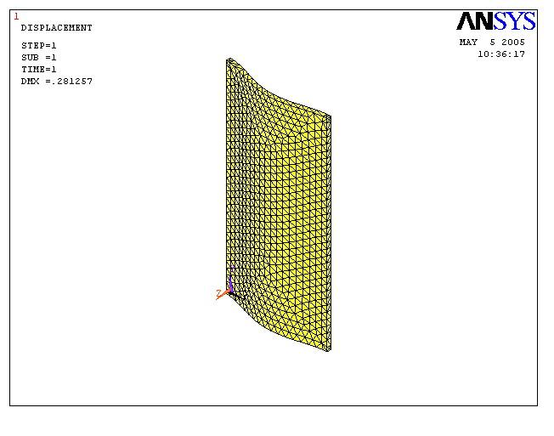
Figure 5: The deformed shape of the membrane under the pressure load
5. CONCLUSION

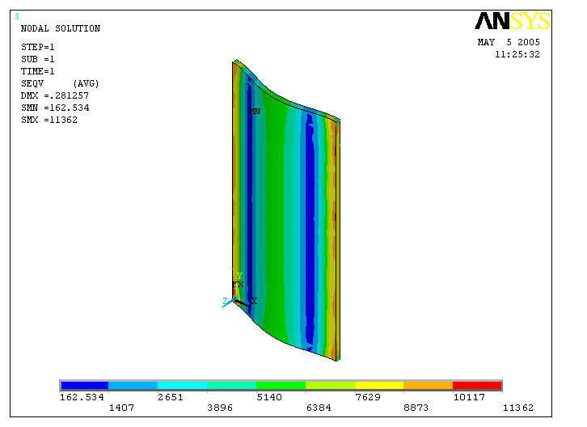
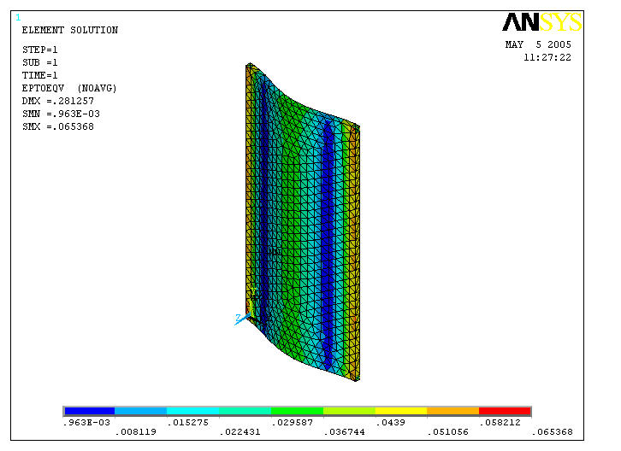
Pressure microsensors play an important role in microsystem technology, related to several advantages such as being cheep, having good resolution, precision, linearity and stability. In order to obtain reliable products, able to be integrated with electronic and signal processing components on a single chip, it is important to pay attention to the design of micromechanical part. The paper describes the overall design procedure and discusses the results obtained by performing finite element analysis and simulation of the sensor membrane. These results would allow the precise positioning of piezoresistors on the pressure sensor. Thus it yields the optimal geometry for the maximum sensor sensitivity. Further, the finite element analysis results are used for manufacturing process optimisation and for determining the electronic components best placement on the substrate.
Figure 7: Stress distribution within the membrane due to pressure load
Figure 6: Strain distribution within the membrane due to pressure load

REFERENCE

- Fatikow, S. Rembold, U.: Tehnologia microsistemelor şi robotică (transl. From English), Ed. Tehnică Bucureşti, 1999.
- Lache, S.: Introducere în Tehnologia microsistemelor, Ed. Universităţii Transilvania din Braşov, 2005.
- Poppinger, M.: Entwurf piezoresistiver Drucksensoren, Mikroelektronik, 1991(5), Fachbeilage Mikroperipherik.

