1st International Conference
″Computational Mechanics and Virtual Engineering ″
COMEC 2005
20 – 22 October 2005, Brasov, Romania

DRILLING TORQUE - A DIAGNOSIS CRITERION

OF THE DRILL WEAR

Mariana Deliu ¹ , Gheorghe Deliu ²
Transilvania University , Braşov, ROMANIA, e-mail: deliu.m@unitbv.ro
Transilvania University , Braşov, ROMANIA, e-mail: deliumec@unitbv.ro

Abstract: Drill life estimation is usually made on the basis of the maximum admissible wear which, unfortunately, is given in a too large range in the literature. Taking into account that the durability distribution depends in a great measure on the adopted value for the admissible wear, in the paper the critical value for drilling torque is proposed as an objective criterion for drill wear limit. In this sense, a relationship between the flank wear and the drilling torque is established and a definition of the critical value of this torque is given. The proposed method is proved by tests made on a batch of HSS drills.

Keywords: tools, flank wear, drilling torque

- INTRODUCTION
The flank wear of a high speed steel tool (HSS) cutting edges is generally the element which imposes the stop of the cutting process, and tool dressing . Tool life estimation as well as the estimation of reliability indicators for such tools are based on the processing of tool life data obtained during cutting tests made with tool batches. All the tools are used till the maximum wear is reached. The literature does recommend values for the maximum admissible wear, but in very large ranges, and these ranges are depending on the author. For example, in the Tables 1 and 2 the recommended values for the admissible flank wear of HSS drills are given.

Table 1: Recommended admissible flank wear ( after [4] )
Tool material | Processed material | Wear criterion | Drill diameter [mm] | Admissible wear [mm]
HSS | Steel | Flank wear | ≤ 20  > 20 | 0.3 ..... 0.8  0.8 ..... 1.2
HSS | Cast iron | Flank wear | ≤ 20  > 20 | 0.6 ..... 0.8  0.8 ..... 1.2

Table 2: Recommended admissible flank wear ( after [5] )
Tool material | Processed material | Wear criterion | Admissible wear [mm]
HSS | Steel | Flank wear | - ..... 1.2  0.5 ..... 1.2
HSS | Cast iron | Flank wear | - ..... 1.2  0.5 ..... 1.2

The bibliographic sources made no reference about the used criteria for the setting of recommended wear limits; not even the reasons to choice one or another value in the respective range are given. Therefore, it is hard enough to choose a proper value for the admissible wear.
Because this value does determine both the form of the repartition function of TBF and its dispersion (as well as the values of reliability indicators ) it will be useful to establish some objective criteria to choose the admissible wear.
Such a criterion for the admissible wear of the drills is proposed in the following paper; it will be based on the relation between the drill wear and the both axial force and drilling necessary torque.
Some authors tried, for specific testing conditions, to establish quantitative relations between flank wear and drilling necessary torque, and/or between wear and axial force. So, for the case of cast iron material and HSS drill of 10.32 mm diameter, in [7] are given:
$M_{T} = 0\text{.}\text{125} \text{HB}⋅d^{2}⋅s+0\text{.}\text{289} \text{HB}⋅d^{2}⋅r+0\text{.}\text{0487} \text{HB}⋅d^{2}⋅\text{VB}$ (1)
$F_{A} = 0\text{.}\text{325} \text{HB}⋅d⋅s+0\text{.}\text{1242} \text{HB}⋅d⋅\text{VB}+0\text{.}\text{785} \text{HB}⋅d⋅r+0\text{.}\text{0022} \text{HB}⋅d^{2}$ (2)
where: M_{T} and F_{A} are the torque and the axial force respectively, HB – Brinell hardness of the processed material, r- mean radius of the main cutting edge, d –drill diameter, s – feed rate, VB –mean wear on the main flank.
For the case of cast iron and HSS drills also, in [6] the following relations are given:
$M_{T} = \left(0\text{.}\text{174} +\frac{0\text{.}4⋅\text{VB}}{d}\right) d^{2}⋅s^{0\text{.}7}{\left(\frac{\text{HB}}{\text{190}}\right)}^{0\text{.}8}$ (3)
$F_{A} = \left(\text{700}+\frac{\text{1500}⋅\text{VB}}{d}\right) d⋅s^{0\text{.}7}{\left(\frac{\text{HB}}{\text{190}}\right)}^{0\text{.}8}$ (4)
It is evident that the above presented relations are valid for author’s specific machining conditions, but nevertheless they can give a first information about the importance of the drill flank wear on the drilling torque and on the axial force. Than, maintaining the drill diameter, the processed material and the feed rate, the drilling torque and the axial force are increasing as the flank wear increase. In this way, the drilling torque and the axial force can follow and announce the drill wear, with the condition to keep the material hardness near constant ($± 5\text{\%}$) [ 7].

2. PROPOSED CRITERION FOR SETTING THE LIMIT DRILL WEAR

In order to found an objective value for the admissible drill wear, we were searching for a relationship between the drilling torque value and the drill flank wear.
Since the axial force needed to bore is generated in great proportion ( 50 – 60%) by the action of the drill cross edge, we have to suppose that the value of this force is also affected by the wear of that cross edge. The flank wear of the main edge, which is responsible of the drill failure, does act mainly on the drilling torque than on the axial force.
First of all, we shall make the assumption of a linear dependence between the drilling torque and the flank wear as follows:
$M_{T} = M_{0}+ b⋅\text{VB}$ (1)
where: M₀ - drilling torque of a sharpened tool,
VB – flank wear,
b – constant slope.
In order to obtain the necessary data to put such a relationship, we used a batch of 10 drills, having 10 mm diameter. We have bored with them holes of 30 mm depth in test pieces of OLC 45 material, having 190 HB hardness. A feed rate of 0.2 mm/rev at 710 rev/min and a standard cooling liquid have been used. At equal time intervals the wear and the driving torque were measured for any drill. The testing data show that the axial force is increasing slower than the drilling moment. On the other hand, the greater was the machining time more greater was the dispersion of the flank wear values and the drilling torque values.

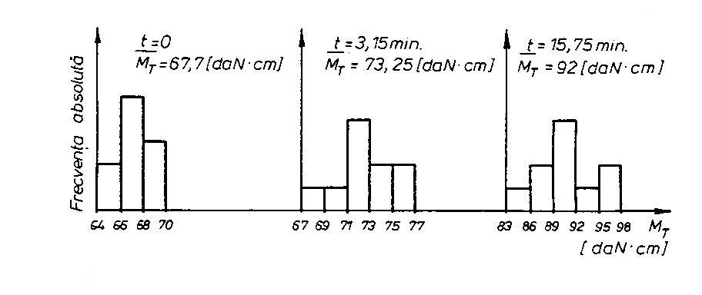
Figure 1: Drilling torque histograms

The drilling torque histograms at different moments during the machining process present a repartition sufficiently close to the normal repartition. Some of these histograms are presented in Fig.1. Consequently, using the mean values of the drilling torque and of the flank wear, we can draw the curves of drilling torque versus time, as well as of wear versus time (Fig.2).

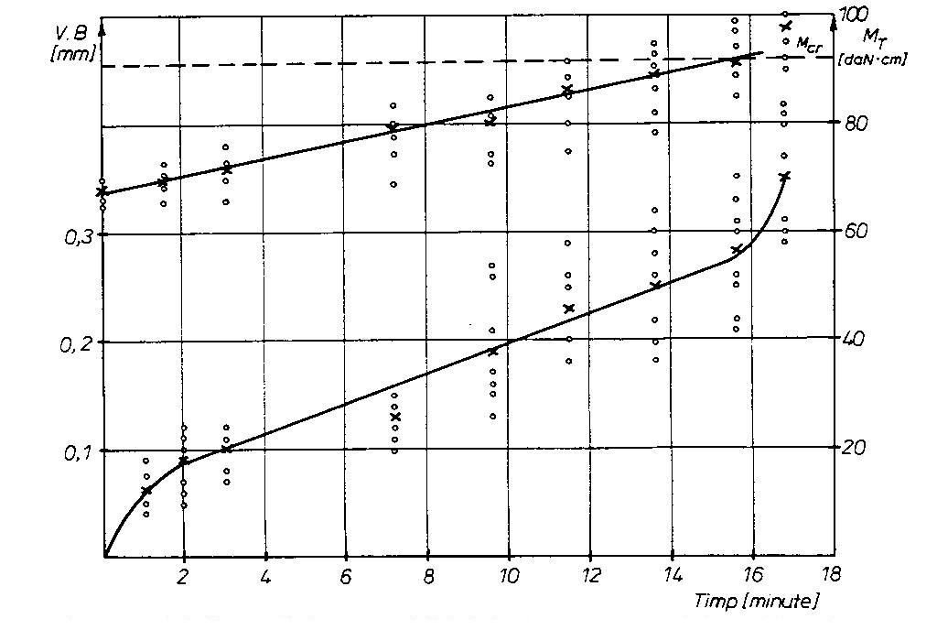
Figure 2: Drilling torque and wear versus time

On the wear curves we can note an inflexion point, which corresponds to the start of so-called “catastrophic wear”; during the machining test this point was marked by the appearance of vibrations. Therefore, it will be justified to stop the machining process at that time, and the mean value of the drilling torque for this point to be considered as a critical value.
As it is evident from Fig.2, for the drills of 10.5 mm diameter, we shall have that critical point at M_{CR} = 92 daN. cm, which will give a ratio between the drilling torques :
$k = \frac{M_{\text{CR}}}{M_{0}} = 1\text{.}\text{35},$
where M₀ = 68.148 daN.cm is the drilling torque for a new sharpened drill.
On the basis of the testing results, we have established also the relation between the drilling moment and the flank wear (Fig.3), which can be expressed by the regression line:

$M_{T} = \text{65}\text{.}\text{45}+\text{89}\text{.}\text{88}⋅\text{VB}$ (2)
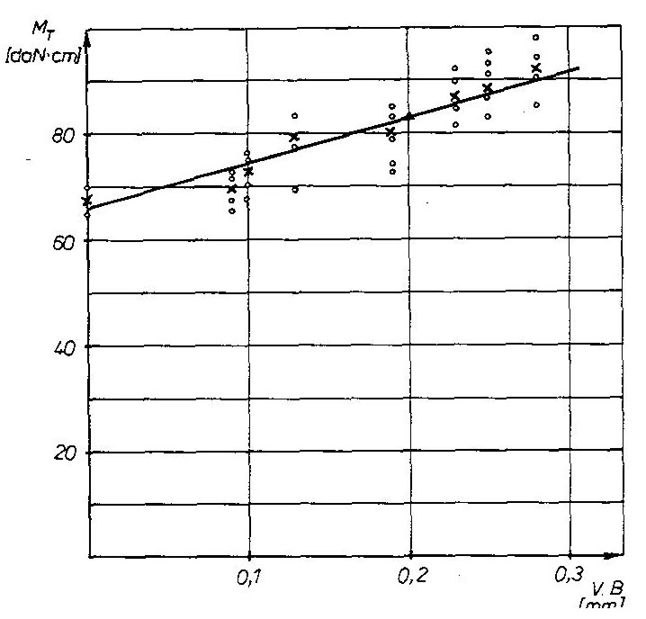
Figure 3: Linear regression of the drilling torque versus wear

After replacing of the critical drilling torque value M_{CR} = 1.35 M₀ in relation (2), we obtain VB_{max} = 0.3 mm. Consequently, it is justified from an energetic point of view to stop the machining process at a 0.3 mm flank wear ( for this drill dimension ), in order to avoid an inefficient machining which will use an energy with 35% greater than that registered at a new tool.
In the same manner, one can determine the critical drilling torque and the admissible wear for any other drill dimension.

REFERENCES

- Deliu M.: Contribuţii teoretice şi experimentale privind fiabilitatea maşinilor-unelte şi sculelor pentru prelucrarea găurilor- teza de doctorat, Universitatea Transilvania din Braşov, 1994.

- Deliu M.: Borer Reliability Estimation Using Alpha-Repartition, Bulletin of the Transilvania University of Brasov, vol.2 (37)- New Series, Series A, 1995, p.135-138, ISSN. 1223-9631.

- Deliu M.: New Requirements for Cutting Tools Quality Standards, International Conference on Economic Engineering and Manufacturing Systems, ICEEMS 2001, Braşov, p. 430-433, ISBN 973-8124-69-7.

- Dumitraş C.,Militaru C.:Aşchierea metalelor şi fiabilitatea sculelor aşchietoare, Bucureşti Editura Tehnică, 1983.

- Vlase A. ş.a. : Regimuri de aşchiere, adaosuri de prelucrare şi norme tehnice de timp, Bucureşti Editura Tehnică, 1983.

- Dorin Al. : Metode indirecte de diagnoză a uzurii sculelor aşchietoare, Construcţia de Maşini Nr.1/1987

- Subramanian K., Cook N.H. : Sensing of Drill Wear and Prediction of Drill Life, Journal of Engineering for Industry, Trans. ASME, May 1977.

