1st International Conference
″Computational Mechanics and Virtual Engineering ″
COMEC 2005
20 – 22 October 2005, Brasov, Romania

Arc Jet Plasma Simulation

B. Izrar, M. Dudeck
Laboratoire d’Aérothermique, 1C avenue de la Recherche Scientifique, 45071 Orléans cedex, France
Boujema.Izrar@cnrs-orleans.fr

Abstract: The plasma properties inside a D.C. arc-jet operating with argon is analysed by means of a continuum description taking into account non equilibrium ionization processes and dissipative effects. The relaxation of the different physical processes inside the nozzle and the evolution of the Mach number are analysed.

Keywords (TNR 9 pt Bold): Arc-Jet – Argon – nozzle - heating - plasma simulation – fluid equation.

1. Introduction

High velocity arc-jet plasma flows at reduced pressure are currently studied for space applications especially for propulsion of space probes, ground tests of materials used for space thermal protection and simulation of the physical processes which occur around a hypersonic vehicle in a planetary atmosphere. For these three applications, an axisymmetric and stationary plasma flow is heated by a D.C. arc which is sustained between a cathode and a nozzle operating as anode.

However, the design of the arc-jet should be different as a function of the chosen application. The constraints imposed for arc-jet propulsion in space require an anode in tungsten without the possibility of the use of a cooling circuit and the working molecular gas is generally hydrogen, hydrazine or ammoniac. These arc-jets are currently used in space for the orbit transfer mission of geostationary satellites. The interest of an arc-jet for the thermal test of material for space interest can be found in the possibility of producing a high specific enthalpy typically a few MJ/kg due to the low mass flow rate. This level of specific enthalpy is required for tests on C-C and C-SiC materials. The last application concerns the simulation in a ground test facility of the non equilibrium properties of the plasma flow appearing between the shock wave and the surface of a spacecraft during the entry flight in planetary atmospheres. This plasma is characterized by chemical processes involving neutral and ionized atoms and molecules and an excitation of internal modes (vibration, rotation, excitation) associated to radiative emissions. The different processes are strongly depending of the composition of the atmosphere (air for Earth, CO₂-N₂ for Mars and N₂-CH₄ for Titan –satellite of Saturn).

The properties of the arc plasma flow are depending of the operating conditions. The knowledge of the plasma parameters can be determined by a numerical code describing the flow properties inside the region of the arc and inside the divergent part of the nozzle. A modelling is used to describe the physical processes and to dispose of a predictive tool. The used Navier-Stokes description takes into account non equilibrium chemical effects. The axisymmetric (r,z) ARES numerical code from CEA/CESTA (Bordeaux – France) has been previously used for a mixture of N₂-O₂ (entry simulation in Earth atmosphere). We present the application of this numerical code for an argon plasma.

2. EXPERIMENTAL SETUP
A D.C. vortex-stabilized arc [1] operating at low voltage (50–100 V) and low current (50–150 A) delivers typical electric powers of 3–10 kW to the flow mainly in the throat region of the nozzle. The arc is standing between the plane tip of a cathode made of thoriated tungsten or made of zirconium depending on the used gas (depending of the presence of oxygen) and the convergent-throat-divergent nozzle made of copper used as anode. The throat is protected by a small cylinder made of tungsten. The cathode is a water-cooled thoriated or zirconium plane implant with a diameter of 2. The anode is a water-cooled copper nozzle whose throat is a cylindrical insert with a constant diameter of 4 mm and a length of 6 mm.
Figure 1: Plasma generator scheme

3. PLASMA FLOW MODELING

3.1 Balance equations

As a first assumption, the modeling of the internal flow supposes that the regime is continuous till the exhaust of the nozzle. The plasma is described as a chemically reactive gas [4] made up of 3 species moving with the velocity of their center of mass (A_{r}, A_{r}⁺, e⁻) with the assumption of a local electric neutrality because the scale of description will be larger than the Debye length in the bulk and the potential sheath near the walls are not introduced.

Moreover, although the flow in the nozzle presents a large gradient of pressure of magnitude 0.1 atm, a preliminary analysis based on the one dimensional approximation shows that even under this condition, a fluid description is valid in the major part of the nozzle. Indeed the mass flow is of order of 0.2 g.s⁻¹ and the pressure at the inlet of the nozzle is more or less 0.7 atm by reason of head-loss in the circuit. Moreover as the flow is clearly hypersonic at the outlet of the nozzle it must be necessarily supersonic before the divergent ie in the throat owing to the heat supply from the discharge.

On the other hand if the heat produced by the arc is greater than a critical value, the flow becomes subsonic before the divergent. For stagnation temperature of 300K and a power supply of 3 kW the critical temperature is 12700K which is of the expected order. So neglecting friction and applying the one dimensional heated flow results we get the inlet initial conditions

The Knudsen number estimated from these values is Kn ≈ 0.07.

Table 1: Inlet flow conditions
Pressure | Density | Velocity | Specific enthalpy | Temperature
613 hPa | 1.00 kg/m³ | 15 m/s | 156 kJ/kg | 293 K

Applying the formulas of the isentropic one dimensional flow and the method of slabs in the divergent, we get an estimation of the characteristics of the outgoing jets of Table 2.

Table 2: Outlet expected flow conditions
Pressure | Density | Mach number | Specific enthalpy | Temperature
Pa | 0.08 10⁻³ kg/m³ | 4.66 | 1992 kJ/kg | 3820 K

As the Debye wavelength is less than the micrometer, the transport terms expressing the electromagnetic field effects are neglected in the momentum equation. The thermodynamic state of the fluid is characterized by mean of the individual species mass equations and the global energy balance equation takes into account the energy per unit of mass, a total pressure and temperature related by Dalton law and a total heat flux density vector such as:
$\vec{q}=−λ_{c}\left(T\right)∇\text{T+}\sum_{\text{s=}1}^{n_{s}}{h_{s}\vec{J_{s}}}$
including heat conductivity transport and diffusion flux.

We assume a thermal equilibrium for the kinetic processes for all the species. From the mass and heat exchange point of view, the copper boundary is impermeable and isothermal for simulating the cooling of the wall. Gas/wall chemical interactions as dissociation and recombination [2-3] are taken into account by mean of a catalysis equation.

3.2 Arc heating

The profile of the nozzle is the following: 1) the throat 5mm long with constant diameter, 2) diverging part 54mm long with semi-angle 29°. The formation of plasma takes place due to electrical discharge in the throat which results in the high energy inducing into the system in the throat. Due to the heating the transition temperature rises.

The mentioned results were obtained for the case then the strong heating due to electrical discharge takes place in the throat. In reality, the copper walls do not support such a high temperature and the cooling is applied in experimental researches. The simulations are made for the nozzle with cooled walls. The temperature on the walls is fixed equal to 500K. However, the arc energy transfer to the flow is deduced from the electric input power taking into account the cooling energy by meaning a global efficiency experimentally determined.

The ignition of the plasma is especially investigated and related to the characteristics of the resulting jet. Two methods are compared in the modeling of the Joule heating of the plasma by a sustained arc between the tip of a cathode and an axi symmetric nozzle. The first one consists in a constant global electrical power density of the arc-jet uniformly distributed in the first cells of the throats. In the second approach the source term is expressed from the electrical conductivity and the local electrical field (mean value estimated from the electric potential). The electrical conductivity is fitted by means of a three parameter Arrhenius-like law.

4. NUMERICAL RESULTS

The presented results are obtained with a structured power law axi-symmetric grid. Convective terms are processed by mean of Harten-Yee TVD scheme while viscous terms are estimated with a simple second order centered finite difference scheme.

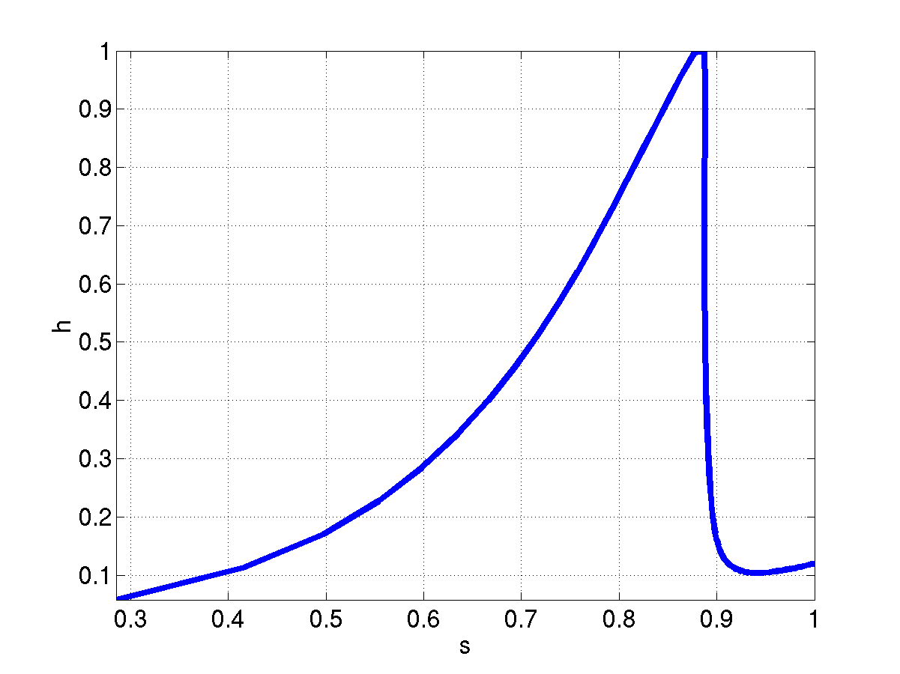 | 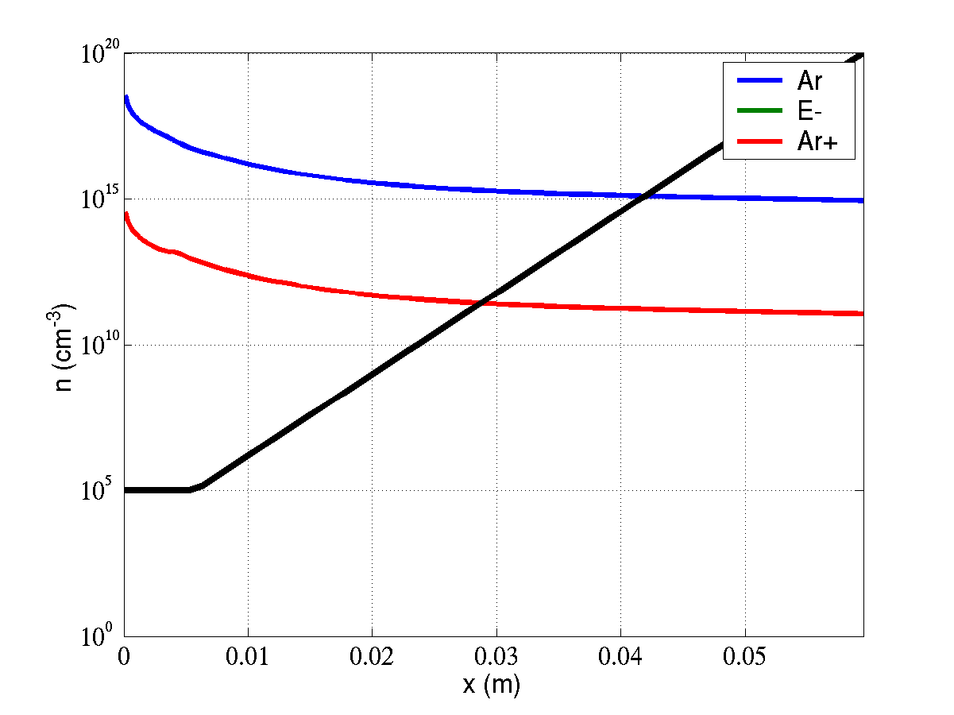
Figure 2(a): The Mollier diagram of the Euler flow along the axis: enthalpy versus entropy in the nozzle (normalized variables). | Figure 2(b): Number density (cm⁻³) of the seven species. The shape of the nozzle is shown with the black line.

The axial velocity increases in the divergent and reaches a value around 4550 m/s (M = 4.66) assuming a supersonic flow at the nozzle exhaust. The sonic point is obtained inside the throat and the maximum value of the Mach number is around 5 for x = 3cm (Fig.3). The temperature (Fig.4) at the throat exit is around 17000K that is a typically value for an electric arc. This temperature decreases in the divergent due to the flow expansion and reach a value around 3800K.

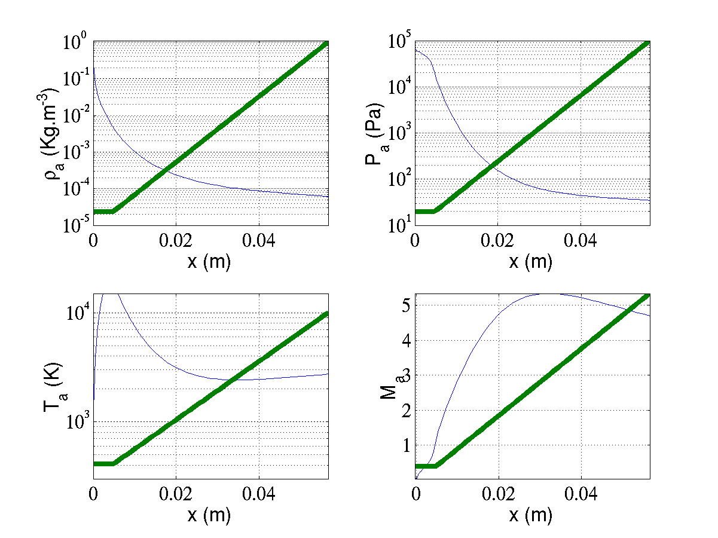Figure 3: Density, temperature, pressure and axial velocity along the nozzle exit from the inlet to the exhaust (on r = 0). The variables are normalized to their inlet values. The nozzle profile is depicted in each subplot.

Table 3: Computed maximal values at the exit of the throat and the nozzle.
 | Pressure | Density | Mach | velocity | Temperature
Throat exit | 13786 Pa | 6 10⁻³ kg/m³ | 1.4 | 3403 m/s | 17356 K
Nozzle exit | 37 Pa | 8.6 10 ⁻⁵ kg/m³ | 4.66 | 4550 m/s | 3818 K

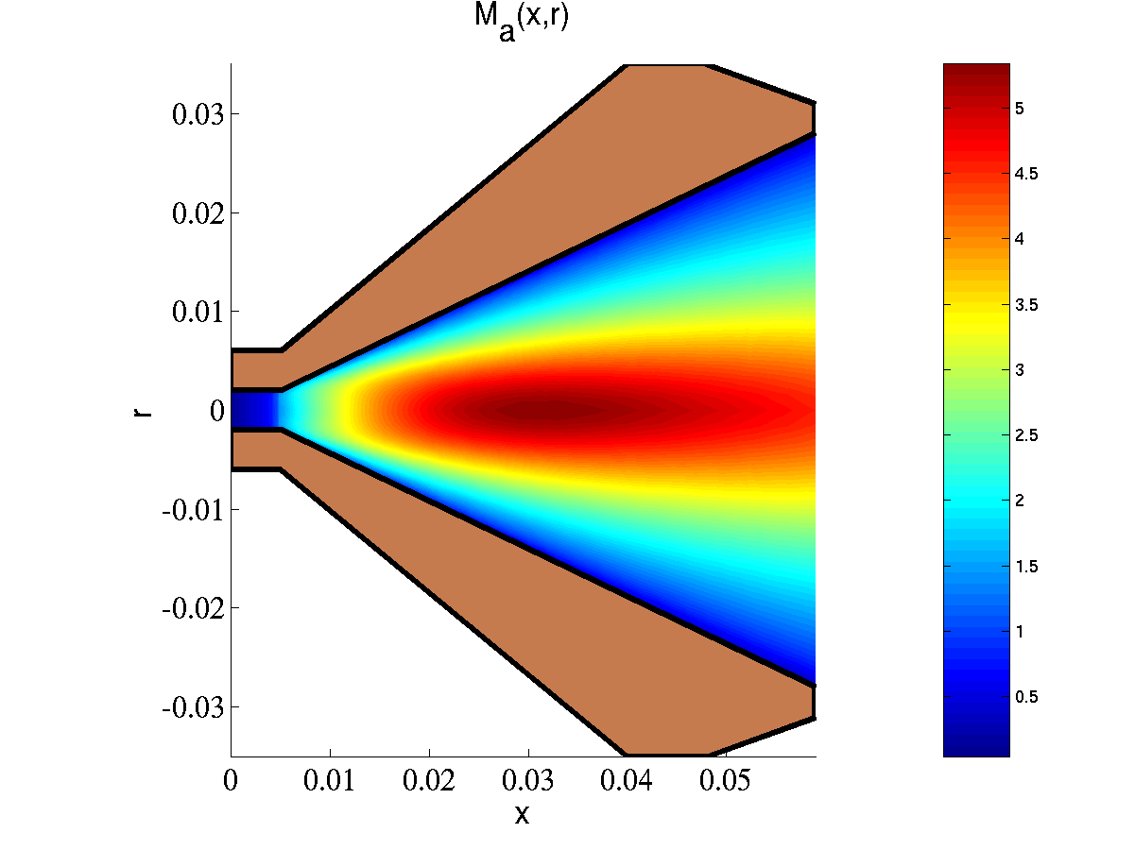 | 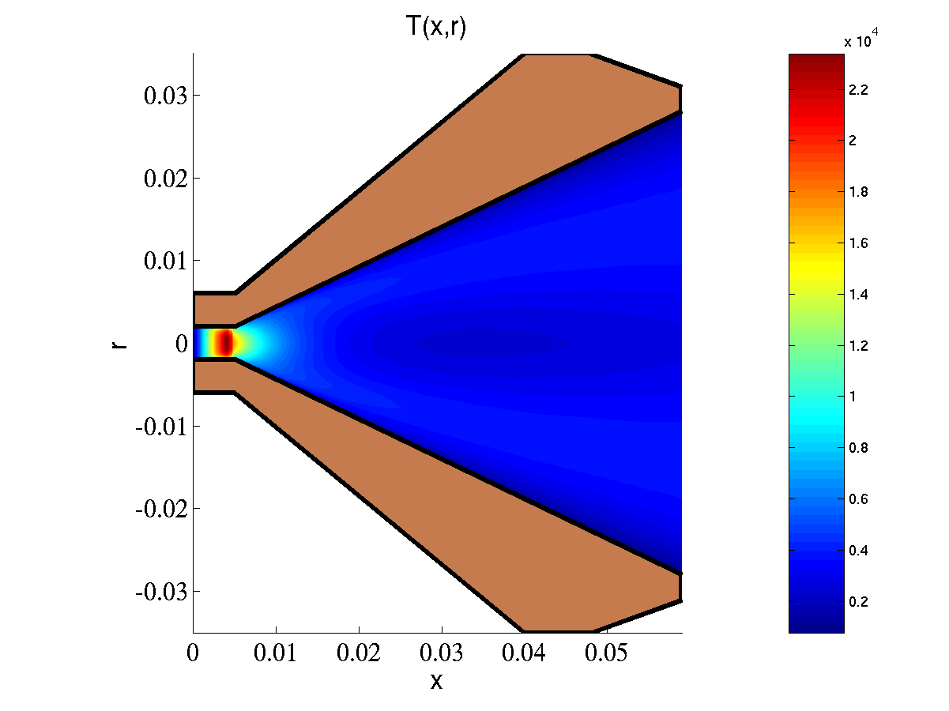
Figure 4 (a): Mach number map. | Figure 4 (b): Temperature distribution

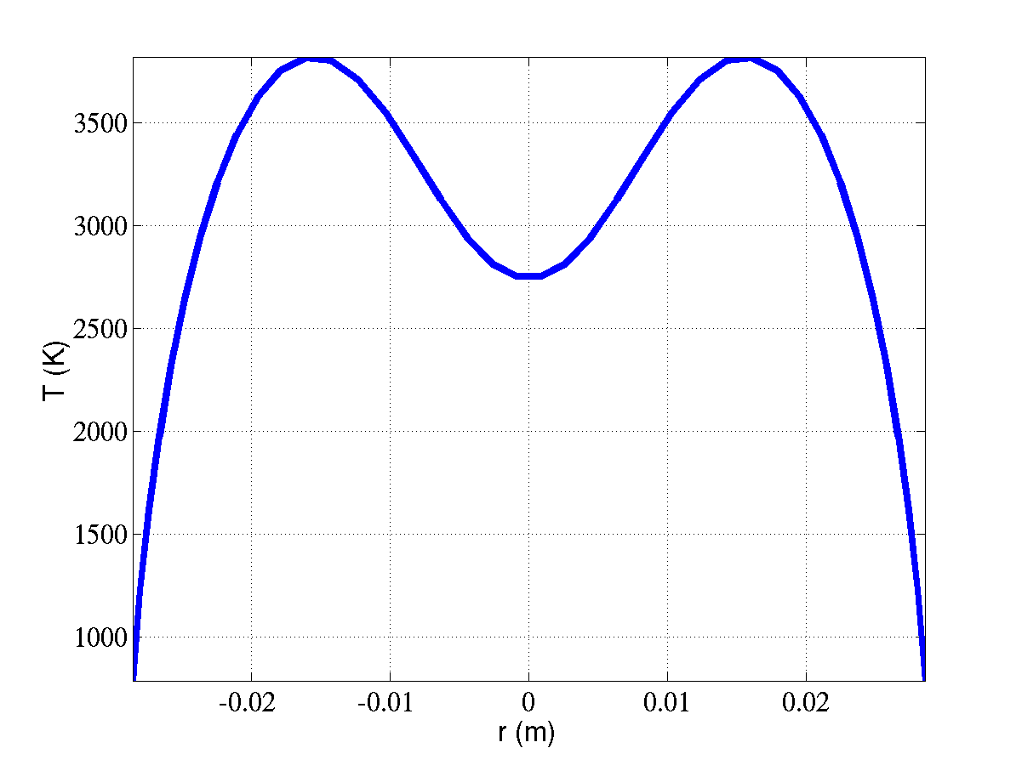 | 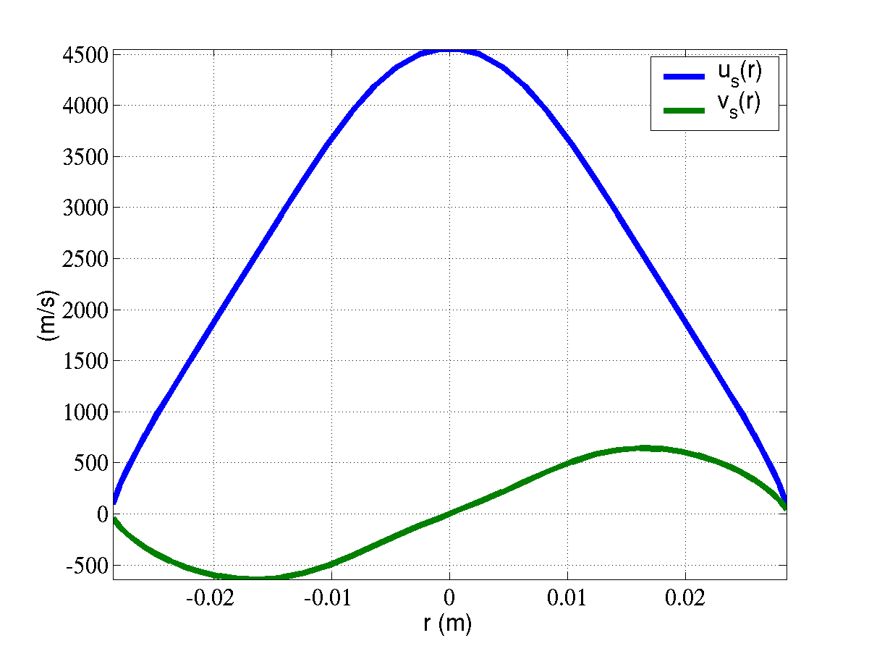 | 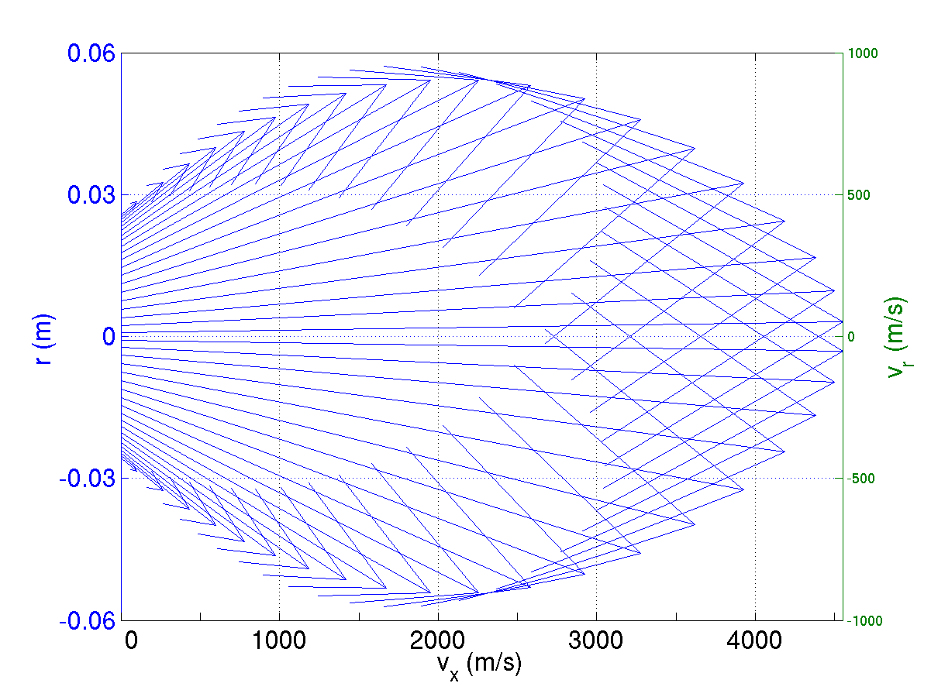

Figure 5: From left to right, temperature, axial and radial velocity profiles and vector representation at the exit of the nozzle.

Only some experimental results are nowadays available. Axial and radial temperature and velocity have previously been measured [5] by laser induced fluorescence spectroscopy (LIF). A non equilibrium between axial and radial temperature is not today included in our modeling by it will be toke into account in a future research program. Electron density will be determined by mean of the electrostatic probe technique in future tests. This measurement seems necessary to fully validate the modeling. The measurements obtained by LIF have been carried out with the same operating conditions as for the modeling.

5. CONCLUSION
The calculated values of temperature and velocity are in good agreement with experimental measurements but they have to be completed by a determination of the plasma density. Moreover, the obtained results show that a simple repartition of the energy of the arc in the volume of the throat permits a satisfying description of the behavior of the plasma flow. Even for an atomic gas the description will be improved by the introduction of slip conditions at the wall of the nozzle, electron temperature, radial temperature and electron mobility.

REFERENCES
[1] A. Kaminska, M. Dudeck, Modelling of non-equilibrium arc-jet plasma flow, J.of Technical Physics, Poland, 40, Special Issue, 33-40, 1999,
[2] J. Aubreton, M.F. Elchinger, V. Rat, P. Fauchais and P. André, "Thermodynamic and transport properties of a ternary Ar-H₂-He mixture out of equilibrium up to 30 000 K at atmospheric pressure", J. Phys. D: Appl. Phys., Vol 37, p 2232-2246, 2004.
[3] P. André, Propriétés de transport pour l'étude de l'arc électrique. Exemple le cuivre, Colloque sur les arcs électriques, Orléans, 14-15 mars 2005
[4] T. Alexandrova, B. Izrar, M. Lino da Silva, M. Dudeck, Modelling of arc jet plasma flow in transitional regime by Navier Stokes and state-to-state coupling, 24th Int. Conf. on Rarefied Gas Dynamics, RGD, Bari, Italie, 12-16 July, 2004
[5] S. Mazouffre, V. Caubet-Hiloutou, E. Pawelec, Examination of the shock wave regular reflection phenomenon in a rarefied supersonic plasma flow, Physics of Plasmas 12, 012323 (2005).

