1st International Conference
″Computational Mechanics and Virtual Engineering ″
COMEC 2005
20 – 22 October 2005, Brasov, Romania

NON-UNIFORM PRESSURE APPLIED TO A
POLIGONAL REGION

Ioan Enescu
“Transilvania” University, Brasov, Romania, enescu@unitbv.ro

Keywords:contact,non -uniform pressure,finite elements
Abstract:Many non-Hetrtzian contact problems do not permit analycal.Any general variation in pressure over a pologonal variation in pressure can be analysed numericaly.

Non-uniform pressure applied to a polygonal region

In this connection it is useful to consider a triangular area DEF on which the pressure varies lineary p_{d} at D to p_{e} at E to p_{f} at F as shown in Fig.1, the pressure distribution form a plane faced def.
Any general polygonal region can be divided into triangular elements such as DEF.In this way a continuos distribution of pressure over the whole polygonal surface may be approximated by linear faced acting on triangular elements such as the one show in Fig.1.
This representation of a continuous pressure distribution may be regarded as an improved approximation may be regarded as an improved approximation upon a series of boundary elements in each of which the pressure is taken to be uniform, since discontinuities in pressure along the sides of the elements have been eleminated and replacedby discontinuities in pressure gradient.
The element shown in Fig.1 can be further simplified by the splified it into three tetragonal pressure elements: the first having pressure p_{d} at D which falls lineary to zero along the side of the triangle EF; the second having pressure p_{e} at E which falls lineary to zero along FD; and the third having pressure p_{f} at F which falls to zero along DE.
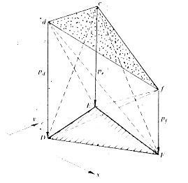
Fig.1

Influence coefficients for the normal deflection of the surface u_{z}(x,y) due to the pressure distribution shown in Fig.1 have been calculated by Kalker & van Raden (1972) in conection with the numerical solution of contact problems
Similary Jihnson & Bentall considered the deflection of a surface under the action of a pyramidal distribution of pressure acting on a uniform hexagonal area of an alestic half-space.
The maximum pressure p₀ acts at the centre O of the hexagonal and falls to zero along the edge.
The deflections at the centre (u_{z})₀ was found to be 3 ln 3(1-ν²)p₀c/2πE and that an aplex to be (u_{z})₀/3, where c is the length of the side of the hexagon. Explicit results for the polynomial distribution of pressure acting on the triunghiular area have been found by Svec & Gladwell.
The stress and the deformations produced by the pressure distribution of the form p₀(1-x²/a²)^{1/2} acting on the rectangle x=±a, y=±b have been calculated by Kunert.
The classsical method, wich has been applied to linear and axi-symetrical problems in which has been applied to line contact and axi-symmetric problems in which the shape of contact area is known, is to represent pressure distributions by an finite serie of known functions. The series is then truncated to satisfy the boundary conditions approximately.
Modern computations facility generaly favour a different approch in which continous distributions of tractions of traction are replaced by a discrete set of ‘tractions elements’ and the boundary conditions are satisfied at a discrete number of points The simplest representations of a tractions distributions is an array of concentrate normal or tangential forces as show in fig.2.

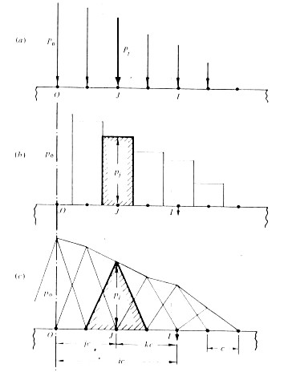

Fig.2
Discrete pressure elements (a) concentrate forces,(b) uniform (piecewise constant),overlapping triangles(c)
When the size of the contact region is comparable with the leading dimensions of one or the bot6h boeies,influence based on a elastichalf-space are no loger appropiate. The techniques which has been applied to contact problems are Finite Elements (contact elements) [1],(Fredrikson 1976) ,Boundary Elements (Andersson 1980).

Reference:
[1] I. ENESCU Aspecte ale mecanicii contactului la rulmenti Editura LUX LIBRIS Brasov 2000
[2] K.L.JOHNSON Contact mechanics Editura CAMBRIDGE UNIVERSITY PRESS Cambridge 1985

