1st International Conference
″Computational Mechanics and Virtual Engineering ″
COMEC 2005
20 – 22 October 2005, Brasov, Romania

Virtual Prototyping methods Applied In
Mechanical Engineering

Ion Barbu, Marius Luculescu, Daniela Barbu
University “Transilvania”, Brasov, Romania, ibarbu@unitbv.ro
University “Transilvania”, Brasov, Romania, lucmar@unitbv.ro
University “Transilvania”, Brasov, Romania, dbarbu@unitbv.ro

Abstract: The paper presents a lot of aspects regarding the usage of modern technologies, such as virtual prototyping and digital mock-up, in mechanical systems engineering (the components of the virtual prototyping platform, the connections between them in a prototyping scheme, and the virtual prototyping phases, respectively). Finally, using the MBS software ADAMS of MSC, licensed to DPR Department, the virtual prototype of an agriculture tractors is developed..
Keywords: Mechanical system, multibody system software, virtual prototyping, digital mock-up.

1. INTRODUCTION

Frequently used in mechanical systems engineering in the last decades, the classic CAD/CAM/CAE technologies were orientated on the concept “art-to-part” that is directed toward the design, development and manufacturing of the system’s components [3]. Three-dimensional solid modelers were used to design the form of the components. Finite element programs performed detailed meshing and analysis of structural, thermal and vibratory characteristics of individual parts. At the same time, specialized software aimed at improving manufacturability of components.
However, optimal component design, do not always leads to optimal system design. The interaction of form, fit, function and assembly of all parts in a mechanical system is a major contributor to overall product quality. The only way to increase quality, and reduce time and cost, consists now of virtual prototyping applied to system level.
Recent publications reveal a growing interest in analysis methods for multibody systems that may facilitate the self-formulating algorithms, having as main goal the reducing of the processing time in order to make possible real time simulation [1, 2]. These methods were used to develop powerful modeling and simulation programs - type MBS (MultiBody Systems) - which allow building and simulating a virtual (software) model of any mechanical system. The main difference of mechanical system dynamics from the conventional structural system dynamics is the presence of a high degree of geometric nonlinearity associated with large rotational kinematics.
 | 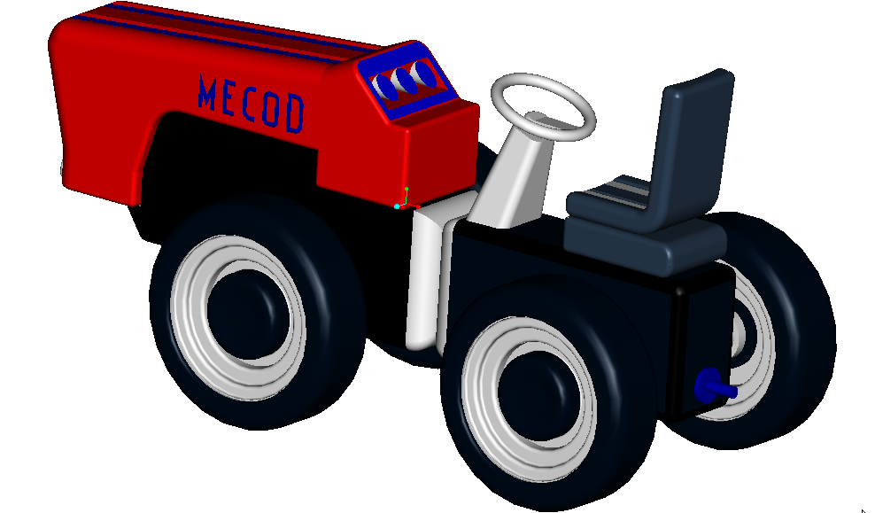
Concept | Virtual prototype (software) | Product (hardware)
Fig. 1 Obtaining the physical product using virtual prototyping

Governing equations for conventional structural dynamics are linear differential equations, while those equations for mechanical system dynamics are nonlinear differential equations that are coupled with nonlinear algebraic equations of kinematics constraints. On the basis of these advanced programs, design engineers have the possibility to build models of not just subsystems but entire systems, and then to simulate their behavior and optimize the design before creating the physical prototype.
Virtual prototyping is a software based engineering process that enables modeling mechanical system, simulating its motion under real operating conditions and, finally, optimizing the form, fit, function, and manufacturing characteristics, long before building the first hardware (physical) prototype, and in a fraction of the cost of traditional hardware prototype processes. In addition to virtual prototyping, which investigates product function and operating performance, digital mock-up is to quickly assess form and fit of entire assemblies of three-dimensional solid models comprising a product.

2. objectives and principles

A typical virtual prototyping platform includes three types of computer programs: CAD (Computer Aided Design) software, for example CATIA, PROENGINEER, EUCLID; MBS (Multi Body Systems) software, for example ADAMS, DYMES, SD-EXACT, PLEXUS; FEA (Finite Element Analysis) software, for example NASTRAN, PATRAN, NISA, COSMOS, ANSYS.
The MBS software is the main component of the virtual prototyping platform, and it allows analyzing, optimizing, and simulating the mechanical system under “real” operating conditions.
The CAD software is used for creating the geometric model of the mechanical system (i.e. solid model). This model contains information about the mass and the inertia properties of the rigid parts. At the same time, the CAD environment provides the ability to perform simple motion studies and to easily transfer geometry between CAD system and virtual prototype software. The part's geometry can be exported from CAD environment to MBS environment using standard format file, for example IGES (Initial Graphics Exchange Standard) or STEP (Standad for the Exchange of Product Model Data). To import the geometry of the rigid parts, the MBS software reads the CAD file and converts the geometry into a set of MBS geometric elements.

Fig. 2: Virtual prototyping phases.
The FEA software is used for modeling flexible bodies in mechanical systems. Virtual prototyping platform provides the ability to transfer loads from virtual prototyping to FEA and to bring component flexibility from FEA back into virtual prototyping. Integrating flexible body into model allows capturing inertial and compliance effects during handling and comfort simulations, study deformations of the flexible components, and predict loads with greater accuracy, therefore achieving more realistic results. The flexible body characteristics are defined in a finite element modeling output file (MNF - Modal Neutral File). The information in an MNF includes: geometry (location of nodes and node connectivity), nodal mass and inertia, mode shapes, generalized mass and stiffness for modal shapes
The steps to create a virtual (software) model mirror the same steps to build a physical (hardware) model, as shown in figure 2. During the build phase, virtual prototypes are created of both the new product concept and any target products which may already exist in the market. The geometry and mass properties of the bodies are obtained from component solid models. The structural, thermal and vibratory characteristics result from component finite element models or experimental tests.
One of the most important axioms for successful functional virtual prototyping is to simulate as you test. Testing of hardware prototypes has traditionally involved both lab tests and field tests in various configurations, which are very expensive. With virtual prototyping, it is enough to create virtual equivalents of the lab tests and the field tests, for example virtual test tracks in automotive simulation or virtual landing strips for aircrafts [3], and this cut time and cost. To validate the virtual prototype, the physical and virtual models are tested identically, using the same testing and instrumentation procedures. The results are compared, and design sensitivity analyses are performed on the virtual model to identify design parameters that have great influence on the performance results that do not correspond. Afterwards, a lot of changes on the main design variables are realized in order to obtain an acceptable correlation between the virtual and hardware models.
Refining the virtual prototype involves the fidelity of the model. Replacing the rigid components with flexible counterparts, adding frictions, and representing the automatic systems that control the operating performance of the mechanical system, respectively, can make the improvement of the virtual prototype.
The optimization of the virtual prototype is made with the following steps: parameterize the model; defining the design variables; defining the objective function for optimization; performing design study and design of experiments; optimizing the model on the basis of the main design variables.
Parameterize the model simplifies changes to model because it helps to automatically size, relocate and orient bodies. Design variables allow creating independent parameters and tie modeling objects to them. Design study describes the ability to select a design variable, sweep that variable through a range of values and then simulate the motion behavior of the various designs in order to understand the sensitivity of the overall system to these design variations. Design optimization represents the capability to define design objectives, constraints and variables, and then the MBS software iterates automatically to the optimally - performing configuration.

3. APPLICATIONS AND CONCLUSIONS

This agriculture tractor has been conceived for hill and mountain tasks and for specialized agriculture. 4 equal drive wheels, excellent weight/power ratio, very short turning radius provide for a very good grip and constant traction and quick maneuvering. Thanks to the low centre of gravity is safe in all soil condition. It has 12 gears: 8 forward and 4 reverse. The steering, which is light and precise, is hydraulically powered, with a “load-sensing” system.
This tractor is provided with two rear PTO and engines range from 30 to 64 HP. Good speed on road transfers. In the last years, the virtual prototyping has become very important in a lot of fields specific to mechanical engineering, for example in agriculture machinery industry.

Fig. 3: Virtual prototype of the agriculture tractor
A453 DTOE
Fitted with all the basic features of the small tractors series, it is the ideal tractor for specialised agriculture. It is primarily aimed at medium sized farms on plains, hills and mountains, rowed crops such as vineyards, orchards and citrus plantations
The major manufacturers use virtual prototyping in different applications, for example: components of tractor, kinematics and dynamics tractor’s component, engine design, body engineering, displacement measuring, force measuring, determination of traction characteristics, determination of masses and mass center coordinates; determination of stability and so on.
To demonstrate the virtual prototyping capabilities, in the present paper, the virtual prototype of a agriculture tractor A 453DTOE is developed (fig. 3), using the MBS software ADAMS [3]. One of the most important advantages of this kind of simulation consists in the possibility of make easy virtual measurements in any point and/or area of the system and for any parameter. This is not always possible in the real cases due to the lack of space for transducers placement, lack of appropriate transducers or high temperature. This helps engineers to make quick decisions on any design changes without going through expensive prototype building and testing.
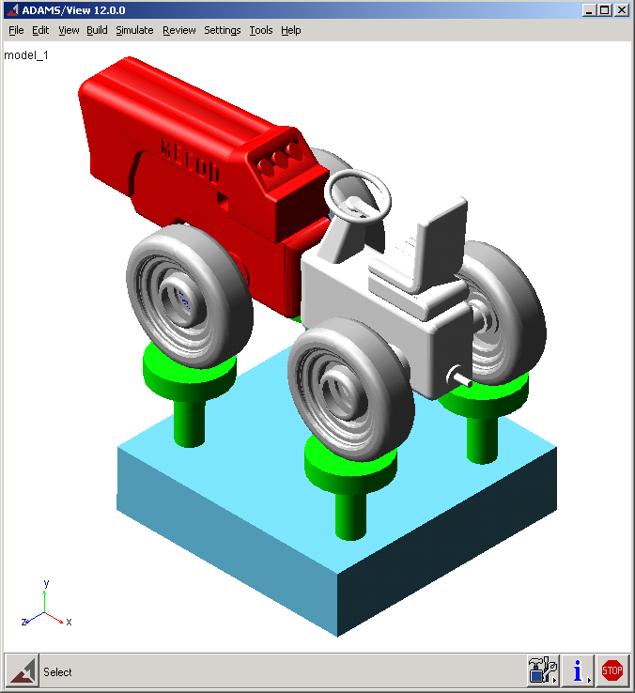 | 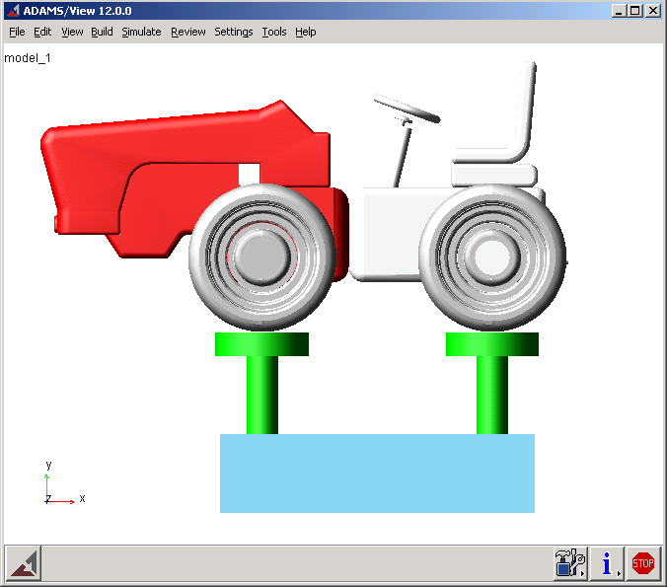 | 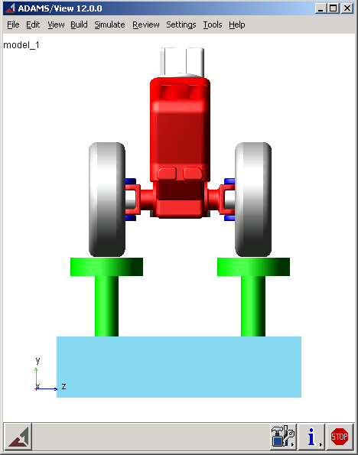
Fig.4. Simulation with ADAMS software

4 conclusion

The virtual prototype is analyzed in passing over bumps dynamic regime, simulating the experimental test on stand. The wheels are anchored on the hydraulic cylinders, which execute vertical motion relative to ground using translational joints. The inputs applied to the cylinders simulate the road profile, considering the passing of the vehicle over a bump with the amplitude h=50 mm, and the speed v=7 km/h defined by the difference between the displacement input signal of the front and rear cylinders / wheels (Δt=1.1 sec.).
The modeling of the motions generator is made using the conditional function IF, with the next format: IF(Expression1: Expression2, Expression3, Expression4), where Expression1 is the evaluated expression; Expression2 - if the value of Expression1 is less than 0, IF returns Expression2; Expression3 - if the value of Expression1 is 0, IF returns Expression3; Expression4 - if the value of Expression1 is greater than 0, IF returns Expression4. In these terms, for the above-described virtual test, the translational motions characteristics are:
- IF(time-0.1: 50*sin(pi*time/0.1), 50*sin(pi*time/0.1),0) - for the front cylinders (wheels);
- IF(time-1.1: 0, 0, -50*sin(pi* time/0.1)) + IF(time-1.2: 0, 0, 50*sin (pi*time/0.1)) - for the rear cylinders (wheels).
The dynamic simulation was achieved for a time interval long enough to catch all relevant motions during the experiment (t=2 seconds). For example, in figure 5 the time simulation histories for the vertical displacement of the front and rear part of the agriculture tractor is presented.
Fig.5. The time simulation histories for the vertical displacement of
the front and rear part of the agriculture tractor A453 DTOE

REFERENCES

- I. Barbu, Vehicle Modeling for Real Time Applications, Bulletin of the Transilvania University of Braşov • Vol. 10 (45) – 2003.
- E.J. Haug, Computer aided kinematics and dynamics of mechanical systems, Allyn and Bacon, Massachusetts, 1989.
- R. Ryan, Functional virtual prototyping, www.adams.com, MSC Software, 2004.

