1st International Conference
″Computational Mechanics and Virtual Engineering ″
COMEC 2005
20 – 22 October 2005, Brasov, Romania

SIMULATION OF COMPOSITE REINFORCEMENT FORMING
FOR RTM PROCESS

P. Boisse ², J-L Daniel ¹, A. Gasser ¹, G. Hivet ¹, J. Launay ¹, D. Soulat ¹
¹ LMSP, Orléans, France, Damien.Soulat@univ-orleans.fr
² LAMCOS, Lyon, France, Philippe.Boissse@insa-lyon.fr)

Abstract: Resin Transfer Moulding process gives composite parts in two stages: the reinforcement is first formed, and then a thermosetting resin is injected in this preform. Composite reinforcements used are dry woven fabrics. The mechanical behaviour of these materials is specific. It can be obtained experimentally by biaxial and shear tests. Simulations of these tests, by 3D finite element method, give complementary information to understand the deformation mechanisms. At least, the simulation of composite reinforcement forming gives the map of angle variation between the weft and warp yarns. The comparison between obtained and maximum angles validates or not the ability to realize the composite part using this process, with this reinforcement.

Keywords: Forming, RTM, finite element analysis, fabrics, process simulation

1. INTRODUCTION

The simulation of a fabrication process is one way for its optimization and reduces its cost. The fabrication of structural composites is very often manual (draping), but other process like RTM can be automatic [1]. For this process, simulation can be useful at two stages, for the forming stage and for resin injection in the obtained preform. This paper concerns the forming stage.
Composite reinforcement used in RTM are generally woven fabrics. They must be resistant to obtain a structural composite and soft, to be easily moulded. They must be able to give parts with non developable geometry and small radius of curvature. The main default to avoid is wrinkles due to an excessive angle between warp and weft during forming. This is one of the results that simulation must predict.
An important point for this simulation concerns the reinforcement mechanical behaviour. During forming, the dry woven fabric works in tension, shearing and bending. The reinforcement is also compacted at the end of this stage. Specific experiments give the required macroscopic values for simulation, but another interesting way is to simulate these experiments by finite element method. .

2. WOVEN FABRIC MECHANICAL BEHAVIOUR IN TENSION

2.1 Mechanical tensile behaviour of fabric

Yarns of composite reinforcements are made of efficient fibres of small diameter ( ≈ 10µm diameter) submitted to a tensile stress in fibre direction. In case of woven fabric, the stress state defined in the two yarn networks oriented in the directions h₁ and h₂ (fig 1), is in the form:
$σ=σ^{\text{11}}h_{1}⊗h_{1}+σ^{\text{22}}h_{2}⊗h_{2}$ (1)
The tensor of the transmitted tension is:
$\begin{aligned}T=T^{\text{11}} h_{1}⊗h_{1}+T^{\text{22}} h_{2}⊗h_{2} \\ T^{\text{11}}=\int{σ^{\text{11}}\text{dS}, }T^{\text{11}}=\int{σ^{\text{11}}\text{dS} } \\ T^{\text{11}}0, T^{\text{22}}0\end{aligned}$ (2)

A1 et A2 are the sections of the warp and weft yarns. For woven fabric, T¹¹ and T²² are linked by the weaving and depend on the axial strains ε₁₁, ε₂₂

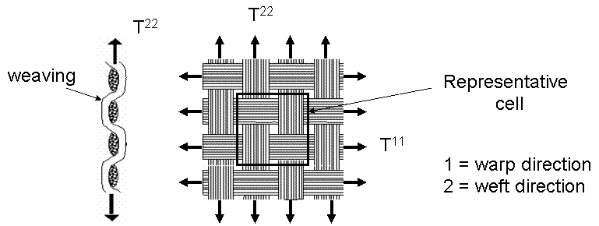

Figure 1: Transverse and in plane scheme of woven fabric

A first approach to analyze the tensile behaviour is experimental tests [2] [3] [4]. Tensions are applied in warp and weft directions. Strains are measured during the test in the same directions. A mean strain value is taken to draw the tension-strain curve. The results Fig 2, represents the tensile behaviour for a glass woven fabric. The curves are ranked by k=ε₁₁/ε₂₂. They are clearly non linear at the beginning of the loading and linear for higher loads. This non linearity is a consequence of non linear phenomena occurring at low load (yarn crushing).

Figure 2: Plain weave tensile behaviour; experimental (Ke) and simulated (Km) results

2.3. Simulation on the tensile test with 3D finite element method.

3 D finite element analysis of the woven unit cell permits to better understand the behaviour of the fabric at this scale (mesoscopic scale) [5]. It needs to correctly model yarns behaviour. This is obtained for shear modulus nearly equal to zero and Young modulus in the transverse direction weak in comparison with the tensile Young modulus. The transverse law is modeled with the following form (Eq. 3):

$E_{i}=E_{0}\left|ε_{\text{ii}}^{n}\right|ε_{\text{11}}^{m}+E_{ε}$ (3)
E₀, m and n are the three material parameters. The direction of the yarn is denoted by index 1, i is a perpendicular direction (i=2 or 3). E_{ε} is the initial transverse modulus (very weak). The value of theses parameters are obtained
using yarn tensile and crushing tests and inverse approaches [6][7]. It is important to follow the fibre directions during the deformation because the anisotropy of the yarns is very important, adding judicious artificial shear stiffness [8]. Fig 3 shows the analysis of an elementary glass woven fabric.

Figure 3: 3D simulation of an elementary cell of woven fabric. Strain in direction 3

The boundary conditions must take into account the periodicity of the cell in the fabric.
The crushing of the yarn is important. It explains a part of the non linearity observed at the beginning of the curves Fig. 3. Comparison between experimental and simulated curves T₁₁=f(E₁₁) Fig 2, validates the simulation hypothesis.

2.3. In plane shear behaviour.

During forming, the yarns can rotate around their contact surface. There is an interaction between yarns at this contact surface. In plane shear tests will give the relation between shear force and yarn rotation. Two experiments are generally used: picture frame and bias tests. 3D simulation by FEM, similarly at tensile tests gives additional information on shear behaviour (Fig 4).

Figure 3: Plain weave shear behaviour; experimental and simulated results

The curve can be divided in three zones. During stage 1, yarns are submitted to a rigid body rotation. There is no shear within the yarn; load is then only due to friction between warp and weft yarns. Zone 2 corresponds to the shear limit angle. The yarns begin to be laterally compressed. In zone 3 wrinkles appear. These phenomena can be observed using optical methods like image correlation [3].

3. FORMING SIMULATION

3.1 Woven finite element.

Specific elements made of elementary cells are used for simulation. A three nodes element with bilinear interpolation is presented Fig 3. It takes into account each elementary cell of the part. The warp and weft directions of each cell are oriented in the ξ₁ and ξ₂ directions. This element is implemented in the industrial numerical code of sheet forming processes: Pam-form (ESI) [9]. Like in most of the efficient numerical codes of sheet forming processes it is based on an explicit dynamic method.

Figure 4: Woven finite element with three nodes and

For a woven domain of ncel elementary cells, a simplified form of the dynamic equation can be written in the following form:
$\begin{aligned}\sum_{p=1}^{\text{ncell}}{\left( ε_{\text{11}}(η)^{p}T^{\text{11}}L_{1}+ε_{\text{22}}(η)^{p}T^{\text{22}}L_{2}\right)+\sum_{p=1}^{\text{ncell}}{γ(η)C}−T_{\text{ext}}(η)=\int_{Ω}{ρ\overset{¨}{u} η}}\text{dV} \\ ∀η/η=0 \text{on} Γ_{u}\end{aligned}$ (4)
T ^{ii} is the tension in each yarn as defined in Eq 2. ^{p}C is the couple due to the shear for the woven cell p and ^{p}γ(η) is the rotation between weft and warp yarn in the virtual displacement field η. They are deduced from the curve on Fig. 3. The description of the used method to find the solution of this equation is described in [10].

3.1 Example of shaping process simulation.

One of the main interests of woven reinforcements is the possibility to obtain complex geometries. Several benchmarks, proposed for sheet metal forming or specific for RTM, can be used to test the simulation method. The test described on Fig 5, has been presented at Numisheet 93 conference [11].

Fig 5. Geometry of the tools for the square box forming test.

The most difficulties to form this box occur in the bottom of the square angle. Two simulations are presented with a plain weave fabric. The first one take into account only tension rigidity. In this case, there is no wrinkle and the maximum angle calculated between weft and warp yarn is of 22 degrees. When tension and shear rigidity are taken into account some wrinkles appear [12]. These are due to shear-locking that leads to out-of plane solution to reduce this shear. The rotation angle is also reduced in this case. This second approach is better and corresponds to the reality.

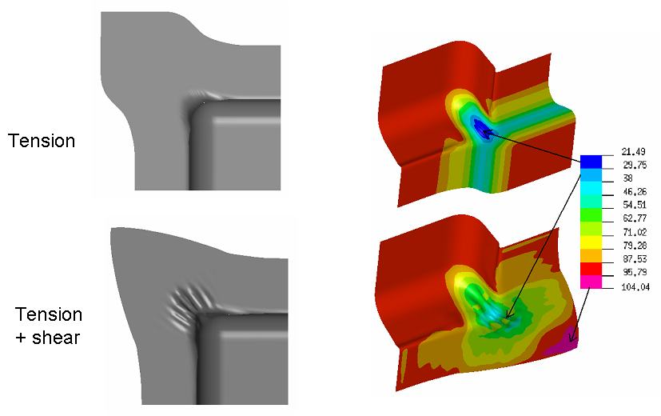

Fig 5. Comparison of final shapes and angle variation for tension and tension + shear formulation

4. CONCLUSIONS

The simulation of composite reinforcement forming for RTM can be based on a simplified form of the dynamic equation. Specific finite elements have been developed. They use an approach at the level of the interaction between warp and weft yarns (mesoscopic approach). The behaviour of the woven fabrics is obtained by experiments in shear and tension. Complementary 3D simulations permit to understand the local phenomena influencing the global fabric mechanical behaviour and leading non linear phenomena. It is a way to analyze the influence of different parameters like yarns crushing. By taking into account shear behaviour, the accuracy of the result increases compared to those obtained with only tension behaviour.

REFERENCES

[1] D. Caronnier, D. Gay; Approche intégrée du RTM. Revue des composites et des matériaux avancés, vol 6, Hermes , Paris 1996.
[2] K. Buet, Analyse et simulation du comportement mécanique des renforts composites tissés, Ph. D.Thesis of University of Orléans, France, 1998
[3] F. Dumont, Contribution à l’experimentation et à la modélisation du comportement mécanique de renforts de composites tissés, Ph. D.Thesis of University of Paris 6, France, 2003
[4] P. Boisse, K. Buet, A. Gasser and J. Launay; Meso/macro-mechanical behaviour of textile reinforcements for thin composites. Composites Science and Technology, Volume 61, Issue 3, February 2001, Pages 395-401
[5] A. Gasser, P. Boisse, S. Hanklar ; Mechanichal behaviour of dry fabric reinforcements. 3D simulation versus biaxial tests. Comput Mater Sci 2000; 17(1): 7-20.
[6] P. Boisse, A. Gasser and G. Hivet; Analyses of fabric tensile behaviour: determination of the biaxial tension–strain surfaces and their use in forming simulations. Composites Part A: Applied Science and Manufacturing, Volume 32, Issue 10, October 2001, Pages 1395-1414.
[7] D.W Marquardt; An algorithm for lest squares estimation of non linear parameters, J. Soc. Indus. Appl. Math. 11(2) (1963) 431-441
[8] Flanagan DP. Belystschko T; A uniform strain hexahedron and quadrilateral with orthogonal hourglass control. Int. J Numer. Mech. Eng 1981; 17:679-706.
[9] J-L Daniel, D. Soulat, P. Boisse ; Shear and tension stiffness influence in composites forming modeling; Proceeding of the 7th Esaform conference on material forming, Trondheim, Norway, April 28-30, 2004
[10] P. Boisse, M. Borr, K. Buet, A. Cherouat ; F.E simulations of textiles composite forming including the fabric behaviour. Compos. Part B 1997; 28: 453-64.
[11] Numisheet’ 93, Numerical simulation of 3-D sheet metal forming processes – verification of simulation with experiments, Makinouchi A, Nakamachi E, Onate E, Wagoner RH (editors), Japan; 1993.
[12] P. Boisse, B. Zouari and A. Gasser ; A mesoscopic approach for the simulation of woven fibre composite forming. Composites Science and Technology, Volume 65, Issues 3-4, March 2005, Pages 429-436

