1st International Conference
″Computational Mechanics and Virtual Engineering ″
COMEC 2005
20 – 22 October 2005, Brasov, Romania

THEORETICAL APPROACHES ON ELECTRICAL PROPERTIES OF PARTICLE REINFORCED COMPOSITE MATERIALS AS CANDIDATES FOR ALTERNATIVE INDUSTRIAL APPLICATIONS

Assoc. prof. eng. Dana I. Luca Motoc¹, PhD, MSc
¹ Transilvania University, Brasov, ROMANIA, danaluca@unitbv.ro

Abstract: The paper summarizes a recent theoretical effort carried out with respect to the electrical properties (conductivity) of particle reinforced composite materials. The interdependence of electrical conductivity with crucial properties of polymer based encapsulates has been investigated analytically using different mixing laws and effective media theories. The filler particles (metal and non-metal) were considered as having spherical shapes and spread all over the composite’s matrix. The aimed property was plotted vs. the particle volume fraction of the fillers, all the models showing differences with respect to the basic model derived by Maxwell. In the dilute limit, all the expressions reduce to this classical model. With respect to the metallic particles, there are relatively small differences among the values obtained using one of the models, differences arising from the “variations” of the particle materials nature.
Keywords: electro-composite, particles, electrical conductivity, models, industrial applications.

1. INTRODUCTION

Composite materials have numerous applications that exploit their electromagnetic properties. These applications include static shielding of delicate electronic components, radar absorption, alternatives for insulating/heating systems or other types of applications from aeronautics and automotive industries, etc. In such circumstances, it is useful to be able to predict the bulk behavior of a composite material from knowledge of the intrinsic properties of its constituents, since this ability is a fundamental requirement in the development/characterization/optimization processes of a novel material.
There is mathematical equivalence in the calculation of a number of physical parameters including elastic coefficients, electrical and thermal conductivity, resistance, impedance and magnetic permeability of particle reinforced composite structures having one or multiple layers [1-5]. This fact has been partly responsible for wide contributions on the subject, as researchers in many fields have addressed the problem of calculating the properties of this class of materials. Hence, the papers cited by this article are related with the research and focus interest of the author, as a natural consequence of developing the subject of its PhD, as well as with the trend in the domain.
A number of models have been proposed to describe the mechanical, thermal and electrical behavior of particle reinforced composite materials. These models vary substantially in assumptions, applicability, accuracy, complexity and completeness. The theoretical models presented herein have taken into account the relative spatial distribution of the composite constitutive, the particles’ shape (e.g. spheres) and nature (e.g. conductive, insulating) and finally, the matrix influence on the overall properties to be evaluated. The mixing laws are derived on effective media theories basis, using the usually assumptions found in this area of concern.
In this work, the particles were considered to be spherical in shape, embedded into a conductive epoxy matrix in various volume fractions. Also, the examples provided were taken into account different metallic (e.g. Cu, Al, Fe, W, etc.) and non-metal (e.g. C) materials for these inclusions (reason – experimental research for electrical conductivity measurements on few samples like the previous mentioned ones are being conducted at the time of writing).
The results presented here will be confined to a single layer of particle reinforced composite material, even there is possible to extend, into a straightforward manner, the idea to a multiple layers composite material. We are convinced that such of extension is feasible and allows modeling of various combinations among the individual materials, layers, distributions of filler particle size, shape and ratio among the layers.
2. THEORETICAL MODELS

Technical literature provides several outstanding reviews of mixing laws and effective media theories for electro-composites, a “brand name” for the electrical conductive composite materials. In the dilute limit, all such equations are reduced to Maxwell’s equation:
$\frac{σ}{σ_{m}}=1+\frac{3⋅\left(r−1\right)}{r+2}⋅V_{p}+\text{higher} \text{order} \text{terms},$ (1)
where σ is the conductivity of the overall composite material, σ_{m} is the conductivity of the matrix phase, r is the ratio of particle conductivity (σ_{p}) to that of the matrix, V_{p} is the volume fraction of particles, and the higher-order terms are neglected. The previous notations and symbols have the same meaning for all the following derived theoretical models.
The other models extend calculations beyond the dilute range. For example, the Maxwell-Wagner equation (also known as the Maxwell-Garnett equation or Wiener’s rule based on the well-known Clausius-Mossoti equation), is given by:
$\frac{σ}{σ_{m}}=\frac{2⋅\left(r−1\right)⋅V_{p}+\left(r+2\right)}{\left(r+2\right)−\left(r−1)⋅r\right)}\text{.}$ (2)
This model is formally equivalent to the Hashin-Strikman lower bound (conductive particles) and upper bound (insulating particles) and sometimes is referred to as the "Maxwell&Wagner-Hashin&Strikman" equation(s).
Zuzovsky and Brenner performed calculations for the effective conductivity of a simple cubic array of spheres embedded in a matrix vs. volume fraction of spheres:
$\frac{σ}{σ_{m}}=1−3⋅V_{p}⋅\left[\frac{r+2}{1−r}+V_{p}−\frac{1\text{.}\text{306}⋅V_{p}^{\text{10}3}}{\frac{43+r}{1−r}+0\text{.}\text{4072}⋅V_{p}^{73}}−\frac{2\text{.}\text{218}⋅{\text{10}}^{−2}⋅\left(1−r\right)⋅V_{p}^{\text{14}3}}{65+r}\right]+\text{higher} \text{order} \text{terms}$ (3)
Bruggeman´s asymmetric medium theory for conducting spheres is given by:
$\frac{σ}{σ_{m}}={\left(1−V_{p}\right)}^{−3},$ (4)
where as for insulating spheres the Bruggeman’s asymmetric equation is:
$\frac{σ}{σ_{m}}={\left(1−V_{p}\right)}^{32}\text{.}$ (5)
Finally, Meredith and Tobias extended Fricke’s treatment of ellipsoidal particles, within a Clausius-Mosotti framework, by mixing half of the spheres at a given volume fraction, calculating the composite conductivity, and using this as the matrix for a new composite made with the addition of the other half of the spheres. The resulting equations are:
$\frac{σ}{σ_{m}}=\frac{\left(1+V_{p}\right)⋅\left(2+V_{p}\right)}{\left(1−V_{p}\right)⋅\left(2−V_{p}\right)}$ (6)
for conducting spheres and
$\frac{σ}{σ_{m}}=\frac{8⋅\left(2−V_{p}\right)⋅\left(1−V_{p}\right)}{\left(4+V_{p}\right)⋅\left(4−V_{p}\right)}$ (7)
for insulating spheres, respectively.
The various mixing laws and effective media theories are plotted vs. particle volume fraction, in figures 1 to 5, for the case of conductive spheres, considering different types of materials for the particles embedded into a conductive epoxy resin.
From all empirical models the Bruggeman asymmetric medium equation exhibits a markedly higher conductivity. This is not unexpected, since the Bruggeman asymmetric model is most applicable for a wide range of particle sizes as opposed to the single size like usually is the case in practice. As expected, all the models approach the Maxwell line for volume fractions less than 0.2, in such circumstance in which the higher order terms were neglected. The slope of 3 in this regime is exactly the intrinsic conductivity of conducting spheres, as was mentioned within the literature.
The cases corresponding to the insulating spheres do not reveal any significance apart from that a data representation shows a decrease in electrical conductivity along with the volume fraction of the fillers. A further approach of the problem can be directed toward the series expansion and coefficients retrieval in all the expressions involving higher order terms (see expressions 1 or 3), steps that refines the data representation and aids the comparisons with the experimental data.

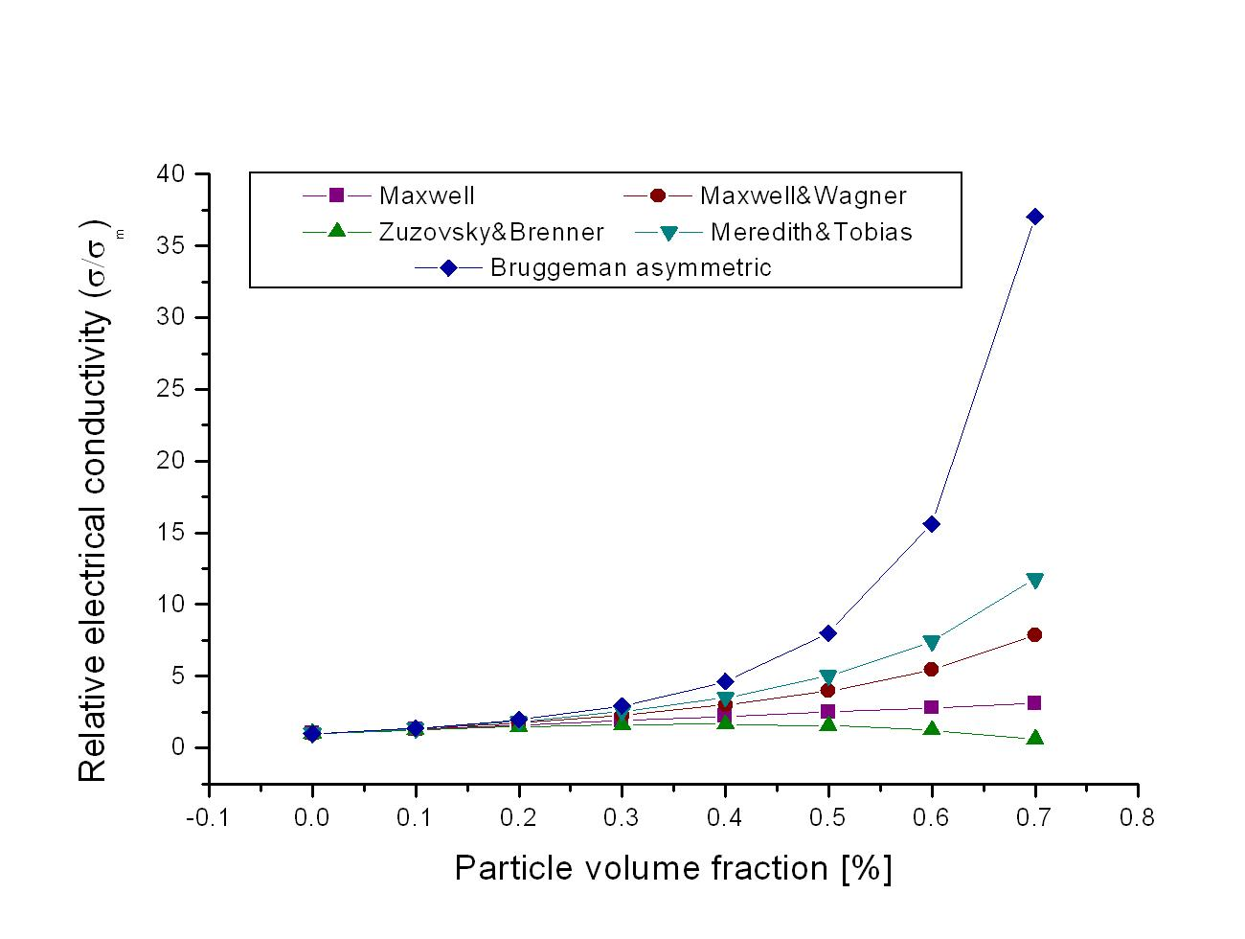
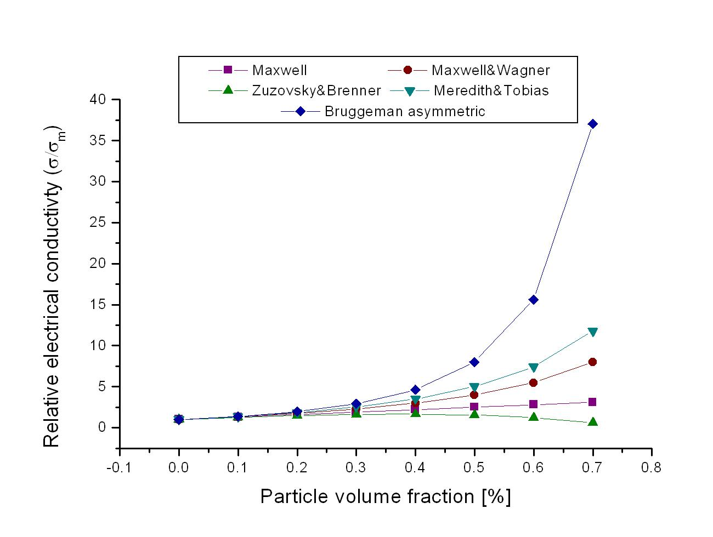
3. RESULTS AND DISCUSSION
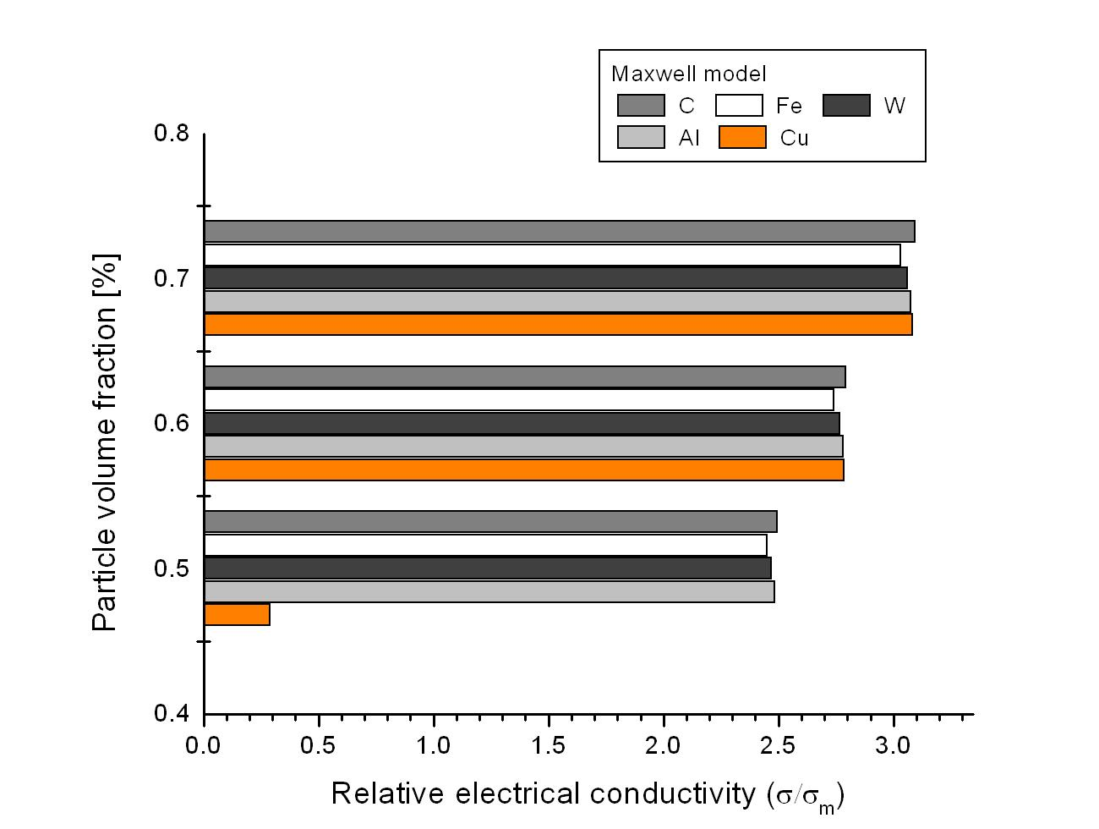
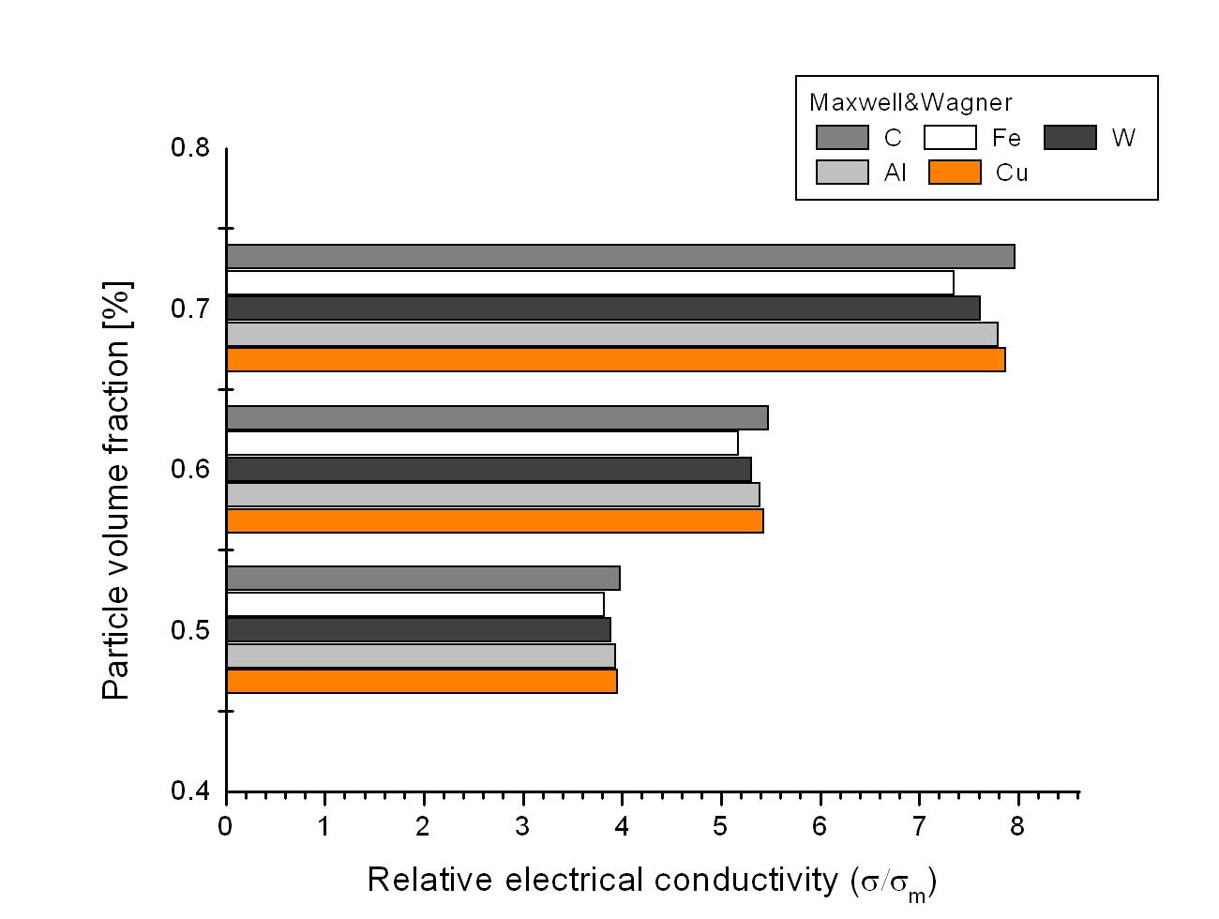
Figure 1: Empirical models - Cu particles Figure 2: Empirical models - C particles
Figure 3: Maxwell model – different metallic particles Figure 4: M&W model – different particles
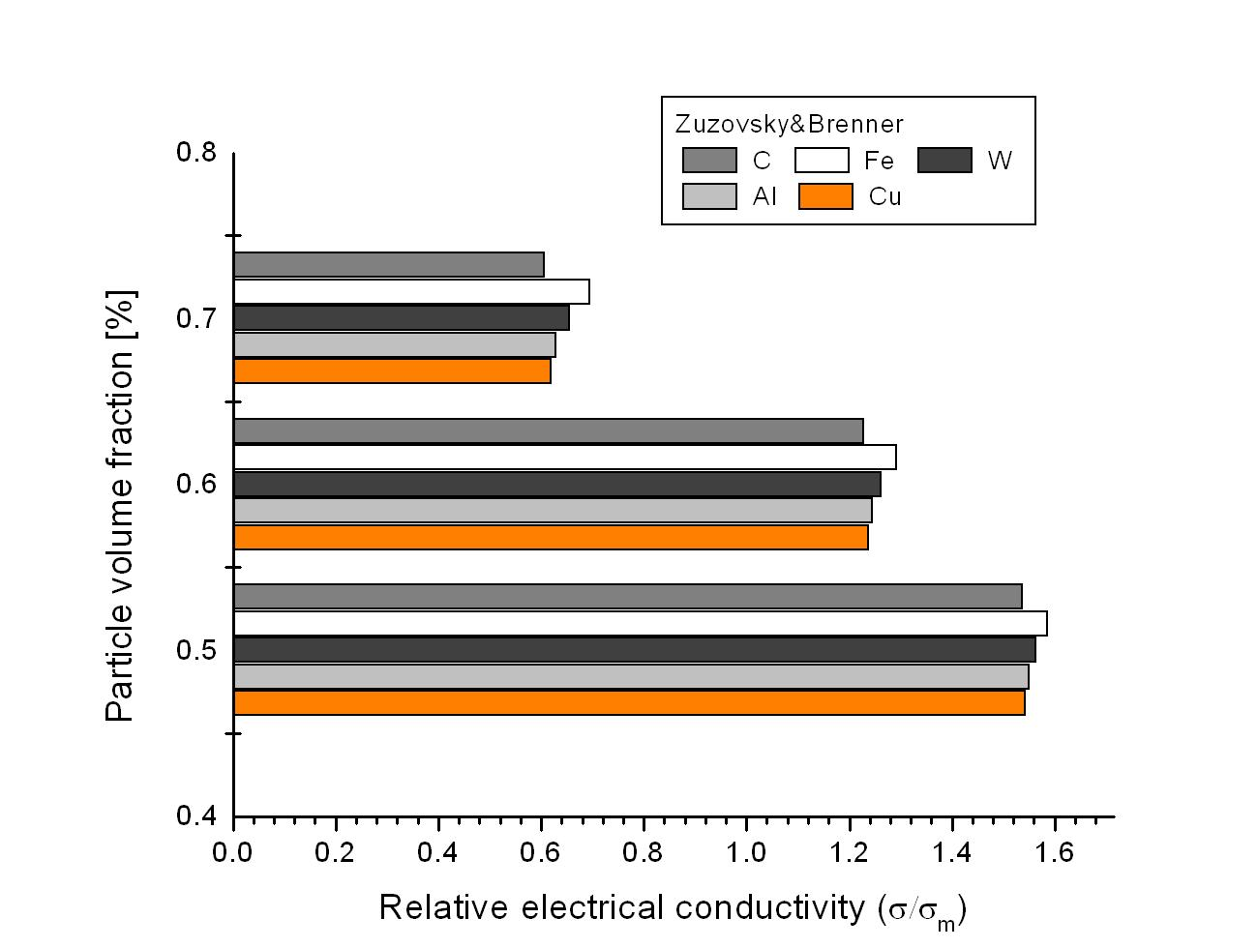
Figure 5: Zuzovsky & Brenner model – different metallic particles
Figures 1 and 2 corresponds to all theoretical models presented previously, outlining the fact that the first goes for Cu particles and the second for the C particles embedded into an epoxy matrix. Figures 3 to 5 represents the variations of electrical conductivities corresponding to different metallic particles as volume fraction of these fillers using different empirical models (the neglected models shows the same values no matter the nature of the fillers).
Here were used only the 0.5, 0.6 and 0.7, respectively, values for the volume fraction, due to the fact that the most used values for sample preparation in practice. One ANOVA statistical method used in the data processing shown that for one type of particle, at the 0.05 (5 %) level of confidence the means associated to each of the empirical model, are not significantly different. Supplementary, from figures it can seen that in case of metallic conductive particles the influence on the overall electrical conductivity is relatively small, significant differences being sized only among different “nature” classes of materials.

4. CONCLUSIONS

The different mixing laws used to predict the electrical conductivity of the particle reinforced composite materials are derived on theoretical assumptions and vary substantially from accuracy, complexity and completeness point of view. These models are relatively restrictively used in the technical literature, partially due to their spread out and most due to the minor people involved in the development and characterization of novel materials. With respect to the last mentioned issue can be outlined the fact that knowledge on novel composite materials involves concerning efforts of team contributions and not solely of one people no matter the qualification and expertise.
This work belongs to a focused research interest of the author in the subject and area of particle reinforced composite materials, especially from properties characterization (theoretically and experimentally) point of view, outlining the fact that the experimental data retrieved so far for these type of materials shown a dielectric nature for the overall composite (experimental data not shown herein), even each of the constitutive are conductive if were considered separately.
With respect to the previous, this focused interest is due to the identified potential of using these types of composite materials in different industrial applications, being only a matter of time to implement the concepts, materials and human resource.

Acknowledgment: The paper was supported under the research grand CNCSIS no. 172/2004.

REFERENCES

- Motoc Luca D.: Contribuţii la studiul corelaţiilor dintre gradul de tensionare şi proprietăţile fizice ale unor materiale utilizând metode nedistructive (sonore, vizuale), teză de doctorat, Universitatea Transilvania din Braşov, 2002.
- Motoc Luca D.: Particle reinforced composite materials' thermal conductivity evaluation - theoretical approaches, Buletinul Universităţii din Oradea, Mai, 2004.
- Motoc Luca D.: Theoretical approaches on novel uni- and multilayers architectures of particle reinforced composite materials, CONAT 2004, the 10th International Congress, Braşov, 20-22 October 2004, http://conat.unitbv.ro.
- Motoc Luca D., Lache S.: Aspecte privind coeficienţii elastici ai materialelor compozite ranforsate cu particule utilizând modele teoretice de aproximare diferite, Analele Universităţii din Oradea, Secţiunea Mecanică , vol. I, 2002, pp. 111-114.
- Campo M. A., Woo L. Y., Mason T. O., Garboczi E. J.: Frequency-dependent electrical mixing law behavior in spherical particle composites, Northwestern University, Evanston, 2002.

