1st International Conference
″Computational Mechanics and Virtual Engineering ″
COMEC 2005
20 – 22 October 2005, Brasov, Romania

INFLUENCE OF THE FLEXURE HINGE GEOMETRY ON
COMPLIANT MECHANISMS FUNCTIONING

Simona NOVEANU¹, Vencel CSIBI², Nicolae LOBONTIU³
¹ Technical University of Cluj-Napoca, Cluj-Napoca, ROMANIA, e-mail: noveanu_s@yahoo.com
² Technical University of Cluj-Napoca, Cluj-Napoca, ROMANIA, e-mail: csibiven@yahoo.com
³ Technical University of Cluj-Napoca, Cluj-Napoca, ROMANIA, e-mail: Nicolae.Lobontiu@rezi.utcluj.ro

Abstract: In this paper, the flexure hinges are presented. Flexure hinges are frequently used in precision motion stages and micro-robotic mechanisms due to their monolithic construction. Because compliant mechanisms are different from the traditional rigid body mechanisms, in second part, we realized some constructively variants the flexure hinge with different geometry. Influence of the flexure hinge geometry is investigated by using the finite element method, and the stiffness is compared.
Keywords: compliant mechanisms, flexure hinge, finite element method

1. INTRODUCTION

The compliant mechanisms are different from the traditional rigid body mechanisms in the sense that the traditional rigid body mechanisms are rigid links connected by movable joints. They are used to transfer or transform energy and motions across themselves as desired by the users. The compliant mechanism does the same work except that their usability is also dependent upon flexibility of some members. Compliant mechanisms have a smaller number of movable joints, such as turning and sliding joints. The result is reduced wear and reduced need for lubrication. They also result in reduction of noise and vibration due to reduced number of components and friction movements. Backlash reduction due to a decreased number of joints increases the mechanism precision. Conventional joints cannot be easily miniaturized. Using compliant mechanisms can solve this problem. Compliant mechanisms can be miniaturized for use in simple microstructures, actuators and sensors. The monolithic construction also simplifies production, enabling low-cost fabrication. On the other hand, flexures do present some limitations related to their physical principles: limited stroke, limited load capacity, presence of restoring forces, complex kinematics and mechanical structures having several degrees of freedom. The monolithic construction also simplifies production, enabling low-cost fabrication, [1].
Furthermore, there are certain applications such as micro and nano systems where compliant designs are indeed essential. Consequently, the application domain of compliant mechanisms continues to expand with better materials and processing techniques, design methods, and specialized needs of emerging areas of engineering and science. The focus of this article is on furthering the analysis of flexure hinge in compliant mechanisms.
As previously mentioned, the flexure joint consists of an elastically flexible, slender region between two rigid parts that must undergo relative limited rotation in a that is supposed to achieve a specific task.
Flexure joints do have limitations [2], such as:
• The flexure joints are capable of providing relatively low levels of rotations.
• The rotation is not pure because the deformation of a flexure is complex, as it is produced by axial shearing and possible torsion loading, in addition to bending.
• The rotation center is not fixed during the relative rotation produced by a flexure joint as it displaces under the action of the combined load.
• The flexure joint is usually sensitive to temperature variations; therefore, its dimensions change as a result of thermal expansion and contraction, which leads to modifications in the original compliance values.

2. FLEXURE HINGES STUDY

2.1. Analysis with finite element

There are analyzed the following geometrical shapes: circular flexure hinge (1a), corner-filleted flexure hinge (1b), parabolic flexure hinge (2a) and hyperbolic flexure hinge (2b). The solid model is designed using SolidWorks software, and for the finite element used COSMOSWorks for structural analysis.

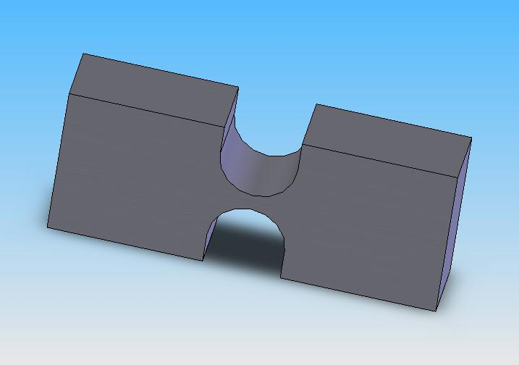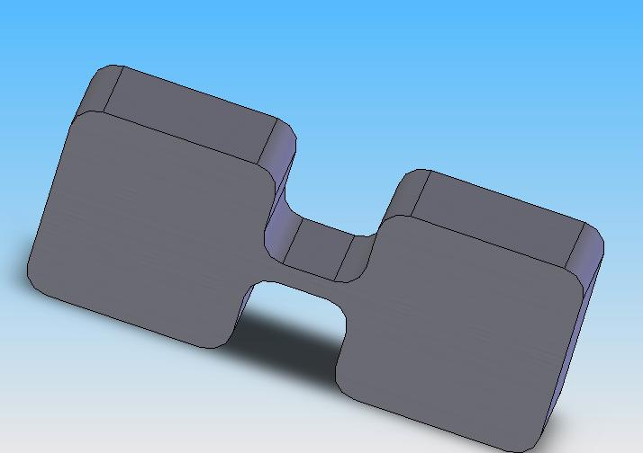
a b
Figure 1: Right Circular Flexure Hinge and Corner Filleted

The above hinge is referred to as a right circular flexure hinge or flexure. Other types of flexure hinges include the hyperbolically and elliptically filleted. These, like the right circular flexure, have dominant compliance in one direction. The differences in geometry of these hinges can be seen in Figure 2

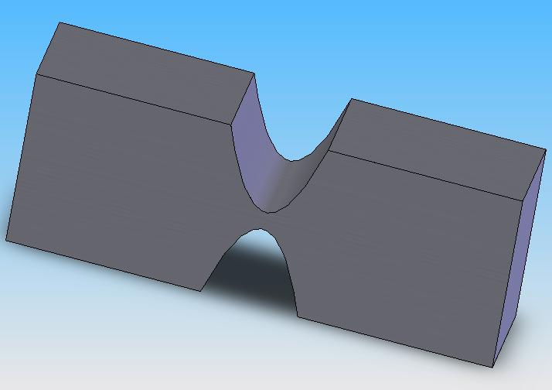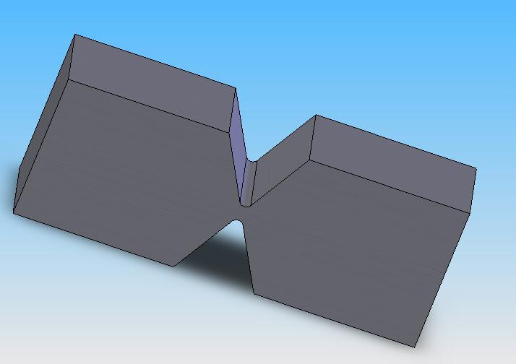
a b
Figure 2: . Other Types of Flexure Hinges: Parabolic and Hyperbolic

Properties of used material are presented in next table:

Table 1: Table caption
Elastic modulus | 2.1e+011 N/m^2
Poisson's ratio | 0.28
Thermal conductivity | 50 W/(m.K)
Specific heat | 460 J/(kg.K)
Yield strength | 6.204e+008 N/m^2
Tensile strength | 7.2383e+008 N/m^2

For a given force of 2N on the actuator it can be shows in the table 2 the maxim and minim resultant displacement and value the von Mises stress of all geometrical variants.

Table 2: Result of finite element
Flexure Hinge | Displacement |  |  |  | von Mises stress
Flexure Hinge | Min |  | Max |  | Min |  | Max
Right Circular | 0 mm  Node: 1
  0.00572311 mm
  Node: 273
  206.468 N/m^2
  Node: 8350
  2.34611e+007 N/m^2
  Node: 173
Corner-Filleted
  0 mm
  Node: 372
  0.0108834 mm
  Node: 9037
  203.733 N/m^2
  Node: 9100
  3.14353e+007 N/m^2
  Node: 8179
Hyperbolic
  0 mm
  Node: 314
  0.0028514 mm
  Node: 118
  318.803 N/m^2
  Node: 1479
  2.69582e+007 N/m^2
  Node: 8728
Parabolic
  0 mm
  Node: 84
  0.00985287 mm
  Node: 397
  203.205 N/m^2
  Node: 7738
  2.50776 e+007 N/m^2
  Node: 7884

The flexure hinges can be designed and analyzed based on their effectiveness during operation according to the following criteria:
• Capacity of producing the desired limited rotation
• Sensitivity to parasitic loading
• Precision of rotation
• Stress levels under fatigue conditions

2.2. Equations

Various flexure geometric configurations will subsequently be analyzed and specific compliance equations given in explicit form for circular, corner-filleted, parabolic, hyperbolic, elliptical, inverse parabolic, and secant designs [3].
The compliance matrix will connect the deformation vector {u} to the load vector {L} according to the matrix equation:
$\left\{u\right\}=[C]\left\{L\right\}$ (1)
the deformation at any point in an elastic body under the action of a load system:
$\left\{u\right\}={\left\{u_{x} u_{y} u_{z} θ_{x} θ_{y} θ_{z}\right\}}^{T}$ (2)
in a generic equation the loads are:
$\left\{L\right\}={\left\{F_{x} F_{y} F_{z} M_{x} M_{y} M_{z}\right\}}^{T}$ (3)
Stiffness matrix [K] is the inverse of the compliance matrix [C] are:
$[C]=[K]^{−1}$ (4)
In a generic equation the compliance are.
$C_{j}=\frac{1}{E}f_{j}(\text{geometry})$ where: E – Young’s Modulus (5)
f – geometry function

where the symmetric compliance matrix [C] is:
$[C]=\left[\begin{matrix}C_{u_{x}−F_{x}} & 0 & 0 & 0 & 0 & 0 \\ 0 & C_{u_{y}−F_{y}} & 0 & 0 & 0 & C_{u_{y}−M_{z}} \\ 0 & 0 & C_{u_{z}−F_{z}} & 0 & C_{u_{z}−M_{y}} & 0 \\ 0 & 0 & 0 & C_{θ_{x}−M_{x}} & 0 & 0 \\ 0 & 0 & C_{u_{z}−M_{y}} & 0 & C_{θ_{y}−M_{y}} & 0 \\ 0 & C_{u_{y}−M_{z}} & 0 & 0 & 0 & C_{θ_{z}−M_{z}}\end{matrix}\right]$ (6)

The first subscript in the compliance factors of Eq. (6) indicates the deformation about a particular degree of freedom while the second one points out the load producing that deformation.
The degrees of freedom correspond to deflection and slope about the two cross-sectional principal directions, to axial deformation and to torsional rotation, as produced by the associated loads acting at the same (free) end.
For example for simple beams are:

$C_{\text{11}}=\frac{\text{12}l}{{\text{Ebt}}^{3}}$ ; $C_{\text{12}}=−\frac{6l^{2}}{{\text{Ebt}}^{3}}$ ; $C_{\text{22}}=\frac{4l^{3}}{{\text{Ebt}}^{3}}$; $C_{\text{33}}=\frac{l}{\text{Ebt}}$;$C_{\text{33}}=\frac{l}{\text{Ebt}}$ (7)

For other types of flexure hinges: right circular , corner filleted, parabolic and hyperbolic Lobontiu [] are presented the equation for compliances.

3. COMPLIANT MECHANISM STUDY

Further a gripper is realised corner-filleted flexure hinges. The in-plane behavior is only analyzed since these rotational connectors are designed to be incorporated in plane amplification mechanism with co-planar loading. An analytical formulation is developed in order to derive the closed-form solutions of the compliance factors in terms of length l, thickness t and fillet radius r for constant-width, corner-filleted flexure hinges. It is demonstrated that a corner-filleted flexure hinge spans a domain bounded by the simple beam (r = 0) and the right circular flexure hinge (r = l/2), [2]. Finite element simulations are performed to verify the accuracy of model-predicted compliance factors for several design configurations. The results are in good agreement with those produced by the analytical approach within 10 % relative errors. The experimental measurements also confirm the analytical predictions with relative errors less than 6% [3]. They also induce substantially lower stresses but are less precise in keeping the position of the rotation center.
Geometrical parameters for the gripper are presented in figure 3.

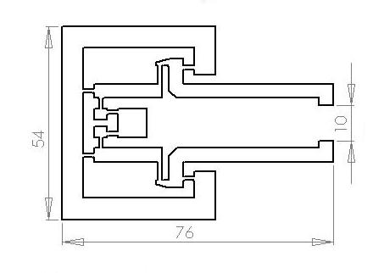
Figure 3: Geometrical parameters of the gripper

The study was made for the following applied loads: 1N, 3N, 5N, 6N, 8N.
The displacements and stresses are presented in the next figure:

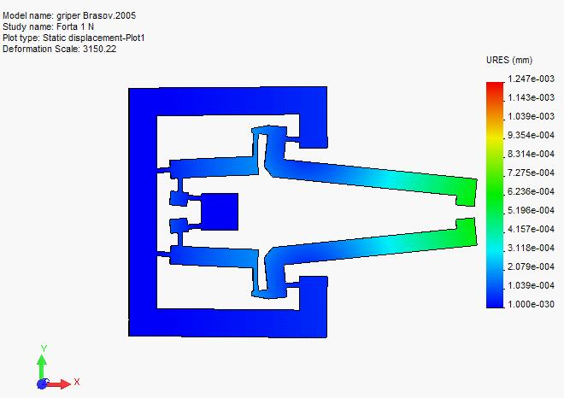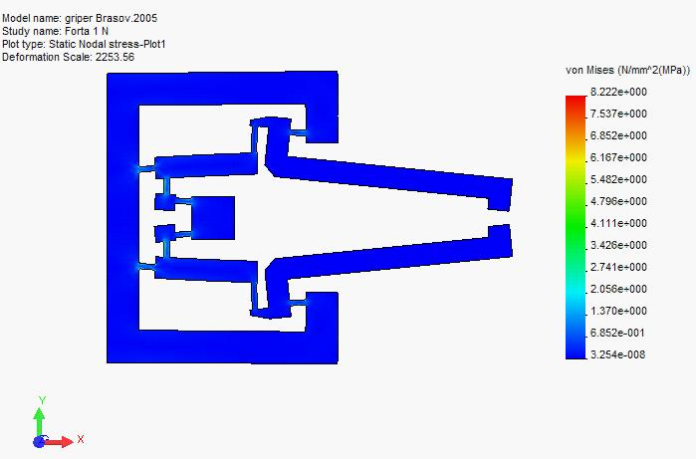

Figure 4: Displacements and von Mises stresses

The stresses vs. loads plot is presented in the next figure:

Figure 5: von Mises stresses for all applied forces

Figure 4: Displacements for all applied forces

3. CONCLUSION

The physical differences in geometry of the flexure hinges manifest themselves in different behaviors. The type of hinge used in a mechanism is dictated by its intended application. The circular flexure hinge is still not an optimum configuration as the motion range might be limited both by its geometry (at small radii, for instance) and the high stresses.
Parabolic hinges flexures are also subject to a reduced level of stress, as the stress concentration factors for this hinge for similar t, b, and h dimensions are typically lower than all other hinges.
Right circular flexures are a middle ground between these four extremes, having slightly less flexibility than corner filleted flexures.
The compliant mechanisms make possible the design of a new generation of high- and ultra-high-precision mechanisms.
Mastering the design of complex flexible structures as well as the interactions at the system level between the: mechanical structure, actuators, sensors, electronics, control algorithms, allows, in fact, to benefit from the proposed compliant mechanisms approach in the design of mechatronic equipment and instrumentation.
In recent years, considerable research efforts have been directed towards development of systematic design approaches to aid design of these unconventional mechanisms. The systematic creation of such mechanisms often requires specific knowledge and a range of tools that cross disciplinary boundaries

REFERENCES

[1] Lobontiu, N. :Compliant Mechanisms: Design of Flexure Hinges, CRC Press, Boca Raton, 2002
[2] Csibi, V., Mândru, D., Noveanu, S., Crişan, R. : Research concerning micromanipulation and design of microgrippers, in vol. Miskolcer Gesprache 2003, “Die neuesten ergebnisse auf dem gebiet fordertechnik und logistik” pag. 175 – 181, ISBN 963 661 595 0, 2003.
[3] Lobontiu, N. et al., : Parabolic and hyperbolic flexure hinges: flexibility, motion precision and stress characterization based on compliance closed-form equations”, Precision Engineering: Journal of the International Societies for Precision Engineering and Nanotechnology , 26(2), 185, 2002
[4] Kota, S., ş.a.: : Tailoring: Unconventional Actuators Using Compliant Transmissions: Design Methods and Applications, IEEE / ASME Transactions on Mechatronics, vol. 4, no.4, pag. 396 – 408, 1999.
[5] Noveanu, S., Csibi, V., Noveanu, D., : Analysis Of Compliant Mechanisms Using Finite Element, A IX-a Conferinţă Internaţională de Mecanisme şi Transmisii Mecanice, MTM 2004, în Acta Technica Napocensis, series Applied Mathemathics and Mechanics, 47, vol. II, Cluj-Napoca, 2004

