1st International Conference
″Computational Mechanics and Virtual Engineering ″
COMEC 2005
20 – 22 October 2005, Brasov, Romania

FRICTION MODELING IN MICRO LINEAR ROLLING SYSTEMS
FOR MEMS APPLICATIONS

Dumitru N. Olaru¹, Gheorghe Prisacaru¹, Gelu Ianus¹, Peter Lorenz²
¹ Technical University ”Gh. Asachi” Iasi, ROMANIA, dolaru@mec.tuiasi.ro
² Hochschule fur Technik und Wirtshaft des Saarlandes, Saarbrucken, Germany, lorenz@htw-saarland.de

Abstract: The authors propose an analytical model to evaluate the friction coefficient in a micro linear ball bearing. The proposed model includes both the friction losses developed in a macro rolling tribosystems and the adhesion and capillary effects specified to microsystems. The numerical values obtained by this model are in correlation with the experimental results obtained in [1].
Keywords : rolling friction coefficient, micro linear ball bearing, MEMS, capillary effects, adhesion

1. INTRODUCTION

The nanotechnology, described often as the technology of the future focused the researches and development activities in the last two decades. A lot of miniaturized devices, known as MEMS (micro electromechanical systems) was realised both for research in the laboratories and for various applications in the automotive industry, medical instrumentation, informatics technology as: micro sensors, linear and rotary micro actuators, micro motors, micro pumps, micro gear transmissions, micro grippers. The MEMS devices include mobile components with dimensions having the order of magnitude of about 10⁻⁶ m. When the dimension of a machine component decreases from millimetres to microns, the area decreases by a factor of 10⁶ and the volume (mass) decreases by a factor of 10⁹ . In the motion of such components the resistive forces as friction, viscous drags or surface tensions that are proportional to the area increase by a factor of 10³ or more that the inertial forces that are proportional with the mass of the elements. As a result of small dimensions friction on the moving surfaces in the MEMS becomes critical and is one of the fundamental limitations in the design and the fabrication of reliable MEMS. Most of the MEMS devices have contact-type bearings with sliding friction, when the friction coefficient can be usually higher than 0.5…1 and the stick-slip instabilities can appear in the low speed conditions. Also, the wear limits the performances of such devices. Non contact-type bearings with more complicated support mechanisms like electrostatic or pressurized air have much less friction and non wear compared to contact-type bearings but are more complex systems. The use of the micro linear or rotating ball bearings in the MEMS applications implies the simplify in construction, low level of friction and high stability, so that the micro ball bearings seems promising for future MEMS applications.
The first micro linear ball bearing structure was studied experimentally by Ghodssi et al. in 1993 and the static coefficient of friction was reported as low as 0.056 [1]. Recent researches realised by Ta-Wei Lin et al. [1] with sophisticated equipment determined the static and dynamic coefficient of friction for a micro ball linear system. By determining the acceleration in a linear micro ball structure, the authors established that the dynamic coefficient of friction is between 0.007 to 0.045 if is not interaction between balls. If the balls interacts the dynamic coefficient of friction can increases up to 0.6.

In this paper the authors propose an analytical model to evaluate the friction coefficient in a micro linear ball bearing. The proposed model includes both the friction losses developed in the macro rolling tribosystems [2] and the adhesion and capillary effects specified to microsystems. The numerical values of the coefficient of friction obtained by the developed model are in correlation with the experimental results obtained in [1].
2. FRICTION IN THE MICRO ROLLING TRIBOSYSTEMS

In macrotribology the processes are developed in components with relatively large mass under heavily loaded conditions. In these conditions, wear is inevitable and the bulk properties of mating components dominate the tribological performance. In micro/nanotribology, the tribological processes are developed in systems with relatively small mass under lightly loaded conditions. In this situation, negligible wear occurs and the surface properties dominate the tribological performance.
The components used in micro- and nanostructures are very light (on the order of a few micrograms) and operate under very light loads (on the order of a few micrograms to a few milligrams). As a result, friction and wear (on a nanoscale) of lightly loaded micro/nanocomponents are highly dependent on the surface interactions (few atomic layers). These structures are generally lubricated with molecularly thin films. In the micro and nanotribosystems a lot of interfacial forces as adhesion, van der Waals, electrostatic, capillary forces can be important and have an important contribution on the friction losses. Must be observed that in micro and nanotribosystems the friction forces and moments can stopped the normal function.
Adhesion between two solid surfaces based on the thermodynamic interfacial free energy can develop attraction forces of 200 - 300μN or more [3, 4, 5]. For a ball on a flat surface the adhesive force Fa is given by relation [3]:
$\text{Fa}=3⋅π⋅R⋅γ$ (1)
where R is the radius of the ball and γ is the interfacial energy ( J/m²).
For two balls in contact with radius R₁ and R₂ , the adhesive force is given by relation:
$\text{Fa}=3⋅π⋅γ⋅{\left[1/R_{1}+1/R_{2}\right]}^{−1}$ (2)
As a result of adhesion, a micro-rolling tribosystem can be loaded supplementary with normal force and the contact area Ac increases. According to the Johnson- Kendall-Robert (JKR) model [3], the contact area between a ball and a plane with including the adhesion effect is given by relation:
$A_{c}=π⋅{\left[\frac{R}{E^{}}⋅\left(Q_{0}+6⋅π⋅γ⋅R+\sqrt{\text{12}⋅π⋅γ⋅R⋅Q_{0}+{\left(6⋅π⋅γ⋅R\right)}^{2}}\right)\right]}^{2/3}$ (3)
where Q₀ is normal force applied to the ball. Even in absence of an applied a normal load, the ball stick to the surface.
E* is the equivalent elastic modulus for the two solids in contact:
$E^{}=\frac{4}{3}⋅{\left[\frac{1−ν_{1}^{2}}{E_{1}}+\frac{1−ν_{2}^{2}}{E_{2}}\right]}^{−1}$ (4)
where $ν$ and E are the Poisson ratio and Young’s modulus, respectively.
The capillary forces are presents as a result of the condensed water from atmosphere on the solids. The most of the solids are hydrophilic surfaces and the atmospheric water cover these surfaces with molecular layers. In the contact zone between the two solids, by the capillary effect the adhered water lead to increase of normal force. A lot of experiences evidenced the influence of the pressure, temperature and humidity of air on the thickness of the condensed water films. So, Opitz, A. et al [6] measured for hydrophilic silicon the water layers between 0.7 nm to 2.6 nm, depending of the pressure. Other experiments presented in [3-5] indicated the water layers of 10 to 50 nm, for various materials. The capillary effects are dominant for the water layers more than (0.7…1) nm [3, 6]. For a ball on a flat surface, as in Figure 1, the ball is attracted on the flat surfaces by a capillary force Fc given by relation [3]:

$F_{c}=4⋅π⋅R⋅γ$ (5)
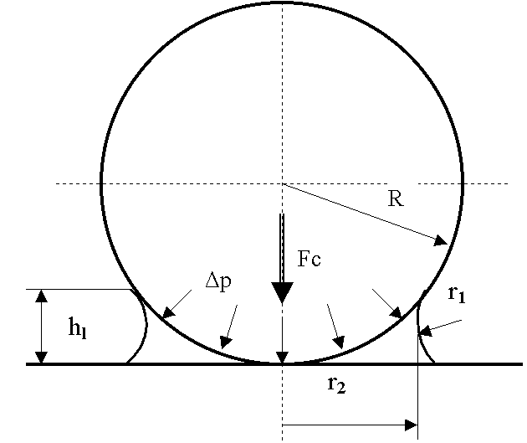
Figure 1: Ball-plane interaction as result of capillary force

For a ball-ball contact the radius R in relation (5) will be changed by the equivalent radius R* given by relation:
$R^{}={\left[1/R_{1}+1/R_{2}\right]}^{−1}$ (6)

3. AN ANALYTICAL MODEL TO EVALUATE FRICTION LOSSES IN A MICRO LINEAR BALL BEARING

In the Figure 2 is presented the geometry of a micro linear ball bearing. The slider is in relative linear motion from the stator with the linear speed v and the ball has a angular velocity ω_{b} .
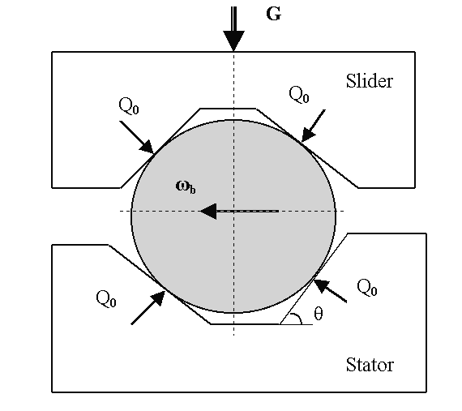
Figure 2: The geometry of the micro - linear ball bearing

Under the external load G all the four contacts of the ball with slider and stator are loaded with a normal force Q₀ given by relation:
$Q_{0}=\frac{G}{2⋅z⋅\text{cos}θ}$ (7)
According to the JRK adhesion model the normal force for every ball – race contact Q will be higher that Q₀ and we propose to be computed by following relation:
$Q=\left(Q_{0}+6⋅π⋅γ⋅R+\sqrt{\text{12}⋅π⋅γ⋅R⋅Q_{0}+{\left(6⋅π⋅γ⋅R\right)}^{2}}\right)$ (8)
Considering thin water layers on the surfaces of balls and races as lubricant, in all four contacts are developed followings forces [2]: hydrodynamic rolling forces FR, pressure forces FP, sliding contact forces FS.
The directions of these forces acting on the ball are presented in figure 3. Note that the index 1 refers to slider and index 2 refers to stator. The hydrodynamic forces FR1 and FR2 are computed with relation:
$\text{FR}=2\text{.}\text{86}⋅E⋅{\text{Rx}}^{2}⋅k^{0\text{.}\text{348}}⋅G^{0\text{.}\text{022}}⋅U^{0\text{.}\text{66}}⋅W^{0\text{.}\text{47}}$ (9)
where E is the equivalent Young’s modulus of the materials in contact, R_{X} is the equivalent radius in the rolling direction, k is the radii ratio.
G is the dimensionless material parameter,
$G=E⋅α_{p}$ (10)
where $α_{p}$ is the piesoviscozitat coefficient.
U is the dimensionless speed parameter,
$U=\frac{η_{0}⋅v}{E⋅\text{Rx}}$ (11)
where$η_{0}$ is the viscosity of the lubricant at the atmospheric pressure and at the contact temperature, v is the tangential speed in the ball-races, in the rolling direction.
W is the dimensionless load parameter definite by relation:
$W=\frac{Q}{E⋅{\text{Rx}}^{2}}$ (12)
where Q is normal load in the ball-race contact.
FP is pressure forces due to the horizontal component of the lubricant pressure in the rolling direction. For a ball – ring contact, the pressure force acting on the centre of the ball can be expressed as a function of hydrodynamic rolling force FR:
$\text{FPb}=2⋅\text{FR}⋅\frac{R_{R}}{R_{R}+R_{b}}$ (13)
where R_{b} is the ball radius and R_{R} is the ring radius.
The friction forces FS on the two contacts are the sliding traction forces due to local micro slip occurring in the contact, and can be calculated explicitly as the integral of the shear stress $τ$ over the contact area:
$\text{FS}=\int{τ⋅\text{dA}}$ (14)

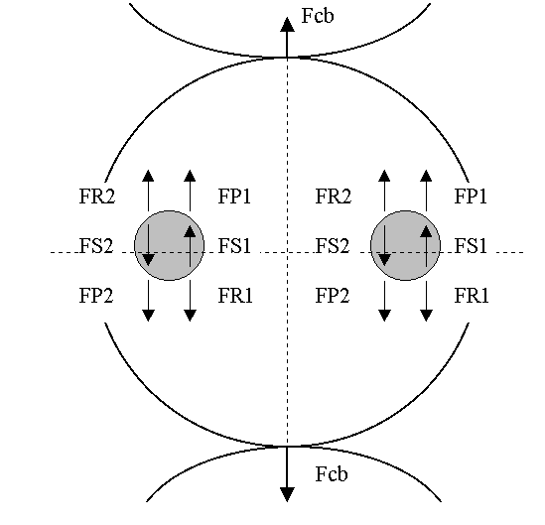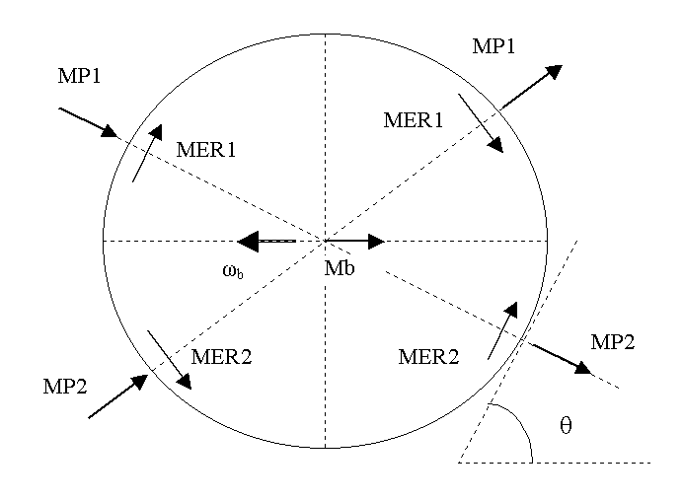
Figure 3: Forces acting on a ball in rolling direction
Figure 4: The moments acting on a ball

The capillary force between balls, Fcb is computed with relations (5). The friction forces FS1 and FS2 can not be easy determined directly by relation (14). Shear stress on the ball race contacts $τ$are depending of microslidings on contact surface, rheology of thin water layers, contact pressure. Based on the equilibrium of the forces and moments acting on the ball, the friction forces FS1 and FS2 can be determined as result of all the other forces and moments acting on the ball. The moments acting on the ball are presented in figure 4. In each ball-race contact, two resistance moments are developed: the elastic resistance moments MER1 and MER2 and the pivoting moments MP1, MP2.
$\text{MER}=7\text{.}\text{48}⋅{\text{10}}^{−7}⋅{\left(\frac{d}{2}\right)}^{0\text{.}\text{33}}⋅Q^{1\text{.}\text{33}}⋅\left[1−3\text{.}\text{519}⋅{\text{10}}^{−3}⋅{\left(k−1\right)}^{0\text{.}\text{806}}\right]$ (15)
where d is the ball diameter.
Considering a constant friction coefficient for the sliding motion in a ball- race contact$μ_{s}$, the pivoting moment MP can be evaluated by relation:
$\text{MP}=\frac{3}{8}⋅μ_{s}⋅Q⋅a$ (16)
The semi major contact ellipse axis a is computed considering both normal load Q₀ and adhesion, according to JRK model. As a result of contacts between balls, for each ball acts a resistance moment Mb evaluated by relation:
$\text{Mb}=μ_{b}⋅\text{Fcb}⋅d$ (17)
where$μ_{b}$is the friction coefficient between two balls and Fcb is the capillary force determined with relations (5).
To determine the friction forces FS1 and FS2, following two equations of equilibrium are written:
- the equilibrium of the forces acting of the ball in the rolling direction,
$\text{FS}1−\text{FS}2−(\text{FR}1−\text{FR}2)+(\text{FP}1−\text{FP}2)=0$ (18)
- the equilibrium of the moments acting on the ball,
$\left[\left(\text{MP}1+\text{MP}2\right)⋅\text{tg}(θ)+(\text{MER}1+\text{MER}2)+\frac{\text{Mb}}{\text{cos}(θ)}\right]=\frac{d}{2}⋅\left(\text{FS}1+\text{FS}2−\text{FR}1−\text{FR}2\right)$ (19)
For the same geometry and material for slider and stator the forces FR and the moments MP and MER are the same values both for contact (1) and contact (2). Results the same values for FS1 and FS2 given by relation:
$\text{FS}1=\text{FS}2=\text{FS}=\frac{1}{d}⋅\left[2\text{MP}⋅\text{tg}(θ)+2\text{MER}+\frac{\text{Mb}}{\text{cos}(θ)}\right]+\text{FR}$ (20)
For every ball-race contact, the ball acts on the race, according to figure 3 with the total tangential force in rolling direction $\text{FS}+\text{FR}−\text{FP}$
Considering that every ball acts on the slider or stator in two contact points and note that the pressure force acting on a linear race is null ( FP = 0) it can be obtained the total tangential resistance force given by a ball in rolling motion:
$F_{\text{ball}−\text{race}}=\frac{1}{d}⋅\left[4\text{MP}⋅\text{tg}(θ)+4\text{MER}+\frac{2\text{Mb}}{\text{cos}(θ)}\right]+4\text{FR}$ (21)
For a system with z balls on the slider or on the stator acts a total tangential force F_{total} given by relation:
$F_{\text{total}}=z⋅F{}_{\text{ball}−\text{race}}^{}{}$ (22)
The friction coefficient can be obtained by dividing the total tangential resistance of the slider by the normal load G:
$μ_{\text{global}}=\frac{z⋅F_{\text{ball}−\text{race}}}{G}$ (23)
Numerical results
The numerical results are performed for the condition used in the paper [1]: stainless steel balls with diameter d = 285 μm; silicon slider and stator with two V – groves realised at an angle θ = 54.7º; temperature of 27 degree and a relative humidity of 40%RH; relative speed between the slider and stator was between zero to 150 mm/s;
The number of the balls and the load G was considered in two variants: Variant A with 4 balls without contact between balls and a mass of the slider G = 0.9 grams; Variant B with 18 balls on the two V – grooves ( 9 balls for each V-groove) with the balls in contact one each other and the mass of slider G = 0.4 grams. The elastically properties of the ball and races was: $E_{\text{steel}}=2\text{.}1⋅{\text{10}}^{\text{11}}\text{Pa}$, $E_{\text{silicon}}=1\text{.}5⋅{\text{10}}^{\text{11}}\text{Pa}$, $ν_{\text{steel}}=0\text{.}3$, $ν_{\text{silicon}}=0\text{.}3$. The viscosity of water $η=0\text{.}\text{001}\text{Pa}⋅s$ and the piesoviscosit coefficient $α_{p}={\text{10}}^{−8}{\text{Pa}}^{−1}$. The selection of the friction coefficient values for the pivoting moment between ball ad races $μ_{s}$ and for the ball-ball contact moment $μ_{b}$was made according to the friction measurements realized with the various devices at the micro scale [3,4,5,6].
Friction coefficient for a system with 4 balls without contacts between balls:
The contact ball –race friction coefficient was computed for two values of the friction coefficient in pivoting motion, so for μ_{s} = 0.5 and for μ_{s} = 1.

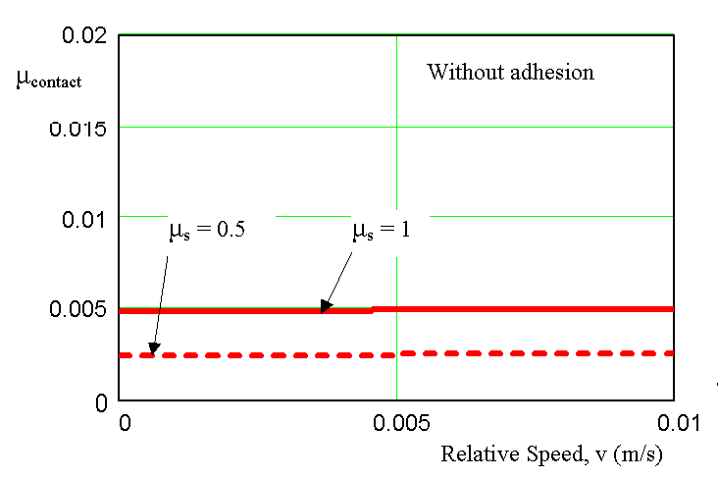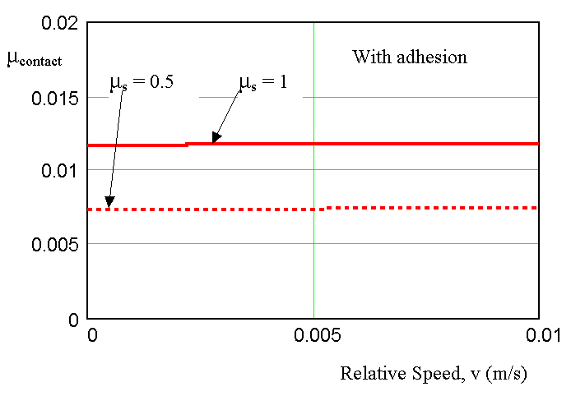
( a ) ( b )
Figure 5: Contact ball-race friction coefficient determined by analytical model:
without ball-race adhesion effect (a) and with ball-race adhesion effect (b)

If it was neglected the adhesion between ball and race, was obtained values for the contact friction coefficient between 0.002 and 0.005 , as in figure 5-a. Including the adhesion effects was obtained increasing of the contact friction coefficient with values between 0.007 and 0.012, as in figure 5-b.
According to our analytical model it can be obtained accepted values for the contact ball-race friction coefficient with a magnitude between 0.002 to 0.012, for a micro linear ball bearing. Comparison with experimental values obtained by [1] in the similar conditions evidenced a good correlations between the average values obtained by experiment ($μ_{\text{contact}}$= 0.007) and the computed values by including adhesion effect ($μ_{\text{contact}}$ = 0.007…0.012).

Friction coefficient for a system with 18 balls with contacts between balls
The global friction coefficient was computed in the variant B for 18 balls and the mass of slider G = 0.4 grams. The friction coefficient for ball-race pivoting motion was imposed μ_{s} = 1 and two values for the friction coefficient between two balls in contact was imposed : μ_{b} = 0.5 and μ_{b} = 1. The results are presented in figure 6.
The obtained values are between 0.25 to 0.55 for the condition imposed. In the similar conditions, by the experiments realized in [1] it was obtained variation of the friction coefficient between 0.2 and 0.6.
It can be observed that the contacts between balls dominates the losses for the given conditions. The influence of the pivoting friction is more smaller that the friction between balls.
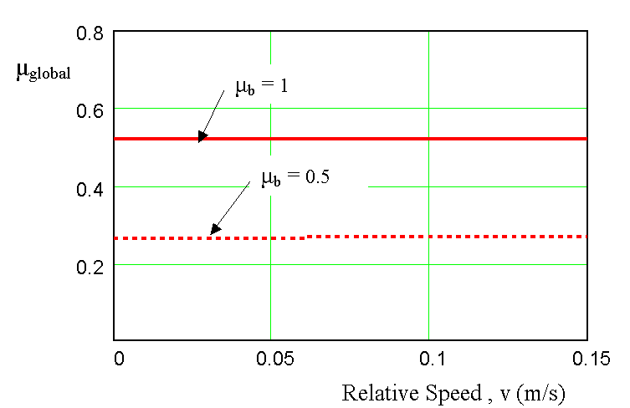
Figure 6: The global friction coefficient determined by analytical model for 18 balls

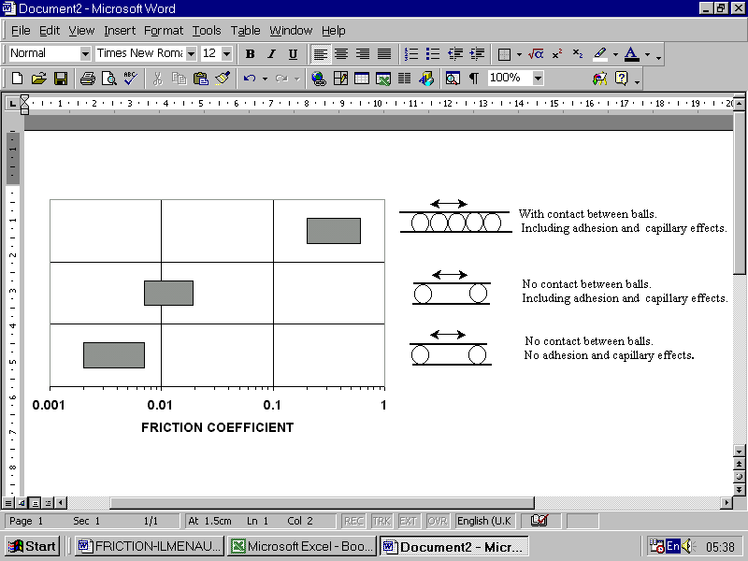
Figure 7: Friction coefficient in a micro linear rolling system

In figure 7 are presented the most important results of friction coefficient in a micro linear rolling system. So, withouth adhesion and capillary effects the friction coefficient in a micro linear rolling system has values between 0.002 to 0.008 (similar with a macro linear system). Adhesion and capillary effects esspecialy lead to an important increasing of the friction coefficient with about two order of magnitude.

4. CONCLUSIONS

A complex analytical model to evaluate the friction coefficient in a micro linear ball bearing has been developed. The model includes following losses sources: pivoting motion between ball-race, elastic resistance in rolling of the ball over the races, hydrodynamic effects in ball-races and the losses in the ball-ball contacts. Both adhesion between balls and the races and capillary effects in ball - ball contacts was considered. To validate the model, the numerical results was performed for a micro linear ball bearing studied experimental by [1]. The numerical results are in the same range of values with experimental results. When the balls are not in direct contact one with other, the friction coefficient have values between 0.007 to 0.012. For this condition the most important source of losses is the ball-race pivoting motion. When the balls are in direct contacts one with other, the friction coefficient increases with an order of magnitude. So, values for friction coefficient between 0.25 and 0.55 was obtained. The friction losses between the ball-ball contacts are dominate.

REFERENCES

[1] Lin, T. W.,Modafe,A., Shapiro,B. and Ghodssi R., 2004, Characterization of Dynamic Friction in MEMS – Based Microball Bearings, IEE Transaction of Instrumentation and Measurement, vol.53, N0.3, June 2004, pp.839-845.
[2] Olaru,D.N., Lorenz, P., Rudy, D., 2004, Friction in the Circular – Arc Grooves Linear Rolling Guidance System, Tribologie und Schmierungstechnik, No.2/2004, pp. 8–12.
[3] Scherge,M. and Gorb, S., 2001, Biological Micro- and Nano- tribology. Nature’s Solution, Springer, Berlin.
[4] Scherge, M., Li, X. and Schaefer, A.,1999, The effect of water on friction of MEMS, Tribology Letters, No.6, vol. 3-4, pp.215-220.
[5] Scherge, M., 2001, Scale Dependence of Friction, Proc. of 2th World Tribology Congress, Vienna, paper No:489.
[6] Opiz,A.,Ahmed,S.,Schaefer,J.A. and Scherge,M., 2002, Friction of the thin water fils: a nanotribological study, Surface Science vol.504, pp.199-207.

