1st International Conference
″Computational Mechanics and Virtual Engineering ″
COMEC 2005
20 – 22 October 2005, Brasov, Romania

FINITE ELEMENT MODELING IN BIOMECHANICAL SYSTEMS

Ciprian Radu¹
¹ Transylvania University, Brasov, ROMANIA, ciprian_radu@hotmail.com

Abstract: Numerical approximation of the solutions to continuum mechanics boundary value problems, by means of finite element analysis, has proven to be of incalculable benefit to the field of musculoskeletal biomechanics. This article briefly outlines the conceptual basis of finite element analysis and discusses a number of the key technical considerations involved, specifically from the standpoint of effective modeling of biomechanical systems. The purpose of this paper is to perform a finite element analysis of a human fibular bone to validate the applicability of the finite element technique to this kind of complex structures, the human bones. The bone is modeled as nonhomogenous, orthotropic and linear elastic material.
Keywords: finite element analysis, 3D modeling, fibular bone, reaction forces, medical implant

1. THE ROLE OF FINITE ELEMENT ANALYSIS IN BIOMECHANICS

The first applications of FEA to biomechanics, which appeared in 1972, involved isotropic linearly elastic structural analyses of bone, performed by groups working independently in the U.S. (Rybicki et al., 1972) and in the Netherlands (Brekelmans et al., 1972). This new capability’s benefit to the field of biomechanics was immediately evident. For the first time, one could calculate mechanical stresses in bodies having complicated shapes, complicated material distributions, and/or complicated loadings.
Other types of biomechanical complexity subsequently addressed have included material anisotropy, material and geometrical nonlinearity, contact and interface nonlinearities, time-variant loadings, adaptive behavior (material and geometrical), and fluid/structure interactions.
Biomechanical FEA studies sometimes involve man-made geometries (e.g., surgical implants), sometimes natural geometries (anatomical structures), and sometimes both. For man-made geometries, mesh zonings at the simplest level can be based on nominally corresponding geometrical abstractions.
Regarding natural geometries, a key consideration is whether the anatomic representation is generic vs. case- (or patient-) specific. Source geometric data for the meshing of natural structures nowadays usually come from three-dimensional imaging modalities such as computed axial tomography (CT), magnetic resonance imaging (MRI), or confocal microscopy. Sometimes photographs of serial physical sections are used instead, and on rare occasions, plane film or biplanar x rays.
Geometric fidelity typically depends on the resolution of the pixel or voxel image source. Another consideration is that such image sources often have limited capability for delineating subregions of differing material behavior.
There are two primary sources of complexity in the loadings typically encountered in biomechanical finite element studies. The first complexity is temporal, some systems are appropriately analyzed with a single static loading, other systems with a series of different quasi-static loadings, yet other systems merit fully dynamic treatment (i.e., inertial effects included). Occasionally, modal analysis is invoked for applications such as vibration studies. The second source of complexity is the spatial distribution of loading. Point loadings (the simplest situation) are relatively rare, as are line loadings. Most frequently, loadings of interest occur across surfaces, and most commonly they are nonuniformly distributed. These can take the form of prescribed traction distributions, or they can be loading-contingent, as for example in contact problems.
Sometimes it is appropriate to also superimpose a distributed body force to account for weight. Besides loading, the other commonly encountered type of external influence is displacement boundary conditions. These can take the form of a constraint against motion in one or more degrees of freedom, either applied at individual element nodes or along element edges or faces. Alternatively, rather than fixities, displacement boundary conditions can involve prescribed nonzero displacements in one or more degrees of freedom, again specified at nodes, along element edges, or over element faces. For some problems it is appropriate to make provision for mechanical interaction across an interface. One type of interface treatment is friction-dependent slip/nonslip.

2. STAGES OF THE MODELING PROCESS

Finite element studies generally involve five stages. In the first stage the 3D virtual model of fibular segment witch was obtained using the MIMICS software is imported into the finite analysis program ANSYS. The 3D model is compound from 2926 areas (figure 1) and to be analyzed these areas mast form a single volume.

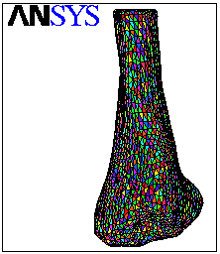
Figure 1: 3D model of the fibular segment compound from 2926 areas.

The next phase, known as preprocessing, involves prescribing the mesh geometry, specifying the material property distributions, and designating the loading. The bone is modeled as nonhomogenous, orthotropic and linear elastic material. This means that the bone elastic modulus vary between 33% (when the density is 1.5g/cm³) and 62% (when the density is 2g/cm³) and has the higher value on axial direction then transversal and longitudinal direction. On the axial direction the elastic modulus is 19.34 GPa, on the transversal direction the value is 11.23 GPa and on the longitudinal direction the value is 9.74 GPa. Also the Poisson coefficient (ν_{x} = 0.31; ν_{y} = 0.18; ν_{z} = 0.18) and tensile strength (σ_{x} = 4.32 GPa; σ_{y} = 3.57 GPa; σ_{z} = 3.57 GPa) are different on the X, Y, Z directions.
In this case, when the material is orthotropic (composite material), for accurate results I have used ten node tetrahedral elements with the element mesh size of 2 mm. The finite element software has generated for fibular model a number of 498,910 nodes and 361,404 elements.

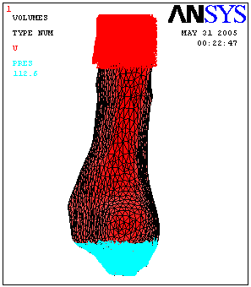
Figure 2: Axial loading applied over the inferior part of the fibular bone.

The 3D model is constrained on the superior part and on the inferior part is subjected with a compression pressure force of 112.6 Pa (figure 2). The compression force is the 1/6 part of the total reaction force witch acts in a human ankle having a weight of 70 kg.

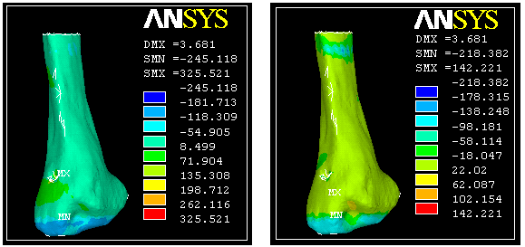
a) b)
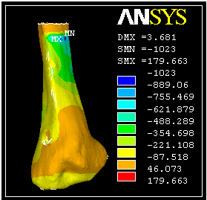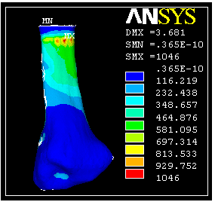
c) d)
Figure 3: The finite element analysis results: a) the stress on the x direction (Sx); b) the stress on the y direction (Sy); the stress on the z direction (Sz); d) equivalent stresses.

Then the finite element solution is executed computationally, a process usually involving little or no direct interaction with the user. There then follows a stage known as post processing, where the FE solution’s raw output is used to compute variables of interest, and where selected information is displayed graphically (figure 3).
The final stage is that of interpretation of the results, a process heavily dependent on analyst judgment. The final results of the finite analysis of the fibular 3D model are written in Table 1.

Table 1: The final result of the finite analysis of the fibular 3D model.
Stress on the x direction  [MPa] |  | Stress on the y direction  [MPa] |  | Stress on the z direction  [MPa] |  | Equivalent stresses  [MPa]
Min. | Max. | Min. | Max. | Min. | Max. | Min. | Max.
-245.118 | 325.521 | -218.382 | -1023 | 179.663 | 142.221 | 0.365x10⁻⁴ | 1046

3. CONCLUSIONS

The potential for mechanobiology to contribute to clinical progress looks promising. Mechanically based diseases such as osteoporosis and osteoarthritis are already areas with intense research activity. In addition, the development of successful synthetic and engineered organs and tissues will depend on mechanobiological progress. It is important that not only knowledge of the natural tissues is focused on. Also controlling and modelling mechanical stimuli will be essential to develop appropriately engineered organs and how to integrate the function with the host.
Additionally, the finite element model used in the present study, characterized by a solid tetrahedral element mesh, was able to analyse the stress in the purpose of validating mechanical and material properties of bone.

REFERENCES

- Brekelmans, W.A.M., Poort, H.W. and Sloof, T.J.J.H.: A new method to analyze the mechanical behavior of skeletal parts, Acta Orthopaedica Scandinavica, 43, 1972.
- Grosland, N.M. and Brown, T.D.: A voxel-based formulation for contact finite element analysis, Computer Methods in Biomechanics and Biomedical Engineering, 5, 2002.
- Keyak, J.H. and Skinner, H.B.: Three-dimensional finite element modeling of bone: Effects of element size, Journal of Biomedical Engineering, 14, 1992.
- Radu C.: On the Design of a Prosthetic Element Using the Rapid Prototyping Technology, Transylvania University from Brasov, Romania 2005.
- Sofia N: Simulation of Bone Mechanics, Technical Reports from Royal Institute of Technology of Mechanics, Stockholm, Sweden, 2002.
- Thomas D.: Finite Element Modeling in Musculoskeletal Biomechanics, Journal of Applied Biomechanics, University of Iowa, 2004.

