1st International Conference
″Computational Mechanics and Virtual Engineering ″
COMEC 2005
20 – 22 October 2005, Brasov, Romania

COMPUTER AIDED DIAGNOSTIC SYSTEM FOR MACULAR DISEASES

Marius C. LUCULESCU¹
¹ “Transilvania” University of Braşov, Romania, lucmar@unitbv.ro

Abstract: This paper presents a Computer Aided Diagnostic (CAD) system for macular diseases consisting from an image acquisition part, a digital image processing part, a neural network for diagnostic recognition and a database for patients. The image of the macula can be obtained from a digital retinoscope or by scanning the slides. It can be processed for emphasizing some characteristics. Image features are extracted and applied on the inputs of a neural network that will suggest what diagnostic is about. The doctor has the final decision after a discussion with the patient. The diagnostic can be stored in a database at the patient corresponding record.
Keywords: Image, diagnostic, computer, macular, neural network.

1. INTRODUCTION

One of the most important problems in our days is related to the eye diseases. There was developed in this sense specialized clinics, research and rehabilitation centers, international associations, foundations and so on. It is enough to remember just some of them: American Foundation for the Blind, American Academy of Ophthalmology, American Optometric Association, Association for Macular Diseases, Macular Degeneration Foundation, Inc., Macular Degeneration Network, National Eye Institute and The Schepens Eye Research Center.

Macular diseases, especially age related macular degeneration are an increasing problem worldwide. Current treatment options can delay progression and research continues into ways of reversing retinal damage.

Macular degeneration is caused by the deterioration of the central portion of the retina, the inside back layer of the eye that records the images we see and sends them via the optic nerve from the eye to the brain. The retina's central portion, known as the macula, is responsible for focusing central vision in the eye and it controls our ability to read, drive a car, recognize faces or colors and see objects in fine detail [1].

2. COMPUTER AIDED DIAGNOSTIC SYSTEM

The Computer Aided Diagnostic system has to analyze the image of the patient’s macula and classify it as a normal one, as a known diagnostic or as an unknown diagnostic. The system is trained to recognize the normal macula and a set for diagnostics, but it can be also further trained to learn more.

The structure of the system is presented in Figure 1. Retina’s image is taken in the computer using two methods, depending on the acquisition modality. It can be used either a digital retinoscope that offers a digital image directly or a retinoscope that has the possibility of taking pictures on colour-reversal film. These last pictures would be digitized using a scanner. The system is ready to work with any image of the retina, in digital format. The file format of the image used for recognition has to be a jpg one.

Having the image on the computer screen, the doctor can analyze it. The software offers a lot of options starting with opening a file, saving it in the same or other format, viewing the image, the Red, Green and Blue components, transforming from RGB to Gray. Histograms for R, G, B components can be computed and plotted for a number of maximum 255 bins. User can zoom, pan, horizontal and vertical mirror and rotate the image. The contrast can be enhanced using histogram equalization and on the image we can apply different types of filters [5]. Doctor can select and crop an interest part of image and can save it. All of these tools are used for emphasizing some image characteristics so that the diagnostic to be easy recognized.

R
etina’s image

to

computer

(digital format)

Image analysis,

feature
extraction

Artificial neural
network
f
or
diagnostic
recognition

Neural network
decision

Information from
a doctor
–
patient
discussion

Diagnostic

Patients

database

Image sent
Figure 1: Structure of the Computer Aided Diagnostic System

It exists also the possibility to compare two images, visual and by plotting the R, G, B histograms or computing a set of seven 2D moment invariants for each R, G, B component and for the gray image. Histograms have to be normalized due to the fact that images may have different sizes.

After the image analyze, doctor can save it and prepare it to be recognized by the system. For doing this, the software will compute a set of values that represent important features of the image.

These values can be: the normalized histograms for a certain number of bins, a set of seven 2D moment invariants that are insensitive to translation, change, scale, mirroring and rotation of the image, computed for R, G, B components and for the gray image and a set of six values that describe a region by quantifying its texture content [2]. The six descriptors are based on statistical properties of the intensity histogram, namely on statistical moments and they are: mean – a measure of average intensity, standard deviation – a measure of average contrast, smoothness of the intensity in that region, third moment – a measure of skewness of a histogram, uniformity and entropy.

Some of these values will represent the inputs for the artificial neural network used in diagnostic recognition [4]. Two types of networks were tested in the design phase of the system: a multilayer perceptron network and a feed-forward backpropagation network. User can design, train and test them for improving the system performance.

For doing this, a training set can be generated form a diagnostics database, selecting a group of the image’s feature values. Database contains atlas digital images of normal macula and of some known diagnostics for macular diseases, but new images can be added further. The number of values representing features will determine the number of inputs in the neural network. The structure of the network can be modified and also the training parameters. Learning is a supervised one. Best results were obtained with multilayer perceptron network.

After the successful training process, the network was tested with a set of images some of them representing similar diagnostics or normal macula status or unknown diagnostics.

The artificial neural network can decide if the image of the patient’s macula is normal or not. If it is not normal, the diagnostic can be recognized if it is a known one or the response will be: “unknown diagnostic” if the network was not trained to recognize it.

The doctor receives the decision from the Computer Aided Diagnostic System and after a discussion with the patient about pathological antecedents, other diseases, different medical treatments, will establish the final diagnostic. This can be stored in the patients’ database.

For the beginning the database is a .mat Matlab file containing a structure called Diagnostic having certain fields that are verified at the opening moment. The database contains information about patient name, male or female, identification number, age, domain, diagnostic date, diagnostic name, diagnostic image file, pathological antecedents, medical treatments, remarks and so on.

Records of the database can be browsed, viewing the evolution of patient diseases with associated text and images. All editing operations are allowed. It is possible to append new records, to modify the existing records and to delete records. Information from this database can be exported to a diagnostic database and can also be used to train the neural network for improving recognition performances.
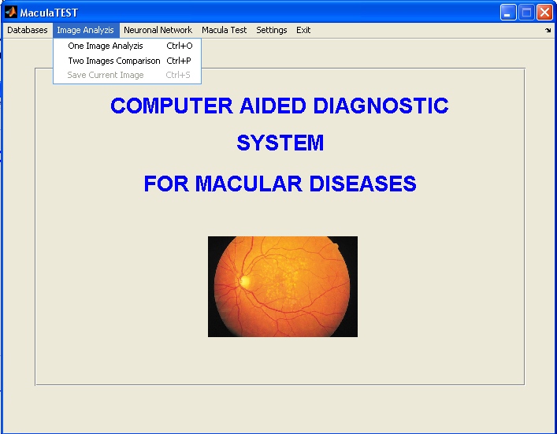
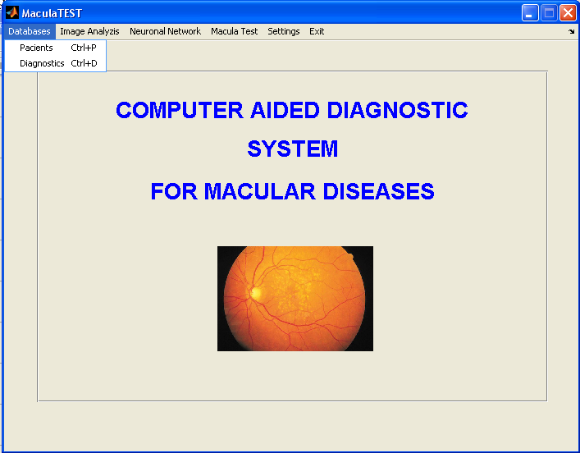
Figure 2: Database menu module and Image Processing menu module of the Computer Aided Diagnostic System

The software was developed in Matlab and consists in a Graphical User Interface [3], [6], [7] with a simple menu bar from where can be accessed all the options for the system: databases for diagnostics and patients, image processing options, diagnostic recognition module, program settings.

I have chosen Matlab as a programming language for this system because it is a high-performance language for technical computing whose basic data element is an array that does not require dimensioning. This allows solving many technical computing problems, especially those with matrix and vector formulations. We know that image files are 2D or 3D arrays of values, so matrix operations will be easy to do.

The software is supplied in an executable format, so it can be installed on every computer without having to install Matlab.

3. CONCLUSION

The system presents important advantages, like:
- The diagnostic obtained using a computer aided procedure will diminish the level of doctor’s incertitude regarding pathological aspects;
- The CAD system allows to trace the evolution of patient’s status during new methods or types of treatment;
- It is possible to generate diagnostic databases that can be used in the research domain, in medical practice and in specialty teaching process;
- A patient database is very useful because it can store personal information and diagnostic information that can be used as a legal base on treatment validation. The doctor will have a better image on the general evolution of patient’s disease. All these information can be secure accessed by other doctors or specialists for consultation;
- The system offers the possibility to process a digital image, to analyze it and to compare images;
- The system can be trained to recognize more diagnostics;
- Not only macular diseases diagnostics can be recognized, but the system can be used for every type of diagnostic based on a digital image.

New development directions for the system will focus on:
- The possibility to implement the remote access for patient and diagnostic databases, using local networks or internet;
- Embedding the system so that to be implemented in a digital retinoscope with a display system, working off-line or on-line with a computer, having the possibility to store information and to send them when computer asks for;
- On-line retina’s image analyzes on the computer;
- Integration in a database server for different types of diagnostics, with remote access for researchers, doctors, teachers and students.

REFERENCES

- www.macular.org – American Macular Degeneration Foundation
- Gonzales R., Woods R., Eddins S.: Digital Image processing using Matlab, Pearson Prentice Hall, 2004
- Marchand P, Holland T.: Graphics and GUIs with MATLAB - Third Edition, CRC Press, 2003
- Tzanakou-Micheli E.: Supervised and Unsupervised Pattern Recognition – Feature extraction and Computational Inteligence, CRC Press, 2000
- Russ J: The Image Processing Handbook, Fourth Edition, , CRC Press, 2002
- The MathWorks Inc. - Matlab – Image Processing Toolbox
- The MathWorks Inc. - Matlab – Neural Network Toolbox

