1st International Conference
″Computational Mechanics and Virtual Engineering ″
COMEC 2005
20 – 22 October 2005, Brasov, Romania

ANIMATING THE HUMAN LOWER LIMBS MODEL

Mihai Cismaru¹, Ileana Constanta Rosca²
¹ Transilvania University of Brasov, ROMANIA, cismaru@unitbv.ro
² Transilvania University of Brasov, ROMANIA, ilcrosca@unitbv.ro

Abstract: After the construction of the human lower limbs, begins the process of building a bone structure. A virtual bone will be constructed for the femur, the tibia and for the toes. Between the femur and tibia it was establish an inverse kinematics chain. Each articulation will have a dummy object that will allow the bones to move. The trajectories of the dummy objects were set manually. The final process was to apply the model on the bones and to establish the influence for each bone. In the end were presented some conclusions about the study.
Keywords: modeling, bone structure, animation and trajectory.

1. INTRODUCTION

One of the difficulties in the animation process of a biped character is the fact that the human eye is familiar with the common walk, and the imperfections like a bad coordination of the limbs or a bad timing of the movements, can be easily detected.
Modeling the human body beginning form a bone structure, which is more or less accurate, it can be done by using the kinematics and interpolation methods to restrain the model to have non-realistic movements.
Because of this reason to animate the lower limbs, it was used the inverse kinematics method.
The kinematics method studies the variation of the geometrical relations of the objects, thru time.

2. ANIMATING THE MODEL

To start the animation, first a model of the human lower limbs it must be created (figure 1). The process modeling of the lower limbs will not be described in this paper.

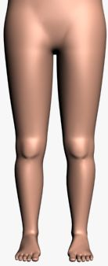
Figure 1: The lower limbs model

To create a more real bone structure, it is necessary to know the human lower limbs bone structure and to study the movements and the restrictions of these bones. The virtual bones were built inside the model of the lower limbs. For a more simple approach, the bone structure it will be represented without the model (figure 2). The model of the lower limbs will be hided thru the animation process, so the system will not crash.

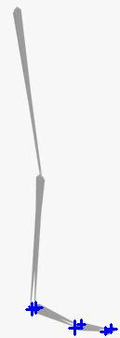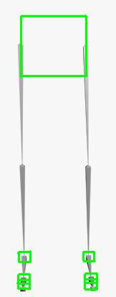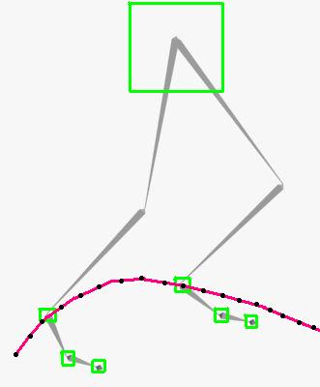
Figure 2: The bone structure

The bone structure contains a bone for the femur, a bone for the tibia, a bone for the whole heel structure (talus, calcaneus, navicular, cumeiform, cuboid and metatarsal) and a bone for the toes. After the construction of the bones, the next step is to create inverse kinematics chains between the bones. The first kinematics chain is establish between the femur and the heel bones, and is formed by the femur and the tibia, the second chain is formed by the heel bones and the third chain is formed by the toes (figure 2). A blue cross represents the end of the kinematics chain.
Each end of the kinematics chains will be tied to dummy object. A green cube represents the dummy object. The role of the dummy object is to ease the movement of the chain. To represent the movement of the pelvis, it will be necessary to create a dummy object, which will have the both lower limbs bone structure connected to it.
The next step is to start establish the trajectories of dummy objects. The trajectories are set manually (figure 3, 4 and 5).

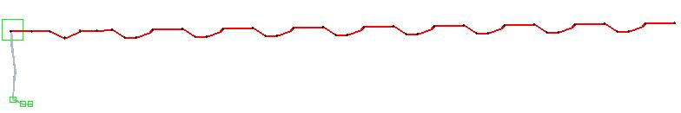
Figure 3: The trajectory of the pelvis

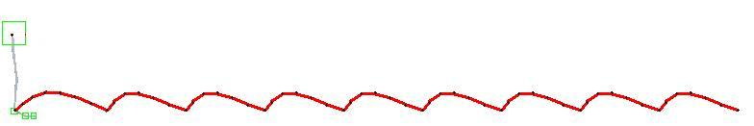
Figure 4: The trajectory of the ankle articulation

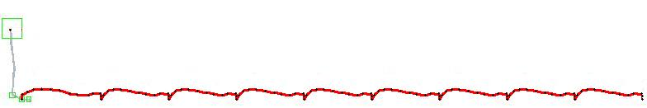
Figure 5: The trajectory of the metatarsal articulation
After establishing the trajectories, the next step is to set the model of the lower limbs as a skin envelope. To do this, is necessary to set the bone structure as a part of the envelope. Each bone must control a part of the skin (figure 6). The vertexes that will be fully connected to a bone, will be red and the vertexes that will be partial connected to a bone, will be yellow or blue. If the color is yellow, the vertex has a fifty-fifty influences form two bones, and if the color is blue, the vertex has a larger influence from one of the two bones. If the bone influence is not correctly establish, the skin will suffer deformations (figure 7 and 8). The biggest problems are at the level of each articulation, especially the knee articulation. For this reason when the knee is bend, the skin form the femur and the skin from the tibia, are starting to enter thru one another.

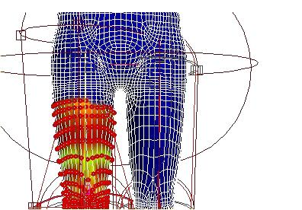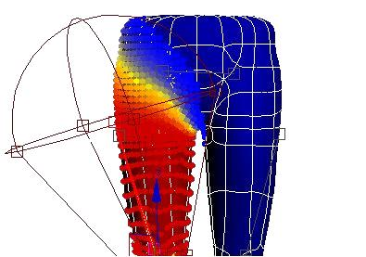
Figure 6: The bone influence

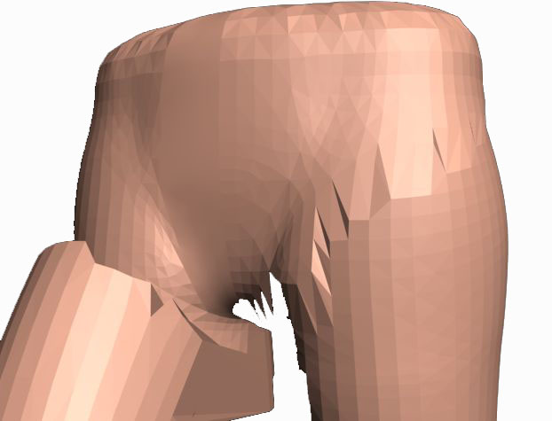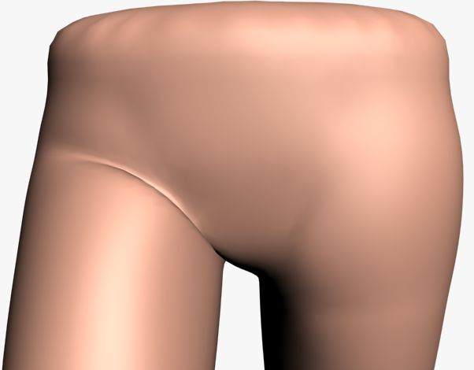
Figure 7: The deformations at the hip articulation

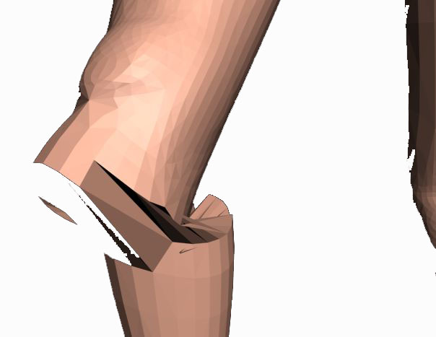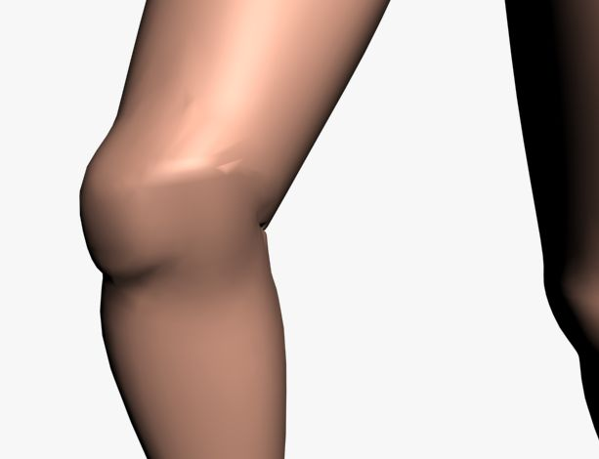
Figure 8: The deformations at the knee articulation

After eliminating the deformations, the skin should be smooth at the level of each articulation. In the end, are presented a few frames from the animation that was made (figure 9).

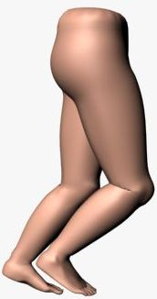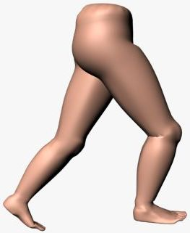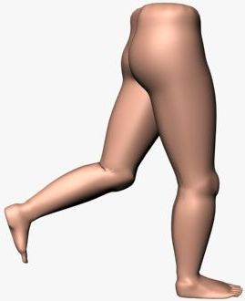
Figure 9: The animating of the lower limb

3. CONCLUSION

The animation process is very hard, because of the bones influence and because of the trajectory that can’t be set automatically. The software that has being used, can’t import trajectory form a real human model. Because of this reason the trajectories were set manually.
The bones influence determine the effect that is called model collision. This effect is avoided by starting the parts of the model to enter thru one another. This is the only way to avoid this problem.
This animated model can be used to simulate a normal walk or to simulate a deficient walk, depends on what the researchers want to do.

REFERENCES

- http://www.vh.org;
- http://www.euclideanspace.com;
- http://www.dlc.fi;
- http://www.tutorialized.com;
- http://www.3d-designer.dk.

